Title of the paper

Author_1 1, Author_2 2 and Author_3 3, *

1 Department of Civil and Environmental Engineering,

The Hong Kong Polytechnic University, Hong Kong, China.

2 Department of Building Services Engineering,

The Hong Kong Polytechnic University, Hong Kong, China.

3 Department of Civil and Environmental Engineering,

The Hong Kong Polytechnic University, China.

*Corresponding author, email: Author_3@polyu.edu.hk

**ABSTRACT**

Your ANCRiSST2025 paper should be formatted in the same way as this template. Please follow the same layout, font styles or sizes, or heading numbering schemes.

**KEYWORDS**

template, full paper, smart structures, artificial intelligence

**Introduction**

All the full-papers submitted will be peer-reviewed and collected in an electronic conference proceeding. Those who cannot prepare the full manuscript and chose to submit the abstract only, the abstract will not be peer-reviewed but will be collected in both printed and electronic conference proceedings.

Both the paper and abstract must be written in English [1]. The length of the paper (including abstract and references) is limited to **six pages** for *full paper* and **one page** for the *abstract*. The paper must be submitted as a PDF document, and optionally also as a Word document. The file size should not exceed 10 MB for PDF and 30 MB for Word files.

**STRUCTURE OF THE PAPER**

***Title***

The title of the paper must be identical to the title of the abstract that has been submitted.

***Authors***

A comma-delimited list of authors must be given, with full affiliations in the form Department, Company/Institution, Address, and the email address of the corresponding author.

***Abstract***

The abstract must give a summary of the paper. The length of the brief abstract should be within 200 and 300 words. It normally includes outline of the research and summary of the findings.

***Key words***

Include a concise list of key words (not more than 5), for example: template, full paper, smart structures, artificial intelligence.

***Main Contents***

The main part of the paper should start with an introduction and end with a conclusion. Section and subsection headings should be formatted as in this example file.

***References***

A numbered list of references should be provided. Make sure that all references are complete: for journal papers, provide initials, name, journal, volume, number, page numbers, and year; for books, provide initials, name, title, edition, publisher, city, country, and year.

**EQUATIONS, FIGURES, AND TABLES**

Equations should be centered and the numbering should be right-justified. Here is an example of an equation:

$\dot{x}=Ax+Bu$ (1)

Use standard symbols and nomenclature. Quantities should be expressed in SI units [2].

Figures and tables should be centered, numbered, and provided with a caption. Figure captions must be placed below the figure, while table captions must be placed above the table. All figures and tables must be explicitly referred to in the text of the paper. Examples are shown in figures, Figure 1 and Figure 2, and in table, Table 1. If you include photographs or other bitmaps, please make sure that the quality is sufficiently high for printing (at least 150 dpi).



Figure 1. First sample figure

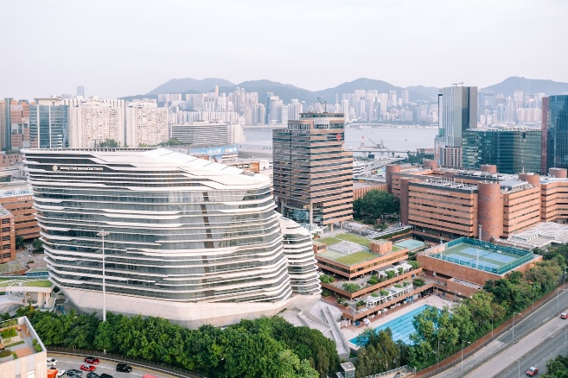

Figure 2. Second sample figure

Table 1. Sample table

|  |  |  |  |
| --- | --- | --- | --- |
| Mesh size | 60 × 20 | 150 × 50 | 300 × 100 |
| Method 1 | 0.65 | 75.19 | - |
| Method 2 | 0.15 | 0.72 | 1.85 |
| Method 3 | 0.13 | 0.69 | 1.98 |
| Method 4 | 0.13 | 0.78 | 2.18 |

**CONCLUSIONS**

This section describes the conclusions of the paper.

**ACKNOWLEDGMENTS**

The authors gratefully acknowledge the financial support provided by the Research Grants Council of Hong Kong (Project No: xxxx) and the Natural Science Foundation of China (National Key Project No. xxxx).

**References**

1. J. Simpson and E. Weiner, Eds., *The Oxford English dictionary*, Clarendon Press, Oxford, UK, second edition, 1989.
2. Bureau International des Poids et Mesures, *The international system of units (SI)*, BIPM, Paris, France, eighth edition, 2006.