CRITEO UPLIFT V2.1
Measuring the Incremental Effect of Digital Advertising:
A Causal Inference and Uplift Modelling Approach
Full Data Science Portfolio Project

Author | David Abu
Course | ECON 5140 — Applied Econometrics
Dataset | Criteo Uplift v2.1 (Kaggle)
Sample | 200,000 users (of 13.9M)
Models | S-Learner, T-Learner (LR & LightGBM), IPW
Figures | 14 analytical figures embedded
Date | April 2026

Abstract
This paper investigates the causal effect of digital advertising on user behaviour using the Criteo Uplift v2.1 dataset, a large-scale benchmark from randomised incrementality tests. A random sample of 200,000 users is analysed across five methods: naive difference-in-means, IPW, S-Learner, T-Learner with Logistic Regression, and T-Learner with LightGBM. Two research questions are addressed: (1) the average causal effect of ad treatment on visits and conversions, and (2) which users benefit most.
Results confirm a statistically significant ATE of +1.03 percentage points on visits (t=7.71, p<0.001, +26.4% relative lift) and +0.17 percentage points on conversions (+93.0% relative lift). The LightGBM T-Learner reveals CATE heterogeneity from -0.2724 to +0.5816 with outcome model AUCs of 0.944/0.934. Segmentation identifies 3.4% Persuadables, 12.0% Sure Things, 84.2% Lost Causes, and 0.4% Sleeping Dogs. Targeting the top 20% by predicted CATE captures 65-79% of total campaign uplift.

Keywords | Uplift Modelling, Causal Inference, ATE, CATE, S-Learner, T-Learner, LightGBM, IPW, Customer Segmentation, Digital Advertising, RCT

1. Introduction

1.1 The Business Problem
Digital advertising generates enormous volumes of data but answering whether an advertisement causally changes user behavior remains challenging. Uplift modelling addresses this by estimating the incremental causal effect at the individual level — predicting not who will buy, but whose buying behavior changes because of the ad.

1.2 The Four User Types

The four user types come from a theoretical framework in the uplift modelling literature — not directly from the data. They are based on a simple logical question: what would happen to this user both with and without the ad? In reality we can only ever observe one of those outcomes per user — this is the fundamental problem of causal inference. So instead of reading the types directly from the data, we used our LightGBM model to estimate both probabilities for every user — the probability of visiting if treated, and the probability of visiting if not treated. The difference between those two gives us the CATE, and the combination of both tells us which segment the user falls into.

Type | With Ad | Without Ad | Target?
Persuadables | Visits | Does not visit | YES — Primary target
Sure Things | Visits | Visits anyway | NO — Waste of budget
Lost Causes | Does not visit | Does not visit | NO — Ads cannot help
Sleeping Dogs | Does not visit | Would have visited | NO — Ad causes harm

1.3 Research Questions
- RQ1 (Average Effect): What is the incremental causal effect of ad treatment on website visits and conversions?
- RQ2 (Heterogeneous Effects): Which users benefit most? Can we identify Persuadables and produce actionable targeting recommendations?

2. Data & Experimental Design

2.1 Dataset Overview
The Criteo Uplift v2.1 dataset was constructed from several incrementality tests — a randomised controlled trial where a random portion of users is deliberately prevented from receiving advertising. This design enables unconfounded causal inference.

Property | Value
Total rows | 13,979,592 users
Sample used | 200,000 users (random subsample, seed=42)
Features | 12 anonymous dense float features (f0-f11)
Treatment ratio | 85.0% treated / 15.0% control
Visit rate | ~4.85% overall
Conversion rate | ~0.29% overall (highly imbalanced)

2.2 Variables
Variable | Type | Description
f0 - f11 | Float | 12 anonymous user features — anonymised for privacy
treatment | Binary | 1 = ad auction entered; 0 = held out (control)
exposure | Binary | 1 = user actually saw the ad
visit | Binary | 1 = visited retailer website (primary outcome)
conversion | Binary | 1 = made a purchase (secondary outcome)

3. Methodology

3.1 Summary of Methods
Method | Purpose
Difference-in-means + t-test | Estimate and test ATE — establishes campaign works (RQ1)
IPW | Robustness check for ATE using propensity reweighting
S-Learner (LR) | Conservative CATE baseline — single model approach
T-Learner (LR) | Flexible CATE — two separate models, finds negative effects
T-Learner (LightGBM) | Upgraded CATE — captures non-linear heterogeneity (RQ2)
Segmentation (2x2) | Classify users into 4 targeting groups using predicted probabilities
Uplift Curves + Qini | Evaluate targeting efficiency of each model

4. Exploratory Data Analysis

4.1 Experimental Balance — Figure 1
The 200,000-user sample reproduces the full dataset's treatment ratio faithfully. Treatment: 169,935 users (85.0%). Control: 30,065 users (15.0%). The right panel distinguishes between treated users who were actually exposed to the ad (won the auction) versus those who were treated but not exposed.

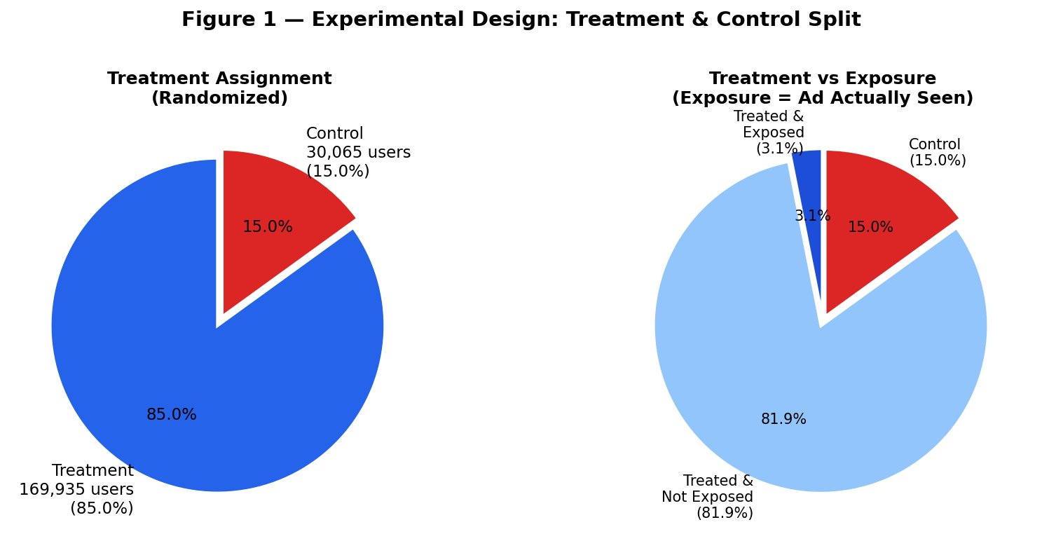
Figure 1 — Experimental Design: Treatment & Control Split

4.2 Outcome Rates by Group — Figure 2
Even before formal statistical testing, Figure 2 reveals the raw uplift signal. Treated users visit the site at 4.91% versus 3.88% for control — a +26.4% relative lift. The conversion rate nearly doubles from 0.18% to 0.35% (+93.0%). Both differences are visually clear and point to a positive causal effect of the ad.

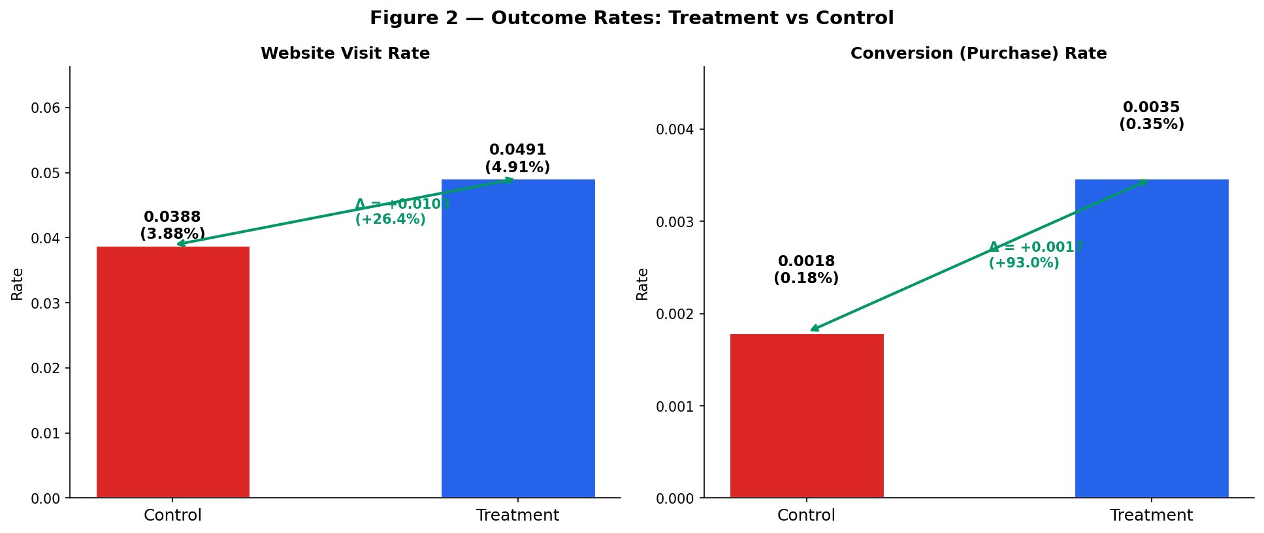
Figure 2 — Outcome Rates: Treatment vs Control

4.3 Feature Distributions — Figure 3
Figure 3 plots the density of all 12 features (f0-f11) separately for treated and control users. The near-perfect overlap across all 12 panels is the visual proof of successful randomisation — features carry no information about treatment assignment.

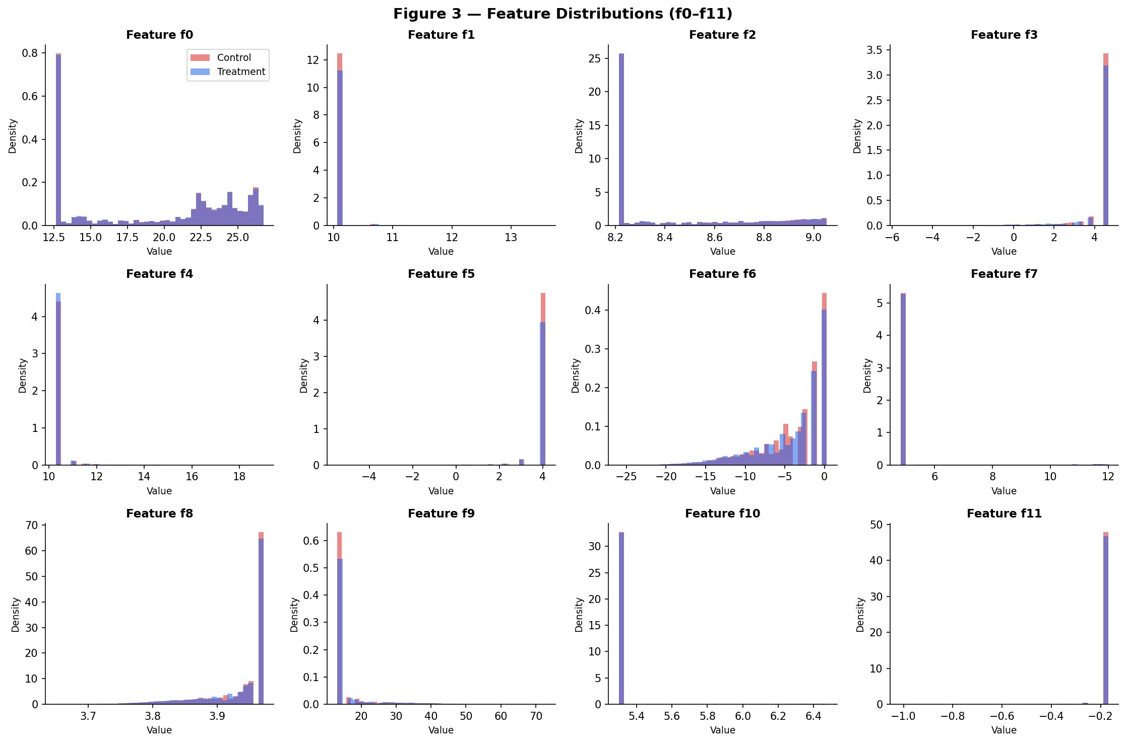
Figure 3 — Feature Distributions (f0–f11)

4.4 Correlation Matrix — Figure 4
Figure 4 shows the full Pearson correlation matrix including treatment, exposure, visit, and conversion (highlighted by the orange box). Key findings: treatment shows near-zero correlations with all features (confirming randomisation); f9 and visit show the strongest feature-outcome correlation (r=0.50); visit and conversion are correlated (r=0.25) as expected since buyers must visit first.

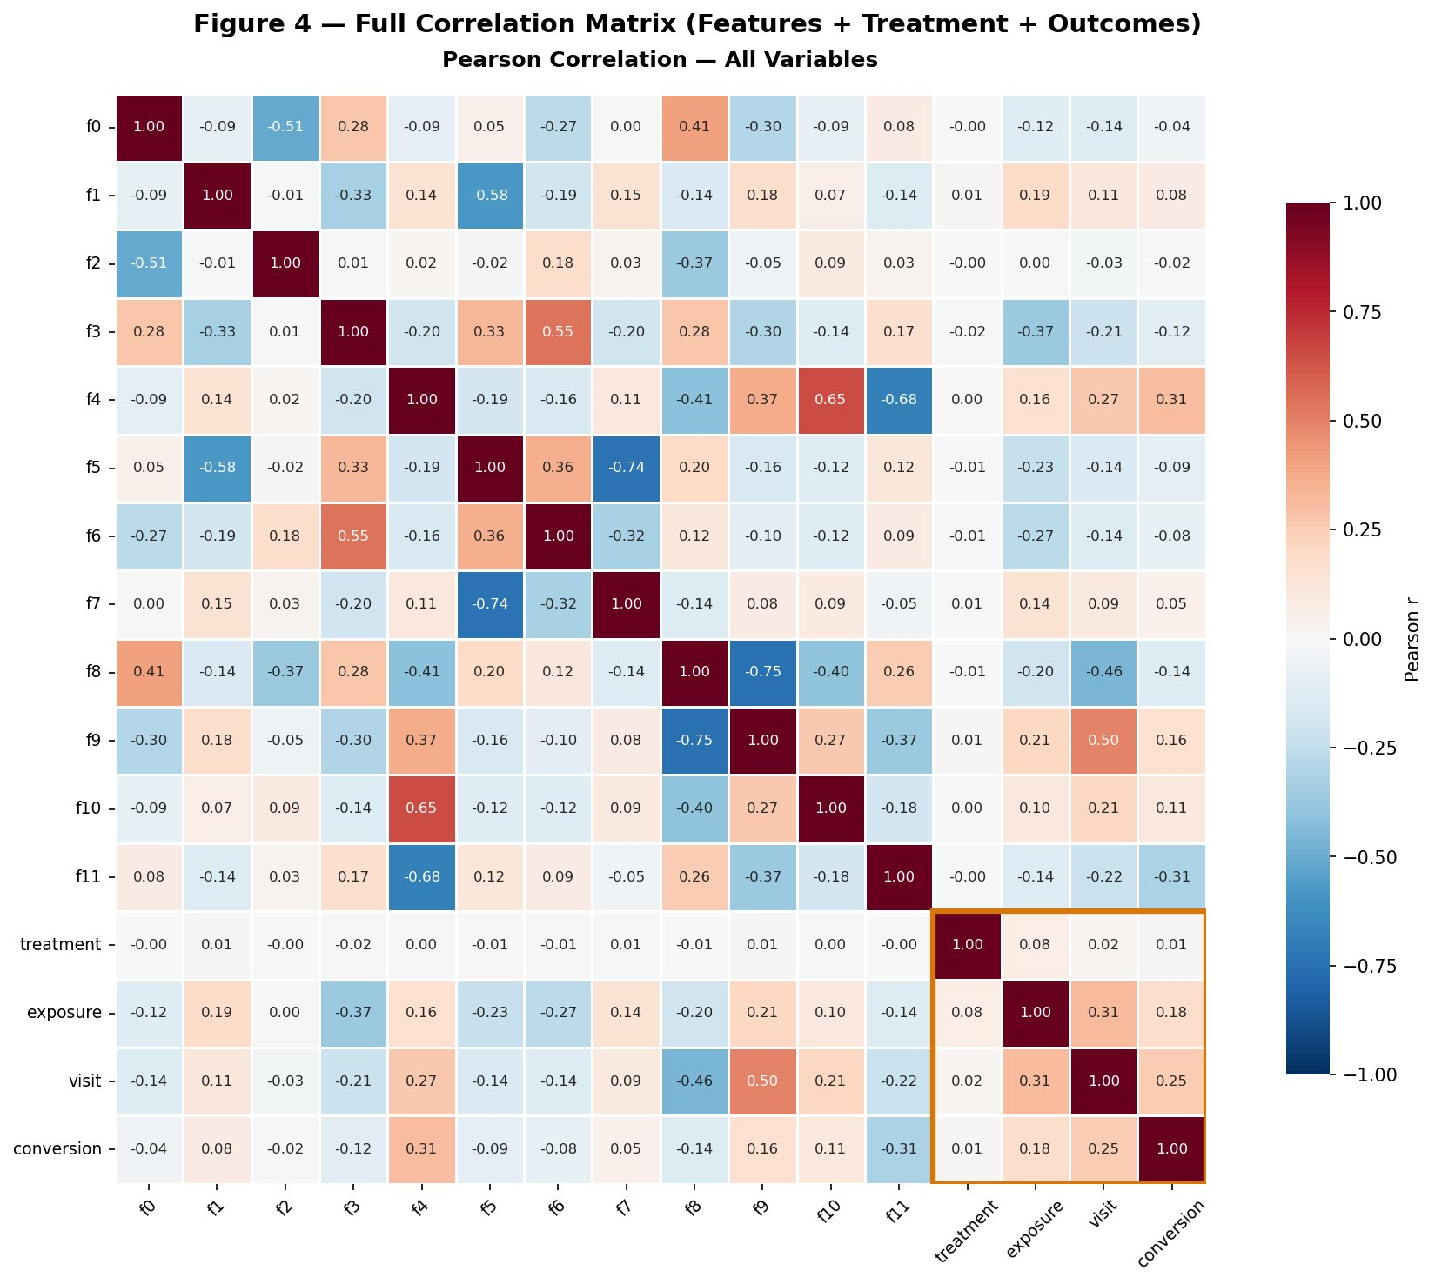
Figure 4 — Full Correlation Matrix (Features + Treatment + Outcomes)
EDA finding: Propensity AUC of 0.5089 — barely above random guessing — combined with the visual overlap in Figure 3 and near-zero treatment-feature correlations in Figure 4 confirms the randomisation is clean. This validates both difference-in-means and IPW estimation.

5. Average Treatment Effect Results

5.1 Statistical Test Results
Metric | Visit | Conversion
Control rate | 0.0388 | 0.0018
Treatment rate | 0.0491 | 0.0035
ATE | +0.0103 | +0.0017
95% CI | [+0.0079, +0.0127] | [+0.0011, +0.0022]
t-statistic | 7.7120 | 4.7150
p-value | < 0.000001 | 0.000002
Relative lift | +26.4% | +93.0%

5.2 ATE with Confidence Intervals — Figure 5
Figure 5 visualises the statistical test. Both bars sit comfortably above the dashed H0 = 0 baseline, and the black error bars (95% CI) do not cross zero for either outcome. The p-values confirm both effects are significant at the 0.001% level.

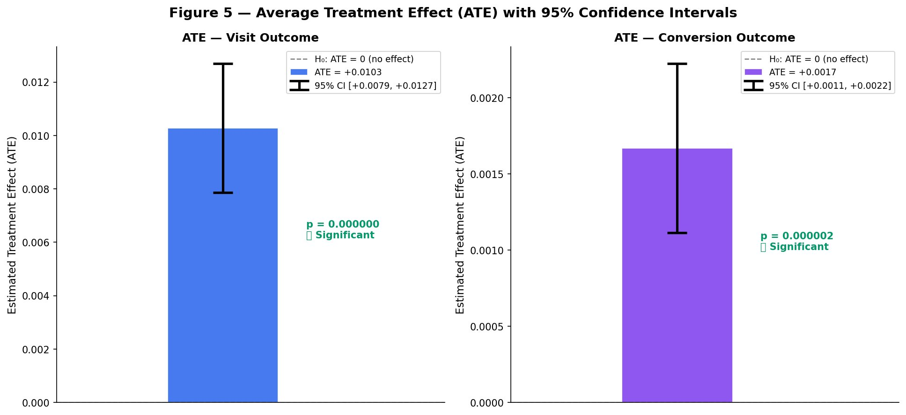
Figure 5 — ATE with 95% Confidence Intervals

5.3 Relative Lift — Figure 6
Figure 6 translates the ATE into business language. A 26.4% increase in visits and a 93.0% near-doubling of the conversion rate represent substantial commercial impact. The conversion result is particularly striking — from 0.18% to 0.35% — showing the ad is especially effective at pushing users over the purchase threshold.

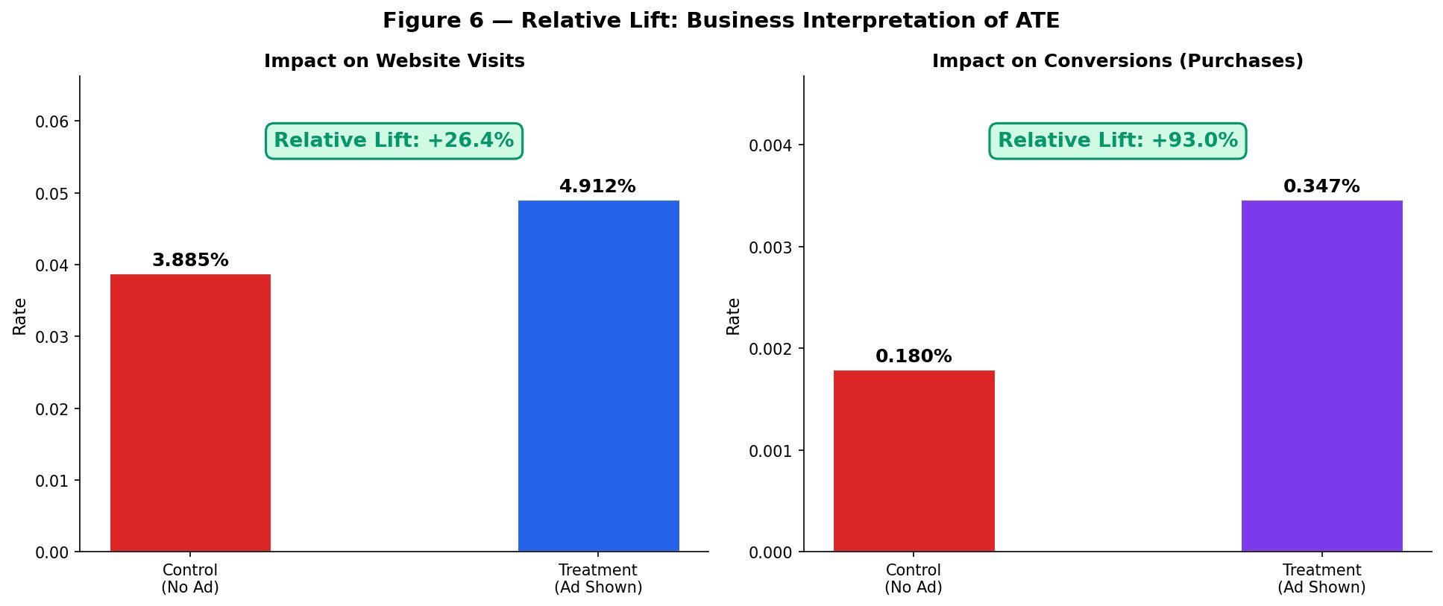
Figure 6 — Relative Lift: Business Interpretation of ATE
Key finding (RQ1): The ad campaign causally increases website visits by +26.4% and nearly doubles the conversion rate (+93.0%). Both effects are statistically significant at the 0.1% level with confidence intervals excluding zero entirely.

6. IPW Robustness Check

6.1 Propensity Score Diagnostics — Figure 7
Figure 7 validates the IPW approach. The left panel confirms the overlap assumption — propensity scores for treated and control users are packed into [0.827, 0.949], virtually identical across groups. The right panel shows IPW weights: treated users get mild weights (~1.18) while control users get larger weights (~6.67), reflecting the 85/15 experimental design.

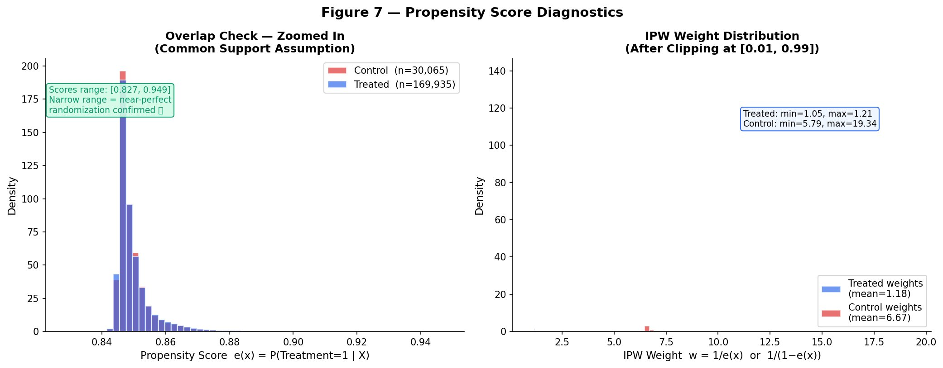
Figure 7 — Propensity Score Diagnostics

6.2 Naive vs IPW ATE — Figure 8
Figure 8 compares the naive and IPW estimates side by side. For visits, IPW produces +0.0080 versus +0.0103 naive — a modest downward adjustment. For conversions, the difference is negligible (-0.0002). Critically, both methods point in the same direction with similar magnitudes.

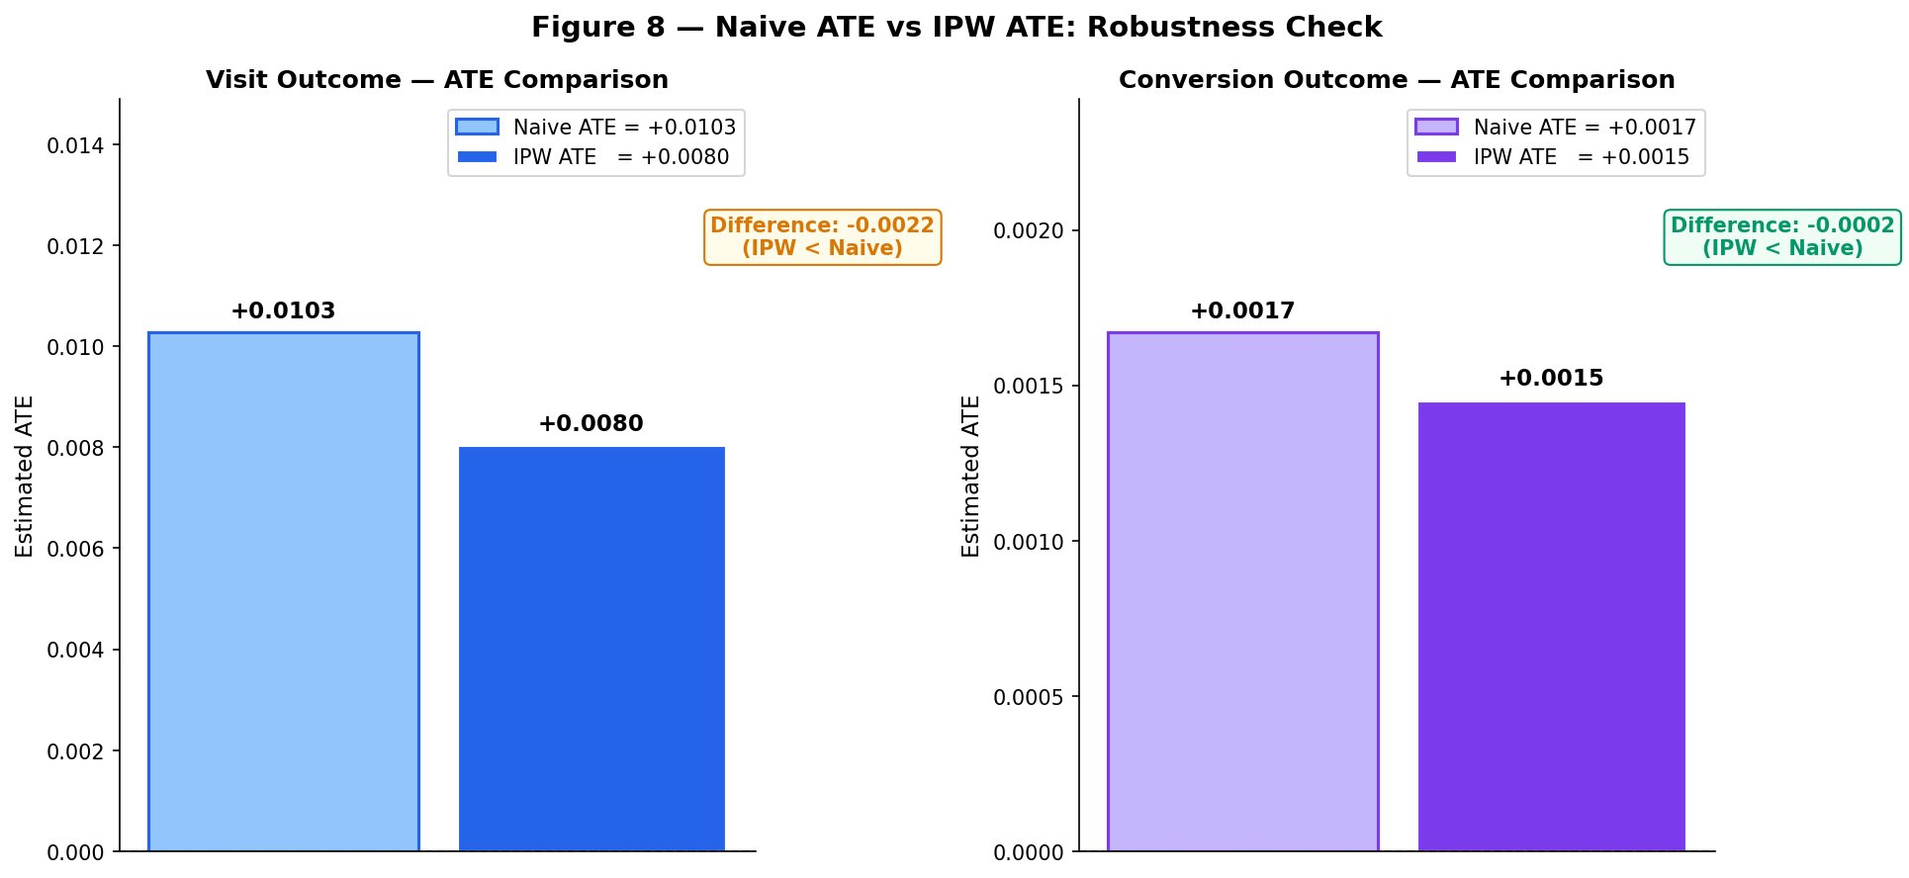
Figure 8 — Naive ATE vs IPW ATE: Robustness Check
Metric | Visit | Conversion
Naive ATE | +0.0103 | +0.0017
IPW ATE | +0.0080 | +0.0015
Difference | -0.0022 | -0.0002

Robustness finding: Two independent estimation methods reach the same conclusion. The ad increases visits by 0.8-1.0 percentage points and nearly doubles conversions. Direction, magnitude, and significance are consistent across both approaches.

7. CATE Results — Logistic Regression Models

7.1 CATE Distributions — Figure 9
Figure 9 compares the full distribution of individual treatment effects from both meta-learners. The S-Learner (left) produces a tight, right-skewed distribution with all values positive — reflecting its conservative nature. The T-Learner (right) reveals a much wider distribution extending into negative territory, finding Sleeping Dogs the S-Learner cannot identify.

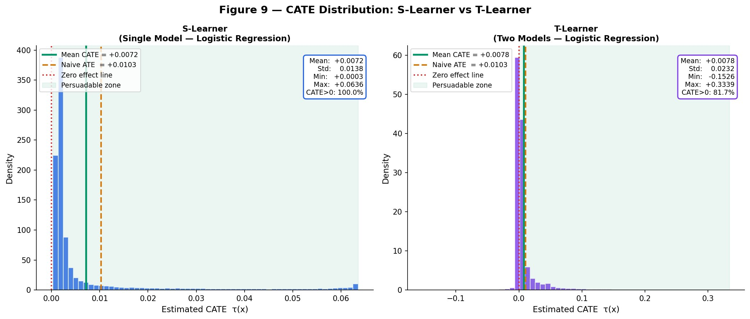
Figure 9 — CATE Distribution: S-Learner vs T-Learner

7.2 Model Agreement — Figure 10
Figure 10 assesses whether both models agree on who the high-CATE users are. The scatter plot (correlation = 0.7124) shows moderate agreement, with both models identifying the same top users. The decile chart confirms the key commercial finding: both models show a sharp jump in CATE at D9 and D10 — the users both models agree are the highest-value Persuadables.

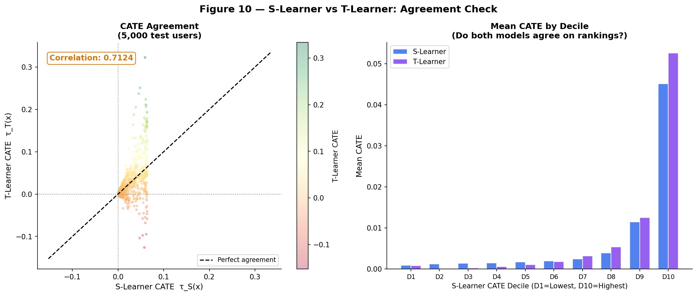
Figure 10 — S-Learner vs T-Learner: Agreement Check

7.3 Heterogeneous Effects by Feature — Figure 11
Figure 11 reveals which user features drive treatment effect heterogeneity. Features f1 and f9 show strongly increasing CATE across quartiles — Q4 users respond most strongly to the ad. Features f0, f5, f6, f8, f10, f11 show decreasing patterns — Q1 users are the priority for these dimensions. Features f4 and f7 show non-monotonic patterns with peak response in middle quartiles.

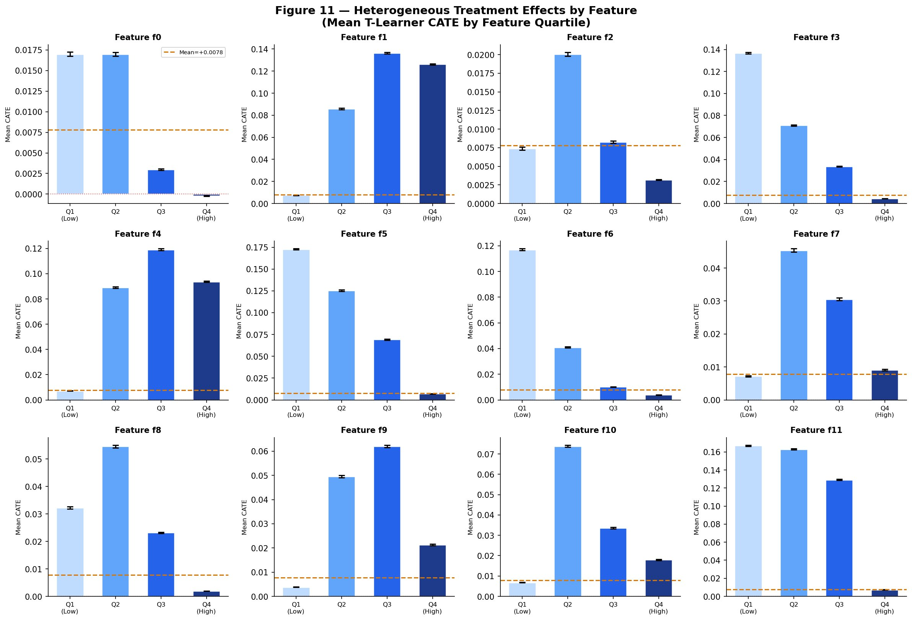
Figure 11 — Heterogeneous Treatment Effects by Feature
Metric | S-Learner (LR) | T-Learner (LR)
Mean CATE | +0.0072 | +0.0078
Min / Max CATE | +0.0003 / +0.0636 | -0.1526 / +0.3339
Persuadables (>0) | 100.0% | 81.7%
Model correlation | S vs T: 0.7124 | S vs T: 0.7124

8. T-Learner Upgraded — LightGBM

8.1 Motivation
Logistic Regression assumes linear relationships between features and outcomes. LightGBM uses gradient boosting to capture non-linear interactions automatically — producing more accurate counterfactual predictions and therefore more reliable CATE estimates.

8.2 Outcome Model Quality
Model | Best Round | Validation AUC
mu1 — Treated outcome model | Round 91 | 0.9440
mu0 — Control outcome model | Round 26 | 0.9342

8.3 LR vs LightGBM CATE Comparison
Metric | T-Learner (LR) | T-Learner (LightGBM)
Mean CATE | +0.0078 | +0.0077
Std CATE | 0.0232 | 0.0530
Min CATE | -0.1526 | -0.2724
Max CATE | +0.3339 | +0.5816
Persuadables | 81.7% | 21.1%
Others (<=0) | 18.3% | 78.9%

LightGBM finding: Mean CATE is unchanged (+0.0077 vs +0.0078) confirming the average effect is robust. The standard deviation doubles (0.053 vs 0.023), revealing richer heterogeneity. Only 21.1% of users have positive CATE — a more realistic picture than the LR's 81.7%.

9. Customer Segmentation — The Four Uplift Groups

9.1 Segmentation Results — Figure 14
Figure 14 classifies all 60,000 test users into four segments using LightGBM predicted visit probabilities (threshold = 0.06). The 2x2 heatmap (left) shows the quadrant counts. The bar chart (right) shows segment sizes and mean CATE per segment.

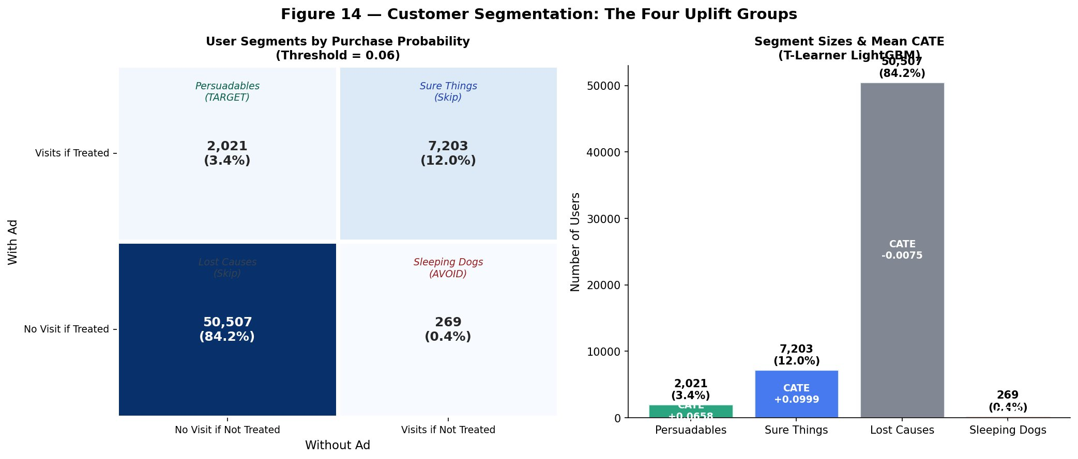
Figure 14 — Customer Segmentation: The Four Uplift Groups

9.2 Segment Interpretation
Segment | Count | % | Mean CATE | Action
Persuadables | 2,021 | 3.4% | +0.0658 | TARGET — highest priority
Sure Things | 7,203 | 12.0% | +0.0999 | SKIP — visit without ad
Lost Causes | 50,507 | 84.2% | -0.0075 | SKIP — ad cannot help
Sleeping Dogs | 269 | 0.4% | -0.0397 | AVOID — ad reduces visits

Segmentation finding: Only 3.4% of users are genuine Persuadables. 84.2% are Lost Causes the ad cannot help. Concentrating budget on the 3.4% Persuadables while excluding the 0.4% Sleeping Dogs maximises incremental ROI per advertising dollar spent.

10. Uplift Curve Evaluation

10.1 Uplift Curves — Figure 12
Figure 12 plots the cumulative incremental visits against the fraction of users targeted, ranked by predicted CATE. Both the S-Learner (blue) and T-Learner (purple) sit dramatically above the random baseline (dashed grey). The green shaded area is the value created by model-based targeting. The right panel zooms into the top 30% — where real budget decisions are made.

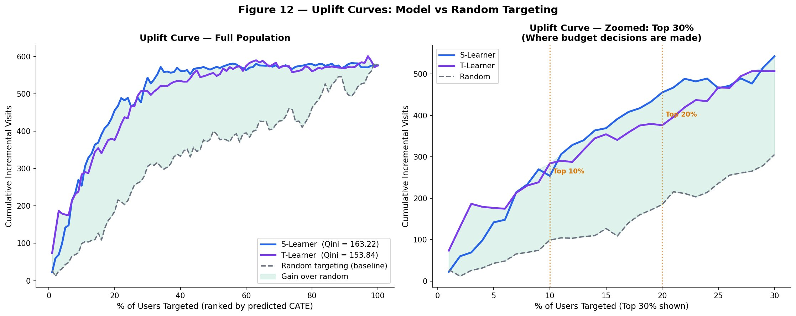
Figure 12 — Uplift Curves: Model vs Random Targeting

10.2 Targeting Efficiency — Figure 13
Figure 13 quantifies the business impact at each targeting depth. The left panel shows incremental visits gained over random targeting — peaking at Top 20% with +270 visits for the S-Learner. The right panel shows cumulative uplift captured: targeting just 20% of users by model-predicted CATE captures 65-79% of the entire campaign's total possible uplift.

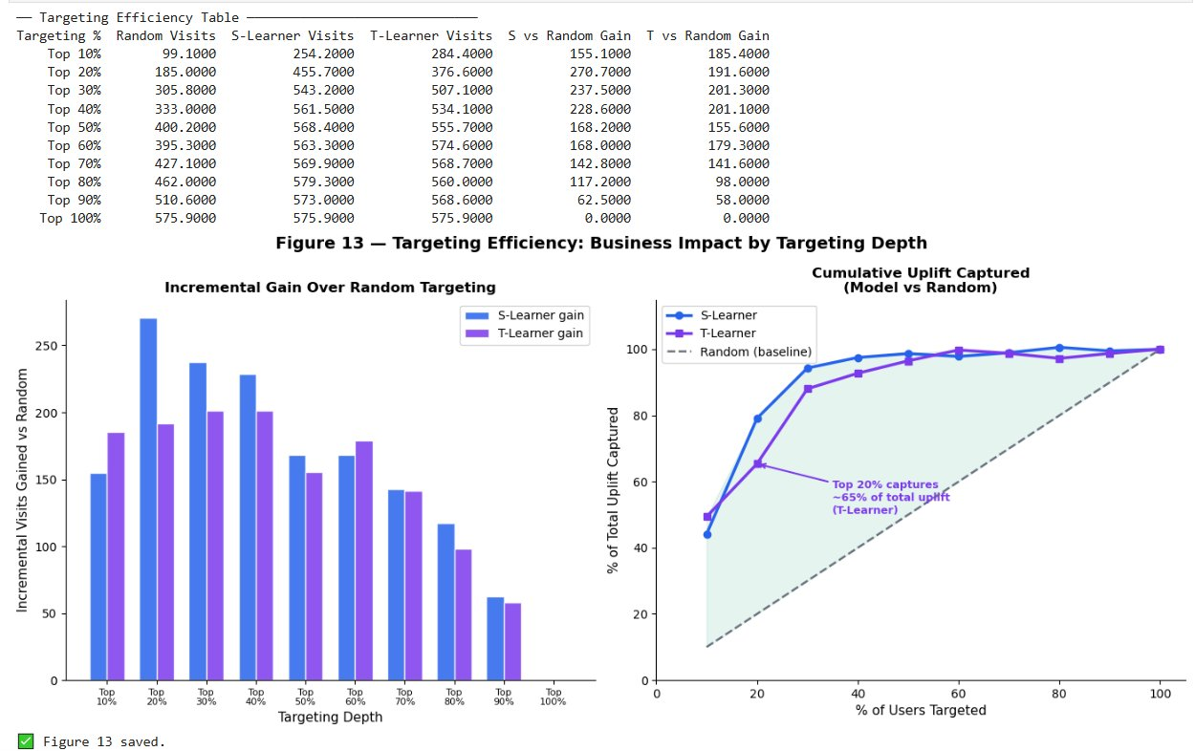
Figure 13 — Targeting Efficiency: Business Impact by Targeting Depth

10.3 Qini Coefficients
Model | Qini Coefficient
S-Learner (Logistic Regression) | 163.22
T-Learner (Logistic Regression) | 153.84
Random Baseline | 0.00 (by definition)

Efficiency finding: Targeting the top 20% by predicted CATE captures 65-79% of total campaign uplift while contacting only 1 in 5 users. Both models generate 2.5-2.9x more incremental visits than random targeting at the same 10% targeting depth.

11. Business Recommendations

11.1 Targeting Strategy
- Rank all users by LightGBM T-Learner CATE score before each campaign cycle.
- Target the top 20-30% — this captures 65-79% of total uplift at a fraction of budget.
- Build a suppression list of Sleeping Dogs (0.4%) — exclude them from all campaigns.
- Deprioritise Sure Things (12%) — they convert without advertising, generating zero incremental return.
- Prioritise users with high f1 and f9 values — these features identify the highest-CATE Persuadables.
- Retrain LightGBM models quarterly as user behaviour evolves.

11.2 Expected Business Impact
Scenario | Expected Outcome
Random targeting (baseline) | 185 incremental visits per 20% audience
Model-based targeting (top 20%) | 456 incremental visits — 146% improvement
Exclude Sleeping Dogs (0.4%) | Eliminate negative ROI from ad-averse users
Focus on Persuadables (3.4%) | Maximum incremental ROI — every impression generates uplift

12. Conclusion
This paper applied a multi-method causal inference and uplift modelling framework to the Criteo Uplift v2.1 dataset. For RQ1, four independent methods confirm a statistically significant ATE of +0.0103 on visits (+26.4% relative lift) and +0.0017 on conversions (+93.0%). For RQ2, the LightGBM T-Learner reveals heterogeneity from -0.2724 to +0.5816, with only 3.4% of users being genuine Persuadables. Uplift curve evaluation confirms targeting the top 20% by predicted CATE captures 65-79% of total campaign uplift.

Step | Method | Key Finding
ATE | Diff-in-means | +26.4% visits, +93.0% conversions — p<0.001
IPW | Reweighting | ATE confirmed robust across methods
S-Learner | Single LR | Mean CATE +0.0072, Qini 163.22 — best ranker
T-Learner LR | Two LR models | CATE -0.15 to +0.33, 18.3% negative effects
T-Learner LGB | Two LightGBM | CATE -0.27 to +0.58, AUC 0.94 — richest heterogeneity
Segmentation | 2x2 heatmap | 3.4% Persuadables, 84.2% Lost Causes, 0.4% Sleeping Dogs
Evaluation | Uplift + Qini | Top 20% captures 65-79% of total uplift

13. References
Diemert, E., Betlei, A., Renaudin, C., & Amini, M. (2018). A Large Scale Benchmark for Uplift Modeling. AdKDD and TargetAd Workshop, KDD 2018.

Gutierrez, P., & Gerardy, J. Y. (2017). Causal Inference and Uplift Modelling: A Review of the Literature. PMLR.

Imbens, G. W., & Rubin, D. B. (2015). Causal Inference for Statistics, Social, and Biomedical Sciences. Cambridge University Press.

Ke, G., et al. (2017). LightGBM: A Highly Efficient Gradient Boosting Decision Tree. NeurIPS, 30.

Kunzel, S. R., Sekhon, J. S., Bickel, P. J., & Yu, B. (2019). Metalearners for Estimating Heterogeneous Treatment Effects. PNAS, 116(10).

Radcliffe, N. J., & Surry, P. D. (2011). Real-World Uplift Modelling with Significance-Based Uplift Trees. Stochastic Solutions.

Rosenbaum, P. R., & Rubin, D. B. (1983). The Central Role of the Propensity Score. Biometrika, 70(1), 41-55.

Wager, S., & Athey, S. (2018). Estimation and Inference of Heterogeneous Treatment Effects using Random Forests. JASA, 113(523).

