XAI: Model-Agnostic Methods
Exercise 5 – Partial Dependence Plots (PDP)
Xavier Ventura Puchol
David Gilsanz Domínguez
May 2026

1. One-Dimensional Partial Dependence Plot

1.1 Background & Methodology
The Partial Dependence Plot (PDP) is a really useful tool to understand how machine learning models work. It shows us how one specific feature changes the final prediction. To do this, the model looks at different values of one feature and averages out all the other features. This helps us to see the connection between a single variable and the result, without the other variables getting in the way.
In this exercise, we trained a Random Forest model (using 100 trees) on the UCI Bike Sharing dataset. The goal was to guess the number of bikes people rent every day. After that, we made PDPs for four variables: days since 2011, temperature, humidity, and wind speed.

1.2 Results and Interpretation

Days Since 2011
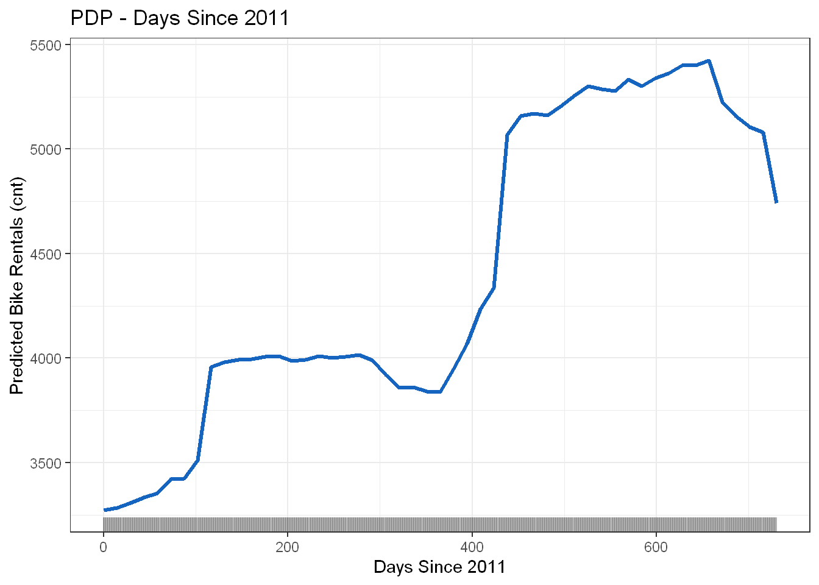
Figure 1. PDP – Days Since 2011
The plot shows that the number of rentals definitely goes up over time. At the beginning of 2011, the prediction is about 3,200 rentals, and it grows to about 5,300 in the middle of 2012. There is a small drop at the very end. We can see two big jumps in the line: one around day 100 (spring 2011) and another around day 400 (early 2012). This is very logical because the service became more popular and more people discovered it, so the demand grew every year.

Temperature
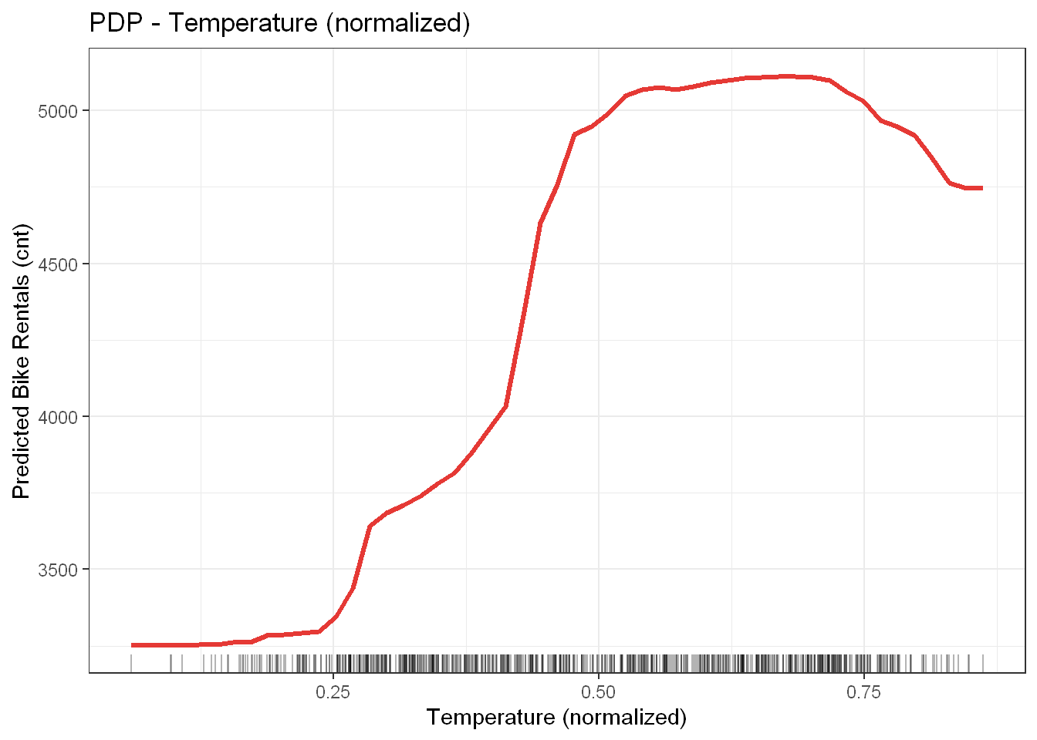
Figure 2. PDP – Temperature (normalised)
Temperature has a very clear and positive effect on bike rentals. When it is very cold (under 0.2 in the normalized scale), the rentals stay around 3,250. But when the temperature goes up, the rentals increase fast, reaching about 5,100. However, when it is extremely hot (over 0.75), the curve goes down a little bit. This tells us that people don't really like cycling in extreme heat. In short, people use the bikes mostly when the weather is nice and warm, which is exactly what we expect.

Humidity
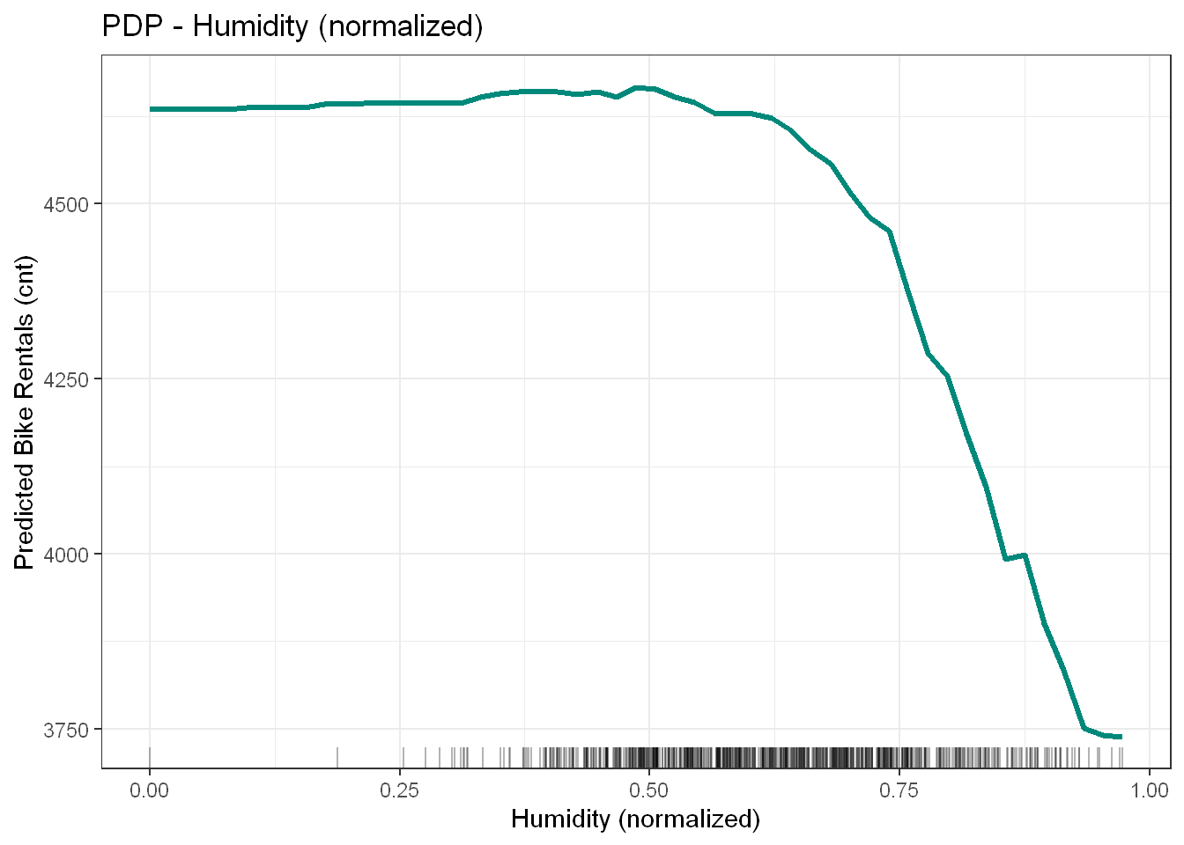
Figure 3. PDP – Humidity (normalised)
When humidity is low or normal (under 0.65), it doesn't really change the rentals. The prediction stays around 4,600. But when the humidity gets higher than that, the number of rentals goes down very fast to about 3,750. This means that people don't mind normal humidity, but if the air feels very wet, they prefer not to ride bikes. The rentals drop by almost 20%, which is a big difference that the model found perfectly.

Wind Speed
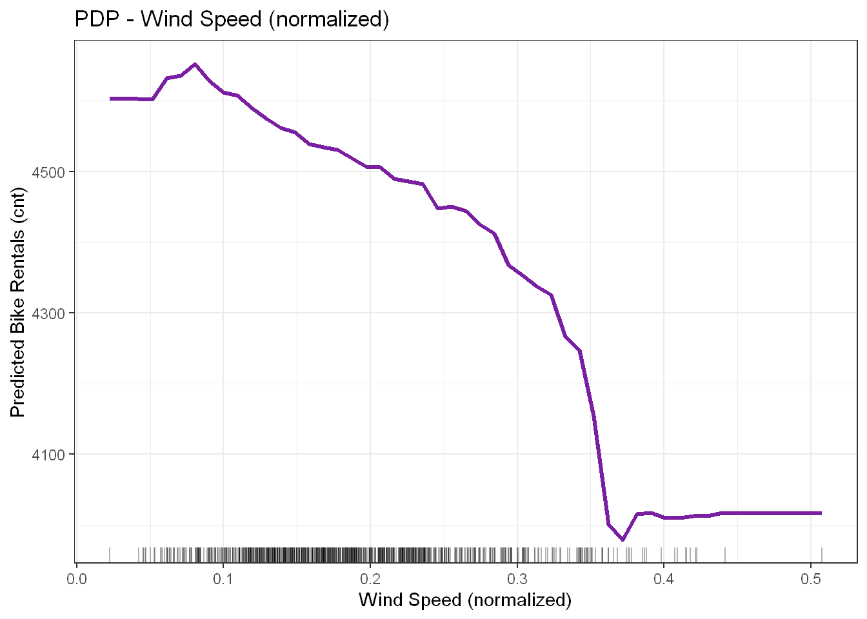
Figure 4. PDP – Wind Speed (normalised)
Wind speed always has a negative effect: more wind means fewer rented bikes. The predictions drop from 4,580 on calm days to about 4,050 on windy days. Then the line stays flat for very high wind. The drop is not as big as the temperature or humidity, so wind is important but not the most important thing. Most days in our dataset don't have a lot of wind, so the model had enough data to learn this well.

2. Bidimensional Partial Dependence Plot

2.1 Background & Methodology
A 2D PDP is like the normal one, but we look at two features at the same time to see the average prediction. The result is a colorful map (called a heatmap). It shows the effect of each variable and also if the two variables interact together in an interesting way.
Because it takes a lot of time for the computer to calculate this for all the data, we used a random sample of 200 days. The map uses colors from dark purple (low rentals) to yellow (high rentals). There are also curves on the sides to show how common the temperature and humidity values are in the real dataset.

2.2 Results and Interpretation
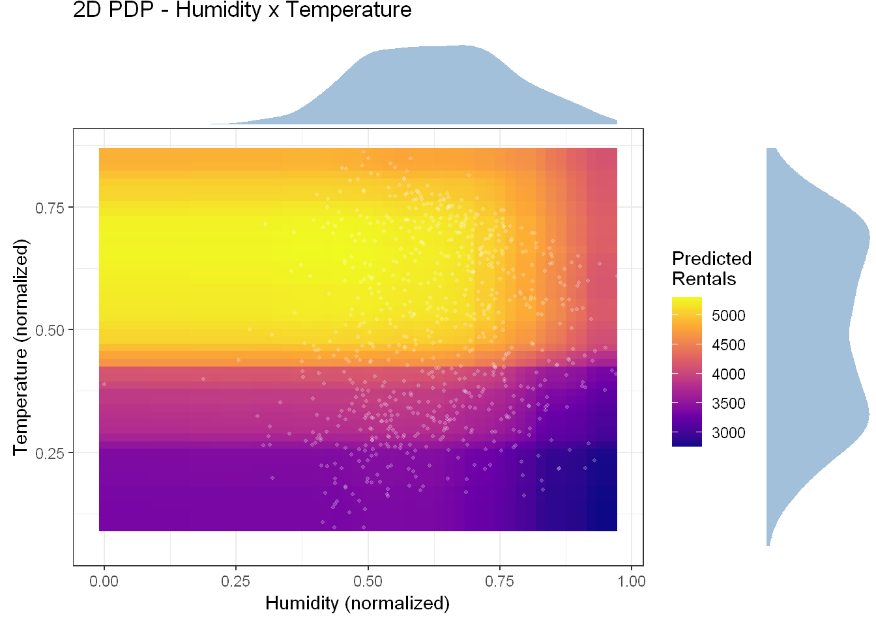
Figure 5. 2D PDP – Humidity × Temperature with marginal density distributions
The heatmap confirms what we already saw in the 1D plots. The highest rentals (the yellow area) are in the top-left corner. This means high temperature and low humidity at the same time. When humidity increases (moving to the right), the colors get darker, so there are fewer rentals. When the temperature drops (moving down), the same thing happens.
An important thing to notice is that the two variables don't have a strange or surprising interaction. The colors change smoothly from yellow to dark blue. This means the temperature has basically the same effect, no matter what the humidity is. Simply put, the best day to rent a bike is a warm and dry day, and the worst day is a cold and wet one.
The curve at the top shows that most days have normal humidity. The curve on the right shows that the temperature has two main groups: cold winter months and warm summer months. This tells us that perfect conditions (warm and dry) happen a lot, especially in the summer.

3. PDP for House Price Prediction

3.1 Background & Methodology
We used the same PDP method on a dataset about house sales in King County to explain the prices predicted by another Random Forest model. The model learned from a random sample of 5,000 houses using six features: bedrooms, bathrooms, living area (sqft), lot area, floors, and year built. We used a smaller sample of 500 houses to make the PDPs so the computer didn't take too much time.

3.2 Results and Interpretation

Bedrooms
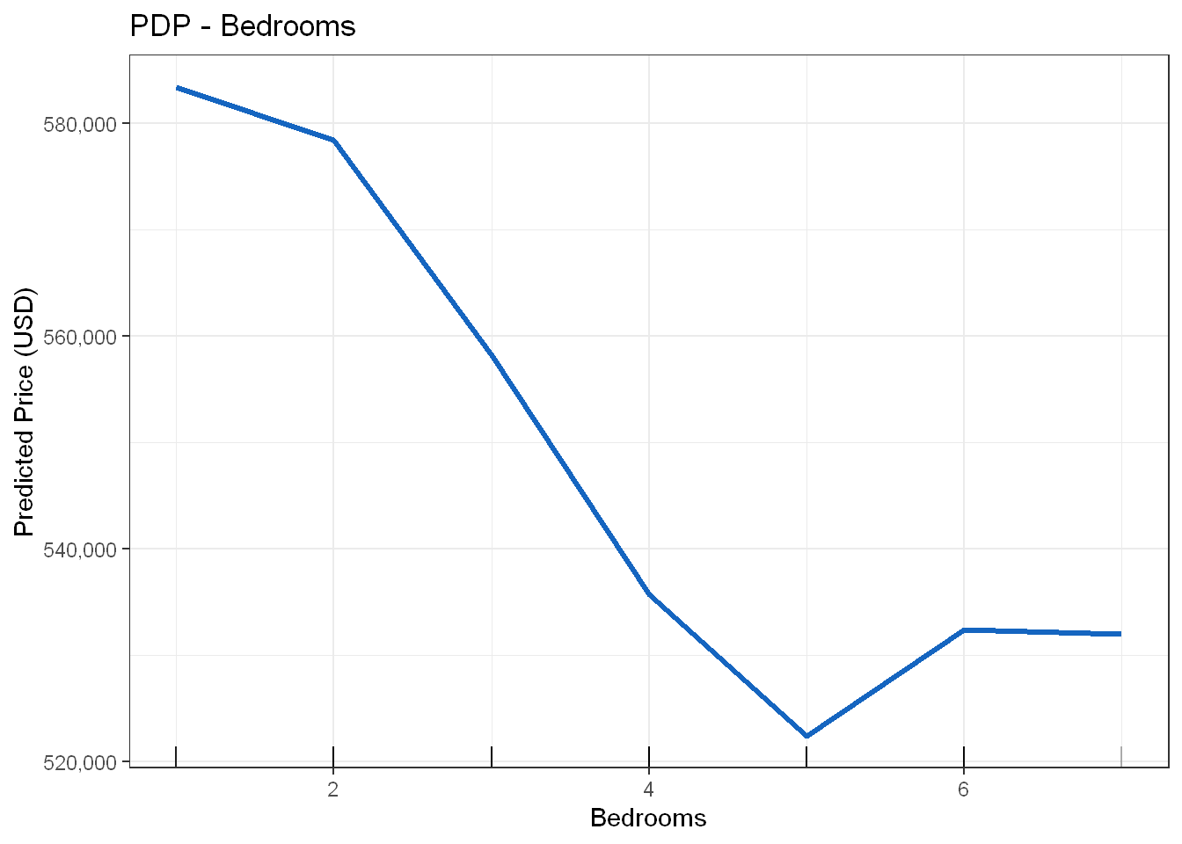
Figure 6. PDP – Bedrooms
Surprisingly, but having more bedrooms actually makes the predicted price lower in this model. It starts at $585,000 for 1-2 bedrooms, and drops to $523,000 for 5 bedrooms. Then it goes up a little bit for 6 or more. This looks strange, but it makes sense when you think about it: the model already knows the total size of the house (living area). So, if a house has many bedrooms but the same total size, it means the rooms are just smaller, and buyers don't like that as much. More bedrooms don't make the house bigger; they just divide the space into more pieces.

Bathrooms
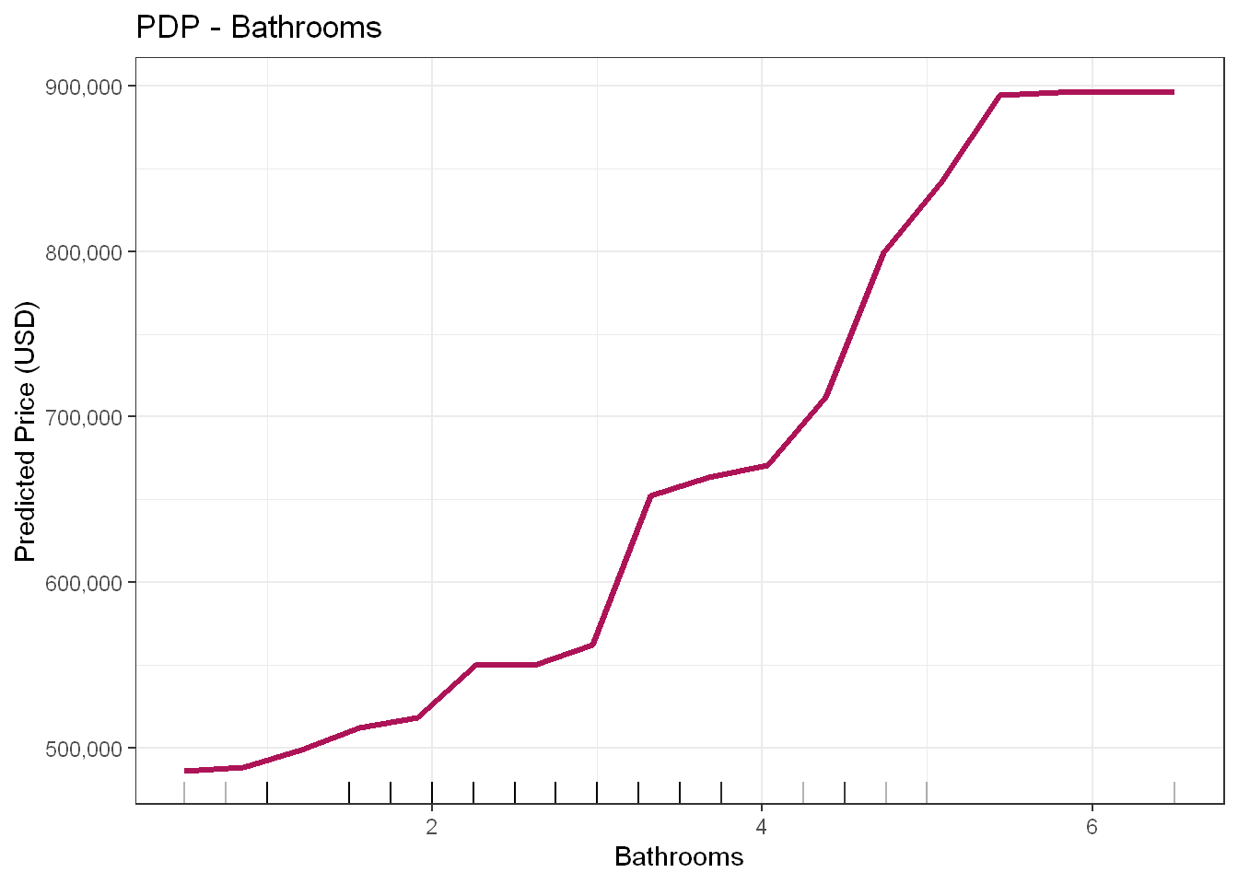
Figure 7. PDP – Bathrooms
Bathrooms have a very strong and good effect on the price. The price goes from $485,000 (1 bathroom) up to $900,000 (5.5 or 6 bathrooms). That is almost double! The curve goes up in steps because bathrooms are counted by 0.5 in the data. The biggest jump is between 4 and 5 bathrooms, which is for luxury houses. Unlike bedrooms, more bathrooms are always a good thing. It usually means the house is bigger and nicer, so people are happy to pay more money.

Living Area (sqft)
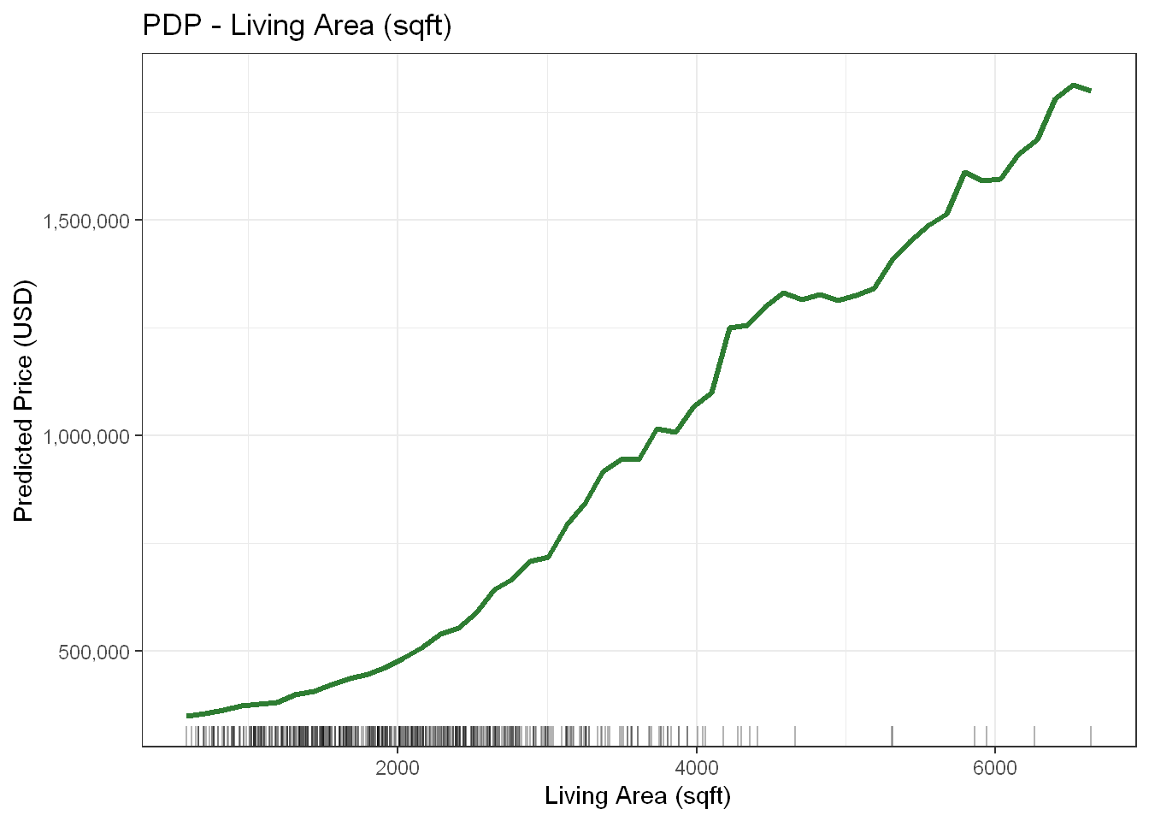
Figure 8. PDP – Living Area (sqft)
The living area is definitely the most important variable in the model. The predicted price goes up continuously when the house gets bigger: from $330,000 for small houses to more than $1,700,000 for very big ones. This relationship is very clear and has no surprises. It makes perfect sense: a bigger house costs more money. Most houses are between 1,000 and 4,000 sqft, which is where the model is the most confident.

Floors
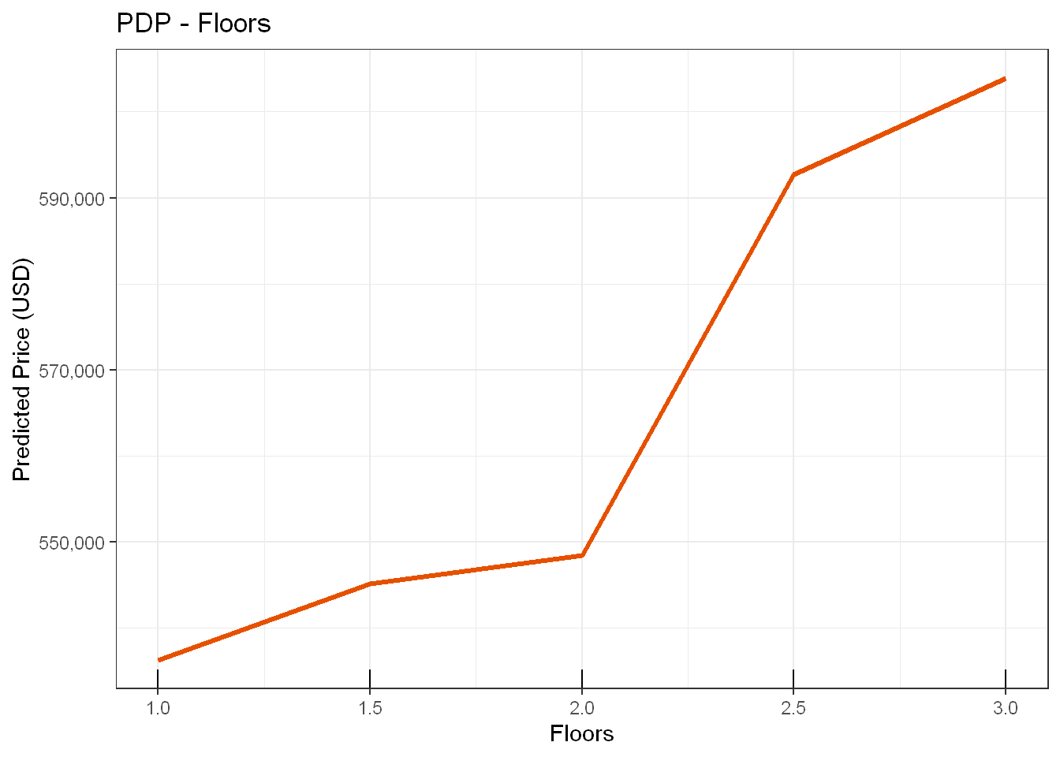
Figure 9. PDP – Floors
The number of floors also makes the price go up, but the effect is smaller than the living area or bathrooms. Houses with one floor are predicted at about $524,000, and it goes up to $598,000 for houses with three floors. There is a noticeable step between 2 and 2.5 floors, where the price starts going up faster. The curve has steps because houses can only have specific numbers of floors. In general, more floors mean a higher price because it probably means the house is larger or more modern.

4. Conclusion
In conclusion, Partial Dependence Plots (PDP) are incredibly useful tools for understanding how machine learning models make their predictions. By looking at both the bike sharing data and the house price data, we can clearly see how individual factors, like weather conditions or the size of a house, change the final results.
While many of these effects match our common sense (like bigger houses costing more or warm weather bringing more cyclists), the plots also reveal interesting and surprising details, such as why having too many bedrooms in the same space can actually lower a house's value. Overall, PDPs help us trust our models much more because they turn complex data into clear and easy-to-understand visual patterns.

