document |

None

2025-03-28

Skip to content

Reset to defaults

[Accessibility statement](https://chirun.org.uk/accessibility-statement/material)

Close

Text size

100%

Spacing

100%

Text font Sans-serif Serif Atkinson Hyperlegible Comic Sans

Colour scheme Automatic (default) Black text on white White text on black Custom

Text colour

Link colour

Background colour

Muted background colour

Accent colour 1

Accent colour 2

Accent colour 3

Accent colour 4

Sepia filter

0%

Rotate hues

0 turns

Invert images in dark mode

* [Download as PDF](document.pdf)

# Table of Contents

Jump to content

1. 1 Functions of Several Variables
   1. Visualising a Scalar Field
   2. 1.1 Partial Differentiation
   3. 1.2 Differentials
      1. Uses of the Differential
      2. Two Useful Identities
   4. 1.3 Problems
2. 2 The Gradient of a Scalar Field
   1. 2.1 Interpretation of \({\nabla }\phi \)
   2. 2.2 Finding Tangents
      1. Directional Derivative
   3. 2.3 Problems
3. 3 Changes of Coordinates – Rotations
   1. 3.1 Transforming Vectors
      1. A More General Method for Finding Basis Vectors
   2. 3.2 What are Scalars and Vectors?
      1. The Scalar Product
      2. The Gradient of a Scalar Field
   3. 3.3 Problems
4. 4 Vector Fields
   1. 4.1 Visualising a Vector Field
   2. 4.2 Calculating Field Lines
   3. 4.3 Divergence and Curl of a Vector Field
   4. 4.4 Problems
5. 5 Derivatives of Scalar and Vector Fields
   1. 5.1 Physical Interpretation of Divergence and Curl
   2. 5.2 All the Second Derivatives
      1. The Laplacian operator, \({\nabla }^2\)
      2. Identities Involving Second Derivatives
   3. 5.3 Maxwell’s Equations
   4. 5.4 Problems
6. 6 Polar Coordinates
   1. 6.1 Converting Scalar and Vector Fields to Polar Coordinates
   2. 6.2 The gradient, \({{\nabla }}V\), in Polar Coordinates
      1. Alternative Derivation Using Scale Factors
   3. 6.3 The divergence, \(\nabla \cdot F\), in Polar Coordinates
   4. 6.4 Problems
7. 7 Polar Coordinates in Three Dimensions
   1. 7.1 Spherical Polar Coordinates
      1. Basis Vectors in Spherical Polars
      2. Converting a Vector Field to Spherical Polars
   2. 7.2 Cylindrical Polar Coordinates
   3. 7.3 Vector Operators
      1. Cylindrical Polars
      2. Spherical Polars
      3. Examples
   4. 7.4 Problems

## 1 Functions of Several Variables

In this course, we are going to studying functions of more than one

variable. Mathematically, I will be writing something like \(f(x_1,x_2,\dots ,x_n)\), where \(x_1\) \(x_2\) etc are the \(n\) variables. Physically, we will be considering things like the electrostatic potential, \(\phi (x,y,z)\) and the electric and magnetic fields \(\mbox{$\bm {E}$}(x,y,z)\) and \(\mbox{$\bm {B}$}(x,y,z)\). When the variables represent position \((x,y,z)\), we will describe the functions as *fields*. The potential \(\phi \) is an example of a *scalar field* – there is a a simple scalar quantity, a single number, defined at each point in space. The electric and magnetic fields are *vector fields*, with a vector, represented by three numbers, defined at each point. For now we will focus on scalar fields, returning to vector fields in later sessions.

Most of this course is to do with such fields. There are, however, many cases in physics where you will meet functions of several variables which have nothing to do with position. In this session, we will look at some problems from thermodynamics, where the equation of state for a gas is written in terms of its pressure, \(P\), volume, \(V\), and temperature \(T\). For an ideal gas, we have \(PV=RT\), where \(R\) is a constant. We can thus think of \(T\) as a function of \(P\) and \(V\), giving \(T=T(P,V)\). However this can be rearranged as \(P=P(T,V)\) etc

#### Visualising a Scalar Field

When thinking of scalar fields, I find it helpful to consider a two dimensional example, the height of the ground, \(h(x,t)\) as a function of position. Then gradients which we will be calculating represent slopes that I would experience. This leads us into a simple way of representing such a field, as a map with contours. It can be difficult to interpret such a map, distinguishing hills from valleys, so adding some shading can be helpful.

(a) 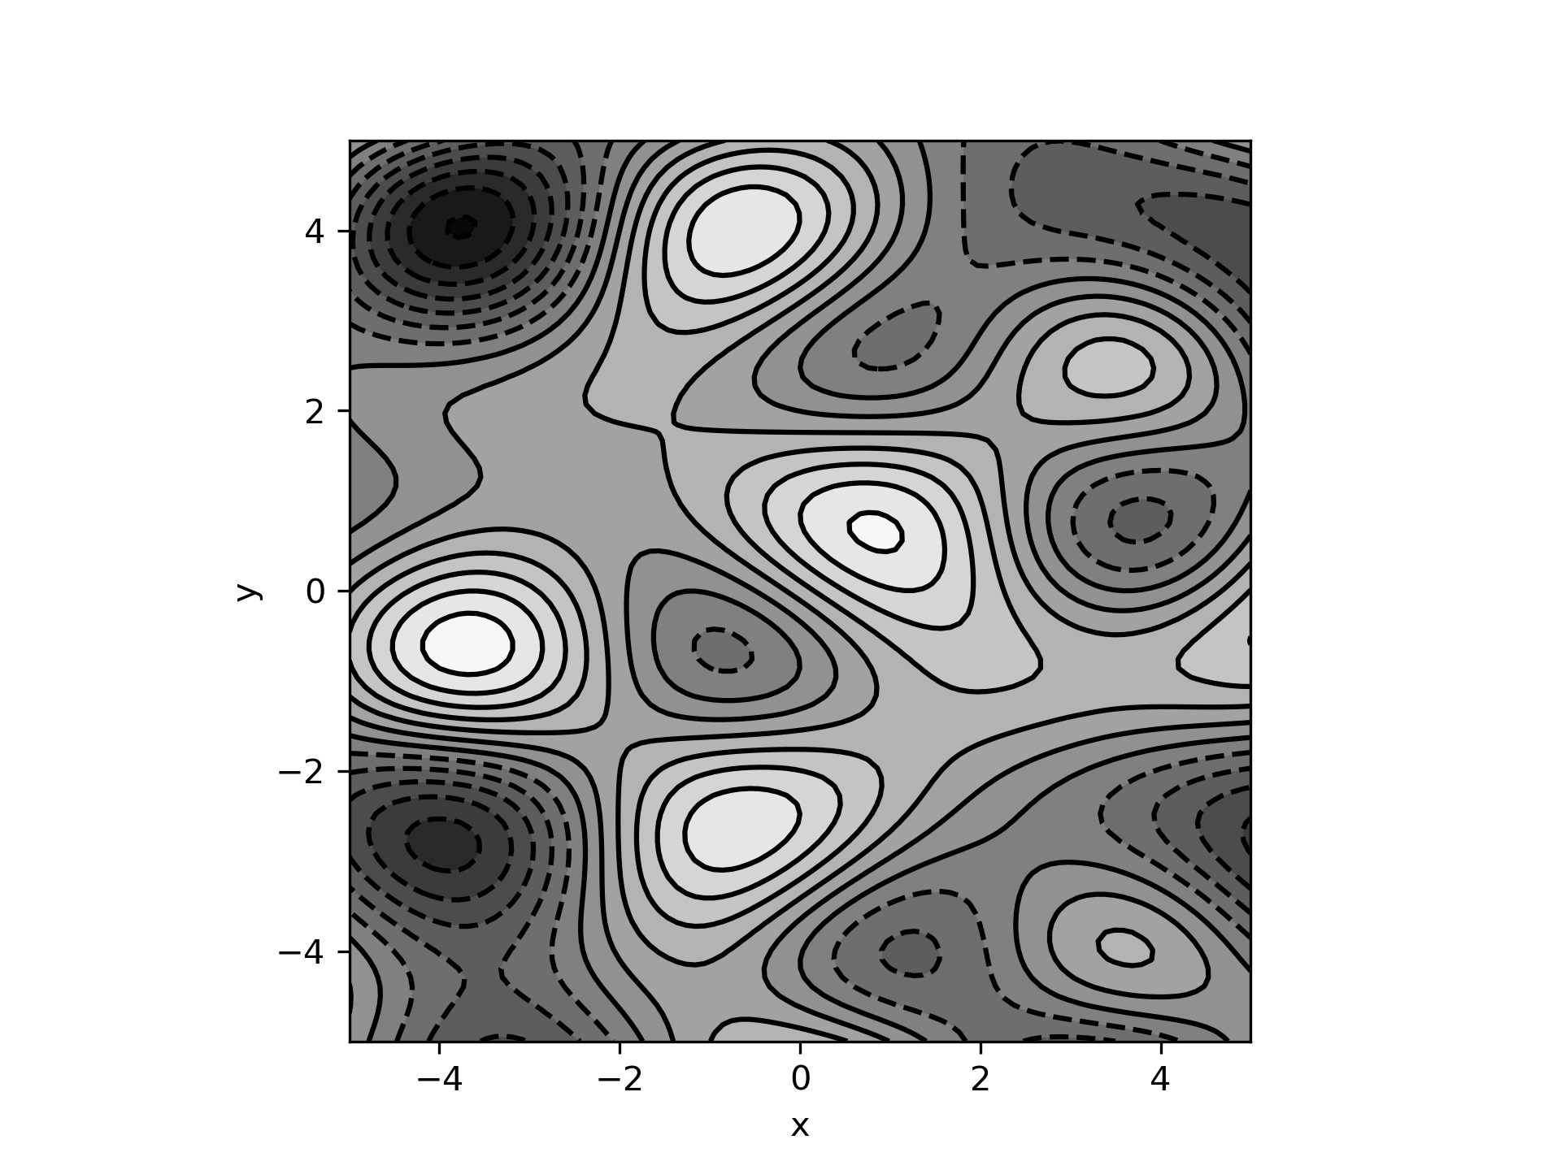 (b) 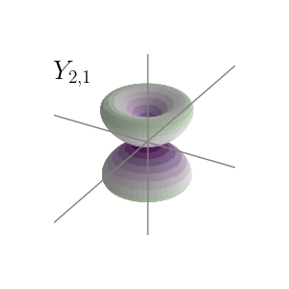

(a) The two-dimensional scalar field \(\phi (x,y)= \sin {(1.3x)}\cos {(0.9y)}+\cos {(0.8x)}\sin {(1.9y)}+\cos {(0.2xy)}\) plotted as contours and a greyscale.  
(b) An isosurface of the spherical harmonic \(|Y_2^1(\theta ,\phi )|^2\).

More formally, contours are a special case of *isosurfaces*, surfaces over which the field has a constant value. In two dimensions, these are lines, the familar contours. In three dimensions, they are two dimensional surfaces.

We can find isosurfaces by solving the equation \(\phi (x,y,z)=c\), where \(c\) is a constant which determines which isosurface we are dealing with. How easy this is to do will depend on the form of the function \(\phi \). We would normally chose to make the steps in \(c\) equal, so the spacing of the contours indicates how rapidly \(\phi \) is changing. However, this is not compulsory or even always appropriate.

**Exercise**  
Plot the isosurfaces (contours) of the two dimensional scalar field \(\phi (x,y)=x^2+y^2\)  
**Solution**  
The contours are given by the equation

which are circles of radius \(r=\sqrt{c}\). Thus if we want to space the values of \(c\) equally, we need to take equal steps in \(r^2\).

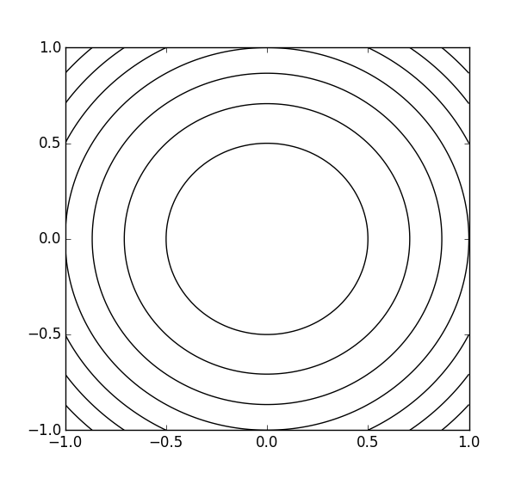

The following python code plots contours for a function of two variables. You may find it useful to be able to visualise some of the functions you are dealing with.

import matplotlib.pyplot as plt   
import numpy as np   
  
# Axis extremes and number of points  
x = np.linspace(-5, 5, 100)   
y = np.linspace(-5, 5, 100)   
  
# Creating 2-D grid   
[X, Y] = np.meshgrid(x,y)   
   
fig, ax = plt.subplots(1, 1)   
ax.set_aspect('equal')   
  
# function defined here  
Z=np.sin(1.3*X)*np.cos(0.9*Y)+np.cos(0.8*X)*np.sin(1.9*Y)+np.cos(0.2*X*Y)  
   
# plots contour lines  
levels=15  
ax.contourf(X, Y, Z, levels=levels, cmap='gray')   
ax.contour(X, Y, Z, levels=levels, colors='black')   
ax.set_xlabel('x')   
ax.set_ylabel('y')   
   
plt.savefig('contour.png', format='png',dpi=300)  
plt.show()

### 1.1 Partial Differentiation

Differentiating is all about finding the gradient or slope of a function. If we have a function of more than one variable, we need to specify which slope we are finding. Taking the example of a map, starting at a particular point, the slope we move along will depend on which direction we choose to travel. In the mathematical terminology, we specify this direction by saying what is being held constant. So if the \(x\)-axis lies in the \(W-E\) direction, and the \(y\) axis is \(S-N\), then travelling east, in the direction of increasing \(x\), is defined as keeping \(y\) constant.

Suppose we have a function \(f(x,y)=xy^3 e^x\). If we want to know the gradient of this when we increase \(x\) without changing \(y\) – that is the slope when we move along the \(x\)-axis – we need the *partial derivative*. We obtain this by treating \(y\) as a constant, then using the usual rules to differentiate a product:

The notation with the ‘curly d’, \(\partial \), indicates that this is a partial derivative, so we are keeping something constant. By default, we assume that this is the other variable(s) in the function, but if we want to be more explicit, we can write

**Exercise**  
For the same function, \(f(x,y)=xy^3 e^x\), evaluate the partial derivative

**Solution**  
The derivative is simply

Higher derivatives are defined in a similar way, by differentiating the first derivatives. For our \(f(x,y)\), we get

We can also find the partial derivative with respect to \(y\) of \(\partial f/\partial x\):

**Exercise**  
Evaluate the cross partial derivative the other way round, to find

**Solution**  
We get

In general

provided the function is continuous at the point \((x,y)\).

**Exercise**  
for the function \(f(x,y)=x \sin {y}\), find the two cross derivatives

**Solution**  
We find the first derivatives

Then

Sometimes, we want to evaluate the partial derivative keeping some other quantity constant, not the default of the other variables in which the function is written. In our example, \(f(x,y)=x y^3 e^x\), we could define a variable \(s=xy\). The function can then be re-written as depending on \(x\) and \(s\):

We are then able to evaluate the partial derivative

Clearly, this is different from \((\partial f/\partial x)_y\), but this is not surprising, as we are calculating a different slope. We are finding how the function changes with \(x\), when we move along a path corresponding to the curve \(s=xy\), when \(s\) is a constant. This path is a hyperbola. Note we are not finding the slope of the path; as we make a small step along the path, we measure the change in \(f\) and the change in \(x\) and calculate the ratio of the two. This sort of partial derivative requires the more explicit notation, specifying that \(s\) is the quantity that we are holding constant.

### 1.2 Differentials

We know that for small changes of a function of a single variable, \(f(x)\),

In the limit of an infinitesimal change \(\delta x\), we can define the *differential* \(df\) by

where the \(d\) indicates an infinitesimal change. Unlike Eq.(1.8), Eq.(1.9) is exact – it defines the differential \(df\).

This generalises to the case of a function of several variables like \(f(x,y)\). Making an step \(\delta x\) in the \(x\)-direction, keeping \(y\) constant,

We can combine steps: making a step \(\delta x\) in the \(x\)-direction, and a step \(\delta y\) in the \(y\)-direction, the change in \(f\) is

The corresponding differential is

For more variables, we adopt the notation \(f(x_1,x_2,\ldots x_n)\). Then

#### Uses of the Differential

The differential is useful if we want to differentiate our function \(f(x,y)\) with respect to some variable other than \(x\) or \(y\). Thinking again of our example of a map, suppose we move along some path, so that our position \((x,y)\) is a known function of time, \((x(t),y(t))\). If the height is \(h(x,y)\), we have

Then the rate at which we are ascending is

More generally, from Eq.(1.13), we get

This is the generalisation of the chain rule to partial differentiation. Of course, \(t\) does not have to represent time, it can be any parameter which, when varied, defines the path. This is called a *parametric representation* of the curve describing the path.

**Exercise**  
For the function \(f(x,y)=(x^2-y^2)^2\), with \(x(t)=\cos {t}\) and \(y(t)=\sin {t}\), evaluate the derivative \(df/dt\). Express your answer as a function of \(t\).  
**Solution**  
The partial derivatives are

hence

This could also be obtain by substituting for \(x(t)\) and \(y(t)\) in the original expression, to obtain \(f(t)=cos^2(2t)\), and differentiating directly with respect to \(t\).

The differential gives an alternative way to evaluate partial derivatives like \((\partial f/\partial x)_s\) in Eq.(1.7), where we keep some quantity other than the default variables constant. We have

The other variable can be written \(s=s(x,y)\), so as this is kept constant

We can thus write

Then

Dividing by \(dx\) gives our partial derivative

In the previous example, we defined \(s\) by \(s=xy\). Thus

Then, at constant \(s\)

so \(dy=-(y/x) dx\). For \(f=x y^3 e^x\) as above, putting in the expressions for \(\partial f/\partial x\) and \(\partial f/\partial y\) gives

This leads to

just as we found before.

**Exercise**  
If \(f(x,y)=(x^2-y^2)^2\), evaluate the partial derivative \((\partial f/\partial y)_s\) when \(s=\cos {x}\sin {y}\).  
**Solution**  
We already have

In addition,

Thus, at constant \(s\),

giving \(dx=\cot {x}\cot {y} \, dy\). Then

Hence

#### Two Useful Identities

We can also derive a couple of useful identities. Suppose we have a function, \(z(x,y)\), of two variables. The differential is

However, we can also rearrange and write \(x\) as function, \(x(y,z)\), of the other two variables. The corresponding differential is

Substituting this in Eq.(1.25) gives

This must be true for any \(dz\) and \(dy\), which we can choose independently, so

and

The first of these identities, Eq.(1.28), is true for functions of any number of variables. As in ordinary differentiation, \(\partial y/\partial x\) is the inverse of \(\partial x/ \partial y\), but only if we keep the same variables fixed in each case.

As an example of Eq.(1.29), consider an ideal gas which is described by variables \(P\), \(V\) and \(T\), with \(PV=RT\), where \(R\) is a constant. We can work out the various derivatives:

Then

as required.

### 1.3 Problems

1. 1.1

* Sketch a contour plot of the following functions, including both positive and negative values of \(x\) and \(y\):

* 1. \(f(x,y)=xy\),

* 1. \(f(x,y)=y-x^2\).

* (a)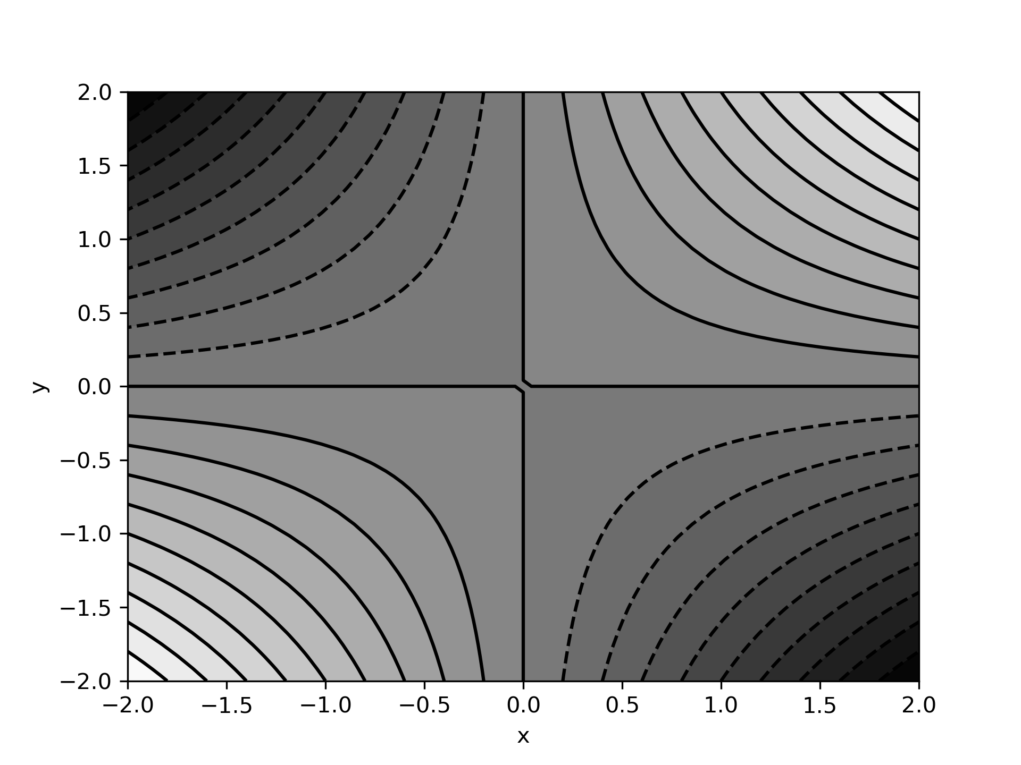 (b) 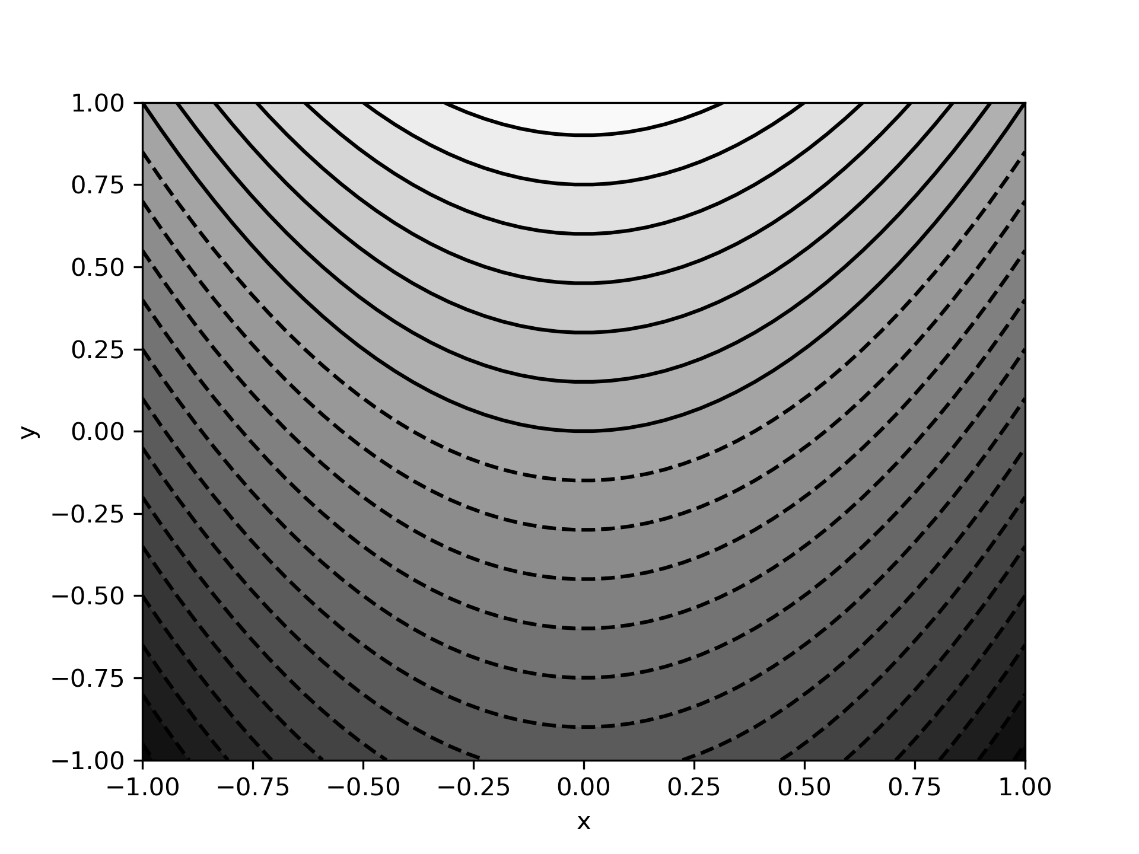

1. 1.2

* Show that Eq.(1.5) is satisfied for the following functions:

* 1. \(f(x,y)=x^3+x y^2 + 2 xy + 3x^2\).

* 1. \(f(x,y)=\frac{x^2+y^2}{xy}\).

* 1. \(f(x,y)=(x+y) \ln {\left({y/x}\right)}\).

* 1. We get

* 1. Writing \(f(x,y)=x/y+y/x\),

* 1. Writing \(f(x,y)=(x+y)(\ln {y}-\ln {x})\),

1. 1.3

* Show that the following functions satisfy the 2D Laplace equation,

* 1. \(f(x,y)=x^2 - y^2\).

* 1. \(f(x,y)=\sin {(kx)} \, e^{ky}\), where \(k\) is a constant.

* 1. \(f(x,y)=\ln {(\sqrt{x^2+y^2})}\).

* 1. We get

* 1. Now

* 1. Finally,

1. 1.4

* Find \(dz/dt\) when \(z\) is given by the following expressions, giving your answer as a function of \(t\). Use Eq.(1.16), then check your answer by substituting in the functions to get \(z(t)\) and differentiating directly.

* 1. \(z=2x^2y^2\), where \(x=\sin {t}\) and \(y=\cos {t}\).

* 1. \(z=\ln {(x^{-2}+y^2)}\), where \(x=e^t\) and \(y=e^{-t}\).

* 1. We have \(dx/dt=y\) and \(dy/dt=-x\), so
  + Alternatively, \(z(t)=2 \sin ^2{t} \cos ^2{t}=\frac12 \sin ^2{(2t)}\), which gives the same result.

* 1. This time \(dx/dt=x\) and \(dy/dt=-y\), so
  + Alternatively, \(z(t)=\ln {(2e^{-2t})}=\ln {2}-2t\), again giving the same result.

1. 1.5

* If \(f(x,y)=ye^{-x^2}\), find the partial derivative \((\partial f/ \partial x)_s\) where \(s=e^{-(x^2+y^2)}\).
* We use Eq.(1.21)
* We have \(\partial f/\partial x=-2xye^{-x^2}\) and \(\partial f/\partial y=e^{-x^2}\).
* It is simplest to get \((\partial y/\partial x)_s\) by implicit differentiation of the expression for \(s\):
* So \((\partial y/\partial x)_s=-x/y\) and

1. 1.6

* Consider the function \(f(x,y)=x^2 (y+1)^2\). Find the maximum and minimum values of this function on the circle \(x^2+y^2=1\).
* Hint: Parametrise the circle by \(x=\cos {\phi }\), \(y=\sin {\phi }\) and use Eq.(1.16) to work out \(df/d\phi \). The maxima and minima occur when this is zero.
* Following the hint, we get
* Putting this all in terms of \(\phi \):
* The roots of the last factor are \(\sin {\phi }=-1\) and \(\sin {\phi }=1/2\), so \(df/d\phi \) is zero when \(\cos {\phi }=0\), \(\sin {\phi }=-1\), or \(\sin {\phi }=1/2\). Translating into \((x,y)\) coordinates, these are the points \((0,\pm 1)\), \((0,-1)\) and \((\pm \sqrt{3}/2,1/2)\). For the first two \(f=0\), while for the third \(f=27/16\), so these are the minimum and maximum values.

1. 1.7

* The first law of thermodynamics can be written in the form
* where \(U\) is the internal energy of a gas, \(S\) its entropy and \(P\), \(V\) and \(T\) have their usual meanings.

* 1. Thinking of \(U\) as a function of \(S\) and \(V\), \(U(S,V)\), use this expression for the differential \(dU\) to write \(P\) and \(T\) as derivatives of \(U\).

* 1. Then use the cross differential relationship, Eq.(1.5), to obtain the *Maxwell identity*

* 1. For \(U(S,V)\), we get the differential
  + Comparing with the expression for the first law, we see

* 1. Differentiating the first of these with respect to \(V\) and the second with respect to \(S\), we get
  + Since the two cross derivatives are the same, the identity follows.

1. 1.8

* The entropy of an ideal monatomic gas, for which \(PV=RT\), can be expressed in the form

* 1. Show that

* 1. Use the differential
  + to calculate \((\partial T/\partial V)_S\).

* 1. Calculate \((\partial P/\partial S)_V\), and hence show that the Maxwell identity in Q.7 is satisfied for the ideal gas.

* 1. The constant can be absorbed in the log to give \(S=\frac32 R \ln {(aPV^{5/3})}\). This can be rearranged as
  + Differentiating,

* 1. From the differential, as in Eq.(1.21),

* 1. Using
  + and differentiating with respect to \(S\),
  + so the Maxwell identity is satisfied.

1. 1.9

* For a Van der Waal’s (non-ideal) gas \(P\), \(V\) and \(T\) are related by
* where \(R\), \(a\) and \(b\) are constants.

* 1. Find the isothermal compressibility of the gas,

* 1. Show that \(\beta _T \rightarrow \infty \) when

* 1. Find the coefficient of expansion

* 1. It is simplest to differentiate with respect to \(V\) and use the reciprocal relationship Eq.(1.28).
  + Thus

* 1. \(\beta _t \rightarrow \infty \) when the term in the square bracket is zero, that is
  + However, this expression involves \(T\). We get rid of this using the original relationship, which can be written as
  + Thus our condition becomes
  + Rearranging gives the required result.

* 1. There are various ways we can do this. One is to use the triple relationship Eq.(1.29), which becomes
  + We already have the first term from part (a), so we just need the third term. Again, working out its reciprocal, we get
  + Then we get
  + Notice that \(\alpha \) also diverges when (b) is satisfied – clearly something significant is happening. In fact, this is the line where the gas is undergoing a phase change to become a liquid.

## 2 The Gradient of a Scalar Field

Suppose we have a scalar field defined in three dimensions \(\phi (x,y,z)\). Using Eq.(1.13), we can write the differential \(d\phi \) as

The spatial steps can be combined to form a vector:

If we then define the *gradient* vector

our differential \(d\phi \), Eq.(2.1), can be written as a dot product of the two vectors:

**Exercise**  
Consider the scalar field

Calculate the gradient, \(\mbox{$\bm {\nabla }$} \phi \) and evaluate it at the point \((1,\pi /2,0)\).  
**Solution**  
For this field, we have

At the required point, \(xy=\pi /2\), so \(\sin {(xy)}=1\) and \(\cos {(xy)}=0\). Also \(e^{2z}=1\). Hence

**Exercise**  
Calculate the electric field \(\mbox{$\bm {E}$}=-\mbox{$\bm {\nabla }$} V\) for the potential

**Solution**  
Ignoring the prefactor for now,

We get equivalent results for \(y\) and \(z\), so

Thus

For a scalar field, we can use this notation to express the generalisation of the chain rule, Eq.(1.16) as a dot product:

where

### 2.1 Interpretation of \({\nabla }\phi \)

Suppose we consider a step of fixed magnitude magnitude \(|d \mbox{$\bm {r}$}|\) from some starting point. Eq.(2.4) gives the change in \(\phi \) when we make this step:

where \(\theta \) is the angle between \(\mbox{$\bm {\nabla }$} \phi \) and \(d \mbox{$\bm {s}$}\). The change in \(\phi \) will have its *maximum* value when the direction of \(d \mbox{$\bm {s}$}\) is the same as \(\mbox{$\bm {\nabla }$} \phi \) (that is, \(\theta =0\)). Thus \(\mbox{$\bm {\nabla }$}\phi \) points in the direction that \(\phi \) is increasing most rapidly. The magnitude of the gradient, \(|\mbox{$\bm {\nabla }$} \phi |\), gives the rate at which \(\phi \) increases moving in that direction. For the example of the surface of the ground, \(h(x,y)\), \(\mbox{$\bm {\nabla }$} h\) points up the slope, and its magnitude tells us how steep the slope is. If we have used the convention of equally spaced contours, the slope is indicated by the distance between the contours; when they are closer together, the slope is steeper.

We can also see that if \(\mbox{$\bm {\nabla }$} \phi \) is perpendicular to \(d \mbox{$\bm {s}$}\), corresponding to \(\theta =\pi /2\), then \(d \phi =0\); there is no change in \(\phi \) (for an infinitesimal step). But, if there is no change in \(\phi \), we must be moving along an isosurface (remember these are contours in two dimensions). Hence the direction of \(\mbox{$\bm {\nabla }$} \phi \) at a given point is always perpendicular to the isosurfaces. You probably know that if you are looking at map, the steepest slope is perpendicular to the contours.

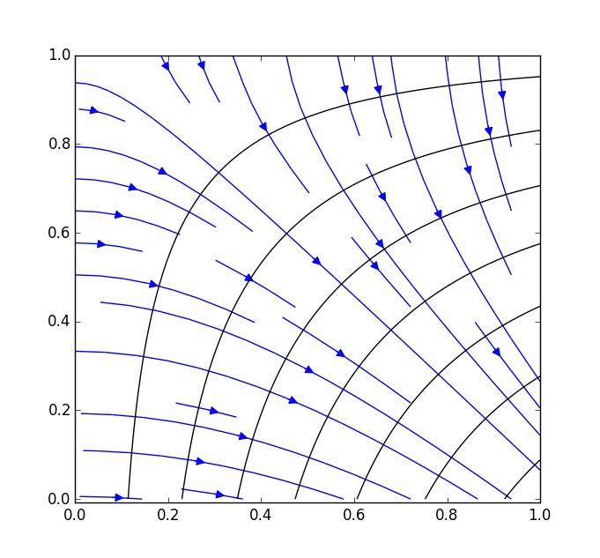

Contours of a function \(\phi =\sin {(x)}\cos {(y+1/2)}\) plotted along with field lines (arrowed lines) of \(\mbox{$\bm {\nabla }$}\phi \). We will define field lines more formally later – they point in the direction of the gradient at a given point.

### 2.2 Finding Tangents

We can use the property that the gradient is perpendicular to the isosurfaces to find equations for tangents to curves and tangent-planes to surfaces.

As an example, let us find the tangent to the hyperbola \(xy=1\) at the point \(x=2\), \(y=1/2\). The first thing we need to do is to find a scalar field for which the curve is a contour. This is easily done: if we take \(\phi (x,y)=xy\), then our hyperbola is the contour corresponding to \(\phi =1\). Next we calculate the gradient

Evaluting this at the point we are finding the tangent, \((2,1/2)\), we get \(1/2\, \mbox{$\bm {i}$} + 2\, \mbox{$\bm {j}$}\). This vector is perpendicular to the tangent we are seeking.

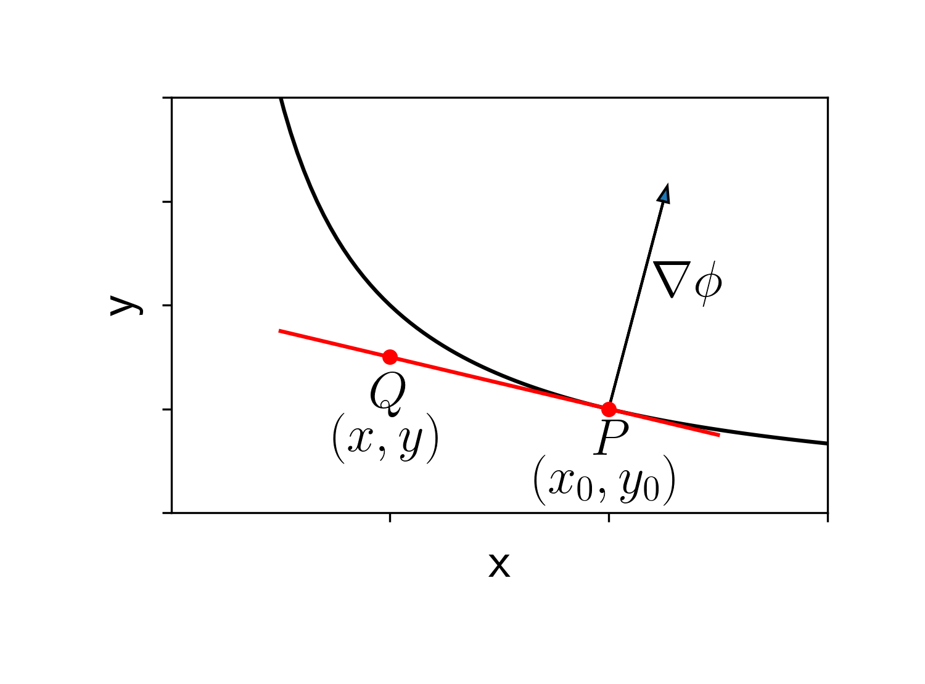

For any point \(Q\) on the tangent, the vector \(\overrightarrow {PQ}\) must be perpendicular to the gradient \({\bf \nabla }\phi \).

To find the tangent, consider the vector \(\overrightarrow {PQ}\) in the figure, linking the point \(P=(x_0,y_0)\), where we are finding the tangent, to \(Q=(x,y)\), some arbitrary point on the tangent line. We have

Since the line is a tangent, it must be perpendicular to the gradient \(\mbox{$\bm {\nabla }$} \phi =1/2\, \mbox{$\bm {i}$} + 2\, \mbox{$\bm {j}$}\). We can express this as a condition on the dot product:

Rearranging to the standard form for a line:

**Exercise**  
Given the surface \(x^3y^2z=12\), find the equation of the tangent plane at the point \(p=(1,-2,3)\).  
 Hint: recall that the equation of a plane perpendicular to the vector \(a\, \mbox{$\bm {i}$} + b\, \mbox{$\bm {j}$} + c\, \mbox{$\bm {k}$}\) has the form

**Solution**  
the surface is an isosurface of the function \(\phi =x^3y^2z\). For this \(\phi \),

Evaluating this at the point \(\mbox{$\bm {p}$}\) gives a vector, \(\mbox{$\bm {n}$}\), normal to the tangent plane:

Thus the equation of the plane must take the form

Then, dividing through by 4, we get the equation of the required plane:

or

#### Directional Derivative

Suppose we want to find the rate of change of \(\phi \) with distance, \(d\phi /ds\), at a given point \((x_0,y_0,z_0)\) along a given line. Let \(\hat{\mbox{$\bm {u}$}}\) be a unit vector directed along the line. We can find this derivative using our previous result

If we write \(d\mbox{$\bm {s}$}=\hat{\mbox{$\bm {u}$}} \, d s\), that is, a vector of length \(d s\) in the direction of the line, we get

Then dividing by \(d s\) and taking the limit \(d s \rightarrow 0\),

This quantity is called the *directional derivative* of \(\phi \) along \(\hat{\mbox{$\bm {u}$}}\).

Note that the directional derivative must have a value between between \(-|\mbox{$\bm {\nabla }$}\phi |\), if \(\hat{\mbox{$\bm {u}$}}\) is in the opposite direction to \(\mbox{$\bm {\nabla }$}\phi \), and \(+|\mbox{$\bm {\nabla }$}\phi |\), if it is in the same direction.

For the function

find \(\mbox{$\bm {\nabla }$}\phi \) and the directional derivative of \(\phi \) at the point \((1,-2,1)\) in the direction \(\mbox{$\bm {a}$}=2\, \mbox{$\bm {i}$}-\mbox{$\bm {j}$}+\mbox{$\bm {k}$}\).

We have

at the point indicated.

To find the directional derivative, we need a unit vector in the direction of \(\mbox{$\bm {a}$}\). This is

The directional derivative is then

**Exercise**  
Find the derivative of the function \(\phi =ze^x\cos {y}\) at the point \((1,0,\pi /3)\) in the direction of the vector \(\mbox{$\bm {i}$}+2 \mbox{$\bm {j}$}\).  
**Solution**  
For this function,

Evaluating this at the given point,

The unit vector in the direction given is \(\hat{\mbox{$\bm {u}$}}= (\mbox{$\bm {i}$}+2 \mbox{$\bm {j}$})/\sqrt{5}\), so the directional derivative is

### 2.3 Problems

1. 2.1

* Consider the scalar field
* Calculate the gradient, \(\mbox{$\bm {\nabla }$} \phi \) and evaluate it at the point \((1,\pi /2,0)\).
* For this field, we have
* Evaluating this at the required point

1. 2.2

* Calculate \(\mbox{$\bm {F}$}=\mbox{$\bm {\nabla }$} \phi \) for the following scalar functions \(\phi (x,y,z)\):

* 1. \(\phi =xyz\)

* 1. \(\phi =xy+yz+xz\)

* 1. \(\phi =3x^2-4z^2\)

* 1. \(\phi =e^{-x}\sin {y}\).

* 1. For \(\phi =xyz\),

* 1. For \(\phi =xy+yz+xz\),

* 1. For \(\phi =3x^2-4z^2\),

* 1. For \(\phi =e^{-x}\sin {y}\),

1. 2.3

* Calculate the electric field \(\mbox{$\bm {E}$}=-\mbox{$\bm {\nabla }$} V\) for a line of charge density \(\lambda \), along the \(z\) axis, with
* We can write
* Differentiating with respect to \(x\)
* There is a similar result for \(y\), but \(\partial \phi /\partial z=0\). Thus

1. 2.4

* Find the tangent plane at the indicated point for the following surfaces:

* 1. \(x^2+y^2+z^2=4\) at the point \((1,1,\sqrt{2})\)

* 1. \(z^2=x^2-y^2\) at the point \((1,1,0)\).

* 1. For the function \(\phi =x^2+y^2+z^2\),
  + Evaluating this at the point \((1,1,\sqrt{2})\) gives the required normal vector, \(\mbox{$\bm {n}$}=(2,2,2\sqrt{2})\) (or any multiple of this). The tangent plane is the plane normal to this vector passing through the point \((1,1,\sqrt{2})\). The general equation of such a plane is \( 2x+2y+2\sqrt{2}z=c\), where \(c\) is a constant. Putting in the requirement for the plane to pass through the point gives \(c=2+2+4=8\). Thus (dividing through by 2), the tangent plane is

* 1. Writing the equation as \(\phi =x^2-y^2-z^2=0\), we can proceed as in the previous part. We get
  + Evaluating at \((1,1,0)\) gives the normal vector \(\mbox{$\bm {n}$}=(2,-2,0)\). The tangent plane is \(2x-2y+0z=2-2+0=0\) or \(x-y=0\).

1. 2.5

* Find a unit vector at the point \((0,1,1)\) in the direction in which the function \(\phi =x^2-3xy+2y^2\) has its maximum rate of change, and find the magnitude of this rate of change.
* For this \(\phi \),
* Evaluating this at \((0,1,1)\) gives
* The unit vector in this direction is
* The magnitude of the rate of change is \(\sqrt{3^2+4^2}=5\).

1. 2.6

* If \(f(x,y,z)\) and \(g(x,y,z)\) are any two scalar fields, show that the gradient of the product \(fg\) satisfies
* We have
* Now
* with similar results for \(y\) and \(z\). Thus

## 3 Changes of Coordinates – Rotations

The calculations in the previous session, involving scalar fields, were all written in terms of Cartesian coordinates \((x,y,z)\). However, we sometimes want to work in other coordinate systems, particularly polar coordinates. In physics, this is because the systems we are dealing with frequently have circular or spherical symmetry. In this session we will look at a particularly simple coordinate change, moving from one cartesian system to another by rotating the axes. We will not look at the most general rotation, about an arbitrary axis, but instead consider a rotation through an angle \(\alpha \) about the \(z\)-axis. This leaves \(z\) unchanged, but mixes up the \(x\) and \(y\) coordinates.

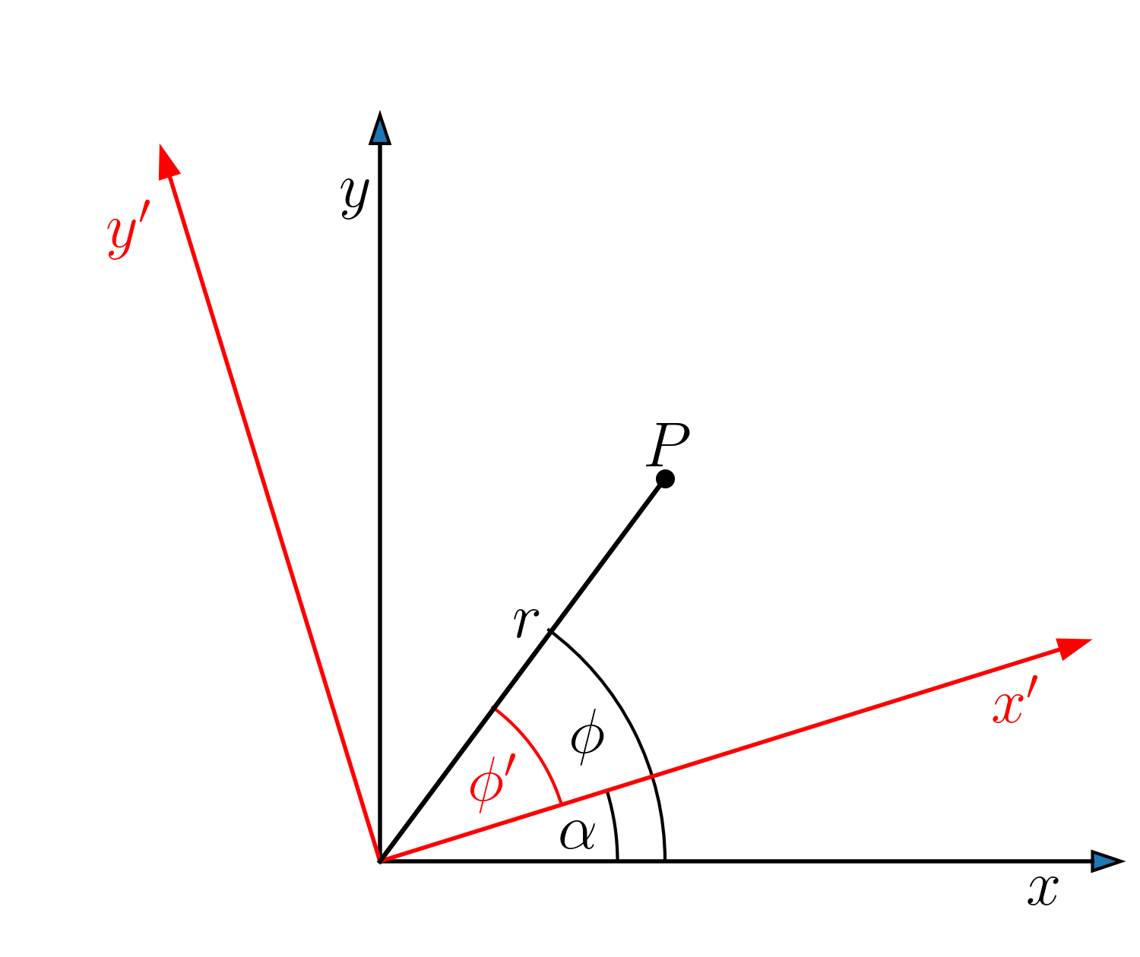

The transformation of \((x,y)\) to \((x',y')\) is most easily calculated using a switch to plane polar coordinates. We have

In polars, the change of coordinates due to the rotation is particularly simple: the radial distance, \(r\), is unchanged, while the polar angle \(\phi \) is transformed to \(\phi '=\phi -\alpha \). Thus \(x'\) and \(y'\) are given by

Note that this transformation can be written in matrix form as

$$
\begin{align}
\tag{3.3}\begin{pmatrix} x'
\\ y'
\end{pmatrix} = \begin{pmatrix} \hfill \cos {\alpha }
& \hfill \sin {\alpha }
\\ \hfill -\sin {\alpha }
& \hfill \cos {\alpha }
\end{pmatrix}\begin{pmatrix} x
\\ y
\end{pmatrix} \; . \label{eq:rotation}
\end{align}
$$

This is the rotation matrix about the \(z\)-axis, \(R_z\). If we include \(z\) in the coordinates, we have \(z=z'\), and the full matrix is

$$
\begin{align}
\tag{3.4}\begin{pmatrix} x'
\\ y'
\\ z'
\end{pmatrix} = \begin{pmatrix} \hfill \cos {\alpha }
& \hfill \sin {\alpha }
& \hfill 0
\\ \hfill -\sin {\alpha }
& \hfill \cos {\alpha }
& \hfill 0
\\ \hfill 0
& \hfill 0
& \hfill 1
\end{pmatrix}\begin{pmatrix} x
\\ y
\\ z
\end{pmatrix} \; .
\end{align}
$$

An important property of the rotation matrices is that they are orthogonal matrices, so the inverse is equal to the transpose. That is \(R_z^{-1}=R_z^T\). This means that it is easy to work out the reverse transformation

$$
\begin{align}
\tag{3.5}\begin{pmatrix} x
\\ y
\end{pmatrix} =R_z^T \begin{pmatrix} x'
\\ y'
\end{pmatrix} = \begin{pmatrix} \hfill \cos {\alpha }
& \hfill -\sin {\alpha }
\\ \hfill \sin {\alpha }
& \hfill \cos {\alpha }
\end{pmatrix}\begin{pmatrix} x'
\\ y'
\end{pmatrix} \label{eq:rotation-reverse} \; ,
\end{align}
$$

or

This can be seen more simply by considering that the reverse transformation is just a rotation in the opposite direction, so we have to replace \(\alpha \) with \(-\alpha \), swapping the signs of the sines, but leaving the cosines unchanged.

**Exercise**  
Show that the rotation matrix in Eq.(3.3) is orthogonal.  
Hint: the easiest way to prove that \(R_z^{-1}=R_z^T\) is to show that \(R_z^T R_z={\mathbb {1}}\).  
**Solution**  
Doing the matrix multiplication using the matrices from Eqs.(3.3,3.5),

$$\begin{align*} R_z^T R_z& = \begin{pmatrix} \hfill \cos {\alpha }
& \hfill \sin {\alpha }
\\ \hfill -\sin {\alpha }
& \hfill \cos {\alpha }
\end{pmatrix}\begin{pmatrix} \hfill \cos {\alpha }
& \hfill -\sin {\alpha }
\\ \hfill \sin {\alpha }
& \hfill \cos {\alpha }
\end{pmatrix}\\ & = \begin{pmatrix} \cos ^2{\alpha }+\sin ^2{\alpha }
& -\cos {\alpha }\sin {\alpha }+\sin {\alpha }\cos {\alpha }
\\ -\sin {\alpha }\cos {\alpha }+\cos {\alpha }\sin {\alpha }
& \sin ^2{\alpha }+\cos ^2{\alpha }
\end{pmatrix} = \begin{pmatrix} \hfill 1
& \hfill 0
\\ \hfill 0
& \hfill 1
\end{pmatrix} ={\mathbb {1}}\; . \end{align*}$$

### 3.1 Transforming Vectors

We often express a vector in terms of the basis vectors (\(\mbox{$\bm {i}$}\), \(\mbox{$\bm {j}$}\) and \(\mbox{$\bm {k}$}\) in cartesians) of the system, for example \(\mbox{$\bm {a}$}=a_x \, \mbox{$\bm {i}$} + a_y \, \mbox{$\bm {j}$} + a_z \, \mbox{$\bm {k}$}\). In order to transform the vector between coordinate systems we need to figure out how to write \(\mbox{$\bm {i}$}\), \(\mbox{$\bm {j}$}\) and \(\mbox{$\bm {k}$}\) in terms of \(\mbox{$\bm {i’}$}\), \(\mbox{$\bm {j’}$}\) and \(\mbox{$\bm {k’}$}\). When we have calculated the transformation of coordinates, this is easy to find. We can write the same position vector in the two coordinate systems as

Now, equating the coefficients of \(x'\) and \(y'\), we get

or

$$
\begin{align}
\tag{3.9}\begin{pmatrix} \mbox{$\bm {i}$}'
\\ \mbox{$\bm {j}$}'
\end{pmatrix} = \begin{pmatrix} \hfill \cos {\alpha }
& \hfill \sin {\alpha }
\\ \hfill -\sin {\alpha }
& \hfill \cos {\alpha }
\end{pmatrix}\begin{pmatrix} \mbox{$\bm {i}$}
\\ \mbox{$\bm {j}$}
\end{pmatrix} \; .
\end{align}
$$

Note that this is the same orthogonal rotation matrix that we found before. Indeed, we will always find that the transformation between sets of orthogonal basis vectors is orthogonal. It is thus easy to invert the relationship and get

We can now transform the components of any vector between the coordinate systems. For the vector \(\mbox{$\bm {a}$}\) above, we have

Now comparing coefficients of \(\mbox{$\bm {i}$}'\), \(\mbox{$\bm {j}$}'\) and \(\mbox{$\bm {k}$}'\) gives

Again this can be inverted to give

Note that the components of the vector transform in the same way as the components of the position vector \(\mbox{$\bm {s}$}=x\, \mbox{$\bm {i}$} + y \, \mbox{$\bm {j}$} + z \, \mbox{$\bm {k}$}\).

#### A More General Method for Finding Basis Vectors

We will now look at how we can calculate the transformation of the basis vectors using partial differentiation. The basis vectors can be defined as ‘unit vectors pointing in the direction you go when increasing one coordinate while holding the others constant’. Thus \(\mbox{$\bm {i}$}\) in cartesians points in the direction of increasing \(x\), when \(y\) and \(z\) are held constant.

This definition points towards partial differentiation. We see that if we write \(\mbox{$\bm {s}$}=x \, \mbox{$\bm {i}$} + y \, \mbox{$\bm {j}$} + z \, \mbox{$\bm {k}$}\),

the required basis vector. Note that this differentation does not always give a unit vector: we may have to normalise what we get so that it has unit length. We can now use this to work out the transformation of the basis vectors corresponding to the rotation of the axes. Using

we calculate

These are already unit vectors (because \(\sin ^2{\alpha }+ \cos ^2{\alpha }=1\)), so we have found the new basis vectors.

**Exercise**  
As we have seen, in plane polar coordinates the distance from the origin, \(r\), and polar angle, \(\phi \), are related to the cartesian \(x\) and \(y\) by

Use the partial differentiation method in to express the basis vectors in the polar coordinates, \(\hat{\mbox{$\bm {r}$}}\) and \(\hat{\mbox{$\bm {\phi }$}}\) in terms of \(\mbox{$\bm {i}$}\) and \(\mbox{$\bm {j}$}\). Show that \(\hat{\mbox{$\bm {r}$}}\) and \(\hat{\mbox{$\bm {\phi }$}}\) are orthogonal to each other, that is \(\hat{\mbox{$\bm {r}$}} \cdot \hat{\mbox{$\bm {\phi }$}}=0\).  
**Solution**  
We can write

Then

The first of these is a unit vector, but the second has length \(r\), so we have to divide through by \(r\). Thus our unit vectors are

The dot product is

### 3.2 What are Scalars and Vectors?

Up until this point, I have used the term ‘scalar’ to apply to a simple number and ‘vector’ for something with magnitude and direction, or three numbers, corresponding to the components (in three dimensions). I shall now give a better definition, which depends on how the quantities involve change when we consider coordinate transformations. For *cartesian* scalars and vectors, the relevant transformation corresponds to a rotation of the axes.

Suppose you are given a quantity \(\phi (x,y,z)\) in the \(x,y,z\) coordinate system and know that it becomes \(\phi '(x',y',z')\) in the rotated \(x',y',z'\) system. If the quantity is unchanged in the primed coordinate system, that is \(\phi '=\phi \), \(\phi \) is said to be a (cartesian) scalar.

The definition of a vector is more complicated because the vector has a direction, so it will have different components when we rotate the axes to go between the primed and unprimed systems. We say that a set of three numbers forms a cartesian vector if they transform under rotations in the same way as a particular prototype vector, which is chosen to be the position vector \(\mbox{$\bm {s}$}=(x,y,z)\), that is, according to Eq.(3.13).

Why is this important? It means that if we have an equation of the form *scalar 1 = scalar 2* or *vector 1 = vector 2* it will look the same however we chose the directions for the coordinate axes. Although the vectors in \(\mbox{$\bm {F}$}= m \mbox{$\bm {a}$}\) will look different if we rotate the coordinates, they transform in exactly the same way, so the equation will always look the same. We do not have to work out what the equation should be depending on our choice of axes. This is a good thing, because choices of axes are pretty arbitrary.

So, how can you tell whether a quantity is a true scalar or vector? One way is that I can tell you; if I state that \(\mbox{$\bm {a}$}=\mbox{$\bm {i}$}+3\, \mbox{$\bm {j}$}+2\, \mbox{$\bm {k}$}\) is a vector, I am telling you not only what its value is in a particular coordinate system, but also how you have to transform it if you change to a different coordinate system. Another way is from physics; if the field \(T(x,y)\) represents the temperature of a metal plate, we know that it must be a scalar field, because the temperature measured at a particular point cannot depend on the choice of coordinate system. Finally, we can prove that something is a scalar or vector, by working out how it transforms when we change the coordinate system.

#### The Scalar Product

The scalar product of two vectors, is, as its name implies, a scalar quantity. This is obvious from its definition as \(\mbox{$\bm {a}$} \cdot \mbox{$\bm {b}$}=a b \cos {\theta }\), where \(\theta \) is the angle between the vectors, because none of these quantities is changed by the rotation. However, we can also demonstrate this using the transformation properties of the vectors, Eq.(3.13). The vector components in the two coordiante systems are related by

Hence the scalar product can be written as

We see that the scalar product comes out the same whichever coordinate system we work in - it is a cartesian scalar.

#### The Gradient of a Scalar Field

We next show that the gradient of a scalar field is a cartesian vector. First let us look at how to transform a differential operator. We start from the differential for a scalar field \(\phi (x,y)\) in two dimensions

From this

From Eq.(3.6),

Hence

Similarly

We have shown that the components of \(\mbox{$\bm {\nabla }$} \phi = \partial \phi /\partial x \, \mbox{$\bm {i}$} +\partial \phi /\partial y \, \mbox{$\bm {j}$}\) transform like those of a vector, Eq.(3.13). Hence \(\mbox{$\bm {\nabla }$} \phi \) is a cartesian vector.

### 3.3 Problems

1. 3.1

* In spherical polar coordinates (which we will meet properly later) the distance from the origin, \(r\), and polar angle, \(\theta \), and azimuthal angle \(\phi \) are related to the cartesian \(x\),\(y\) and \(z\) by

* 1. Use the partial differentiation method in Section 3.1 to express the basis vectors in the polar coordinates, \(\hat{\mbox{$\bm {r}$}}\), \(\hat{\mbox{$\bm {\theta }$}}\) and \(\hat{\mbox{$\bm {\phi }$}}\) in terms of \(\mbox{$\bm {i}$}\) and \(\mbox{$\bm {j}$}\) and \(\mbox{$\bm {k}$}\).

* 1. Write down the corresponding \(3 \times 3\) transformation matrix and show that it is an orthogonal matrix.

* 1. We can write
  + Then, the required derivatives are
  + We need to find unit vectors in each of these directions, so work out the lengths.
  + So our unit vectors are

* 1. The corresponding matrix is
  + Its transpose is
  + \(R^T R={\mathbb {1}}\), as required.

1. 3.2

* In plane polar coordinates, we saw that,
* Suppose that the coordinates \((r(t),\phi (t))\) represent the position of a particle which is changing with time.

* 1. Show that
  + and find the corresponding expression for \(d \hat{\mbox{$\bm {\phi }$}}/dt\).

* 1. The position vector of the particle is \(\mbox{$\bm {s}$}(t)=r(t) \, \hat{\mbox{$\bm {r}$}}\). Find the velocity, \(\mbox{$\bm {v}$}=d\mbox{$\bm {s}$}/{dt}\) in terms of \(\hat{\mbox{$\bm {r}$}}\) and \(\hat{\mbox{$\bm {\phi }$}}\).

* 1. Differentiating the expression for \(\hat{\mbox{$\bm {r}$}}\) using the chain rule
  + Similarly

* 1. \(\mbox{$\bm {s}$}(t)=r(t) \, \hat{\mbox{$\bm {r}$}}\), so differentiating using the product rule

1. 3.3

* Using the vector transformations Eq.(3.17), show that the cross product \(\mbox{$\bm {c}$}=\mbox{$\bm {a}$} \times \mbox{$\bm {b}$}\) is a cartesian vector, that is \(\mbox{$\bm {c}$}\) transforms in the same way as \(\mbox{$\bm {a}$}\) and \(\mbox{$\bm {b}$}\).
* Using Eq.(3.17), we find
* as required. Similarly,
* and

1. 3.4

* The derivative
* is symmetric with respect to \(x\),\(y\) and \(z\), so we might expect it to be a scalar. Determine how this derivative transforms when we rotate the axes. Is it, in fact, a cartesian scalar?
* From Eqs.(3.21,3.22), and using \(\partial \phi /\partial z' =\partial \phi /\partial z\),
* So the derivative does not transform as a scalar – we would not typically expect to see it in physics equations.

1. 3.5

* The equations for the transformation of first derivatives, Eqs.(3.21,3.22), are
* We can work out the transformation of the second derivatives by substituting the first derivatives in place of \(\phi \) on the right hand side. So

* 1. Show that

* 1. Work out the equivalent expression for the transformation of \(\partial ^2 \phi / \partial y^{\prime 2}\).

* 1. Hence show that the Laplacian operator is a cartesian scalar, that is

* 1. There is not much more to do. Differentiating and multiplying everything out

* 1. The second derivative with respect to \(y'\) is

* 1. Adding these together, the cross terms cancel and we can use \(\sin ^2{\alpha }+\cos ^2{\alpha }=1\), so the required result follows.

## 4 Vector Fields

So far we have been considering dealing mainly with scalar fields such as \(\phi (x,y,z)\), where we have a scalar quantity defined at every point in space, a simple function. A vector field consists of a vector quantity defined at each point, \(\mbox{$\bm {F}$}(x,y,z)\). Of course, the space can be one or two dimensional as well. We have already met an example of a vector field: \(\mbox{$\bm {\nabla }$} \phi \), the gradient of a scalar field.

Vector fields should be very familiar concepts from physics. You are studying the electric and magnetic fields, \(\mbox{$\bm {E}$}\) and \(\mbox{$\bm {B}$}\). For an intuitive example, I like to think about the field corresponding to the velocity in a moving fluid, \(\mbox{$\bm {v}$}(x,y,z)\)

### 4.1 Visualising a Vector Field

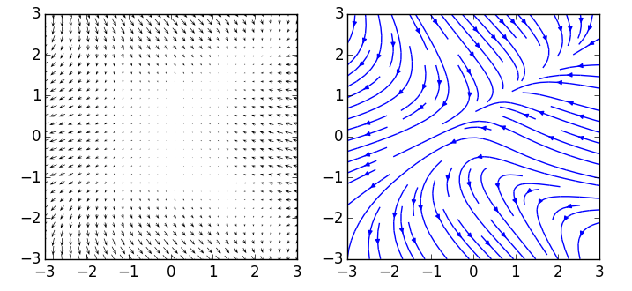

The two-dimensional field \(F_x=y^2-x^2-1\), \(F_y=x-y^2\) plotted as arrows and field lines

There is more than one way to picture a vector field. The most straight forward to construct is obtained by evaluating the field at a set of points on a grid and drawing a small arrow, with the corresponding magnitude and direction, at each point. This is called a *quiver plot*, because it is a collection of arrows. However, that is not normally what we do in physics. Instead, we use field lines. A field line is a line, usually curved, such that the tangent at each point in space is in the direction of the field at that point. Note that this says nothing about the magnitude of the field. We can indicate this by how close together we plot the field lines: the higher the density, the stronger the field. However, there are many other ways, such as colour scales, line thicknesses etc. One of the reasons for using field lines is that they have a nice connection to the *divergence* and *curl* of the field, which we shall meet shortly.

**Exercise**  
Obtain a formula, using cartesian coordinates, a vector field in two dimensions (\(x\),\(y\)) which is in the positive radial direction (that is pointing away from the origin) and had magnitude 1.  
**Solution**  
This is just \(\hat{\mbox{$\bm {r}$}}\), but we have to express it in cartesian coordinates.

### 4.2 Calculating Field Lines

In order to get more of an idea of what a field line means, suppose our vector field represents the velocity of particles in a moving fluid. Then, each field line represents the trajectory of a particle - the tangent to the trajectory points in the direction of the velocity. Hence we can calculate the field lines by integrating the equations of motion for the particle. If our velocity field is \(\mbox{$\bm {F}$}(x,y,z)\), then the position of a point on the field line at time \(t\), \(\mbox{$\bm {s}$}=(x,y,z)\) is obtained by solving the differential equations

This gives the parametric equation for a field line; as \(t\) is varied, our point \(\mbox{$\bm {s}$}(t)\) traces out a field line. If \(\mbox{$\bm {F}$}\) really is a velocity field (and it is independent of time), then \(t\) is a real time, so \(\mbox{$\bm {s}$}(t)\) is actually the position of a particle at time \(t\). However, the method works for any vector field, with \(t\) an arbitrary parameter if nothing is really moving.

As an example, consider a two dimensional field \(\mbox{$\bm {F}$}=-y\, \mbox{$\bm {i}$}+x\, \mbox{$\bm {j}$}\). Here Eq.(4.1) gives the two differential equations

Differentiating the first of these again and substituting for \(dy/dt\) from the second, we find

This is the equation for a harmonic oscillator, so we know the general solution is

where \(A\) and \(\phi \) are arbitrary constants. Then, differentiating,

These represent the parametric equations for a field line - changing the constant \(A\) gives different field lines. In this case, it is easy to get rid of the parameter \(t\) by squaring and adding:

which is the equation for a circle of radius \(A\).

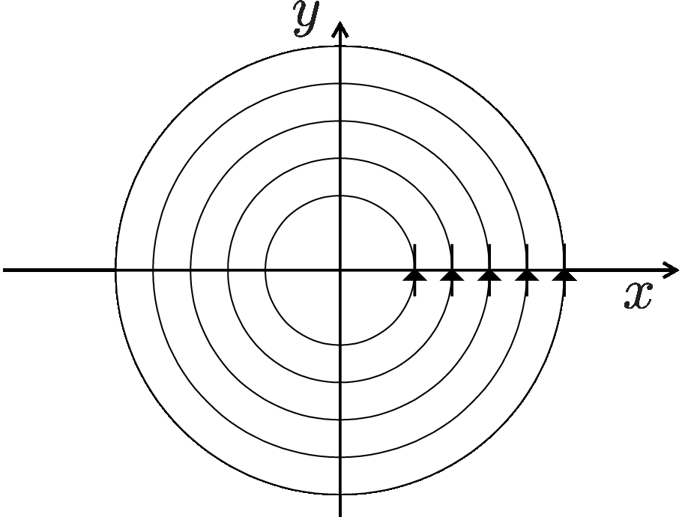

**Exercise**  
Calculate the field lines of the vector field \(\mbox{$\bm {F}$}(x,y)=x\, \mbox{$\bm {i}$} + y\, \mbox{$\bm {j}$}\). Eliminate \(t\) to express your answer as a relationship between \(x\) and \(y\).  
**Solution**  
Now we have

We can solve these by separation of variables:

which has general solution \(\ln {|x|}=t + A\), or \(|x|=Be^t\). Similarly \(|y|=C e^t\). We can eliminate \(t\) by dividing: \(|y/x|=B/C=D\), so \(y=\pm Dx\), which represents a set of straight lines passing through the origin, with slope \(D\). We can chose any value for \(D\), so the field lines are a set of lines radiating from the origin.

For two dimensional fields, there is a convenient way of solving for \(y\) as a function of \(x\), without first finding the parametric solution. Take

and divide to get

Solving this differential equation then gives the relationship between \(y\) and \(x\) without introducing \(t\).

Let us use this method to calculate the field lines for the previous example, where \(\mbox{$\bm {F}$}=-y\, \mbox{$\bm {i}$} + x \, \mbox{$\bm {j}$}\). For this case

so

Doing the indefinite integrals,

where \(A\) is an arbitrary constant. Thus

as before.

Notice that this method does not tell us the direction of the field lines. To figure this out, we have to look at the direction of the field at some particular point. If we consider the point \(x=0\), \(y=1\), we find \(\mbox{$\bm {F}$}=\mbox{$\bm {j}$}\) so the field points in the direction corresponding to increasing \(y\). That is enough to show that the direction of ‘flow’ around the circle passing through this point is anti-clockwise.

**Exercise**  
Use this method to find the field lines of \(\mbox{$\bm {F}$}(x,y)=x\, \mbox{$\bm {i}$} + y\, \mbox{$\bm {j}$}\).  
**Solution**  
We get

Then

which has solution \(\ln {|y|}=\ln {|x|}+A\). Taking exponents of either side, we get \(|y|=e^A |x|=B|x|\), as before.

Usually, it will not be possible to find analytic solutions by integrating Eq.(4.1) and we have to proceed numerically. This is a situation where it is very helpful to be able to use a computer package which can plot out field lines. An example is the python environment that you will be taught next year. The following python code produced the field line plot at the start of this section. Without needing to understand it in detail, you can change the definitions of \(F_x\) and \(F_y\) to plot other vector fields.

import numpy as np  
 import matplotlib.pyplot as plt  
  
 Y, X = np.mgrid[-3:3:100j, -3:3:100j]  
  
 Fx = Y*Y - X**2 - 1  
 Fy = X - Y**2  
  
 plt.figure()  
 plt.streamplot(X, Y, Fx, Fy, density=1)  
 plt.show()

### 4.3 Divergence and Curl of a Vector Field

We have previously seen the vector operator

If we think of \(\mbox{$\bm {\nabla }$}\) as a bit like an ordinary vector, we can consider the scalar and vector product of it with another vector. To be meaningful, this other vector must be a vector field, so the differential operators have something to act on. It turns out these quantities are very important in physics. Note that \(\mbox{$\bm {\nabla }$}\) is not really a vector - we cannot specify its direction or magnitude until it acts on some function. However, the notation is very suggestive, and we shall see that often we can treat \(\mbox{$\bm {\nabla }$}\) like an ordinary vector.

The scalar product of \(\mbox{$\bm {\nabla }$}\) with a vector field \(\mbox{$\bm {F}$}\) is called the *divergence* of \(\mbox{$\bm {F}$}\) (usually said as ‘div F’). In cartesian coordinates, the divergence of the field \(\mbox{$\bm {F}$}=F_x\, \mbox{$\bm {i}$}+F_y\, \mbox{$\bm {j}$}+F_z\, \mbox{$\bm {k}$}\), is

$$
\begin{align}
\tag{4.14} \boxed { \mbox{div}\, \mbox{$\bm {F}$}=\mbox{$ \bm {\nabla } \cdot $}{\mbox{$\bm {F}$}}= \dfrac {\partial F_x}{\partial x}+ \dfrac {\partial F_y}{\partial y}+\dfrac {\partial F_z}{\partial z}. }
\end{align}
$$

Note that, as it is like a scalar product, \(\mbox{$ \bm {\nabla } \cdot $}{\mbox{$\bm {F}$}}\) is a *scalar field*.

Remember that each component of \(\mbox{$\bm {F}$}\) is, in general, a function of all the coordinates, so \(F_x=F_x(x,y,z)\) etc, and when we take the partial derivative \(\partial F_x/\partial x\), we are keeping \(y\) and \(z\) constant.

The vector product of \(\mbox{$\bm {\nabla }$}\) with \(\mbox{$\bm {F}$}\) is called the *curl* of \(\mbox{$\bm {F}$}\). In cartesian coordinates it is

Since it is like a vector product, \(\mbox{ $\bm {\nabla } \times $}{\mbox{$\bm {F}$}}\) is a *vector field*.

It can be shown that knowledge of \(\mbox{$ \bm {\nabla } \cdot $}{\mbox{$\bm {F}$}}\) and \(\mbox{ $\bm {\nabla } \times $}{\mbox{$\bm {F}$}}\), along with appropriate boundary conditions, is sufficient to define \(\mbox{$\bm {F}$}\) uniquely. So we can think of the divergence and curl as the two gradients of a vector field. Indeed, they are the only scalar and vector fields we can obtain by taking first derivatives of a vector field, so they are the only such derivatives we expect to see in physics equations.

We shall see expressions for divergence and curl in other coordinate systems in a later section.

**Exercise**  
Consider the vector field \(\mbox{$\bm {F}$}=x^2\, \mbox{$\bm {i}$} + xy\, \mbox{$\bm {j}$} + yz \, \mbox{$\bm {k}$}\). Find \(\mbox{$ \bm {\nabla } \cdot $}{\mbox{$\bm {F}$}}\) and \(\mbox{ $\bm {\nabla } \times $}{\mbox{$\bm {F}$}}\).  
**Solution**  
We have

Then

$$\begin{align*} \mbox{$ \bm {\nabla } \cdot $}{\mbox{$\bm {F}$}}=\dfrac {\partial F_x}{\partial x}+ \dfrac {\partial F_y}{\partial y}+\dfrac {\partial F_z}{\partial z}=2x+x+y=3x+y \end{align*}$$

and

### 4.4 Problems

1. 4.1

* Write down formulae, using cartesian coordinates, for the following vector fields. You may find it useful to make a simple quiver plot, drawing the vectors at a few points.

* 1. A field in two dimensions whose direction makes an angle of \(45^{\circ }\) with the positive \(x\)-axis and whose magnitude at the point (\(x\),\(y\)) is \(x^2+y^2\)

* 1. A field in two dimensions whose direction is tangential (that is, perpendicular to the radial direction) and whose magnitude at any point (\(x\),\(y\)) is equal to the distance from the origin.

* 1. A field in three dimensions which is in the radial direction and has magnitude 1.

* 1. to make an angle of \(45^{\circ }\), the two components of the vector have to be equal, so the field is

* 1. In polar coordinates this is \(r \hat{\mbox{$\bm {\phi }$}}\). Converting to cartesians

* 1. Generalising from the two dimensional case, we have

1. 4.2

* Consider the two dimensional vector field \(\mbox{$\bm {F}$}= -xy \mbox{$\bm {i}$}-y \mbox{$\bm {j}$}\). Use the two methods in the notes to obtain an equation for the field lines.
* The differential equations for the field lines are
* The second equation can be solved by simple integration to get \(y=A e^{-t}\), where \(A\) is the integration constant. Substituting in the first equation then gives
* This can be solved by separating variables:
* Hence
* where \(B\) is another constant. Substituting the expression for \(y\), this gives us the equation for the field lines:
* Using the second method, we get
* Then
* so \(y = \ln {|x|}+B\) again. Note that the field lines only give the direction of the field, not its magnitude. The second method shows that we would get the same field lines for the field \(\mbox{$\bm {F}$}= x\, \mbox{$\bm {i}$}+ \mbox{$\bm {j}$}\).

1. 4.3

* The field lines of a two-dimensional vector field, \(\mbox{$\bm {F}$}(x,y)\) are given by the parametric equations

* 1. Sketch these field lines.

* 1. Find a possible expression for the field, \(\mbox{$\bm {F}$}(x,y)\). (Note that the field lines only give the direction of the field, not its magnitude, so we can multiply all of the components by the same constant, or even function, without changing the form of the field lines.)

* 1. Without the \(e^{-t}\), the field lines would be circles, as in the example in the notes. The decaying exponent makes the radius of the circle decrease with time, so the circles become spirals inwards towards the origin.

* 1. Reversing the process of finding the field lines,
  + So the field is \(\mbox{$\bm {F}$}(x,y)=-(x+y) \, \mbox{$\bm {i}$} + (x-y) \, \mbox{$\bm {j}$}.\)

1. 4.4

* In polar coordinates, the field of a dipole (electric or magnetic) takes the form
* Use the method described in the previous question to show that the equation for the field lines in polar coordinates can be written
* where \(A\) is a constant. Make a plot of these field lines, on polar axes.
* Remember (Section 3, problem 2) that the components of velocity in polar coordinates are \(dr/dt\) and \(r d\phi /dt\).
* Following the hint, we have
* Hence,
* We solve this equation by separation of variables:
* These are standard integrals, so we can integrate to get
* where \(C\) is the integration constant. Taking the exponent of both sides gives
* where \(A=e^C\).

* 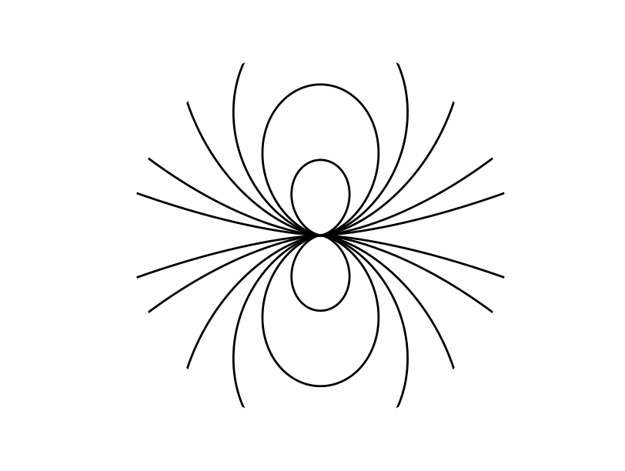

1. 4.5

* Find the divergence and curl of the following vector fields:

* 1. \(\mbox{$\bm {F}$}=z \, \mbox{$\bm {i}$}+y \, \mbox{$\bm {j}$} + x \, \mbox{$\bm {k}$}\)

* 1. \(\mbox{$\bm {F}$}=x^2 y \, \mbox{$\bm {i}$}+ y^2 x \, \mbox{$\bm {j}$} + xyz \, \mbox{$\bm {k}$}\)

* 1. We have

$$\begin{align*} \mbox{$ \bm {\nabla } \cdot $}{\mbox{$\bm {F}$}}=\dfrac {\partial z}{\partial x}+\dfrac {\partial y}{\partial y}+\dfrac {\partial x}{\partial z} = 1 \end{align*}$$

* + and

* 1. Now

$$\begin{align*} \mbox{$ \bm {\nabla } \cdot $}{\mbox{$\bm {F}$}}& = \dfrac {\partial }{\partial x}(x^2 y)+ \dfrac {\partial }{\partial y}(y^2x)+ \dfrac {\partial }{\partial z}(xyz) \\ & =2 xy + 2 xy + xy = 5 xy. \end{align*}$$

* + and

1. 4.6

* Find the divergence and curl of the following vector fields \(\mbox{$\bm {F}$}\):

* 1. \(\mbox{$\bm {F}$}=yz\, \mbox{$\bm {i}$} + xz\, \mbox{$\bm {j}$} + xy \, \mbox{$\bm {k}$}\).

* 1. \(\mbox{$\bm {F}$}=xy\, \mbox{$\bm {i}$} + yz\, \mbox{$\bm {j}$} + zx \, \mbox{$\bm {k}$}\).

* 1. \(\mbox{$\bm {F}$}=e^{-x}\sin {y} \, \mbox{$\bm {i}$} -e^{-x}\cos {y} \, \mbox{$\bm {j}$}\).

* 1. For \(\mbox{$\bm {F}$}=yz\, \mbox{$\bm {i}$} + xz\, \mbox{$\bm {j}$} + xy \, \mbox{$\bm {k}$}\),

$$\begin{align*} \mbox{$ \bm {\nabla } \cdot $}{\mbox{$\bm {F}$}}=\dfrac {\partial (yz)}{\partial x}+\dfrac {\partial (xz)}{\partial y}+\dfrac {\partial (xy)}{\partial z}=0+0+0=0. \end{align*}$$

* + and

* 1. For \(\mbox{$\bm {F}$}=xy\, \mbox{$\bm {i}$} + yz\, \mbox{$\bm {j}$} + zx \, \mbox{$\bm {k}$}\),

$$\begin{align*} \mbox{$ \bm {\nabla } \cdot $}{\mbox{$\bm {F}$}}=\dfrac {\partial (xy)}{\partial x}+\dfrac {\partial (yz)}{\partial y}+\dfrac {\partial (zx)}{\partial z}=y+z+x. \end{align*}$$

* 1. For \(\mbox{$\bm {F}$}=e^{-x}\sin {y} \, \mbox{$\bm {i}$} -e^{-x}\cos {y} \, \mbox{$\bm {j}$}\),

$$\begin{align*} \mbox{$ \bm {\nabla } \cdot $}{\mbox{$\bm {F}$}}=\dfrac {\partial }{\partial x}(e^{-x}\sin {y})+\dfrac {\partial }{\partial y}(-e^{-x}\cos {y}) =-e^{-x}\sin {y}+e^{-x}\sin {y}=0. \end{align*}$$

## 5 Derivatives of Scalar and Vector Fields

We have already met the first derivatives of scalar and vector fields. For a scalar field, \(\phi (x,y,z)\), we have

For a vector field, \(\mbox{$\bm {F}$}(x,y,z)\), we have the divergence and curl

$$
\begin{align}
\tag{5.2} \mbox{$ \bm {\nabla } \cdot $}{\mbox{$\bm {F}$}}= \dfrac {\partial F_x}{\partial x}+ \dfrac {\partial F_y}{\partial y}+\dfrac {\partial F_z}{\partial z}
\end{align}
$$

and

These are the *only* scalar and vector quantities which can be obtained from the first derivatives of scalar and vector fields. Only these derivatives turn up in the differential equations of mathematical physics. They can describe physics which does not depend on the arbitrary choices we make in setting up our coordinate systems.

**Exercise**  
Show that \(\mbox{$ \bm {\nabla } \cdot $}{\mbox{$\bm {s}$}}=3\) and \(\mbox{ $\bm {\nabla } \times $}{\mbox{$\bm {s}$}}=\mbox{$\bm {0}$}\), where \(\mbox{$\bm {s}$}=x \, \mbox{$\bm {i}$} + y\, \mbox{$\bm {j}$} +z\, \mbox{$\bm {k}$}\) is the position vector.  
**Solution**  
We get

$$\begin{align*} \mbox{$ \bm {\nabla } \cdot $}{\mbox{$\bm {s}$}}=\dfrac {\partial }{\partial x}x+\dfrac {\partial }{\partial y}y+\dfrac {\partial }{\partial z}z=3 \end{align*}$$

and

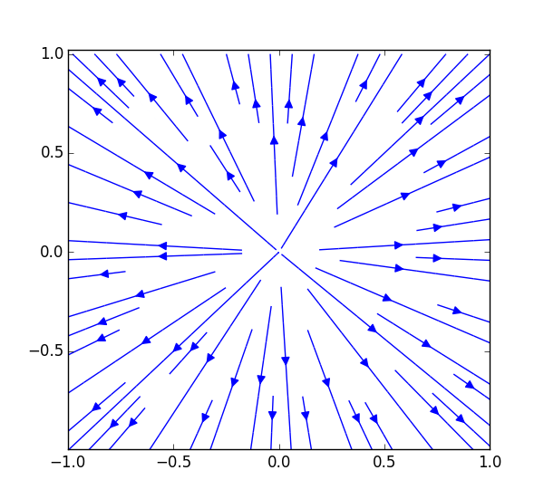

The vector field \(\mbox{$\bm {s}$}\), which represents a ‘flow’ outwards from the origin, has non-zero divergence everywhere, but zero curl.

**Exercise**  
Consider water flowing in a circular path, like stirring a cup of tea. A small volume of water at the point \((x,y,z)\) at time \(t\) has coordinates \(x=r \cos {\omega t}\), \(y=r \sin {\omega t}\), \(z=z_0\).

Calculate the velocity field

and determine \(\mbox{$ \bm {\nabla } \cdot $}{\mbox{$\bm {v}$}}\) and \(\mbox{ $\bm {\nabla } \times $}{\mbox{$\bm {v}$}}\).  
**Solution**  
Differentiating, we have

Then

$$\begin{align*} \mbox{$ \bm {\nabla } \cdot $}{\mbox{$\bm {v}$}}=\dfrac {\partial }{\partial x} (-\omega y) + \dfrac {\partial }{\partial y} (\omega x)+ \dfrac {\partial }{\partial z}(0)=0 \end{align*}$$

and

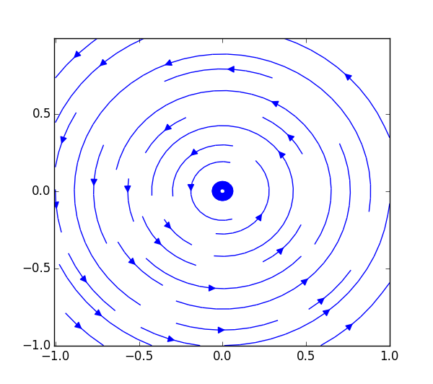

This vector field, representing something rotating, has non-zero curl everywhere, but zero divergence

### 5.1 Physical Interpretation of Divergence and Curl

We saw in the previous examples that divergence is associated with outwards (or inwards) flow and curl with rotation. We shall now look at this a bit more carefully.

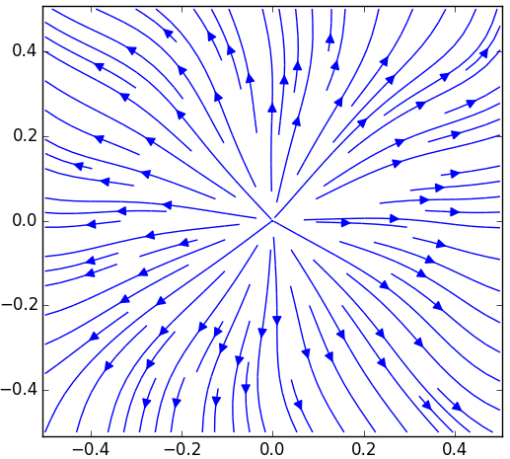

Field lines for the two dimensional vector function \(\mbox{$\bm {F}$}=(x/(x^2+y^2)^{3/2}+\sin {(10y)},y/(x^2+y^2)^{3/2}+\cos {(10x)})\), which has \(\mbox{$ \bm {\nabla } \cdot $}{\mbox{$\bm {F}$}}\neq 0\) at the origin, but not elsewhere.

Suppose we have a field with zero divergence except at a single point in space. Then field lines will flow out from this point (or in towards it if the divergence is negative). If we think of our field lines as representing the flow of an incompressible fluid a region of non-zero divergence represents a source adding fluid to the system (if \(\mbox{$ \bm {\nabla } \cdot $}{\mbox{$\bm {v}$}}{\gt}0\)) or a sink removing it (if \(\mbox{$ \bm {\nabla } \cdot $}\mbox{$\bm {v}$}{\lt}0\)). If fluid is neither added or removed then the divergence must be zero everywhere. You will later meet the *Divergence Theorem* which says that the total flow of fluid out of a region is equal to the integrated divergence of the field within the region. In electromagnetism, this corresponds to Gauss’s law, which relates the flux of electric field lines through a surface to the total charge within it.

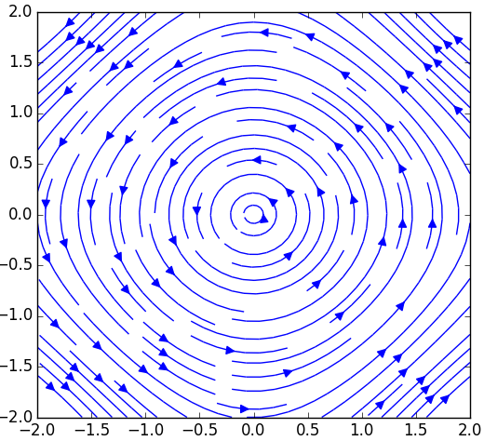

Field lines for the two dimensional vector function \(\mbox{$\bm {F}$}=(-\sin {y},\sin {x})\), which has zero divergence everywhere but finite curl.

Now consider a field with zero divergence and non-zero curl. There is no need for the field lines to have ends, so they form loops. If, again, we think about a fluid then this means the fluid is rotating, with the direction of the rotation determined by the sign of the curl within the loop. If the curl is non-zero only at a single point the loops must all go around that point. If the divergence is non-zero, field lines can have ends and the possibilities are more complicated, but a non-zero curl is still associated with rotation. A nice way to think about it is to imagine swimming round a loop in the fluid; if it is easier to swim round one way than the other, the curl of the field inside the loop must be non-zero. You will meet *Stokes’ Theorem* which states that the circulation round a loop is equal to the integrated curl of the field within the loop. In electromagnetism, this becomes Ampère’s law, relating the circulation of lines of magnetic field around a loop to the current flowing through it.

### 5.2 All the Second Derivatives

Turning to second derivatives, we can think about using the gradient, divergence and curl operators again to obtain second derivatives which are scalar and vector fields. The possibilities are:

$$
\begin{align}
\tag{5.4} \mbox{$\bm {\nabla }$}\cdot (\mbox{$\bm {\nabla }$} \phi )& = \nabla ^2 \phi = \dfrac {\partial ^2\phi }{\partial x^2}+\dfrac {\partial ^2\phi }{\partial y^2}+\dfrac {\partial ^2\phi }{\partial z^2}. \label{laplacian}\\
\tag{5.5}\mbox{$\bm {\nabla }$}\times (\mbox{$\bm {\nabla }$} \phi )& =0 \label{identity1} \\
\tag{5.6}\mbox{$\bm {\nabla }$}(\mbox{$ \bm {\nabla } \cdot $}\mbox{$\bm {F}$})& = \left(\dfrac {\partial ^2F_x}{\partial x^2} + \frac{\partial ^2 F_y}{\partial x \partial y} + \frac{\partial ^2 F_z}{\partial x \partial z}\right) \mbox{$\bm {i}$} + \left( \frac{\partial ^2 F_x}{\partial y \partial x} + \dfrac {\partial ^2F_y}{\partial y^2} + \frac{\partial ^2 F_z}{\partial y \partial z}\right) \mbox{$\bm {j}$} + \left( + \frac{\partial ^2 F_x}{\partial z \partial x} + \frac{\partial ^2 F_y}{\partial z \partial y} + \dfrac {\partial ^2F_z}{\partial z^2} \right) \mbox{$\bm {k}$} \\
\tag{5.7}\mbox{$\bm {\nabla }$}\cdot (\mbox{ $\bm {\nabla } \times $}{\mbox{$\bm {F}$}})& =0 \label{identity2} \\
\tag{5.8}\mbox{$\bm {\nabla }$}\times {(\mbox{ $\bm {\nabla } \times $}{\mbox{$\bm {F}$}})}& =\mbox{$\bm {\nabla }$}(\mbox{$ \bm {\nabla } \cdot $}\mbox{$\bm {F}$})-\nabla ^2 \mbox{$\bm {F}$}. \label{identity3}
\end{align}
$$

#### The Laplacian operator, \({\nabla }^2\)

The most common second derivative you will meet is 5.4, which is given a special name, the Laplacian operator. Starting from

we take the divergence to get

which is, of course, a scalar. This combination of operators occurs often, so we abbreviate it, defining the Laplacian operator \(\nabla ^2\) (‘del-squared’) by

This is a cartesian scalar – as you showed in one of the problems, it looks the same for any choice of cartesian axes.

The Laplacian operator can also act on a vector field \(\mbox{$\bm {F}$}=F_x\, \mbox{$\bm {i}$}+F_y\, \mbox{$\bm {j}$}+F_z\, \mbox{$\bm {k}$}\). It then gives

which is a vector field. Note that this did not appear on our previous list because it is not itself the first derivative of a vector or scalar field. Sometimes we think we have considered all the possibilities but still miss something!

**Exercise**  
For the scalar field \(\phi =z e^x \cos {y}\), calculate \(\nabla ^2 \phi \) and show explicitly that \(\mbox{$\bm {\nabla }$} \times ( \mbox{$\bm {\nabla }$} \phi ) = 0\).  
**Solution**  
For this function,

Hence

and

#### Identities Involving Second Derivatives

Three of the second derivatives were given as identities, (5.5), (5.7) and (5.8). Here I shall look at proving them.

To prove (5.5), use

and take the curl to get

This might be expected, as the operator involved is \(\mbox{$\bm {\nabla }$} \times \mbox{$\bm {\nabla }$}\). For ordinary vectors, such a cross product is always zero. This is not a proof (it does not actually have to be the case for vector operators), but it is a useful way of remembering the result.

For 5.7, we start from

Then, taking the divergence,

$$\begin{align*} \mbox{$ \bm {\nabla } \cdot $}{(\mbox{ $\bm {\nabla } \times $}{\mbox{$\bm {F}$}})}& =\dfrac {\partial }{\partial x}\left(\dfrac {\partial F_z}{\partial y}-\dfrac {\partial F_y}{\partial z}\right) +\dfrac {\partial }{\partial y}\left(\dfrac {\partial F_x}{\partial z}-\dfrac {\partial F_z}{\partial x}\right) +\dfrac {\partial }{\partial z}\left(\dfrac {\partial F_y}{\partial x}-\dfrac {\partial F_x}{\partial y}\right) \\ & =\frac{\partial ^2 F_z}{\partial x\, \partial y} - \frac{\partial ^2 F_y}{\partial x\, \partial z} +\frac{\partial ^2 F_x}{\partial y\, \partial z} - \frac{\partial ^2 F_z}{\partial y\, \partial x} +\frac{\partial ^2 F_y}{\partial z\, \partial x} - \frac{\partial ^2 F_x}{\partial z\, \partial y} =0. \end{align*}$$

We could prove identity (5.8) in a similar way. It is a bit more messy, as we have to evaluate both sides and show they are equal. I will leave that as an exercise.

### 5.3 Maxwell’s Equations

Next year, you will meet Maxwell’s equations which determine the electric field, \(\mbox{$\bm {E}$}\), and magnetic field, \(\mbox{$\bm {B}$}\). For the special case of no time dependence, and in free space, the equations are

$$
\begin{align}
\tag{5.12}& \mbox{$ \bm {\nabla } \cdot $}\mbox{$\bm {E}$}=\frac{\rho }{\varepsilon _0} \qquad \, \mbox{$ \bm {\nabla } \cdot $}\mbox{$\bm {B}$}=0 \\
\tag{5.13}& \mbox{ $\bm {\nabla } \times $}{\mbox{$\bm {E}$}}=\mbox{$\bm {0}$} \qquad \mbox{ $\bm {\nabla } \times $}{\mbox{$\bm {B}$}}=\mu _0{\mbox{$\bm {J}$}}.
\end{align}
$$

Here, \(\rho \) is the charge density (a scalar) and \(\mbox{$\bm {J}$}\) is the current density (a vector).

We see that, in the static case, for electric fields, there is zero curl and the divergence is non-zero only where there is charge. Electric field lines start and end on charges. For magnetic fields, there is always zero divergence, so field lines must form loops. Currents generate non-zero curl, so field lines loop around currents.

**Exercise**  
The magnetic field due a cylindrical wire along the \(z-\)axis, carrying current \(I\), is

where \(r^2=x^2+y^2\). Show that \(\mbox{$ \bm {\nabla } \cdot $}\mbox{$\bm {B}$}=0\) and \(\mbox{ $\bm {\nabla } \times $}{\mbox{$\bm {B}$}}=\mbox{$\bm {0}$}\) (outside the wire).  
**Solution**  
We get

$$\begin{align*} \mbox{$ \bm {\nabla } \cdot $}\mbox{$\bm {B}$} =\frac{\mu _0 I}{2 \pi } \left[ \dfrac {\partial }{\partial x} \left(\frac{-y}{x^2+y^2}\right) + \dfrac {\partial }{\partial y} \left(\frac{x}{x^2+y^2}\right) \right]. \end{align*}$$

Now,

so the two terms cancel and \(\mbox{$ \bm {\nabla } \cdot $}\mbox{$\bm {B}$}=0\) as required.

Turning to the curl,

Now

so the two terms cancel and \(\mbox{ $\bm {\nabla } \times $}{\mbox{$\bm {B}$}}=\mbox{$\bm {0}$}\).

### 5.4 Problems

1. 5.1

* Could the vector function
* represent an electrostatic field?
* In electrostatics \(\mbox{ $\bm {\nabla } \times $}{\mbox{$\bm {E}$}}=\mbox{$\bm {0}$}\); any function which satisfies this could be an electrostatic field. Taking the curl,
* Hence the given \(\mbox{$\bm {E}$}\) could represent an electrostatic field.

1. 5.2

* The electric field \(\mbox{$\bm {E}$}\) is related to the electrostatic potential, \(V\), by \(\mbox{$\bm {E}$}=-\mbox{$\bm {\nabla }$} V\). Find \(\mbox{$\bm {E}$}\) if \(V=\ln {(x^2+y^2)}\). Verify that \(\nabla ^2 V=0\) for this \(V\).
* For this \(V\), we have
* so
* Differentiating again, using the quotient rule
* Hence
* as required.

1. 5.3

* The electric field from a point charge \(Q\) at the origin is,
* where \(r^2=x^2+y^2+z^2\). Show that \(\mbox{$ \bm {\nabla } \cdot $}\mbox{$\bm {E}$}=0\) (except at the origin) and \(\mbox{ $\bm {\nabla } \times $}{\mbox{$\bm {E}$}}=\mbox{$\bm {0}$}\).
* For the given

* \(\bm {E}\)
* , we have

$$\begin{align*} \mbox{$ \bm {\nabla } \cdot $}\mbox{$\bm {E}$}=\frac{Q}{4\pi \varepsilon _0} \left( \dfrac {\partial }{\partial x}\left(\frac{x}{r^3}\right) +\dfrac {\partial }{\partial y}\left(\frac{y}{r^3}\right) +\dfrac {\partial }{\partial z}\left(\frac{z}{r^3}\right) \right). \end{align*}$$

* Now, using the quotient rule
* Using the symmetry to get the other derivatives,

$$\begin{align*} \mbox{$ \bm {\nabla } \cdot $}\mbox{$\bm {E}$}=\frac{Q}{4\pi \varepsilon _0} \left( \frac{3}{r^3}-\frac{3(x^2+y^2+z^2)}{r^5} \right)=0, \end{align*}$$

* as required.
* Turning to the curl, consider first the \(x-\)component,
* For the given

* \(\bm {E}\)
* ,
* This is symmetric between \(x\) and \(z\), so will be equal to \(\partial E_y/\partial z\). Hence the two terms cancel, giving \([\mbox{ $\bm {\nabla } \times $}{\mbox{$\bm {E}$}}]_x=0\). By symmetry the other components are also zero, so \(\mbox{ $\bm {\nabla } \times $}{\mbox{$\bm {E}$}}=\mbox{$\bm {0}$}\) as required.

1. 5.4

* The magnetic field \(\mbox{$\bm {B}$}\) and the current density \(\mbox{$\bm {J}$}\) are related by \(\mbox{ $\bm {\nabla } \times $}{\mbox{$\bm {B}$}}=\mu _0 J\). Suppose that, for \(|y|\leq a\), \(\mbox{$\bm {B}$}\) is given by
* and for \(|y|{\gt}a\), \(\mbox{$\bm {B}$}\) is a constant. Here \(B_0\) and \(a\) are constants and \(\mbox{$\bm {B}$}\) is continuous at \(y=\pm a\).
* Find \(\mbox{$\bm {B}$}\) for \(y{\gt}a\) and \(y{\lt}-a\). Find \(\mbox{$\bm {J}$}\) for \(|y|{\lt}a\) and show that \(\mbox{$\bm {J}$}=\mbox{$\bm {0}$}\) for \(|y|{\gt}a\).
* Since \(\mbox{$\bm {B}$}\) is continuous at \(y=\pm a\), we can find the constant values for \(|y|{\gt}a\) by evaluating the given expression at \(y=\pm a\). This gives \(\mbox{$\bm {B}$}=\pm B_0 \mbox{$\bm {k}$}\), so the values are \(\mbox{$\bm {B}$}=-B_0 \mbox{$\bm {k}$}\) for \(y{\lt} -a\) and \(\mbox{$\bm {B}$}=B_0 \mbox{$\bm {k}$}\) for \(y{\gt}a\).
* In the regions \(|y|{\gt}a\), where \(\mbox{$\bm {B}$}\) is a constant, \(\mbox{ $\bm {\nabla } \times $}{\mbox{$\bm {B}$}}=\mbox{$\bm {0}$}\) so \(\mbox{$\bm {J}$}=\mbox{$\bm {0}$}\).
* Where \(|y|{\lt}a\) we obtain \(J\) from

1. 5.5

* For the electric field \(\mbox{$\bm {F}$}=x \sin {y} \, \mbox{$\bm {i}$} + y \sin {z}\, \mbox{$\bm {j}$} + z \sin {x} \, \mbox{$\bm {k}$}\), calculate explicitly \(\mbox{$\bm {\nabla }$} \times (\mbox{ $\bm {\nabla } \times $}{\mbox{$\bm {F}$}})\) and \(\mbox{$\bm {\nabla }$}(\mbox{$ \bm {\nabla } \cdot $}\mbox{$\bm {F}$})-\nabla ^2 \mbox{$\bm {F}$}\), hence showing that they are equal.
* First,
* Then
* Looking at the other expression,

$$\begin{align*} \mbox{$ \bm {\nabla } \cdot $}\mbox{$\bm {F}$}=\sin {y}+\sin {z}+\sin {x}\; , \end{align*}$$

* so

$$\begin{align*} \mbox{$\bm {\nabla }$}(\mbox{$ \bm {\nabla } \cdot $}\mbox{$\bm {F}$})=\cos {x}\, \mbox{$\bm {i}$}+\cos {y}\, \mbox{$\bm {j}$}+\cos {z}\, \mbox{$\bm {k}$}\; . \end{align*}$$

* Now
* so \(\nabla ^2 F_x=-F_x\). By symmetry, \(\nabla ^2 F_y=-F_y\) and \(\nabla ^2 F_z=-F_z\). Hence
* Putting these bits together

$$\begin{align*} \mbox{$\bm {\nabla }$}(\mbox{$ \bm {\nabla } \cdot $}\mbox{$\bm {F}$})-\nabla ^2 \mbox{$\bm {F}$}= (\cos {x}\, \mbox{$\bm {i}$}+\cos {y}\, \mbox{$\bm {j}$}+\cos {z}\, \mbox{$\bm {k}$})+\mbox{$\bm {F}$}=\mbox{ $\bm {\nabla } \times $}(\mbox{ $\bm {\nabla } \times $}\mbox{$\bm {F}$})\; , \end{align*}$$

* as required.

1. 5.6

* Show that
* where \(\mbox{$\bm {A}$}\) is any constant vector and \(\mbox{$\bm {s}$}=(x,y,z)\) is the position vector.
* We have
* Taking the curl of this gives
* Multplying both sides by \(\frac{1}{2}\) then gives the required result.

1. 5.7

* If \(\phi (\mbox{$\bm {r}$})\) is a scalar field and \(\mbox{$\bm {F}$}(\mbox{$\bm {r}$})\) is a vector field, show that

$$\begin{align*} \mbox{$\bm {\nabla }$}\cdot (\mbox{$\bm {F}$}\phi )= \phi (\mbox{$ \bm {\nabla } \cdot $}\mbox{$\bm {F}$})+(\mbox{$\bm {\nabla }$}\phi )\cdot \mbox{$\bm {F}$}. \end{align*}$$

* We have

$$\begin{align*} \mbox{$\bm {\nabla }$}\cdot (\mbox{$\bm {F}$}\phi )& = \dfrac {\partial }{\partial x}(\phi F_x)+\dfrac {\partial }{\partial y}(\phi F_y)+\dfrac {\partial }{\partial z}(\phi F_z) \\ & =F_x \dfrac {\partial \phi }{\partial x}+\phi \dfrac {\partial F_x}{\partial x} +F_y \dfrac {\partial \phi }{\partial y}+\phi \dfrac {\partial F_y}{\partial y} +F_z \dfrac {\partial \phi }{\partial z}+\phi \dfrac {\partial F_z}{\partial z} \\ & =\phi \left(\dfrac {\partial F_x}{\partial x}+\dfrac {\partial F_y}{\partial y}+\dfrac {\partial F_z}{\partial z}\right) +\dfrac {\partial \phi }{\partial x}F_x+\dfrac {\partial \phi }{\partial y}F_y+\dfrac {\partial \phi }{\partial z}F_z \\ & =\phi (\mbox{$ \bm {\nabla } \cdot $}\mbox{$\bm {F}$})+(\mbox{$\bm {\nabla }$}\phi )\cdot \mbox{$\bm {F}$}. \end{align*}$$

1. 5.8

* Prove, by direct differentiation, the identity

$$\begin{align*} \mbox{$\bm {\nabla }$}\times {(\mbox{ $\bm {\nabla } \times $}{\mbox{$\bm {F}$}})}& =\mbox{$\bm {\nabla }$}(\mbox{$ \bm {\nabla } \cdot $}\mbox{$\bm {F}$})-\nabla ^2 \mbox{$\bm {F}$}. \end{align*}$$

* It is enough to show that the \(x\)-component of the two sides is the same. The identity then follows, because the two sides are cartesian vectors, and we can always chose an orientation of the axes such that the field at a particular point is directed in the \(x\)-direction.
* We have
* The curl of this is thus
* Taking just the \(x\)-component of this
* Turning now to the right hand side of the expression,

$$\begin{align*} \mbox{$ \bm {\nabla } \cdot $}\mbox{$\bm {F}$}=\dfrac {\partial F_x}{\partial x}+\dfrac {\partial F_y}{\partial y}+\dfrac {\partial F_z}{\partial z} \end{align*}$$

* Taking the \(x\)-component of the gradient of this,

$$\begin{align*} [\mbox{$\bm {\nabla }$}(\mbox{$ \bm {\nabla } \cdot $}\mbox{$\bm {F}$})]_x= \dfrac {\partial ^2F_x}{\partial x^2} + \frac{\partial ^2 F_y}{\partial x \partial y} + \frac{\partial ^2 F_z}{\partial x \partial z}, \end{align*}$$

* while
* Subtracting the two, the \(\partial ^2 F_x/\partial x^2\) terms cancel, leaving

$$\begin{align*} [\mbox{$\bm {\nabla }$}(\mbox{$ \bm {\nabla } \cdot $}\mbox{$\bm {F}$})-\nabla ^2 \mbox{$\bm {F}$}]_x= \frac{\partial ^2 F_y}{\partial x \partial y} + \frac{\partial ^2 F_z}{\partial x \partial z} -\dfrac {\partial ^2F_x}{\partial y^2}-\dfrac {\partial ^2F_x}{\partial z^2}= [\mbox{$\bm {\nabla }$}\times {(\mbox{ $\bm {\nabla } \times $}{\mbox{$\bm {F}$}})}]_x. \end{align*}$$

* This proves the \(x\) components of the two expressions are the same. By symmetry, the \(y\) and \(z\) components will also be equal, so the identity is proved.

## 6 Polar Coordinates

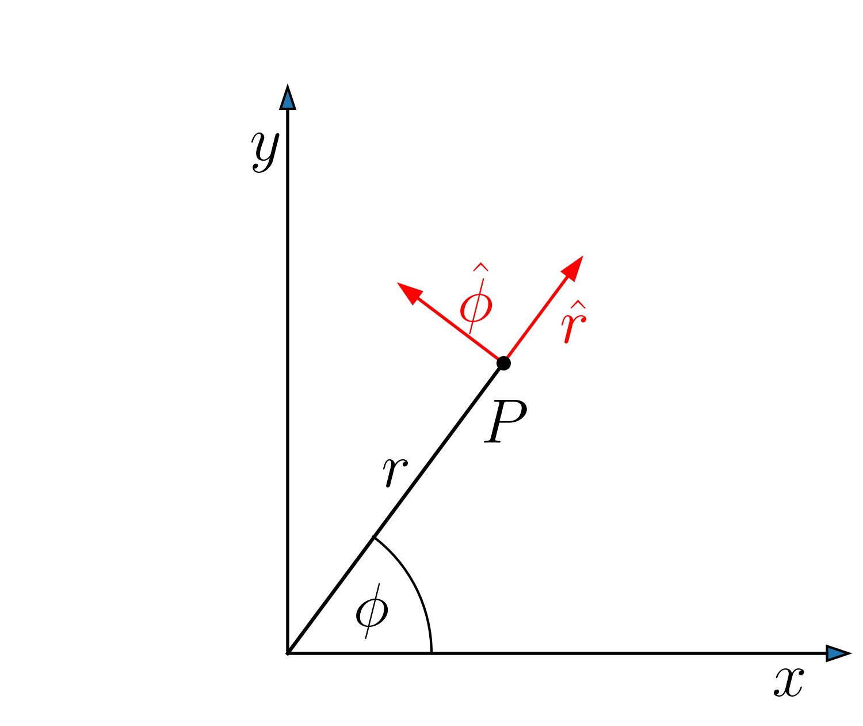

In plane polar coordinates the distance from the origin, \(r\), and polar angle, \(\phi \), are related to the cartesian \(x\) and \(y\) by

Frequently, \(\theta \) is used as the angular coordinate, rather that \(\phi \) – you should expect to see both.

Recall that we can find the basis vectors using partial differentiation. We write

The basis vectors are unit vectors pointing in the directions in which \(\mbox{$\bm {s}$}\) changes when we increase one coordinates but keep the other constant. To get the directions we differentiate:

However, the basis vectors are unit vectors, so we need to divide by their lengths. These are \(h_r=1\) and \(h_\phi =r\). Doing the division, the basis vectors are

Unlike the basis vectors of Cartesian coordinates, \(\hat{\bm r}\) and \(\hat{\bm \phi }\) depend on the position \((r,\phi )\). The direction of the basis vectors changes as you move around in polar coordinates.

As we saw for rotations, we can express the relationship between the basis vectors in matrix form

$$
\begin{align}
\tag{6.5}\begin{pmatrix} \hat{\bm r}
\\ \hat{\bm \phi }
\end{pmatrix} = \begin{pmatrix} \hfill \cos {\phi }
& \hfill \sin {\phi }
\\ \hfill -\sin {\phi }
& \hfill \cos {\phi }
\end{pmatrix}\begin{pmatrix} \mbox{$\bm {i}$}
\\ \mbox{$\bm {j}$}
\end{pmatrix} \; .
\end{align}
$$

An important propert of this matrix is that it is orthogonal, because the basis vectors are orthogonal. The inverse is just the transpose, making it easy to invert the relationship:

$$
\begin{align}
\tag{6.6}\begin{pmatrix} \mbox{$\bm {i}$}
\\ \mbox{$\bm {j}$}
\end{pmatrix} = \begin{pmatrix} \hfill \cos {\phi }
& \hfill -\sin {\phi }
\\ \hfill \sin {\phi }
& \hfill \cos {\phi }
\end{pmatrix}\begin{pmatrix} \hat{\bm r}
\\ \hat{\bm \phi }
\end{pmatrix} \; ,
\end{align}
$$

so

Note that we can write

\(h_r\) and \(h_\phi \) are the *scale factors* for the polar coordinate system. We can define similar scale factors for any coordinate transformation – they are simply the lengths of the vectors we get when we differentiate \(\mbox{$\bm {s}$}\), the position vector, with respect to the variables of that coordinate system.

### 6.1 Converting Scalar and Vector Fields to Polar Coordinates

We now have the ingredients we need to convert scalar and vector fields from Cartesian coordinates to polar coordinates. In this section, I will use \(V\) as my generic scalar field, as \(\phi \) is now one of the coordinates.

Scalar fields are simple. We require the field at any point in space to be the same whether the point is described by Cartesian coordinates or polars. Thus \(V(x,y) \rightarrow V(r\cos {\phi },r\sin {\phi })\). For example

To do the reverse transformation, we need to write \(r\) and \(\phi \) in terms of \(x\) and \(y\). From the definitions, Eq.(6.1), we get

Thus

**Exercise**  
Express \(V(r,\phi )=\sin {2\phi }\) in Cartesian coordinates, without using \(\tan ^{-1}{(y/x)}\).  
**Solution**  
In this case, we can write

Next look at converting a vector field. Let us use this approach to convert the field \(\mbox{$\bm {F}$}(x,y)=x^2 \, \mbox{$\bm {i}$} + xy \, \mbox{$\bm {j}$}\) to polar coordinates. There are two things we need to convert: the \(x\) and \(y\) coordinates, as for a scalar field, but also the basis vectors, \(\mbox{$\bm {i}$}\) and \(\mbox{$\bm {j}$}\). The relationships we need for the latter come from Eq.(6.7).

For the coordinates, we have \(x^2=r^2 \cos ^2{\phi }\) and \(xy=r^2 \cos {\phi } \sin {\phi }\), so

In polar coordinates, the field is \(\mbox{$\bm {F}$}(r,\phi )=F_r(r,\phi ) \, \hat{\bm r} + F_\phi (r,\phi ) \, \hat{\bm \phi }\), so the \(r\) component is \(F_r=r^2 \cos {\phi }\) and the \(\phi \) component \(F_\phi =0\).

In fact, we can use the property that the basis vectors are orthogonal to do this in a slightly simpler way. Starting from

we take the dot product with \(\hat{\bm r}\) and \(\hat{\bm \phi }\) in Eq.(6.4) to obtain

**Exercise**  
Find the gradient of the two dimensional scalar field \(V(x,y)=xy\). Convert your expression for \(\mbox{$\bm {\nabla }$}V\) into polar coordinates.  
**Solution**  
The gradient is

Using \(x=r \cos {\phi }\), \(y=r\sin {\phi }\), this is

Taking the dot product with \(\hat{\bm r}\) and \(\hat{\bm \phi }\) gives

so

### 6.2 The gradient, \({{\nabla }}V\), in Polar Coordinates

In cartesians, the gradient operator is the vector field (in two dimensions)

We can express this in polar coordinates using the same approach as above, converting both the derivatives and the basis vectors to polar form.

To convert the derivatives, we use the generalisation of the chain rule in partial differentiation, Eq.(1.16):

This is really the wrong way round, but the conversion is the same orthogonal matrix we found for the basis vectors:

$$
\begin{align}
\tag{6.14}\begin{pmatrix} {\partial V}/{\partial r}
\\ \frac{1}{r}{\partial V}/{\partial \phi }
\end{pmatrix} = \begin{pmatrix} \hfill \cos {\phi }
& \hfill \sin {\phi }
\\ \hfill -\sin {\phi }
& \hfill \cos {\phi }
\end{pmatrix}\begin{pmatrix} {\partial V}/{\partial x}
\\ {\partial V}/{\partial y}
\end{pmatrix} \; .
\end{align}
$$

So the inverse is just

We can now write

Taking the dot product with \(\hat{\bm r}\) gives

Similarly

Hence

**Exercise**  
Consider again the scalar field \(V(x,y)=xy\). Convert this field to polar coordinates then calculate the gradient using Eq.(6.19).  
**Solution**  
In polar coordinates

Thus

Then

as before

#### Alternative Derivation Using Scale Factors

There is, however, a simpler way of deriving our expression for the gradient operator in polar coordinates. This starts from the definition of the gradient, Eq.(2.4),

If \(V\) is in polar coordinates, the differential \(dV\) can be written as

We write \(\mbox{$\bm {\nabla }$}V\) in polar coordinates as

Using these and \(d\mbox{$\bm {s}$}\) from Eq.(6.8), Eq.(6.20) becomes

Equating coefficients of \(dr\) and \(d\phi \),

Hence

as we found before. However, this formula generalises easily to other coordinates systems – once we know the scale factors, we can write down the equation for the gradient. For example, in spherical polars, where \(h_r=1\), \(h_\theta =r\) and \(h_\phi =r\sin {\theta }\) (see problem 7), it is

### 6.3 The divergence, \(\nabla \cdot F\), in Polar Coordinates

In cartesians, the divergence of \(\mbox{$\bm {F}$}\) is given, in two dimensions, by

$$
\begin{align}
\tag{6.26} \mbox{$ \bm {\nabla } \cdot $}\mbox{$\bm {F}$}=\dfrac {\partial F_x}{\partial x}+\dfrac {\partial F_y}{\partial y}
\end{align}
$$

so to change to polars we need to convert the differentials, as above, and also the components of the vector \(\mbox{$\bm {F}$}\). For the latter, we use the expressions for the unit vectors, Eq.(6.4), to write

We can now read off the components in cartesians,

Using these, and the expressions for the differentials, Eq.(6.15) we get

and

Adding these, lots of terms again cancel, leaving

$$
\begin{align}
\tag{6.31} \mbox{$ \bm {\nabla } \cdot $}\mbox{$\bm {F}$}& =\dfrac {\partial F_r}{\partial r}+\frac{1}{r}F_r +\frac{1}{r}\dfrac {\partial F_{\phi }}{\partial \phi } \; .
\end{align}
$$

This is usually written

$$
\begin{align}
\tag{6.32} \boxed { \mbox{$ \bm {\nabla } \cdot $}\mbox{$\bm {F}$}= \frac{1}{r}\dfrac {\partial }{\partial r}(r F_r)+ \frac{1}{r}\dfrac {\partial F_{\phi }}{\partial \phi } \; .}
\end{align}
$$

The divergence can also be calculated using a general formula involving the scale factors. The derivation of this is more complicated than for the gradient. In two dimensional polars, the result reduces to

$$
\begin{align}
\tag{6.33} \mbox{$ \bm {\nabla } \cdot $}\mbox{$\bm {F}$}=\frac{1}{h_r h_\phi }\left( \dfrac {\partial }{\partial r}(h_\phi F_r) + \dfrac {\partial }{\partial \phi }(h_r F_\phi )\right)\; .
\end{align}
$$

Putting \(h_r=1\) and \(h_\phi =r\) gives the same result as above.

### 6.4 Problems

1. 6.1

* Express the following scalar fields in plane polar coordinates \(V(r,\phi )\):

* 1. \(V(x,y)=\frac{1}{x^2+y^2}\)

* 1. \(V(x,y)=\sin ^{-1}{\left(\dfrac {x}{\sqrt{x^2+y^2}}\right)}\)

* 1. \(x^2+y^2=r^2\), so \(V(r,\phi )=\dfrac {1}{r^2}\).

* 1. This can be written as

1. 6.2

* Express the following vector fields in plane polar coordinates \(\mbox{$\bm {F}$}(r,\phi )=F_r \, \hat{\bm r} + F_\phi \, \hat{\bm \phi }\):

* 1. \(\mbox{$\bm {F}$}(x,y)=xy \, \mbox{$\bm {i}$}\).

* 1. \(\mbox{$\bm {F}$}(x,y)=(x+y) \, \mbox{$\bm {i}$} + (x-y) \, \mbox{$\bm {j}$}\).

* 1. \(\mbox{$\bm {F}$}(x,y)=\sin ^{-1}{\left(\dfrac {y}{\sqrt{x^2+y^2}}\right)} \, \mbox{$\bm {i}$} +\cos ^{-1}{\left(\dfrac {x}{\sqrt{x^2+y^2}}\right)} \, \mbox{$\bm {j}$} \).

* 1. \(xy=r^2 \cos {\phi } \sin {\phi }\), so

* 1. We get

* 1. \(\sqrt{x^2+y^2}=r\), so
  + Similarly
  + So
  + Actually there are several more cases to consider here (as in 1(b)),but this is correct for \(0\leq \phi \leq \pi /2\).

1. 6.3

* Find the gradients of the following scalar fields:

* 1. \(V(r)=\dfrac {1}{r}\).

* 1. \(V(r)=r \cos {\phi }\).

* 1. \(V(r,\phi )=e^{ikr\cos {\phi }}\), where \(k\) is a constant.
* We use

* 1. We have \(\dfrac {\partial V}{\partial r}=-\dfrac {1}{r^2}\) and \(\dfrac {\partial V}{\partial \phi }=0\). Hence

* 1. We have \(\dfrac {\partial V}{\partial r}=\cos {\phi }\) and \(\dfrac {\partial V}{\partial \phi }=-r \sin {\phi }\). Hence

* 1. the derivatives are
  + Hence

1. 6.4

* Find the divergences of the following vector fields:

* 1. \(\mbox{$\bm {F}$}(r,\phi )=r (\sin {2\phi } \, \hat{\bm r} + \cos {2\phi } \, \hat{\bm \phi })\)

* 1. \(\mbox{$\bm {F}$}(r,\phi )=\dfrac {1}{r} \, \hat{\bm r}\)

* 1. \(\mbox{$\bm {F}$}(r,\phi )=\hat{\bm r}\)

* 1. \(\mbox{$\bm {F}$}(r,\phi )=\hat{\bm \phi }\)
* We use

$$\begin{align*} \mbox{$ \bm {\nabla } \cdot $}\mbox{$\bm {F}$}& = \frac{1}{r}\dfrac {\partial }{\partial r}(r F_r)+ \frac{1}{r}\dfrac {\partial F_{\phi }}{\partial \phi } \; . \end{align*}$$

* 1. \(F_r=r \sin {2\phi }\) and \(F_\phi =r \cos {2\phi }\) So
  + Hence \(\mbox{$ \bm {\nabla } \cdot $}\mbox{$\bm {F}$}=0\).

* 1. \(F_r=\frac{1}{r}\) and \(F_\phi =0\). So \(\partial (r F_r)/\partial r=0\) and \(\mbox{$ \bm {\nabla } \cdot $}\mbox{$\bm {F}$}=0\).

* 1. \(F_r=1\) and \(F_\phi =0\).
  + so \(\mbox{$ \bm {\nabla } \cdot $}\mbox{$\bm {F}$}=1/r\).

* 1. \(F_r=0\) and \(F_\phi =1\). Hence \(\partial F_\phi /\partial \phi =0\) and \(\mbox{$ \bm {\nabla } \cdot $}\mbox{$\bm {F}$}=0\).

1. 6.5

* Consider the vector field

* 1. Work out \(\mbox{$ \bm {\nabla } \cdot $}\mbox{$\bm {F}$}\).

* 1. Convert the expression to cylindrical polar coordinates, writing \(\mbox{$\bm {F}$}\) in terms of the unit vectors \(\hat{\mbox{$\bm {r}$}}\) and \(\hat{\mbox{$\bm {\phi }$}}\).

* 1. Using the expression in the notes for divergence in polars, work out \(\mbox{$ \bm {\nabla } \cdot $}\mbox{$\bm {F}$}\).

* 1. Convert the result of (c) in to cartesian coordinates and show that you get the same answer as in part (a).

* 1. From the expression for

* + \(\bm {F}\)
  + , we have
  + Hence
  + Which gives

$$\begin{align*} \mbox{$ \bm {\nabla } \cdot $}\mbox{$\bm {F}$}=\frac{-(x^2+y^2)y}{(x^2+y^2)^2}=\frac{-y}{x^2+y^2}. \end{align*}$$

* 1. For the basis vectors, we have
  + Also
  + Putting these together gives

* 1. Since only \(F_{\phi }\neq 0\),

$$\begin{align*} \mbox{$ \bm {\nabla } \cdot $}\mbox{$\bm {F}$}=\frac{1}{r}\dfrac {\partial F_{\phi }}{\partial \phi }=-\frac{\sin {\phi }}{r}. \end{align*}$$

* 1. Converting back to cartesian coordinates

$$\begin{align*} \mbox{$ \bm {\nabla } \cdot $}\mbox{$\bm {F}$}=-\frac{r\sin {\phi }}{r^2}=\frac{-y}{x^2+y^2}, \end{align*}$$

* + as required.

1. 6.6

* Use the expressions for the gradient and divergence in polar coordinates to show that the Laplacian is

* \(\nabla ^2 V\) is

1. 6.7

* In spherical polar coordinates the distance from the origin, \(r\), and polar angle, \(\theta \), and azimuthal angle \(\phi \) are related to the cartesian \(x\),\(y\) and \(z\) by

* 1. Show that the scale factors for spherical polars are \(h_r=1\), \(h_\theta =r\) and \(h_\phi =r\sin {\theta }\).

* 1. In terms of scale factors, the divergence in three dimensions is

$$\begin{align*} \mbox{$ \bm {\nabla } \cdot $}\mbox{$\bm {F}$}=\frac{1}{h_r h_\theta h_\phi }\left( \dfrac {\partial }{\partial r}(h_\theta h_\phi F_r) + \dfrac {\partial }{\partial \theta }(h_r h_\phi F_\theta ) + \dfrac {\partial }{\partial \phi }(h_r h_\theta F_\phi ) \right)\; . \end{align*}$$

* + Use this to obtain an expression for \(\mbox{$ \bm {\nabla } \cdot $}\mbox{$\bm {F}$}\) in spherical polars.

* 1. We write
  + Then calculate
  + We need to find the lengths of these vectors:
  + the scale factors are the square roots of these quantities: \(h_r=1\), \(h_\theta =r\) and \(h_\phi =r\sin {\theta }\).

* 1. Substituting these in the formula for \(\mbox{$ \bm {\nabla } \cdot $}\mbox{$\bm {F}$}\),

$$\begin{align*} \mbox{$ \bm {\nabla } \cdot $}\mbox{$\bm {F}$}& =\frac{1}{r^2 \sin {\theta }}\left( \dfrac {\partial }{\partial r}(r^2 \sin {\theta } F_r) + \dfrac {\partial }{\partial \theta }(r\sin {\theta } F_\theta ) + \dfrac {\partial }{\partial \phi }(r F_\phi ) \right) \\ & =\frac{1}{r^2} \dfrac {\partial }{\partial r}(r^2 F_r) + \frac{1}{r\sin {\theta }}\dfrac {\partial }{\partial \theta }(\sin {\theta } F_\theta ) + \frac{1}{r\sin {\theta }}\dfrac {\partial F_\phi }{\partial \phi } \; . \end{align*}$$

1. 6.8

* Starting from the formula for \(d\mbox{$\bm {s}$}\) involving the scale factors \(h_r\) and \(h_\phi \), , Eq.(6.8),

* 1. Find an expression for \(|d\mbox{$\bm {s}$}|^2=\mbox{$\bm {ds}$}\cdot \mbox{$\bm {ds}$}\).

* 1. Show that this can be written in matrix form as

$$\begin{align*} |d\mbox{$\bm {s}$}|^2=(dr \; \; d\phi ) \begin{pmatrix} \hfill h_r^2
& \hfill 0
\\ \hfill 0
& \hfill h_\phi ^2
\end{pmatrix}\begin{pmatrix} dr
\\ d\phi
\end{pmatrix} \; . \end{align*}$$

* This matrix is known as the *metric tensor* for the plane polar coordinate system. Metric tensors are an important part of the theory of general relativity, where they describe the curvature of space time.

  + where we have used the orthogonality \(\hat{\bm r} \cdot \hat{\bm \phi }=0\).

* 1. Multiplying out the matrix,

## 7 Polar Coordinates in Three Dimensions

Frequently in physics we will wish to use coordinate systems other than cartesians. This is usually because a problem will be easier to solve if our coordinates have the same symmetry as the physical system we are dealing with. For example, when dealing with systems with spherical symmetry, it is best to use spherical polar coordinates. As an example, the electric field produced by a point charge in free space is spherically symmetric – it just depends on the radial distance from the charge, with no angular dependence.

### 7.1 Spherical Polar Coordinates

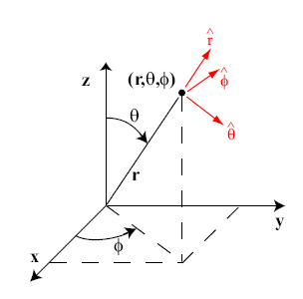

The most common three-dimensional polar coordinate system that you will meet in physics is spherical polars. The three coordinates are \((r,\theta ,\phi )\), with

Note that spherical polar coordinates used by astronomers are not the same as this; in astronomy, the angle \(\theta \) is measured from the equatorial plane, not the polar axis.

#### Basis Vectors in Spherical Polars

To work out expressions for the basis vectors, we write

Vectors in the direction of the basis vectors are then

We need to find unit vectors in each of these directions, so next work out the lengths, which also give the scale factors \(h_r\), \(h_\theta \) and \(h_\phi \).

Dividing by the lengths to get unit vectors, our basis vectors are

The scale factors are \(h_r=1\), \(h_\theta =r\) and \(h_\phi =r \sin {\theta }\).

The relationship can be written in matrix form as

This is an orthogonal matrix so

or

#### Converting a Vector Field to Spherical Polars

A common task is to convert between cartesian and spherical polar coordinates. We have seen how to do something similar with plane polar coordinates. Suppose we have the vector field

and we want to express it in polar coordinates, in the form

We need to convert two things. First we write the \(x^2\) in polars using Eq.(7.1):

Then we use Eq.(7.9) to substitute for the basis vector \(\mbox{$\bm {i}$}\):

Hence the components in spherical polars are

As we have seen previously, we can simplify this slightly by using the fact that the basis vectors are orthogonal. We use \(\mbox{$\bm {F}$}(\mbox{$\bm {s}$})\) in Eq.(7.12) and take dot products with \(\hat{\mbox{$\bm {r}$}}\), \(\hat{\mbox{$\bm {\theta }$}}\) and \(\hat{\mbox{$\bm {\phi }$}}\):

**Exercise**  
Use this method to convert the vector field \(\mbox{$\bm {F}$}(x,y,z)=x\, \mbox{$\bm {i}$}+y\, \mbox{$\bm {j}$}+z\, \mbox{$\bm {k}$}\) into spherical polar coordinates.  
**Solution**  
We write

Taking the dot products,

Thus, in spherical polars, \(\mbox{$\bm {F}$}=r \, \hat{\bm r}\).

### 7.2 Cylindrical Polar Coordinates

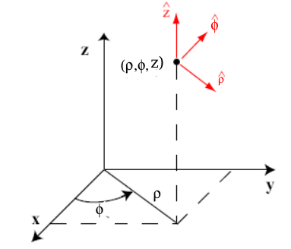

Cylindrical polar coordinates are a straightforward extension of the plane polar coordinates defined in Eq.(6.1) of Section 6:

Cylindrical polars are useful, obviously, when we have a system with cylindrical symmetry. An example is the magnetic field surrounding a long straight wire, which circles around the wire.

**Exercise**  
Show that the basis vectors in polar coordinates are

Show also that the scale factors are \(h_\rho =1\), \(h_\phi =\rho \) and \(h_z=1\).  
**Solution**  
Starting from

Work out

The first and third of these are already unit vectors, so they are the basis vectors, and \(h_\rho =1=h_z\). The second has length \(\rho \), so \(h_\phi =\rho \) and we divide by \(\rho \) to get the second basis vector.

**Exercise**  
Show that the reverse transformation is

**Solution**  
In matrix form, the transformation is

This matrix is orthogonal, so

The transformation given then follows from this.

### 7.3 Vector Operators

As we saw when looking at plane polar coordinates, it is possible to derive expressions for the vector operators, gradient, divergence and curl by starting from the formulas in cartesian coordinates and transforming the variables and basis vectors. However, it was simpler to do the derivation using the scale factors, \(h_r\) and \(h_\phi \). This is the approach we will follow here. I will give general expressions which apply to any orthogonal coordinate transformation, then the specific forms for cylindrical and spherical polars.

You do not have to learn any of these expressions. The formulas for the polar coordinate system are given on the exam formula sheet. If you need the general formulas in terms of scale factors, I will provide them. It is, however, important that you practise using them, so you understand how to do the calculations.

The general expressions are, by necessity, fairly abstract. We have three coordinates \((u_1,u_2,u_3)\) and corresponding scale factors \(h_1\), \(h_2\), \(h_3\). The basis vectors are \(\hat{\bm e}_1\), \(\hat{\bm e}_2\) and \(\hat{\bm e}_3\), so a vector will have components \(F_1\), \(F_2\) and \(F_3\) in these directions. That is

Then the gradient (which we derived) is

The divergence is

$$
\begin{align}
\tag{7.19} \mbox{$ \bm {\nabla } \cdot $}\mbox{$\bm {F}$}& = \frac{1}{h_1 h_2 h_3}\left(\dfrac {\partial }{\partial u_1}(h_2 h_3 F_1)+ \dfrac {\partial }{\partial u_2}(h_1 h_3 F_{2}) + \dfrac {\partial }{\partial u_3}(h_1 h_2 F_3)\right) \; . \label{eq:div-scalefactors}
\end{align}
$$

And the curl is

#### Cylindrical Polars

In cylindrical polars, \(u_1=\rho \), \(u_2=\phi \), \(u_3=z\). We have found that \(h_1=h_\rho =1\), \(h_2=h_\phi =\rho \) and \(h_3=h_z=1\). Thus

$$
\begin{align}
\tag{7.22} \mbox{$ \bm {\nabla } \cdot $}\mbox{$\bm {F}$}& = \frac{1}{\rho }\dfrac {\partial }{\partial \rho }(\rho F_\rho )+ \frac{1}{\rho }\dfrac {\partial F_{\phi }}{\partial \phi } + \dfrac {\partial F_z}{\partial z} \; .
\end{align}
$$

Once we know \(\mbox{$\bm {\nabla }$}V\) and \(\mbox{$ \bm {\nabla } \cdot $}{F}\), obtaining \(\nabla ^2 V\) is trivial. It is

#### Spherical Polars

In spherical polars, \(u_1=r\), \(u_2=\theta \) and \(u_3=\phi \). The scale factors are \(h_r=1\), \(h_\theta = r\) and \(h_\phi =r \sin {\theta }\). The gradient is

The divergence is

$$
\begin{align}
\tag{7.26} \mbox{$ \bm {\nabla } \cdot $}\mbox{$\bm {F}$}=\frac{1}{r^2} \dfrac {\partial }{\partial r}(r^2 F_r) +\frac{1}{r \sin {\theta }} \dfrac {\partial }{\partial \theta }(\sin {\theta }F_{\theta }) +\frac{1}{r \sin {\theta }} \dfrac {\partial F_{\phi }}{\partial \phi }\; ,
\end{align}
$$

and the curl is

The Laplacian is

#### Examples

Using these equations is straightforward, provided you understand what everything means. Taking an example from magnetism, in cylindrical polar coordinates, the magnetic field outside a current carrying wire is

We will work out \(\mbox{$ \bm {\nabla } \cdot $}\mbox{$\bm {B}$}\) and \(\mbox{ $\bm {\nabla } \times $}\mbox{$\bm {B}$}\). The calculation is simplified by the fact that \(\mbox{$\bm {B}$}\) has only a \(\hat{\mbox{$\bm {\phi }$}}\) component, \(B_{\phi }=\mu _0I/2\pi \rho \), so

$$
\begin{align}
\tag{7.30} \mbox{$ \bm {\nabla } \cdot $}\mbox{$\bm {B}$}=\frac{1}{\rho }\dfrac {\partial B_{\phi }}{\partial \phi } =0 \; ,
\end{align}
$$

because \(B_\phi \) does not depend on \(\phi \). The curl is

because \(\rho B_\phi \) is a constant and \(B_\phi \) does not depend on \(z\).

**Exercise**  
Show, using spherical polar coordinates, that the gravitational potential,

satisfies Laplace’s equation \(\nabla ^2 V=0\).  
**Solution**  
Since \(V\) only depends on \(r\), not \(\theta \) and \(\phi \), the only non-zero term in the Laplacian is

### 7.4 Problems

1. 7.1

* Calculate \(\nabla ^2 (e^{-r^2})\) where \(r^2=x^2+y^2+z^2\). Do the calculation first in cartesian coordinates, then in spherical polars.
* Using the properties of exponentials
* Hence
* and
* Using the symmetry of the function, we can deduce the expressions for the \(y\) and \(z\) derivatives. Combining then gives
* Working instead in spherical polar coordinates, the function depends only on \(r\), not \(\theta \) and \(\phi \), so we only need the first term in the Laplacian
* For our function,
* so
* Dividing by \(r^2\), the Laplacian is then
* as before.

1. 7.2

* For the function \(V=e^{-r}/r^2\), where \(r\) is the distance from the origin in spherical polar coordinates, show that
* and find \(\nabla ^2 V\)
* Using the expression for the gradient in spherical polar coordinates, and since \(\phi \) depends only on \(r\) (not on \(\theta \) and \(\phi \)),
* as required.
* Similarly,
* Starting from (as above)
* we get
* Hence

1. 7.3

* In spherical polar coordinates \((r,\theta ,\phi )\),
* Find \(\mbox{$\bm {\nabla }$}V\) in spherical polars.
* From the notes,

$$\begin{align*} \mbox{$\bm {\nabla }$}V & = \dfrac {\partial V}{\partial r} \hat{\mbox{$\bm {r}$}} + \frac{1}{r}\dfrac {\partial V}{\partial \theta } \hat{\mbox{$\bm {\theta }$}} + \frac{1}{r\sin {\theta }}\dfrac {\partial V}{\partial \phi } \hat{\mbox{$\bm {\phi }$}} \\ & = \left(1+\frac{2a^3}{r^3}\right)\sin {\theta }\sin {\phi }\, \hat{\mbox{$\bm {r}$}} + \frac{1}{r}\left(r-\frac{a^3}{r^2}\right) \cos {\theta }\sin {\phi } \, \hat{\mbox{$\bm {\theta }$}} + \frac{1}{r\, \cancel{\sin {\theta }}}\left(r-\frac{a^3}{r^2}\right) \cancel{\sin {\theta }}\cos {\phi } \, \hat{\mbox{$\bm {\phi }$}}. \end{align*}$$

1. 7.4

* In spherical polar coordinates, a vector field, \(\mbox{$\bm {F}$}\) is given by
* Calculate \(\mbox{$ \bm {\nabla } \cdot $}\mbox{$\bm {F}$}\) and \(\mbox{ $\bm {\nabla } \times $}\mbox{$\bm {F}$}\).
* With just an \(r\) component, the divergence simplifies to

$$\begin{align*} \mbox{$ \bm {\nabla } \cdot $}\mbox{$\bm {F}$}=\frac{1}{r^2} \dfrac {\partial }{\partial r}(r^2 F_r) =\frac{1}{r^2} \dfrac {\partial }{\partial r}(r^2 e^{i\phi } e^{-kr}) =e^{i\phi }\frac{1}{r^2} (2r-kr^2) e^{-kr} =\left(\frac{2}{r}-k\right)e^{i\phi } e^{-kr} \; . \end{align*}$$

* Similarly, the curl simplifys to

1. 7.5

* The magnetic field \(\mbox{$\bm {B}$}\) and current density \(\mbox{$\bm {J}$}\) are related by \(\mbox{ $\bm {\nabla } \times $}{B}=\mu _0 J\). In cylindrical polar coordinates \((\rho ,\phi ,z)\), you are given that, for \(\rho \leq a\),
* and for \(\rho {\gt}a\),
* Find \(\mbox{$\bm {J}$}\) for \(\rho {\lt}a\) and \(\rho {\gt}a\).
* In cylindrical polar coordinates,
* In our case, only \(B_\phi \neq 0\) and it does not depend on \(z\), so this simplifies to
* Hence, for \(\rho \leq a\),
* While for \(\rho {\gt}a\),

1. 7.6

* Three dimensional parabolic coordinates, \((u,v,\phi )\), are defined by the transformation
* Find expressions for the basis vectors, scale factors and the Laplacian operator in this coordinates system.
* To find the basis vectors, we write
* Then
* The scale factors are given by
* Thus the scale factors are \(h_u=\sqrt{u^2+v^2}=h_v\), \(h_\phi =uv\). These are also what we need to divide by to get normalised basis vectors:
* To get the Laplacian, we need the gradient and divergence operators Using Eq.(7.18), the gradient is
* From Eq.(7.19)

$$\begin{align*} \mbox{$ \bm {\nabla } \cdot $}\mbox{$\bm {F}$}& =\frac{1}{h_u h_v h_\phi } \left( \dfrac {\partial }{\partial u}(h_v h_\phi F_u) + \dfrac {\partial }{\partial v}(h_u h_\phi F_v) + \dfrac {\partial }{\partial \phi }(h_u h_v F_\phi ) \right)\\ & =\frac{1}{uv(u^2+v^2)} \left( \dfrac {\partial }{\partial u}(uv \sqrt{u^2+v^2} F_u) + \dfrac {\partial }{\partial v}(uv\sqrt{u^2+v^2} F_v) + \dfrac {\partial }{\partial \phi }((u^2+v^2) F_\phi ) \right)\\ & =\frac{1}{u(u^2+v^2)}\dfrac {\partial }{\partial u}(u \sqrt{u^2+v^2} F_u) +\frac{1}{v(u^2+v^2)}\dfrac {\partial }{\partial v}(v\sqrt{u^2+v^2} F_v) +\frac{1}{uv}\dfrac {\partial }{\partial \phi }(F_\phi ) \; . \end{align*}$$

* Then

$$\begin{align*} \nabla ^2 V= \mbox{$ \bm {\nabla } \cdot $}(\mbox{$\bm {\nabla }$}V) & =\frac{1}{u(u^2+v^2)}\dfrac {\partial }{\partial u}\left(u \dfrac {\partial V}{\partial u}\right) +\frac{1}{v(u^2+v^2)}\dfrac {\partial }{\partial v}\left(v \dfrac {\partial V}{\partial v}\right) +\frac{1}{uv}\dfrac {\partial }{\partial \phi }\left(\frac{1}{uv}\dfrac {\partial V}{\partial \phi }\right) \\ & =\frac{1}{(u^2+v^2)} \left( \frac{1}{u} \dfrac {\partial }{\partial u}\left(u \dfrac {\partial V}{\partial u}\right) +\frac{1}{v} \dfrac {\partial }{\partial v}\left(v \dfrac {\partial V}{\partial v}\right) \right) +\frac{1}{u^2v^2}\dfrac {\partial ^2V}{\partial \phi ^2} \; . \end{align*}$$

1. 7.7

* Consider a vector field \(\mbox{$\bm {A}$}\) written in cartesian coordinates

* 1. Find \(\mbox{ $\bm {\nabla } \times $}\mbox{$\bm {A}$}\) in cartesian coordinates.

* 1. Calculate \(\mbox{$\bm {A}$}\) in spherical polar coordinates.

* 1. Using the expression for curl in spherical polar coordinates from the notes, calculate \(\mbox{ $\bm {\nabla } \times $}\mbox{$\bm {A}$}\) in spherical polars.

* 1. Convert the answer in (c) back to cartesian coordinates and show that it is the same as you obtained in (a).

* 1. In cartesian coordinates

* 1. Writing the \(x\) and \(y\) in spherical polars:
  + Comparing with the expressions for the basis vectors, we see

* 1. Using the expression for curl in spherical polars,
  + In our case, only \(A_\phi \neq 0\), so this simplifies to

* 1. From Eq.(7.9), we see that this is just \(B\, \mbox{$\bm {k}$}\) again.

Back to top

Generated using [Chirun](https://chirun.org.uk) v1.2.1, written by the Digital Learning Unit, School of Mathematics & Statistics, Newcastle University

This page last generated: 2025-03-28