DESIGN AND IMPLEMENTATION OF A CROWDFUNDING PLATFORM FOR HUMANITARIAN AID (AIDREACH)

SENIOR DESIGN PROJECT
By
David Sike (A00023981)
Shekinah Oloche Odola (A00023789)
Emerson Attoh-Mensah (A00023987)
BSc Report
Supervisor: Dr. Alexey Vedishchev
Project Report submitted in Partial fulfillment of requirements for the Degree of Bachelor in Computer Science and Software Engineering

School of Information Technology & Computing
American University of Nigeria
November, 2025
Bachelor’s Degree Report (BSc)

DESIGN AND IMPLEMENTATION OF A CROWDFUNDING PLATFORM FOR HUMANITARIAN AID

A Project Report
By

David Sike (A00023981)
Shekinah Oloche Odola (A00023789)
Emerson Attoh-Mensah (A00023987)

Supervisor: Dr. Alexey Vedishchev
School of Information Technology & Computing
American University of Nigeria

November, 2025

DESIGN AND IMPLEMENTATION OF A CROWDFUNDING PLATFORM FOR HUMANITARIAN AID

DAVID CHINECHEREM SIKE
SHEKINAH OLOCHE ODOLA
EMERSON ATTOH-MENSAH

BSc Report

Project Report submitted in Partial fulfillment of requirements for the Degree of Bachelor in Software Engineering and Computer Science

Supervisor: Dr. Alexey Vedishchev
School of Information Technology & Computing
American University of Nigeria

NOVEMBER, 2025

DECLARATION
We affirm that the Humanitarian Aid Crowdfunding Platform team (David Chinecherem Sike, Emerson Kekeli Attoh-Mensah & Shekinah Oloche Odola) completed this project fully on their own time and that it has not been submitted for a degree. The report is prepared entirely in our own words, with appropriate credit and acknowledgment provided to external sources. Mr. Alexey Vedishchev oversaw the project's work and report.
Student Names:
David Chinecherem Sike Signature.…………………...
Emerson Kekeli Attoh-Mensah Signature.…………………...
Shekinah Oloche Odola Signature.…………………...

Supervisor’s Name:
Alexey Vedishchev Signature.…………………...

Program Chair’s Name:
Dr. Zainab S. Usman (Computer Science) Signature..................................
Dr. Zainab S. Usman (Software Engineering) Signature..................................

Dean’s Name:
Dr. Chidi Ononiwu Signature..................................

SDP Coordinator’s Name:
Dr. Amir Sa’ad Signature..................................

ACKNOWLEDGEMENT
Firstly, we would like to thank God Almighty who gave us the strength, courage, commitment and ability to bring this project to life. We would also like to thank our supervisor, Mr. Alexey Vedishchev, at the American University of Nigeria, who guided and supported us through this daunting project. We would also like to thank the Dean of the School of Information Technology and Computing. We also thank Dr. Ibrahim Inuwa and Dr Amir Sa’ad for their contributions to making this project a success.
Our gratitude also extends to our friends and family at the American University of Nigeria, especially, William Richard, Daniel Sati, Angel Sydney, Fatima Yahaya, Daniel Isaac, Daniel Eke, Mahmud Modibbo, and Mahdi Adeiza Salau for their encouragement and belief in us have kept us going from the beginning.
We must acknowledge our wonderful and most supportive parents who provided us with the amazing opportunity of going to university. God bless you all.
Lastly, we want to thank ourselves for pushing through every obstacle that came our way.

ABSTRACT
The crowdfunding for humanitarian aid in crisis-affected regions like North-Eastern Nigeria faces significant challenges, including inefficiency, lack of transparency, and lack of awareness. This project proposes the development of a digital platform to streamline aid crowdfunding by connecting donors with beneficiaries, leveraging technology to enhance accountability and accessibility. The platform integrates features such as aid requests in form of campaigns, secure transactions, and recipient updates, addressing gaps in existing systems like fraud risks and bureaucratic delays. A user-centered design methodology, supported web-based technologies, ensures scalability, security, and usability. This research highlights the platform’s potential to empower local communities, reduce intermediary dependency, and improve aid crowdfunding efficiency by analyzing case studies and literature on digital humanitarian tools. The project’s scope includes system design, prototyping, and stakeholder validation, with future implications for scalable deployment in conflict zones.
Keywords: humanitarian aid, digital platform, Crowdfunding, North-East Nigeria, donor-recipient engagement
TABLE OF CONTENTS
DESIGN AND IMPLEMENTATION OF A CROWDFUNDING PLATFORM FOR HUMANITARIAN AID 3
DECLARATION 4
ACKNOWLEDGEMENT 5
ABSTRACT 6
CHAPTER ONE: INTRODUCTION 10
1.0 Background and Motivation of the Project 10
1.1 Problem Statement 11
1.2 Aim & Objectives 12
1.3 Significance of Work 13
1.4 Scope of work 13
1.5 Structure of the Project 14
CHAPTER TWO: LITERATURE REVIEW 16
2.0 Introduction 16
2.1 Core Concepts and studies 16
2.1.1 Crowdfunding 16
2.1.2 Humanitarian Ethics, Accountability, and Power Dynamics 16
2.1.3 System Design Principles for Secure and Transparent Aid Platforms 17
2.1.4 Digital systems comparisons to paper-based systems 17
2.1.5 Blockchain Technologies 18
2.1.6 Web Technologies 18
2.2 Debates and Controversies 19
2.2.1 Impartiality and Integrity 19
2.2.2 Government Interference 19
2.2.3 Corruption 20
2.2.4 Accountability 20
2.3 Gaps in Existing Solutions 21
2.3.1 Word of Mouth 21
2.3.2 Limitations in Northeastern Regions 21
2.3.3 Integration challenges 21
2.3.4 Crowdfunding in Africa 22
2.4 Feasibility Study 22
2.5 Project Questions 24
2.6 Conclusion 24
CHAPTER THREE: METHODOLOGY 25
3.0 Introduction 25
3.1 Research Design 25
3.2 Data Collection Methods 27
3.3 Requirement Analysis 28
3.3.1 Functional Requirements 29
3.3.2 Non-Functional Requirements 30
3.3.3 Hardware Requirements 31
3.3.4 Software Requirements 31
3.4 Rationale 32
3.5 Perceived and Envisioned Challenges 32
CHAPTER FOUR: DESIGN AND IMPLEMENTATION 34
4.0 Introduction 34
4.1 Entity-Relationship Diagram (ERD) 34
4.2 System Designs 37
4.3 Data Flow Diagram 38
4.4 Sequence Diagrams 40
4.5 Class Diagram 44
4.6 Results and User Interface 45
CHAPTER FIVE: CONCLUSION 50
5.0 SUMMARY 50
5.1 Future Advancements 50
5.2 Challenges Encountered 51
5.3 Conclusion 51
REFERENCES 52

LIST OF FIGURES
Figure 1: Agile Development Lifecycle 26
Figure 2: AudReach Entity Relationship (ER) Diagram 36
Figure 4: AidReach System Architecture 37
Figure 5: AidReach Use Case Diagram 38
Figure 6: AidReach Data Flow Diagram (DFD) 39
Figure 7: User Registration Flow Sequence Diagram 40
Figure 8: Donation Flow Sequence Diagram 41
Figure 9: Beneficiary Creating Aid Request Sequence Diagram 42
Figure 10:Logout Flow Sequence Diagram 42
Figure 11:Beneficiary verification Sequence Diagram 43
Figure 12:Humanitarian Aid Distribution Class Diagram 44
Figure 13: AidReach Home Page 45
Figure 14: AidReach Home page and featured donations 46
Figure 15: Donation Page 47
Figure 16: Donation Page and Details 47
Figure 17: Donation Page and Details 48
Figure 18: Create a campaign form 49

CHAPTER ONE: INTRODUCTION

Background and Motivation of the Project
Developing a digital Crowdfunding Platform for Humanitarian Aid (AidReach) addresses the complex challenges of delivering assistance effectively. The growing scale of humanitarian crises highlights the urgent need for innovative solutions, with nearly 7.9 million people in North-East Nigeria requiring aid and protection in 2022 alone (Connor, 2022). This increasing demand is driven by various factors, including natural disasters, pandemics, and conflicts, all of which complicate logistics, resource allocation, and aid transparency. By leveraging digital technologies, this platform aims to streamline aid crowdfunding, enhance accountability, and ensure that resources reach those who need them most.
With instances of mismanagement and corruption in the distribution of humanitarian aid during the Boko Haram insurgency in Nigeria, the challenges of delivering aid in conflict zones are well-recognized. The Civilian Joint Task Force (CJTF), a local vigilante group formed to combat Boko Haram, has faced allegations of abuses, including diverting food intended for displaced families and engaging in sexual violence within camps (Imasuen, 2015).
Additionally, the International Committee of the Red Cross (ICRC) has highlighted the extreme difficulties in delivering humanitarian aid to areas affected by conflict, noting that displacement camps are often overcrowded, and host communities have limited resources to offer newcomers (Ólafsson, 2024). These challenges underscore the critical need for enhanced transparency, and accountability in humanitarian aid to ensure that assistance reaches those most in need.
The rapid growth of technology has transformed humanitarian aid crowdfunding, offering solutions to long-standing challenges such as inadequacies, corruption, and logistical struggles. Over the years, international organizations, governments, and NGOs have increasingly relied on Information and Communication Technology (ICT) to enhance aid coordination (Oni, 2020). Platforms like Microsoft’s Disaster Response Team and NetHope have demonstrated how digital tools can improve the speed, accuracy, and transparency of aid delivery (Ólafsson, 2024). For instance, the World Food Programme's "Building Blocks" initiative leveraged blockchain technology to ensure secure and transparent food distribution to refugees, reducing fraud and enhancing donor confidence. Despite these successes, traditional aid distribution models still struggle to efficiently bridge the gap between individual donors who want to help and the communities in need, often due to a lack of direct communication and means of donating directly to beneficiaries. The proposed digital platform seeks to address this gap by creating a direct, transparent, and efficient link between donors, humanitarian organizations, and beneficiaries (Imasuen, 2015).
Providing direct aid to those in need can be challenging for both individual donors and communities. These challenges include logistical complexities, a lack of transparency, and difficulties in identifying legitimate recipients, all of which can lead to inefficiencies and potential resource misuse. Traditional aid distribution systems are typically centralized, relying on large organizations that may not always be able to respond quickly to localized needs (Connor, 2022). This gap highlights the critical need for a locally tailored, technology-driven solution that allows individuals to connect directly with beneficiaries in their communities, ensuring efficient and transparent aid. A digital platform that allows for secure, real-time transactions, verification of requests, and recipient engagement via beneficiary updates can help bridge this gap. By leveraging technology, such a system can reduce fraud, eliminate unnecessary intermediaries, and help aid reach vulnerable populations promptly and effectively, ultimately enhancing the impact of humanitarian efforts at the grassroots level (Sirisawat et al., 2022).
The growing complexities in humanitarian aid distribution demand innovative, technology-driven solutions. With millions of people in crisis-affected regions like North-East Nigeria requiring assistance, traditional aid systems have proven inadequate in ensuring fair and timely distribution. The proposed digital platform offers a localized approach, bridging the gap between donors and beneficiaries. As humanitarian needs continue to rise, integrating technology in aid distribution is necessary to ensure that relief efforts reach the right people, at the right time, and with the right impact (Watts, 2023).

1.1 Problem Statement
In many communities, vulnerable groups (such as Internally Displaced Persons (IDP) camps, orphanages, and other aid-dependent centres) struggle to access the necessary resources and support they need. Although many individuals and organizations are willing to help, there is often no efficient or direct way for them to connect with those in need. Existing systems tend to be bureaucratic, slow, and sometimes lack accountability, leading to delays in response, misallocation of resources, and even instances of fraud or misuse of funds (Ashara, 2025).
One of the biggest challenges in the current system is the lack of a centralized, user-friendly platform that can efficiently match donors with recipients. Many donors, both individuals and organizations, find it difficult to verify the legitimacy of aid requests, track their contributions, or ensure that their donations reach the intended beneficiaries. On the other hand, those in need often have limited means of reaching potential donors beyond traditional word-of-mouth appeals or scattered social media posts, which are not always effective (Ólafsson, 2024).
To address these challenges, a digital platform is needed to bridge the gap between donors and recipients by providing a transparent, efficient, and secure means of connecting those who need help with those willing to give. This platform would serve as a centralized hub where beneficiaries can register and list their specific needs, while donors can browse verified requests, make contributions, and receive updates on the impact of their support. By leveraging technology, the system can ensure accountability, and direct engagement, ultimately enhancing the speed, transparency, and effectiveness of humanitarian aid distribution (Okoli,2018).

1.2 Aim & Objectives
This project aims to develop a digital platform that enhances the efficiency, transparency, and accessibility of humanitarian aid crowdfunding by connecting donors (Individuals, Groups, NGOs etc.) with verified beneficiaries.
Objectives
- Conduct a feasibility study to completely grasp the extent and needs of the Humanitarian Aid Platform.
- Define requirements from the feasibility study and stakeholder analysis
- To design and develop a centralized digital platform that facilitates engagement between donors and recipients.
- Develop and implement a user-friendly module that enables beneficiaries to upload and update their specific needs through a structured form, including campaign descriptions, amount, and urgency.
- To create comprehensive documentation containing system architecture, database schemas, user interface designs, workflow diagrams, and other relevant papers.

1.3 Significance of Work
This study is important since it addresses the issues with offering humanitarian aid and the persistent challenges of inefficiency and lack of transparency from organizations. This project aims to use a centralized platform,
• Bridging the Gap Between Donors and Recipients: Helps individuals and organizations connect with aid recipients, ensuring that the right resources reach those who need them.
• Empowering Local Communities: Enables grassroots organizations and aid-dependent centres to communicate their needs effectively and receive timely support.
• Encouraging More Participation in Humanitarian Efforts: Provides an accessible and user-friendly platform that encourages more individuals and groups to contribute to humanitarian causes.
• Leveraging Technology for Greater Impact, by using digital tools to maximize the effectiveness of relief efforts by individuals.
- Reducing Reliance on Intermediaries: Eliminates unnecessary third parties that can slow down aid delivery and increase the risk of corruption.

1.4 Scope of work
This research focuses on creating a Crowdfunding Platform for Humanitarian Aid, with a particular emphasis on the challenges faced by donors, beneficiaries, and aid organizations. The research will look at the platform's design, implementation, and potential impact, with an emphasis on transparency and accessibility.
However, this study is limited to the platform's development and testing phases and does not cover large-scale deployment or long-term impact assessment. Furthermore, data collection limitations, financial constraints, and potential difficulties in obtaining feedback from humanitarian organizations may all have an impact on the study's depth.

- System Design and Architecture: Develop the system's architecture, encompassing the database schema, backend logic, and frontend components. Create wireframes and mock-ups to design a user-friendly interface, specifying the structure and connections between data elements and functionalities.
- System Requirement Gathering: Interviews and surveys with individuals are performed to collect detailed system needs. Specify both functional requirements (e.g., Real-time aid request listing, user management, communication and feedback etc) and non-functional requirements (e.g., usability, security, scalability) for the system.
- Development of Core Functionalities: Design and implement key features such as user registration, Beneficiary need submission features, and secure transaction processing within the platform.
- Documentation and Stakeholder Approval: Create comprehensive documentation outlining the design specifications and functionalities in detail. Obtain feedback and approval from stakeholders on the user interface designs and core features to ensure the platform meets the needs of the AUN community before proceeding to full implementation.

Exclusions: Does not cover physical aid delivery logistics but monetary aid.

1.5 Structure of the Project
Chapter One will serve as an introduction to the problem that probed this research. It will include a background of the study, a detailed description of the problem that led to the study, the aims and objectives of the study, and why the study is significant.
Chapter Two will be a comprehensive literature review of the existing literature relevant to the topic. It looks at past studies and ideas related to humanitarian aid, its distribution and crowdfunding. It will cover foundational concepts, gaps in the research, and existing debates.
Chapter Three will explore the research methodology that will underpin the whole project. It describes how the platform will be developed, the tools to be used, and how information will be gathered and tested. It also covers how the system will be evaluated to check if it meets the project goals.
Chapter Four will present the design and implementation phases of platform. It outlines the system architecture, database schema and the key modules that support crowdfunding, aid requests and transaction processing. The chapter also discusses how data relationships and role-based access controls are structured to ensure traceability, transparency and security.
Chapter Five concludes the project by describing the system’s contribution to humanitarian aid, reflecting on the problems encountered during development, and recommending future enhancements to improve the system's capabilities.

CHAPTER TWO: LITERATURE REVIEW

2.0 Introduction
The increasing complexity of humanitarian crises caused by things like conflict, natural disasters and pandemics has made it clear the need for efficient and transparent technology driven solutions in aid distribution (Ashara, 2025). In response, a growing body of literature explores the integration of digital platforms into humanitarian operations, addressing both their potential benefits and inherent risks. Studies have emphasized the transformative role of blockchain, digital identity systems, and web-based tools in enhancing transparency, optimizing logistics, and empowering donor-beneficiary relationships (Pendyala & Figueira, 2015). At the same time, there are significant concerns around cyber vulnerabilities, data privacy, and the sociopolitical complexities surrounding aid delivery (de Torrente, 2013). This chapter reviews the core concepts, existing technologies, related studies, and debates surrounding digital humanitarian systems, identifying major gaps and informing the proposed platform's crowdfunding system design.

2.1 Core Concepts and studies

2.1.1 Crowdfunding
Crowdfunding is practice of pooling together funds from a large number of people to fund an initiative or cause (GeeksforGeeks, 2025). It can be broken down into 4 broad categories: loan based, equity based, donation based and reward based (Ismaila, 2023). Our project deals with donation-based crowdfunding as its mostly a humanitarian/charity-oriented software. This means donors pay without expecting any tangible rewards.

2.1.2 Humanitarian Ethics, Accountability, and Power Dynamics
Humanitarianism is ideally grounded in impartiality, equality, and the moral imperative to provide relief regardless of identity (de Torrente, 2013). However, real-world implementation often deviates due to political influence, limited autonomy, and resource constraints. Aid organizations can become entangled in broader political agendas, limiting impartial decision-making. Historical examples such as Biafra show how insurgent groups may exploit aid for political leverage (Terry, 1998). Digital systems must therefore account for manipulation risks, ethical implications, and potential misuse. Technology also introduces new vulnerabilities. Studies show that cyber-based systems may reduce humanitarian independence by increasing exposure to cyberattacks, compromising private data, or restricting user autonomy (Searle, 2018). Thus, digital innovation must balance transparency and accountability with robust privacy and security safeguards.

2.1.3 System Design Principles for Secure and Transparent Aid Platforms
Designing humanitarian technology requires careful consideration of security, usability, scalability, accessibility and accountability. Studies emphasize that platforms must minimize dependence on powerful hardware, ensure honest reporting, and avoid exposing beneficiaries to harm (Wang et al., 2023). These principles directly guide the design of the proposed digital aid crowdfunding system.

2.1.4 Digital systems comparisons to paper-based systems
Humanitarian organizations using paper-based systems use a list with the recipient’s information or vouchers when they allocate goods and provide aid, but these are all flawed and have several shortcomings like being prone to fraud (Wang et al,2023). So, with all these problems moving to digital systems that are easy to scale seems like the better option, because it addresses some of these problems. Digital technology should be seen as an enabler rather than a be all end all solution to the problem, and in this context a medium to help beneficiaries more effectively, while trying to balance all the risks and benefits against its primary purpose (Veron, 2022). By incorporating Identity Management Systems that create central databases that can be protected using security systems like requiring authentication like biometric data, however their reliance on data can cause concerns over the privacy (Wang et al, 2023). The problems that may arise over adapting digitalized humanitarian aid Crowdfunding is a fundamental worry that must be considered for our project. We must create systems that accurately store user data but provide security and privacy. In recent years, there has been an interest in incorporating blockchain technology in humanitarian aid, with the use of cryptocurrencies and smart contracts to fight corruption and gender inequality, handling property rights and secure digital identities (Ba et al., 2022). This is in the form of Complementary Currencies (CC) which are a form of currency that is used in conjunction with the official/national currency such as Mumbuca E-Dinheiro and Sarafuv. Sarafu’s adoption of blockchain allows increased transparency as transaction data allows to properly report to donors the impact of their donations and its data analysis allows detection of ways to prevent potential misuse (Ba et al., 2022).

2.1.5 Blockchain Technologies
Blockchain is a shared, immutable ledger that structures data. Blockchain is a shared, immutable ledger that structures data in a secure decentralized system, it can be understood as a chronological database of transactions recorded by a network of computers called nodes organized in linear sequences (called blocks) that result in a “blockchain” (Kulhari, 2018). Blockchain focuses on a distributed database with peer-to-peer transmission for communication which can offer good protection. This is using mathematical algorithms that would take an input variable and turn it into an output cryptographically changing the original information, this includes all the transactions in a block (Kulhari, 2018). Also, for the data protection side, since block chain uses a two-step authentication using public key encryption, the recipients and beneficiaries can be given a public key that can be shared and a private key (which are both algorithmically generated strings of numbers and letters), the public key encrypts the data while the private key decrypts the data (Kulhari, 2018). This will allow for the transactions made to the beneficiaries/recipients to keep kept private and secure and not allow for people to be able to access these accounts for evil purposes.

2.1.6 Web Technologies
The World Wide Web or The Web/Internet for short is an already popular technology, it’s a tool that connects various sectors together and provides a platform for the sharing of information and communication between people worldwide. So, it makes perfect sense that the internet can be a place to further humanitarian aid. Most popular crowdfunding platforms are online to add to this, their exists popular examples like Paystack. According to Pendyala and Figueira, “There are already a number of humanitarian projects that have been made possible by the Web. There are more that are possible. One such possible application is medical diagnosis using the techniques presented in last year's Global Humanitarian Technology Conference” (Pendyala & Figueira, 2015). Websites such as RedSafe, also exist to support those in need. There’s also the use of Wireless Sensor Mesh, creating a system of self managing networks. This is used to create a safe communication network to track personnel supplies (Saadi & Evans, 2016). But according to the International Federation of Red Cross and Red Crescent Societies, the most used form of technology (making up nearly a third of the examples) were web technologies, most notably websites like in Serbia where an online information platform focused on supporting people transiting through the country was developed, other notable technologies used are QR codes like the Philippines, messaging apps and custom built software (IFRC, 2024).

2.2 Debates and Controversies

2.2.1 Impartiality and Integrity
It is important for Humanitarian aid organizations to remain impartial and help people, with the rise of more digital systems to combat some corruption but the question arises “Are humanitarian organizations truly helpful and incorrupt”. In an ideal situation according to de Torrente “Humanitarianism is premised on the radical notion that every person's worth is equal, irrespective of origin, religion, political persuasion, gender, and racial or ethnic identity. This fundamental precept contains the promise that, in case of disaster affecting any person, necessary and essential assistance will be provided, at least to overcome a period of acute crisis” (de Torrente, 2013). This is the core of all humanitarian work but however this is an ideal situation and most times it is never as clear cut and there’s usually ulterior political agendas mixed in.

2.2.2 Government Interference
Aid organizations themselves don’t have much power during the crises, they cannot affect the political and military situation and can only provide support to the recipients, also the aid is neither timely nor is it sufficient (de Torrente, 2013). Aid organizations have an upward relationship due to being majorly funded by government or public parties, which they are answerable to, this means the aid organizations are subject to the sometimes-contradictory impulses of these parties and as a they link the aid to larger political objectives, not every humanitarian need becomes equally important (de Torrente, 2013). Aid provision can lead to various outcomes, some of which may be unwanted or negative, the paradox of aid itself can play a contrary role to that which is anticipated which can be heightened in situations of conflict (Terry, 1998). As Sandvik et al states (2014), technology can act also as medium of violence as well as good, like when the radio was used to incite mass killings in Rwanda during the Rwandan genocide, so we must consider the possibly fatal secondary effects of implementations of technology/systems.

2.2.3 Corruption
When providing aid to people it may lead to people becoming complacent or taking advantage of the system to abuse it, so knowing how these issues may arise and in this form is helpful when developing our system. When engaging in humanitarian aid there’s bound to be trouble that inevitably arises. Some of the complications that may arise according to Wang et al are, that the program must not be reliant on powerful hardware, must prove that the aid was distributed without any dishonesty or corruption and must not bring harm to the recipient especially through exposing sensitive data about them (Wang et al., 2023). All these factors must be taken note of because humanitarian aid is delicate work, and our system takes these constraints into mind. Corruption and mismanagement in aid distribution remain major concerns. While can never truly stop the agendas that may spring from aid, we keep our project and the user policy neutral and prevent beneficiaries from campaigning. We can incorporate similar technologies to blockchain to create immutable records to prevent tampering. We ensure requests are based on need not affiliation through the implementation of admins that oversee the process.

2.2.4 Accountability
Another key question is: “What about accountability and how do technological systems affect this”. Accountability in Humanitarian aid includes having to show the effectiveness of the system to donors i.e. efficiency and cost effectiveness while the beneficiaries require proper feedback that help them become active participants in the whole reconstruction process and so that they can be able to criticize the system (VanRooyen, 2013). This study highlights the need for proper accountability both on the benefits of the beneficiary and donor side to avoid unwanted situations like corruption. These are relevant to our project because accountability and transparency are cornerstone to developing software for public use. A study looked to address how the use of cyber based systems affects humanitarian independence in humanitarian operations. According to their analysis, there is a so-called vulnerability paradox that states that organizations proportionally increase the involvement of cyber space technologies with operational management so does the risk of cyber-attacks that may compromise the entire system (Searle, 2018). Searle also states that these restrict the individual’s autonomy and independence (Independence itself is also a function of autonomy), people having their sensitive data taken without their consent is a bad thing (Searle,2018). Digital tools themselves have limits and can lead to difficulties in implementation when things like software glitches occur (IFRC, 2024). The chance of sensitive information being stolen is relevant to our project because we keep these vulnerabilities in mind in the design of our system.

2.3 Gaps in Existing Solutions

2.3.1 Word of Mouth
Crowdfunding platforms today require people to spread information about with word of mouth otherwise it would remain mostly anonymous and die out. This is due to Nigeria and other similar countries having low crowdfunding awareness which in Nigeria’s case is as low as 24% (Ismaila, 2023). This brings up the fact that crowdfunding is reliant on the people’s initiative and marketing/promotion to work. Our platform can circumvent this limitation by attaching itself to already established NGO’s and with ability for single individuals to be able to make campaigns while also being able to share information on the software to relevant parties.

2.3.2 Limitations in Northeastern Regions
There are often no systems that consider the North East region, infrastructure/limited internet access and security limitations (as highlighted in Searle, 2018 and Wang et al., 2023) which our system can be designed to account for. Our system gives robust encryption, easy accessibility and user-controlled data visibility, directly addressing these risks.

2.3.3 Integration challenges
With the advent of digital solutions and the digitalization of money, humanitarian aid has begun to revolve around such technologies so the amount of the affected population that has access to digital devices can affect the effectiveness of humanitarian aid today (Sandvik et al., 2014).This is something that greatly affects the viability of our platform and is something we combat through the encouraging solo campaigns which means that individuals with average diital experience can navigate the system and offer help to the less privileged.

2.3.4 Crowdfunding in Africa
Crowdfunding platforms find difficulty to maintain success in Africa especially in West Africa. In West and North Africa only a meagre 22% and 33% of the platforms created between 2012 to 2020 remain operational compared to the 70% and 55% of East and South Africa (Ismaila, 2023). Our platform seeks to combat this by being more accessible for individuals to be able to independently start their own donation campaigns and being used by NGO’s with already considerable backing and influence.

2.4 Feasibility Study
The success of the “digital platform for the humanitarian aid crowdfunding” project hinges on three essential aspects:
Technical Feasibility:
- Development of a Secure and User-Friendly Platform: Build a safe, intuitive, and easy-to-use platform using modern web development technologies.
- Cross-Platform Compatibility: Ensure compatibility with various devices (desktops, laptops, tablets, smartphones) and major web browsers using common tools like React.js, HTML/CSS, Node.js etc.
- Ensure Security: The implementation of Firebase Authentication will be integrated to ensure secure login and identity management and secure payment integration via Paystack.
With all these factors to be considered the project is technically feasible with current tools, skillsets, and available infrastructure.
Economic/Financial Feasibility:
- Comprehensive Cost-Benefit Analysis: Perform a detailed analysis of initial development costs and ongoing operational expenses. Internet and electricity for deployment and testing.
- Potential Savings: Consider cost savings from consolidating multiple tools into one platform.
- Funding Opportunities: Explore funding through university budgets, grants, or government partnerships.
- Time: Consider the time it takes for developers to test and run the system

The project is economically viable in the short term, with potential for scale through funding or partnerships.
Operational Feasibility:
- Meeting User Needs: Conduct user testing to ensure the platform meets the expectations of students and faculty. Facilitate donor-recipient interaction and feedback.
- Training and Support: Provide resources and training sessions to facilitate smooth adoption.
- Risk Management: Identify and address potential risks to ensure efficient and convenient use. Reduces fraud through identity verification and digital tracking.

Legal Feasibility:
- Data Protection: User consent will be required before collecting personal information. Sensitive beneficiary information will be encrypted, and access controlled.
- Transparency: Logs of aid transactions will be publicly viewable in anonymized form.
- Compliance with laws: The platform will align with national cybersecurity guidelines and international data protection norms.

The project presents no foreseeable legal barriers during the prototype phase and is legally feasible.

2.5 Project Questions
The following are five main questions this study seeks to answer:
- Are users willing to adopt and regularly use the platform?
Rationale:
To assess user acceptance, trust, and usability.
- Can the system run reliably and securely using the chosen technologies?
Rationale:
To confirm that the platform performs well under real-world technical conditions.
- Does the platform improve transparency and speed in aid distribution?
Rationale:
To determine if the system creates meaningful improvements in humanitarian support.
- Can the platform handle growth in users, campaigns, and transactions?
Rationale:
To evaluate whether the system can expand without losing performance.

2.6 Conclusion
The discussed literature shows that digital technologies hold the key to improving humanitarian aid by enhancing efficiency, increasing accountability, and fostering recipient engagement. Use of crowdfunding allows a platform that is able to encourage mass donations to different campaigns/causes. However, these systems are not without risk, concerns around cybersecurity, data misuse, and political manipulation of aid persist. Successful digital platforms must therefore integrate both technical safeguards and ethical frameworks that prioritize user autonomy and data protection. Existing gaps in paper maps(fraud) and shortcomings of some of the current digital systems (corruption, inefficiency and insecurity). Future research should prioritize the accessibility and availability of such platforms in less technologically privileged regions. Ultimately, this project represents an opportunity for more local parties to able to avoid common limitations and contribute to the overall humanitarian efforts in northeastern Nigeria as whole.

CHAPTER THREE: METHODOLOGY

3.0 Introduction
This chapter outlines the methodology adopted for the design and development of the digital humanitarian aid crowdfunding platform (AidReach). To achieve this, the Agile Development Approach was adopted to gather relevant data, analyze system requirements, and implement a functional prototype. Agile methodology emphasizes collaboration, iterative development, and flexibility, ensuring that both donor and recipient perspectives are continuously integrated throughout the project lifecycle. This approach enhances the platform’s usability, security, and overall effectiveness by accommodating changes and improvements based on stakeholder feedback.

3.1 Research Design
Agile methodology in project management is an iterative approach to software development that emphasizes flexibility, collaboration, and continuous improvement. It breaks projects into small, manageable cycles called sprints, allowing teams to quickly adapt to changes and deliver incremental value (Laoyan, 2025).
The project will be broken into short development cycles, where each cycle focuses on delivering a specific set of features or system components. Regular meetings and feedback sessions with stakeholders including donors and recipients will guide ongoing refinements to the platform. This iterative process allows the team to respond quickly to changing requirements and ensures that the final product aligns closely with user needs and expectations. Figure 1 below illustrates the Agile Development Model
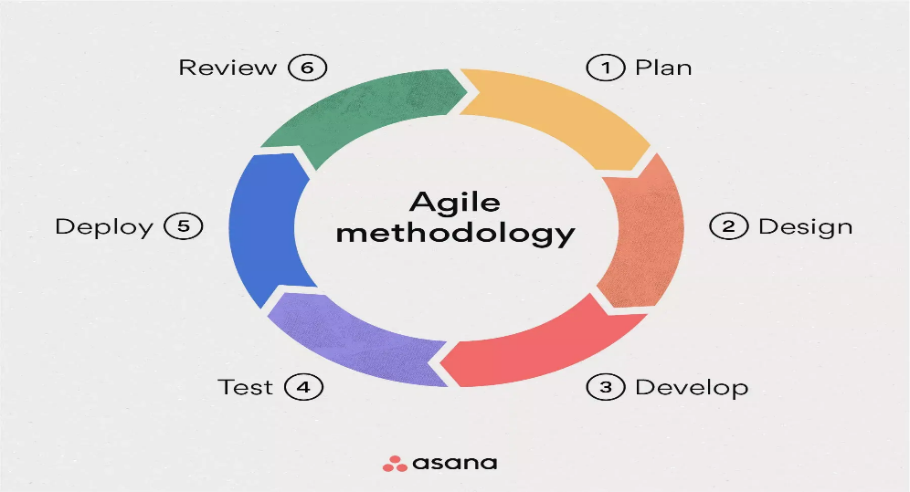
2
(Laoyan, 2025)

Figure 1: Agile Development Lifecycle
This agile design approach consists of six key stages in the cycle which are essential in the run of the project.
- Planning – Engage stakeholders to identify user needs, security concerns, and system requirements. Created a product backlog outlining core features and goals.
- Design – Developed system architecture, user flows, and interface wireframes. Defined roles including Donor, Beneficiary and Admin and integrated data protection principles.
- Development – Built the platform using React.js (frontend), Node.js(backend), Firebase API (database), Authentication method and Paystack API for payments. Each feature set is delivered in short sprints.
- Testing – Conduct unit, integration, security testing. Performed usability testing with selected users to refine system functionality.
- Deployment – Deployed a prototype in a staging environment for controlled use. Monitored system performance and user interaction.
- Review – Collecting feedback from users and stakeholders. Adjusted features and priorities for the next development cycle based on insights gathered.
This approach ensures that the platform remains user-focused, adaptable, and responsive to real-world challenges. Each stage is built upon the last, which results in a secure, efficient and scalable solution for transparent humanitarian aid crowdfunding.

3.2 Data Collection Methods
To ensure the effectiveness and relevance of AidReach, a comprehensive and structured data collection approach was employed. This approach aimed to capture diverse perspectives from key stakeholders, understand real-world operational challenges, and incorporate lessons from existing research and systems. The insights gathered informed the platform’s design, functionality, and user experience, ensuring it is both practical and user-centered.
User Interviews and Surveys
Structured interviews and surveys were conducted with various stakeholder groups, including individual donors, representatives of internally displaced persons (IDPs), orphanage administrators, NGO staff, and technical personnel. These interactions aimed to capture expectations, concerns, and functional needs from each group’s perspective.
- Donors (individuals and organizations) – Shared expectations around transparency, donation tracking, and feedback mechanisms. Some donors also highlighted concerns about fraud, misuse of funds and lack of trust in traditional channels. Their feedback led to prioritization of blockchain integration, donor dashboards and a verified request system
- Beneficiaries – Provided insight into their needs , digital accessibility, and challenges with current aid systems emphasizing on privacy and security.
- Developers and IT Administrators – Gave input on platform scalability, integration capabilities, and potential technical constraints.
The insights provided were gathered through semi-structured interviews using prepared research questions. Questions were tailored to each group and focused on platform usability, trust concerns and desired features. These findings significantly influenced the platform’s feature set, including donor dashboards, beneficiary request forms, and identity verification mechanisms.
Usability Testing
Interactive prototypes of the platform were tested with a sample group of users from the university and the local humanitarian community. Participants were asked to complete typical tasks, such as submitting aid requests or navigating the donation portal. Observations from these sessions revealed areas for improvement in layout, form clarity, and overall navigation. Adjustments were made accordingly to enhance usability and ensure accessibility across devices.
Document and Literature Review
A thorough review of existing literature, case studies, and technical reports was undertaken to understand the strengths and limitations of similar digital aid platforms. The review focused on areas such as transparency, fraud prevention, data privacy, and donor engagement. Lessons from successful implementations such as the World Food Programme’s blockchain initiative were used to inform system design, particularly around secure transaction logging and decentralized verification.
System Usage Metrics
Post-deployment, analytical tools were implemented to track system performance and user behavior. Metrics such as page visits, session durations, drop-off points, and transaction completions were monitored. These data points provided valuable insights into user engagement and helped prioritize subsequent feature updates and improvements.
This multi-faceted data collection process ensured that both the functional and non-functional requirements of the platform were grounded in real-world needs and expectations. By combining qualitative insights and empirical data the development team was able to design a platform that is secure, efficient, user-friendly, and responsive to the challenges of humanitarian aid delivery in North Eastern Nigeria.

3.3 Requirement Analysis
The requirement analysis phase is crucial to ensure the successful design and implementation of AidReach. This phase involves identifying, categorizing and documenting the essential needs of the system based on stakeholder input, technical constraints and real-world use cases. This analysis is divided into Functional requirements which describes the specific actions, features and behaviors that the system must be able to perform and Non-Functional requirements which define the quality attributes of the system. Additionally, this section outlines the Hardware and Software requirements which are the necessities to support the development, deployment and operation of the platform. Together, these requirements provide a comprehensive foundation for building a secure, scalable and user-centered solution.

3.3.1 Functional Requirements
REQUIREMENT ID | REQUIREMENT TEXT
FR001 | Users can register and log into the platform.
FR002 | Users can create, view, and manage their profiles.
FR003 | Recipients can create aid requests or campaigns.
FR004 | Donors can view available campaigns and make donations securely.
FR005 | The system updates campaign progress automatically after every confirmed donation.
FR006 | Admins can approve, reject, or remove campaigns
FR007 | Admins can verify beneficiaries before allowing them to post aid requests.
FR008 | The system sends real-time notifications for approval, donations and updates.
FR009 | User can view donation history and campaign transaction records.
FR010 | The payment system integrates with Paystack for secure online transactions.
FR011 | The system stores all donation, user and campaign data in the database for tracking and reporting.
FR012 | The system logs all major user actions for transparency and traceability i.e. approvals and donations.
Table 1: Functional Requirements

3.3.2 Non-Functional Requirements
REQUIREMENT ID | REQUIREMENT TEXT
NFR001 | The system must be available 24/7 with minimal downtime.
NFR002 | The system must be scalable to support increasing users, campaigning and donations.
NFR003 | Donations and page requests must be processed within 2-3 seconds.
NFR004 | All data must be transmitted securely using HTTPS and encrypted user roles.
NFR005 | The interface must be clean, mobile-responsive and easy to navigate for all user roles.
NFR006 | Data integrity must be ensured so that transactions cannot be altered or lost.
NFR007 | The system must support role-based access control to prevent unauthorized actions.
NFR008 | The system must maintain high reliability with proper logging and error handling
Table 2:Non-Functional Requirements

3.3.3 Hardware Requirements
REQUIREMENT ID | REQUIREMENT TEXT
HR001 | The application server should use a multi-core processor, minimum 8GB RAM and SSD storage.
HR002 | The MySQL database server should have minimum 8GB RAM, SSD storage and high-write performance.
HR003 | User devices can be laptops, mobile phones, tablets, or any device with a modern web browser.
HR004 | For development, a laptop/desktop with minimum 4GB RAM and stable internet connection is required.
Table 3: Hardware Requirements

3.3.4 Software Requirements
REQUIREMENT ID | REQUIREMENT TEXT
SW001 | Frontend: HTML, CSS, JavaScript, BotstrapCSS.
SW002 | Backend: Node.js, Express.js, Prisma ORM, Firebase API(Database).
SW003 | Payment Gateway: Paystack API for donation processing
SW004 | Tools: VSCode, GitHub, Postman for API testing
SW005 | Server Tools: dotenv for environment variables, nodemon for local development
SW006 | Security Tools: JWT for authentication, bcrypt for password hashing
Table 4: Software Requirements

3.4 Rationale
The chosen methodology and data-collection strategies were selected to maximize the relevance and effectiveness of AidReach. Agile development approach is well suited to projects with evolving requirements and diverse stakeholders. By breaking development into iterative cycles, the team can incorporate feedback quickly and address emerging needs critical in humanitarian contexts where conditions and user expectations can change rapidly. Agile also promotes collaboration between developers and stakeholders, ensuring that features prioritize transparency, security and ease of use.
Multiple data-collection methods complement the Agile framework. Interviews and surveys capture the perspectives of donors, beneficiaries and technical experts, ensuring that functional requirements reflect real-world needs. Usability testing reveals practical issues with the interface and workflow, guiding adjustments before full deployment. Literature reviews provide insight into best practices and pitfalls observed in similar projects, enabling informed decisions on features such as blockchain integration or payment gateways. Monitoring system metrics after deployment grounds future iterations in quantitative evidence of user behavior. Together, these methods create a strong rationale for the design choices made, aligning the platform with stakeholder priorities and industry standards.

3.5 Perceived and Envisioned Challenges
Despite the potential impact of the proposed digital platform, several challenges, both current and anticipated may arise during development, deployment, and operation. Identifying these challenges early allows for strategic planning and mitigation.
1. Digital Accessibility and Literacy: Many intended beneficiaries, particularly in rural and displaced communities, may have limited access to smartphones, the internet, or the digital literacy required to navigate a web-based platform. This could hinder adoption and equitable participation.
2. Network and Power Limitations: Regions in Northeastern Nigeria often experience inconsistent internet connectivity and frequent power outages. These infrastructural limitations may affect users’ ability to access or interact with the platform in real time.
3. Data Privacy and Security Concerns: Collecting and managing sensitive information such as beneficiary identities, locations, and aid details pose significant privacy risks. Ensuring data protection, consent management, and compliance with local and international regulations (e.g., NDPR) is critical but challenging.
4. Fraud and Misuse of the System: There is a risk of individuals submitting false aid requests, duplicate entries, or attempts to exploit the platform for personal gain. Implementing reliable verification and fraud detection mechanisms is essential.
5. Trust and Credibility Issues: Building trust among donors, beneficiaries, and partner organizations may take time. Without transparency and accountability measures, users may be hesitant to engage with or invest in the platform.
6. Resource Constraints: Limited funding, technical personnel, or development time may impact the quality and completeness of the initial deployment. Balancing scope with available resources will be a key challenge.
7. Cultural and Language Barriers: Beneficiaries may speak different local dialects and come from diverse cultural backgrounds. Without multilingual and culturally sensitive design, some users may feel excluded or find the platform difficult to use.

CHAPTER FOUR: DESIGN AND IMPLEMENTATION

4.0 Introduction
This chapter presents the design and implementation phases of AidReach. It outlines the system architecture, database schema and the key modules that support crowdfunding, aid requests and transaction processing. This chapter also discusses how data relationships and role-based access controls are structured to ensure traceability, transparency and security.
The system is developed as a web-based application which uses Javascript, HTML and Boostrap CSS as its frontend to create a clean, responsive and user-friendly interface. On the backend, Node.js with Express.js handles server-side operations, while Firebase API is used for database management. Paystack API is also integrated to ensure seamless donation transactions.

4.1 Entity-Relationship Diagram (ERD)
The Entity-Relationship Diagram (ERD) offers a conceptual view of the system’s database structure. It identifies the major entities within the platform and illustrates how they interact. This model ensures data consistency and enforces logical relationships across user roles and operations such as donations, requests, verifications, and messaging. The ER diagram forms the foundation for designing relational tables and implementing secure data access mechanisms.
Key Features of the Humanitarian Aid Crowdfunding ERD
The platform is built around eight key entities, each serving a specific function in managing aid flow and stakeholder interactions:
Entities and Attributes
- User – Represents all users on the platform (Donors, Beneficiaries, Admins).
Attributes: user_id, name, email, password etc.
- Donor – A specialized user role linked to aid contributions.
Attributes: donor_id, campaign_id
- Beneficiary – Represents individuals or organizations receiving aid.
Attributes: beneficiary_id, location, verified_status
- Admin – A user type with privileges to manage verifications and oversee platform activity.
Attributes: admin_id
- AidRequest – Represents requests submitted by beneficiaries.
Attributes: request_id, item_description, quantity, urgency_level, date_requested, status
- Verification – Captures verification actions taken by Admins.
Attributes: verification_id, beneficiary_id, admin_id, date_verified, status
- Donation – Records aid or monetary contributions from Donors.
Attributes: donation_id, donor_id, request_id, amount, date_donated
- Transaction – Documents financial transactions tied to Donations.
Attributes: transaction_id, donation_id, amount, payment_method, receipt_number, status
- Updates – Facilitates communication from beneficiaries.
Attributes: message_id, sender_id, donation_id, content, timestamp
Relationships
- User ↔ Donor/Beneficiary/Admin – Each role is derived from the general User entity.
- Beneficiary ↔ AidRequest – One-to-many (a beneficiary can submit multiple requests).
- Admin ↔ Verification ↔ Beneficiary – Many-to-many mediated by verification actions.
- Donor ↔ Donation ↔ AidRequest – Donations fulfill aid requests made by beneficiaries.
- Donation ↔ Transaction – One-to-one, each donation may trigger a financial transaction.
- Beneficiary ↔ Updates – Beneficiaries can send updates regarding the AidRequest.
This database design supports the platform’s goals of efficient aid crowdfunding, fraud prevention, and clear communication between stakeholders.
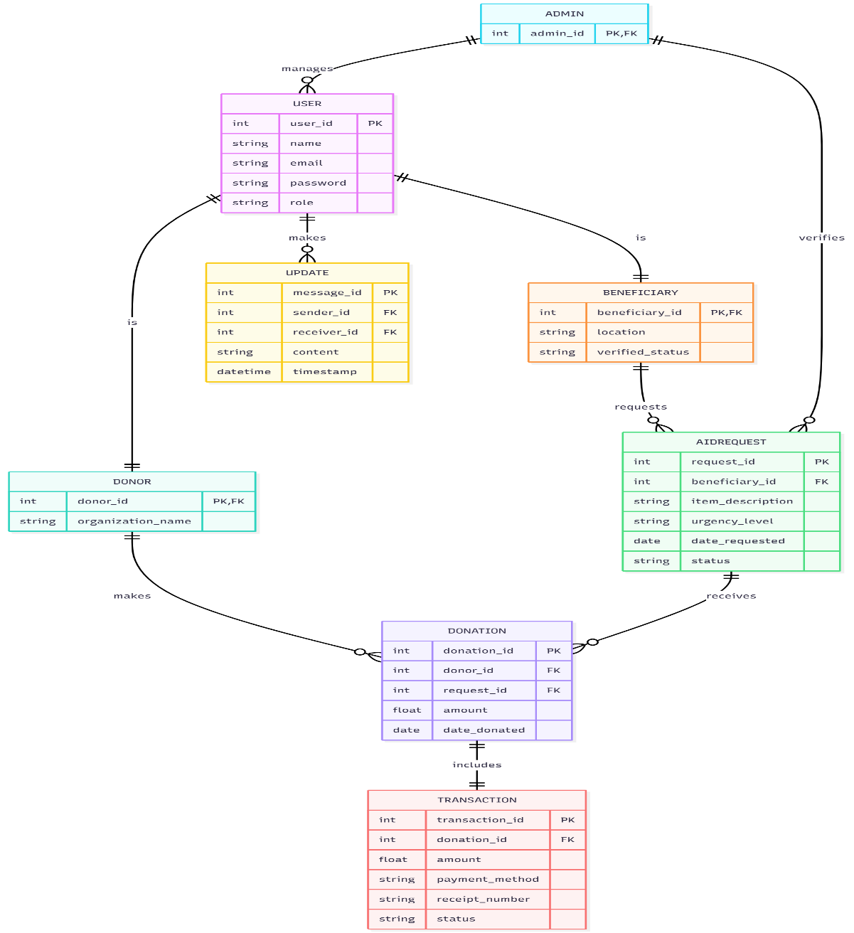
Figure 2: AudReach Entity Relationship (ER) Diagram

4.2 System Designs
4.2.1 System Architecture
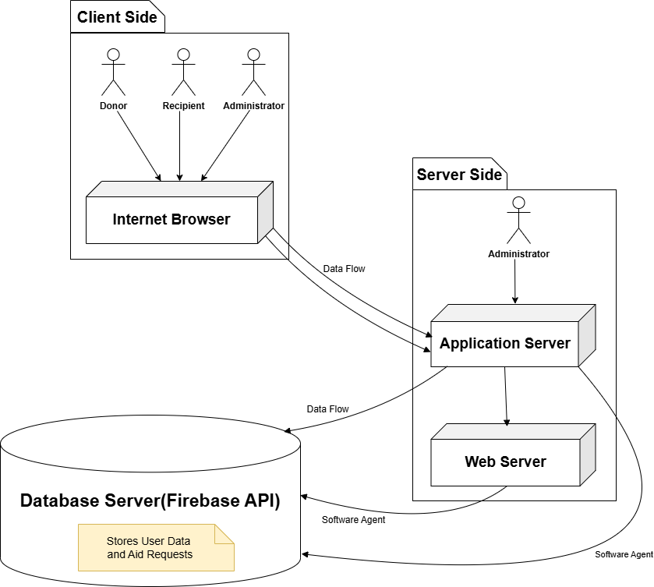
Figure 4: AidReach System Architecture
In the diagram shown above the system is divided into three core layers: the Presentation Tier, the Business Logic Tier, and the Data Tier. The Presentation Tier represents the client side, where users including donors, recipients, and administrators interact with the system through a web browser. The Business Logic Tier, situated on the server side, consists of the Application Server and Web Server, which coordinate the processing of user requests, such as verifying aid requests, managing donations, and updating system records. The Data Tier houses a central Firebase API database, where all user data and aid-related information are securely stored and retrieved. This tiered architecture ensures a well-structured, responsive, and secure environment for delivering and managing humanitarian support.

4.2.2 Use-Case Diagram
The use case diagram illustrates the core interactions between users and the humanitarian aid crowdfunding platform. It identifies the actors such as donors, beneficiaries, and administrators and outlines the key functionalities each actor can perform.
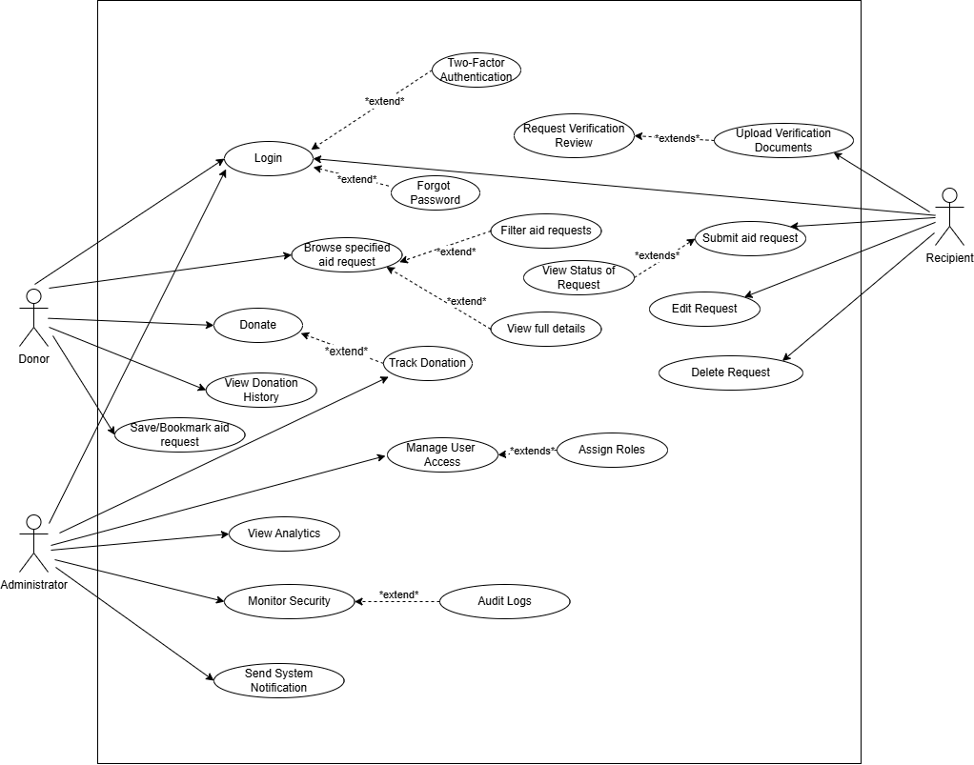
Figure 5: AidReach Use Case Diagram

4.3 Data Flow Diagram
The Data Flow Diagram (DFD) offers a high-level visualization of how data moves throughout the system. It illustrates how entities such as donors, beneficiaries, and administrators interact with the system, and how data flows between core modules like donations, transactions, aid requests, and verifications. This helps in understanding the functional behaviour of the system and identifying input, processing, and output points essential for implementation.
Key Components Identified in the Diagram
- Entities: A general role that may represent a donor, admin, or beneficiary.
- Processes and Actions: Makes donation, uploads aid request, verifies beneficiary and manages system
- Data Stores/Entities: Stores donation details including amount, date, and associated request, records financial transactions linked to donations and captures requests submitted by verified beneficiaries.
- Relationships: Donations support aid requests, Transactions are linked to donations, Admins manage users and verify beneficiaries, Users can be donors or beneficiaries.
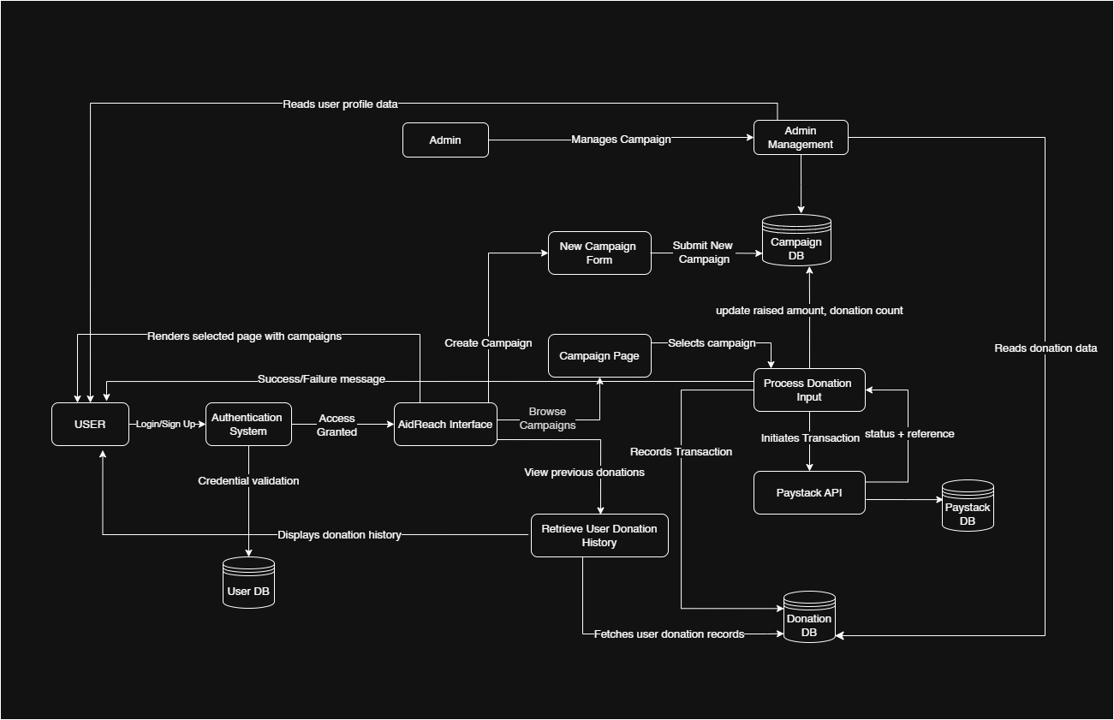
Figure 6: AidReach Data Flow Diagram (DFD)

4.4 Sequence Diagrams
A Sequence Diagram presents a detailed visualization of how actors and system components interact over time. It specifies the order of operations within the system and defines how messages are exchanged between system components during task execution.
Key Features
Objects and Actors: These represent the participants in the system, such as Visitors, Security Personnel, and the database.
Lifelines: A dotted vertical line extending from each object/actor signifies the duration for which they are active within the sequence
- Interactions: Horizontal arrows represent messages exchanged between system elements. For example, a visitor check-in process sends a request to the security system for validation.
- Activation Bars: Rectangular bars on lifelines indicate time periods when a component is actively processing an operation, such as validating a visitor’s identity.
- Alternative Paths: Represented using alt fragments, they indicate different outcomes based on conditions, such as approved vs. denied entry for a visitor.
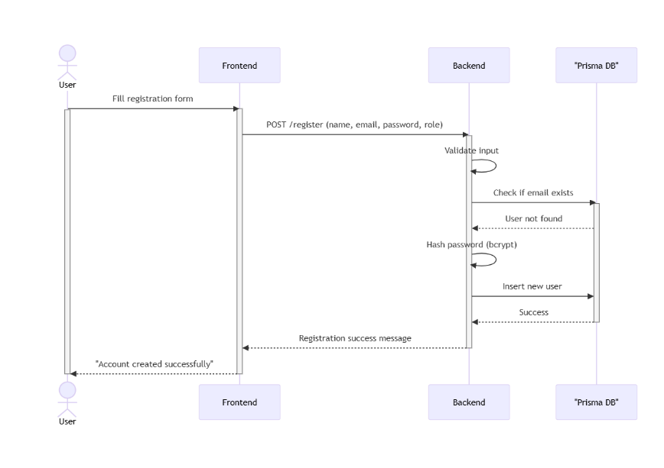
Figure 7: User Registration Flow Sequence Diagram
The registration sequence depicts how new users securely join the platform. A user begins by submitting their personal details, including name, email, password, and role. The frontend relays this information to the backend, where input validation checks for accuracy and completeness. The backend then queries the database to confirm that no duplicate email exists. If the email is unique, the password is encrypted using bcrypt hashing for security, and the new user record is stored in the database. The backend then sends a confirmation response to the frontend, informing the user that their account has been successfully created. This process ensures that only valid, unique, and securely stored user credentials are admitted into the system, establishing trust from the very first interaction.
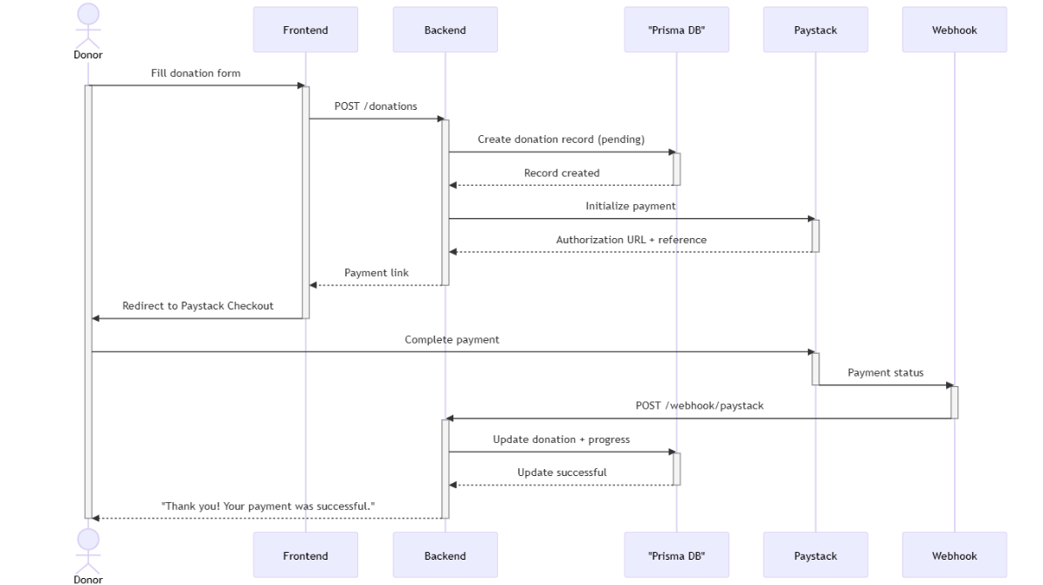
Figure 8: Donation Flow Sequence Diagram
The donation sequence illustrates the streamlined process of contributing to a campaign through the platform. A donor initiates the process by filling out a donation form, which is submitted to the backend for processing. The backend records the donation request in the database and forwards payment details to the external payment gateway (Paystack). The donor completes payment through the gateway’s secure interface, after which Paystack triggers a webhook notification to the backend. The backend validates this webhook, ensuring that the transaction is legitimate, and updates both the donation record and the campaign’s funding progress in the database. Finally, the donor receives confirmation of a successful contribution. This flow highlights transparency, security, and automation in the donation process, ensuring that funds are properly tracked and campaigns are updated in real time.

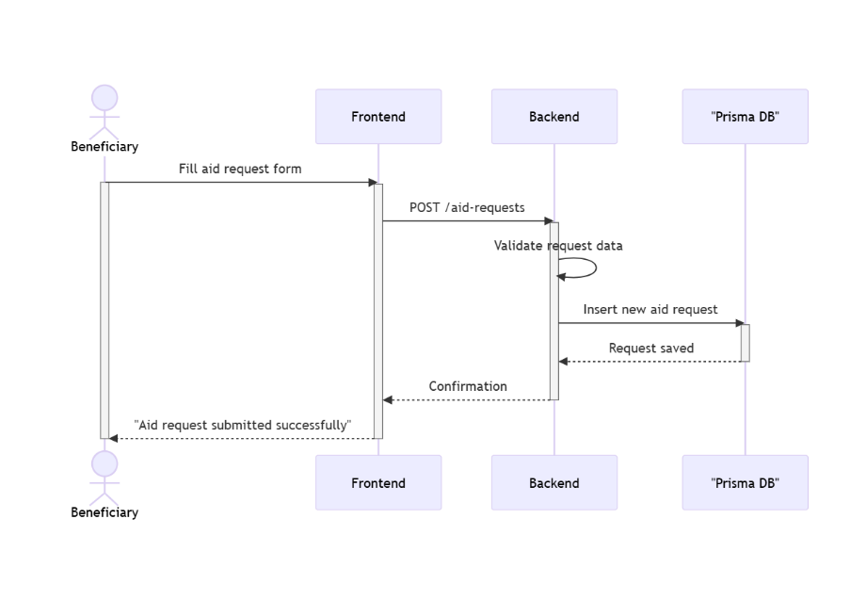
Figure 9: Beneficiary Creating Aid Request Sequence Diagram
The aid request sequence demonstrates how beneficiaries submit needs through the platform. A beneficiary completes an aid request form with details such as description, urgency level, and requested resources. The frontend sends this information to the backend, where input validation ensures data integrity. Once validated, the backend records the request in the database and returns a confirmation to the beneficiary. This flow not only captures urgent needs efficiently but also ensures accountability by storing requests in a centralized database where they can later be reviewed by administrators and matched with donor contributions.
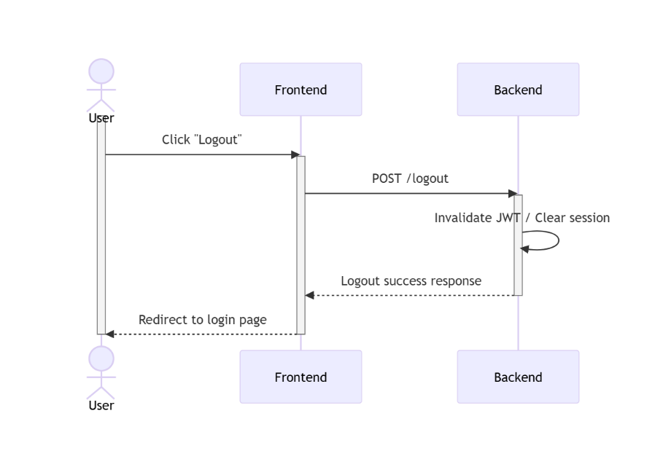
Figure 10:Logout Flow Sequence Diagram
The logout sequence ensures that user sessions are securely terminated. When a user selects the logout option, the frontend sends a request to the backend. The backend invalidates the user’s session. A confirmation response is then sent to the frontend, which redirects the user back to the login page. This process ensures that once a user has logged out, thereby protecting the system against unauthorized access and reinforcing account security.

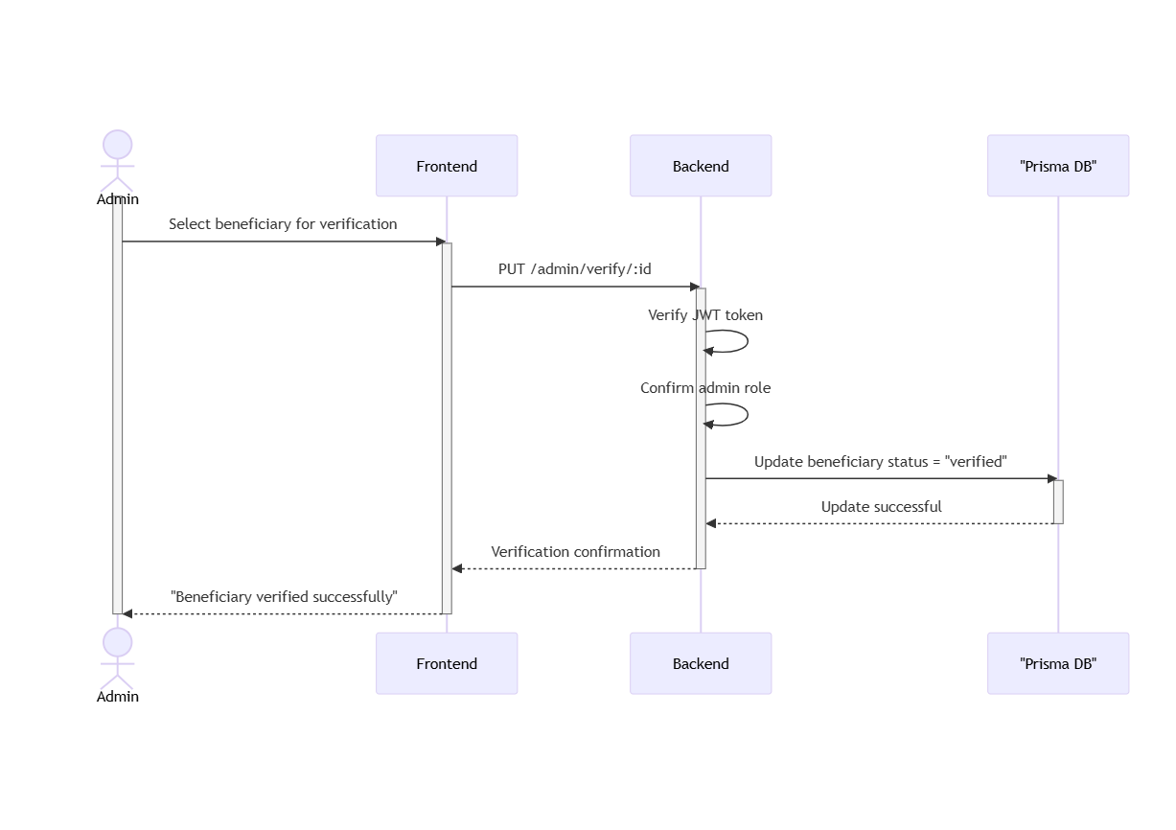
Figure 11:Beneficiary verification Sequence Diagram
The beneficiary verification sequence highlights the administrative control that safeguards platform integrity. When an administrator chooses a beneficiary to verify, the frontend sends a secure request to the backend. The backend first confirms the admin’s identity and ensures that only authorized personnel can perform this action. Once validated, the backend updates the beneficiary’s record in the database to reflect a “verified” status. A confirmation is then sent back to the administrator, closing the loop. This process strengthens trust by ensuring that only authentic beneficiaries can request aid, thereby protecting donor contributions from fraud or misuse.

4.5 Class Diagram
A Class Diagram in the Unified Modeling Language (UML) is a type of static structure diagram that describes the structure of a system by showing the system's classes, their attributes, operations (or methods), and the relationships among objects. AidReach includes classes for users, donors, beneficiaries, administrators, aid requests, verifications, donations, transactions and updates. Each class encapsulates data and behaviours relevant to its role, and relationships such as inheritance (donors, beneficiaries and administrators inherit from the user class) illustrate how roles are derived.

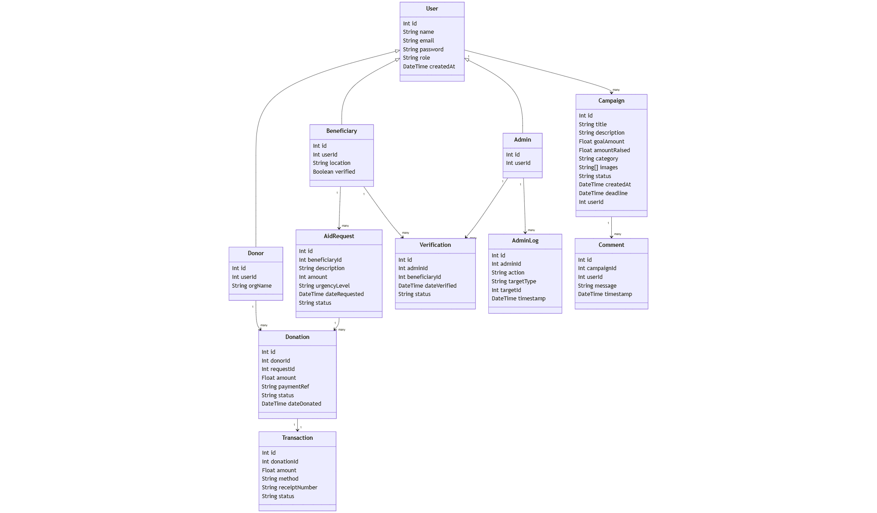
Figure 12:Humanitarian Aid Distribution Class Diagram

4.6 Results and User Interface
The images below show the user interface of the humanitarian aid crowdfunding platform
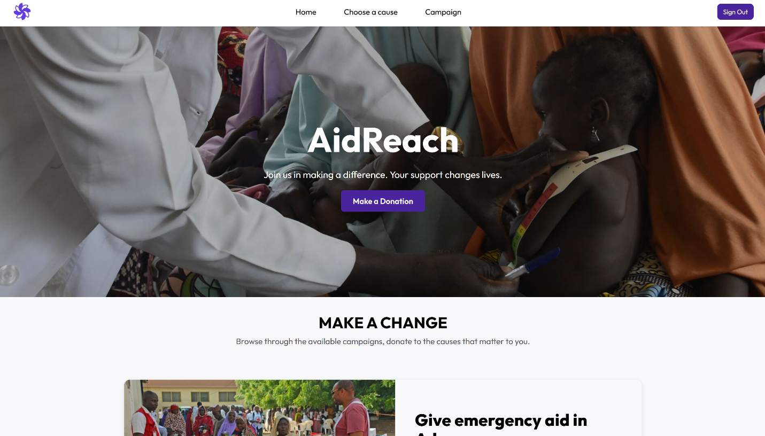
Figure 13: AidReach Home Page
Figure 12: The Homepage displays the main hero section of the AidReach homepage, featuring a humanitarian banner image, the platform title, and a donation call-to-action. It introduces the platform’s purpose and directs users toward making a contribution.

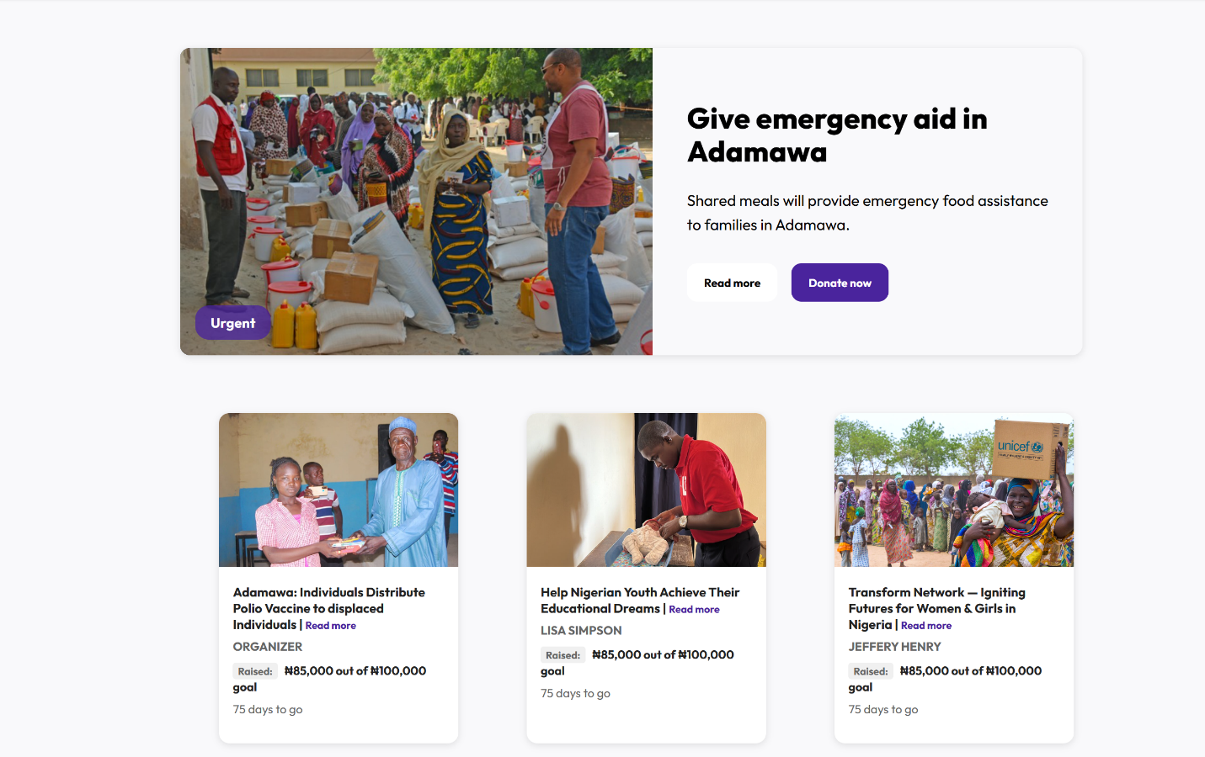
Figure 14: AidReach Home page and featured donations
Figure 13 shows the campaign listing section of the homepage, where active campaigns are presented with images, titles, organizers, progress details, and quick access to donation options.

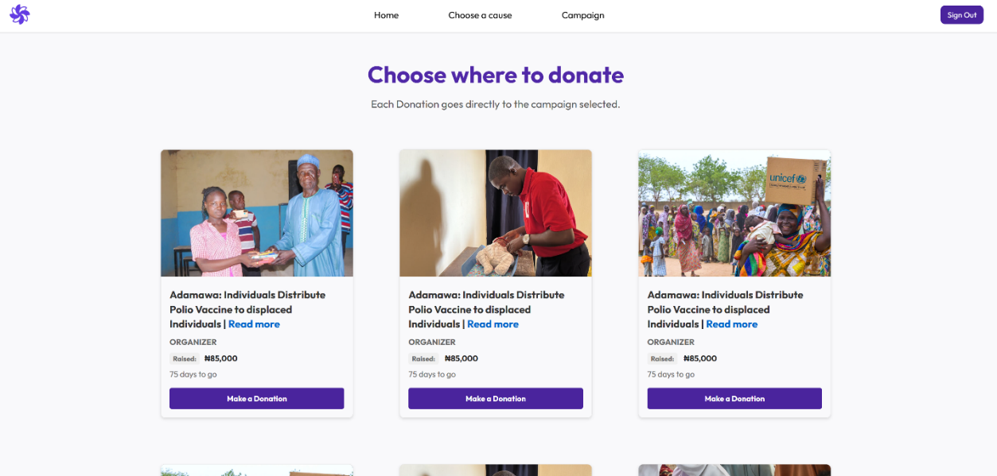
Figure 15: Donation Page
Figure 14 displays the donation page, where users can browse available campaigns and select a cause to support. Each campaign card shows the title, image, amount raised, remaining days, and a donation button, allowing donors to contribute directly to specific humanitarian needs.

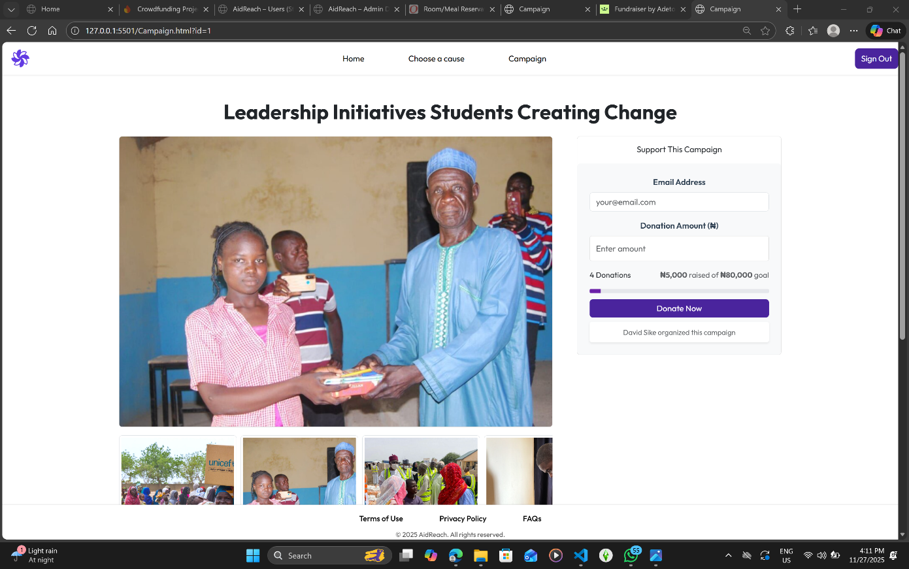
Figure 16: Donation Page and Details
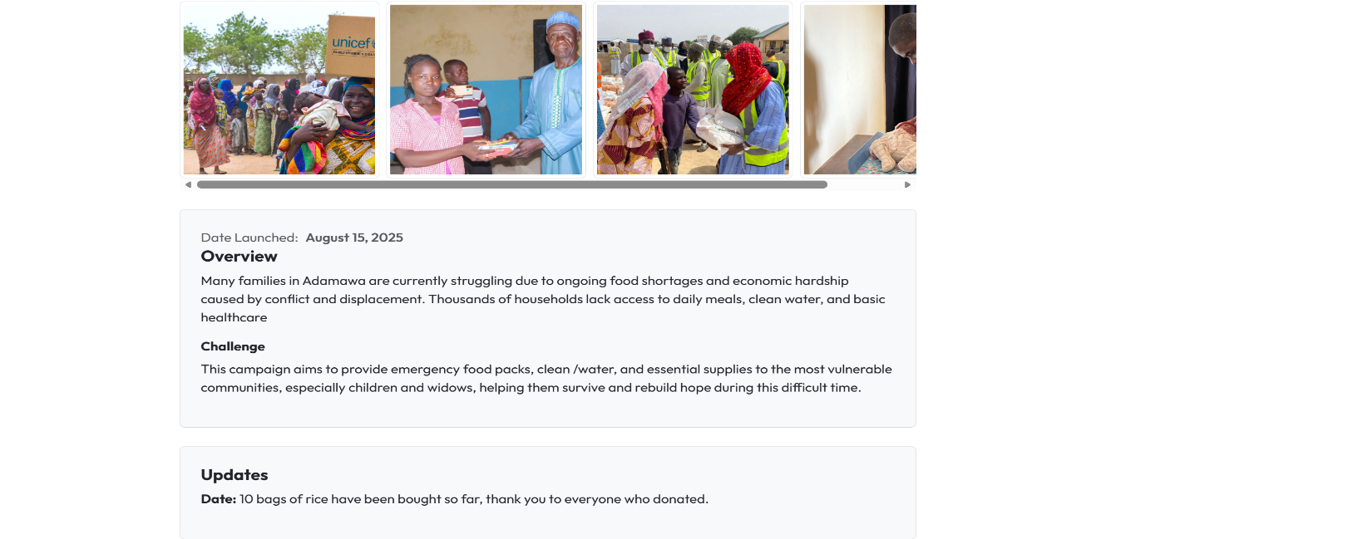
Figure 17: Donation Page and Details
Figures 15-16 displays the campaign details page, where users can view campaign images, read the overview and challenges, and track updates provided by the organizer. The page also includes a donation panel that displays the amount raised, the funding goal, total donations, and a form for contributing directly to the campaign.

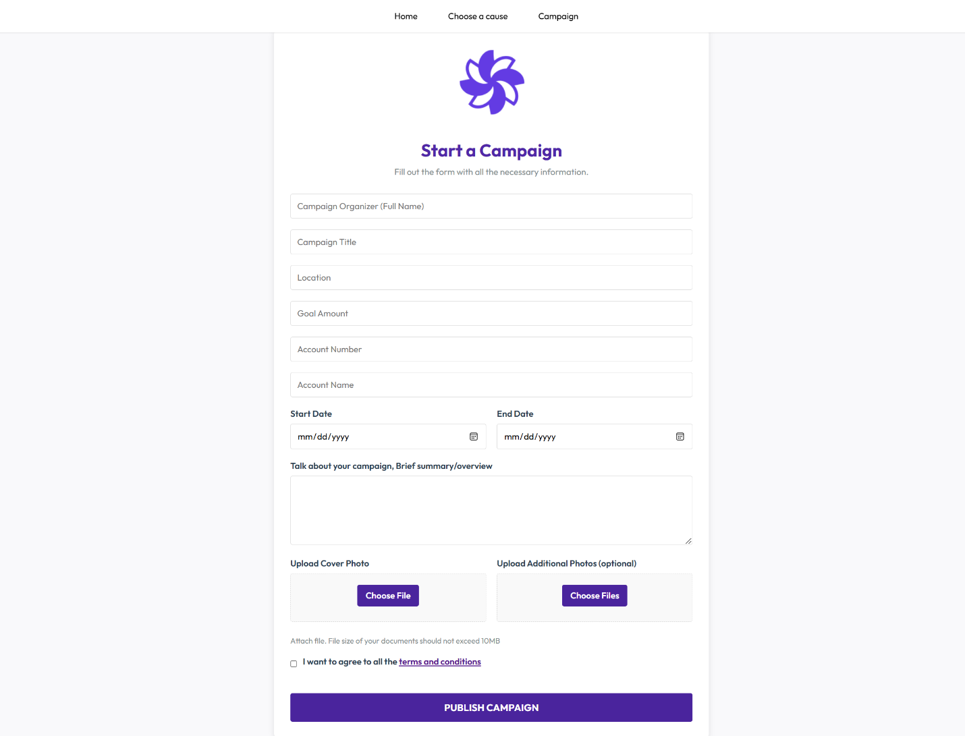
Figure 18: Create a campaign form
Figure 17 shows the campaign creation form, where organizers input key details such as campaign title, location, goal amount, description, dates, and supporting images. This interface enables beneficiaries to publish structured and verifiable campaign requests on the platform.

CHAPTER FIVE: CONCLUSION

5.0 SUMMARY
This project aims to design and implement a secure, user-friendly crowdfunding aid platform for connecting donors with beneficiaries in need. The primary objective is to build a functional system that supports campaign creation, donation processing, beneficiary verification and transparent fund tracking. Using a combination of modern web technologies, the frontend is implemented using HTML CSS and JavaScript, while the backend is powered by Node.js, Express.js, Prisma ORM and Firebase API. The platform provides an accessible medium for users to request and contribute aid.
The system architecture is developed through an iterative, user-centered approach (Agile), ensuring donors, recipients, and administrators can each perform their required tasks effectively. The application will integrate Paystack as a reliable payment gateway to ensure secure transactions, while authentication, validation and access-control mechanisms are to be implemented to safeguard the platform from unauthorized use. Overall, AidReach aims to enhance transparency, accountability and efficiency in humanitarian aid support.

5.1 Future Advancements
Looking ahead, AidReach offers several promising opportunities for expansion and improvement. One major advancement involves developing a mobile application for Android and iOS, making the system accessible to users in regions where mobile devices are more common than computers. Artificial intelligence can also be integrated to enhance fraud detection by identifying suspicious donation patterns or duplicate beneficiary information. Additionally, incorporating blockchain or other immutable technologies could significantly strengthen the transparency of fund-tracking processes. AidReach may also benefit from expanding support for offline interactions, especially in communities with poor internet connectivity, through SMS-based systems or local caching. Furthermore, integrating the system with government agencies, NGOs, or international aid organizations could increase its credibility and broaden its impact. Enhanced reporting dashboards and analytics tools would also give administrators and donors deeper insights into campaign performance and aid distribution. These potential advancements position the platform for long-term scalability and relevance within humanitarian and social-impact ecosystems.

5.2 Challenges Encountered
Throughout the development process, several challenges were encountered that shaped the evolution of AidReach. One of the primary difficulties involved configuring the Prisma ORM and ensuring stable communication with the Firebase API database, which required multiple iterations of schema adjustments and troubleshooting. Integrating Paystack for secure transaction processing presented its own challenges, including correctly validating payment events and handling webhook verifications. Ensuring robust security through authentication, authorization, and input validation also required careful planning to protect both user data and system integrity. Development progress was further slowed by issues such as unreliable internet access and limited electricity, which impacted testing and deployment cycles. Another challenge involved designing access controls that correctly differentiated between donors, recipients, and administrators, ensuring each user role functioned within its defined permissions. Despite these obstacles, each challenge ultimately contributed to strengthening the system’s architecture, security, and usability.

5.3 Conclusion
The development of AidReach represents an important step toward improving transparency and accessibility in humanitarian support processes. By connecting donors directly with verified beneficiaries, the platform reduces inefficiencies commonly associated with traditional aid distribution channels. Its secure payment integration, tracking capabilities, and structured workflow allow for greater accountability and trust.
Although the system has limitations, its architecture ensures that future enhancements such as mobile versions, improved analytics, and smarter verification can be implemented without major structural changes. Ultimately, the platform provides a foundation for a more transparent, inclusive, and technologically supported approach to aid management. With continued development and adoption, it has the potential to significantly impact how communities mobilize resources and respond to urgent humanitarian needs.

REFERENCES
Ashara, D. U. (2025). Management of humanitarian crises in Borno, Nigeria: the role of humanitarian intelligence. Journal of Policing, Intelligence and Counter Terrorism, 1-16.
https://doi.org/10.1080/18335330.2025.2481638
Ba, C. T., Galdeman, A., Zignani, M., & Gaito, S. (2022). Temporal analysis of cooperative behaviour in a blockchain for humanitarian aid during the COVID-19 pandemic. Proceedings of the 2022 ACM Conference on Information Technology for Social Good (pp. 292–299). https://doi.org/10.1145/3524458.3547245
Connor, E. (2022). Using technology to better support conflict-affected families in Nigeria. Cisco Blogs. https://blogs.cisco.com/csr/using-technology-to-better-support-conflict-affected-families-in-nigeria
GeeksforGeeks. (2025). Crowdfunding: Meaning, working, types, advantages and
disadvantages. GeeksforGeeks. https://www.geeksforgeeks.org/finance/crowdfunding-
meaning-working-types-advantages-and-disadvantages.
Imasuen, E. (2015). Insurgency and Humanitarian Crises in Northern Nigeria: The Case of Boko Haram. African Journal of Political Science and International Relations, 9, 284-296. https://doi.org/10.5897/AJPSIR2015.0789
International Federation of Red Cross and Red Crescent Societies (2024). Digital Innovation for Migrants and Displaced Communities: Emerging Humanitarian Approaches. In International Federation of Red Cross and Red Crescent Societies. From https://www.ifrc.org/document/digital-innovation-migrants-and-displaced-communities-emerging-humanitarian-approaches
Ismaila, B. (2023). The state of crowdfunding in Africa and its potential impact: a literature
review. International Journal of Research in Business and Social Science (2147- 4478).
Kulhari, S. (2018). The Midas touch of Blockchain: Leveraging it for data protection.
JSTOR Nomos Verlagsgesellschaft.mbH. http://www.jstor.org/stable/j.ctv941qz6.6
Ólafsson, G. R. (2024). The role of technology in humanitarian assistance: Opportunities and
Challenges. https://skemman.is/handle/1946/48549.
Okoli, A. C., & Ogayi, C. O. (2018). Herdsmen militancy and humanitarian crisis in Nigeria: A theoretical briefing. African Security Review, 27(2), 129–143. https://doi.org/10.1080/10246029.2018.1499545
Oni, O. (2020). Challenges and opportunities of adopting ICT’s in the humanitarian sector in Nigeria. Institution of Engineering and Technology EBooks, 311–331. https://doi.org/10.1049/pbte089e_ch14
Pendyala, V. S., & Figueira, S. (2015). Towards a truthful world wide web from a humanitarian
perspective. 2015 IEEE Global Humanitarian Technology Conference (GHTC) (pp. 137–
143). https://doi.org/10.1109/GHTC.2015.7343966
Saadi, R. A., & Evans, D. (2016). The mesh network for refugees and displaced persons. 2016
IEEE Global Humanitarian Technology Conference (GHTC) (pp. 47–53).
https://doi.org/10.1109/GHTC.2016.7857259
Sandvik, K. B., Gabrielsen Jumbert, M., Karlsrud, J., & Kaufmann, M. (2014). Humanitarian technology: a critical research agenda. International Review of the Red Cross, 96(893), (pp. 219–242). https://doi:10.1017/S1816383114000344.
Searle, M. S. (2018). Is use of cyber-based technology in humanitarian operations leading to the
reduction of humanitarian independence? S. Rajaratnam School of International Studies.
http://www.jstor.org/stable/resrep19928
Sirisawat, S., Chatjuthamard, P., Kiattisin, S., & Treepongkaruna, S. (2022). The future of digital donation crowdfunding. PLOS ONE, 17(11), e0275898. https://doi.org/10.1371/journal.pone.0275898.
Terry, F. (1998). The paradoxes of humanitarian aid. Agenda: A Journal of Policy Analysis and
Reform, 5(2), 135–146. http://www.jstor.org/stable/43199462
VanRooyen, M. (2013). Effective aid: Ensuring accountability in humanitarian assistance.
Harvard International Review, 35(2), 12–16. http://www.jstor.org/stable/42763567
Veron P. (2022). Digitalisation in humanitarian aid: opportunities and challenges in forgotten
crises. European Centre for Development Policy Management
Wang, B., Lueks, W., Sukaitis, J., Narbel, V. G., & Troncoso, C. (2023). Not yet another digital
ID: Privacy-preserving humanitarian aid distribution. 2023 IEEE Symposium on Security
and Privacy (SP) (pp. 645–663). https://doi.org/10.1109/SP46215.2023.10179306
Wang, D., Yih, Y., Service, J., Lajous, L., & Robbins-Penniman, S. (2016). Web-based, multi-
platform, centralized, offline-compatible supply chain management system for
emergency responses. 2016 IEEE Global Humanitarian Technology Conference (GHTC)
(pp. 248–253). https://doi.org/10.1109/GHTC.2016.7857288
Watts, M. J. (2023). Nigeria and the humanitarian international: From Biafra to Boko Haram. In K. Mitchell & P. Pallister-Wilkins (Eds.), The Routledge international handbook of critical philanthropy and humanitarianism (pp. 145–169). Routledge. https://doi.org/10.4324/9781003162711-13
Laoyan, S. (2025). What is Agile methodology? (A beginner’s guide). Asana. https://asana.com/resources/agile-methodology

