Report

Tianyu Zhang

CPS: Project Management, Northeastern University

ALY 6000: Introduction to Analytics

Professor: Richard He

January 13, 2023,

Key findings based on instruction

a. A scatter plot of the age ~ salary data

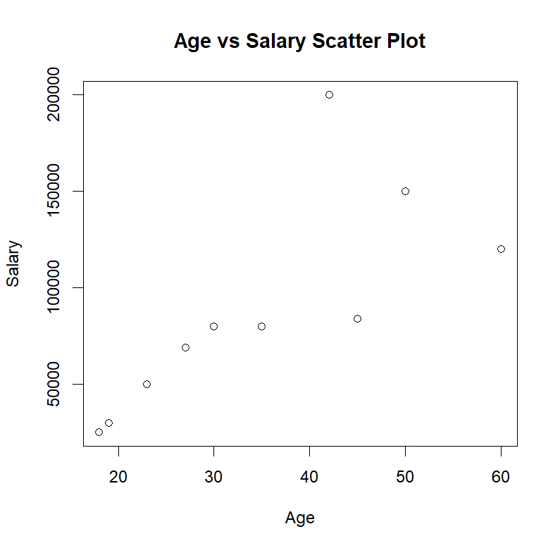

b. The mean and median salary

mean(salary) 88800

median(salary) 80000

c. Display the data after steps 6 and 7

# 6. Delete the 6th element from the salary vector

[1] 69000 80000 50000 84000 80000 30000 25000 150000 120000

# 7. Insert 150000 as the 6th element into the salary vector

[1] 69000 80000 50000 84000 80000 150000 30000 25000 150000

[10] 120000 NA

d. Display the movies vector

movies

[1] "Lord of Ring" "Harry Pottery" "Top Gun"

e. Display the 7 row by 5 column matrix of 35 integers from 1 to 35

matrix

[,1] [,2] [,3] [,4] [,5]

[1,] 1 8 15 22 29

[2,] 2 9 16 23 30

[3,] 3 10 17 24 31

[4,] 4 11 18 25 32

[5,] 5 12 19 26 33

[6,] 6 13 20 27 34

[7,] 7 14 21 28 35

f. Display the employee data frame

employee

age salary

1 27 69000

2 30 80000

3 23 50000

4 45 84000

5 35 80000

6 42 150000

7 19 30000

8 18 25000

9 50 150000

10 60 120000

g. Display the structure and summary of the employee data frame

str(employee)

$ age : num 27 30 23 45 35 42 19 18 50 60

$ salary: num 69000 80000 50000 84000 80000 150000 30000 25000 150000 120000

summary(employee)

age salary

Min. :18.00 Min. : 25000

1st Qu.:24.00 1st Qu.: 54750

Median :32.50 Median : 80000

Mean :34.90 Mean : 83800

3rd Qu.:44.25 3rd Qu.:111000

Max. :60.00 Max. :150000

h. Display the variable names only from the bank.csv data set.

[1] "age" "job" "marital" "education" "default"

[6] "balance" "housing" "loan" "contact" "day"

[11] "month" "duration" "campaign" "pdays" "previous"

[16] "poutcome" "y"

i. A summary of the information you learned about the data sets based on the instructions you followed.

From this module’s learning, I acquired a lot of knowledge about how to install packages and load the library, learn how to use some functions to set plots, insert or delete some data in the vector, and create frames for the dataset. In addition, I search a lot of material on the Internet about how to import the data into the RStudio and how to display only the variables. It is interesting for me to explore the method to solve these problems.

Bibliography

Brydon, M. (2020, April 3). *Basic analytics in R*. Lesson 2 Importing Data. Retrieved January 15, 2023, from https://www.sfu.ca/~mjbrydon/tutorials/BAinR/data.html

Person. (2020, May 25). *Read_csv - could not find function*. RStudio Community. Retrieved January 15, 2023, from https://community.rstudio.com/t/read-csv-could-not-find-function/67381

*R programming: Create a Dataframes which contain details of 5 employees and display the details*. w3resource. (n.d.). Retrieved January 15, 2023, from https://www.w3resource.com/r-programming-exercises/basic/r-programming-basic-exercise-25.php

YouTube. (2019, June 6). *R programming tutorial - LEARN THE BASICS of statistical computing*. YouTube. Retrieved January 15, 2023, from https://www.youtube.com/watch?v=_V8eKsto3Ug

Zach. (2021, October 21). *How to fix in R: Arguments imply differing number of rows*. Statology. Retrieved January 15, 2023, from https://www.statology.org/r-arguments-imply-differing-number-of-rows/

Appendix

# 1. Print your name at the top of the script

print("Tianyu Zhang")

# 2. Install the vcd package

install.packages("vcd")

# 3. Import the vcd library

library(grid)

library(vcd)

library(readr)

# 4. Plot an age ~ salary scatter plot using the data below

age <- c(27,30,23,45,35,42,19,18,50,60)

salary <- c(69000,80000,50000,84000,80000,200000,30000,25000,150000,120000)

plot(age, salary, xlab = "Age", ylab = "Salary", main = "Age vs Salary Scatter Plot")

# 5. Find the mean and median salary

mean_salary <- mean(salary)

mean(salary)

median_salary <- median(salary)

median(salary)

# 6. Delete the 6th element from the salary vector

salary <- salary[-6]

salary

# 7. Insert 150000 as the 6th element into the salary vector

salary <- c(salary[1:5], 150000, salary[6:10])

salary

# 8. Create a vector <movies> with elements Lord of Ring, Harry Pottery, Top Gun

movies <- c("Lord of Ring", "Harry Pottery", "Top Gun")

movies

# 9. Create a 7 row and 5 column matrix of 35 integers from 1 to 35

matrix <- matrix(1:35, nrow = 7, ncol = 5)

matrix

# 10. Create a data frame <employee> with age and salary attributes

employee <- data.frame(age = c(27,30,23,45,35,42,19,18,50,60) ,

salary = c(69000,80000,50000,84000,80000,150000,30000,25000,150000,120000) )

employee

# 11. Display the data frame structure and summary of the employee data frame

str(employee)

summary(employee)

# 12. Import the dataset bank.csv

bank <- read_csv("bank.csv")

# 13. Display only the variable names of the bank.csv dataset

colnames(bank)