**Navigating Financial Landscapes: Insights from Data Visualizations**

**Group 5**

**Tianyu Zhang**

**Rahat Rafique Khan**

**Sai Sharat Paila**

**Thoma Glads Choppala**

**Zhouyang Sheng**

**2024/1/29**

**Introduction**

In the current landscape where data is the linchpin of strategic decision-making, a profound comprehension of financial patterns and irregularities becomes indispensable for organizational success (Acharya, 2023). This report presents a meticulous analysis of financial data spanning fiscal years 2020 to 2022. Through the lens of detailed data visualizations, we dissect and interpret the intricate financial interactions among diverse departments and vendors. Key elements under scrutiny include voucher numbers, line numbers, distribution lines, entry dates, and numerical representations of months, alongside fiscal months and years. Additionally, we delve into vendor names, account numbers and descriptions, department codes and names, 6-digit organization names, and the monetary values of transactions. This comprehensive exploration not only sheds light on complex financial dynamics but also equips stakeholders with critical insights, paving the way for enhanced strategic planning and operational efficiency in an ever-evolving economic environment.

**Main Part:**

**Vendor Financial Dynamics:**

Our journey begins with a deep dive into vendor financial activities. Line charts reveal the ebb and flow of transactions over two fiscal years, highlighting significant fluctuations. For instance, "Harvard Pilgrim Health Care, Inc." demonstrated a notable peak in 2020, followed by a decline. This variability suggests an inconsistent financial engagement across years. Further, a bar chart elucidating the top 10 vendors in monetary terms for a specific fiscal year reveals "Harvard Pilgrim Health Care, Inc." at the forefront with a staggering 906M, far outpacing the second-ranked "TRANSDEV SERVICES..."

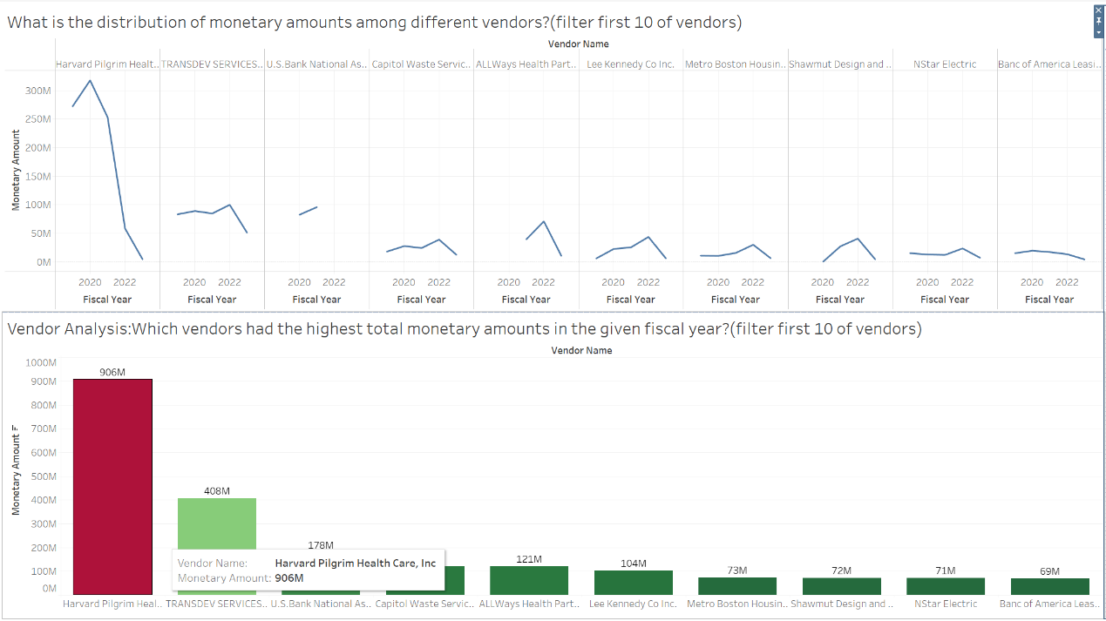

Research questions:

1) Which vendors had the highest total monetary amounts in the given fiscal year?

Based on the graph, the vendor with the highest total monetary amount in the given fiscal year is Harvard Pilgrim, with a total of $906M .

2) What is the distribution of monetary amounts among different vendors?

The distribution of monetary amounts among different vendors is as follows:

Harvard Pilgrim: $906M

TRANSDEV SERV.: $408M

U.S. Bank National: $178M

Capitol Waste / S.: $121M

Always Health Partners: $121M

Lee Kennedy Co Inc.: $104M

Metro Boston RTA: $73M

Shawmut Design and Construction: $72M

NSTAR Electric: $71M

Banc of America Leasing & Capital, LLC: $69M

It contains a series of line graphs and a bar graph displaying the monetary amounts associated with various vendors over the fiscal years 2020 to 2022. The line graphs are color-coded to match the corresponding bars in the bar graph below. Each line graph represents a different vendor, showing fluctuations in their monetary amounts over three fiscal years. The bar graph at the bottom provides a clear visual representation of each vendor’s total monetary amount for comparison.

**Departmental Spending Trends:**

Next, we explore departmental spending. A line chart chronicles expenditures across various departments, with the "Boston Public School Dept" peaking sharply in 2020. This suggests a significant financial move, perhaps a large project or an extraordinary expense. Complementing this, a heatmap vividly displays spending by department, with "Boston Public School Dept" again leading at 28.176M. This visualization aids in identifying departments with the highest fiscal outlays, crucial for budgetary adjustments.

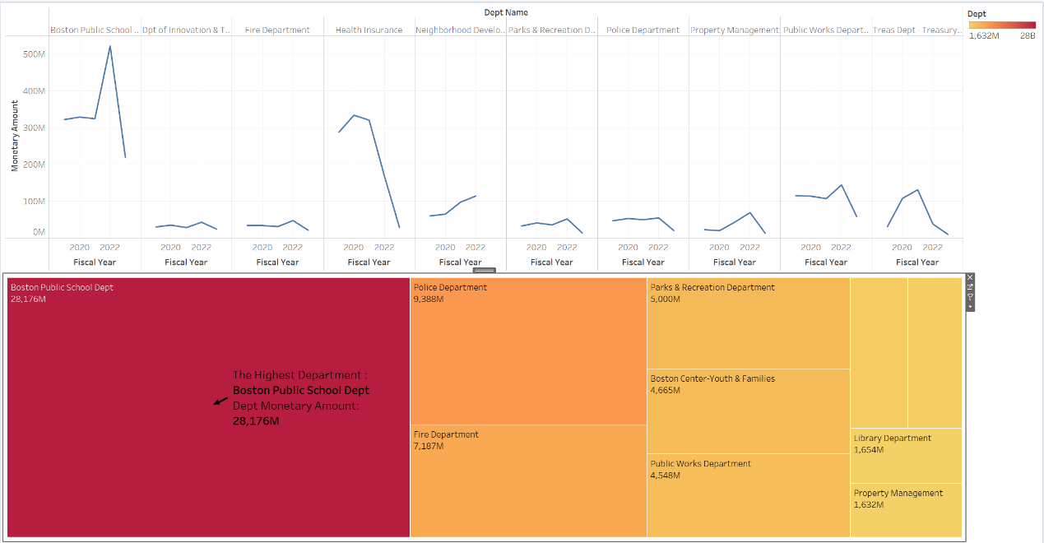

Research questions:

1) Which departments had the highest total spending in the fiscal year?

Based on the graph, the department with the highest total spending in the fiscal year is Boston Public School Department, with a monetary amount of $28.176M.

2) How does spending vary across different departments?

The spending varies significantly across different departments. The Fire Department and Police Department follow with $7.187M and $9.838M, respectively. Other departments like Health Insurance, Parks & Recreation, Property Management, and Library have lower spending.

**Expense Categories:**

Delving into account descriptions, a bar chart shows "EducSup Instructional.." leading in spending, a testament to the organization's commitment to educational support. The accompanying line chart, tracking this spending over several years, reveals a peak in 2020, mirroring the heightened activity in the "Boston Public School Dept."

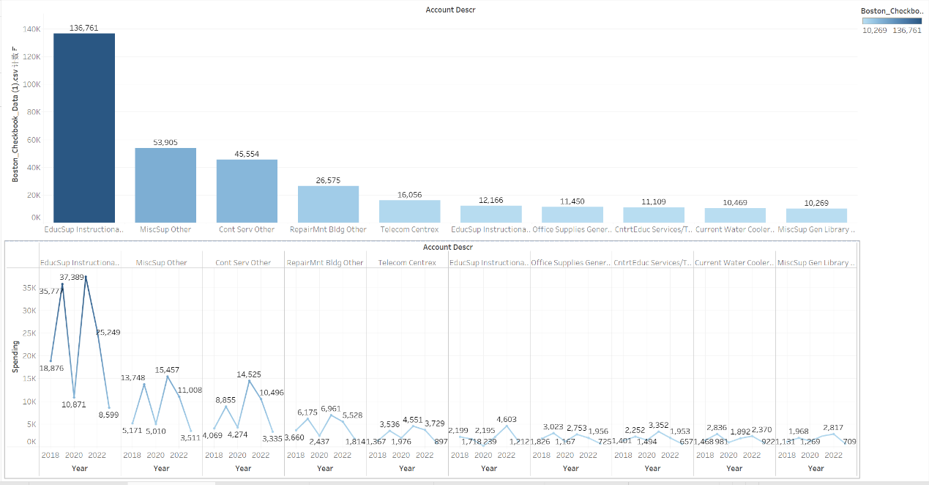In the expense analysis, a visual representation of the monetary amounts associated with different account descriptions shows significant disparities in spending across various categories. The plot shows that "Health Ins. Payments" under the "Health Insurance" department holds the highest monetary amount, standing at $1,105,555,794.65. And, the lowest expenditure is seen in "Adult Library Programs" under the "Office of Economic Development," totaling $5,000.

Major Expense Categories:

1. Account Descriptions:

The major expense categories, identified by their account descriptions, vary widely in terms of spending. "Health Ins. Payments" emerges as the highest t category with its financial allocation, while "Adult Library Programs" represents a category with comparatively minimal expenditure.

2. High Expenditure:

"Health Ins. Payments" in the "Health Insurance" department signifies a major allocation of financial resources. The substantial monetary amount suggests that health insurance payments constitute a significant portion of the overall expenses, possibly reflecting the importance of employee benefits and well-being.

3. Low Expenditure:

On the other end of the spectrum, "Adult Library Programs" under the "Office of Economic Development" incurs a minimal expenditure of $5,000. This suggests that expenses related to adult library programs are relatively modest in comparison to other categories, possibly indicating a lower priority in the allocation of financial resources.

Understanding the distribution of spending across these expense categories is crucial for effective budget management and strategic decision-making. The disparity in monetary amounts highlights the varying financial significance of different categories within the organization.

**Monthly Spending Patterns:**

The analysis of monthly spending uncovers a rising trend towards the year's end, peaking in November with about $634 million. This pattern suggests a fiscal year-end surge in spending, possibly due to departments utilizing their full budgets.

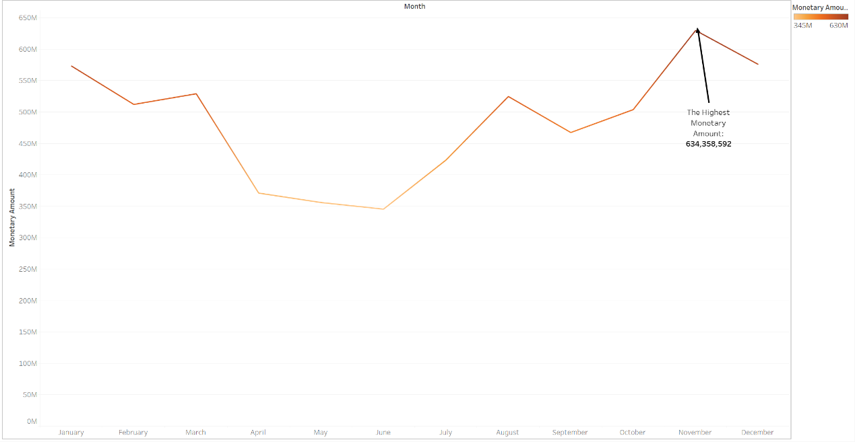

Month wise analysis

In the month-wise analysis, the visualization of monetary amounts across different months reveals notable trends and patterns, with November recording the highest total spending and June recording the lowest.

Research questions:

Which month had the highest total spending, and is there any seasonality in the data? Highest Total Spending:

* The analysis identifies November as the month with the highest total spending, reaching $629,822,183.89. This suggests that November experiences a significant financial outlay compared to other months.

Seasonality in the Data:

* The variation in spending across months may indicate potential seasonality in the data. Seasonality refers to recurring patterns or fluctuations that follow a specific time frame, such as monthly or quarterly cycles.

Potential Seasonality Indicators:

* Increased spending during certain months may align with holiday seasons, year-end financial activities, or specific operational demands.
* Decreased spending in other months might coincide with periods of reduced activity or budget constraints.

Understanding these trends and patterns is essential for strategic financial planning. Identifying the highest spending month and assessing seasonality can guide resource allocation, budget adjustments, and operational planning. The organization can leverage this information to optimize financial strategies and align spending with seasonal variations or specific business needs.

**Insights from Negative Transactions:**

A unique perspective is offered by examining negative transactions. A bar chart reveals refunds or adjustments, with "Action Training Systems, Inc." linked to the Fire Department showing the largest negative amount. Such insights are vital for maintaining financial integrity and understanding the flow of funds.

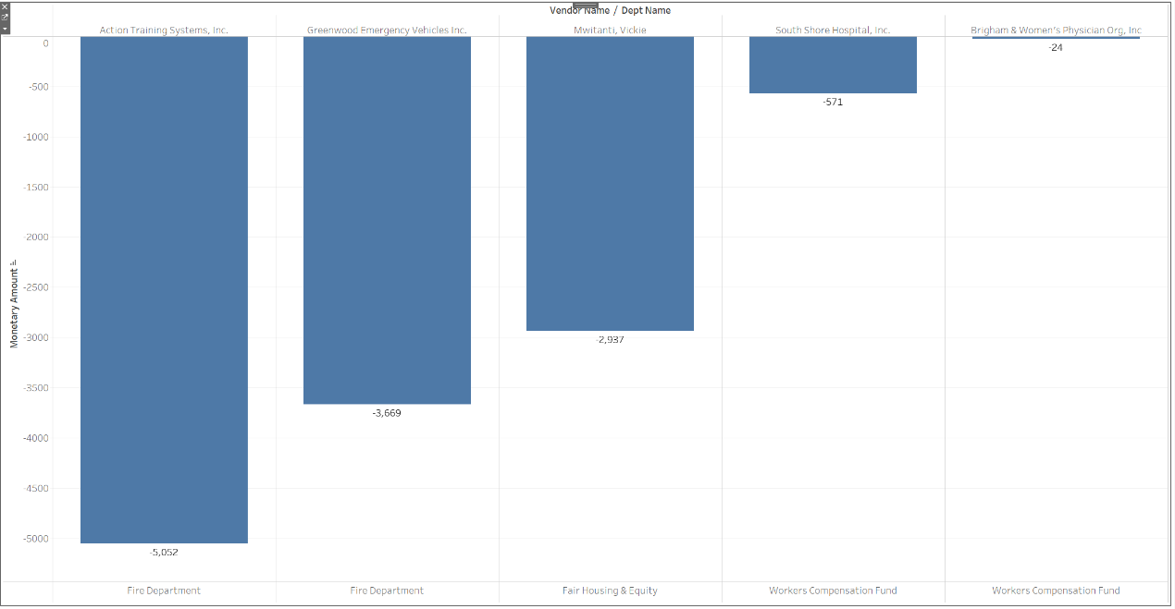

The image features a bar chart with negative monetary amounts, which could represent refunds, rebates, returned funds, or accounting corrections:

* + Each bar represents a different vendor or department with a negative monetary amount.
  + The "Action Training Systems, Inc." associated with the Fire Department shows the largest negative amount, over $5,000.
  + Other notable negative amounts are associated with "Greenwood Emergency Vehicles Inc." and a person named "Mwitanti, Vickie," suggesting refunds or adjustments in those accounts.

This chart is particularly important for financial oversight as it can help in identifying areas where funds are being returned or where expenses have been retracted. Such data is crucial for accounting accuracy and for understanding the overall financial health and transactional integrity of the organization.

**Outlier Detection and Analysis:**

A scatter plot and a box plot serve as potent tools for outlier detection. They highlight unusual transactions, like a significant negative amount of around -$24.87 million, suggesting a major refund or correction. Similarly, the presence of a large positive transaction over $61.74 million calls for scrutiny. These outliers, juxtaposed against an average transaction value, provide a clear perspective on the organization's financial landscape.

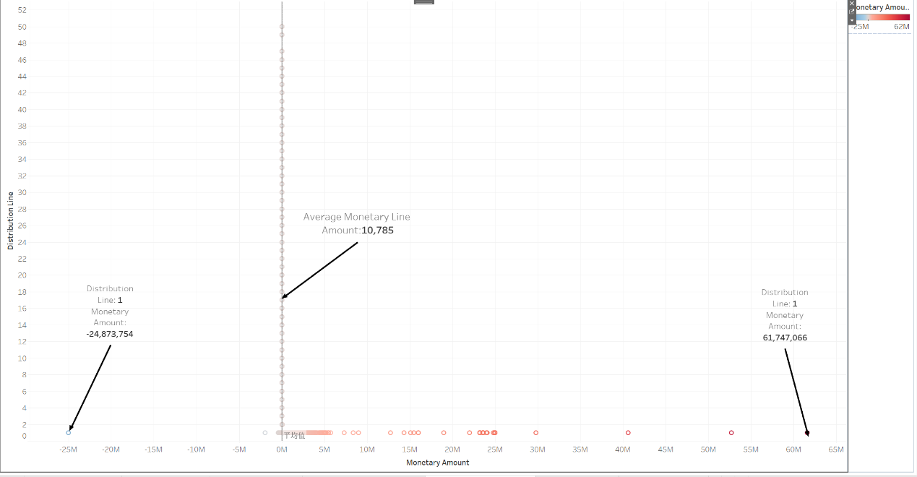

* + The plot likely represents individual transactions or financial events, with their monetary values on the x-axis and distribution line numbers on the y-axis.
  + There are two notable data points highlighted with arrows: one showing a large negative monetary amount (around -$24.87 million), and another showing a large positive amount (over $61.74 million).
  + The "Average Monetary Line" is indicated, which gives an average transaction value across all the distribution lines, in this case, $10,785.

This type of graph is useful for detecting outliers in financial data, which could represent unusual transactions that require further investigation. The presence of a significant negative transaction could indicate a large refund or accounting correction, while the large positive transaction could be a major expenditure or revenue.

The average line provides a benchmark for comparing individual transactions and understanding the typical scale of financial activity for the entity.

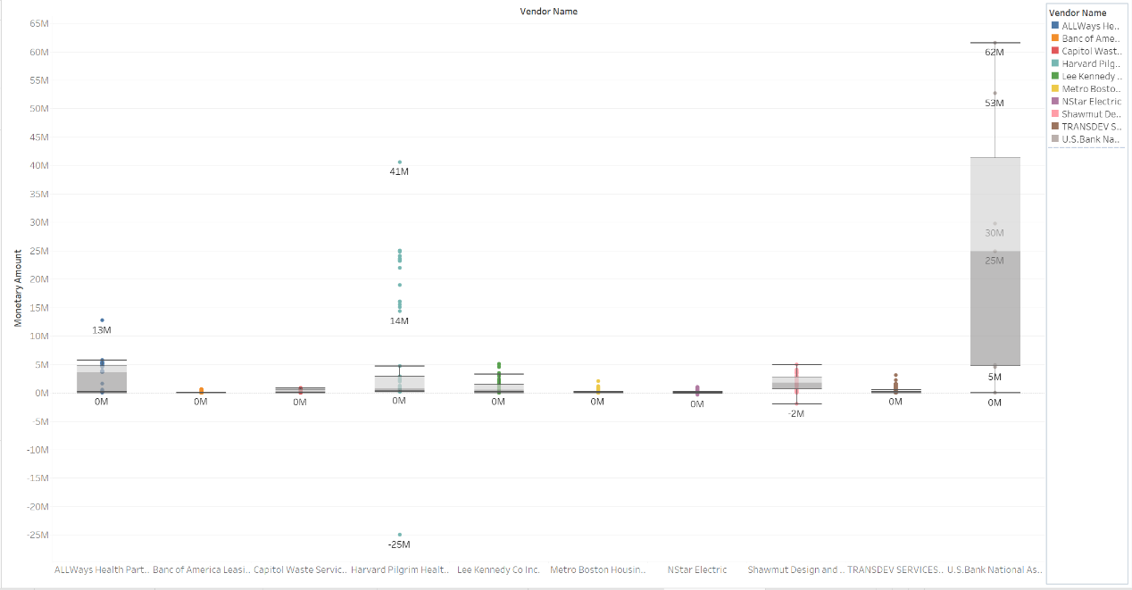

The box plot overlaid with individual data points, representing payments to different vendors. The Y-axis shows the monetary amount, and the X-axis lists the vendor names. This kind of plot can show the distribution of payments for each vendor, indicating the median, interquartile range, and any outliers. There are some key observations:

* The box represents the interquartile range (IQR), which is the middle 50% of the payments for each vendor.
* The line inside the box shows the median payment.
* Dots represent individual payment amounts, with those outside the 'whiskers' considered outliers.
* Some vendors, like the one corresponding to the 62M mark, have a wide range of payments (large IQR), indicating variability in the payment amounts.
* Other vendors, such as the one at the 53M mark, have a more consistent payment size (small IQR).
* The vendor with the highest median payment is around 53M, and the one with the lowest is around 13M.
* There are notable outliers, particularly for the vendor at the 41M mark, indicating a few payments much higher than the typical range.

**Correlation Analysis:**

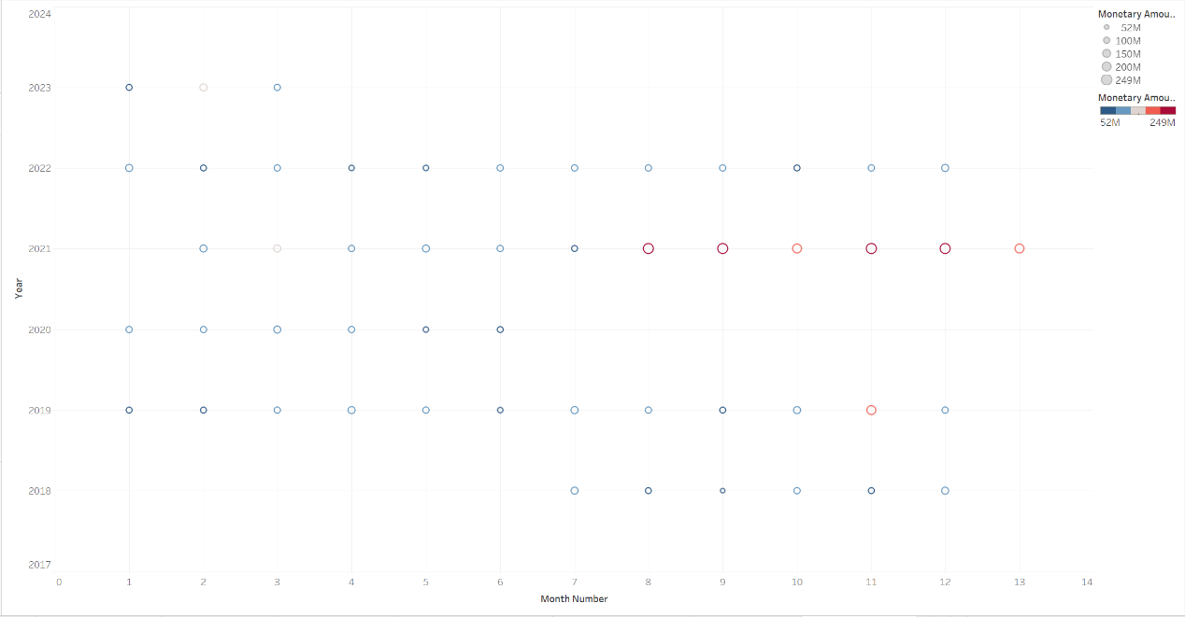

The final graph appears to be a time-series scatter plot displaying monetary amounts over time. The X-axis represents month numbers, and the Y-axis represents years, with the size of the dots corresponding to different monetary amounts. Here are some findings behind the correlation analysis:

* The data points are spread across different years, suggesting a dataset spanning several years.
* The color coding and the size of the dots are associated with the monetary amount – larger dots signify larger amounts.
* There are instances of large payments (largest dots) that appear periodically. For example, there seems to be a concentration of larger amounts at certain times, such as around the 10th month in recent years.
* The plot does not show a clear trend but does indicate seasonality or periodicity in larger payments.

**Conclusion:**

Through the lens of these visualizations, we gain a comprehensive understanding of the organization's financial operations. The insights gleaned are not just numbers on a chart but narratives of fiscal prudence, operational challenges, and strategic decisions. This analysis underscores the power of data in shaping financial strategies and ensuring organizational accountability and transparency.

**References:**

Acharya, M. (2023, November 23). *Unveiling the power of business analytics: Elevating decision-making in every business dimension*. The Importance of Business Analytics in Decision-Making. https://www.linkedin.com/pulse/unveiling-power-business-analytics-elevating-every-mohit-acharya-n9aof/