Amazon OWES You Money — Click THIS to Get It Back!
FRIDAY, AUGUST 7
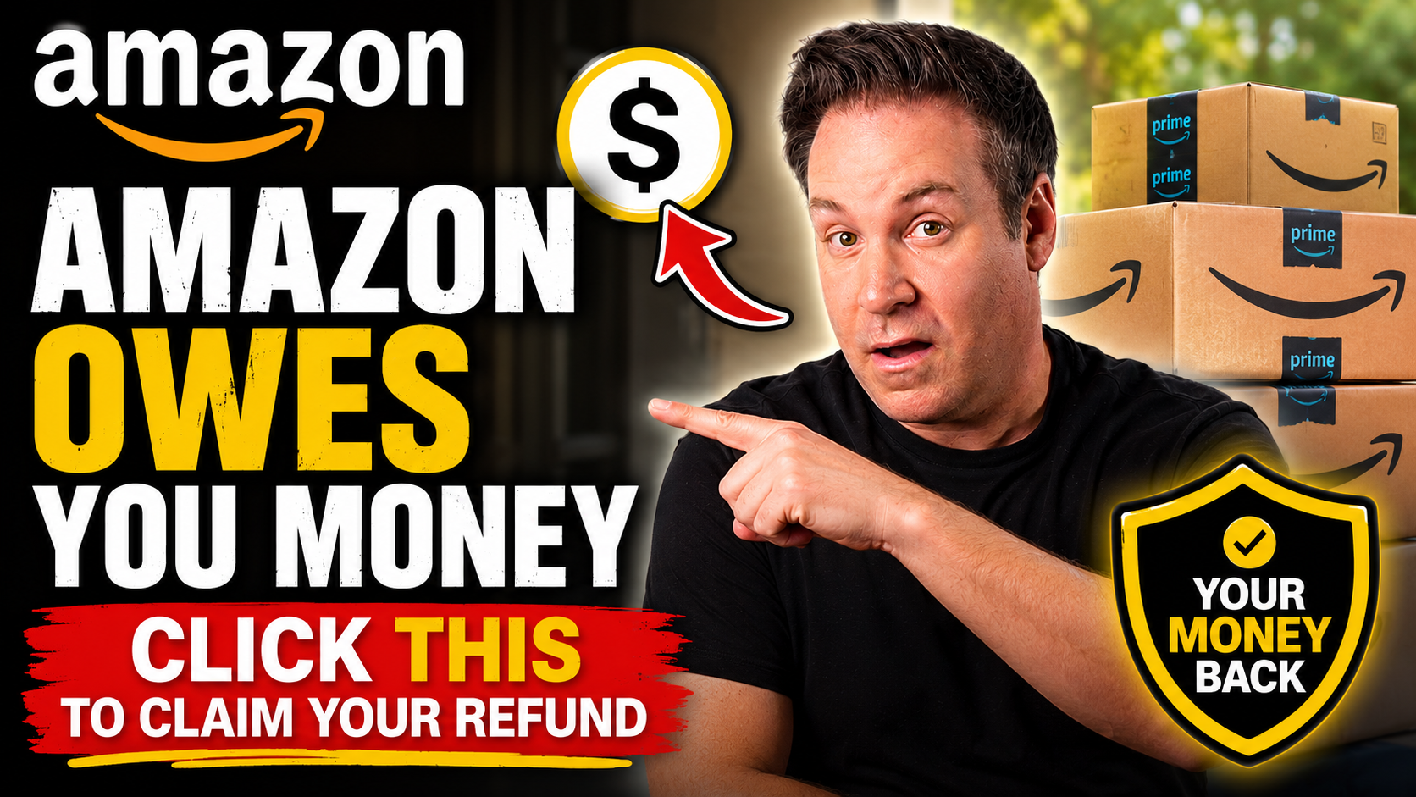

Amazon OWES You Money — Click THIS To Get It Back

AMAZON IS SITTING ON MONEY THAT BELONGS TO YOU

-AND THEY ARE NEVER GOING TO CALL YOU ABOUT IT.

-YOU CAN GET YOUR MONEY BACK. I’M GOING TO WALK YOU THROUGH EVERY BUTTON YOU NEED TO CLICK.

-IF A PACKAGE CAME LATE… AMAZON’S OWN GUARANTEE MAY OWE YOU A REFUND. ALMOST NOBODY CLAIMS IT.

-IF IT SAID DELIVERED AND IT WASN’T THERE… YOU ARE NOT BEGGING FOR A FAVOR. YOU ARE OWED.

-ONE WOMAN WAS OUT $12,000 AND GOT DENIED TWICE. WAIT UNTIL YOU SEE WHAT SHE DID.

-AND AMAZON AGREED TO PAY $309.5 MILLION OVER REFUNDS THAT NEVER LANDED.

-ONE MAN GOT PAID $1,798 FOR A TV HE RETURNED IN 2018. SEVEN YEARS LATER!!

—------------------------------------------------

THE HOTTEST AMAZON DEALS OF THE WEEK WITH THE FOLKS FROM DEALSEEK

-SECRET PROMO CODES YOU’LL ONLY FIND HERE

-WE’VE GOT XXX PRODUCTS AT XX% SAVINGS OR MORE

—------------------------------------------------

-AND, YOUR LIVE REQUESTS… SEND THEM IN BECAUSE OUR DEAL HUNTERS ARE STANDING BY

HIT LIKE AND SUBSCRIBE

JOIN THE CHAT

AMAZON OWES YOU MONEY — HERE’S HOW TO TAKE IT BACK

-AMAZON HAS POLICIES THAT PUT REAL MONEY BACK IN YOUR POCKET.

-BUT THEY ONLY PAY OUT IF YOU ASK.

-SO LET’S START WITH THE EASIEST ONE, AND YOU CAN WIN THIS ONE TODAY.

YOUR PACKAGE CAME LATE — THAT IS A REFUND YOU NEVER CLAIMED

-WHEN YOU CHECK OUT, SOMETIMES AMAZON SHOWS YOU A GUARANTEED DELIVERY DATE.

-NOT AN ESTIMATE. A GUARANTEE. AND THEY PUT IT IN WRITING IN YOUR CONFIRMATION EMAIL.

-AMAZON’S OWN TERMS SAY IF THEY MISS THAT DATE, YOUR SHIPPING FEES MAY BE REFUNDED.

-SO GO FIND THAT EMAIL. THAT EMAIL IS YOUR RECEIPT.

-HERE’S THE EXACT PATH AMAZON PUBLISHES. GO TO YOUR ORDERS… SELECT THE LATE ORDER…

-CLICK PROBLEM WITH AN ORDER… THEN SHIPPING OR DELIVERY ISSUES… THEN SHIPMENT IS LATE.

-NOW IF YOU’RE A PRIME MEMBER WHO NEVER PAID A SHIPPING FEE, THERE’S NOTHING TO REFUND…

-…SO ASK THE AGENT FLAT OUT FOR AN ACCOUNT CREDIT INSTEAD. YOU HAVE TO SAY THE WORDS.

-WATCH HIM SHOW YOU HOW.

(((PLAY CLIP 1 HORIZONTAL)))
https://www.youtube.com/watch?v=_8W0-cK5XTQ
IN 1:02 OUT 1:41
OUTCUE: “worth a shot though”

-DO THIS EVERY TIME AN AMAZON PACKAGE ARRIVES LATE. IT TAKES A MINUTE.

(((PLAY CLIP 2 VERTICAL)))
https://www.tiktok.com/@johnsfinancetips/video/7028390544061730095
IN 0:00 OUT 0:30
OUTCUE: “thank you”

NOW IT GETS WORSE — IT SAYS DELIVERED AND THERE’S NOTHING THERE

-YOUR PHONE BUZZES. DELIVERED. YOU GO OUTSIDE… AND THE PORCH IS EMPTY.

-AMAZON TELLS YOU TO WAIT 24 TO 48 HOURS, BECAUSE SOMETIMES THE SCAN RUNS AHEAD OF THE TRUCK.

-FINE. WAIT. BUT AFTER THAT, YOU ARE NOT ASKING FOR A FAVOR. YOU ARE OWED.

-LISTEN TO THESE SHOPPERS WHO PAID, WATCHED THE TRACKING MOVE… AND NEVER GOT A THING.

(((PLAY CLIP 3 VERTICAL)))
https://www.tiktok.com/t/ZP8tHoohG/
IN 0:00 OUT 0:52
OUTCUE: “around this time”

AND WHEN AMAZON SAYS NO? THIS WOMAN GOT DENIED TWICE

-MOST OF WHAT YOU BUY THERE ISN’T SOLD BY AMAZON — IT’S SOLD BY THIRD-PARTY SELLERS.

-AMAZON HAS SAID MORE THAN 60% OF SALES IN ITS STORE COME FROM INDEPENDENT SELLERS.

-SO WHEN IT GOES WRONG, YOU GET BOUNCED BETWEEN AMAZON AND A SELLER WHO WON’T ANSWER.

-THAT’S WHAT THE A-TO-Z GUARANTEE IS FOR. YOU FILE IT THROUGH YOUR ORDERS PAGE.

-AND AMAZON DECIDES THE CLAIM — NOT THE SELLER WHO TOOK YOUR MONEY.

-BUT PEOPLE GET DENIED. AND WHEN THEY GET DENIED, THEY GIVE UP. DON’T.

-THIS WOMAN SPENT $12,000 ON A TINY HOME THAT NEVER ARRIVED.

-SHE FILED. SHE GOT DENIED. SHE FILED AGAIN. DENIED AGAIN.

-YOU AREN’T GOING TO BELIEVE WHAT IT TOOK TO GET ANYBODY TO LISTEN TO HER.

CLIP 4 — HORIZONTAL — $12,000 tiny home, denied twice
https://abc7.com/post/socal-woman-asks-for-help-after-spending-12k-on-tiny-home-that-never-arrived/15409472/
IN 0:22 OUT 1:55
OUTCUE: “was denied twice”

AND NOW THE ONE THAT MAKES ME THE ANGRIEST — THE REFUND THAT NEVER CAME

-YOU RETURN SOMETHING. YOU DROP IT OFF. YOU GET THE SCAN.

-AMAZON SAYS REFUND ISSUED… AND THE MONEY NEVER SHOWS UP ON YOUR CARD.

-OR WORSE. IT SHOWS UP, AND THEN AMAZON CHARGES YOU AGAIN FOR THE SAME ITEM.

-THAT HAS A NAME. IT IS CALLED A RETROCHARGE.

-AND IT HAPPENED ENOUGH THAT AMAZON AGREED TO PAY $309.5 MILLION TO SETTLE A CLASS ACTION.

-AND IT HAD ALREADY QUIETLY REFUNDED ABOUT $570 MILLION BEFORE THAT CASE WAS EVEN FILED…

-THEN A JUDGE IN SEATTLE GAVE THAT SETTLEMENT PRELIMINARY APPROVAL BACK IN FEBRUARY.

-SO THIS IS REAL. IT JUST ISN’T PAYING OUT YET.

-AND IT REACHES ALL THE WAY BACK TO SEPTEMBER 2017.

-SO IF YOU HAVE RETURNED ANYTHING TO AMAZON IN THE LAST NINE YEARS… THIS IS ABOUT YOU.

-STEVEN POPE, WHO RUNS MY AMAZON GUY, POSTED THAT AMAZON CREDITED HIM $1,798.81…

-…FOR A TELEVISION HE RETURNED IN 2018. HE GOT PAID SEVEN YEARS LATER.

-SEVEN YEARS!!! THAT IS HOW LONG HE WAITED FOR MONEY HE WAS ALREADY OWED.

-HERE’S THE LATEST ON THAT SETTLEMENT RIGHT NOW.

CLIP 5 — VERTICAL — Latest on the $309.5M returns settlement
https://www.tiktok.com/t/ZP8txTTEr/
IN 0:00 OUT 0:27
OUTCUE: “after a refund.”

-NOW HEAR ME ON THIS — THE CLAIM WINDOW IS NOT OPEN YET. WATCH YOUR EMAIL FOR A NOTICE.

-THE OFFICIAL SITE IS RETURNSETTLEMENT.COM. ANYBODY ELSE ASKING YOU FOR A FEE IS A SCAMMER.

-BUT YOU DO NOT HAVE TO WAIT ON A COURT TO GO CHECK YOUR OWN ACCOUNT TONIGHT.

HERE’S HOW TO GET YOUR MONEY BACK

-SEARCH YOUR EMAIL FOR THE WORDS GUARANTEED DELIVERY DATE AND SEE WHAT AMAZON PROMISED YOU.

-IF A PACKAGE SAYS DELIVERED AND IT ISN’T THERE, GIVE IT THE FULL 48 HOURS, THEN FILE. DON’T EAT IT.

-SCREENSHOT THE DELIVERY PHOTO AMAZON SENT YOU AND TAKE YOUR OWN PHOTO OF THE EMPTY PORCH.

-IF YOU GET DENIED, ESCALATE AND ASK FOR A SUPERVISOR. THE FIRST NO IS NOT THE LAST NO.

-NOW OPEN YOUR ORDERS, CLICK RETURNS, AND CHECK EVERY REFUND ISSUED AGAINST YOUR CARD STATEMENT.

-IF THE CREDIT NEVER LANDED, OR YOU GOT CHARGED TWICE, CALL AMAZON AND MAKE THEM FIX IT.

-AND KEEP THE DROP-OFF RECEIPT OR THE QR SCAN CONFIRMATION. THAT IS YOUR PROOF YOU RETURNED IT.

(((SPONSOR TEASE - KILL BANNERS)))

I’M ALWAYS LOOKING FOR WAYS TO PROTECT YOU AND YOUR MONEY…

-OUR SPONSOR TODAY DOES JUST THAT.

-HERE’S HOW TO GET A FREE ACCOUNT SCAN RIGHT NOW AND GET EVEN MORE PROTECTION.

(((PLAY OMNIWATCH SPONSOR)))

TIME FOR ONE OF THE BEST PARTS OF A FRIDAY

(((BRING IN TREY)))

-THE HOTTEST AMAZON DEALS OF THE WEEK WITH OUR AMAZON EXPERT TREY DONOVAN, CO-FOUNDER OF DEALSEEK.COM!

-HEY TREY, SO GREAT TO SEE YOU! I CAN’T WAIT TO GET STARTED AND SAVE OUR ROSSEN REPORTS VIEWERS MONEY!

-WE’RE TAKING YOUR LIVE REQUESTS, SO TELL US WHAT YOU’RE LOOKING TO BUY! DEAL HUNTERS ARE STANDING BY!

-TREY, LET’S GO!!

-HOTTEST DEALS OF THE WEEK-

((QR CODE UP))

(((PRODUCER — DEAL LIST NOT IN YET. DROP THIS WEEK’S TEN PRODUCTS IN HERE IN THIS FORMAT, THEN UPDATE THE COUNT AND HEADLINE DISCOUNT IN THE TEASE TO MATCH)))

1. PRODUCT NAME XXX
- RETAIL PRICE: $XX.XX
- DEAL PRICE: $XX.XX
- XX% OFF WITH THE PROMO CODE / PRICE DROP / SUB & SAVE

2. PRODUCT NAME XXX
- RETAIL PRICE: $XX.XX
- DEAL PRICE: $XX.XX
- XX% OFF WITH THE PROMO CODE / PRICE DROP / SUB & SAVE

3. PRODUCT NAME XXX
- RETAIL PRICE: $XX.XX
- DEAL PRICE: $XX.XX
- XX% OFF WITH THE PROMO CODE / PRICE DROP / SUB & SAVE

4. — 10. XXX

(((JEFF AND TREY LIVE DEAL REQUESTS)))

-END OF SHOW-

