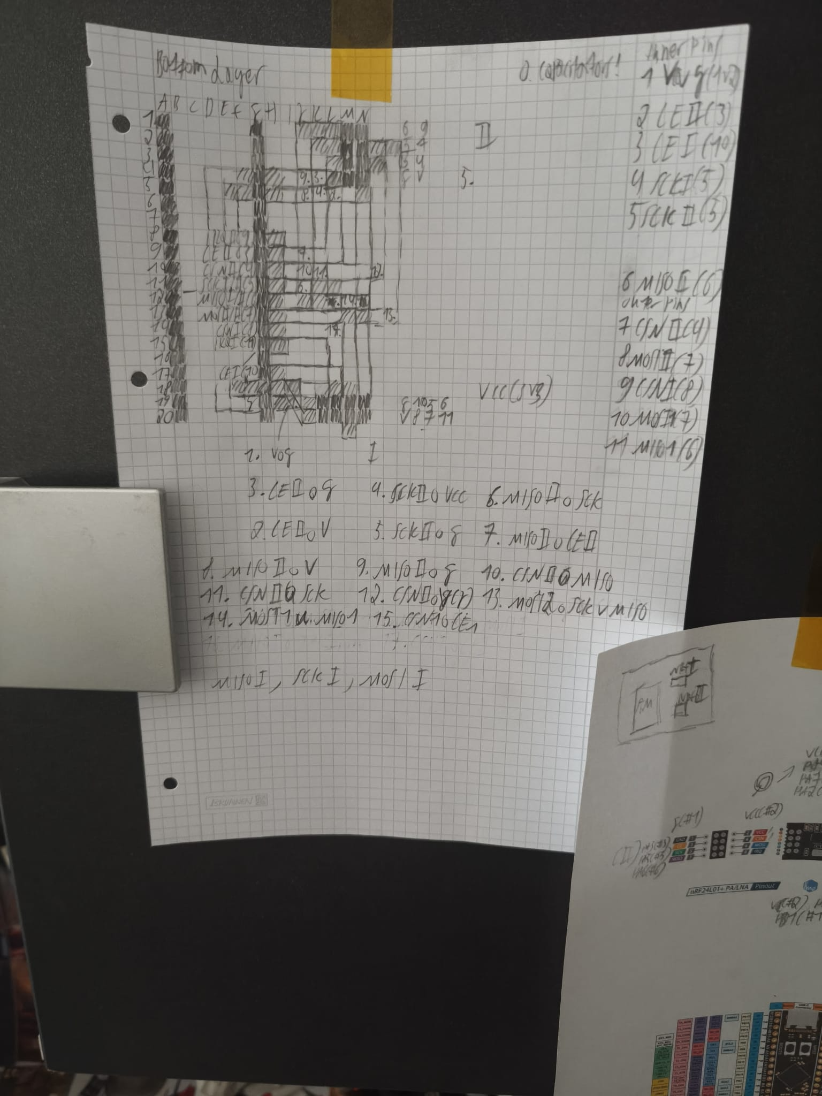

II Tests:
SCK Test (only individual line):
corresponding code loop:

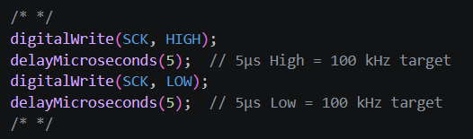

pulseview logic analyzer signal:
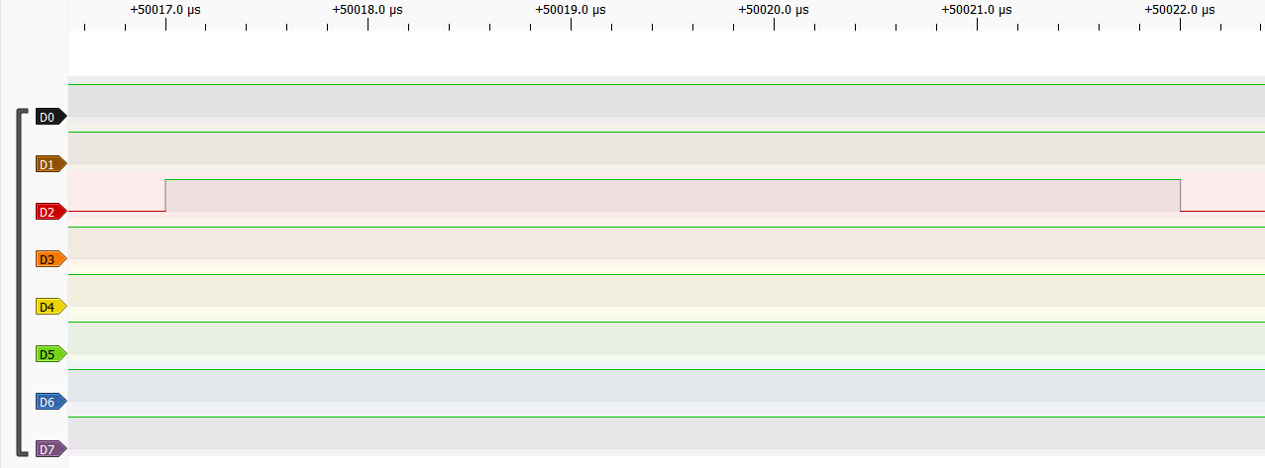
higher set frequencies in pulseview cause a jitter of 1 microsecond in nearly all parts of the signal (look at difference between the left and right signal), which is to be expected with the used peripherals (arduino overhead adds around 0.5-1 microseconds of jitter), the former highly zoomed in screenshot doesnt accomodate for this

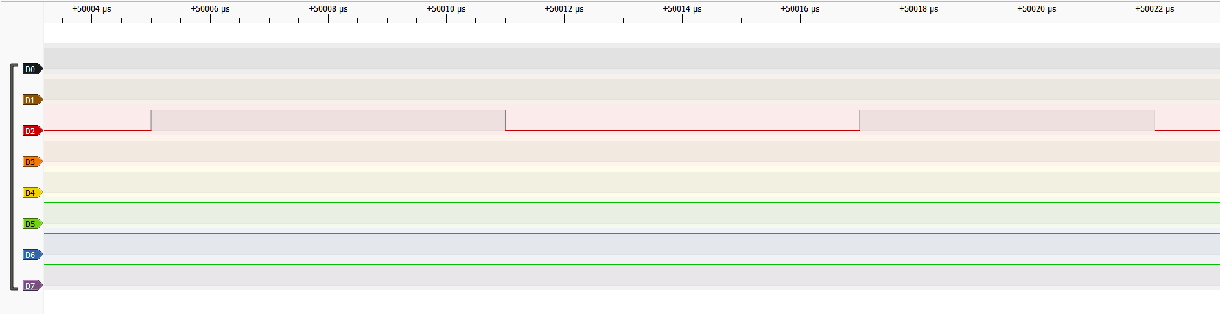

this jitter is common to even the highest frequencies
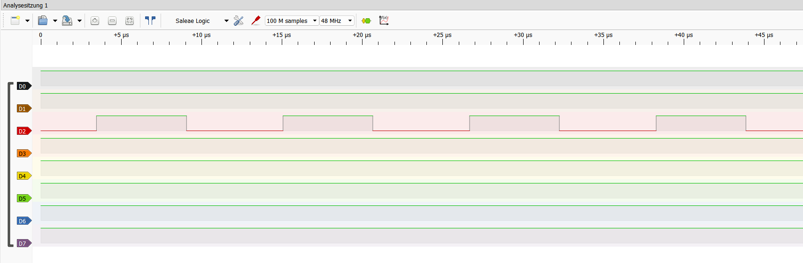
Oscilloscope reading:
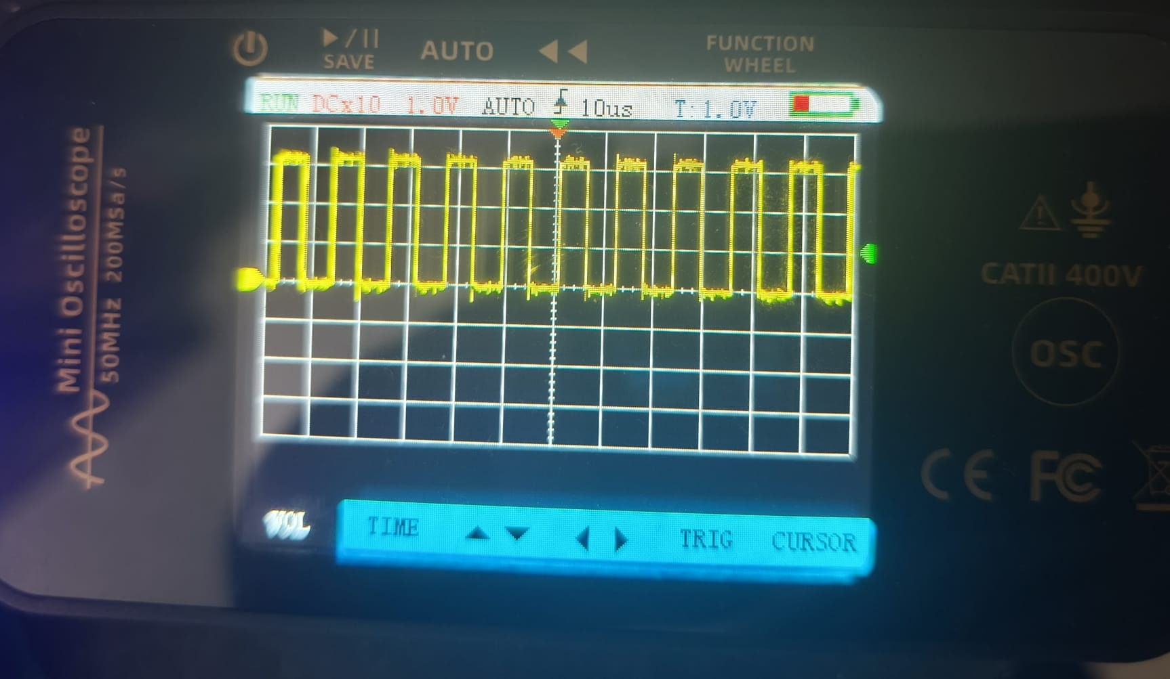
picked up noise is to be expected with budget handheld oscilloscopes, device has them even with nothing plugged in

CSN II :
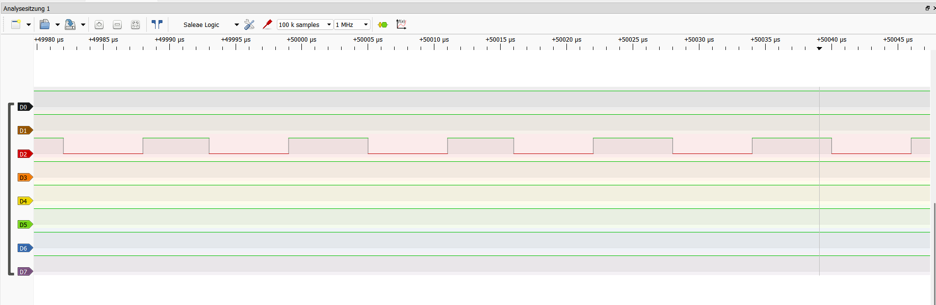
low sampling rates should be completly avoided, causes false values and a false sense of correct/false values, some pins work fine at low rates because of random synchronizations with the budget logic analyzer, while others randomly dont
testing with a sample rate lower than 100k is not recommended
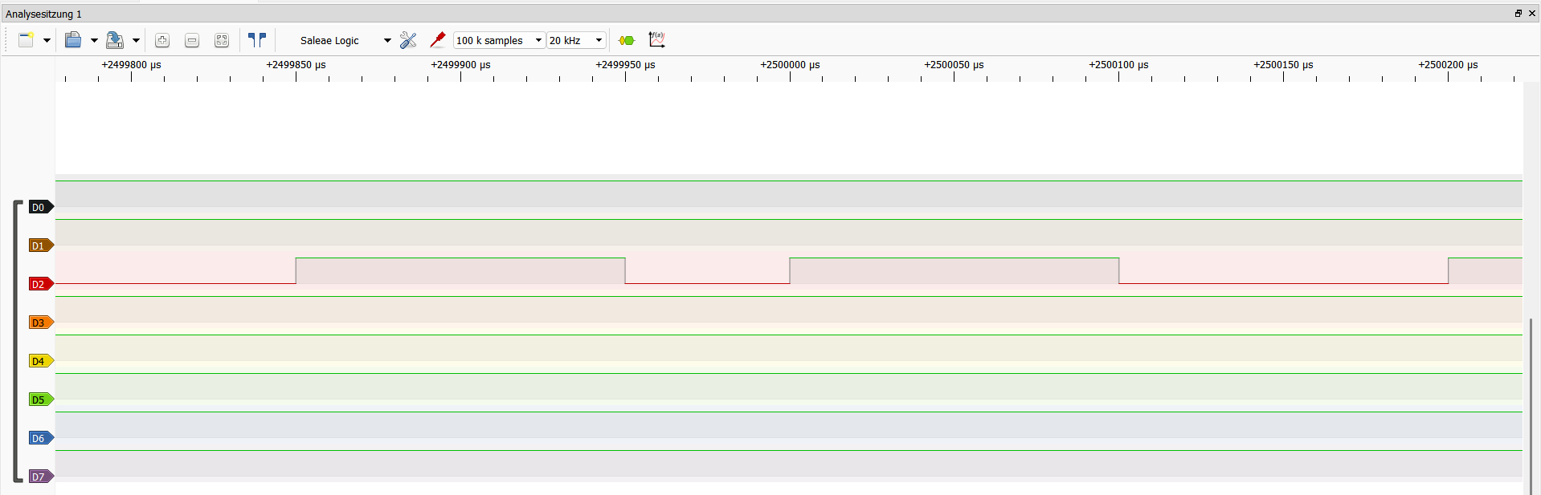
(inaccurate signal of 40-55 mus)
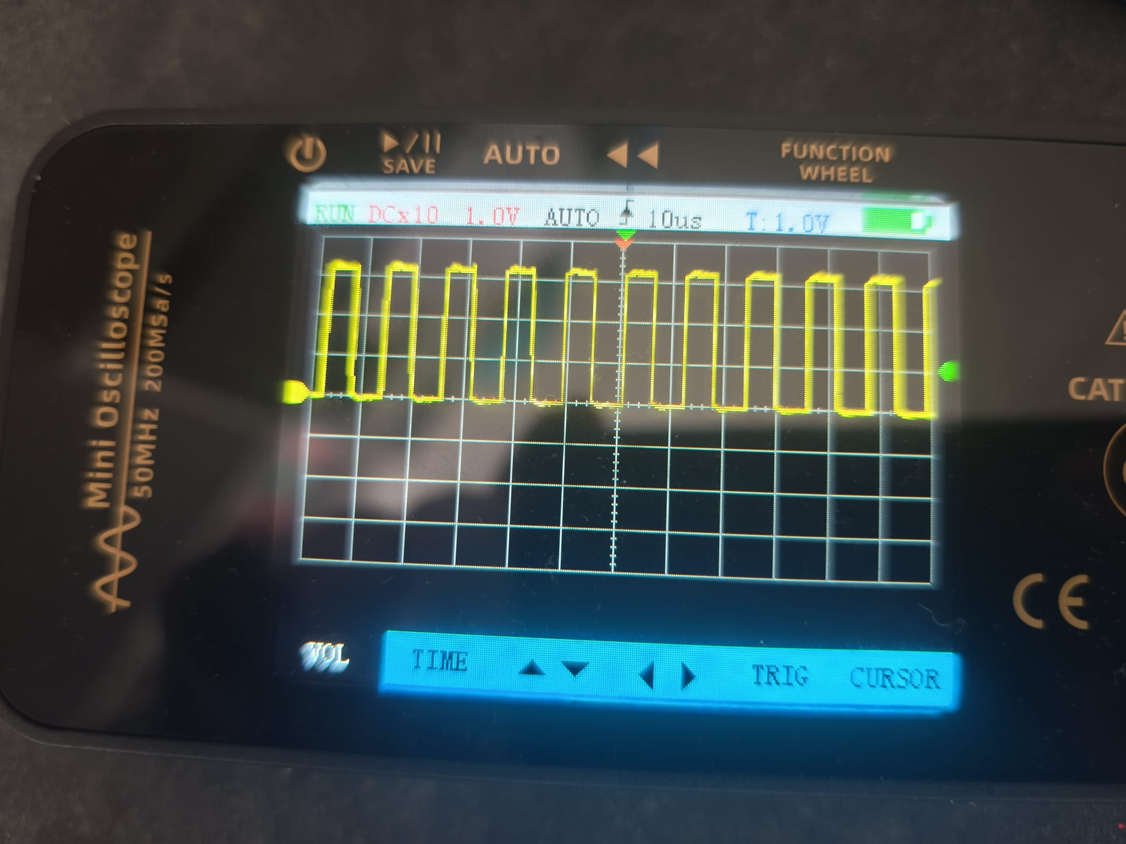
a bit shaky without shielding, but still stable enough
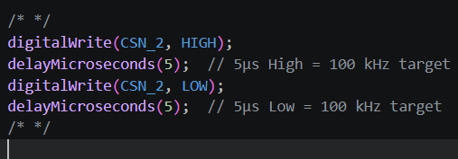

CE II :
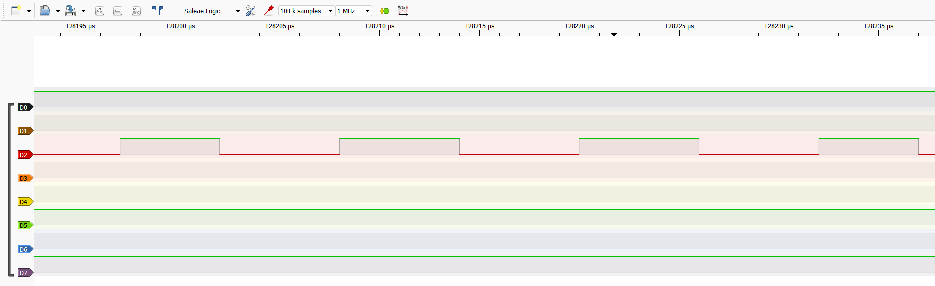
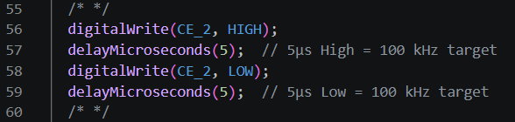

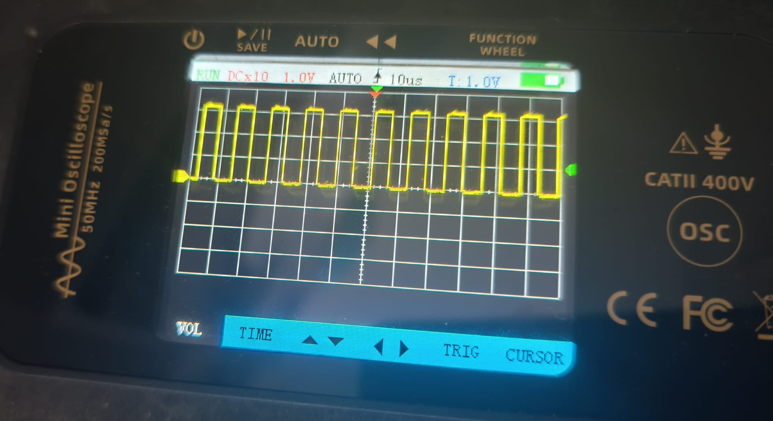
CE I :

