-Before a single component got soldered to the perfboard a series of sketches were drawn on paper to make up a „theoretical“ layout plan for both the top and bottom layer of the perfboard
-To make the build possible, lots of careful consideration and planning has to be done to fit several dozen rails on a 40x60mm perfboard, including detailed planning on which rails belong to which layer, which pin should fulfill which function, and which orientation both the stm32 f411 ce and the nrf pa/lna (write down the full name here later) transceivers should have on the perfboard

Points to adress:
Orthogonal routing
Layout decisions; stm32, transceiver I and II
modularity (female headers, casing components), avoidance of using pcbs over a perfboard build
pin decisions
perfboard size decision

-To keep the build as readable and clean as possible an orthogonal approach was chosen
-Original print for testing height distances and to test the fittingness of the slot
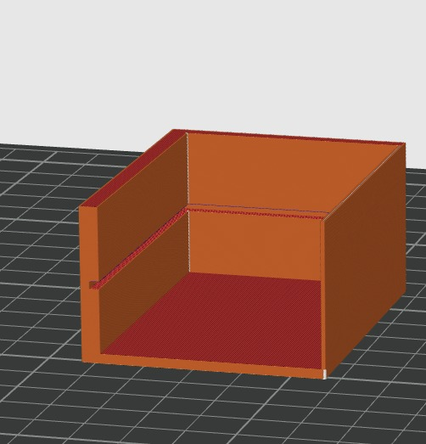

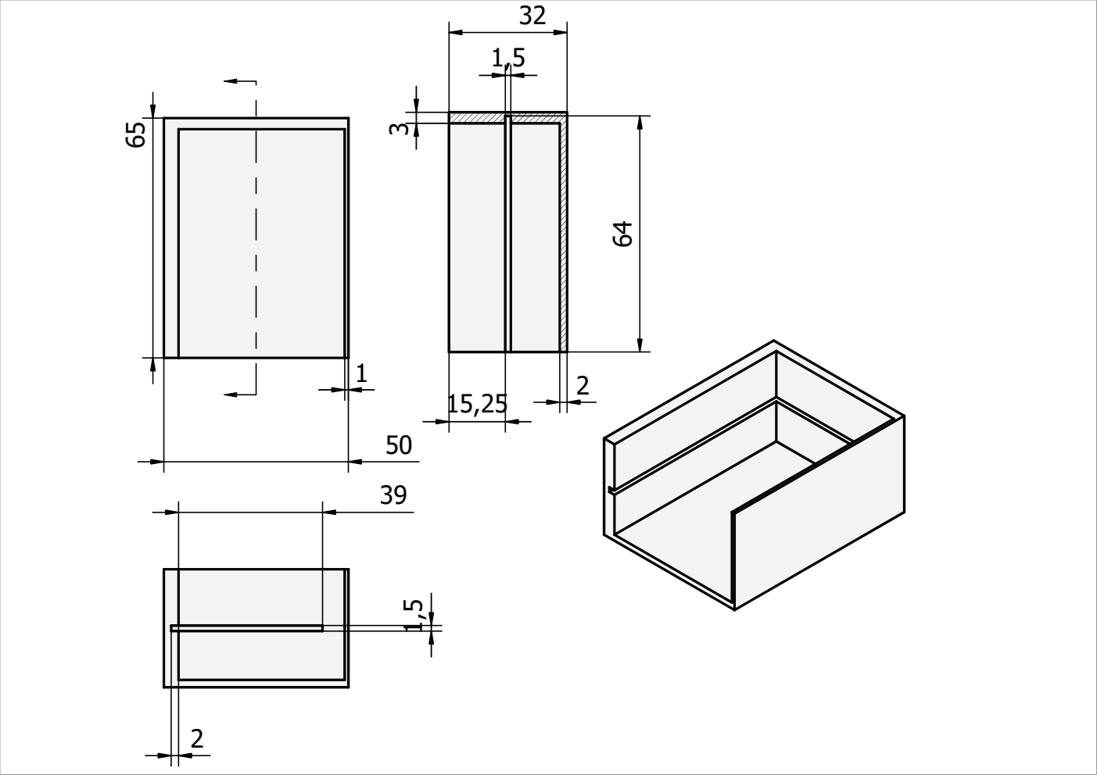

-Removed the slot at the back wall, unnecessary component that didnt fit well

-Added enclosures at the top which are meant to give room for the exposed transceivers and their antennas

-Enhanced the wall to the right to give the resting transceiver more stability
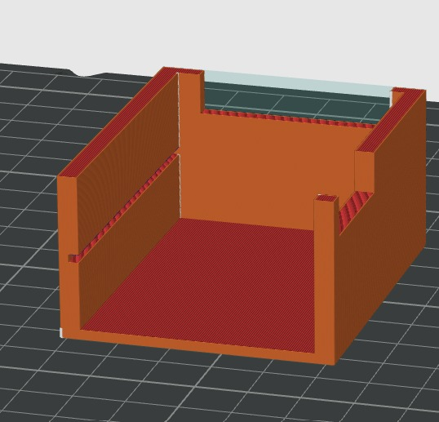

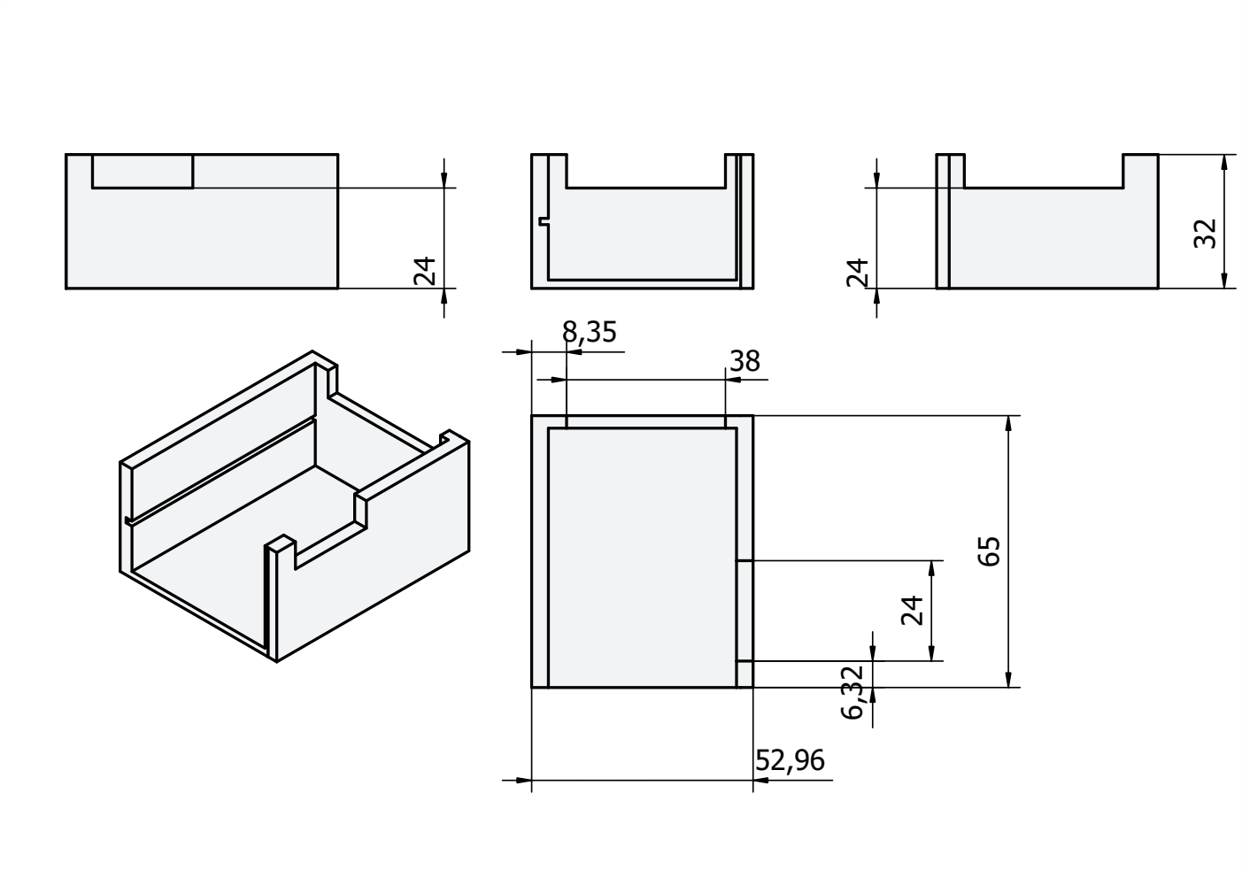

-Mitigated the width of the transceiver enclosures because of them being way too deep, transceivers barely rested on the walls during tests

-Added slots at the bottom wall for a snapfit mechanic to close in the circuitboard with an external wall, in an attempt to help the board from falling out when pushing inside the usb cable connection from the front wall enclosure

-Added circular slots at the top wall in an attempt for a snapfit mechanic with an external ceiling, which is meant to fully enclosure the circuitboard for more mechanical stability and prevention from potential physical external harm

-External ceiling includes small circular pegs for the circular slots resting on vertical square rises to make more space for the usb input from the top wall, and an opening for the microcontrollers pins to allow easy flashing to the circuit without having to dismantle the casing
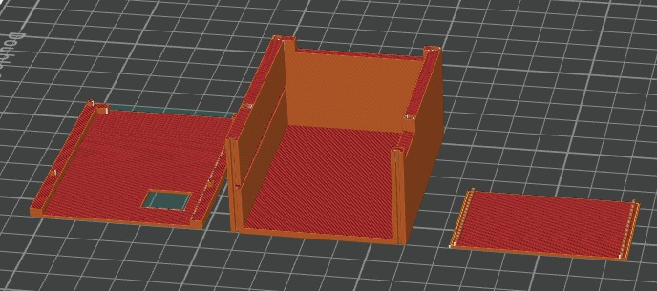

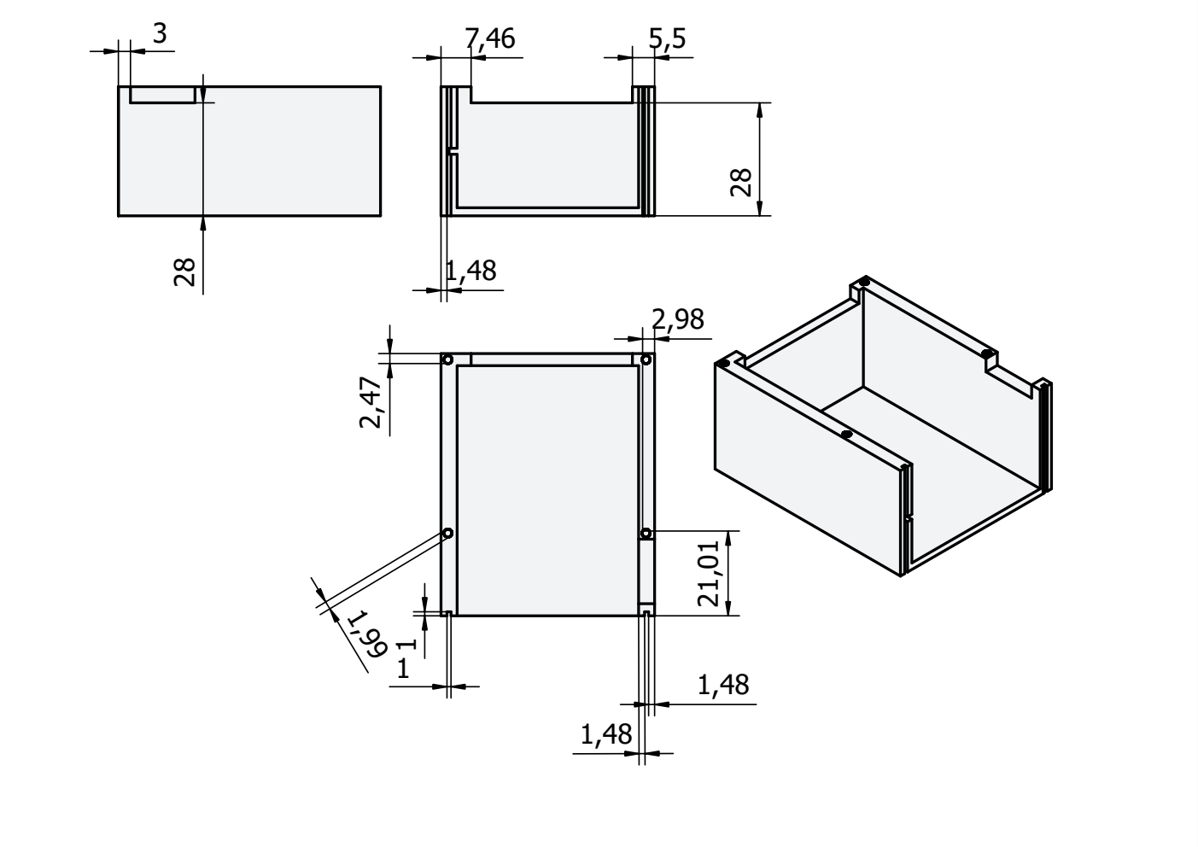

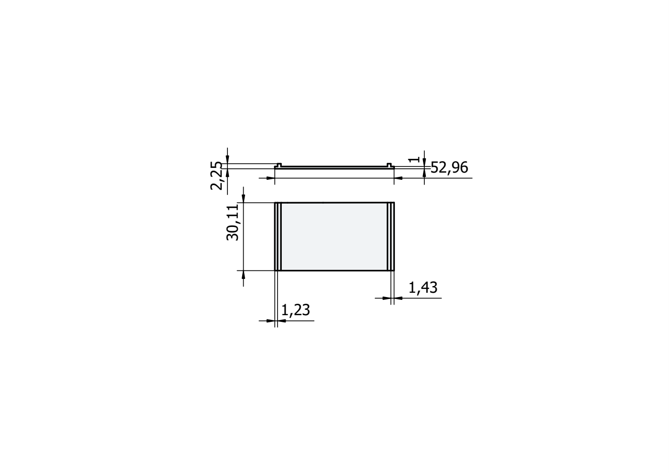
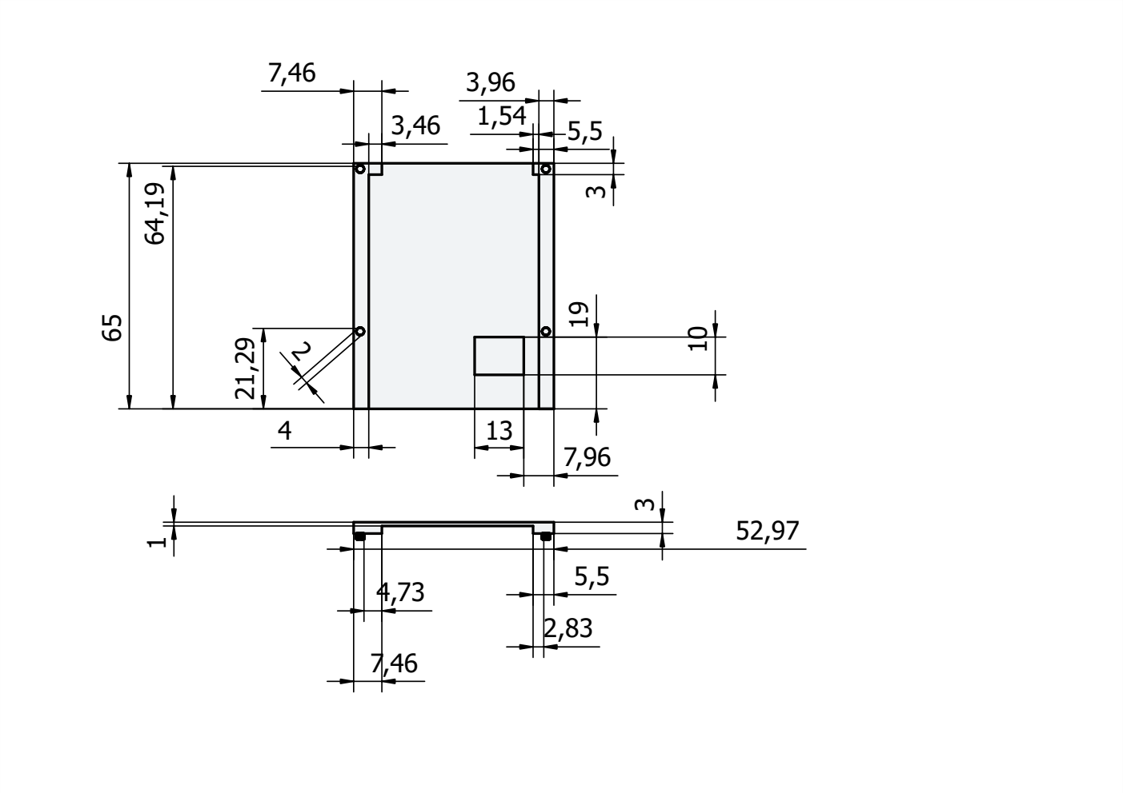

-Added a second slot in an attempt to stabilize the circuitboard by giving space to the stm32

-Added a slot at the ceiling for the main casing and a snapfit for the ceiling wall to replace the previous peg attempt, resulted in a much simpler modular build and a much more stable ceiling

-Adjusted the headerpin opening position for the ceiling wall and opened it up toward the bottom wall to make the modular build (pushing in the ceiling and pulling it off) easier and give enough room for the jumper wires

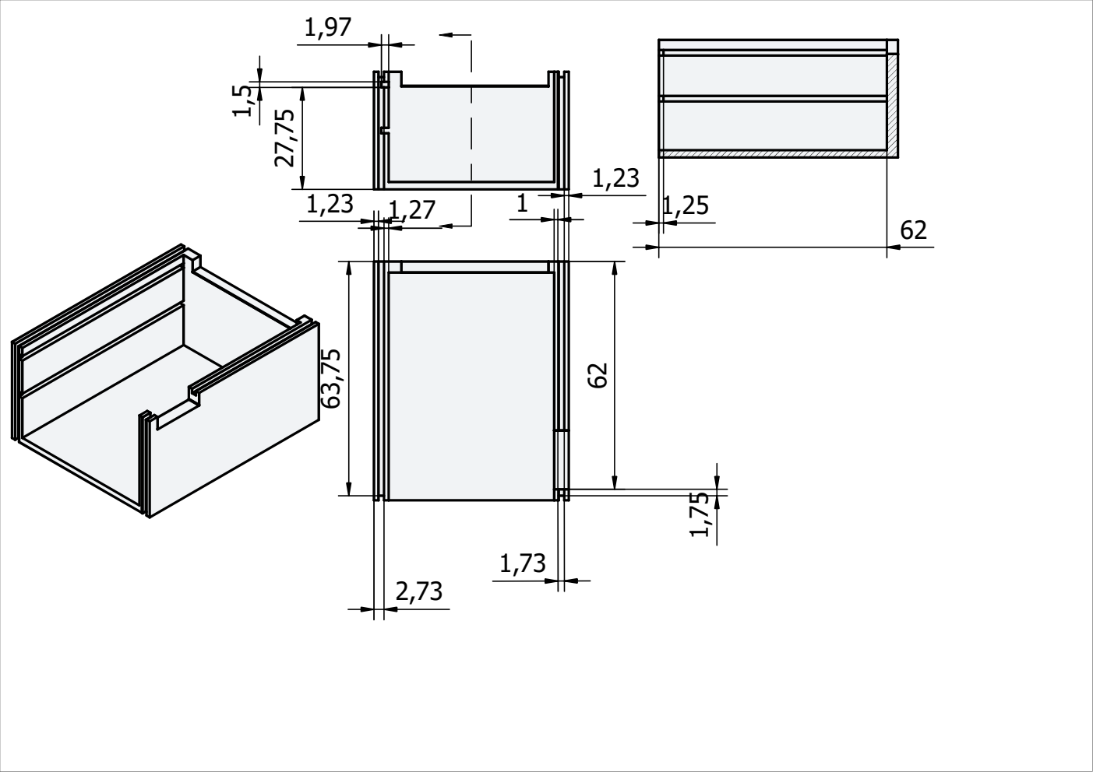
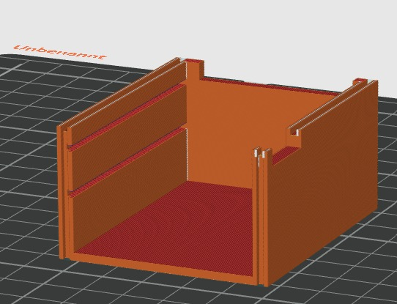

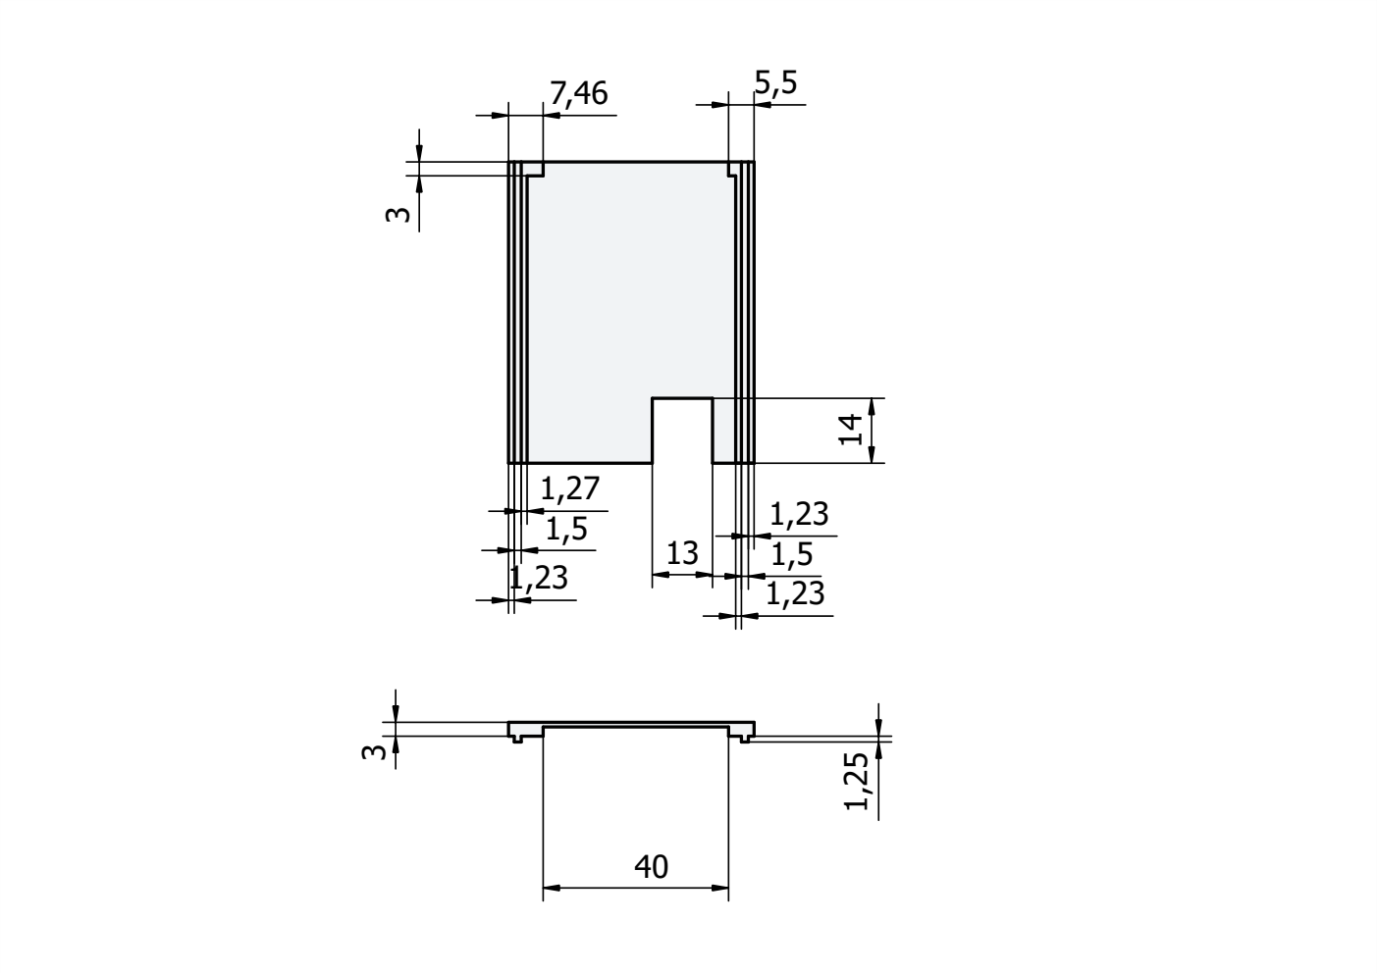

Final print: -Added holsters for the transceivers to stabilize the whole build and physically protect the transceivers against external mechanical influence
->Holsters include slots at the ceiling for the ceiling wall to further stabilize the build, wasnt needed in tests so far but is left in for possible future enhancements to the build

-Added a bottom wall to the ceiling right beneath the stm32 to stabilize the internal circuit
->prior tests showed that the circuit fell out occasionally when pushing in a usb c cable into the microcontrollers usbc socket, the ceiling wall translates the physical energy generated from the push to the whole casing instead of leaving it entirely on the circuitboard

-Extended the ceiling wall to cover up the transceivers from the top up to the antennas

-Removed the second upper slot because of it worsening the stability of the first essential slot

