1st step: Female header soldering
-Soldered the female header pins to the perfboard by pushing in male header pins on a breadboard for each angle , pushing in the female headers and layering in the perfboard holes in the needed constellation, and then soldering the female headers through the perfboard holes to the perfboard
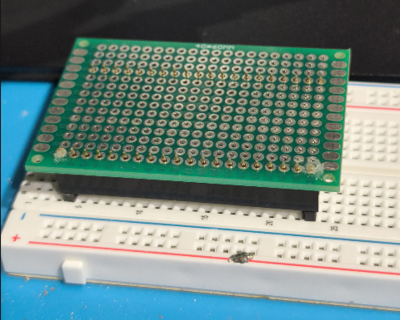

-The female header pins for the transceiver were a bit more tricky in order to keep them at a (somewhat) equal angle during the soldering process, soldering the row closer to the perfboard border first fully and then glueing the second row behind to it with kapton-tape did the trick
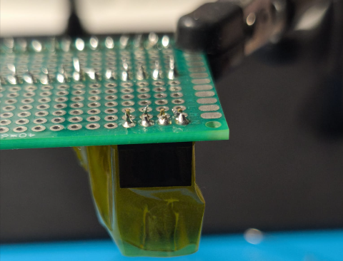

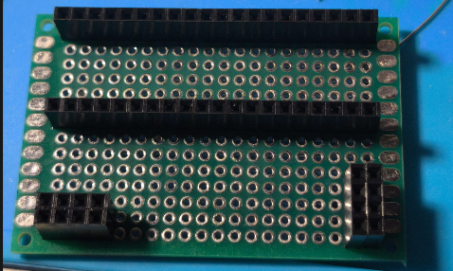
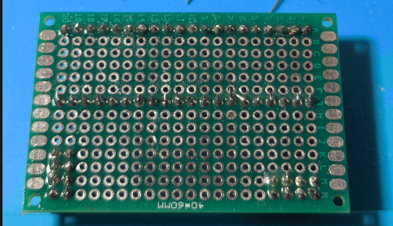

2nd step: V and Gnd rail
-The stm32s Voltage supply and Gnd pins (X,X) get soldered through rails and wires to the transceivers Voltage and Gnd pins (X,X)
-The layout of the bottom transceiver (I,II?) requires a crossover over the gnd rail, which is why that one gets soldered first
-In order to avoid even more complicated layers for the busy right side of the board, the rail for V and Gnd go over the left side to the top transceiver (I,II?) , the pins the rail cover at the top arent needed whatsoever for this project
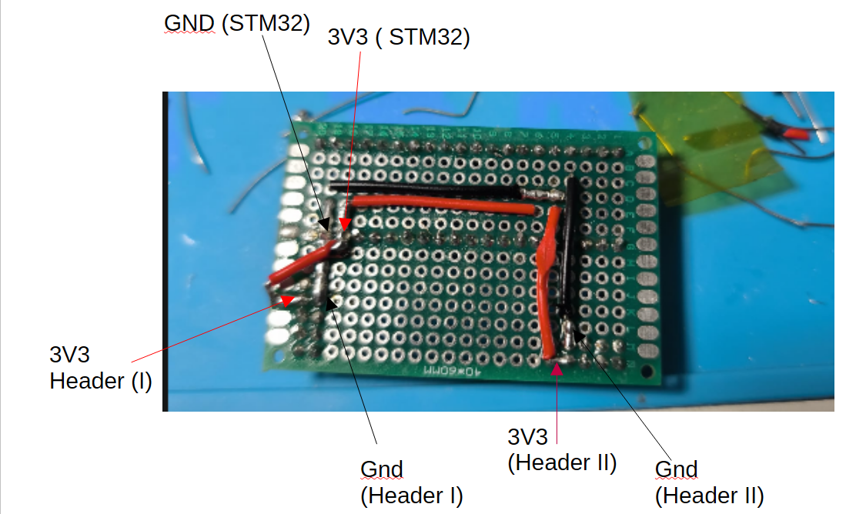

3rd step: Focus on Header II
-After the initial VCC and Gnd rails the first SPI rails can be soldered
-In theory the board can be soldered by going layer by layer, exactly just how the layout sheet documented the build
->In practice after the first layer was finished a focus on the second header with 3 layers started was chosen for testing purposes

-Both the layout sheet build and the one documented here are valid, for this document the order in which the rails were soldered is detailed

-Worth noting in this step is that the MISO II rail goes through the top layer to avoid overly complicated cluttering on the bottom layer

-One recommendation that deviates from the physical build: Colorcoding for the rails is heavily documented, i.e. using different wire colors
-Another recommendation is to use less solder rails and use component legs ( resistors, diodes etc.) instead for lengthier solder connections if wires arent ideal for the situation
-After each rail is fully soldered, signal continuation tests should be made for the rail and the neighboring rails to rule out short circuits, cold joints, etc.
-Soldering joints that are in proximity of other joints or wires require tons of kapton tape all around them, around every nearby part except the spot being soldered

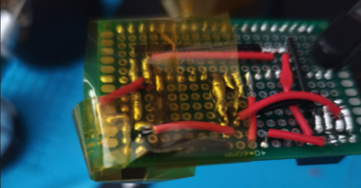

-To test the signal quality of the rail proper bitbanging code was flashed to the stm32 and then heavily tested using an oscilloscope and a logic analyzer software, this part is detailed seperately in the bitbanging chapter

I. CE I (1st bottom layer)
II. MISO I (1st bottom layer)
III. MISO II (top layer)
IV. CE II (2nd bottom layer over GND II and 3V3 II)
V. CSN II (2nd bottom layer over 3V3 II’s pin)
VI. SCK II (3rd bottom layer)
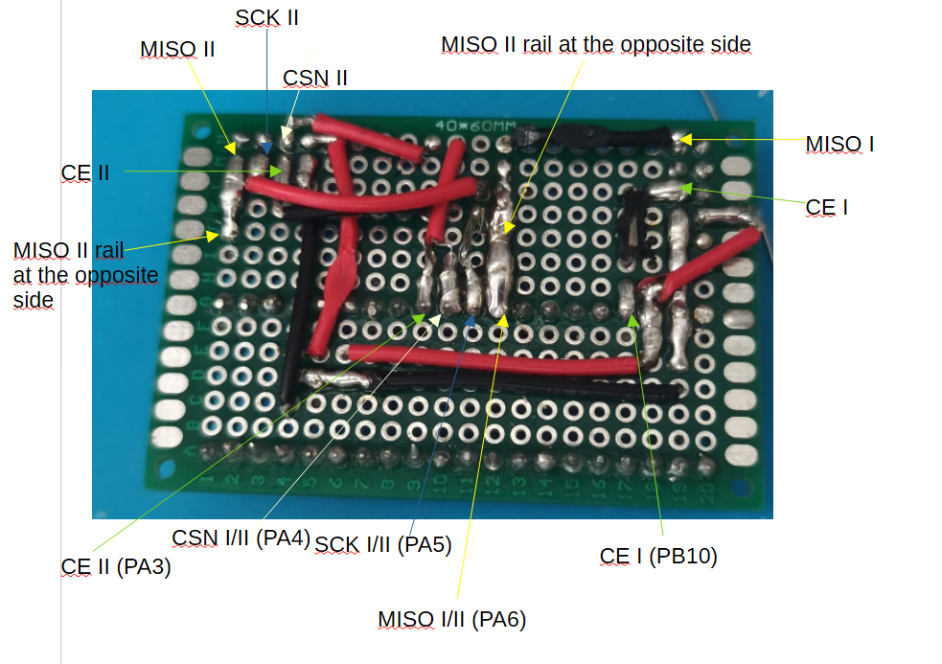

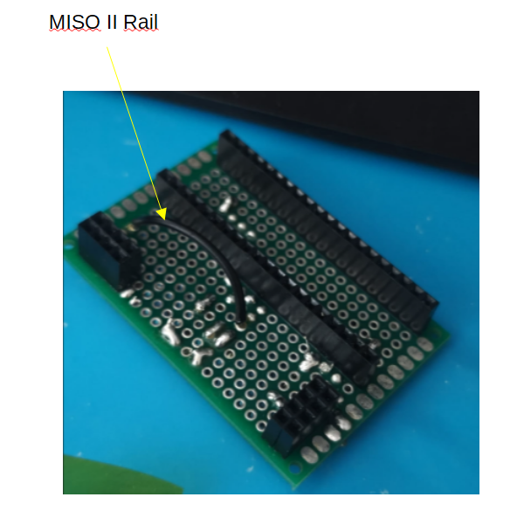

4th step: More 2nd and 3rd layer rails
-Soldering of the rails MOSI II, SCK I and CSN I in the following order:
VII. SCK I
VIII. MOSI II
IX. CSN I

-The image used for documentation doesnt have the rails to the wires fully soldered which is why colored errors go over the board to symbolize the corresponding rails, following images show the soldered rails
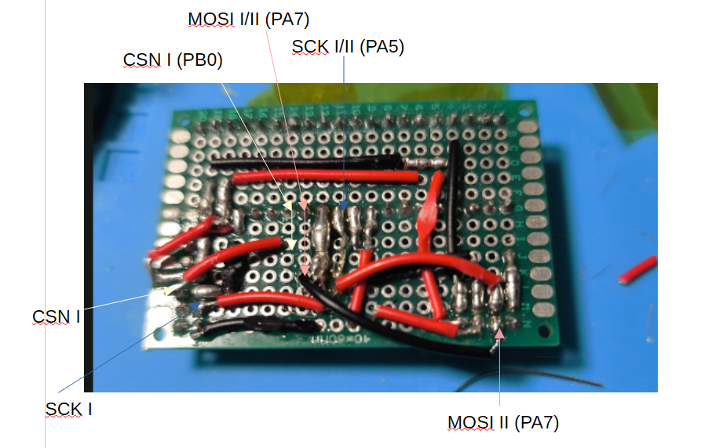

5th step: Capacitators, final 3rd and fourth layer rails
-In this step the final 3rd layer rail is soldered together with the capacitators
X. MOSI I
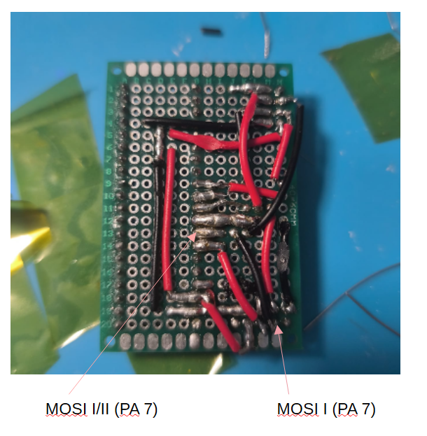

-Since its heavily recommended to use (minimum) 10 microfarad electrolytic caps, a combination of them and 100 nanofarad ceramic caps are used for both headers 3V3 and Gnd pins (I and II), the 100 nanofarad caps are meant to stabilize the electric build by decoupling high switching noises and voltage spikes
-An additional 100 nanofarad ceramic capacitator was added to the header pins for the stm32 microcontrollers 3V3 and Gnd rail to further stabilize the build
-The ceramic caps should be as close as possible to the centerpoint of the headerjoints, the electrolytic ones can also be very near to the centerpoint but work fine at a smaller distance of a few mms to a cm to the header joints
-Both ceramic and electrolytic caps were soldered to the perfboard by sliding the legs into nearby empty perfboard holes and resting the caps at a 90 degree angle towards the targeted joints
→It is a known „issue“ that nrf transceivers require 10 microfarad electrolytic capacitators to avoid constant brownouts, it is recommended to always use them for projects involving nrf transceivers
-It is recommended to solder the capacitators right after step 2 when the 3v3 and gnd rails are finished to avoid further complications with space issues, not in this fifth step as shown here
-Notice: To clearly show the locations for the capacitators an image was chosen for documentation where only the ceramic caps were soldered first, however both types of caps should be soldered to the header locations shown here

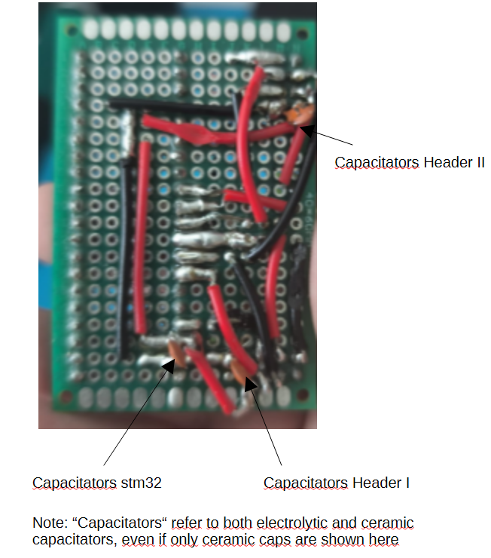

-After the capacitators get soldered to the board the final fourth layer including the IRQ rails get soldered

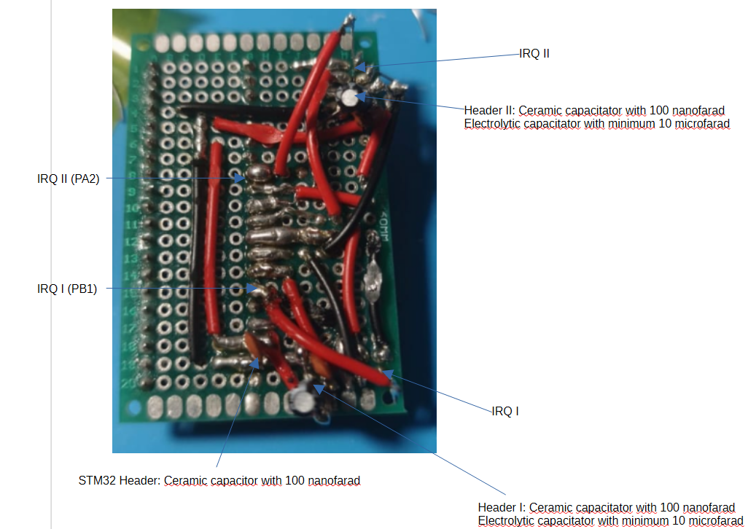

-After this step the board has everything it needs to fulfill its purpose, outside of a mechanical casing to give it stability and protection

Casing build goes into here

Firmware/Software bringup:
-The next step after bringing up the protodeck from the hardware side is to validate its integrity through software tests
-The first step for the software tests is a bitbanging validation process, meant to test if the pins can properly handle the speeds necessary for an spi protocol
-The bitbanging tests should be done in the following order:
I. crisscross 1 at 500 nanoseconds
II. crisscross 2 at 500 nanoseconds
III. Full output at 500 nanoseconds
-crisscross 1 pulls the following pins high and low in a (targeted) 500 nanosecond distance:
CE I/II, MOSI I/II, MISO I/II
-crisscross 2 pulls the following pins high and low in a (targeted) 500 nanosecond distance:
CSN I/II, SCK I/II, IRQ I/II
-full output pulls every pin on Header I and II high and low in a targeted 500 nanosecond distance except GND I/II and 3V3 I/II

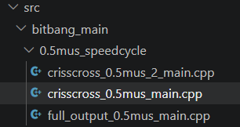

Only the following source files are needed for this test, the other speedcycles arent relevant

-This crisscross layout allows each tested headerpin to have free unpulled headerpins all around, showing if undetected prior coldjoints are present or if heavy crosstalk between the rails is at play

IMPORTANT: -The code and hardware verification repositories include tests for other speeds than 500 nanoseconds, however, DO NOT WASTE TIME ON TESTS ABOVE 500 NANOSECONDS SPEED, 500 nanosecond speed tests are more than enough to verify the pins quality, lower speeds do not give enough varying or in depth data to excuse running thorough tests for them

-In order to flash the needed bitbanging code, plug in the stm32debugger to the exposed upper 4 pins after the corresponding labels using jumper wires and follow the following steps on visual studio code:
1.Navigate to the platformio.ini file
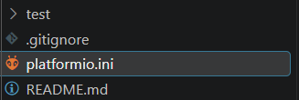

2.uncomment the build_src_filter line that includes the src.-file you wanna flash to the prototype by removing the „;“ in front of the line
IMPORTANT: only uncomment the single line in the .ini file that corresponds to the test youre running at the moment, never leave several uncommented at once

3.start compiling the code by opening the CLI terminal and typing pio run -t clean, then running pio run -t upload to properly flash the code to the prototype

IMPORTANT: -Visual studio code’s graphical user interface bottom bar should not be used for this bitbanging phase of the project since it doesnt work well with the build_src_filter approach used, which is why CLI terminal direct commands are very recommended
-always run pio rin -t clean before building or flashing different code since without that step you will likely flash the same code as before to the microcontroller
The interface on this bottom bar should be completly avoided from using

4. run physical tests on the pins with the oscilloscope
Calibrate the settings of the oscilloscope so it has the displayed values as discussed in the setup chapter
-put the oscilloscopes gnd potential into each of the GND header pins
→It doesnt matter which GND pin (GND I or II)
-put the oscilloscopes voltage input into whichever pin you wanna test first
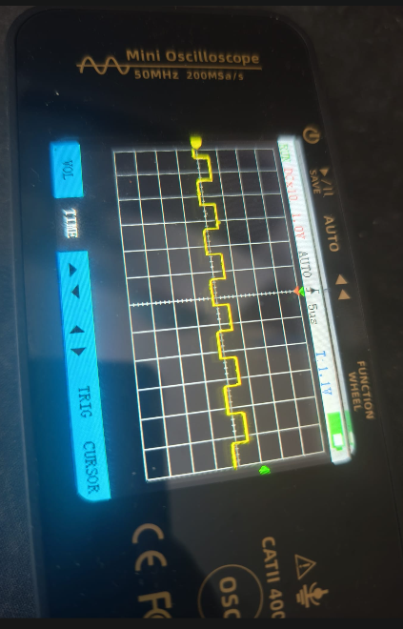
-For a nonpulled pin (that isnt 3V3 or GND): The oscilloscope should show a squarewave with an amplitude that raises slightly upwards but not above 700-800mV for a period of 500ns, before showing a squarewave that raises downwards for 500 nanoseconds which shouldnt go above 700-800mV as well
→Anything above 800mvs for a nonpulled pin can be received as a logic low threshold and cause unwanted behavior both on the software and the electrical side of the build, values above the threshold of 800 mv require reworks until the threshold or below is reached

Example of a typical, even if high amplitude, square wave of a non pulled pin

NOTICE: the squarewave can be different from the one detailed, for example in the form of a sawtooth instead of a square, or have a rise and fall that isnt a clean vertical line, whats important is that the highest point of the amplitude isnt above 800mV and that the time between the rise and fall of each wave isnt above (roughly) 500 nanoseconds
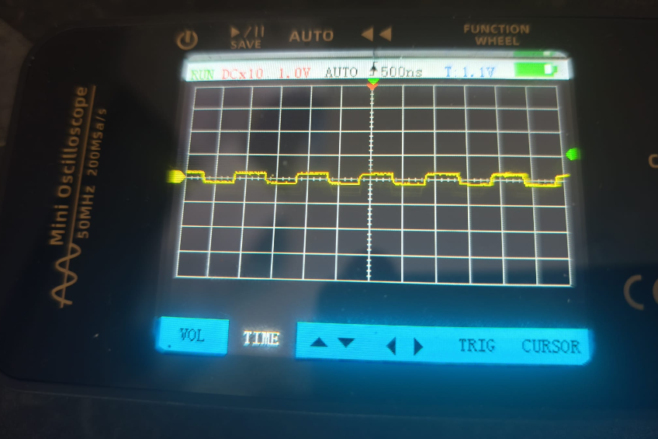
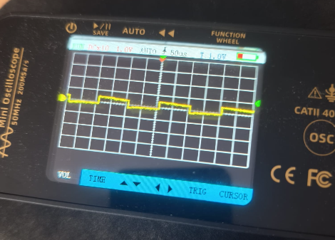

Exemplory images of nonpulled pins that show acceptable and expectable behavior, even if the waves arent „clean“ squares

For pulled pins (that arent 3V3 or GND) :The squarewave has to have an amplitude of 3.3 V and a distance between the fall of the wave and the rise of the next wave of 500 nanoseconds
IMPORTANT: The waves will not be completly clean squares and oftentimes look like exponential rc charges instead, this is completly expected and normal

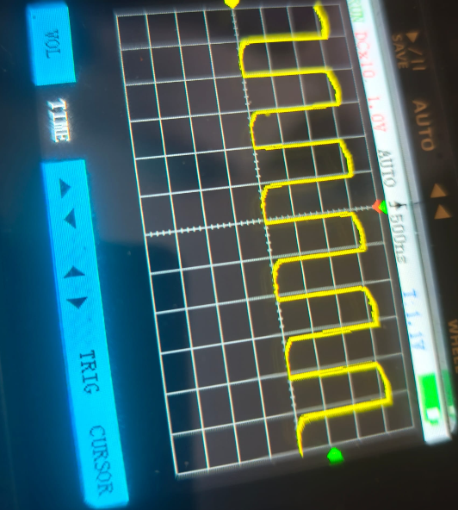

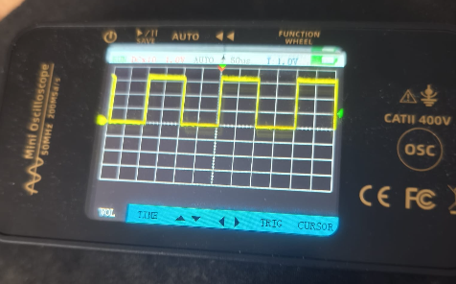

example of exponential square waves (left) next to „clean“ squarewaves (right)

-Any pin that deviates greatly from the discussed threshold ranges will need overwork until the criteria are met, otherwise hardware faults will only cause more problems later
→undisclosed differences like speed differences between unpulled pins and etc. are not an issue, only the discussed criteria have to be fulfilled

-After every pin was tested on the oscilloscope its time to move on to the logic analyzer test

5.logic analyzer test
-Once the oscilloscope test for the corresponding test was successfully pulled through, plug in the logic analyzer to your pc and put in the analyzers jumper wires into the tested pins
→Dont forget to put in the logic analyzers GND potential to one of the header pin GNDs to get reliable results

Open the logic analyzer software nrf pulseview and apply the following settings:
-navigate to the „connect device…“ menu next to the screwdiver
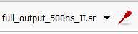

-click on the arrow pointing down and select the highlighted option „Connect to device…“
-In step 1 pick the driver fx2lafw
→Other drivers are also possible, however fx2lafw as a general driver is recommended
-In step 2 pick usb
-In step 3 click on the bar to search for connected compatible devices, which should be the plugged in logic analyzer, after which the device should appear in step 4
-select the device in step 4 and click on OK
IMPORTANT: -If your pc does not have the fx2lafw driver, update your usb drivers to include them
→As a recommendation, zadig is a straightforward software to get this done
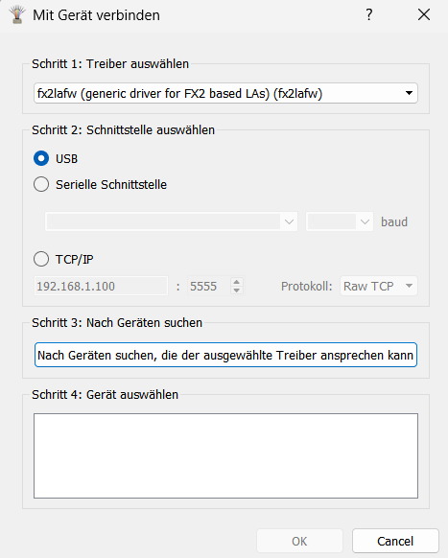

-Adjust the samplerate to 1 Million samples, set a frequency of 24 MHz
→lower frequencies are also possible but less accurate, anything below 1 MHz isnt fast enough to produce reliable results
→the cheap logic analyzer used here tended to often get stuck on old settings, if it happens change the frequency and run play again
-After everything is set up, press the start button and let the logic analyzer run its test
- the zoomed out picture should look like constant and nearly identical squarewaves
-zoom in and click on the blue markers next to the select device option
-move one marker to the rise of one squarewave and the other to the fall of one squarewave, the markers now measure the time between a rise and fall for all the plugged in signals if you subtract the right markers value against the left markers value
-On nrf pulseview the measured squarewaves should not be up or below around 400-1000 nanoseconds, below 300 ns and above 1500 nanoseconds are untolerable hardware faults on the tested pins that need to be fixed
→the range of 400 ns to 1000ns is completly acceptable, even if 500 ns is the flashed code target the logic analyzer together with the logic analyzer software increase heavy jitter that explains the deviating value
Hint:Its recommended to run two logic analyzer tests for the full output run, one for header I the other for header II, since the used logic analyzer doesnt have enough pins to run the test on 12 pins simultaneously

-Repeat this cycle of flashing bitbang test→running oscilloscope test→ running logic analyzer test→fixing potential errors for each bitbang cycle (crisscross I, II, full output)
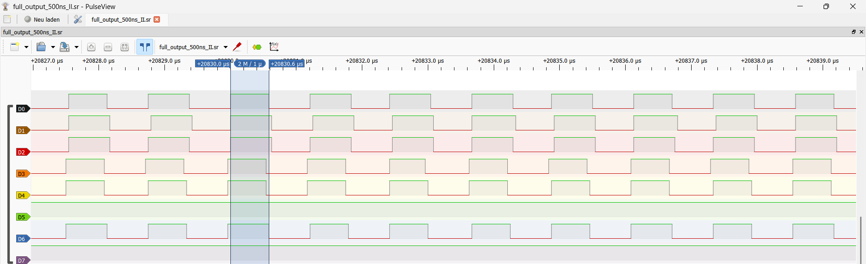

IMPORTANT: -After these bitbanging tests were run through succesfully, the perfboard build is confirmed to run in the thresholds that are needed for the prototype
-upcoming issues in tests and etc. are very likely to be caused by external factors or hardware faults with the plugged in modules, not the board itself

