QCWWAN Drivers   
Build Procedures

(Major Version 1, Minor Version 0)

June 24, 2015

Submit technical questions at:  
https://support.cdmatech.com

Contents

1 Introduction 4

1.1 Purpose 4

1.2 Revision history 4

2 Basic Release Procedures 5

2.1 Versioning Scheme 5

2.2 Scheduling release 5

2.3 Release notes 5

2.4 Perforce changes 5

2.5 Build locally 5

2.6 Manually create a label 5

2.7 Build using CRM Build Request Tool 6

3 QUD.WIN.1.1 7

3.1 Introduction 7

3.2 Build Environment: 7

3.3 Build script description 7

3.3.1 CRM Build Syntax 7

3.3.2 Internal Build Syntax 7

3.3.3 Perforce 7

3.3.4 Versioning 8

3.3.4.1 Changing version in INF files: 8

3.3.4.2 Folder and File Mappings 8

3.3.4.3 Changing version in Resource (RC) files: 9

3.3.4.4 Changing version in Source files: 9

3.3.4.5 Changing version in Installer: 9

3.3.5 Readme Update 9

3.4 CRM Build Request 9

3.5 Publishing 11

3.6 Notes 18

Tables

Table 1 Revision history 4

Table 2 Release Information 5

# Introduction

## Purpose

This specification documents the build process for QCWWAN drivers deliverables.

## Revision history

Table 1 Revision history

| Version | Date | Description |
| --- | --- | --- |
| 1.1 | Jun 2015 | Initial release |

# Basic Release Procedures

## Versioning Scheme

* CRM versions are multiples of 1 (ie. 1.00.35, 1.00.36, 1.00.37, 1.00.38…)

## Scheduling release

All CRM releases should be scheduled at least a week before the release date, ideally 2 weeks prior. Schedule the release at:

<http://go/tiberium>

Table 2 Release Information

| WWAN Drivers | WWAN Drivers Description |
| --- | --- |
| QUD.WIN.1.1-<100XX-GENERAL> | Tool descriptive name: This will build the full package including drivers and installer |



## Release notes

The release notes are updated as part of readme.txt file.

## Perforce changes

All changes needed for a release must be checked in prior to doing a build because the build script gets the latest versions before it builds.

## Build locally

The purpose of building locally is to find errors before running the build request.

From the command line, traverse to the appropriate folder for your client spec, then run the Batch build command. This will run the build script.

## Manually create a label

Within P4 labels, create a copy of an existing label by right clicking on the existing label and selecting “Create/Update label using XXXX as the template”, enter new name, make sure it is unlocked.

Within client view select the files to label, then right click on label and select “Add/Replace files…” Here you can sync the files to a label, changelist or head revision. To create a label for release, do the same as a config file, sync in same order as is listed in the config file lists.

Example:

label: QUD_WIN_1.00.36

head_paths: //depot/QMI/win/qcwwan/...

1. Sync all //depot/QMI/win/qcwwan/ files to QUD_WIN_1.00.36

## Build using CRM Build Request Tool

This request tool runs our build script on a CRM build server. Follow the instructions in the following sections to build each release.

Once the request has been sent a series of emails are received that indicate the status of the build. When it successfully completes the build path will be part of the emails

# QUD.WIN.1.1

## Introduction

The QUD.WIN.1.1 is built for two reasons

1. Provide generic build for internal Qualcomm use and select external customers.

This build creates an installer with drivers.

## Build Environment:

1. Visual Studio 2010
2. Perl 5.6
3. Microsoft Windows Driver Kit 8186 (go/wdk)
4. Install Shield 2012

## Build script description

### CRM Build Syntax

buildCustomer.bat: This batch file should be used to build drivers package on CRM server























































































































































































### Internal Build Syntax

buildCustomerLocal.bat: This batch file should be used for building drivers package on local system.

### Perforce

Server: qctp402:1666

Location: //depot/QMI/win/qcwwan

Client Spec:

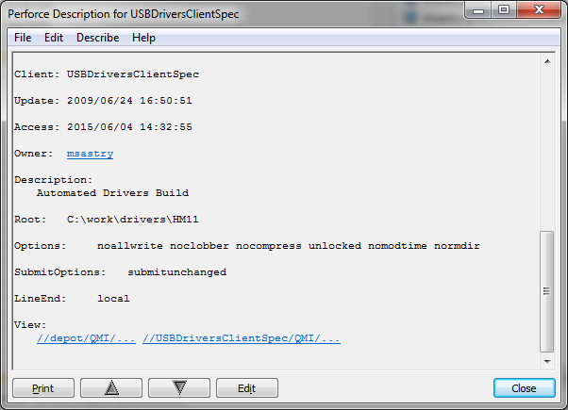

Lable : QUD_WIN_x.xx.xx (For Ex. QUD_WIN_1.00.36)

### Versioning

Please make sure the local copy is synced to the head of the perforce path.

#### Changing version in INF files:

INF files Location: //depot/QMI/win/qcwwan/build/

Files to change: qcfilter.inf, qcmdm.inf, qcnet.inf, qcser.inf, qcwwan.inf, qdbusb.inf

Update the DriverVer <Date,Version>. Update to the next incremental number

#### Folder and File Mappings

qcfilter.inf: Sources are in filter folder, this driver is for QMI communication.

qcser.inf: Sources are in serial folder, information file for Ports (DIAG, SER, NMEA, etc.)

qcmdm.inf: Sources are in serial folder, information file for MODEM (MODEM).

qcnet.inf: Sources are in ndis folder, information file for Network Adapter (Ethernet NDIS 5.1 driver)

qcwawn.inf: Sources are in ndis folder, information file for Network Adapter (WWAN NDIS 6.20 driver)

qdbusb.inf: Sources are in qdss folder, information file for QDSS (QDSS)

#### Changing version in Resource (RC) files:

Filter Driver RC file: //depot/QMI/win/qcwwan/filter/qcfilter.rc -> Open in any editor and update to next version number.

NDIS Driver RC file: //depot/QMI/win/qcwwan/ndis/qcusbnet.rc -> Open in any editor and update to next version number.

Serial Driver RC file: //depot/QMI/win/qcwwan/serial/qcusbser.rc -> Open in any editor and update to next version number.

#### Changing version in Source files:

We have to hard code the version numbers in 2 .c files, this is needed for printing version numbers in the log files:

NDIS Driver: //depot/QMI/win/qcwwan/transport/usb/usbpnp.c -> Search for “Driver Version” and change the version number.

Serial Driver: //depot/QMI/win/qcwwan/serial/qcpnp.c -> Search for “Driver Version” and change the version number.

#### Changing version in Installer:

File: //depot/QMI/win/qcwwan/installer/QualcommDriverInsatll.ism -> Search for “ProductVersion” and update the version number to the next installer version.

File: //depot/QMI/win/qcwwan/installer/QualcommDriverInstall/String1033.txt -> Search for “PRODUCT_VERSION” and update the version number to the next installer version.

### Readme Update

The readme.txt is in the following path //depot/QMI/win/qcwwan/installer/. Please update the readme.txt with the changes for this release

## CRM Build Request

Please update the files and check-in the files to the perforce and update the LABEL QUD_WIN_1.00.XX with all the files. And submit the build request using go/tiberuim.

Following is the screen shot of the build request:

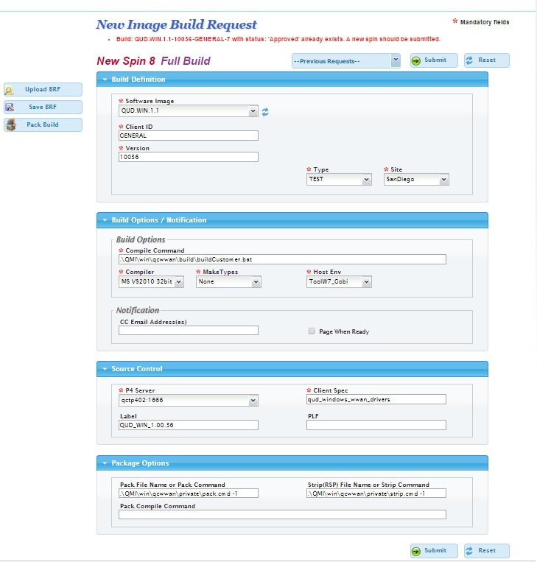

## Publishing

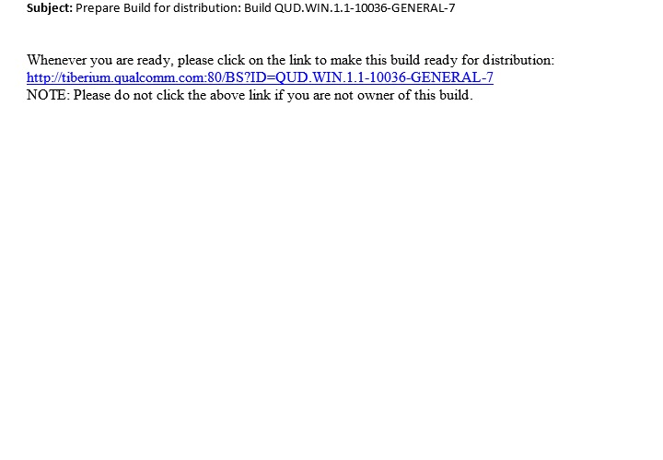

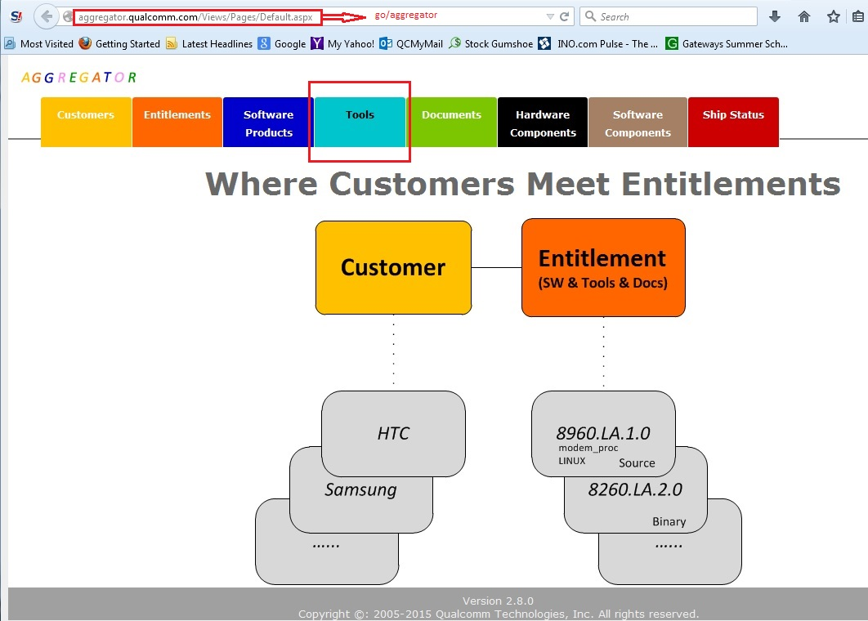

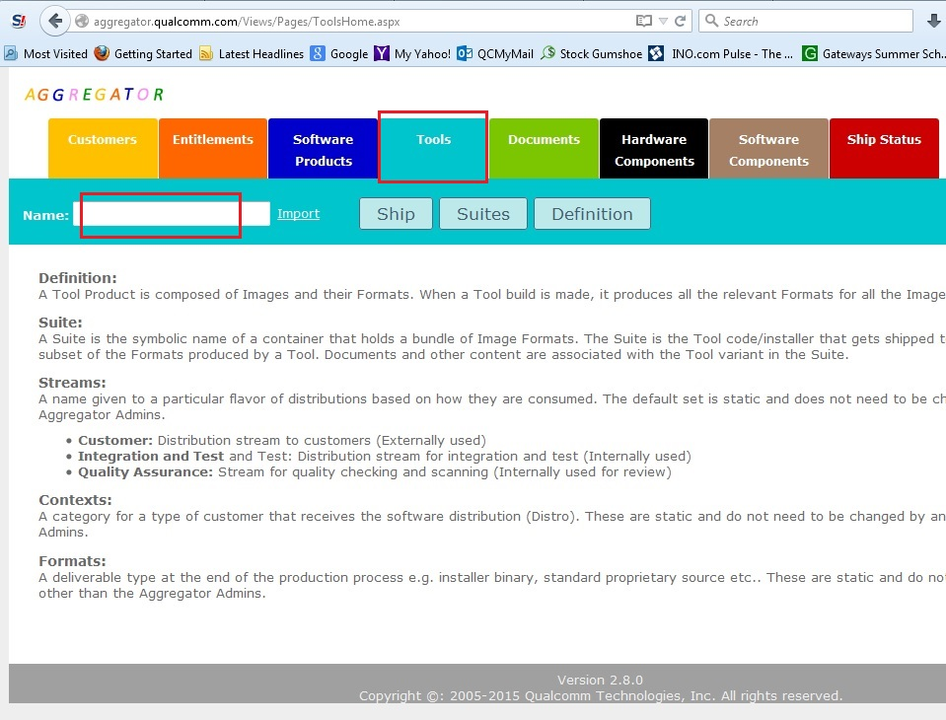

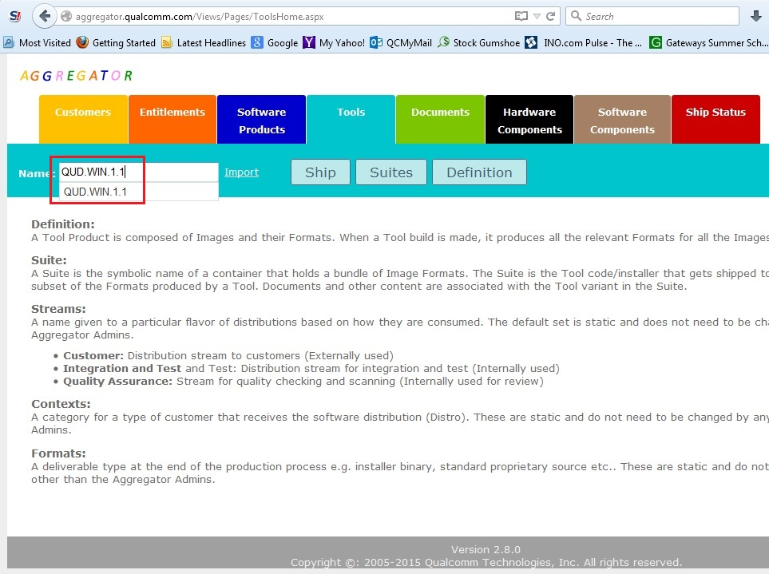

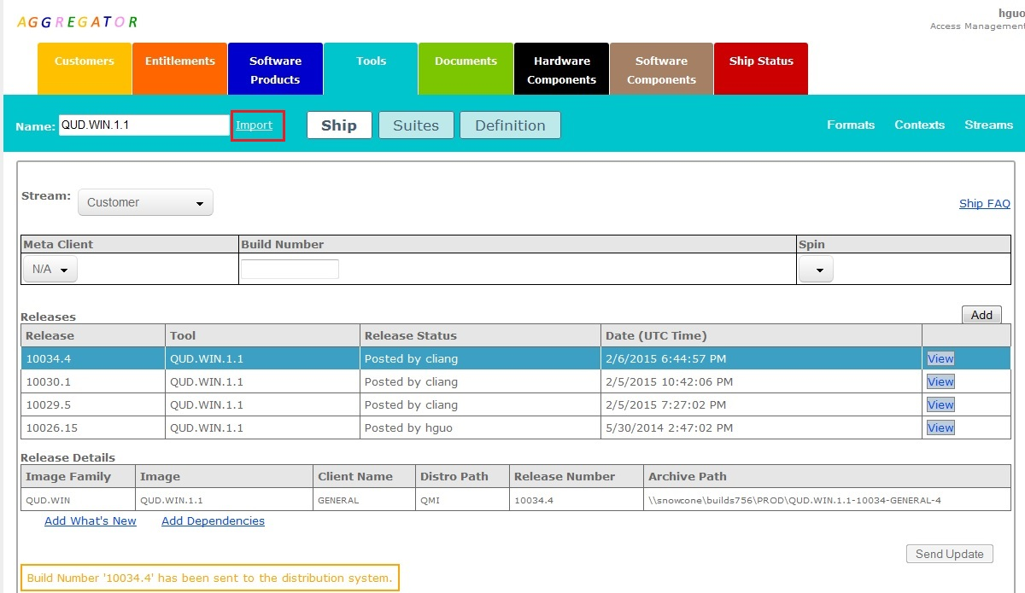

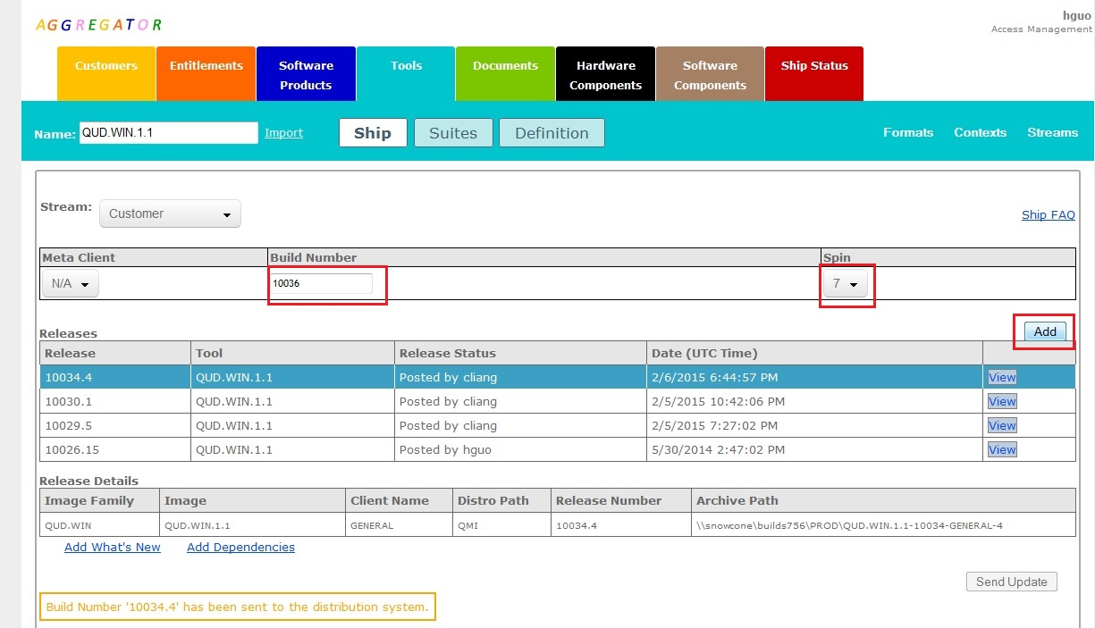

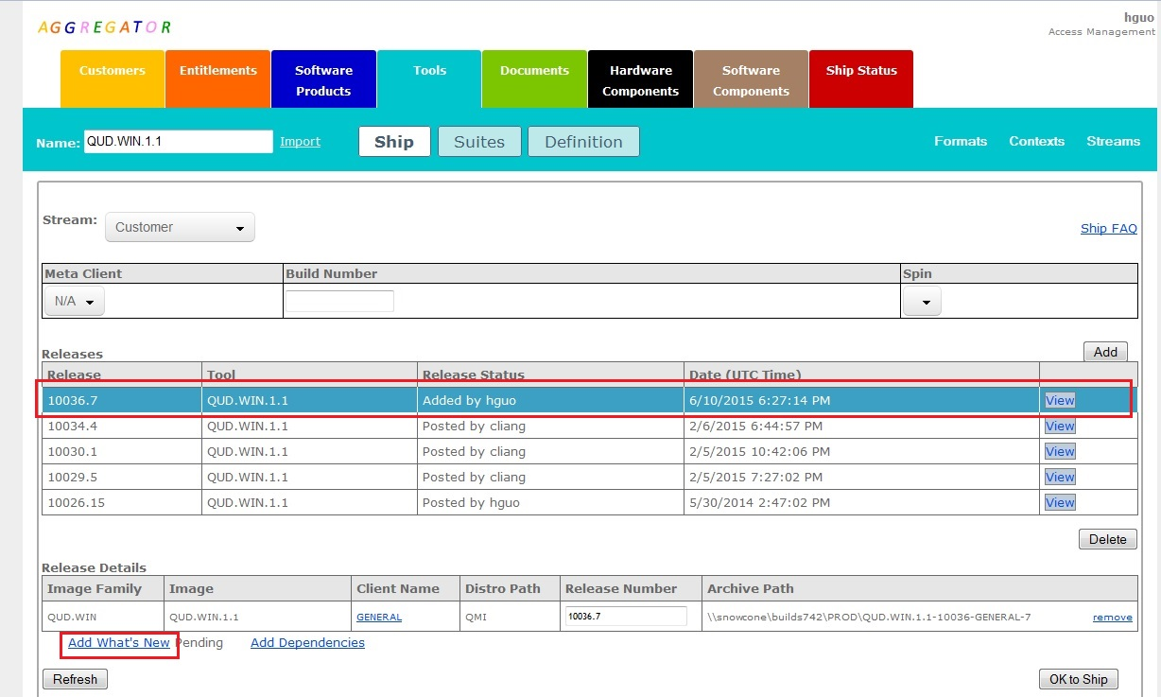

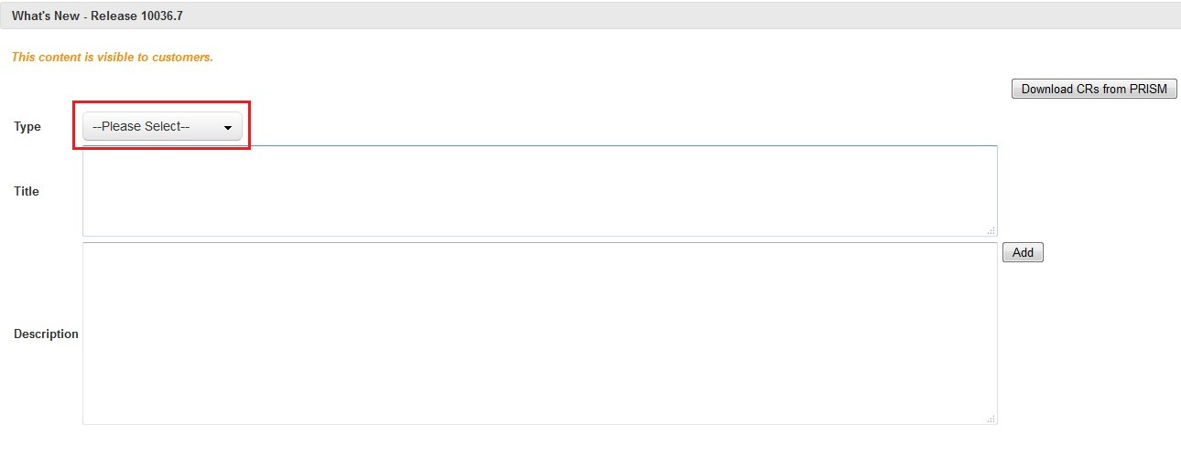

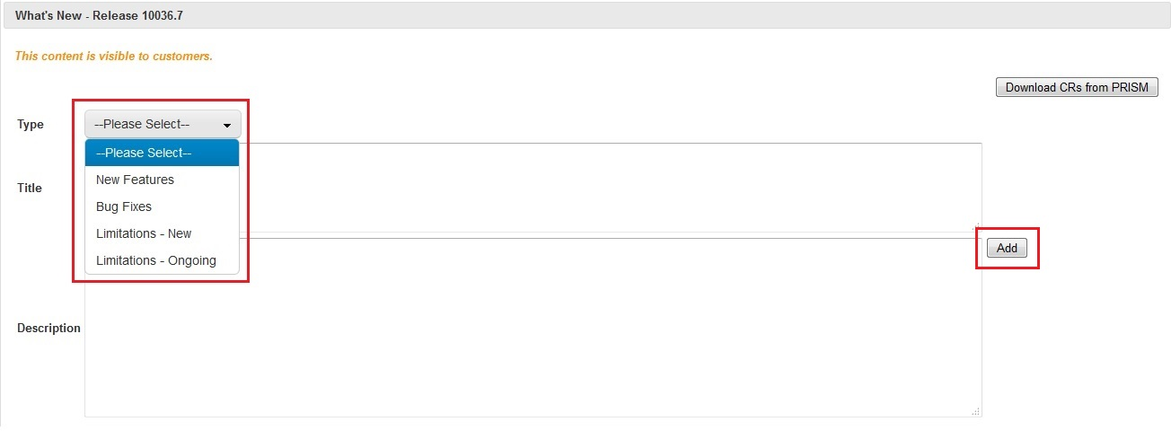

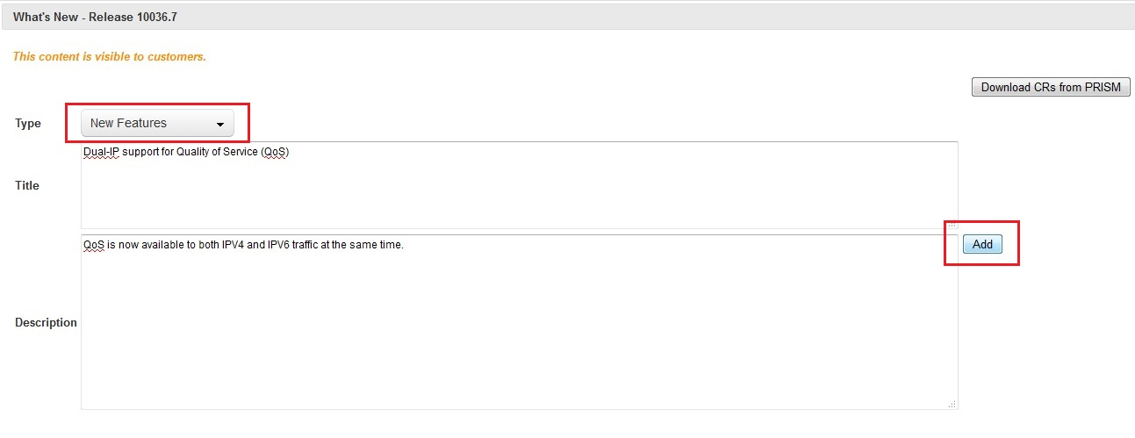

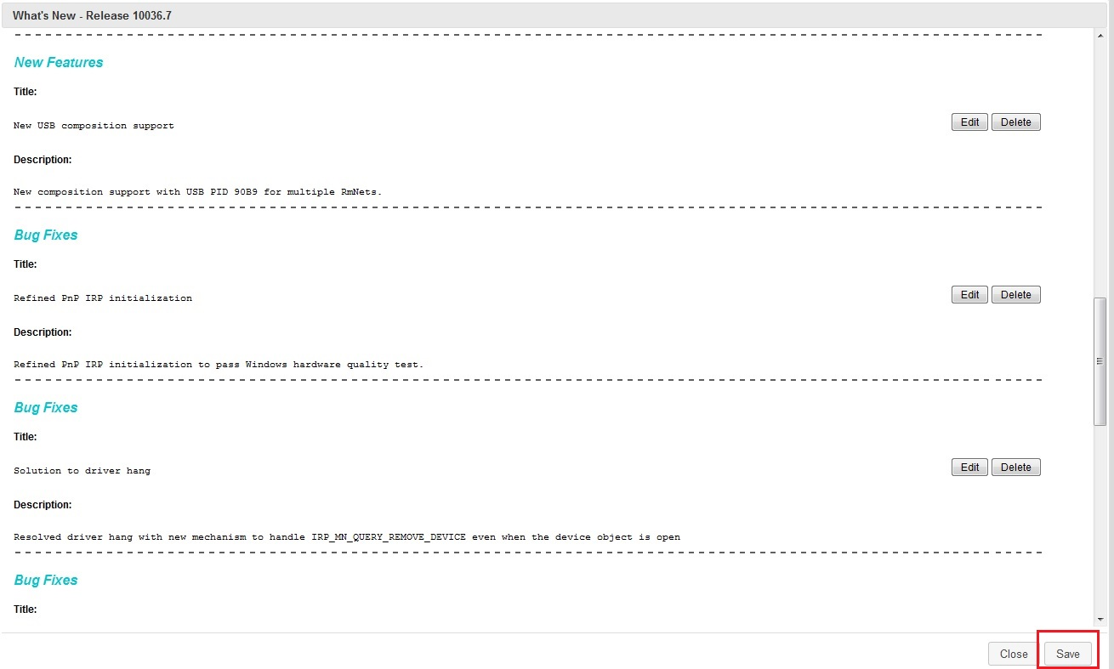

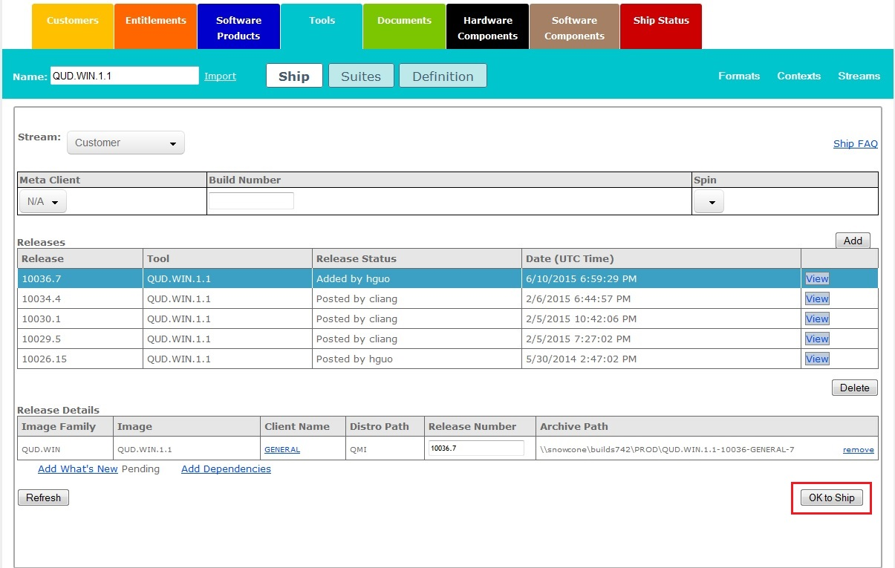

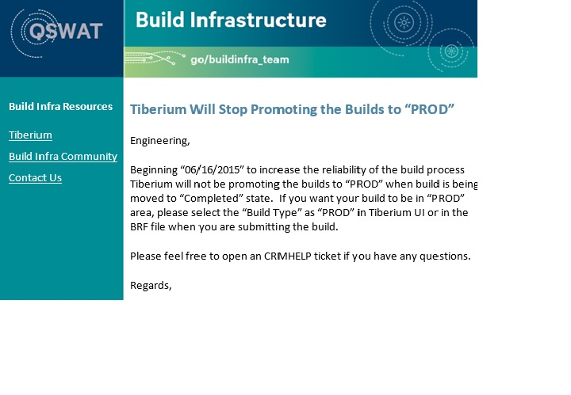

## Notes

We always use ToolW7_Gobi as Tool Env for building the tiberium build and this internally uses the QCTCRMBLD10 as the CRM build server. There is one issue with the build, the user aswbldsv should be logged into the server before submitting the build. Please refer to the JIRA ticket <https://jira-quic.qualcomm.com/jira/browse/QSOHELP-43578>. If the build fails please reopen the ticket.