Documentation of the project and notes for myself

VIDEO

* [INT 10H](https://en.wikipedia.org/wiki/INT_10H) - this interruption will allow me to set the video mode, will provide video services and will write pixels in graphic mode. Click on the headline to see the Wikipedia page of the interruption where you'll find the table that shows that different ways this interrupt can act, based on the value in the ah register (supported functions).
* תמונה שמכילה טקסט

  התיאור נוצר באופן אוטומטיIn the Wikipedia table, you'll see the first function that enables the video mode (AH=00h), it will tell you there that you'll need to specify that video mode in the AL register, here is the list of all of the available video modes (and the differences between them), I will be using 13h.
* Background – navigating to the AH=0Bh Section of the Wikipedia table, you will see the different options for setting of the background color. Click [here](https://en.wikipedia.org/wiki/BIOS_color_attributes) to see a list of the colors.
* Pixel Drawing - navigating to the AH= 0Ch Section of the Wikipedia table, you will see the different options for drawing a pixel on the screen. Click [here](https://en.wikipedia.org/wiki/BIOS_color_attributes) to see a list of the colors.

Time

* Background – In the game, we'll need to move the ball. When you think about it, movement means change the coordinates of the ball every certain amount of time by a changing number of units. For this, we'll need to use time in the program. In my game, I will draw 1 frame every 100th of a second, which means 100fps.
* Int 21h – One of the functionalities of the of the 21h interrupt is getting the system time.

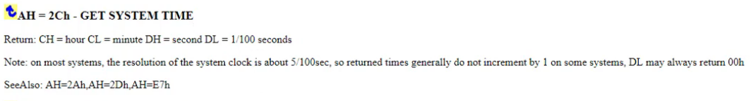

* In the project, I will be using the interrupt and the DL register, to find whether 10 ms have passed.

Input

* [Int 16h](https://en.wikipedia.org/wiki/INT_16H#:~:text=INT%2016h%2C%20INT%2016H%20or,control%20of%20the%20PC%20keyboard.) – In the game, this is the interrupt that will help us tell whether a key is pressed and what key is pressed.
* Checking whether a key is pressed with 01h in the ah register, result will be stored in zero flag.
* Checking what key is being pressed with 00h in the ah register, result will be stored in the AL register, as the ascii value of the key.

