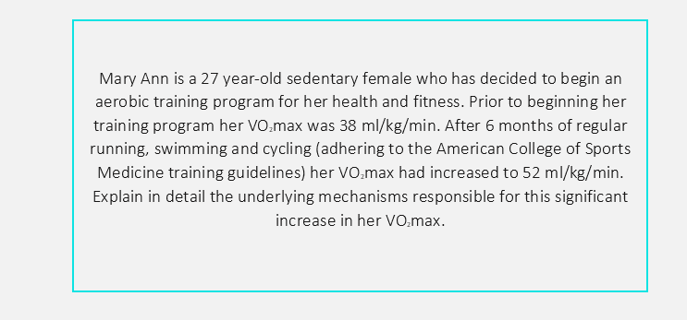

In Mary’s case, first of all, we can turn to the principles of exercise physiology. Due to the “overload principle”, Mary’s physical capacity increased considerably during the first weeks due to imposed stress and the change from a rest state to a physical activity state. Later, due to the continuity of physical activity and recurring sessions, she had chronic adaptations.

Essentially, VO2Max is nothing more than the maximum volume of oxygen the body can process during an exercise. In other words, the term refers to the amount of oxygen that can be used when breathing, and that therefore we can really use when doing a sport (such as running, for example).

VO2Max is expressed in milliliters of oxygen per kilogram of body and minute (ml / kg / min). The general population usually has standard VO2 max values ​​around 40-50 ml / kg / min, and professional athletes are usually around 70-80 ml / kg / min.



The importance of VO2 Max is due to the fact that, in the face of great efforts with high resistance, a VO2 max will give us the opportunity to lengthen the time in which our body uses oxygen best. That is, the more VO2Max, the better we will endure the intensity of the race, and for longer.

Regarding the type of exercises performed by Mary (running, swimming and cycling), which are essentially resistance exercises, Mary presented changes in her respiratory system and circulatory system, this includes an increase in the heart's pumping capacity and increased blood flow. of red blood cells and capillaries that improves the supply of oxygen, and an increase in the number of mitochondria and therefore an increase in the use of oxygen to produce energy by absorption.

Mary also had changes in her endocrine system. In response to recurrent sports training sessions, hormones such as insulin that allows a higher glucose uptake and glucagon that allows maintaining glucose concentrations increase its effect and epinephrine that is responsible for increasing heart rate, stroke volume and blood flow. All this together with the constant activation of the nervous system.