TOKEN RING

David Giampa

Using the make file. Check and see if the makefile is in the same directory as bbpeer.c and bbserver.c.



Starting the server, the arguments are the port number and how many clients can connect.

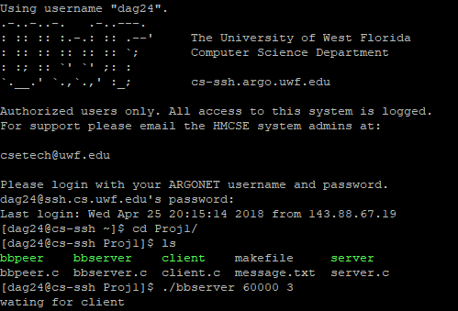

Running the client

2nd arg is ipAddress of the client and the server

3rd arg 3 is the connecting port number

4th clients port number

5th the shared file

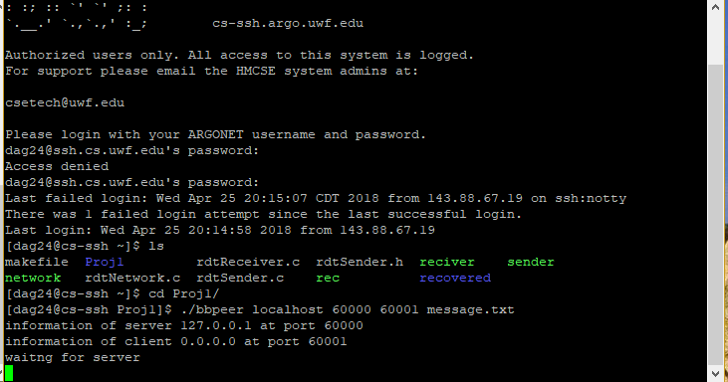

Write and list command. Type in Write and the message you wish to send.

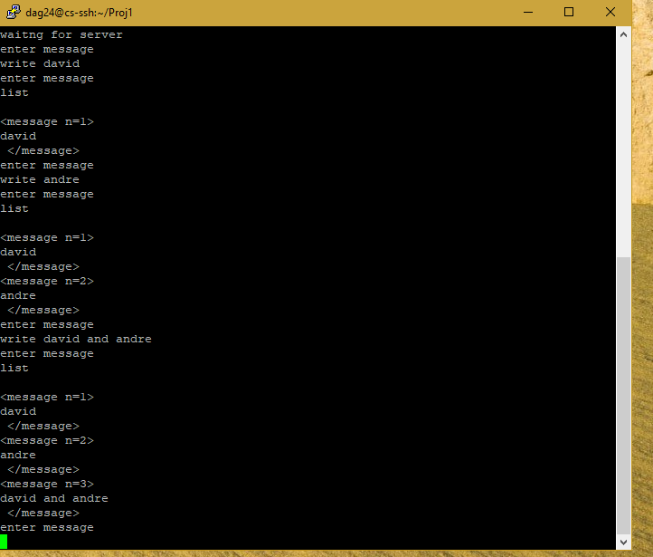

Reading a certain message. Read #.

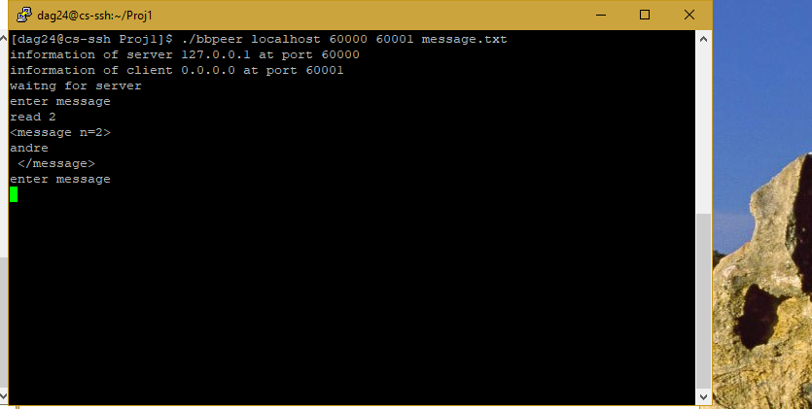

Exiting the ring

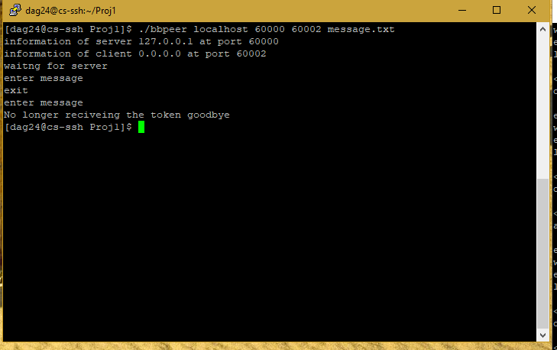

Exiting and reconnecting; notice that the 3rd argument is now 60001. The port of one of the peers in the ring.

