**Synopsis**

**Project 1.2:**

International student in Aarhus?!

**Name:** Luka Gurovic

**Class:** 17x1

**School:** BAA

**Teachers:** Ian, Maria,

**Website url:**

**Characters:** 9162

**Concept and Research**

Choosing the topic of the magazine which I wanted to make was really hard! Even though I had many ideas about what should I write, I always came across come kind of problem. So, after thinking it true, I figured out that using my own experience is the best way of doing it. That is the biggest reason why I have chosen to write and help future generations of students!

The day after I have done the online poll with basic questions, I have got 13 answers. After looking through all of them I was stunned. Since today, I was completely sure that only a few of us in the class had these many problems when we came to Denmark, but to my surprise I was wrong. According to the answers, almost 100% of participants had the same problems as I had!

After looking at my results I came to the conclusion that all of the future generations of students in the city of Aarhus should be able to get access to the magazine where they can find everything that one international should know in first few weeks of arrival.To apply for the residency permit and CPR we were forced to skip school because everything closes at 3, then finding a student job while knowing what to search for and also knowing how many hours you have to work.

On the other hand, in future when magazine becomes for popular between students, besides these "most important" things, we could cover even smaller things such as: How to buy a bus ticket, what type of bus ticket is the most affordable, where can you find the cheapest stores?

Now I will show you my pole results:

**Question 1:**

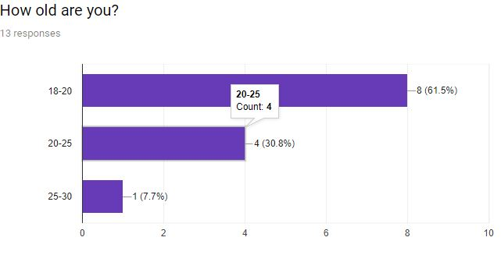

There is nothing much to say about this question. The point of it was just to welcome people with a simple question!

**Question 2:**

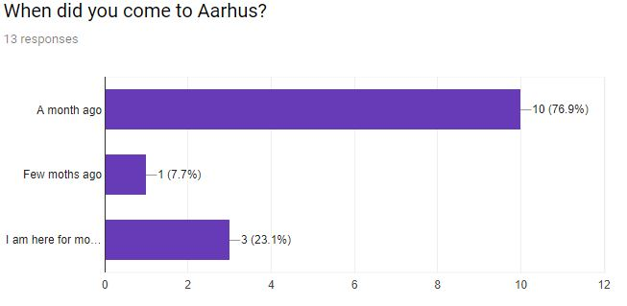From 13 people who participated in the pole, only 3 of them stayed in Aarhus more than a month before university. This was not surprising, but from my point of view, this is the thing where the problem begins.

Our university started one month ago which tells us that most of us came here right before begging. Because of that, there was not much time to adapt to the whole different culture.

If every one of us had opportunity to have simply structured website with instructions and suggestions before we came here we could prepare ourselves much better and easier.

**Question 3:**

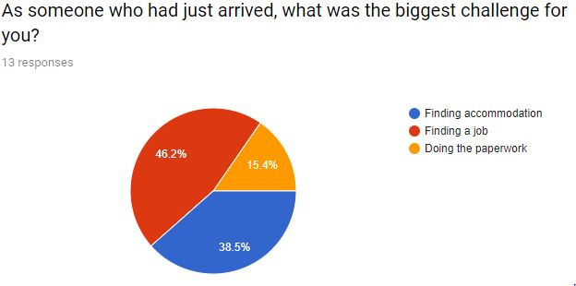So, for the third question, I basically wanted to get straight to my point.From the answers people had given we can see that most of them had issues regarding finding a student job. There are many facebook groups and websites where students can search for a regular job, but also only a few of them knows that right in front of them in our university there is a place where you can see job offers. There is no one to blame here, lack of information leads to many issues so I will use this big percentage of 46% and focus on that while writing the article about "job hunt”.

**Questions 4:**

I think that only by looking at the stats from this question everyone can see what am I talking about. From all people who attended in the pole, only one could catch up with school before solving these issues. From my point of view, it clearly tells us that something is wrong. My point when asking this question was asked to prove that either student should be noticed that they might come to Aarhus 2 weeks earlier because they can not keep up with their studies. From my personal experience, I regret that I haven't come here at least 2 weeks before university started because then I would not have misunderstood first assignments at school and I could have better point ranking on them too…

**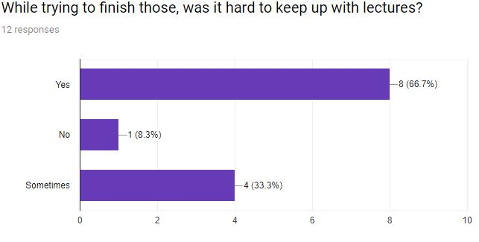  
Question 5:  
  
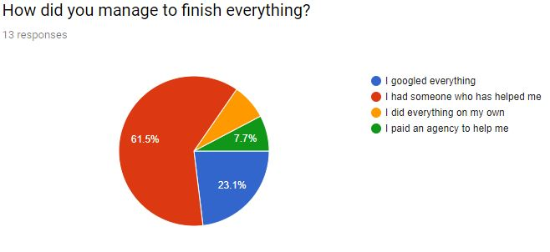**

From the date I have collected, it was kind of logical to get this answer. I just wanted to get the insight on how did everyone get the actual info. In my case, I had to find someone to help me too.

**Questions 6-10:**

First 5 questions were more personal. Even though they gave me very good insight of things which they have done so far, to make the pole more simple and to keep participants interested in, I changed the topic of questions from experiences to the actual website and idea behind it!

**I will provide screenshots in appendix to the text is more visible!**

First of all, I wanted to ask people for one more time if they like the idea of making this magazine just to be sure! I didn't get any negative answers, so I was ready to ask questions about actual content. From the answers, I was pretty sure what people want to see! Everyone said that they are looking for a basic website with not much content on it, website without many colours to keep focus on the theme, website with primary content so they can easily find the results for what they want to see. On the other hand almost half of participants are not interested in many videos, so to keep both sides happy content will have only the most important content until I start writing articles on more interesting , and in the future when this idea gets bigger and more famous, I would combine important information with another web page where people can see interesting events and so on...

**Visual**

**Colors:**

From results that I have got from my online pole, people wanted a website with 3 colors. In order to make articles more visible and easy to read for students, I have chosen to go with simple combination of warm colors. Whole website is based on shades of grey, but to make the landing page stand out, I used more visually appealing color, such as red! Also I used the same shade of red to make important article parts be more visible to the users and the color of hyperlinked content is matching the same shade of red. For the color of the articles text, I used grey color which is darker than the background color, but still does not make much contrast so it is easier to read and navigate true the content. I used two shades of the same color in the article sections to make the transition from one to the other more easy and logical for the reader.

**Logo:**

For the design of the logo, I used minimalistic design to make it as simple as possible but to still give out true impression of the meaning of the content of the page. While thinking about logo design, I tried to keep it in the same style as the rest of the magazine. The book represents knowledge and the “I” represents information sign! With the combination of these three parts, I made it simple and eye pleasing to the user to figure out the meaning of the magazine.

**Layout:**

First of all, I used background which covers the whole first page, in order to make website look more professional and modern. It also provides a special feeling to the landing page which is really important because the landing page is the place for the users first impressions! The first thing that user see when start scrolling is the parallex effect.. So like many famous webistes which are using parallex to make website more interesting, my content is based on serious information which is not attractive and enjoyable to the user while reading, but with parralex I achieve eye pleasant effect! In between the parallex images, there is the article with information about the magazine. The article is full width so it catches the view of user and also it is easy for them to skip if they are not interested in reading it!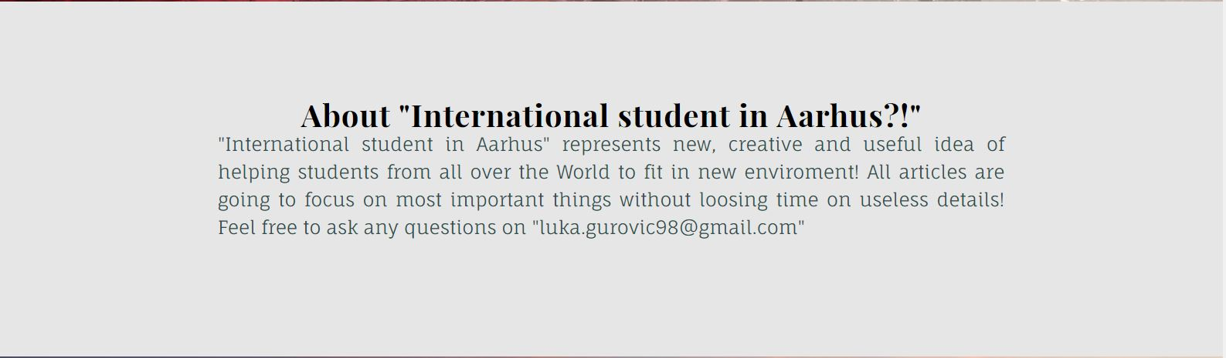

After scrolling down user comes to article part. I have chosen the layout of the articles based on research true more famous websites, and I saw that there is growing number of them which are using this layout to achieve more minimalistic look and in same time to make visual separation between articles.

**Perfect layout:**

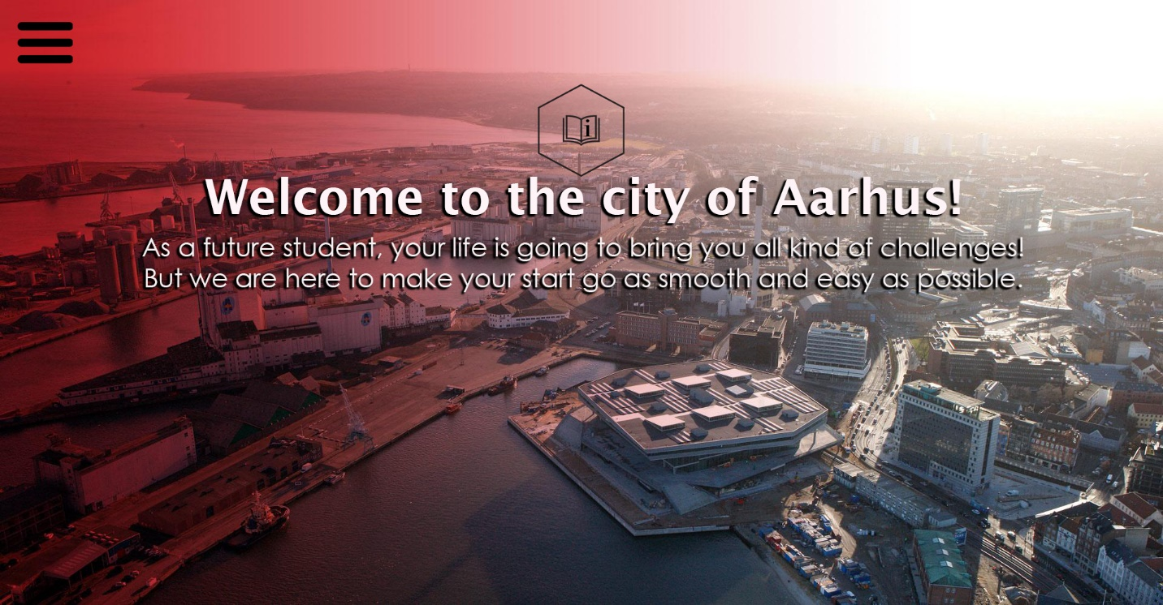

The difference between my landing page and the perfect layout is in menu and in logo position. Reason why I haven’t made this layout is the lack of knowledge in making responsive parts of website. Position of logo would make huge difference in this position but after I tried to make it it wasn’t responsive. Also for menu I hadto use javascript and that’s the reason why I haven’t done it.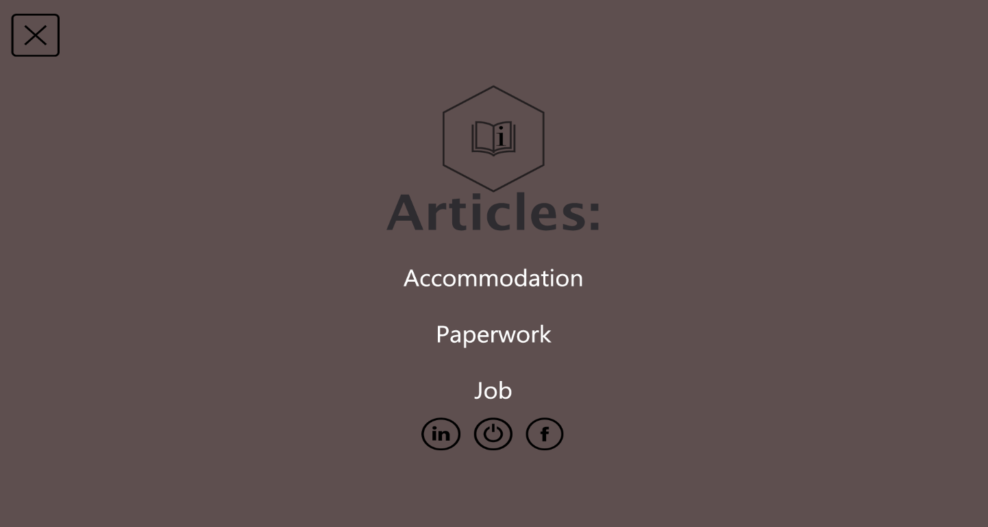

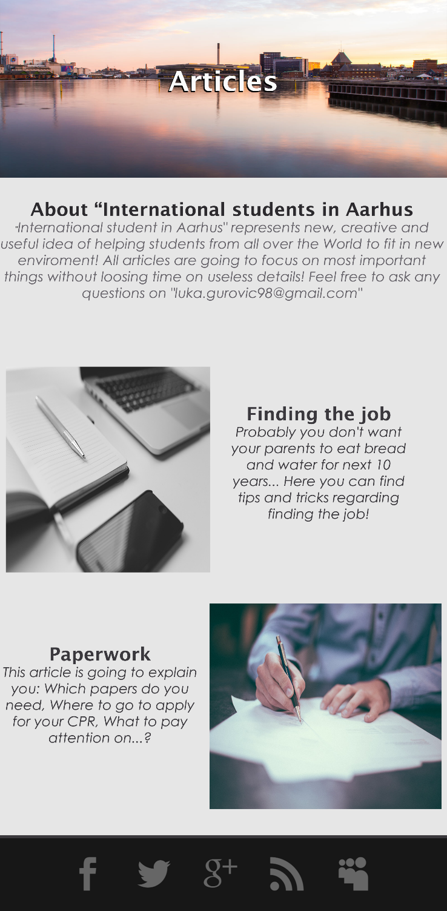This is look of the menu when user presses menu button. Again simple with social media buttons. This would replace my navbar which covers the content of website and would look much more professional.

When it comes to the main part, I have achieved the perfect idea! But on the other side look of the perfect footer is completely different from the actual one. I would love to make footer like this, only with social media buttons because it is more useful.

**Articles:**

My articles are based on the pole research, so there is not much to say about them. I used a little bit of sarcasm while writing the names, but otherwise they are based on general info. I used different style on lists so it makes them more visible to the users.

I think that by using the simple and general way of explaining things I achieved smart and useful look magazine.

**Conclusion:**

With this project, I have learned how to work long hours, how to work under the pressure…

The most important thing I have learnt is how to organize my time to finish everything until deadline! Also, this was my first time to use minimalistic style, so except organization, I have learnt basics of making website with different style from those which I have done so far. It was nice experience and I can’t wait for a new project.

Appendix