Research and Analysis on EUI Prediction and EUI-OCEI Coupling of Beijing Hotel Buildings Based on Parametric Simulation and Machine Learning
Xiangyu Xiao ¹, Xiong Zheng ²
Abstract
To improve the efficiency of energy consumption and carbon emission assessment in the design and operation phases of hotel buildings, this study focuses on hotel buildings in Beijing and develops an integrated research framework combining parametric simulation, interpretable sensitivity analysis, machine-learning-based prediction modeling, and operational carbon analysis. First, based on regulatory requirements, literature review, and the actual operational characteristics of hotels, 38 key parameters affecting hotel building energy consumption were selected. The Latin hypercube sampling (LHS) method was used to generate parameter combination samples, and EnergyPlus software was used to simulate annual energy consumption, thereby constructing a parametric simulation database for hotel buildings. Second, standardized regression coefficients (SRC) combined with bootstrap resampling were used to evaluate the magnitude, direction, and sign stability of each input parameter’s effect on EUI, identifying the key variables for subsequent modeling. Then, based on these key variables, 17 machine learning models were trained and compared, and the optimal EUI prediction model was selected using the coefficient of determination (R²), cross-validation variance, root mean square error (RMSE), and mean absolute percentage error (MAPE) as the main evaluation metrics. Finally, based on the Energy Use Intensity (EUI) analysis framework, energy-carrier emission factors and energy-supply scenario settings were introduced to construct an Operational Carbon Emission Intensity (OCEI) analysis module. This revealed the coupling relationship between EUI and OCEI in hotel buildings and further clarified the differences between energy-saving performance and low-carbon performance across design schemes. The results show that domestic hot water demand, building form parameters, selected envelope thermal parameters, and HVAC operational control parameters are the main factors affecting EUI in Beijing hotel buildings. Within the current simulation sample space, the Poly3-RidgeCV and MLP models performed best in terms of prediction accuracy and stability. Furthermore, although EUI and OCEI are generally significantly correlated, they are not entirely equivalent, and the energy-carrier mix and associated emission factors also significantly affect the low-carbon performance of hotel buildings. Finally, the method proposed in this study can provide a reference for the comparison of schemes, energy-saving design, and low-carbon optimization of hotel buildings in Beijing and other regions with similar climates or other boundary conditions.

Keywords: hotel buildings; Beijing; energy use intensity (EUI); operational carbon emission intensity (OCEI); sensitivity analysis; machine learning; energy–carbon coupling; prediction model.

1. Introduction
Since 2006, China has been the world's largest emitter of carbon dioxide [1]. Meanwhile, against the backdrop of rapid global urbanization, fuel consumption has increased dramatically, with building construction and maintenance consuming over 40% of global energy and emitting approximately one-third of carbon dioxide [2]. Among various commercial, residential, and government buildings, hotels are particularly energy-intensive; existing research indicates that hotels consume more energy than any other type of building, accounting for over 45% of total building energy consumption [3]. China's large and continuously growing population will lead to a sustained increase in demand for hotel buildings in the future. As a result, the demand for heating, cooling, ventilation, lighting, and domestic hot water services in hotel buildings remains high and is expected to continue increasing as indoor environmental quality requirements rise [4]. However, there is a significant amount of waste in hotel energy consumption in China, so there is still considerable room for improvement in energy efficiency and in reducing energy consumption and carbon emissions through management [5].
Traditional building energy consumption prediction primarily relies on physical simulation software. This software uses heat conduction to establish heat balance equations, thereby estimating building performance, calculating energy consumption, and performing corresponding analyses. Commonly used software in this field includes EnergyPlus [6], DeST [7], and eQuest [8]. While these programs offer high accuracy, they often require detailed input parameters and have long calculation cycles, making them unsuitable for the rapid screening of large numbers of building design alternatives. In recent years, machine learning technology, with its ability to handle high-dimensional data and nonlinear mappings, has been gradually introduced into the field of building energy consumption prediction. However, among numerous machine learning algorithms, selecting the optimal prediction model for a specific building type (such as a hotel) remains a pressing issue. Furthermore, hotel building energy consumption is influenced by various factors, including structural parameters (such as window-to-wall ratio and external wall heat transfer coefficient), climatic conditions (such as outdoor temperature and humidity), and operational parameters (such as room occupancy rate and restaurant operating hours), making energy consumption prediction even more challenging.
Compared with physical-model-based prediction approaches (i.e., white-box methods), this study adopts a data-driven approach (i.e., a black-box method) for building energy prediction [9]. It is worth noting that existing research largely focuses on complex machine learning models (such as deep learning and random forests) [10], [11], [12]. While these models perform well in certain scenarios, they typically require large amounts of real-time data and suffer from the "black box" problem, making it difficult to explain the specific impact of each parameter on energy consumption.
While existing research has utilized machine learning for building energy consumption prediction, most studies focus on black-box fitting of single energy consumption indicators, lacking systematic identification of key influencing parameters and further discussing the coupling relationship between building energy intensity and carbon emission intensity under different energy supply structures. Based on these issues, this study takes hotel buildings in Beijing as the research object, aiming to construct a comprehensive research framework combining parametric simulation, interpretable sensitivity analysis, machine-learning-based predictive modeling, and operational carbon analysis. Specific objectives include: constructing a parametric simulation database for Beijing hotel buildings; identifying key variables affecting EUI; comparing various machine learning models and selecting the optimal EUI prediction model; and introducing energy-carrier-specific emission factors based on simulated end-use energy results to analyze the coupling relationship between EUI and OCEI under the same energy supply scenarios.

2. Literature Review and Research Hypotheses

2.1. Literature Review
Building Energy Use Intensity (EUI) is a crucial indicator for measuring a building's energy performance during operation and is widely used for scheme comparison, energy-saving design, and operational assessment [13]. Existing research generally agrees that a building's EUI is not determined by a single factor, but rather by the combined effects of multiple factors, including the thermal performance of the building envelope, building geometry, internal occupant and equipment loads and the operation and control of the HVAC system [14], [15], [16]. For hotel buildings, due to their characteristics of continuous year-round operation, a high proportion of public areas, stable and intense domestic hot water demand, and the integration of guest rooms and service spaces, their energy consumption formation mechanism is more complex than that of general office buildings or ordinary residential buildings [17], [18]. Especially in cold or mixed climates, the heat transfer performance of the building envelope, building shape and orientation, domestic hot water load, and HVAC system settings often simultaneously affect multiple sub-items of energy consumption, such as cooling, heating, lighting, and hot water, and these effects are ultimately reflected in the overall EUI level through coupling.
While existing research has discussed the energy consumption of public buildings from the perspectives of envelope optimization, building form control, equipment efficiency improvement, and operating parameter adjustment, studies specifically on hotel buildings—a high-energy-consuming and highly operationally dependent building type—remain relatively fragmented [19], [20], [21], [22]. On the one hand, some studies focus only on the thermal performance of the building envelope or parameters of a single type of equipment, lacking a comprehensive characterization of the energy efficiency response (EUI) mechanism under the combined influence of multiple variables [23], [24]. On the other hand, many studies employ local parameter perturbations or single-factor analyses, making it difficult to reflect the overall energy consumption response characteristics of hotel buildings under simultaneous changes in multiple parameters [25], [26].
In the field of building energy consumption prediction, physical simulation methods can comprehensively depict building thermal processes and equipment operation logic, possessing strong mechanistic explanation capabilities [27], [28]. However, they typically rely on detailed input parameters, resulting in high computational costs and hindering large-sample scheme selection and rapid optimization [29], [30]. In contrast, machine learning methods, by learning the mapping relationship between input variables and target energy consumption indicators, can significantly improve prediction efficiency while maintaining a certain level of accuracy. Therefore, they are increasingly being used to construct prediction models for building energy consumption [31]. Especially in scenarios with multiple parameters, high dimensionality, and significant nonlinear relationships, prediction models provide a new technical path for rapid evaluation in the early stages of building design.
However, existing research still faces two prominent problems. First, some studies directly employ complex models for black-box fitting, which, while achieving good predictive accuracy, lacks sufficient explanation of the direction and relative importance of variable influences, making it difficult to provide clear decision support for building design optimization [32], [33], [34]. Second, different building types have different energy consumption formation mechanisms, and existing model conclusions cannot be directly transferred to hotel buildings. For objects like hotel buildings in Beijing, which exhibit significant heating, cooling, and hot water load characteristics, further research is needed to determine which variables are the core variables affecting EUI and which type of model is more suitable for constructing its prediction model [35]. Therefore, this study, based on a parametric simulation database, first screens interpretable variables and then conducts a systematic comparison of different machine learning models, thus becoming a feasible path that balances physical rationality, interpretability, and predictive efficiency.
As research on low-carbon buildings deepens, the limitations of using only the EUI (Energy Use Intensity) to evaluate the overall performance of design schemes are becoming increasingly apparent. EUI reflects the energy consumption level per unit building area, but it is not directly equivalent to the carbon emission level per unit area. Even if two schemes have similar total energy consumption, their carbon emission performance may differ significantly if the final energy carrier structure or the corresponding carbon emission factor is different [36], [37].
This issue is particularly important for hotel buildings. Hotel buildings often involve multiple end-energy consumption modules, including electricity, gas, heating, cooling, and domestic hot water. Different energy consumption items not only contribute different amounts to the total energy consumption but also have different impacts on total carbon emissions due to their different energy forms. Therefore, while there is usually a significant correlation between EUI and carbon emission intensity, it is not a strict one-to-one correspondence. If reducing EUI is the sole optimization objective, it may not guarantee that the solution will simultaneously achieve optimal carbon emissions. Therefore, revealing the coupling relationship and deviation mechanism between EUI and carbon emission intensity is a key step in shifting hotel building evaluation from a "single energy-saving assessment" to a "synergistic assessment of energy saving and low carbon emissions."
In summary, existing research has at least three shortcomings. First, research on hotel buildings primarily relies on local or single-factor analyses to identify EUI influencing factors, lacking systematic variable screening based on large-sample parametric simulations. Second, while research on building energy consumption prediction models is relatively abundant, a systematic comparison of the differences in accuracy, stability, and generalization ability among different model types is still lacking for specific objects like Beijing hotel buildings. Third, existing research largely focuses on single energy consumption indicators, with insufficient discussion of the relationship between EUI and carbon emission intensity. Therefore, this study takes Beijing hotel buildings as the object and constructs an integrated research framework of "parametric simulation - key variable identification - machine learning predictive modeling - EUI/OCEI coupling analysis": First, a simulation database is constructed through parametric modeling and LHS sampling; second, SRC combined with Bootstrap is used to identify key variables that have a significant and stable impact on EUI within the current parameter space; third, various machine learning regression models are trained and compared based on key variables to select the optimal EUI prediction model; finally, the OCEI index is introduced under a unified carbon accounting boundary to analyze the coupling and deviation relationship between EUI and OCEI, in order to provide a more systematic evaluation basis for energy-saving design and low-carbon optimization of hotel buildings.

2.2. Research Hypotheses
It should be noted that this study belongs to the "parametric simulation-predictive modeling" research paradigm. The following assumptions are more accurately described as research propositions to be verified, and their applicable boundaries are limited to hotel buildings in the Beijing area and the parameter space and carbon accounting boundaries set in this paper.
Based on the principles of building thermal balance and the operational characteristics of hotel buildings, the thermal performance of the building envelope affects the building's heat transfer and solar heat gain levels; the building's geometry and functional layout alter the shape coefficient, spatial organization, and usable area structure; personnel and equipment loads directly impact internal heat gain and hot water demand; and HVAC system operating control parameters further influence heating, cooling, and ventilation energy consumption. Therefore, in hotel buildings, a type of building with high operational loads, EUI should be the result of the combined effects of multiple variables, rather than being explained by a single design parameter. Based on the above analysis, we propose the following research hypotheses:
H1: Within the parameter space defined in this study, a subset of key variables from four categories—envelope, building geometry and function, personnel and equipment load, and HVAC operation control—significantly affect the EUI of Beijing hotel buildings.
There is often a nonlinear relationship and coupling effect between building EUI and design parameters. Therefore, after the key variables are selected, a prediction model can be constructed using machine learning methods. Theoretically, this can approximate the physical simulation results with lower computational cost. Compared with simple linear models, models that can capture higher-order nonlinear relationships and interaction effects are expected to have higher accuracy and better stability in EUI prediction.
H2: A machine learning prediction model built on key variables can achieve high predictive accuracy of EUI for Beijing hotel buildings.
H2a: Models capable of characterizing nonlinear relationships and variable coupling effects generally achieve better EUI prediction performance than simple linear models.
Under a unified carbon accounting boundary, building carbon intensity is essentially determined by the levels of individual energy consumption components and the carbon emission factors of their corresponding energy carriers. Therefore, as building EUI increases, OCEI usually increases as well, and the two should generally show a significant positive correlation. However, since different energy consumption components account for different proportions in the final energy mix, and different energy carriers also have different emission factors, a lower EUI does not necessarily correspond to a lower OCEI.
H3: Under a unified carbon accounting boundary, the EUI and OCEI of Beijing hotel buildings show a significant positive correlation overall.
H4: EUI and OCEI are not entirely equivalent; the influence pattern of input variables on EUI may not be fully consistent with their influence pattern on OCEI.
Based on the literature review and research hypotheses described above, this paper establishes the following research framework: First, a database of energy consumption in Beijing hotel buildings is constructed through parametric simulation; second, key influencing variables are identified and their direction and stability are analyzed using the SRC and Bootstrap methods; then, various EUI prediction models are constructed and compared using the key variables as inputs; finally, the OCEI index is introduced under a unified carbon accounting boundary to analyze the coupling relationship between EUI and OCEI and its deviation mechanism. This framework retains the mechanistic basis of physical simulation while also taking into account the efficiency of machine learning prediction models, and further extends building energy efficiency evaluation to the synergistic evaluation of energy conservation and low carbon emissions.

3. Materials and Methods
This study focuses on hotel buildings in Beijing, a representative northern Chinese city. Beijing's geographical center is situated at 116.20° E and 39.56° N, with a total area of ​​16,410.54 km². Beijing has a warm-temperate, semi-humid, semi-arid monsoon climate, characterized by hot, rainy summers and cold, dry winters. The region experiences significant seasonal fluctuations in temperature and humidity, and receives relatively high levels of solar radiation compared to other parts of China. Given the large number of hotels in Beijing and its hot summers and cold winters, resulting in significant winter heating needs, summer cooling needs, and a stable year-round demand for domestic hot water, Beijing is a suitable representative region for studying the coupling of hotel energy consumption and carbon emissions. Therefore, accurately predicting and effectively managing the energy consumption and carbon emissions of hotel buildings in Beijing is of paramount importance [38].
The study was carried out in four main steps:
- High-dimensional samples are generated through parametric modeling and Latin hypercube sampling [39], and a hotel energy consumption database is built using EnergyPlus.
- Sensitivity analysis of input variables was conducted using standardized regression coefficients (SRC) [40], [41] and bootstrap resampling [42], [43] to identify key variables affecting EUI.
- Various machine learning models were trained and compared to identify the optimal prediction model for EUI prediction.
- Based on the EUI prediction framework, carbon emission factors and energy supply scenario settings are introduced and extended to OCEI analysis to reveal the coupling relationship between EUI and OCEI in hotel buildings.

3.1. Parametric sample generation and simulation database construction
This study requires the construction of a hotel parameter space that is both engineering-feasible and physically representative. Therefore, 38 input variables affecting hotel-building energy consumption were selected based on the underlying energy-use formation mechanisms and relevant previous studies [44], [45], [46]. These input variables cover four aspects: thermal performance of building envelope, building geometry and shape, personnel and equipment load, and HVAC operation control. Furthermore, since this study involves 38 high-dimensional input parameters, simple random sampling can easily lead to uneven coverage of the parameter space, local sample redundancy, or insufficient representativeness of boundary areas. To improve sample representativeness and control computational costs, this study adopts the Latin hypercube sampling (LHS) method, uniformly sampling each parameter within a preset range. LHS, by dividing each variable dimension into equally probable intervals and performing stratified sampling, can more uniformly cover the high-dimensional parameter space with a smaller sample size, making it suitable for problems such as building energy consumption simulation where single-sampling computation costs are relatively high.
Based on the generated parameter combinations, this study uses Python [47] to write an automated parametric modeling script to batch generate building input files and calls EnergyPlus [48] to perform annual energy consumption simulation. The simulation output includes key results such as total annual energy consumption, energy consumption indicators for each component, building heating and cooling loads, and EUI. This process constructs a mapping database between parametric building samples and physical simulation responses to facilitate rapid evaluation, parameter selection, and scheme comparison during the design phase.

3.2. Sensitivity analysis based on standardized regression coefficients and bootstrap
To identify key variables with significant impact on EUI within the current parameter space, this study employs a sensitivity analysis method combining standardized regression coefficients (SRC) and bootstrap resampling. Unlike direct global variance decomposition, this method is more suitable for variable screening and interpretive analysis tasks based on simulated databases, providing information on the strength, direction, and stability of variable influences simultaneously.
The specific steps are as follows: First, the input and target variables are standardized to eliminate the influence of dimensional differences on the comparison of regression coefficients. Then, a linear regression model is constructed, and the standardized regression coefficients (SRC) are used as an indicator to measure the relative strength of each variable's influence on EUI. A positive SRC value indicates a positive correlation between the input variable and EUI, while a negative value indicates a negative correlation. A larger absolute value of the SRC indicates a stronger linear influence of the input variable on EUI within the current parameter space. Finally, the bootstrap resampling method is used to repeatedly sample the original sample, and the distribution of the standardized regression coefficients (SRC) for each variable is recalculated based on each resampling. We constructed 95% confidence intervals for the standardized regression coefficients (SRC) of each variable using empirical distributions. If the confidence intervals of the input variables consistently lie on the same side of 0, it indicates that the variable's impact on EUI has good statistical stability under repeated sampling; conversely, if the confidence intervals do not lie on the same side of 0, the variable was considered to have insufficient sign stability under repeated sampling.
Furthermore, it is worth noting that since the SRC method relies on linear regression coefficients for interpretation, and linear regression is quite sensitive to multicollinearity among independent variables, this study further performs a multicollinearity diagnosis of the input variable system before conducting sensitivity analysis.

3.3. Machine learning model training and evaluation
In this study, the term “prediction model” refers to a data-driven model trained on simulation outputs to approximate the EUI response of the EnergyPlus-based parametric simulation dataset for rapid evaluation purposes.
To comprehensively compare the applicability of different model types, this study selected 17 commonly used machine learning regression models [49], [50], including basic linear regression models (Linear, RidgeCV, LassoCV, ElasticNetCV, Poly2-RidgeCV, Poly2-ElasticNetCV, Poly2-Interaction-RidgeCV, Poly3-RidgeCV), KNN, SVR-RBF, decision trees, random forests, ExtraTrees, GB, MLP, XGBoost, and LightGBM.
When constructing the energy use intensity (EUI) prediction model, The key variables identified through sensitivity analysis were used as input features, while the remaining variables were fixed at their reference-case values to improve training efficiency and reduce input redundancy (The baseline values of the non-core variables were set according to the reference-case configuration, and the reduced dataset retained the same sample size as the original filtered simulation database). During model training, a combination of training-test set splitting and k-fold cross-validation was used for evaluation. Model performance was mainly evaluated using metrics such as coefficient of determination (R²), cross-validation variance, root mean square error (RMSE), mean absolute percentage error (MAPE). In addition, to evaluate the stability and generalization ability of the model, this paper also focuses on the performance dispersion of the model under different numbers of folds and the performance differences on the training set and the test set.

3.4. EUI–OCEI Coupled Analysis Method
After establishing the EUI prediction model, this study further introduces carbon emission intensity analysis to expand the low-carbon application value. Considering that building schemes with similar total energy consumption levels may still exhibit different carbon emission performances due to different energy structures, relying solely on the EUI index is insufficient to comprehensively reflect the low-carbon characteristics of buildings. Therefore, this study introduces the OCEI (Operational Carbon Emission Intensity) index based on energy consumption analysis [51].
Specifically, based on the results of various energy consumption analyses of the building, this study mapped electricity, natural gas, district heating, and district cooling consumption to their corresponding carbon emissions using carrier-specific emission factors and further calculates the Operational Carbon Emission Intensity (OCEI). Therefore, this study can analyze the coupling and deviation relationships between Energy Use Intensity (EUI) and carbon emission intensity (OCEI) under a consistent energy-supply assumption.
To compare the factor-importance patterns of EUI and OCEI under a unified statistical framework, this study further applied the same standardized regression coefficient (SRC) method combined with bootstrap resampling to OCEI using the selected key variables. The resulting SRC values, confidence intervals, and sign-stability indicators were then compared with those of EUI to identify similarities and differences in the dominant influencing factors under the energy-performance and operational-carbon-performance perspectives.
For the comparative SRC analysis between EUI and OCEI, the selected building-design and operation variables were retained as explanatory variables, while OCEI served as the response variable under the fixed carbon-accounting boundary.

4. Results

4.1. Sample generation and database construction
The input variables used in this study can be divided into four categories: the first category is the thermal parameters of the building envelope; the second category is the building geometric parameters; the third category is the personnel and equipment load parameters; and the fourth category is the HVAC system operation and control parameters. The selection of these four categories of variables was based on the Chinese "Energy Conservation Design Standard for Public Buildings" (GB 50189-2015) [52], and is combined with the actual operation of the hotel. The building envelope parameters include the thickness of the external wall insulation layer, window-to-wall ratio, external wall thickness, heat transfer coefficient of windows facing different orientations, heat transfer coefficient between walls and roof, heat transfer coefficient of the ground, solar heat gain coefficient of windows facing different orientations, window construction type, and thickness of the roof insulation layer. The building geometric parameters include the total number of floors, public area, guest room area, total number of rooms, building length, building width, length-to-width ratio, floor height, and building orientation. The personnel and equipment load parameters include equipment power density, lighting power density, personnel density, and per capita domestic hot water consumption. The HVAC system operation and control parameters include summer cooling setpoint temperature, winter heating setpoint temperature, domestic hot water supply temperature, cooling COP, heating COP, boiler thermal efficiency, fan efficiency, fresh air exchange rate, and annual system operating time. The value ranges for each parameter are shown in Table 1.

Table 1. Input variables and their value ranges.
Variable | Range
External wall insulation layer thickness (m) | 0.05-0.12
Overall window-to-wall ratio | 0.25-0.60
External wall structure thickness (m) | 0.20-0.30
Heat transfer coefficient of north-facing windows (W/(m²·K)) | 0.8-2.0
Heat transfer coefficient of south-facing windows (W/(m²·K)) | 0.8-2.0
Heat transfer coefficient of east-facing windows (W/(m²·K)) | 0.8-2.0
Heat transfer coefficient of west-facing windows (W/(m²·K)) | 0.8-2.0
Heat transfer coefficient of main external wall structure (W/(m²·K)) | 0.25-0.80
Heat transfer coefficient of roof (W/(m²·K)) | 0.20-0.45
Heat transfer coefficient of ground foundation (W/(m²·K)) | 0.15-0.40
Solar heat gain coefficient of north-facing windows | 0.20-0.65
Solar heat gain coefficient of south-facing windows | 0.20-0.45
Solar heat gain coefficient of east-facing windows | 0.20-0.65
Solar heat gain coefficient of west-facing windows | 0.20-0.65
Window construction type number | 1-3
Roof insulation layer thickness (m) | 0.08-0.15
Total number of floors (floors) | 6-20
Total area of ​​public areas (m²) | 80-150
Floor area of ​​a single guest room (m²) | 22-30
Total number of guest rooms (rooms) | 36-240
Main building length (m) | 35-50
Main building width (m) | 12-18
Building length-to-width ratio | 2.0-3.0
Standard floor height (m) | 2.8-3.3
Overall building orientation (°) | 0-90
Indoor equipment power density (W/m²) | 2.5-4.0
Daily domestic hot water consumption per Capita (m³/(person·d)) | 0.06-0.20
Personnel density (person/m²) | 0.08-0.25
Indoor lighting power density (W/m²) | 4-7
Summer cooling set temperature (°C) | 24-26
Winter heating set temperature (°C) | 19-22
Domestic hot water supply temperature (°C) | 45-55
Rated COP of refrigeration unit | 3.0-5.0
COP of heat pump heating | 2.2-4.2
Thermal efficiency of hot water boiler | 0.82-0.95
Efficiency of air conditioning fan | 0.55-0.70
Fresh air exchange rate (h⁻¹) | 0.5-1.2
Total annual operating hours of system (h/a) | 2000-3000

This study involves 38 high-dimensional input parameters. Traditional random sampling is prone to parameter overlap or omission, while Latin hypercube sampling, by dividing each parameter dimension into equally probable intervals, ensures that the samples are evenly distributed throughout the parameter space, effectively improving the representativeness of the samples. Furthermore, compared with full factorial sampling and simple random sampling, Latin hypercube sampling can capture the nonlinear coupling relationships between parameters with a smaller sample size. After completing the LHS sampling, a rule-based feasibility screening procedure was performed before EnergyPlus simulation to remove physically infeasible parameter combinations. This screening was based only on input-parameter consistency and was not conducted according to simulated EUI, total energy consumption, or carbon-emission outputs. Specifically, the main building width was recalculated from the sampled building length and length-to-width ratio and was constrained within the predefined feasible range. The gross floor area, building footprint area, building height, and building volume were then derived from the adjusted geometric parameters. To further ensure the feasibility of hotel functional-space allocation, the total guest-room area was calculated as the product of the single guest-room area and the total number of guest rooms, and the usable area was calculated as the sum of the guest-room area and public-area setting. The ratio of usable area to gross floor area was then used as the main screening criterion. Samples were retained only when this ratio fell within the predefined feasible range of 0.55–0.95; samples outside this range were regarded as having unrealistic functional-space allocation and were removed. Through this feasibility screening procedure, the initial 20,000 LHS samples were reduced to 4,640 valid samples, which were subsequently used for EnergyPlus simulation, EUI calculation, sensitivity analysis, and machine-learning model training.
After completing high-dimensional sample sampling and simulation calculations based on the 38 input variables, this study constructed a hotel building EUI simulation database for subsequent analysis. Figure 1 shows the distribution of EUI across the simulated samples, and Figure 2 shows the distribution of total energy consumption across the samples. Statistical results show that both the sample EUI and total energy consumption exhibit a certain degree of right skewness. This result indicates that the constructed database covers both typical hotel design schemes and a small number of high-energy-consumption boundary combinations, possessing a certain degree of representativeness and diversity.
The right-skewed distribution of EUI and total energy consumption reflects that hotel buildings have significant baseline energy consumption, and that when certain high-load, high-heat-transfer, or low-efficiency parameter combinations are superimposed, the total energy consumption of the building will increase significantly, forming a long-tail sample of high energy consumption. This distribution characteristic is also consistent with the actual operating mode of hotel buildings. For example, hotel buildings usually have long operating hours and high hot water and public space service loads [53].

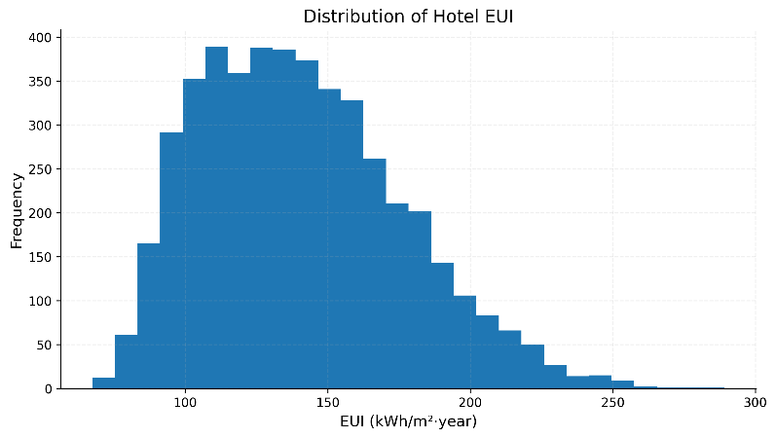
Figure 1. EUI distribution of each set of samples.

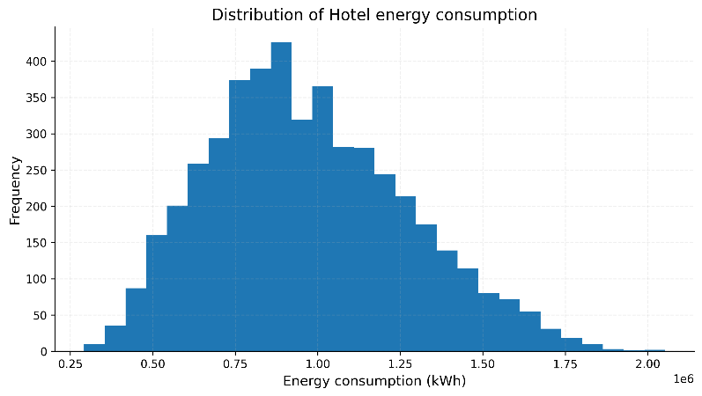
Figure 2. Energy consumption distribution of each set of samples.

4.2. Sensitivity Analysis
Before conducting the sensitivity analysis, considering that building orientation is a periodic variable, we converted the original angle values ​​to radians and then calculated their corresponding sine and cosine values. This transformation allowed the periodic nature of building orientation to be represented appropriately. Additionally, considering that the building's length and width might not change completely independently, we converted them into two more physically meaningful variables: building area and building aspect ratio. Finally, to avoid complete collinearity of window type variables, we set window types as dummy variables, including: Window Type 2 and Window Type 3 (if the values ​​of Window Type 2 and Window Type 3 are both 0, the default is Window Type 1). Thus, our input variables were adjusted from 38 to 39. Subsequently, we assessed multicollinearity among the input variables. Multicollinearity indicates a strong linear correlation between multiple independent variables, and its mathematical expression is as follows:
$$VIF_{j}=\frac{1}{1-R_{j}^{2}}$$
In the above formula, $VIF_{j}$ reflects the multicollinearity of a variable with other variables; a larger VIF value indicates a more severe linear overlap between the variable and other variables. $R_{j}^{2}$ is a coefficient of determination obtained by regressing a variable as the dependent variable against all other variables; it reflects the explanation of the dependent variable by all other variables. The VIF values ​​for each input variable calculated in this study are shown in Table 2 below.

Table 2. VIF values ​​for input variables.
Variable | VIF
Sine term of overall building orientation | 6.377178
Cosine term of overall building orientation | 6.367548
Total number of floors (floors) | 3.372843
Total number of guest rooms (rooms) | 2.708470
Building footprint area = main building length × main building width (m²) | 2.326528
Window construction type: Type 2 relative to Type 1 baseline | 1.520823
Window construction type: Type 3 relative to Type 1 baseline | 1.512838
Floor area of a single guest room (m²) | 1.238025
Building length-to-width ratio | 1.039574
Total area of public areas (m²) | 1.013866
COP of heat pump heating | 1.011825
Heat transfer coefficient of roof (W/(m²·K)) | 1.011405
Domestic hot water supply temperature (°C) | 1.010630
Overall window-to-wall ratio | 1.010233
Heat transfer coefficient of east-facing windows (W/(m²·K)) | 1.010085
External wall insulation layer thickness (m) | 1.010062
Thermal efficiency of hot water boiler | 1.010027
Indoor lighting power density (W/m²) | 1.010018
Roof insulation layer thickness (m) | 1.009988
Heat transfer coefficient of north-facing windows (W/(m²·K)) | 1.009931
Rated COP of refrigeration unit | 1.009705
Total annual operating hours of system (h/a) | 1.009674
Solar heat gain coefficient of east-facing windows | 1.008949
Heat transfer coefficient of main external wall structure (W/(m²·K)) | 1.008887
Heat transfer coefficient of south-facing windows (W/(m²·K)) | 1.008407
Indoor equipment power density (W/m²) | 1.007929
Summer cooling set temperature (°C) | 1.007858
Winter heating set temperature (°C) | 1.007749
Solar heat gain coefficient of west-facing windows | 1.007571
Personnel density (person/m²) | 1.007303
Heat transfer coefficient of west-facing windows (W/(m²·K)) | 1.007214
Heat transfer coefficient of ground foundation (W/(m²·K)) | 1.007068
Solar heat gain coefficient of south-facing windows | 1.007012
Standard floor height (m) | 1.006600
Fresh air exchange rate (h⁻¹) | 1.006499
External wall structure thickness (m) | 1.005990
Daily domestic hot water consumption per capita (m³/(person·d)) | 1.005887
Solar heat gain coefficient of north-facing windows | 1.005785
Efficiency of air conditioning fan | 1.005410

As shown in Table 2 above, among all variables, except for the sine and cosine terms of building orientation which exhibit relatively high VIF values, the VIF values ​​of other input variables are all less than 5, and most are even close to 1. This indicates that the predictor set does not exhibit problematic multicollinearity. The high VIF values ​​of the two orientation variables mainly reflect the mathematical correlation of the circular coding method. Therefore, we can conclude that the current input variables are suitable for sensitivity analysis using the SRC method.
After completing sample generation, database construction, and determining the multicollinearity of the input variables, this study used EUI as an indicator to conduct sensitivity analysis on all input variables to verify their impact. Furthermore, this study employed a sensitivity analysis framework based on standardized regression coefficients (SRC) and bootstrap resampling [54]. To assess the robustness of the SRC estimation, we resampled the original data with replacement, with the number of bootstrap resamples set to B = 1000, and recalculated the corresponding standardized regression coefficients for each sample. Finally, the final standardized regression coefficients (SRC) for each input variable, the lower bound of the 95% confidence interval (CI_low) for the variable's SRC after resampling, the upper bound of the 95% confidence interval (CI_high) for the variable's SRC after resampling, and the stability of the direction of influence of each input variable on EUI (a value of True for Sign_stable indicates stability, and a value of False for Sign_stable indicates instability) are shown in Table 3 below.

Table 3. Standardized regression coefficients (SRC), confidence intervals, and sign stability of input variables.
Variable | SRC | CI_high | CI_low | Sign_stable
Daily domestic hot water consumption per capita (m³/(person·d)) | 0.807575 | 0.820046 | 0.794425 | TRUE
Total number of floors (floors) | -0.704986 | -0.687823 | -0.723987 | TRUE
Total number of guest rooms (rooms) | 0.554055 | 0.572922 | 0.536145 | TRUE
Building footprint area (m²) | -0.503801 | -0.490321 | -0.517103 | TRUE
Domestic hot water supply temperature (°C) | 0.214751 | 0.222062 | 0.206489 | TRUE
Thermal efficiency of hot water boiler | -0.107936 | -0.100632 | -0.114931 | TRUE
COP of heat pump heating | -0.078699 | -0.071584 | -0.085234 | TRUE
Total annual operating hours of system (h/a) | 0.070385 | 0.077459 | 0.063076 | TRUE
Fresh air exchange rate (h⁻¹) | 0.068249 | 0.075127 | 0.061188 | TRUE
Indoor lighting power density (W/m²) | 0.063473 | 0.070232 | 0.056706 | TRUE
Overall window-to-wall ratio | 0.062386 | 0.069139 | 0.055801 | TRUE
Rated COP of refrigeration unit | -0.036060 | -0.028806 | -0.042789 | TRUE
Standard floor height (m) | 0.035939 | 0.042842 | 0.029433 | TRUE
Building length-to-width ratio | 0.034168 | 0.041540 | 0.027238 | TRUE
Indoor equipment power density | 0.033327 | 0.039562 | 0.026645 | TRUE
Winter heating set temperature | 0.029649 | 0.036671 | 0.023257 | TRUE
Floor area of a single guest room | -0.025072 | -0.018322 | -0.032195 | TRUE
Heat transfer coefficient of main external wall structure (W/(m²·K)) | 0.022648 | 0.029763 | 0.015839 | TRUE
Solar heat gain coefficient of south-facing windows | 0.019813 | 0.027057 | 0.012813 | TRUE
Sine term of overall building orientation | 0.018599 | 0.034442 | 0.001257 | TRUE
Cosine term of overall building orientation | 0.013082 | 0.029768 | -0.003898 | FALSE
Heat transfer coefficient of south-facing windows (W/(m²·K)) | 0.012728 | 0.019405 | 0.005516 | TRUE
Solar heat gain coefficient of north-facing windows | 0.011505 | 0.018209 | 0.004556 | TRUE
Solar heat gain coefficient of east-facing windows | 0.010789 | 0.017478 | 0.003507 | TRUE
Heat transfer coefficient of north-facing windows (W/(m²·K)) | 0.009185 | 0.015369 | 0.002033 | TRUE
Summer cooling set temperature (°C) | -0.009081 | -0.002630 | -0.016149 | TRUE
Heat transfer coefficient of east-facing windows (W/(m²·K)) | 0.007381 | 0.014073 | 0.000881 | TRUE
Total area of public areas (m²) | -0.006395 | 0.000412 | -0.013501 | FALSE
Solar heat gain coefficient of west-facing windows | 0.006273 | 0.013049 | -0.000460 | FALSE
Window construction type: Type 3 relative to Type 1 baseline | -0.005848 | 0.002316 | -0.013878 | FALSE
External wall insulation layer thickness (m) | 0.005465 | 0.012430 | -0.001282 | FALSE
Window construction type: Type 2 relative to Type 1 baseline | -0.005237 | 0.002567 | -0.013953 | FALSE
Heat transfer coefficient of roof (W/(m²·K)) | 0.004470 | 0.010805 | -0.002370 | FALSE
Personnel density (person/m²) | 0.002535 | 0.008965 | -0.003481 | FALSE
Heat transfer coefficient of west-facing windows (W/(m²·K)) | 0.001993 | 0.008449 | -0.004657 | FALSE
Roof insulation layer thickness (m) | 0.001807 | 0.008933 | -0.005670 | FALSE
Efficiency of air conditioning fan | -0.001710 | 0.005371 | -0.008751 | FALSE
External wall structure thickness (m) | 0.000941 | 0.007796 | -0.005501 | FALSE
Heat transfer coefficient of ground foundation (W/(m²·K)) | 0.000115 | 0.006438 | -0.006396 | FALSE

Based on the above research, the results of sensitivity analysis of all input variables are shown in Figures 3-5 below.

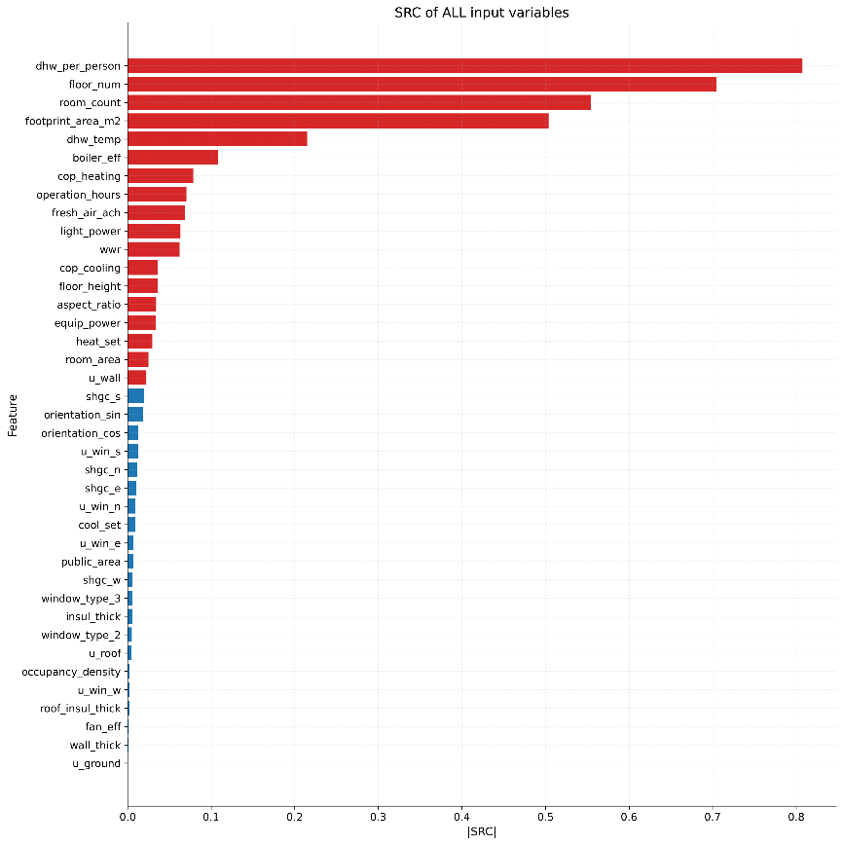
Figure 3. SRC of all input variables.

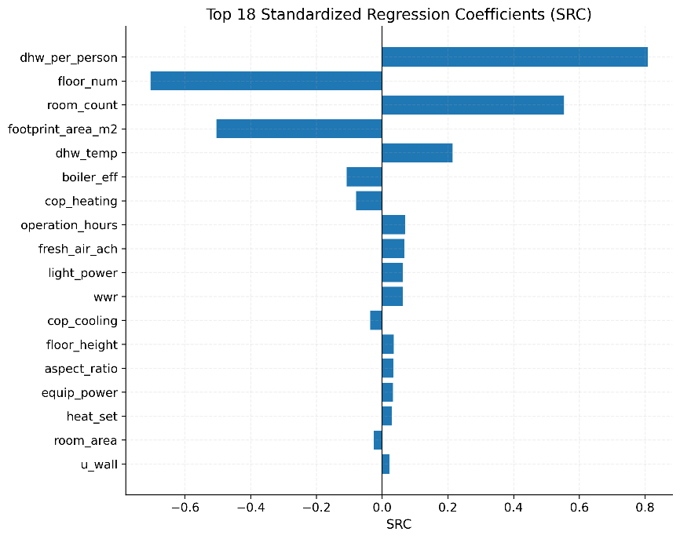
Figure 4. Top 18 SRC of all input variables.

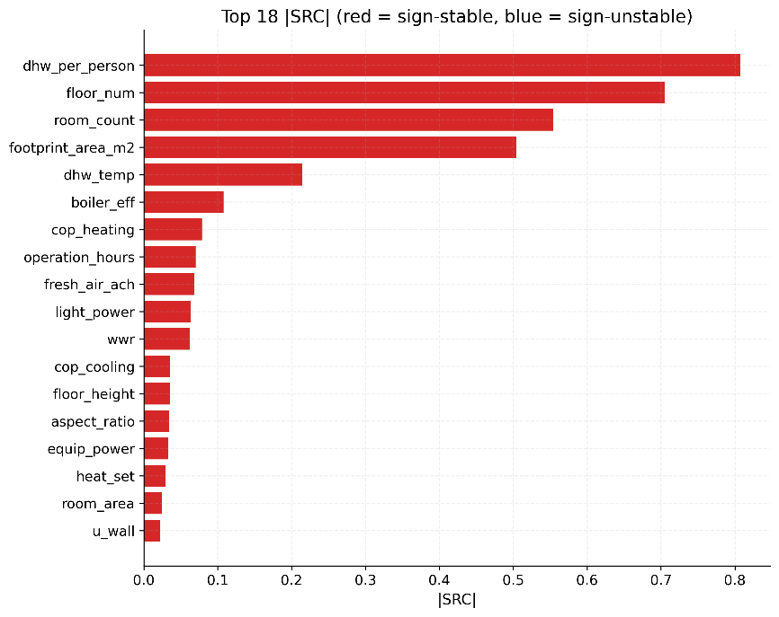
Figure 5. Top 18 SRC of all input variables (including the stability index of the direction of influence).

After comprehensively considering and evaluating the standard regression coefficients (SRC) of each input variable and the stability of their influence on EUI, in order to reduce the dimensionality of the input variables to avoid noise introduced by weakly influential input variables and reduce the training cost of the machine learning model, we selected 18 input variables with significant and stable effects on EUI for subsequent modeling, while other input variables were set as constants. The 18 variables retained for subsequent modeling and their categories are listed as follows:
- Thermal parameters of the building envelope: Overall window-to-wall ratio (wwr), Heat transfer coefficient of main external wall structure (u_wall).
- Building geometric parameters: Total number of floors (floor_num), Total number of guest rooms (room_num), Building footprint area (footprint_area_m2), Standard floor height (floor_height), Building length-to-width ratio (aspect_ratio), Floor area of a single guest room (room_area).
- Personnel and equipment load parameters: Daily domestic hot water consumption per capita (dhw_per_person), Indoor lighting power density (light_power), Indoor equipment power density (equip_power).
- HVAC system operation and control parameters: Domestic hot water supply temperature (dhw_temp), Thermal efficiency of hot water boiler (boiler_eff), COP of heat pump heating (cop_heating), Total annual operating hours of system (operation_hours), Fresh air exchange rate (fresh_air_ach), Rated COP of refrigeration unit (cop_cooling), Winter heating set temperature (heat_set).

The above conclusions indicate that subsequent analysis and research should focus more on these core parameters that significantly impact Energy Use Intensity (EUI). Furthermore, during the actual design, construction, and management phases of the hotel, these parameters should be adjusted to improve energy efficiency and reduce building energy consumption.

4.3. EUI Prediction Model Training and Evaluation
After completing the construction and sensitivity analysis of the hotel EUI database, we selected 18 core input variables that significantly and stably affect EUI as input features for the machine learning model, and fixed the remaining less influential parameters as baseline values. A reduced simulation dataset was then reconstructed using these 18 key variables, while the remaining variables were fixed at baseline values. This approach preserves the dominant EUI variation patterns of the samples while avoiding the introduction of noise, and also improves model training efficiency. The EUI distribution of the reconstructed simulation dataset is shown in Figure 6.

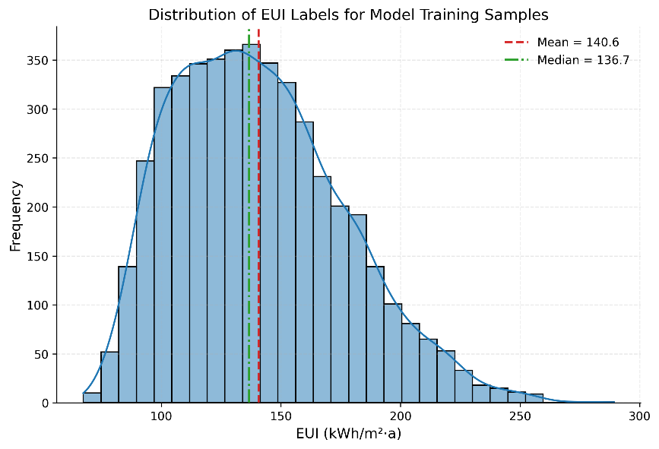
Figure 6. The EUI distribution of the reconstructed samples.

As shown in Figure 6, the EUI distribution of the reconstructed samples roughly falls within the range of 80–220 kWh/(m²·a), with a mean of 140.6 kWh/(m²·a) and a median of 136.7 kWh/(m²·a). The sample distribution does not exhibit pronounced discontinuities or strong clustering, indicating that after fixing non-critical variables, the combination of core variables can still effectively reflect the EUI variation patterns of hotel buildings in Beijing under different envelope structures, building shapes, hot water loads, and HVAC system operation control conditions. This also demonstrates that the constructed dataset retains sufficient variation range while avoiding redundant interference from excessively high-dimensional samples, providing a reliable data foundation for subsequent supervised learning model training.
In the model construction and comparison process, 17 machine learning regression models were evaluated, including linear and regularized linear models (Linear, RidgeCV, LassoCV, ElasticNetCV), polynomial feature-based models (Poly2-RidgeCV, Poly2-ElasticNetCV, Poly2-Interaction-RidgeCV, Poly3-RidgeCV), KNN, SVR-RBF, Decision Tree, Random Forest, ExtraTrees, Gradient Boosting, MLP, XGBoost, and LightGBM, and each model was evaluated using 10-fold cross-validation. Evaluation metrics included the coefficient of determination (R²), cross-validation variance, root mean square error (RMSE), and mean absolute percentage error (MAPE). The evaluation results for all models are presented in Figures 7–10 and Table 4.

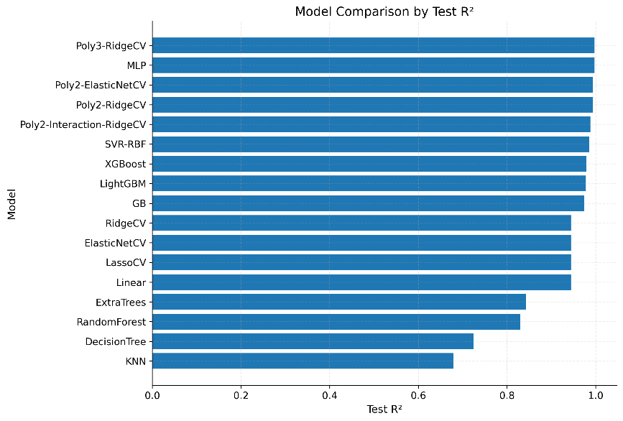
Figure 7. Coefficient of determination (R²) for all models.

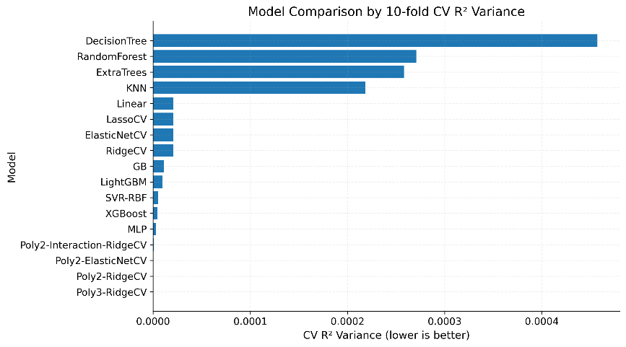
Figure 8. Cross-validation variance for all models.

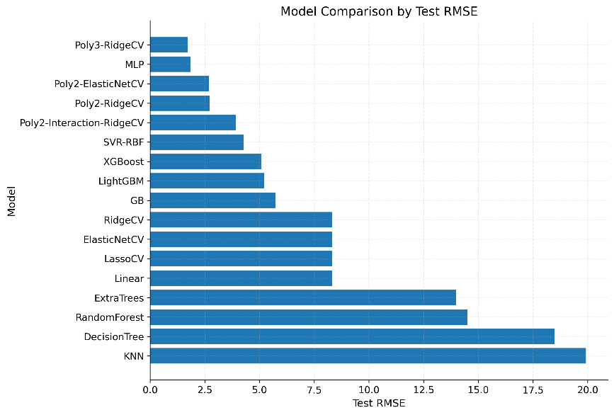
Figure 9. Root mean square error (RMSE) for all models.

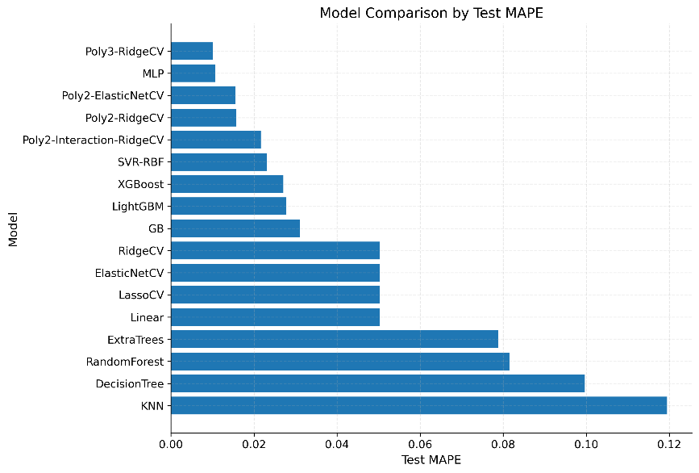
Figure 10. Mean absolute percentage error (MAPE) for all models.

Table 4. Coefficient of determination ($R^{2}$), cross-validation variance, RMSE and MAPE (%) for all models.
Model | $$R^{2}$$ | Cross-validation Variance | RMSE | MAPE (%)
Poly3-RidgeCV | 0.997611 | 0.0000001 | 1.720662 | 1.339084
MLP | 0.997292 | 0.0000028 | 1.831926 | 1.408780
Poly2-ElasticNetCV | 0.994146 | 0.0000003 | 2.693698 | 2.037151
Poly2-RidgeCV | 0.994066 | 0.0000003 | 2.711975 | 2.051008
Poly2-Interaction-RidgeCV | 0.987656 | 0.0000011 | 3.911384 | 3.011756
SVR-RBF | 0.985294 | 0.0000053 | 4.269315 | 3.152914
XGBoost | 0.979091 | 0.0000045 | 5.090622 | 3.820211
LightGBM | 0.978093 | 0.0000097 | 5.210779 | 3.914514
GB | 0.973482 | 0.0000112 | 5.732936 | 4.353022
RidgeCV | 0.944259 | 0.0000209 | 8.311758 | 6.614025
ElasticNetCV | 0.944256 | 0.0000209 | 8.312040 | 6.614293
LassoCV | 0.944251 | 0.0000210 | 8.312392 | 6.614876
Linear | 0.944231 | 0.0000210 | 8.313894 | 6.615972
ExtraTrees | 0.842358 | 0.0002582 | 13.977958 | 11.092293
RandomForest | 0.830304 | 0.0002709 | 14.502501 | 11.498535
DecisionTree | 0.724378 | 0.0004573 | 18.482634 | 14.225098
KNN | 0.679638 | 0.0002183 | 19.926343 | 16.056651

In addition, as we have previously stated, we have divided the EUI database into training and test sets. Figure 11 below shows the gap in the coefficient of determination for all models between the training and prediction sets.

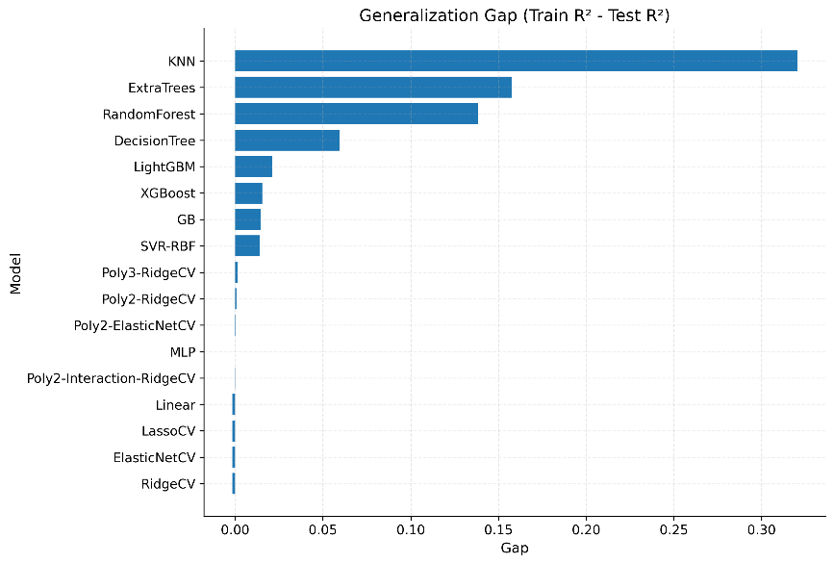
Figure 11. The gap in the coefficient of determination for all models between the training and test sets.

The results above show that, using this test set, the Coefficient of determination (R²) of Poly3-RidgeCV is approximately 0.9976, the Cross-validation Variance is 0.0000001, the RMSE is approximately 1.72, and the MAPE is approximately 1.34%. The Coefficient of determination (R²) of MLP is approximately 0.9973, the Cross-validation Variance is 0.0000028, the RMSE is approximately 1.83, and the MAPE is approximately 1.41%. Comparatively, these two models significantly outperform other machine learning models in terms of both fitting ability and overall accuracy and error control. Poly3-RidgeCV and MLP exhibited the best overall predictive performance among the evaluated models. This suggests that the EUI response surface in the present sample space contains substantial nonlinearity and variable interaction effects. The strong performance of Poly3-RidgeCV indicates that a considerable part of this structure can be captured through explicit higher-order feature expansion with regularization, whereas the competitive performance of MLP suggests that additional nonlinear mappings may also exist. Although the two models are derived from two different modeling approaches—"explicit feature construction" and "implicit feature learning"—both achieved superior results. This suggests that the EUI response surface contains both structured higher-order nonlinearities and complex variable interactions.
To visually demonstrate the superior performance of Poly3-RidgeCV and MLP in predicting hotel EUI, we visualized the relationship between the predicted values ​​and simulated values ​​calculated using the 10-fold cross-validation method for these two models in Figure 12-13.

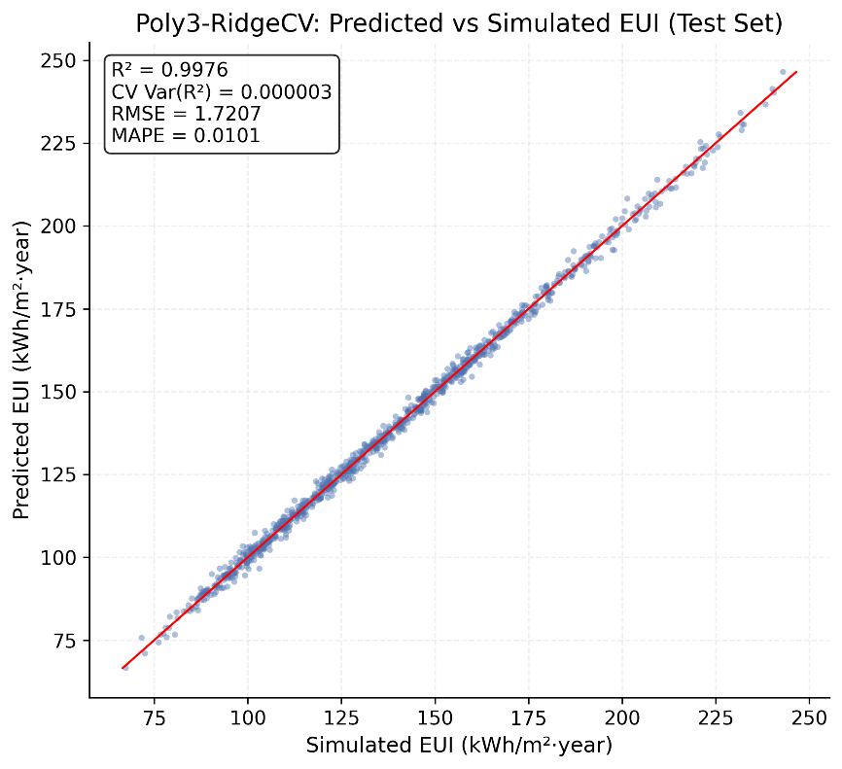
Figure 12. Comparison of EUI predicted and simulated values ​​in Poly3-RidgeCV.

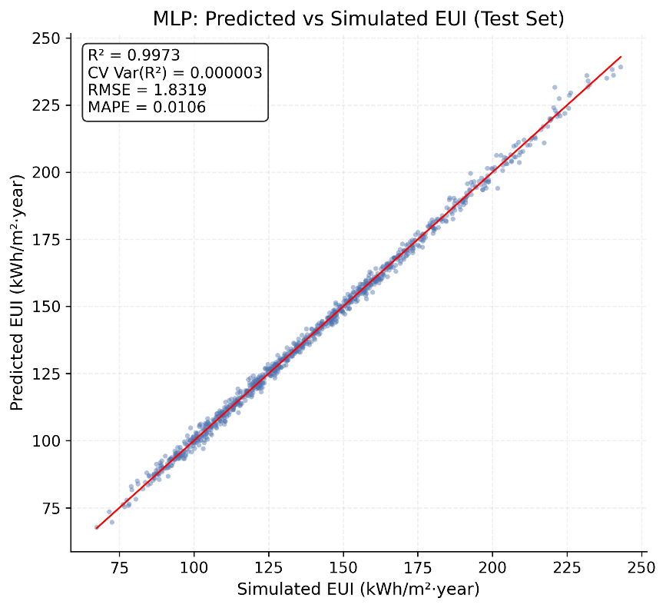
Figure 13. Comparison of EUI predicted and simulated values ​​in MLP.

4.4. EUI–OCEI Coupling Analysis
After selecting the EUI prediction model, this study further extended the analysis to the dimension of operational carbon emission intensity per unit floor area (OCEI) in order to reveal the coupling relationship between building energy use intensity and operational carbon emission intensity. The OCEI analysis was conducted as follows.
At this stage, the inputs used for OCEI calculation are no longer the original building design parameters, but the carrier-specific end-use energy results extracted from the EnergyPlus simulations. These mainly include electricity-related, natural-gas-related, district-heating-related, and district-cooling-related end-use energy consumption. Total energy consumption and EUI are used only for comparison and coupling analysis, rather than as direct inputs to carbon accounting.
Before using carbon emission factors to calculate OCEI, we classified the relevant end-use energy results into four energy carriers: electricity, natural gas, district heating, and district cooling. Based on this, we established a mapping relationship between end-use energy consumption and energy carriers, providing the basis for subsequent carbon-emission conversion.
After identifying the energy carriers corresponding to each energy consumption item, we further standardized the units of measurement for various energy consumption types and assigned corresponding carbon emission factors to them. The carbon emission factors for each energy carrier and their values ​​are shown in Table 5. Subsequently, based on the principle of "energy consumption multiplied by the carbon emission factor," we calculated the carbon emissions corresponding to each energy carrier and added them together to obtain the total carbon emissions for the building sample. Finally, we divided the total carbon emissions by the building area to construct the carbon emission intensity index per unit building area (OCEI). Through this step, we achieved the conversion from energy consumption item results to carbon emission item results.

Table 5. Carbon emission factors for each energy carrier.
Carbon emission factor | Value
Electricity emission factor (kgCO₂e/kWh) | 0.55
Natural gas emission factor (kgCO₂e/kWh) | 0.202
District heating emission factor (kgCO₂e/kWh) | 0.22
District cooling emission factor (kgCO₂e/kWh) | 0.16

After calculating the OCEI for each sample, we statistically analyzed its distribution characteristics, as shown in Figure 14. The results indicate that OCEI follows a relatively continuous unimodal distribution, mainly concentrated within a reasonable range, without obvious outlier points or discrete clusters. Statistical results show that the mean of the sample OCEI is 48.19 kgCO₂e/(m²·a), the median is 47.40 kgCO₂e/(m²·a), the standard deviation is 7.91 kgCO₂e/(m²·a), and the minimum and maximum values ​​are 29.80 kgCO₂e/(m²·a) and 80.57 kgCO₂e/(m²·a), respectively. This indicates that, under the adopted carbon-accounting boundary, the samples still exhibit adequate dispersion and representativeness, and can be used for subsequent EUI-OCEI coupling analysis.

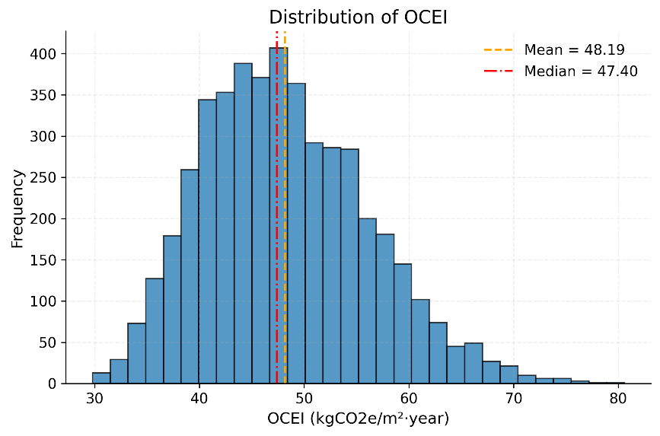
Figure 14. The distribution characteristics of the sample OCEI.

Figures 15 and 16 illustrate the differences in the contributions of the four energy carriers to building carbon emissions from two perspectives: total annual carbon emissions and average annual OCEI. Within the current research boundary, natural gas accounts for the largest share in both total annual carbon emissions and average annual OCEI, making it the primary source of carbon emissions from hotel buildings. Electricity ranks second, indicating that electricity consumption for lighting, equipment, and auxiliary systems remains a significant component of carbon emissions. district heating and district cooling each account for part of the space-heating and space-cooling demand, contributing to both total carbon emissions and OCEI, but overall less than natural gas and electricity. Specifically, natural gas, electricity, district heating, and district cooling contribute approximately 38.06%, 27.23%, 22.21%, and 12.49% to total carbon emissions, respectively. This result demonstrates that carbon emissions from hotel buildings are not determined by a single energy form but are formed by the combined effects of multiple energy carriers; among them, domestic hot water and related heat source systems remain key control targets for low-carbon optimization.

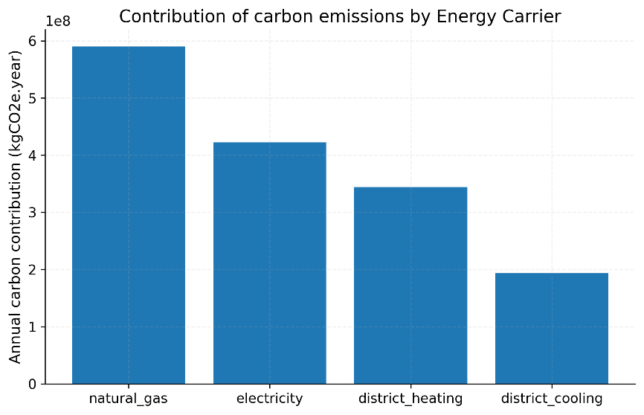
Figure 15. Contribution of total annual carbon emissions by Energy Carrier.

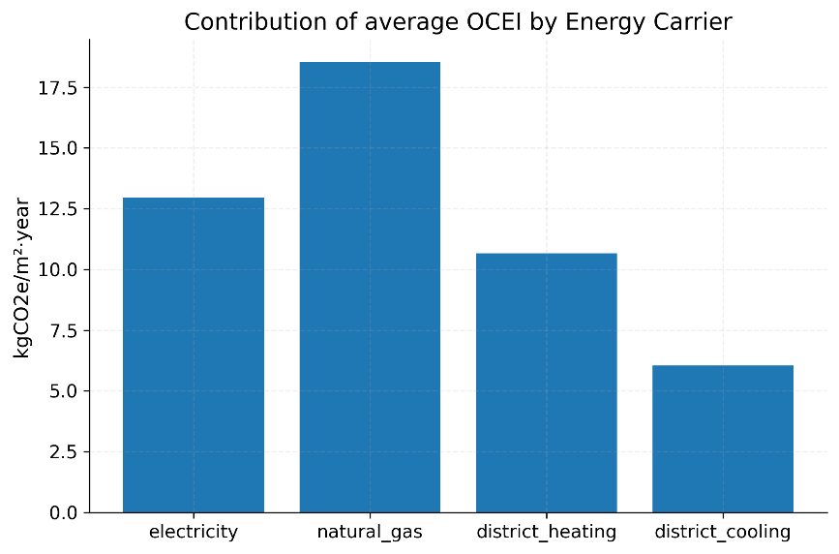
Figure 16. Contribution of average annual OCEI by Energy Carrier.

Figure 17 further illustrates the relationship between EUI and OCEI. The two indicators show a strong and statistically significant positive correlation, with a Pearson correlation coefficient of 0.9542 (p < 0.001). This indicates that energy use intensity per unit floor area is an important determinant of operational carbon emission intensity per unit floor area; in general, higher-EUI samples tend to correspond to higher OCEI values. However, OCEI still exhibits noticeable dispersion within similar EUI intervals, suggesting that although the two indicators follow a consistent overall trend, they are not completely equivalent. In other words, operational carbon performance depends not only on the level of energy use itself, but also on the structure of energy carriers and their corresponding emission factors. Therefore, evaluating building schemes solely by EUI is insufficient to fully reflect their low-carbon performance.

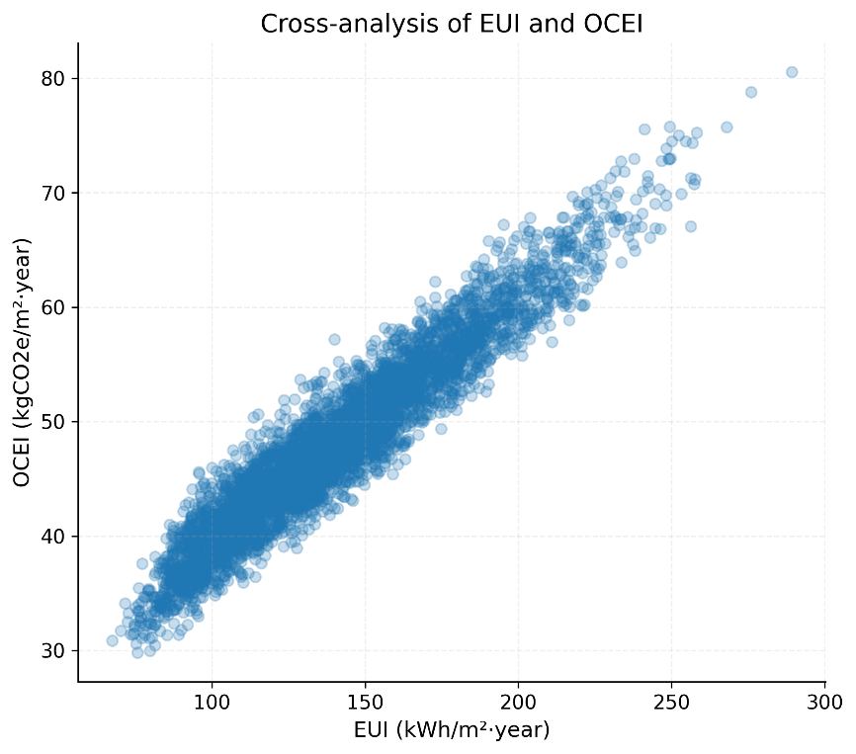
Figure 17. Relationship between EUI and OCEI.

To further identify the discrepancy between energy-saving performance and low-carbon performance, we ranked the samples according to EUI and OCEI, respectively, and compared the ranking changes of the same sample under the two evaluation dimensions, as shown in Figure 18. Although many samples show a broadly consistent trend under both EUI and OCEI rankings, some samples deviate substantially from the 1:1 reference line, indicating that their advantage in EUI ranking has not fully translated into an advantage in OCEI ranking. In other words, a low EUI sample does not necessarily correspond to the lowest OCEI, further illustrating that "energy-saving priority" and "low-carbon priority" do not completely overlap. To explain this discrepancy from a factor-analysis perspective, Figure 19 compares the standardized regression coefficients (SRC) of the selected key variables for EUI and OCEI under the same bootstrap-based analytical framework. The results show that domestic-hot-water-related variables, operational-control variables, and equipment-efficiency variables remain important under both indicator systems. However, the relative contribution of domestic hot water load and heat-source efficiency becomes more pronounced in the OCEI dimension, indicating that these variables not only affect end-use energy demand, but are also further amplified by the emission characteristics of the corresponding energy carriers.

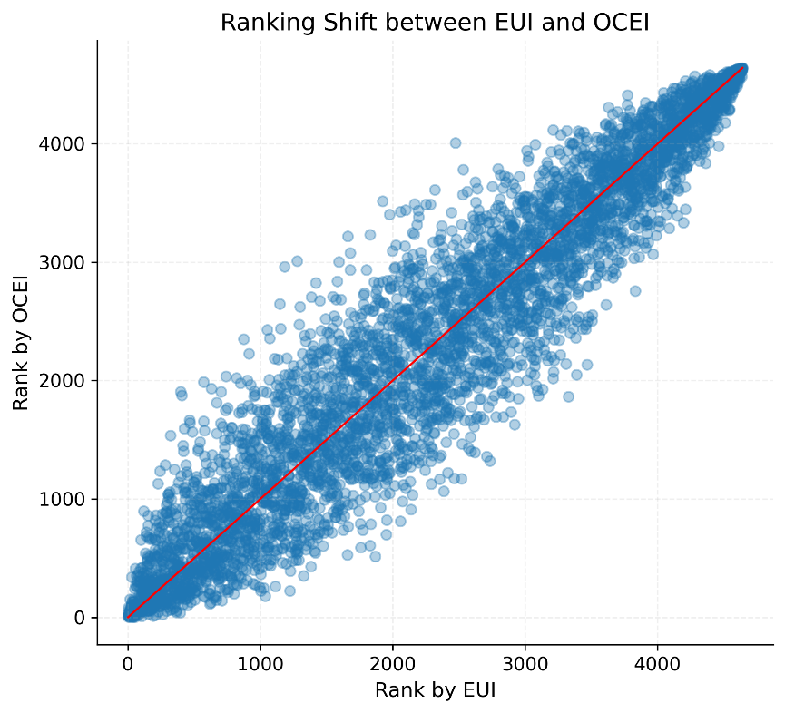
Figure 18. Ranking shift between EUI and OCEI.

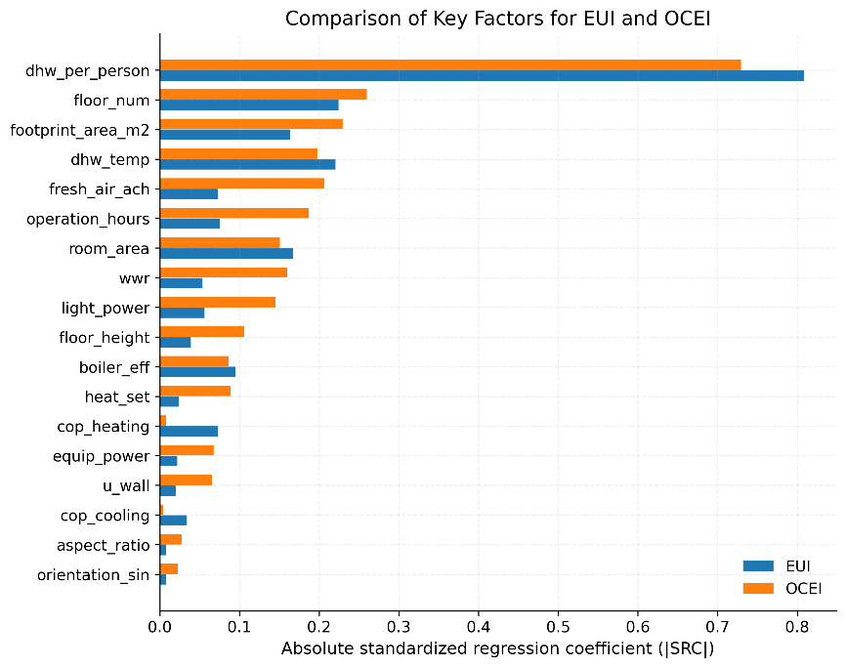
Figure 19. Bootstrap-based SRC comparison of key factors for EUI and OCEI.

Based on the above results, we can conclude that the EUI and OCEI of hotel buildings in Beijing exhibit a significant coupling relationship overall, but this coupling is not a simple one-to-one correspondence. Natural gas and electricity remain the dominant sources of carbon emissions from hotel buildings, while the formation mechanism of OCEI is the result of the combined effects of building energy consumption demand and the carbon emission characteristics of energy carriers. Therefore, for hotel buildings, an optimization strategy that only aims to minimize EUI is insufficient. A more reasonable approach is to incorporate EUI and OCEI into a unified evaluation framework, conducting synergistic optimization among building envelope, HVAC system operation and control, domestic hot water system, and energy use structure, thereby further expanding from a single energy-saving evaluation to a synergistic evaluation of energy saving and low carbon emissions.

5. Discussion
This study constructed an integrated research framework consisting of "parametric simulation—key variable identification—machine-learning-based predictive modeling—EUI and OCEI coupled analysis," and verifies the applicability of the method using hotel buildings in Beijing as an example. Compared with the traditional method of conducting physical simulation analysis on a per-scheme basis, this study not only focuses on the formation mechanism of building energy consumption, but also further emphasizes improving the efficiency of scheme evaluation and the ability to analyze energy conservation and low carbon emissions in a coordinated manner while ensuring prediction accuracy. The results show that variation in hotel-building EUI is not determined by a single parameter, but by the combined effects of envelope thermal parameters, building geometric parameters, occupant and equipment load parameters, and HVAC operational control parameters. The machine learning prediction model established on this basis can approximate the EnergyPlus simulation results with high accuracy, thereby supporting rapid screening and early-stage decision-making across a large number of schemes.
Compared with previous studies that focused either on local parameter analysis or on black-box model fitting alone, the present study contributes a more integrated pathway that links variable screening, predictive modeling, and energy-carbon coupling analysis within one unified framework. This is particularly valuable for hotel buildings, whose energy use is strongly shaped by domestic hot water demand and operational control rather than envelope variables alone.
However, this study has several limitations:
- The study did not explicitly distinguish among different hotel categories or operational typologies. In practice, hotel category is associated with differences in service level, operational scale, occupancy characteristics, and end-use energy demand, which may affect both EUI and OCEI.
- The study focuses on hotel buildings in the Beijing area, and its sample parameter range, climate boundaries, and operational patterns exhibit significant regional characteristics. Therefore, the direct applicability of the model to other climate zones or other functional building types still needs further validation.
- This study does not explicitly incorporate intelligent energy-management technologies, high-efficiency building service systems, or renewable-energy applications currently used in hotel buildings.
- This study's OCEI research currently focuses primarily on the EUI–OCEI coupling relationship under a fixed carbon accounting boundary, and has not yet expanded to include multi-energy supply scenarios and dynamic emission factor conditions.

6. Conclusions
In summary, this study established an integrated framework for EUI prediction and EUI–OCEI coupling analysis of hotel buildings in Beijing through four steps. Firstly, the value ranges of 38 key feature parameters affecting hotel building energy consumption were determined. Then, Latin hypercube sampling was used to generate building samples with different parameter combinations, and EnergyPlus was employed to perform annual energy simulations, generating the target outputs required for subsequent sensitivity analysis and model training.
Secondly, this study applied the standardized regression coefficient (SRC) method combined with Bootstrap resampling to evaluate the strength, direction, and stability of the effects of input variables on EUI, and 18 core variables with significant and stable effects were selected for subsequent modeling. The results show that domestic hot water load, building form parameters, envelope performance, and HVAC operation and control parameters are the main factors affecting the EUI of hotel buildings in Beijing.
Thirdly, based on the reconstructed simulation dataset, 17 commonly used and representative machine learning regression models were trained and compared. A 10-fold cross-validation method was adopted, and the coefficient of determination (R²), cross-validation variance, root mean square error (RMSE), and mean absolute percentage error (MAPE) were used as the main evaluation indicators. The results show that Poly3-RidgeCV and MLP achieved the best overall performance in EUI prediction, among which Poly3-RidgeCV was slightly superior to MLP in fitting accuracy, error control, and model stability.
Finally, based on the EUI prediction framework, carbon emission factors were further introduced to construct the OCEI indicator, and an EUI–OCEI coupling analysis was carried out. The results indicate that EUI and OCEI are significantly positively correlated overall, but they are not completely equivalent. Natural gas and electricity remain the main sources of carbon emissions in hotel buildings, while bootstrap-based SRC comparison further indicates that domestic-hot-water-related variables and heat-source-efficiency variables play a more prominent role in the OCEI dimension. This suggests that the optimization goal for hotel buildings in Beijing should not be limited to minimizing EUI alone, but should instead incorporate both EUI and OCEI into a unified evaluation framework for coordinated optimization of the building envelope, operational control, domestic hot water system, and energy-use structure.
Overall, the results indicate that the EUI of hotel buildings in Beijing can be predicted with high accuracy by combining parametric simulation and machine learning methods, and that this framework can further support OCEI coupling analysis. Therefore, during the design, construction, and operation stages of hotel buildings, managers and designers can use a limited number of key inputs to rapidly establish EUI prediction and OCEI evaluation models, thereby providing a reference for energy-saving design, low-carbon optimization, and scheme comparison.

References
- Zhao, Z.-Y.; Chang, R.-D.; Zillante, G. Challenges for China’s energy conservation and emission reduction. Energy Policy 2014, 74, 709–713. https://www.sciencedirect.com/science/article/pii/S030142151400408X.
- Pérez-Lombard, L.; Ortiz, J.; Pout, C. A review on buildings energy consumption information. Energy and Buildings 2008, 40, 394–398. https://www.sciencedirect.com/science/article/pii/S0378778807001016.
- Chung, M.; Park, H.-C. Comparison of building energy demand for hotels, hospitals, and offices in Korea. Energy 2015, 92, 383–393. https://www.sciencedirect.com/science/article/pii/S0360544215004442.
- Han, S.; Yao, R.; Li, N. The development of energy conservation policy of buildings in China: A comprehensive review and analysis. Journal of Building Engineering 2021, 38, 102229. https://www.sciencedirect.com/science/article/pii/S2352710221000851.
- Wu, P.; Shi, P. An estimation of energy consumption and CO2 emissions in tourism sector of China. J. Geogr. Sci. 2011, 21, 733–745. https://doi.org/10.1007/s11442-011-0876-z.
- Fumo, N.; Mago, P.; Luck, R. Methodology to estimate building energy consumption using EnergyPlus benchmark models. Energy and Buildings 2010, 42, 2331–2337. https://www.sciencedirect.com/science/article/pii/S0378778810002574.
- Hu, J.; Wu, J. Analysis on the influence of building envelope to public buildings energy consumption based on DeST simulation. Procedia Engineering 2015, 121, 1620–1627. https://www.sciencedirect.com/science/article/pii/S1877705815030209.
- Ke, M.-T.; Yeh, C.-H.; Jian, J.-T. Analysis of building energy consumption parameters and energy savings measurement and verification by applying eQUEST software. Energy and Buildings 2013, 61, 100–107. https://www.sciencedirect.com/science/article/pii/S0378778813000881
- Shahcheraghian, A.; Madani, H.; Ilinca, A. From White to Black-Box Models: A Review of Simulation Tools for Building Energy Management and Their Application in Consulting Practices. Energies 2024, 17, 376. https://doi.org/10.3390/en17020376.
- Chen, C.; Gao, Z.; Zhou, X.; Wang, M.; Yan, J. Energy consumption prediction and energy-saving suggestions of public buildings based on machine learning. Energy and Buildings 2024, 320, 114585. https://www.sciencedirect.com/science/article/pii/S0378778824007011.
- Ahmad, M.W.; Mourshed, M.; Rezgui, Y. Trees vs. Neurons: Comparison between random forest and ANN for high-resolution prediction of building energy consumption. Energy and Buildings 2017, 147, 77–89. https://doi.org/10.1016/j.enbuild.2017.04.038.
- Wang, Z.; Wang, Y.; Zeng, R.; Srinivasan, R.S.; Ahrentzen, S. Random forest based hourly building energy prediction. Energy and Buildings 2018, 171, 11–25. https://doi.org/10.1016/j.enbuild.2018.04.008.
- Li, C.; Hong, T.; Yan, D. An insight into actual energy use and its drivers in high-performance buildings. Applied Energy 2014, 131, 394–410. https://doi.org/10.1016/j.apenergy.2014.06.032.
- Olu-Ajayi, R.; Alaka, H.; Egwim, C.; Grishikashvili, K. Comprehensive Analysis of Influencing Factors on Building Energy Performance and Strategic Insights for Sustainable Development: A Systematic Literature Review. Sustainability 2024, 16, 5170, https://doi.org/10.3390/su16125170.
- Muhič, S.; Manić, D.; Čikić, A.; Komatina, M. Influence of Building Envelope Modeling Parameters on Energy Simulation Results, Sustainability 2025, 17, 5276, https://doi.org/10.3390/su17125276.
- Kim, D.; Lee, J.; Do, S.; Mago, P.J.; Lee, K.H.; Cho, H. Energy Modeling and Model Predictive Control for HVAC in Buildings: A Review of Current Research Trends. Energies 2022, 15, 7231. https://doi.org/10.3390/en15197231.
- Echarri-Iribarren, V.; Fernández-Sedas, C.; López-Zapata, R. DHW Storage and Recirculation Systems in High-Rise Hotel Buildings: A Comparison of Energy Efficiency and Environmental Impacts. Buildings 2026, 16, 863. https://doi.org/10.3390/buildings16040863.
- Permana, I.; Wang, F.; Agharid, A.P.; Rakshit, D.; Luo, J. Energy Consumption Analysis Using Weighted Energy Index and Energy Modeling for a Hotel Building. Buildings 2023, 13, 1022. https://doi.org/10.3390/buildings13041022.
- Papadakis, N.; Katsaprakakis, D.A. A Review of Energy Efficiency Interventions in Public Buildings. Energies 2023, 16, 6329. https://doi.org/10.3390/en16176329.
- Kistelegdi, I.; Horváth, K.R.; Storcz, T.; Ercsey, Z. Building Geometry as a Variable in Energy, Comfort, and Environmental Design Optimization—A Review from the Perspective of Architects. Buildings 2022, 12, 69. https://doi.org/10.3390/buildings12010069.
- Agharid, A.P.; Permana, I.; Singh, N.; Wang, F.; Gustiyana, S. Energy-Efficient and Cost-Effective Approaches through Energy Modeling for Hotel Building. Energy Engineering 2024, 121, 3549–3571. https://doi.org/10.32604/ee.2024.056398.
- Xu, X.; Dan, Z. Exploring the Evolution of Energy Research in Hospitality: Mapping Knowledge Trends, Insights, and Frontiers. Energy Rep. 2023, 10, 864–880. https://doi.org/10.1016/j.egyr.2023.07.030.
- Zhu, W.; Zheng, Z.; Liu, M.; Deng, G. A Case Study on Existing Building HVAC System Optimization of a Five-Star Hotel in Shanghai. In Proceedings of the 11th International Symposium on Heating, Ventilation and Air Conditioning (ISHVAC 2019); Springer: Singapore, 2020; pp. 589–597. https://doi.org/10.1007/978-981-13-9524-6_62.
- Alhuwayil, W.K.; Gadi, M.B.; Almaziad, F.A.; Alhuthali, A.H.; Abdelrahman, M.A.E. Energy Performance of Passive Shading and Thermal Insulation in Multistory Hotel Building under Different Outdoor Climates and Geographic Locations. Case Stud. Therm. Eng. 2023, 45, 102940. https://doi.org/10.1016/j.csite.2023.102940.
- Tian, W. A Review of Sensitivity Analysis Methods in Building Energy Analysis. Renew. Sustain. Energy Rev. 2013, 20, 411–419. https://doi.org/10.1016/j.rser.2012.12.014.
- Roka, R.; Figueiredo, A.; Vieira, A.; Cardoso, C. A Systematic Review of Sensitivity Analysis in Building Energy Modeling: Key Factors Influencing Building Thermal Energy Performance. Energies 2025, 18, 2375. https://doi.org/10.3390/en18092375.
- Pan, Y.; Zhu, M.; Lv, Y.; Yang, Y.; Liang, Y.; Yin, R.; Yang, Y.; Jia, X.; Wang, X.; Zeng, F.; Huang, S.; Hou, D.; Xu, L.; Yin, R.; Yuan, X. Building Energy Simulation and Its Application for Building Performance Optimization: A Review of Methods, Tools, and Case Studies. Adv. Appl. Energy 2023, 10, 100135. https://doi.org/10.1016/j.adapen.2023.100135.
- Dimara, A.; Krinidis, S.; Ioannidis, D.; Tzovaras, D. Building Performance Simulation. In Disrupting Buildings: Digitalisation and the Transformation of Deep Renovation; Lynn, T.; Rosati, P.; Kassem, M.; Krinidis, S.; Kennedy, J., Eds.; Palgrave Macmillan: Cham, Switzerland, 2023; pp. 53–67. https://doi.org/10.1007/978-3-031-32309-6_4.
- Solmaz, A.S. A Machine Learning-Based Early Design Energy Prediction Framework for School Buildings Across Multiple Climatic Regions of Türkiye. Buildings 2026, 16, 779. https://doi.org/10.3390/buildings16040779.
- Westermann, P.; Evins, R. Surrogate Modelling for Sustainable Building Design—A Review. Energy Build. 2019, 198, 170–186. https://doi.org/10.1016/j.enbuild.2019.05.057.
- Ji, J.; Yu, H.; Wang, X.; Xu, X. Machine Learning Application in Building Energy Consumption Prediction: A Comprehensive Review. J. Build. Eng. 2025, 104, 112295. https://doi.org/10.1016/j.jobe.2025.112295.
- Chen, Z.; Xiao, F.; Guo, F.; Yan, J. Interpretable Machine Learning for Building Energy Management: A State-of-the-Art Review. Adv. Appl. Energy 2023, 9, 100123. https://doi.org/10.1016/j.adapen.2023.100123.
- Manfren, M.; Gonzalez-Carreon, K.M.; James, P.A.B. Interpretable Data-Driven Methods for Building Energy Modelling—A Review of Critical Connections and Gaps. Energies 2024, 17, 881. https://doi.org/10.3390/en17040881.
- Shirzadi, N.; Lau, D.; Stylianou, M. Surrogate Modeling for Building Design: Energy and Cost Prediction Compared to Simulation-Based Methods. Buildings 2025, 15, 2361. doi:10.3390/buildings15132361. https://doi.org/10.3390/buildings15132361.
- Arenhart, R.S.; Martins, T.; Ueda, R.M.; Souza, A.M.; Zanini, R.R. Energy Use and Its Contributors in Hotel Buildings: A Systematic Review and Meta-Analysis. PLoS ONE 2024, 19, e0309745. doi:10.1371/journal.pone.0309745. https://doi.org/10.1371/journal.pone.0309745.
- Cornette, J.F.P.; Blondeau, J. Operational Greenhouse Gas Emissions of Various Energy Carriers for Building Heating. Cleaner Energy Systems 2024, 9, 100148. https://doi.org/10.1016/j.cles.2024.100148.
- Yang, S.; Gao, H.O.; You, F. Building Electrification and Carbon Emissions: Integrated Energy Management Considering the Dynamics of the Electricity Mix and Pricing. Adv. Appl. Energy 2023, 10, 100141. https://doi.org/10.1016/j.adapen.2023.100141.
- Xu, L.; Liu, J.; Pei, J.; Han, X. Building energy saving potential in hot summer and cold winter (HSCW) zone, China—Influence of building energy efficiency standards and implications. Energy Policy 2013, 57, 253–262. https://www.sciencedirect.com/science/article/pii/S030142151300075X.
- Tian, W. A review of sensitivity analysis methods in building energy analysis. Renewable and Sustainable Energy Reviews 2013, 20, 411–419. https://www.sciencedirect.com/science/article/pii/S1364032112007101.
- Saltelli, A.; Ratto, M.; Andres, T.; et al. Global Sensitivity Analysis: The Primer; John Wiley & Sons: Hoboken, NJ, USA, 2008. https://doi.org/10.1002/9780470725184.
- Chatterjee, S.; Hadi, A.S. Sensitivity Analysis in Linear Regression; John Wiley & Sons: New York, NY, USA, 1988. https://doi.org/10.1002/9780470316764.
- Bland, J.M.; Altman, D.G. Statistics notes: Bootstrap resampling methods. BMJ 2015, 350, h2622. https://doi.org/10.1136/bmj.h2622.
- Chernick, M.R. Resampling methods. WIREs Data Mining and Knowledge Discovery 2012, 2, 255–262. https://doi.org/10.1002/widm.1054.
- Li, X.; Li, Q.; Qiu, Z.; et al. Study on influencing factors of energy consumption building characteristics of high-rise hotel standard floor. Journal of Physics: Conference Series 2023, 2468, 012148. https://iopscience.iop.org/article/10.1088/1742-6596/2468/1/012148.
- Zhang, J.; Yuan, C.; Yang, J.; Zhao, L. Research on Energy Consumption Prediction Models for High-Rise Hotels in Guangzhou, Based on Different Machine Learning Algorithms. Buildings 2024, 14, 356. https://doi.org/10.3390/buildings14020356.
- Arenhart, R.S.; Souza, A.M.; Zanini, R.R. Energy Use and Its Key Factors in Hotel Chains. Sustainability 2022, 14, 8239. https://doi.org/10.3390/su14148239.
- Python. Available online: https://www.python.org.
- EnergyPlus. Available online: https://energyplus.net/.
- Borowski, M.; Zwolińska, K. Prediction of Cooling Energy Consumption in Hotel Building Using Machine Learning Techniques. Energies 2020, 13, 6226. https://doi.org/10.3390/en13236226.
- Kömürcü, D.; Edis, E. Machine Learning Modeling for Building Energy Performance Prediction Based on Simulation Data: A Systematic Review of the Processes, Performances, and Correlation of Process-Related Variables. Buildings 2025, 15, 1301. https://doi.org/10.3390/buildings15081301.
- Zheng, L.; Luo, K.; Zhao, L. An Operational Carbon Emission Prediction Model Based on Machine Learning Methods for Urban Residential Buildings in Guangzhou. Buildings 2024, 14, 3699. https://doi.org/10.3390/buildings14113699.
- GB 50189-2015. Energy Efficiency Design Standard for Public Buildings; Ministry of Housing and Urban-Rural Development of the People’s Republic of China; China Construction Industry Press: Beijing, China, 2015.
- Sheng, Y.; Miao, Z.; Zhang, J.; Lin, X.; Ma, H. Energy consumption model and energy benchmarks of five-star hotels in China. Energy and Buildings 2018, 165, 286–292. https://www.sciencedirect.com/science/article/pii/S0378778817340537.
- Tian, W.; Song, J.; Li, Z.; de Wilde, P. Bootstrap techniques for sensitivity analysis and model selection in building thermal performance analysis. Applied Energy 2014, 135, 320–328. https://doi.org/10.1016/j.apenergy.2014.08.110.
- Zheng, W.; Xu, W.; Wang, D.; Li, L.; Niu, L.; Wang, W.; Wang, B.; Song, Y. A study of city-level building energy efficiency benchmarking system for China. Energy and Buildings 2018, 179, 1–14. https://www.sciencedirect.com/science/article/pii/S0378778818314063.
- Ji, Y.; Lu, Q.; Niu, M.; Zhang, N.; Xie, J. Research on the characteristics and influence factors of residential building energy usage patterns: A case study in Beijing. Energy for Sustainable Development 2025, 85, 101654. https://www.sciencedirect.com/science/article/pii/S0973082625000043
- Cai, W.G.; Wu, Y.; Zhong, Y.; Ren, H. China building energy consumption: Situation, challenges and corresponding measures. Energy Policy 2009, 37, 2054–2059. https://www.sciencedirect.com/science/article/pii/S0301421508007398.
- Yu, H.; Pan, S.Y.; Tang, B.J.; et al. Urban energy consumption and CO2 emissions in Beijing: Current and future. Energy Efficiency 2015, 8, 527–543. https://doi.org/10.1007/s12053-014-9305-3.

