Plot of Coefficient of Performance (COP) against Evaporating Temperature (Tev) for Refrigerants R22 and R170.

By:
Odum, Godwin
Olopade, Tofunmi
Onyeali, David
Oyelakin, Ayodeji
Oyetade, Pelumi
Yekini, Yusuf
For:
PGG 503 - Refrigeration and Liquefaction.

Contents
- Introduction
- Theory
- Procedure
- Plots
- Discussion
- Conclusions
- References
Introduction
A heat pump is a device that pumps heat from a low-temperature source to a high-temperature sink with the help of an external energy source. Heat pumps usually absorb heat from a cold space and release it to a warmer one. They can be either used as heating systems as well as cooling systems by operating reversing its operation
Heat pumps are very efficient in its operation because they transfer heat, rather than burn fuel to create it which helps in reducing greenhouse emission from industries. Heat pumps transfer heat by circulating a substance called a refrigerant during the evaporation and condensation cycle. A compressor is used to pump the refrigerant between two heat exchanger coils. Hence, in one of the coils, the refrigerant is evaporated at low pressure and absorbs heat from its surroundings; afterwards, the refrigerant is then compressed and sent to the other coil, where it condenses at high pressure. At this point, it releases the heat it absorbed earlier in the cycle.
Refrigerators and air conditioners are both good examples of heat pumps operating only in the cooling mode. A refrigerator is essentially an insulated box with a heat pump system connected to it. The evaporator coil is located inside the box, usually in the freezer compartment. Heat is absorbed from this location and transferred outside, usually behind or underneath the unit where the condenser coil is located. Similarly, an air conditioner transfers heat from inside a house to the outdoors.
While heat pumps may have lower fuel costs and easier installation than conventional heating and cooling systems, they are more expensive to buy but it is also very important to realize that heat pumps will be most economical when used year-round. Generally, the heat pumps used in industries start giving paybacks approximately after 1.5-2 years of their installation depending upon their use.
TYPES OF HEAT PUMPS
Heat pumps are characterized by the mediums between which they transfer heat. There are three primary sources of energy, air, water and the ground. The heat extracted can be transferred to heat air or water, although it would also be possible in a cooling application to reject heat to the ground.
1.1 Air-to-Air Heat Pump
In an air-to-air heat pump energy is extracted usually from ambient air and transferred to heat or cool a second air stream. Ambient air is the most common energy source used by heat pumps. It should be remembered that air contains energy down to very low temperatures i.e. the point at which its constituents, Nitrogen and Oxygen, become liquids. The cooling system can be used for comfort air conditioning and cold store operation, while the heating system can be used for drying of clothes, agro products, regeneration of desiccants, etc.
1.2 Air-to-Water Heat Pump
In an air-to-water heat pump energy is transferred from ambient air, as above, to a water heating circuit. The cooling system can be used for comfort air conditioning and cold store operation, while the heating system can be used for direct heating of process fluids like cleaning solutions in Industrial washing machines, drying agro products, regeneration of desiccants which can be used for taking care of latent cooling load, etc.
1.3 Water -to-Air Heat Pump
In a water-to-air heat pump heat is transferred from a water circuit to heat an air stream. This can be viewed as heating the air stream or alternatively, if the air is ambient, as cooling the water circuit. The cooling system can be used for pre-cooling of fresh fruits, vegetables or flowers, direct process fluid cooling in chemical, pharmaceutical and food processing industry, while the heating system can be used for drying of clothes, agro products, regeneration of desiccants, etc.
1.4 Water-to-Water Heat Pump
In a water-to-water heat pump energy is transferred from one water circuit to another at a higher temperature. This gives the heat pump an advantage over a passive heat recovery device, such as a plate heat exchanger, where the maximum temperature available is just below the source water temperature. The cooling system can be used for direct process fluid cooling in chemical, pharmaceutical and food processing industry, while the heating system can be used in industrial washing machines, drying agro products, regeneration of desiccants which can be used for taking care of latent cooling load, etc.
REFRIGERANT
Meanwhile, a refrigerant is a fluid used for heat transfer in a refrigerating system that absorbs heat during evaporation from the region of low temperature and pressure and releases heat during condensation at a region of higher temperature and pressure. Refrigerants are the working medium used in refrigerating systems which evaporates by taking the heat from the space that is to be cooled, thus producing the cooling effect.
The use of refrigerants has advanced through the years, from the early 19th century the first generation refrigerants were used and they were majorly natural refrigerants. Refrigerators that were built in the late 1800s to 1929 used the first generation refrigerants like methyl chloride, ammonia and sulphur dioxide. The common refrigerants for the first hundred years included whatever worked and whatever was available. Nearly all the first generation refrigerants were flammable, toxic or both and some were also highly reactive. The numerous fatal accidents that occurred when these refrigerants leaked out of refrigerator lead to the discovery of the next generation refrigerants.
The second-generation refrigerants were distinguished by a shift to chlorofluoro chemicals for safety and durability. Compounds that are unstable, toxic, yielding insufficient volatility and inert gases based on their low boiling point were disregarded Thus CFC refrigerants made the second generation of refrigerants. CFC is a non-toxic, non-flammable gas with relatively high mass. It is a good refrigerant because it can be compressed easily to liquid and carries away lots of heat when it evaporates. Unfortunately, it is the CFC and it has unusually high potential to cause the depletion of the ozone layer.
The third generation refrigerants were mostly low ozone depletion potential refrigerants. Another new class of fluorocarbon refrigerants called hydrofluoro-olefin (HFO) with potential for reduced GWP (global warming potential) have been developed. Their primary advantage, other than their low GWP, is that they can be used with existing refrigeration system designs.
Alternative refrigerants such as R-32 and R-410A are phasing out the older refrigerants (more harmful and less efficient). R-22 is harmful to the ozone layer and was discontinued for use in new AC units in 2010 which is then replaced by R-410A. R-410A is an HFC (hydro fluorocarbon) that does not contribute to ozone depletion and will be the new standard for U.S. residential AC systems as of 2015.
R-32 is an even newer refrigerant that will likely gain popularity over the next few years. R-32 efficiently conveys heat; it can reduce electricity consumption up to approximately 10% compared to that of AC units using R-22. Compared to R-22 and R-410A, R-32 has a global warming potential (GWP) that is one-third lower and is remarkable for its low environmental impact.
The next-generation refrigerants should be developed based on zero ODP and low GWP. In the future further research, regulation changes, the design of new systems suitable for the use of newly developed and natural refrigerants and the optimization of the system can be expected. There cannot be any ideal refrigerant but it is very important that the refrigerants should do less harm to the environment.
The objective of this project is to ;
- Prepare a graph each, of Theoretical Rankine Coefficient of Performance, for cooling (COP)RCL, against Evaporating Temperature (TEV) using Compression Ratio (CR) and Temperature Lift (TCO – TEV) as parameters, for working fluids R22 and R600a respectively.
- Prepare an appropriate table, for each of the fluids, for values of (COP)RCL,(CR) and (TCO – TEV), under two selected (TEV).
- Discuss the values in the tables on comparative bases.

THEORY
Heat pumps are devices for raising the temperature of low-grade heat energy to a more useful level using a relatively small amount of high-grade energy. This input of high-grade energy may be either in the form of mechanical energy or relatively high-temperature heat energy depending on the type of heat pump. Heat pumps are amplifiers or multipliers of useful heat. The most common type of heat pump is the vapour compression heat pump using a mechanical compressor. It consists of two heat exchangers, a compressor, an expansion valve and a working fluid. Refrigerators and air conditioners are both common examples of this technology.
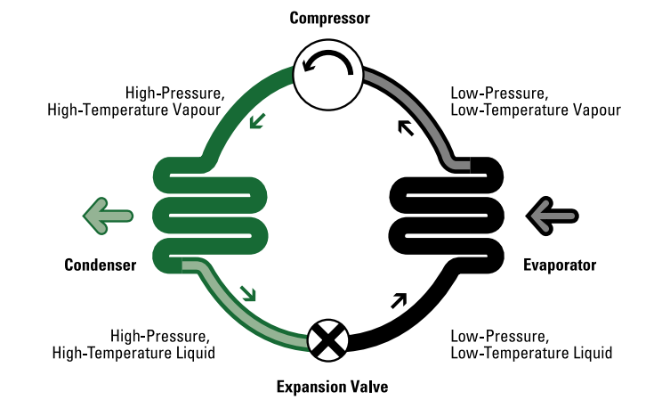
Figure 1: Vapor Compression Heat Pump
Heat pump cycle is fully reversible and transfers heat by circulating a refrigerant through a cycle of evaporation and condensation (see Figure 1). A compressor pumps the refrigerant between two heat exchanger coils. In one coil, the refrigerant is evaporated at low pressure and absorbs heat from its surroundings. The refrigerant is then compressed en route to the other coil, where it condenses at high pressure. At this point, it releases the heat it absorbed earlier in the cycle.
Heat pumps constitute a possibility for efficient electrical and mechanical based heat supply and increasing demand for high-performance equipment for these in obvious. The performance of a heat pump is limited by the temperatures of the heat source and heat sink and to what extent the maximum achievable performance can be exploited depends strongly on the working fluid.
Figure 2: Schematic for a heat pump
Introducing the first law of thermodynamics shows that the heat discharged is a summation of the heat supplied and the high-grade energy.
$$Q_{D}=Q_{S}+(HGE)$$
According to the second law of thermodynamics, the expenditure of a quantity of (HGE) is necessary to achieve the temperature lift (T_{D}- T_{S}).
The coefficient of performance of a compressor driven vapour compression heat pump can be written in the form;
$$\left(COP\right)=\frac{Q_{CO}}{W}=\frac{Q_{CO}}{Q_{CO}-Q_{EV}}$$
The vapour compression heat pump cycle can be illustrated with reference to a pressure-enthalpy diagram as shown in Fig. 2. It approximates closely to the ideal Rankine cycle. A theoretically ideal Rankine coefficient of performance can be written with reference to Fig. 3 as
$${\left(COP\right)}_{R}=\frac{H_{D1}-H_{D3}}{H_{D1}-H_{S2}}$$
It should be noted that temperature differences are required in order to transfer heat in the condenser and evaporator heat exchangers and these introduce thermodynamic inefficiencies. In addition, superheating, subcooling and pressure cause deviations from the ideal Rankine cycle.
Figure 3: Pressure-Enthalpy diagram for a heat pump
The critical temperature of the working fluid provides the upper limit at which a condensing vapour pump can deliver heat energy. The working fluid should be condensed at a temperature sufficiently below the critical temperature to provide an adequate amount of latent heat per unit mass.
There are four important parameters to consider when .selecting a working fluid for a vapour compression heat pump system.
- the temperature of condensation, Tco
- the compression ratio, (CR)= Pco/PEV
- the gross temperature lift, (Tco- TEV)
- the theoretical Rankine coefficient of performance (COP)_{R}.
These parameters are not independent and when two are specified, the other two are determined automatically for a given working fluid.
The first parameter Tco is largely determined by the required delivery temperature TD since the temperature difference driving force in the condenser is (Tco- TD).
The second parameter (CR) = Pco/PEV is often determined by the characteristics of an available compressor. Therefore, in practice one may have little control of the gross temperature lift (Tco- TEv) and the theoretical Rankine coefficient of performance (COP)R since these are a function of the thermodynamic properties of the chosen working fluid.
The net temperature lift (TD- Ts) is of course less than the gross temperature lift (Tco- TEV) by the sum of the temperature difference driving forces in the condenser and evaporator heat exchangers. The actual coefficient of performance (COP)_{A} is also less than the theoretical Rankine coefficient of performance (COP)_{R} and the difference in both cases is a function of the design of the equipment.
A heat pump effectiveness compared to the theoretical Rankine cycle can be defined as
$${\left(HPE\right)}_{R}=\frac{{\left(COP\right)}_{A}}{{\left(COP\right)}_{R}}$$
The (HPE)R is effectively the ratio of work required in an ideal Rankine cycle to that in an actual cycle in order to transfer a given amount of heat to the condenser. It is possible to exceed (HPE)R values of 0.8 in a well-designed heat pump system.
In conclusion, before a refrigerant/working fluid is selected, these properties are accessed foremost to determine whether the fluid meets the specification to facilitate the heat pump operations. This information is gotten at first glance on a theoretical Rankine coefficient of performance against condensing temperature for various compression ratios and gross temperature lifts.
For this paper, this plot will be made for two refrigerants (R22 and R170).
Procedure
The following was done using the python programming language. Libraries used include numpy, pandas, scipy, math and matplotlib.
- Prepared all the needed formulas for calculations.
  - Compression Ratio (CR), H3, COP.
- Prepared a spreadsheet containing all the needed properties of the refrigerants.
  - Temperature, Pressure, Enthalpy (liquid and vapor) and Entropy (liquid and vapor).
- Picked out points for Temperature Lift, TL, (Tco-Tev) based on the available data.
- Using the TL points, all possible combinations of the temperature data that gives each point was evaluated.(i.e. given a TL point 10, possible combinations of TL data that gives 10 include, 50-40, 35-25, 82-72, (-10)-(-20), etc., all in the format Tco-Tev).
- All the corresponding calculations were made for each combination to obtain the CR and COP values.
- It was confirmed that for each combination, S2 > S4. The combinations where S2 < S4 were removed before proceeding.
- For each point, the COP values were plotted against their respective Tev values to obtain a line for each point. The lines were smoothed out using an interpolation algorithm.
- All of the data for each point is stored in a pandas DataFrame, with the following information: Tev, Tco-Tev, COP, CR.
- From the DataFrame above, each CR value appearing at least 4 times is extracted.
- The corresponding Tev and COP values to the CR values above are plotted to obtain the CR lines. The lines were alsi smoothed out using an interpolation algorithm.

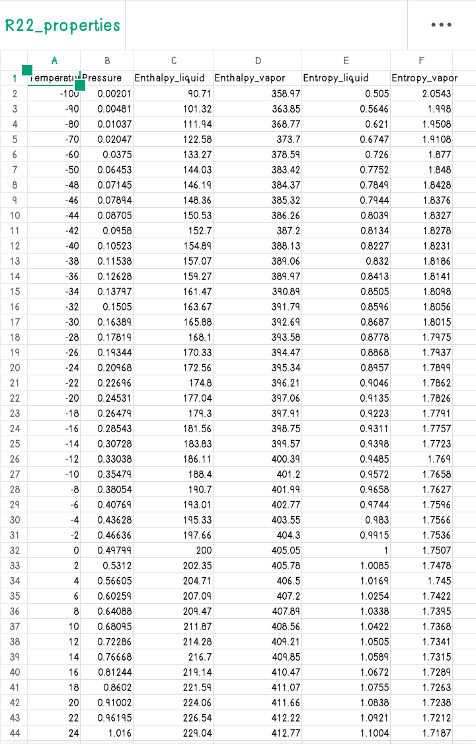
Properties
R22

R22 Data
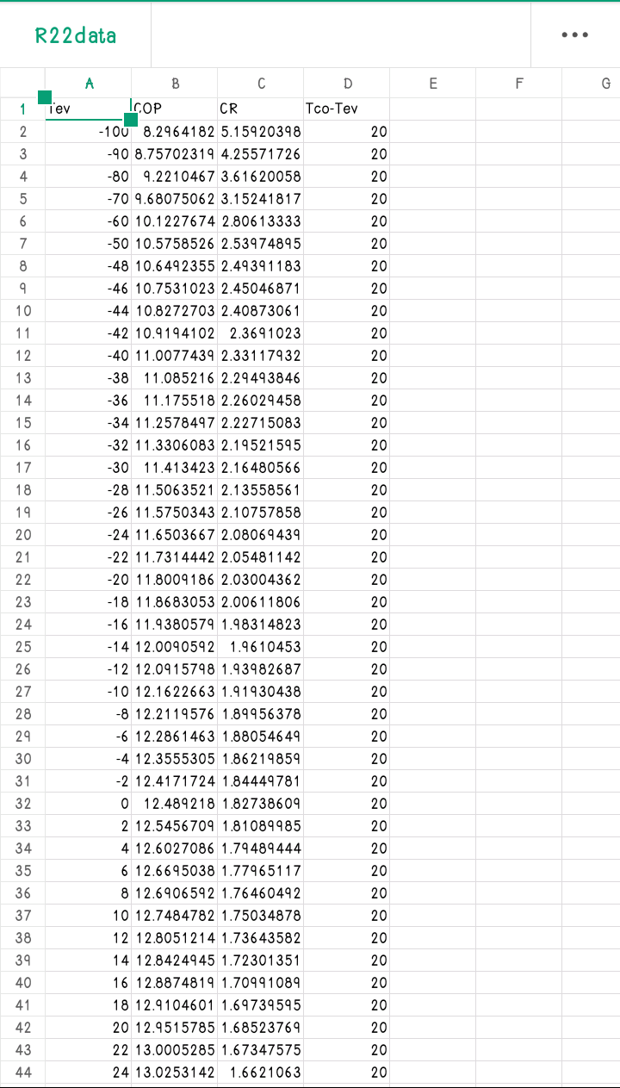

Plots

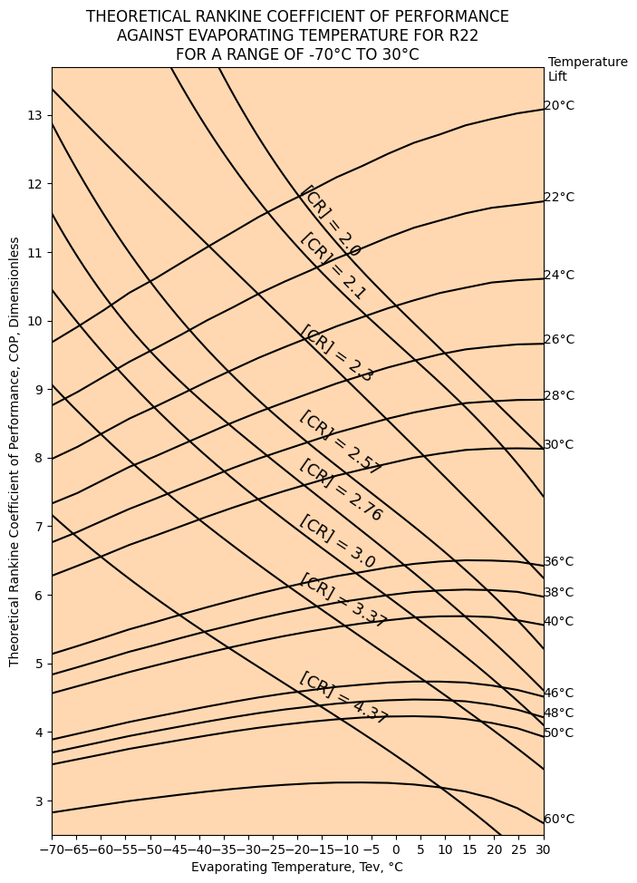

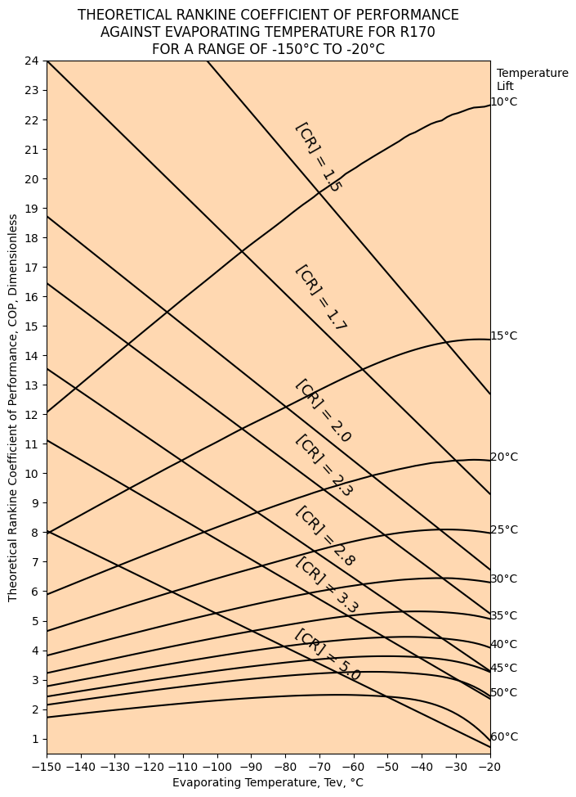

Discussion
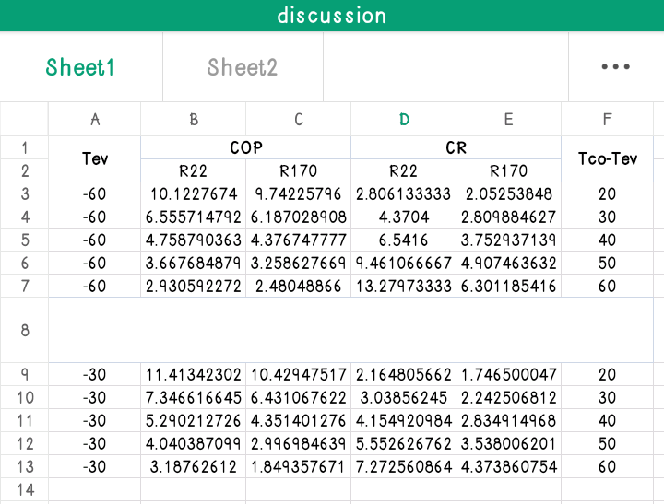

The table above shows the COP, CR and Tco-Tev values for both R22 and R170.

We notice that at each point, under the same conditions R22 performs better than R170 in terms of COP and CR, but the difference is not a lot.
We also notice that the COP and CR values for both fluids decreases and increases as Tco-Tev increases.

Conclusions
We can conclude that R170(ETHANE) can be used as a replacement for R22(Chlorodifluoromethane) because of the following reasons.
- The performance of R170 is only slightly lesser than that of R22.
- R170 is more Eco-friendly than R22, which contains chlorine atoms(that are harmful to the environment).

REFERENCES
- Zühlsdorf, Benjamin & Jensen, Jonas & Elmegaard, Brian. (2018). Heat pump working fluid selection – Economic and thermodynamic comparison of criteria and boundary conditions. International Journal of Refrigeration. 98. 10.1016/j.ijrefrig.2018.11.034.
- Authors A. A. .Heating and Cooling with a heat pump. ISBN 0-662-37827-X. Energy Publications, Canada. Natural Resources Canada’s Office of Energy Efficiency.
- Devotta S., Holland F. A.. (1985). Comparison of Theoretical Rankine Heat pump cycle performance data for twenty-one working fluids. Heat Recovery Systems, Vol 5, No. 3, pp 225-231.
- Arpit Gagneja and Siddhant Pundhir, 2016, heat pumps and its applications, Int’l Journal of Advances in Chemical Engg., & Biological Sciences (IJACEBS) Vol. 3, Issue 1, ISSN 2349-1507 EISSN 2349-1515
- Madhu Sruthi Emani, Ranendra Roy And Bijan Kumar Mandal, 2017, developments of refrigerants: a brief overview, Indian J.Sci.Res. 14 (2): 175-181, 2017
- Andy Neave, 2002, heat pumps and their applications, Calorex heat pumps limited, Maldon, Essex, 41, 1-9

