

**Investing just got a lot more interesting.**

*MyBit Go* is a next generation investment platform built for the *IOT economy*. It allows anyone to securely invest any amount of capital in high value IOT assets with minimal fees and real-time revenue distributions

**What’s an IOT asset?**

An *IoT asset* is an asset that can connect to the internet of things (IOT). Rapidly progressing technology is creating what is known as ‘*The* *Automation era’* inwhich IOT assets arerecasting the modern investment landscape through their ability to autonomously generate revenue.

**How?**

Take a Bitcoin ATM as an example –once produced and installed, they provide a valuable service with virtually no further human input. Provided the location is viable, Bitcoin ATM’s can generate revenue equating to multiple times what they cost to produce within a short period of time. IOT devices like these bring new investment opportunities much better than most options available traditionally.

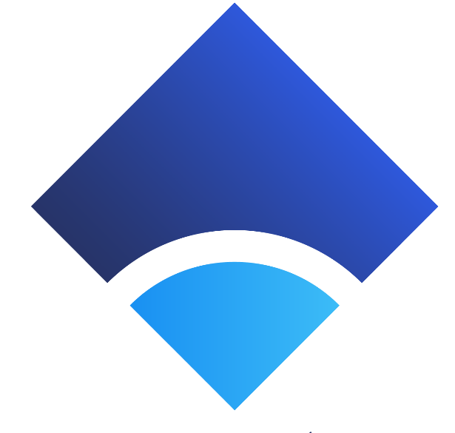

**Where does MyBit GO come in?**

To capitalise on the ROI potential of IOT devices today, an entire asset must be purchased and managed directly. This is a complicated and expensive process that requires either a large capital investment or going into debt, not to mention carrying out the due diligence and maintenance required to manage the asset effectively.

*MyBit GO* implements a fractional ownership model into the IOT economy, enabling anyone to safely and conveniently invest any amount of capital in prospective IOT asset installations around the world. This is made possible by connecting thousands of investors with verified asset producers and managers through specific asset listings on the platform, then fractionating and recording *ownership* of the assets on the blockchain.

As assets generate revenue in the economy, *MyBit GO* seamlessly distributes asset specific revenue streams back to investors proportional to their equity, giving *MyBit GO* user’s full exposure to the IOT investment ecosystem with maximum convenience, minimal fees and *NO* barriers to entry.

**Why does this matter?**

With machines taking over as the main actors in the economy, the ROI associated with IOT assets is set to increase dramatically. Now on track to be working more hours than humans by 2025, machines are becoming more efficient than people in generating economic value.

*Ownership is critical*; as IOT assets increasingly outcompete human capital in the labour market, IOT asset ownership disparity will drive a set of unnecessary social problems. Along with UBI (universal basic income), extensively distributing IOT asset ownership is key to offsetting the negative aspects associated with automation while maximising the positive aspects.

**Why MyBit Go?**

If *MyBit GO* were not integrated into the IOT economy, the *centralised human management* of broker functions would inevitably venture into the space. On top of being unnecessary, this is an inefficient and opaque system with large fees, enormous entry barriers, heavy bureaucracy and a multitude of counterparty risks; all of which contribute to mass exclusion.

*MyBit GO* is a decentralised application that provides permission-less access to investment opportunities in the IOT sector, ensuring that the revenue streams associated with IOT assets become decentralised.

**Is it secure?**

Absolutely**.** MyBit GO is more secure than most other systems used to manage investments today. Built on Ethereum, it utilises all the necessary components needed to ensure that crowdfunding procedures, ownership records and revenue distribution contracts are secured on the blockchain.

**What about the Assets?**

The MyBit team ensures that *IOT asset partners* who supply assets to the ecosystem first meet extensive criteria before becoming approved partners of the platform. The sole focus of this process is to ensure that all assets bring the *Highest ROI* potential with the *Lowest Risk* to investors over all time frames.

Also, *insurance* is a big part of the platform. MyBit GO integrates policies that are professionally tailored to the specific asset with premiums seamlessly integrated in a transparent way that best suits investors.

**And the asset managers?**

*Asset managers* compete in an open market to manage assets for investors. Not only are asset managers verified before participating in the ecosystem but are also subject to a dynamic reputation system native to the platform. Additionally, asset managers are required to post a security deposit as collateral to ensure investors are protected through an incentive structure.

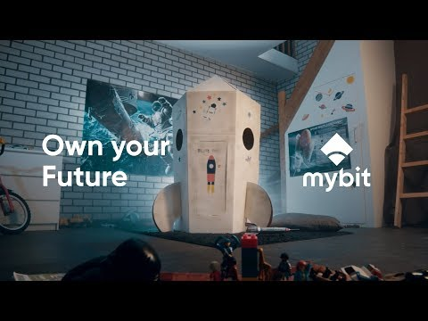

**How do I get involved?**

MyBit GO is currently in alpha phase on the Ethereum ropsten test-net and is available to [try here](http://app.mybit.io).

To learn more about how it works you can visit the [website](https://go.mybit.io), or you can find information about the [team](https://mybit.io/about-us#top) and the MyBit Network [here](http://mybit.io).

Lastly, feel free to join the friendly [telegram](https://t.me/mybitio.) community to ask questions, read the latest updates, and get involved in the future of investing!