# **MyBit Go**

In short, MyBit Go is a decentralised Application (dApp) which connects you, as an investor, to the machine economy. It is built on top of the [MyBit Network protocol](https://developer.mybit.io/portal/mybit-ecosystem/mybit-network) and enables any person around the globe to securely profit from the Internet of Things (IoT) industry. All with low fees, in real time, and with no intermediaries.

The machine economy has only just begun, but we can already profit from it. Over the next 5 years, it is projected that the machine economy will generate over US$10 trillion in revenue.

#### **The old school trend: infrequent revenue and excessive fees**

Traditionally, in order to invest in an IoT project, there are several obstacles which must be overcome. These obstacles are mainly related to *trust*.

In the old model, the investor has to *trust* on a human-managed third-party, normally a fund or a broker, which makes investments on his behalf and provides an agreed revenue. These third-parties are usually *black boxes*, with their own interest as a company, which lead to an increase of the risk.

At the end of the day, trust clearance means extra cost.

Also, in the old school way of investing in the machine economy, revenue is gathered infrequently, usually quarterly, annually, etc. and the fees range on average from 20%-30%. This is, in the minds of many, excessive.

#### **Why is MyBit Go valuable?**

Regarding [several studies](https://www.cnbc.com/2017/11/29/one-third-of-us-workers-could-be-jobless-by-2030-due-to-automation.html), one-third of all jobs will be partially or totally automated by 2030. This means an upcoming new economy based on connected assets which provide services of any kind, from transportation, financial or real estate, to advanced energy, agriculture or retail. In this scenario, who owns the asset is who profits from it.

However, putting an asset into service and maintaining it can be costly. Hence, as always, investors are welcome.

Here is where MyBit Go enters the game, but why is it valuable?

In summary, the value comes from these sources:

* Intermediaries are removed from the value chain. Anyone can invest capital without going through a broker, fund or any other third-party.
* No location restrictions. It is a global service from minute 0.
* Revenue is gathered in real time.
* Investments are managed (added or removed) instantly from every part of the world.
* The investor revenue percentage is automated based on the initial investment. Nobody can modify or cancel it.
* There are no barriers to entry, so people can invest with small amounts of capital.

#### **Collateral added value**

Democratisation of the machine economy

Under the current model, only large funds and institutions are able to profit from the machine economy. They have the potential to deploy the assets and to profit from them. In the future, this will drastically increase income disparity.

Nevertheless, in the long-term, the MyBit model implies that any asset manager can raise funds to provide a service and any person can be an investor who profits from it. This means a democratisation of the machine economy and an equalisation of opportunities.

MyBit Go acts as the bond market for crypto

Crypto investment can sometimes incur a high risk due to its volatility. This volatility can be reduced by having a consistent rate of revenue source from the IoT market. In this way, stable coins make it easy to swap in and out of volatile cryptos, but MyBit Go takes it an extra step by enabling returns to investors.

#### **How does MyBit Go work?**

The best way of understanding a concept is going through a practical use case. For the sake of simplicity, let’s imagine Alice wants to raise funds for her brand new co-working space at Trust Square. At the same time, Bob is looking for stable revenue from an IoT investment.

MyBit Go makes the process easy. It can be securely carried out in five easy steps.

1. Alice submits her investment opportunity to MyBit. The project is exhaustively assessed to minimise the risk for investors and gets accepted.
2. A portion of Alice’s asset value is put down as a collateral, which can be forfeited if the project fails. This encourages Alice to complete her duties.
3. Bob explores the different investment opportunities through the MyBit Go dApp and finds Alice’s project attractive. He decides to invest some money in it.

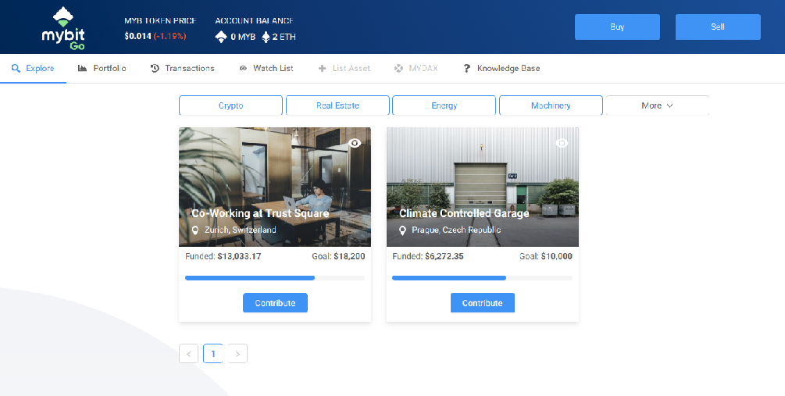

1. Other investors complete the full funding of the asset and it starts to generate stable revenue.

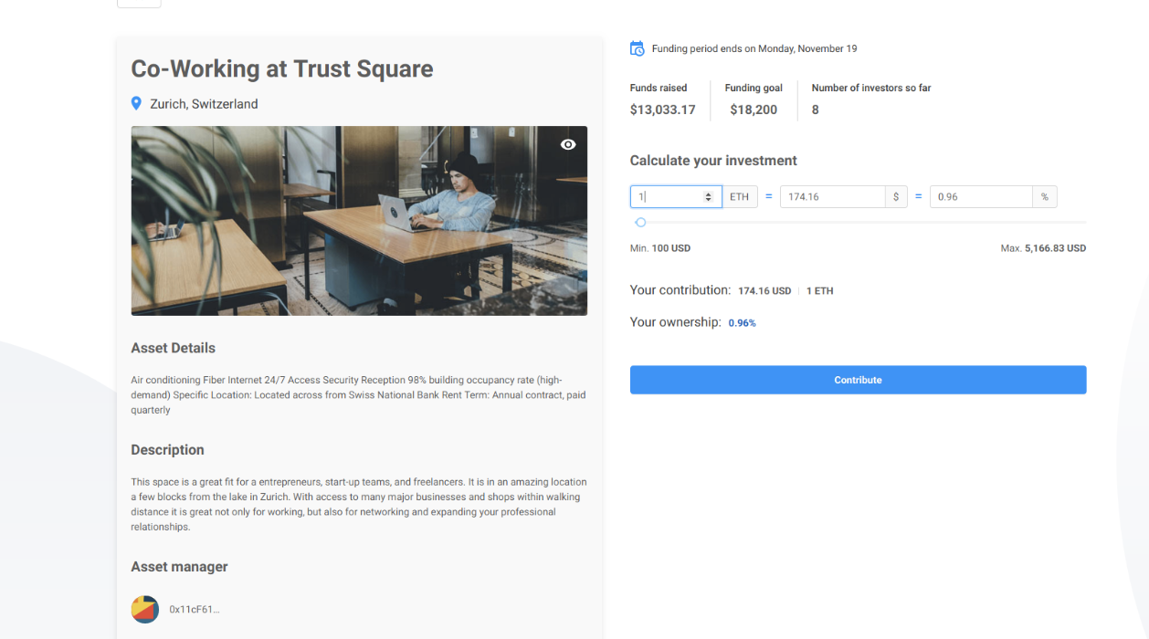

1. When the asset generates revenue, Bob receives his portion of it in real-time.

Wasn’t that easy?

At any moment, Bob is able to manage his portfolio, check his real-time revenue, and transfer funds from/to his personal address. Also, if the asset does not get fully funded, the capital is automatically returned to every investor within 30 days.

At this point, Bob is getting stable revenue from the IoT market, in real time and with no extra intermediaries.

This is just the beginning for MyBit Go. It will remain a key focus for the MyBit development team and will continue to evolve over the coming months and years.

For all of the latest updates and any comments or questions, reach out to us on Telegram.

Until next time!

The MyBit Team