Auditable Incident Routing in SOC Report Router with Human Review and Reproducible Simulation
David Adrian Lucano Nieves¹, Geraldine Daniela Rojas Villegas¹, Robert Jerry Sánchez Ticona² and Juan Pedro Santos Fernández²
¹ School of Systems Engineering, Universidad Nacional de Trujillo, Av. Juan Pablo II s/n, Trujillo 13011, Peru.
dalucanoni@unitru.edu.pe; gdrojasvi@unitru.edu.pe
² Department of Systems Engineering, Universidad Nacional de Trujillo, Av. Juan Pablo II s/n, Trujillo 13011, Peru.
rsanchezt@unitru.edu.pe; jsantos@unitru.edu.pe
Abstract: Cybersecurity incident routing requires dependable records and accountable decisions even when language models or workflow services fail. This study examines SOC Report Router, a locally orchestrated application with hosted language model inference, to characterize the relationship between workflow reliability, human review, and potential operational benefit. A design science evaluation combines inspection of the implemented React and FastAPI application, archived functional verification, and a reproducible simulation of 2,400 paired cases. The artifact uses PostgreSQL as the authoritative store, Langflow for constrained classification, n8n for assignment and notification, and Redis for recoverable routing queues. The inspected archives contain 74 successful local checks and 22 successful checks from an earlier integrated run; these are functional evidence, not operational outcomes. Under explicitly assumed confidence and work distributions, a 0.75 review threshold accepts 70.96% of cases with a 5.46% type error among accepted cases. Simulated response SLA attainment increases from 60.29% to 89.04%, while active triage time decreases by 8.48 minutes per case, with a conditional 95% bootstrap interval of 8.16–8.80 minutes. Shuffling confidence removes its screening value, and constrained review or recovery capacity reduces the apparent benefit. The contribution is a traceable implementation and evaluation protocol that separates verified software behavior from assumption dependent numerical effects. No measured improvement in a working SOC is claimed.
Keywords: security operations center; incident routing; human oversight; auditability; reproducible simulation

1 Introduction
Natural language incident reports describe suspicious behavior and uncertain assets that resist fixed intake fields. Routing must interpret this information, preserve the report, and establish responsibility. NIST SP 800-61 Revision 3 situates incident response within organizational cybersecurity risk management [9]. The engineering objective therefore extends beyond a plausible classification: each report must remain actionable and its handling reconstructable.
Independent inference and workflow services introduce separate failure modes. A valid model answer does not guarantee a committed assignment, registered notification, or duplicate free retry. An unavailable classifier must not silently discard a valid submission. We therefore examine the complete intake workflow, including incomplete states that a dashboard of completed assignments could conceal.
A recent SOC survey maps language model applications across security functions and identifies integration challenges [6]. Rieger et al. evaluate 178 labeled alerts and find that prioritization remains challenging despite useful classification behavior [12]. These findings motivate independent policy checks and human review; they do not establish performance on free text reports from end users.
We study SOC Report Router as a design science artifact [7] covering reporting, classification, assignment, internal notification, and response and resolution tracking. It neither ingests continuous SIEM streams nor executes containment. The research problem is to combine uncertain classification with durable, idempotent, auditable routing and evaluate potential benefits without presenting constructed examples as organizational observations.
RQ1 asks which contracts preserve state and constrain routing across failures and repeated delivery. RQ2 asks how assumed confidence affects coverage, error, and review burden. RQ3 asks which work and capacity assumptions permit better SLA attainment and less active effort. Inspection and archived checks address RQ1; simulation addresses RQ2 and RQ3.
The contributions are an inspectable implementation, explicit failure and audit contracts, and a fixed seed evaluation with adverse scenarios. The numerical analysis identifies assumptions that enable or weaken a benefit. It proposes neither a new language model nor a measured field productivity result.

2 Related Work and Research Position
A targeted review on November 3, 2026 consulted primary publishers, NIST, and research repositories. Searches combined “security operations center” with “large language model”, “alert triage”, or “prioritization”, alongside calibration, selective classification, and prompt injection. Accessible primary texts or abstracts and verified metadata were required. Selection covered 2024–2026 SOC research and foundations, without claiming systematic completeness.
APOLLO combines phishing classification with user explanations [2]; its email evaluation does not establish accuracy on mixed incident categories. Rieger et al. compare language models with lightweight supervised baselines and distinguish classification from severity prioritization [12]. Both studies concern evidence targets different from persistence and orchestration. A model accuracy score alone cannot establish complete workflow quality.
Selective classification motivates declining uncertain decisions [3]. Calibration concerns correspondence between confidence and correctness [5], while verbal elicitation depends on task and procedure [13]. Here, confidence triggers administrative review without establishing a calibrated risk guarantee. Table 1 distinguishes the evidence targets.
Instructions embedded in data can change model behavior [4], motivating limits on generated content’s authority. Understandable behavior and correction opportunities also matter [1]. The model therefore proposes classification fields, deterministic policy sets teams and deadlines, and human review exposes uncertainty.
The evaluated contribution is a traceable composition of classification, oversight, and persistence contracts, rather than a claim to the first SOC architecture of this kind.
Table 1
Selected primary literature and the evaluation boundary addressed here
Study | Evidence or method | Boundary relevant to this artifact
Nelson et al. [9] | Risk management guidance | No prescribed application SLA values.
Desolda et al. [2] | Email classification and explanations | No mixed incident benchmark.
Rieger et al. [12] | 178 labeled alerts | Separate severity evaluation needed.
Habibzadeh et al. [6] | SOC literature synthesis | Research map rather than implementation test.
Geifman and El-Yaniv [3] | Selective classification | Risk bounds do not transfer to self reported scores.
Greshake et al. [4] | Prompt injection attacks | Text filtering is an incomplete defense.

3 Implemented Architecture and Contracts

3.1 Deployment and Trust Boundaries
The inspected deployment is a Windows workstation operated through PowerShell. The application entry point is FastAPI at port 8000. PostgreSQL 16, Redis 7, and n8n run in project specific Docker containers bound to loopback ports 5434, 6380, and 5680. Langflow is an independent local service at port 7861. React 18, TypeScript, TailwindCSS, and Recharts provide the authenticated operator interface. Persistent project volumes are separate from other local workflows. Figure 1 distinguishes local state management from hosted inference.
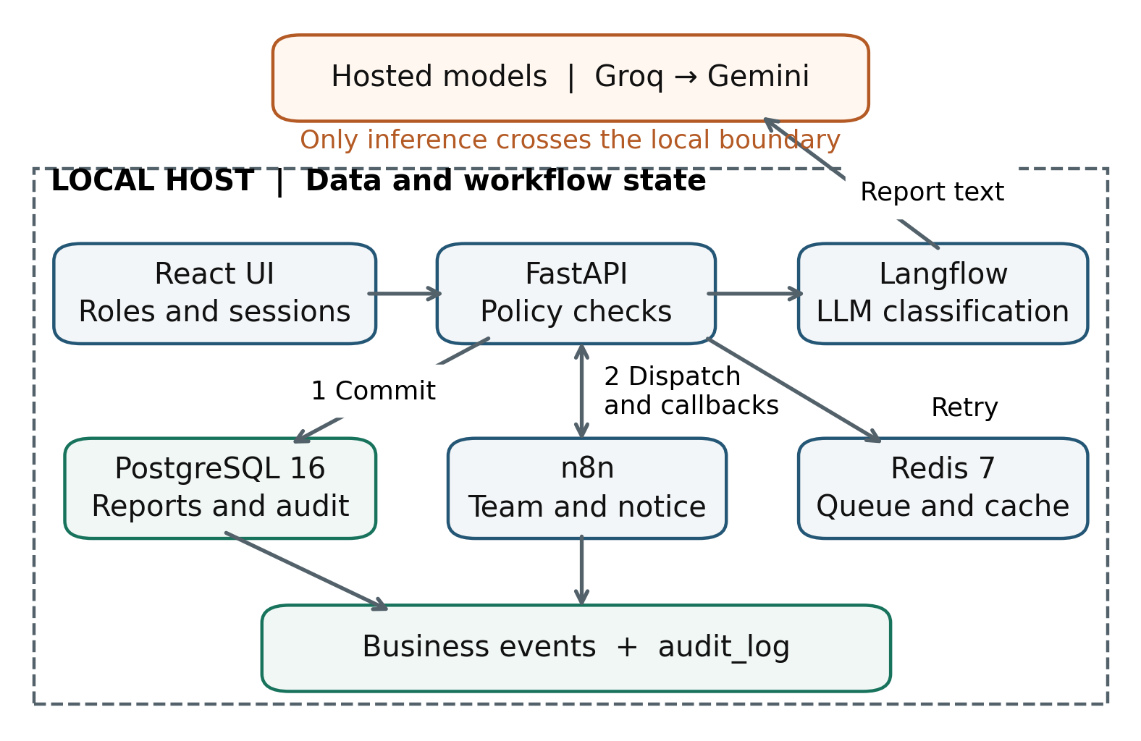
Figure 1
Implemented service composition. Local orchestration and storage coexist with external inference. n8n callbacks pass through FastAPI; the model has no direct database or assignment authority.
Langflow wraps Groq with Gemini backup, defaulting to openai/gpt-oss-20b and gemini-3-flash-preview. These configurable hosted identifiers do not freeze model weights. No local model is required. Report text leaves the workstation for inference; local persistence therefore requires a separate assessment of provider retention and production data handling.
The inspected environment uses Python 3.12.9, FastAPI 0.162.0, SQLAlchemy 2.1.6, Pydantic 2.14.2, psycopg 3.3.7, Redis client 6.4.0, and Langflow 1.11.0. Compose pins n8n 1.109.2 and PostgreSQL major version 16, with Redis 7-alpine. The UI specifies React 18.3.1. SHA-256 manifests identify central modules and evidence logs; mutable image tags and hosted models still limit exact reproduction.

3.2 Classification and Deterministic Assignment
The contract contains tipo, severidad, activo_afectado, and confianza. Ten types cover phishing, malware, unauthorized access, denial of service, data leakage, vulnerability, misuse, physical incident, fraud, and other. Pydantic enforces four severities, finite confidence in [0, 1], no extra fields, and a nullable length limited asset. Structural validity does not establish correctness.
Confidence below 0.75, invalid output, a detected instruction injection pattern, or Langflow failure produces an explicit review reason. Integrated failure handling preserves other type, medium severity, no asset, and zero confidence, with routing to Triaje SOC. Keyword classification belongs to the separate demo mode, rather than the integrated failure path.
Team assignment and deadlines come from the versioned routing policy derived from integrations/reglas.json. For example, phishing maps to Seguridad de correo, whereas unauthorized access maps to Identidades y accesos. Critical, high, medium, and low cases have first response limits of 15, 60, 240, and 480 minutes, and resolution limits of 240, 480, 1,440, and 2,880 minutes. These are project policy values, not NIST prescribed standards. The policy version is pinned to the saved report, and internal callback payloads are checked against it.

3.3 Persistence Ordering and Recovery
The handler checks the UUID key, obtains a classification or conservative fallback, then commits the report and policy association before invoking n8n (Figure 2). Persistence thus precedes routing but follows classification. A crash before commit falls outside the saved record guarantee; clients without a successful receipt must retry with the same key.
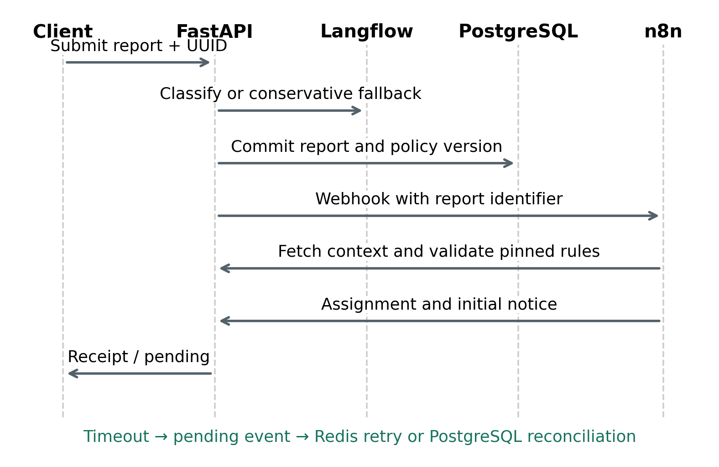
Figure 2
Implemented ordering of the submission workflow. Horizontal steps summarize API interactions rather than transaction durations. Assignment and initial notification are independent idempotent callbacks.
An identical key and payload return the existing report; changed content produces HTTP 409. Database conflict handling suppresses duplicate inserts [10]. Primary keys on assignment report_id and business event (report_id, accion) bound initial effects despite repeated delivery. Network execution is not exactly once: concurrent first submissions may classify repeatedly before one insert succeeds.
n8n receives an identifier, fetches context through FastAPI, and calls protected assignment and notification endpoints. Distinct tokens protect webhook and callbacks. Failure or missing confirmation creates enrutamiento_pendiente. Redis schedules recovery, while PostgreSQL reconciliation reconstructs lost queue entries. Redis persistence [11] supplements authoritative database state. Table 2 summarizes these contracts and their limits.
Table 2
Implemented contracts and their explicit limits
Contract | Enforcement | Limit
Persist before routing | Database transaction before n8n dispatch | No guarantee for a crash before commit.
Unique submission | UUID key plus content comparison | Not semantic deduplication of different keys.
Unique initial effects | Primary keys on assignment and business event action | Network calls can occur repeatedly.
Policy constrained routing | Pinned version and callback validation | Policy may still be operationally inappropriate.
Visible uncertainty | Review reasons and Triaje SOC routing | Review accuracy and capacity are unmeasured.
Recoverable pending work | Redis scheduling plus PostgreSQL reconciliation | No measured upper recovery time bound.
Traceable actions | Business events and protected audit_log | Database administrator can bypass triggers.

3.4 Audit and Human Interaction
Business events record receipt through resolution. The separate audit_log stores user, role, action, module, IP, timestamp, result, and request correlation. API middleware records entry, exit, and authorization rejection; triggers cover critical database changes. UPDATE, DELETE, and TRUNCATE protections restrict ordinary operations but provide neither cryptographic tamper evidence nor protection from a fully privileged administrator.
Administrator, analyst, manager, and auditor roles have backend permission checks. JWT sessions are revocable, role or password changes invalidate tokens, and passwords use salted PBKDF2. Reviewers confirm or correct classifications; the interface separates response and resolution milestones. Navigation leases can infer expiry rather than observe browser exit. A hosted assistant provides application help without private case records or action tools.

4 Evaluation Method

4.1 Evidence Design and Scope
Stream A comprises source inspection and archived checks dated November 3, 2026. Stream B is a newly executed synthetic scenario study (Figure 3). The numerical comparisons use no operational cohort, analyst observations, or provider benchmark. Synthetic cases contain generated attributes rather than messages classified by a provider.
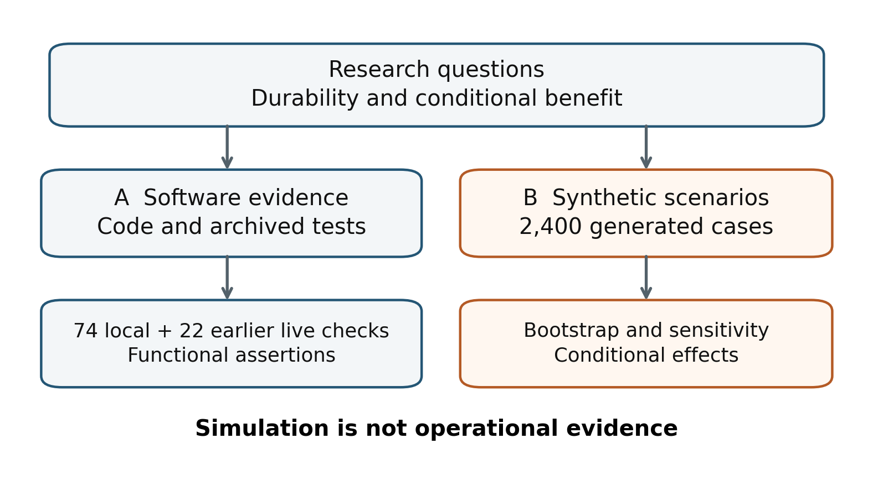
Figure 3
Evaluation protocol and evidence separation. Functional checks can support implementation claims; synthetic operational effects remain conditional on the declared data generating mechanism.
We specify aims, data generating mechanisms, estimands, methods, and performance measures following simulation reporting guidance [8]. Policies share the same latent cases, reducing noise and isolating stipulated workflow differences. This pairing provides no causal estimate for a real SOC.

4.2 Synthetic Cases and Assumptions
NumPy default_rng with seed 20261103 generates 2,400 cases, exactly 240 per type. Independent severity probabilities are 0.15, 0.25, 0.45, and 0.15 for critical through low. All cases are included. No model is fitted, so there is no train/test split. Balanced classes, independence, and absent temporal drift are explicit simplifications.
A confidence group is sampled with probabilities 0.70, 0.20, and 0.10. Within these groups, scores follow uniform distributions on [0.80, 0.99], [0.60, 0.80], and [0.25, 0.60]. Type correctness is Bernoulli with probabilities 0.96, 0.80, and 0.55, respectively. An incorrect prediction is selected uniformly from the other nine categories. These correctness values are assumed to create an informative confidence signal; they are not estimates for Groq or Gemini. The experiment assesses type routing only and does not estimate the semantic quality of severity or asset extraction.
Bernoulli flags represent invalid output (0.03), detected suspicious instructions (0.02), primary failure (0.08), and backup failure conditional on primary failure (0.25). The first two flags or both providers failing force review; remaining cases must meet the confidence threshold. Injection flags model the consequence of detection, without evaluating detector sensitivity. Table 3 states timing assumptions.
Table 3
Assumed distributions for the synthetic experiment
Quantity | Distribution or setting | Interpretation
Manual active work M | Lognormal median 12 min; log SD 0.45 | Assumed hands on triage time.
Accepted active work V | Lognormal median 2 min; log SD 0.35, plus 0.5 min | Verification and workflow overhead.
Referred active work H | Lognormal median 9 min; log SD 0.45, plus 0.5 min | Human review and overhead.
Baseline waiting W | Response deadline × lognormal median 0.65; log SD 0.65 | Queue time scaled by severity.
Guarded waiting | 0.35 W if accepted; 0.95 W if referred | Assumed coordination benefit.
Remediation K | Resolution deadline × lognormal median 0.50; log SD 0.45 | Same post response work in every policy.
Inference latency L | Lognormal median 2 s, log SD 0.4; backup adds 25 s then median 3 s; both fail 50 s | Stipulated timings, not provider measurements.
Reviewer correctness | Bernoulli probability 0.98 | Used only in illustrative final type accuracy.
Uncertainty | 2,000 paired percentile bootstrap replicates; seed 20261104 | Conditional case resampling intervals.
All quantities in this table are assumptions. Log SD is the standard deviation of the natural logarithm. SLA limits are the project policy values described in Section 3.2.
A lognormal median m and log SD s imply a natural logarithm with mean ln(m) and SD s. These illustrative values are neither fitted to tests nor elicited consensus. simulate.py preserves parameters; exported cases have SYN identifiers and explicitly assumed times.

4.3 Comparators and Measures
Manual first response is W + M and resolution adds K. An unguarded counterfactual accepts every proposal with first response 0.35 W + V + L. This analytical comparator is not a safe implemented mode. Guarded cases use V or H and waiting multipliers 0.35 or 0.95 for acceptance or referral, respectively. Durations are in minutes.
Let a count accepted cases, e count incorrect types among them, and N denote cohort size. Equations (1) and (2) define coverage C and selective error R. Coverage includes all submitted cases; forced review contributes zero acceptance. Risk uses accepted cases only and is undefined if none are accepted. Illustrative final accuracy assumes reviewer correctness of 0.98 rather than measured analyst performance.
(1)
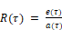 (2)
SLA attainment counts milestones completed within severity specific deadlines from receipt. Synthetic milestones are fully observed. The application instead excludes pending milestones still within deadline and includes overdue or completed ones. Operational comparisons must respect this denominator and matched observation windows.
Let A denote guarded active work, equal to V or H. Equation (3) sums manual minus guarded minutes over N cases and converts to hours. Waiting, inference, and remediation are excluded from labor savings. Totals scale with assumed volume rather than establish staffing reductions. Paired percentile intervals use 2,000 case resamples for effort and SLA differences; they quantify sampling under fixed assumptions, not parameter uncertainty.
(3)
The principal threshold is 0.75, matching the application default. Sensitivity thresholds are 0, 0.60, 0.70, 0.80, 0.90, and 0.95. A negative control shuffles confidence with seed 20261107 while keeping predictions and forced review flags unchanged. Further stress cases add 15–240 minutes of waiting only to referred cases. A separate deterministic fluid queue illustrates recovery after a 30 minute outage for arrival rates of 6, 18, and 22 cases per minute and service capacity 20 per minute. Those rates do not measure the deployed worker throughput.

5 Results

5.1 Synthetic Coverage and Error
The generated severity counts are 360 critical, 613 high, 1,102 medium, and 325 low cases. There are 68 invalid output flags, 43 suspicious instruction flags, and 50 cases with both providers unavailable. Their overlapping union forces 157 reviews before thresholding. The primary fails in 188 cases and backup recovers 138. These generated counts are not logged outages. Table 4 reports threshold sensitivity.
Table 4
Synthetic threshold sensitivity with informative confidence
Threshold | Accepted n | Coverage % | Type error % | Active min | Response SLA %
0.00 | 2,243 | 93.46 | 11.50 | 3.11 | 96.25
0.60 | 2,031 | 84.62 | 7.68 | 3.81 | 93.33
0.70 | 1,810 | 75.42 | 6.30 | 4.56 | 90.38
0.75 | 1,703 | 70.96 | 5.46 | 4.90 | 89.04
0.80 | 1,605 | 66.88 | 4.61 | 5.20 | 87.75
0.90 | 740 | 30.83 | 4.73 | 7.99 | 75.58
0.95 | 312 | 13.00 | 3.53 | 9.39 | 70.50
N = 2,400 at every threshold. Type error uses accepted cases only; active time is mean human minutes across all cases. Forced review remains enabled at threshold 0. No row reports measured model performance.
At 0.75, 1,703 cases are accepted (70.96%) and 697 referred (29.04%). Accepted predictions contain 93 type errors (5.46%). With assumed human corrections, final type accuracy is 95.38%; this constructed value is not an implementation benchmark.
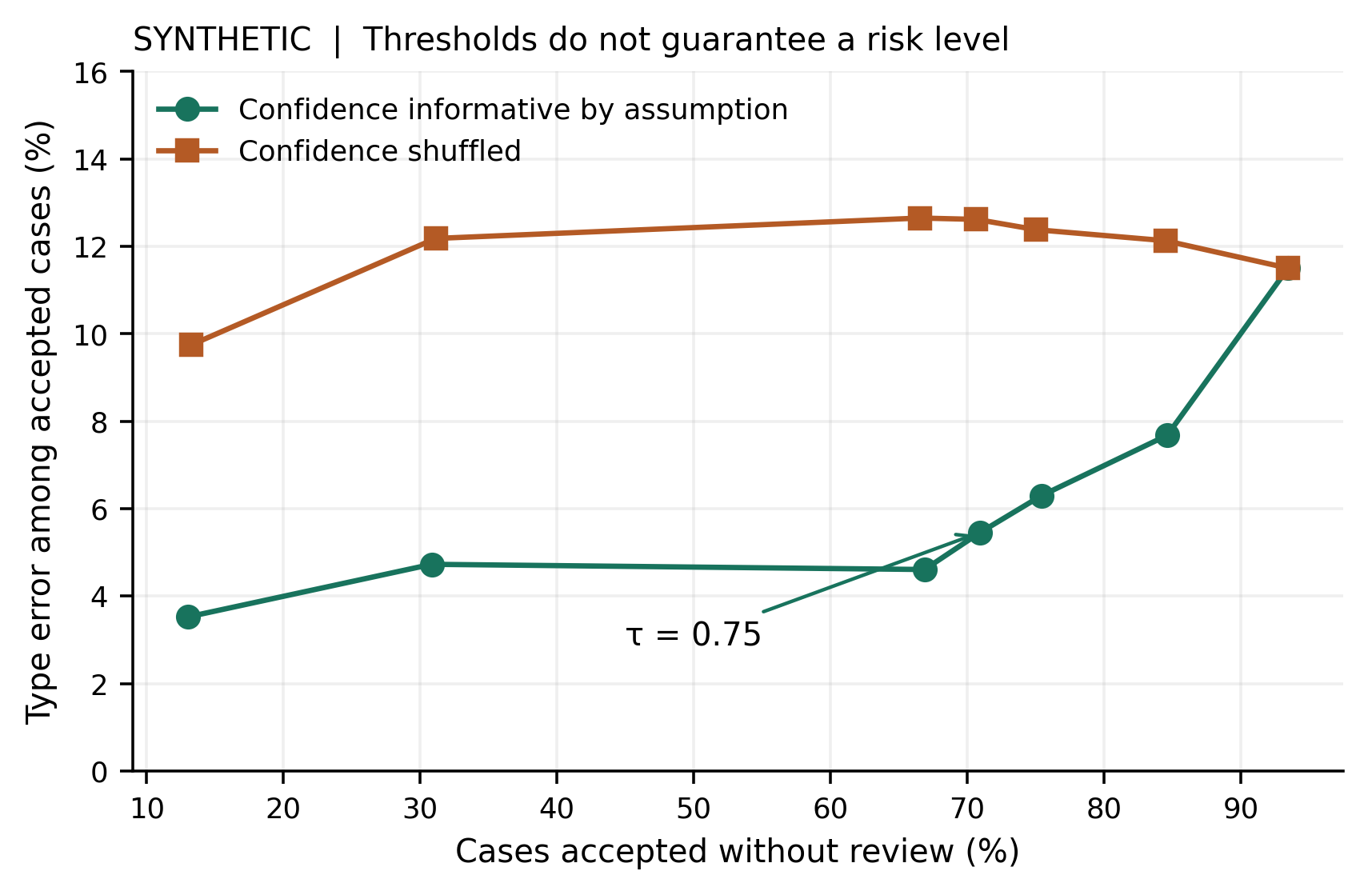
Figure 4
Synthetic coverage and accepted type error as the review threshold changes. The shuffled confidence control retains almost the same coverage but loses the association with correctness. No calibrated risk guarantee is established.
Figure 4 shows accepted error of 3.53%, coverage 13.00%, and active work 9.39 minutes at 0.95. Sampling causes local nonmonotonicity. Shuffled confidence at 0.75 gives 70.67% coverage but 12.62% error, demonstrating dependence on score informativeness.

5.2 Synthetic SLA and Effort Outcomes
Table 5 and Figure 5 compare the policies on paired cases.
Table 5
Synthetic policy comparisons on the same fully observed cohort
Policy | Active min/case | Response SLA met | Resolution SLA met
Manual | 13.38 | 1,447 / 2,400  60.29% | 2,099 / 2,400  87.46%
Unguarded | 2.63 | 2,357 / 2,400  98.21% | 2,217 / 2,400  92.38%
Guarded | 4.90 | 2,137 / 2,400  89.04% | 2,182 / 2,400  90.92%
N = 2,400 paired synthetic cases per policy. The unguarded policy is an analytical counterfactual and cannot safely handle malformed or adversarial outputs. These values are scenario outputs, not field observations.
Guarded response SLA is 2,137/2,400 (89.04%) versus manual 1,447/2,400 (60.29%): +28.75 percentage points, with conditional 95% interval 27.04–30.58. Resolution rises from 2,099/2,400 (87.46%) to 2,182/2,400 (90.92%): +3.46 points [2.75–4.21]. Shared remediation durations limit resolution gains.
Active time falls from 13.38 to 4.90 minutes: an assumed difference of 8.48 [8.16–8.80]. The hypothetical cohort total is 339.37 [326.38–352.05] hours. This arithmetic consequence of stipulated work and referral rates excludes inference cost, maintenance, training, and false routing consequences. It is not measured savings.
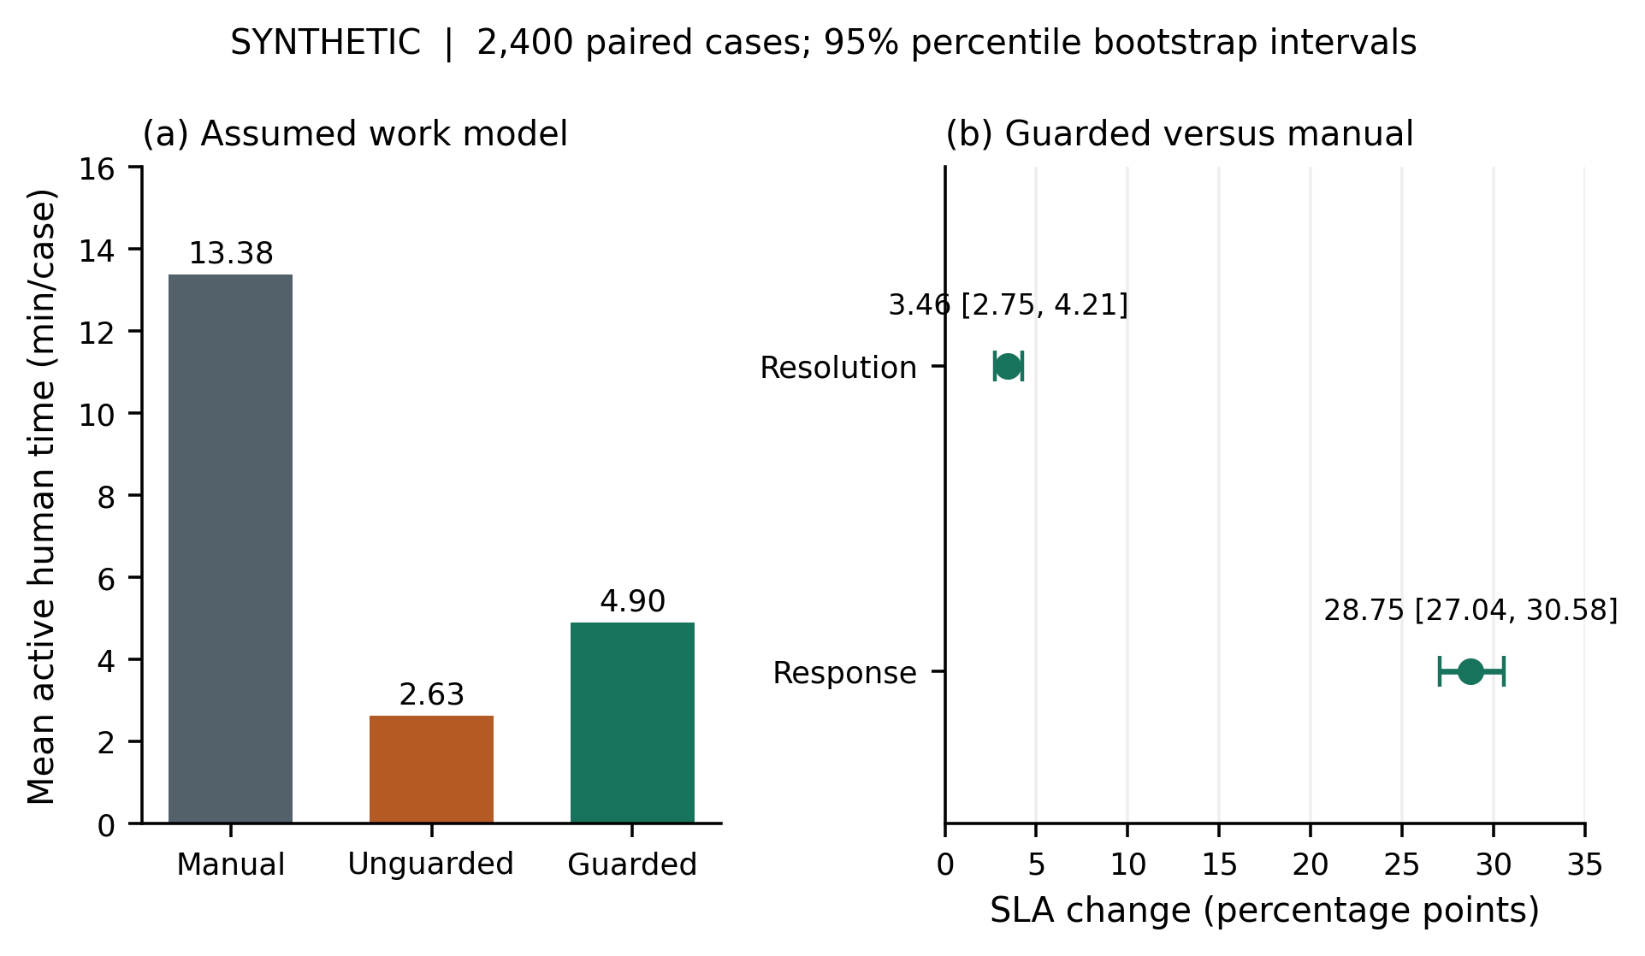
Figure 5
Synthetic human effort and paired SLA differences. Error bars are conditional 95% percentile bootstrap intervals. Active minutes exclude queue waiting and remediation; an apparent time advantage is not evidence of safe autonomous handling.
Unguarded response SLA reaches 98.21% with 2.63 active minutes by bypassing review, including flagged and invalid cases. Guarding costs 2.27 additional minutes per case and reduces timeliness relative to this counterfactual. The fastest scenario therefore does not establish an acceptable security process.

5.3 Capacity and Recovery Stress Scenarios
Adding 60 minutes of waiting to referred cases reduces guarded response SLA attainment to 80.17%; adding 240 minutes reduces it to 71.08%. The manual reference remains 60.29% in this sensitivity analysis. These outcomes describe a direct waiting penalty, not a full staffing or priority queue model. They show that a larger review queue can erode the coordination benefit without changing classification accuracy. Figure 6 pairs this effect with a recovery capacity counterexample.
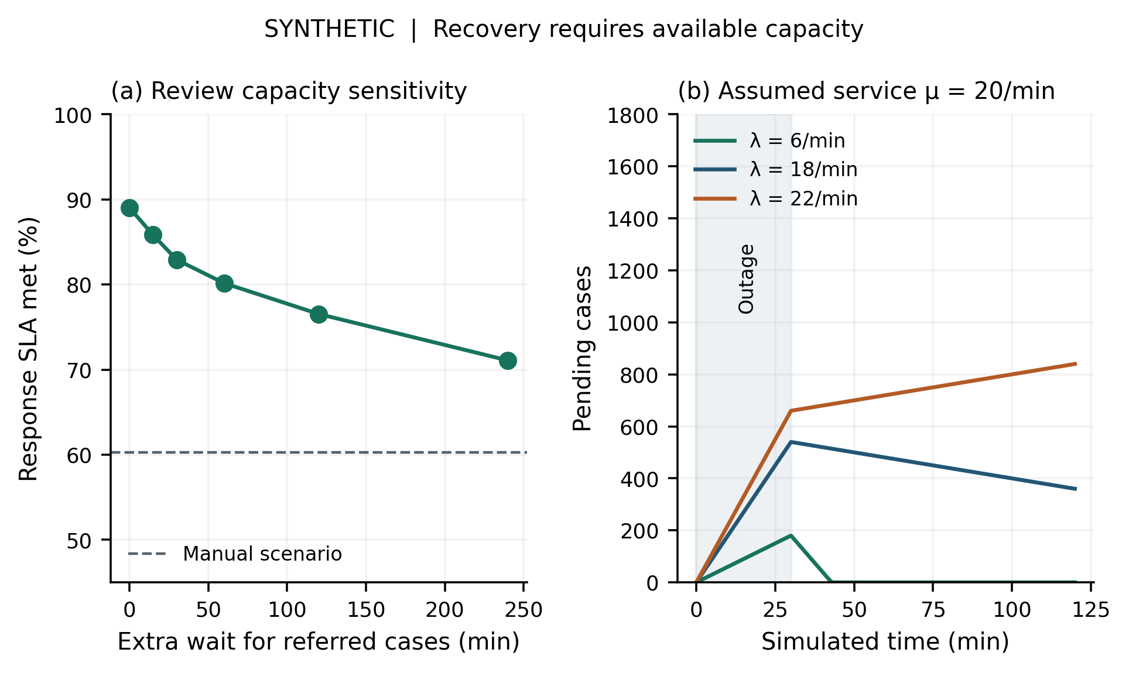
Figure 6
Synthetic failure sensitivities. Panel a adds waiting only to referred cases. Panel b uses a fluid queue with an assumed 30 minute outage and fixed service capacity. Service restoration alone cannot drain a queue when arrivals exceed capacity.
At 6 arrivals per minute, 180 pending cases drain in 12.86 minutes after restoration. At 18, 540 cases require 270 minutes, beyond the plotted window. At 22, backlog keeps growing. Recovery capacity must exceed arrivals; these stipulated rates establish no throughput commitment for the deployed stack.

5.4 Archived Functional Verification
The latest inspected local log, docs/diseno/ronda-2/pruebas-despues.log, records 55 successful Python checks, 2 JavaScript rule checks, 17 React tests, and a successful TypeScript build. Its Python environment is explicitly SQLite and simulations. The 74 local checks are therefore distinct from cloud or PostgreSQL integration tests; compilation is reported separately.
The earlier archive soc-tests-20261103-161108.log records 22 successful integrated checks: 6 core, 9 platform, 2 chat, and 5 recovery, backup, TOTP, and impact checks. Their sources use real PostgreSQL, Redis, Langflow, n8n, and hosted generation, with controlled outputs or failures for some adverse cases (Table 6). This suite was not rerun for the paper’s numerical results; its frontend count differs from the latest local run.
Table 6
Verification evidence reviewed separately from the simulation
Evidence group | Recorded result | Scope and principal limit
Latest local Python | 55 / 55 passed | SQLite and controlled substitutes; classification, access, audit and workflow behavior.
Latest rule logic | 2 / 2 passed | JavaScript n8n policy code; not a running webhook.
Latest React suite | 17 / 17 passed | Component behavior; not a field usability study.
Latest UI build | Exit code 0 | TypeScript and Vite build; not an operational test.
Earlier integrated core | 6 / 6 passed | Real stack and workflow; selected negative cases controlled.
Earlier integrated platform | 9 / 9 passed | Roles, audit, metrics, exports and module checks.
Earlier integrated chat | 2 / 2 passed | Provider response checks; no representative quality benchmark.
Earlier recovery and backup | 1 + 1 passed | Controlled outage and restore checks; not a load test.
Earlier TOTP and impact | 1 + 2 passed | Authentication and measurement logic; no real labor observations.
Evidence date: November 3, 2026. The first three rows total 74 latest local checks. The last five rows total 22 earlier integrated checks. Successful checks support only their specified assertions.
Core checks assert health mode, persistence, expected team and deadlines, n8n event actors, content conflicts, and webhook authentication. Their success supports those exercised paths at the recorded time, without proving security, arbitrary concurrency correctness, continuous availability, or model generalization.

6 Discussion

6.1 Interpretation of the Research Questions
RQ1 is answered by separating authoritative state from execution: PostgreSQL commits precede orchestration, unique keys bound initial effects, policy versions constrain callbacks, and database reconciliation reconstructs pending work. Business and audit events support investigation without granting the model assignment authority. These contracts cover committed records and require available recovery services.
RQ2 identifies a conditional tradeoff. Informative confidence permits lower accepted error at reduced coverage; shuffled confidence conceals higher error at similar coverage. Threshold configurability alone therefore provides insufficient evidence of reliability. Deployment needs temporally held out labels and separate evaluation of category, severity, assets, calibration, and deferral.
RQ3 remains a scenario: its benefit follows from assumed reductions in coordination waiting and active work. Longer reviews, correlated outages, urgent backlogs, or different case mixes can change the result. Simulated hours support study planning rather than realized savings claims.

6.2 Implications for SOC Workflow Design
The reviewed literature emphasizes that useful classification and dependable prioritization are distinct [12]. The artifact accordingly separates a proposal from a policy controlled action. A syntactically correct output may still route to the wrong team or assign an inappropriate severity, and the present simulation evaluates only type errors. In particular, conservative medium severity during provider failure can be insufficient for a genuinely critical incident. A production deployment needs a human emergency escalation path and an independently validated severity policy.
Observable degradation is a transferable design principle. Pending routing, completed assignment, and conservative fallback require different operator actions. Showing these states supports correction and intelligibility [1], although no usability study establishes whether analysts interpret this interface reliably.
Provider backup addresses only some failures. Models can share weaknesses, quotas, or network dependencies. The implementation also treats policy refusals differently from ordinary failures rather than forwarding every refusal. Independent simulation flags simplify these dependencies, so generated backup recovery is not a measured availability gain.
Audit triggers do not resist privileged administrators or host compromise. Signed external checkpoints and separated administrative duties could strengthen protection. Similarly, delimiters and regular expressions identify familiar patterns but cannot resolve the instruction and data ambiguity behind prompt injection [4]. Constraining generated output authority remains useful when detection fails.

6.3 Threats to Validity
Type error can preserve the assigned team when categories share responsibility; timeliness alone does not establish security quality. The work model excludes investigation, misassignment cost, and verification burden. Reviewer correctness of 0.98 is unmeasured. Milestones cannot establish labor; future studies need separate active time measurements.
Internal validity depends on favorable confidence, waiting multipliers, independent failures, and shared remediation durations. Pairing does not validate these mechanisms. Bootstrap intervals omit parameter uncertainty, site clustering, temporal dependence, and model drift. They neither establish real improvement nor provide calibrated risk bounds for model decisions.
External validity is limited by one workstation and snapshot, balanced categories, and numerical rather than linguistic cases. There are no measured analysts, organization specific streams, cost constraints, or multilingual benchmarks. Spanish reports and categories require their own evaluation. Integration evidence cannot establish production accuracy or equivalence to a SIEM or SOAR platform.
Conclusion validity is constrained by archived integration checks, changing hosted identifiers, and mutable container tags. Test counts describe assertions rather than requirement coverage. Hashes permit snapshot comparison, but neither a public immutable release nor independent replication is established. Comparative claims against commercial platforms are therefore unsupported.

6.4 Operational Validation Protocol
An operational study should preregister SLA, accepted error, and review workload targets, then collect comparable manual and assisted windows. Inclusion must specify organizational unit, categories, severity policy, staffing, and follow up. Pause and resume events should measure active work. Reopened cases and missing measurements must remain visible.
At least two qualified reviewers should adjudicate a temporally held out report set under a documented disagreement procedure. Risk–coverage and calibration analyses need severity, language, and completeness strata and a rules or lightweight classifier baseline. Reproduction records should include provider, prompt, policy, error status, and timing without credentials or unnecessary report exposure.
Recovery experiments should measure sustained arrivals, concurrent duplicates, provider timeouts, Redis restart, and partial n8n completion. Success criteria should bound lost committed reports, duplicate effects, pending states, and recovery duration at a declared workload. Actual SLA improvement and labor savings remain unmeasured until such operational evidence is collected.

7 Conclusions
SOC Report Router implements constrained classification, deterministic routing, human review, and recoverable orchestration. Inspection and archived checks support persistence before dispatch, bounded initial effects, and distinct business and audit records on the exercised paths. General reliability and operational effectiveness remain unestablished.
The 2,400 case simulation yields 70.96% coverage and 5.46% accepted type error at threshold 0.75. Assumed work and waiting produce +28.75 SLA percentage points and 8.48 fewer active minutes per case. Shuffled confidence and capacity limits weaken these conditional benefits.
The research output separates verified software behavior from assumed operational effects. Real improvement claims require adjudicated reports, active time measurements, comparable periods, and an agreed success criterion. The system supports this evidence collection; the present study supplies no field impact measurements.
Reproducibility and Data Availability
The manuscript is accompanied locally by simulate.py, figures.py, synthetic-cases.csv, simulation-results.json, source-manifest.json, and a reproduction note in the task’s supplementary material folder. The seed is 20261103; bootstrap and shuffled confidence seeds are 20261104 and 20261107. Scripts use NumPy 2.3.5 and Matplotlib 3.10.8. They contain no service credentials and make no provider calls. The application evidence logs are identified in Section 5.4 and hashed in the manifest. No public repository, permanent archive, or external availability of the application is claimed.
Ethics and Disclosure
Generated attributes and durations involve no recruited analysts or real incident dataset; no field study authorization is claimed. Generative AI assisted drafting and inspection. Authors must verify content, sources, responsibilities, and journal disclosure requirements before submission. Funding, competing interests, and contribution declarations await author confirmation.
References
[1] S. Amershi, D. Weld, M. Vorvoreanu, A. Fourney, B. Nushi, P. Collisson, J. Suh, S. Iqbal, P. N. Bennett, K. Inkpen, J. Teevan, R. Kikin-Gil, E. Horvitz: Guidelines for Human-AI Interaction, Proceedings of the 2019 CHI Conference on Human Factors in Computing Systems, pp. 1–13, May 2019. https://doi.org/10.1145/3290605.3300233
[2] G. Desolda, F. Greco, L. Viganò: APOLLO: A GPT-based tool to detect phishing emails and generate explanations that warn users, Proceedings of the ACM on Human-Computer Interaction, Vol. 9, No. 4, pp. 1–33, June 2025. https://doi.org/10.1145/3733049
[3] Y. Geifman, R. El-Yaniv: Selective Classification for Deep Neural Networks, Advances in Neural Information Processing Systems, Vol. 30, 2017. https://proceedings.neurips.cc/paper/2017/hash/4a8423d5e91fda00bb7e46540e2b0cf1-Abstract.html
[4] K. Greshake, S. Abdelnabi, S. Mishra, C. Endres, T. Holz, M. Fritz: Not what you’ve signed up for: Compromising Real-World LLM-Integrated Applications with Indirect Prompt Injection, arXiv preprint 2302.12173, revised May 2023. https://doi.org/10.48550/arXiv.2302.12173
[5] C. Guo, G. Pleiss, Y. Sun, K. Q. Weinberger: On Calibration of Modern Neural Networks, Proceedings of the 34th International Conference on Machine Learning, PMLR, Vol. 70, pp. 1321–1330, August 2017. https://proceedings.mlr.press/v70/guo17a.html
[6] A. Habibzadeh, F. Feyzi, R. Ebrahimi Atani: Large Language Models for Security Operations Centers: A Comprehensive Survey, Journal of Electrical and Computer Engineering, Vol. 2026, No. 1, Article 3383674, June 2026. https://doi.org/10.1155/jece/3383674
[7] A. R. Hevner, S. T. March, J. Park, S. Ram: Design Science in Information Systems Research, MIS Quarterly, Vol. 28, No. 1, pp. 75–105, March 2004. https://doi.org/10.2307/25148625
[8] T. P. Morris, I. R. White, M. J. Crowther: Using simulation studies to evaluate statistical methods, Statistics in Medicine, Vol. 38, No. 11, pp. 2074–2102, May 2019. https://doi.org/10.1002/sim.8086
[9] A. Nelson, S. Rekhi, M. Souppaya, K. Scarfone: Incident Response Recommendations and Considerations for Cybersecurity Risk Management: A CSF 2.0 Community Profile, NIST Special Publication 800-61 Revision 3, April 2025. https://doi.org/10.6028/NIST.SP.800-61r3
[10] PostgreSQL Global Development Group: PostgreSQL 16 Documentation, INSERT, online reference, accessed November 3, 2026. https://www.postgresql.org/docs/16/sql-insert.html
[11] Redis: Redis persistence, online technical documentation, accessed November 3, 2026. https://redis.io/docs/latest/operate/oss_and_stack/management/persistence/
[12] M. Rieger, A. Shah, A. Alam, M. J. Hossain: Possibilities and limitations of using large language models (LLMs) for alert classification and prioritisation in security operations centers (SOCs), Expert Systems with Applications, Vol. 331, Article 133194, 2026. https://doi.org/10.1016/j.eswa.2026.133194
[13] K. Tian, E. Mitchell, A. Zhou, A. Sharma, R. Rafailov, H. Yao, C. Finn, C. Manning: Just Ask for Calibration: Strategies for Eliciting Calibrated Confidence Scores from Language Models Fine-Tuned with Human Feedback, Proceedings of the 2023 Conference on Empirical Methods in Natural Language Processing, pp. 5433–5442, December 2023. https://doi.org/10.18653/v1/2023.emnlp-main.330

