TRANSIMS Version 5
File Reference

ACCESS_FILE 5
ACTIVITY_FILE 5
ARC_ACCESS_FILE 5
ARC_ACCESSIBILITY_FILE 5
ARC_ BANDWIDTH_FILE 6
ARC_CENTERLINE _FILE 6
ARC_CONNECTION_FILE 6
ARC_ DETECTOR_FILE 6
ARC_DISTANCE_CONTOUR _FILE 6
ARC_ LANE_USE _FILE 7
ARC_ LINK_FILE 7
ARC_LOCATION _FILE 7
ARC_ NODE_FILE 7
ARC_ PARKING_DEMAND_FILE 8
ARC_ PARKING_FILE 8
ARC_ PHASING_PLAN _FILE 8
ARC_ PLAN_FILE 8
ARC_ POCKET_FILE 8
ARC_PROBLEM _FILE 9
ARC_RIDERSHIP _FILE 9
ARC_ ROUTE_NODES _FILE 9
ARC_ SIGN_FILE 9
ARC_ SIGNAL _FILE 9
ARC_ SNAPSHOT _FILE 10
ARC_ STOP_DEMAND _FILE 10
ARC_ STOP_GROUP _FILE 10
ARC_ SUBZONE_DATA _FILE 10
ARC_ TIME_CONTOUR _FILE 10
ARC_ TIMING_PLAN _FILE 11
ARC_ TRANSIT_DRIVER _FILE 11
ARC_ TRANSIT_ROUTE _FILE 11
ARC_ TRANSIT_STOP _FILE 11
ARC_ TURN_PENALTY _FILE 11
ARC_ ZONE _FILE 12
COMPARE_PERFORMANCE_FILE 12
COMPARE_PLAN_FILE 12
CONNECTION_FILE 12
COST_DISTRIBUTION_FILE 16
DELETE_LINK_FILE 16
DELETE_NODE_CONTROL_FILE 16
DELETE_NODE_FILE 16
DESTINATION_LOCATION_FILE 17
DESTINATION_ZONE_FILE 17
DETECTOR_FILE 17
DIRECTIONAL_DATA_FILE 17
GROUP_TRAVEL_FILE 17
HOUSEHOLD_FILE 17
INPUT_LINK_FILE 18
INPUT_NODE_FILE 18
INPUT_SIGN_FILE 18
INPUT_SIGNAL_FILE 18
INPUT_SPDCAP_FILE 18
INPUT_ZONE_FILE 18
KEEP_LINK_FILE 18
KEEP_NODE_FILE 18
LANE_USE_FILE 18
LINK_ACTIVITY_FILE 19
LINK_DATA_FILE 19
LINK_DELAY_FILE 19
LINK_DETAIL_FILE 19
LINK_EQUIVALENCE_FILE 19
LINK_FILE 20
LINK_NODE_LIST_FILE 23
LINK_SUMMARY_FILE 23
LINK_VOLUME_FILE 23
LOCATION_FILE 23
MERGE_LINK_DELAY_FILE 24
MERGE_PLAN_FILE 24
MERGE_TRIP_FILE 24
NODE_FILE 24
OCCUPANCY_FILE 25
ORIGIN_LOCATION_FILE 25
ORIGIN_ZONE_FILE 26
PARKING_FILE 26
PARKING_PENALTY_FILE 26
PERFORMANCE_DATA_FILE 26
PERFORMANCE_FILE 26
PERSON_FILE 26
PHASING_PLAN_FILE 27
PLAN_FILE 27
POCKET_FILE 27
PROBLEM_FILE 28
REPORT_FILE 29
RIDERSHIP_FILE 29
ROUTE_NODES_FILE 29
SELECTION_FILE 30
SHAPE_FILE 30
SIGN_FILE 32
SIGNAL_FILE 33
SKIM_FILE 33
SNAPSHOT_FILE 33
STOP_EQUIVALENCE_FILE 33
SUBZONE_DATA_FILE 33
SUBZONE_ZONE_FACTOR_FILE 33
TIME_DISTRIBUTION_FILE 34
TIMING_PLAN_FILE 34
TOLL_FILE 34
TRANSIT_DRIVER_FILE 34
TRANSIT_FARE_FILE 34
TRANSIT_PENALTY_FILE 34
TRANSIT_ROUTE_FILE 35
TRANSIT_SCHEDULE_FILE 35
TRANSIT_STOP_FILE 35
TRIP_COST_GAP_FILE 35
TRIP_FILE 36
TRIP_TIME_FILE 36
TRIP_TIME_GAP_FILE 36
TURN_PENALTY_FILE 36
TURN_VOLUME_FILE 36
UPDATE_LINK_FILE 36
UPDATE_NODE_FILE 37
VEHICLE_FILE 37
VEHICLE_TYPE_FILE 37
VERSION4_PLAN_FILE 37
ZONE_BOUNDARY_FILE 37
ZONE_EQUIVALENCE_FILE 37
ZONE_FILE 38
ZONE_LOCATION_MAP_FILE 39
ZONE_TRAVEL_FILE 39

ACCESS_FILE

Names: ACCESS_FILE and NEW_ACCESS_FILE
Used In:
ArcNet
ConvertTrips Default Control K
LocationData
Microsimulator
NewFormat
PathSkim
Router
TransimsNet Default Control Ke

To be defined

ACTIVITY_FILE

Name: ACTIVITY_FILE
Used In:
NewFormat
To be defined

ARC_ACCESS_FILE

Names: ARC_ACCESS_FILE, NEW_ARC_ACCESS_FILE

Used in ArcNet

To be defined

ARC_ACCESSIBILITY_FILE

Names: ARC_ACCESSIBILITY_FILE, NEW_ARC_ACCESSIBILITY_FILE

Used in ArcPlan

To be defined

ARC_ BANDWIDTH_FILE

Names: ARC_ BANDWIDTH_FILE, NEW_ARC_ BANDWIDTH_FILE

Used in ArcpLAN

To be defined

ARC_CENTERLINE _FILE

Names: ARC_ CENTERLINE _FILE, NEW_ARC_ CENTERLINE _FILE

Used in ArcNet

To be defined

ARC_CONNECTION_FILE

Names: ARC_ CONNECTION _FILE, NEW_ARC_ CONNECTION _FILE

Used in ArcNet

To be defined

ARC_ DETECTOR_FILE

Names: ARC_ DETECTOR _FILE, NEW_ARC_ DETECTOR _FILE

Used in ArcNet

To be defined

ARC_DISTANCE_CONTOUR _FILE

Names: ARC_ DISTANCE_CONTOUR _FILE, NEW_ARC_ DISTANCE_CONTOUR _FILE

Used in ArcPlan

To be defined

ARC_ LANE_USE _FILE

Names: ARC_ LANE_USE _FILE, NEW_ARC_ LANE_USE _FILE

Used in ArcNet

To be defined

ARC_ LINK_FILE

Names: ARC_ LINK _FILE, NEW_ARC_ LINK _FILE

Used in ArcNet

To be defined

ARC_LOCATION _FILE

Names: ARC_ LOCATION _FILE, NEW_ARC_ LOCATION _FILE

Used in ArcNet

To be defined

ARC_ NODE_FILE

Names: ARC_NODE _FILE, NEW_ARC_NODE _FILE

Used in ArcNet

To be defined

ARC_ PARKING_DEMAND_FILE

Names: ARC_ PARKING_DEMAND _FILE, NEW_ARC_ PARKING_DEMAND _FILE

Used in ArcPlan

To be defined

ARC_ PARKING_FILE

Names: ARC_ PARKING _FILE, NEW_ARC_ PARKING _FILE

Used in ArcNet

To be defined

ARC_ PHASING_PLAN _FILE

Names: ARC_ PHASING_PLAN _FILE, NEW_ARC_ PHASING_PLAN _FILE

Used in ArcNet

To be defined

ARC_ PLAN_FILE

Names: ARC_ PLAN_FILE, NEW_ARC_PLAN _FILE

Used in ArcPlan

To be defined

ARC_ POCKET_FILE

Names: ARC_ POCKET_FILE, NEW_ARC_POCKET _FILE

Used in ArcNet

To be defined

ARC_PROBLEM _FILE

Names: ARC_ PROBLEM_FILE, NEW_ARC_PROBLEM _FILE

Used in ArcPlan

To be defined

ARC_RIDERSHIP _FILE

Names: ARC_ RIDERSHIP _FILE, NEW_ARC_ RIDERSHIP _FILE

Used in ArcPlan

To be defined

ARC_ ROUTE_NODES _FILE

Names: ARC_ ROUTE_NODES _FILE, NEW_ARC_ ROUTE_NODES _FILE

Used in ArcNet

To be defined

ARC_ SIGN_FILE

Names: ARC_SIGN _FILE, NEW_ARC_ SIGN_FILE

Used in ArcNet

To be defined

ARC_ SIGNAL _FILE

Names: ARC_ SIGNAL _FILE, NEW_ARC_ SIGNAL _FILE
Used in ArcNet

To be defined

ARC_ SNAPSHOT _FILE

Names: ARC_ SNAPSHOT _FILE, NEW_ARC_ SNAPSHOT _FILE

Used in ArcSnapshot

To be defined

ARC_ STOP_DEMAND _FILE

Names: ARC_ STOP_DEMAND _FILE, NEW_ARC_ STOP_DEMAND _FILE

Used in ArcPlan

To be defined

ARC_ STOP_GROUP _FILE

Names: ARC_ STOP_GROUP _FILE, NEW_ARC_ STOP_GROUP _FILE

Used in ArcPlan

To be defined

ARC_ SUBZONE_DATA _FILE

Names: ARC_ SUBZONE_DATA _FILE, NEW_ARC_ SUBZONE_DATA _FILE

Used in ArcNet

To be defined

ARC_ TIME_CONTOUR _FILE

Names: ARC_ TIME_CONTOUR _FILE, NEW_ARC_ TIME_CONTOUR _FILE

Used in ArcPlan

To be defined

ARC_ TIMING_PLAN _FILE

Names: ARC_ TIMING_PLAN _FILE, NEW_ARC_ TIMING_PLAN _FILE
Used in ArcNet

To be defined

ARC_ TRANSIT_DRIVER _FILE

Names: ARC_ TRANSIT_DRIVER _FILE, NEW_ARC_ TRANSIT_DRIVER _FILE

Used in ArcNet

To be defined

ARC_ TRANSIT_ROUTE _FILE

Names: ARC_ TRANSIT_ROUTE _FILE, NEW_ARC_ TRANSIT_ROUTE _FILE
Used in ArcNet

To be defined

ARC_ TRANSIT_STOP _FILE

Names: ARC_ TRANSIT_STOP _FILE, NEW_ARC_ TRANSIT_STOP _FILE

Used in ArcNet

To be defined

ARC_ TURN_PENALTY _FILE

Names: ARC_ TURN_PENALTY _FILE, NEW_ARC_ TURN_PENALTY _FILE
Used in ArcNet

To be defined

ARC_ ZONE _FILE

Names: ARC_ ZONE _FILE, NEW_ARC_ ZONE _FILE

Used in ArcNet

To be defined

COMPARE_PERFORMANCE_FILE

Used in LinkSum

To be defined

COMPARE_PLAN_FILE

Used in PlanCompare

To be defined

CONNECTION_FILE

Names: CONNECTION_FILE, NEW_CONNECTION_FILE
Used In:
ArcNet
ArcPlan
ArcSnapshot
IntControl
LinkDelay
LinkSum
Microsimulator
NewFormat
PathSkim
PlanSelect
PlanSum
Router
TransimsNet

Formerly known as lane_connectivity, this is a list of intersection connections in the network. A typical field definition (.def) file is as follows:
TRANSIMS50, TAB_DELIMITED, 1
LINK, INTEGER, 1, 10
DIR, INTEGER, 2, 1
TO_LINK, INTEGER, 3, 10
LANES, STRING, 4, 8, LANE_RANGE_TYPE
TO_LANES, STRING, 5, 8, LANE_RANGE_TYPE
TYPE, STRING, 6, 8, CONNECTION_TYPE
PENALTY, UNSIGNED, 7, 5, IMPEDANCE
SPEED, DOUBLE, 8, 5.1, KPH
CAPACITY, UNSIGNED, 9, 8, VPH
NOTES, STRING, 10, 128

The fields are defined as follows:

Table 1 Fields in the Connection File
Field(s) | Description | Use | Default Units
LINK | The link number (an integer) | Key
DIR | Direction on the link AB=0, BA=1 | Req.
TO_LINK | Outbound Link | Req.
LANES | Range of inbound lanes, numbered from right to left | Req. | Note 1
TO_LANES | Range of outbound lanes, numbered from right to left | Req. | Note 1
TYPE | Connection Type | Req. | Note 2
PENALTY | Penalty for the movement | Opt. | Seconds
SPEED | Maximum turning speed | Opt. | m/s
CAPACITY | Hourly vehicle capacity for the turn | Opt. | veh/hr
NOTES | Character string for user notes | Opt.

Note 1: Could either be a single lane number, or a range, e.g., 1..2

Note 2: Connection types include NO_TYPE, THRU, R_SPLIT, L_SPLIT, R_MERGE, L_MERGE, RIGHT, LEFT, UTURN

The following figure and table shows some examples.
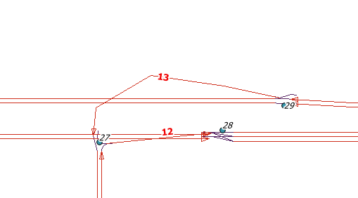
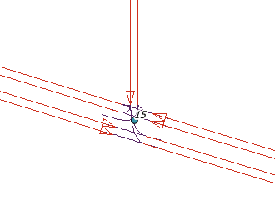

9
7
16
17
[Type a quote from the document or the summary of an interesting point. You can position the text box anywhere in the document. Use the Text Box Tools tab to change the formatting of the pull quote text box.]
19
8

Table 2 Example Connections
LINK | DIR | TO_LINK | LANES | TO_LANES | TYPE | PENALTY | SPEED | CAPACITY | NOTES
16 | 0 | 13 | R1 | 1 | R_SPLIT | 0 | 0 | 0 | Off Ramp
16 | 0 | 9 | 1..2 | 1..2 | THRU | 0 | 0 | 0 | Thru lanes at off ramp
8 | 0 | 17 | 1..2 | 1..3 | THRU | 0 | 0 | 0 | Thru lanes at on ramp
12 | 0 | 17 | 1 | 1..2 | R_MERGE | 0 | 0 | 0 | On ramp
7 | 0 | 19 | 1..2 | 1..2 | THRU | 0 | 0 | 0 | Eastbound thru lanes
7 | 0 | 22 | L1 | 1 | LEFT | 0 | 0 | 0 | Eastbound left turn
19 | 1 | 22 | 1 | 1 | RIGHT | 0 | 0 | 0 | Westbound right turn
19 | 1 | 7 | 1..2 | 1..2 | THRU | 0 | 0 | 0 | Westbound thru lanes
22 | 1 | 7 | 1 | 1..2 | RIGHT | 0 | 0 | 0 | Southbound right turn
22 | 1 | 19 | 1 | 1..2 | LEFT | 0 | 0 | 0 | Southbound left turn

Differences from Version 4

Lane numbering has changed significantly from version 4. In version 5, lanes are numbered from right to left, and pocket lanes are treated separately.
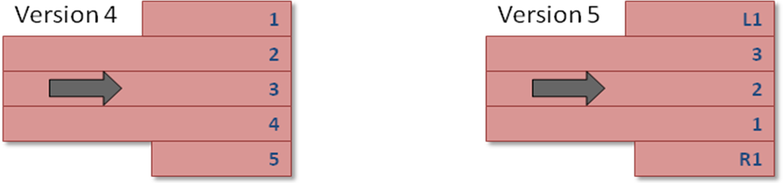
Figure 2 Lane Number Difference Between V4 and V5

This simplifies the lane connectivity edits. In version 4, the edits would often cascade from one intersection to another.

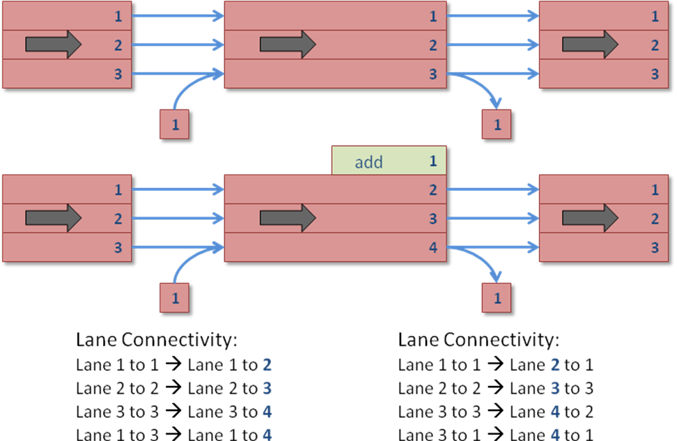
Figure 3 Version 4 Lane Connectivity Edits

In version 5, the edits are simpler:

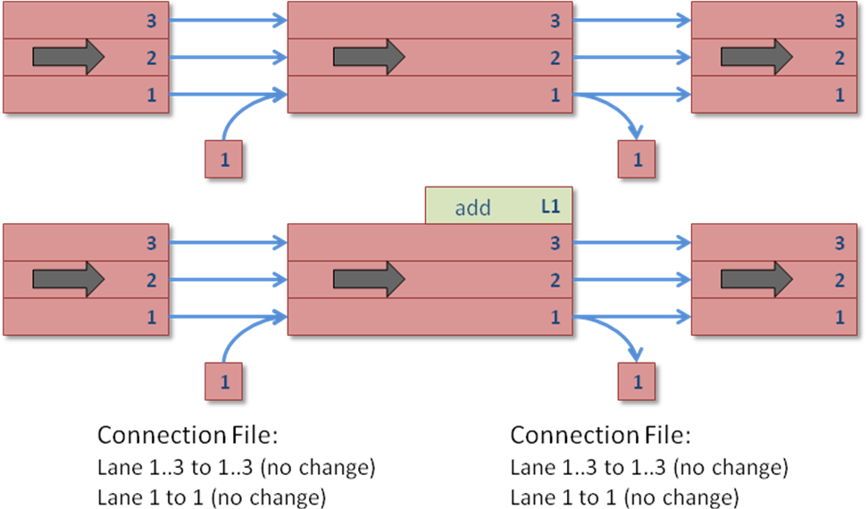
Figure 4 Version 5 Connection Edits

COST_DISTRIBUTION_FILE
NEW_COST_DISTRIBUTION_FILE
PlanCompare

DELETE_LINK_FILE
DELETE_LINK_FILE
NetPrep
TransimsNet Default Control Ke

DELETE_NODE_CONTROL_FILE
DELETE_NODE_CONTROL_FILE
IntControl Default Control Key

DELETE_NODE_FILE
DELETE_NODE_FILE
NetPrep
TransimsNet Default Control Ke

DESTINATION_LOCATION_FILE
DESTINATION_LOCATION_FILE
PathSkim
NEW_DESTINATION_LOCATION_FILE
PathSkim

DESTINATION_ZONE_FILE
DESTINATION_ZONE_FILE
PathSkim

DETECTOR_FILE
DETECTOR_FILE
ArcNet
IntControl Default Control Key
Microsimulator
NewFormat
NEW_DETECTOR_FILE
IntControl Default Control Key
NewFormat

DIRECTIONAL_DATA_FILE
DIRECTIONAL_DATA_FILE
LinkData
NEW_DIRECTIONAL_DATA_FILE
LinkData

GROUP_TRAVEL_FILE
NEW_GROUP_TRAVEL_FILE
LinkSum

HOUSEHOLD_FILE
HOUSEHOLD_FILE
ConvertTrips Default Control K
Microsimulator
NewFormat
PathSkim
RandomSelect Default Control K
Router
NEW_HOUSEHOLD_FILE
ConvertTrips Default Control K
NewFormat

INPUT_LINK_FILE
INPUT_LINK_FILE
NetPrep

INPUT_NODE_FILE
INPUT_NODE_FILE
NetPrep

INPUT_SIGN_FILE
INPUT_SIGN_FILE
IntControl Default Control Key

INPUT_SIGNAL_FILE
INPUT_SIGNAL_FILE
IntControl Default Control Key

INPUT_SPDCAP_FILE
INPUT_SPDCAP_FILE
NetPrep

INPUT_ZONE_FILE
INPUT_ZONE_FILE
NetPrep

KEEP_LINK_FILE
KEEP_LINK_FILE
NetPrep

KEEP_NODE_FILE
KEEP_NODE_FILE
NetPrep

LANE_USE_FILE
LANE_USE_FILE
ArcNet
IntControl Default Control Key
LinkSum
Microsimulator
NewFormat
PathSkim
PlanSelect
PlanSum
Router
NEW_LANE_USE_FILE
NewFormat

LINK_ACTIVITY_FILE
NEW_LINK_ACTIVITY_FILE
LinkSum

LINK_DATA_FILE
NEW_LINK_DATA_FILE
LinkData

LINK_DELAY_FILE
LINK_DELAY_FILE
ArcPlan
IntControl Default Control Key
LinkDelay
NewFormat
PathSkim
PlanSelect
PlanSum
Router
NEW_LINK_DELAY_FILE
LinkDelay
NewFormat
PathSkim
PlanSum
Router

LINK_DETAIL_FILE
NEW_LINK_DETAIL_FILE
NetPrep

LINK_EQUIVALENCE_FILE
LINK_EQUIVALENCE_FILE
LinkSum
PlanSum

LINK_FILE

Names: LINK_FILE, NEW_LINK_FILE

Used In:
ArcNet
ArcPlan
ArcSnapshot
ConvertTrips
IntControl
LinkDelay
LinkSum
LocationData
Microsimulator
NetPrep
NewFormat
PathSkim
PlanSelect
PlanSum
ProblemSelect
Router
TransimsNet

This is a list of links in the network. A typical field definition (.def) file is as follows:
TRANSIMS50, TAB_DELIMITED, 1
LINK, INTEGER, 1, 10
NAME, STRING, 2, 40
NODE_A, INTEGER, 3, 10
NODE_B, INTEGER, 4, 10
LENGTH, DOUBLE, 5, 8.1, METERS
SETBACK_A, DOUBLE, 6, 5.1, METERS
SETBACK_B, DOUBLE, 7, 5.1, METERS
BEARING_A, INTEGER, 8, 4, DEGREES
BEARING_B, INTEGER, 9, 4, DEGREES
TYPE, STRING, 10, 12, FACILITY_TYPE
DIVIDED, UNSIGNED, 11, 1
AREA_TYPE, UNSIGNED, 12, 3
GRADE, DOUBLE, 13, 5.1, PERCENT
LANES_AB, UNSIGNED, 14, 2
SPEED_AB, DOUBLE, 15, 5.1, KPH
FSPD_AB, DOUBLE, 16, 5.1, KPH
CAP_AB, UNSIGNED, 17, 8, VPH
LANES_BA, UNSIGNED, 18, 2
SPEED_BA, DOUBLE, 19, 5.1, KPH
FSPD_BA, DOUBLE, 20, 5.1, KPH
CAP_BA, UNSIGNED, 21, 8, VPH
USE, STRING, 22, 128, USE_TYPE
NOTES, STRING, 23, 128

The fields are defined as follows:

Table 1 Fields in the Link File
Field(s) | Description | Use | Default Units
LINK | The link number (an integer) | Key
NAME | Typically, the name of the street | Opt.
NODE_A | The node at one end of the link (an integer) | Req.
NODE_B | The node at the other end of the link (an integer) | Req.
LENGTH | Length of the link | Req. | m
SETBACK_A, SETBACK_B | When the link is drawn, the setback from each end to its corresponding node | Opt. | m
BEARING_A | Compass direction entering the link at the A end | Opt. | Degrees
BEARING_B | Compass direction exiting the link at the B end | Opt. | Degrees
TYPE | Facility type (functional classification) of the link | Req. | Note 1
DIVIDED | Is it a divided highway? | Opt.
AREA_TYPE
GRADE | Percent grade from A to B | Opt. | Pct.
LANES_AB, LANES_BA | Number of thru lanes in the indicated direction. For a one-way link going from A to B, LANES_BA = 0 | Req.
SPEED_AB, SPEED_BA | Speed limit in the indicated direction | Opt. | m/s
FSPD_AB,  FSPD_BA | Free flow speed in the indicated direction | Opt. | m/s
CAP_AB,  CAP_BA | Hourly vehicle capacity in the indicated direction (used for Volume / Capacity functions) | Opt. | veh/hr
USE | Vehicle types, modes, or use types permitted on the link | Req. | Note 2
NOTES | Character string for user notes | Opt.

Note 1: Facility types include FREEWAY, EXPRESSWAY, PRINCIPAL, MAJOR, MINOR, COLLECTOR, LOCAL_THRU, LOCAL, FRONTAGE, RAMP, BRIDGE, TUNNEL, OTHER, WALKWAY, BIKEWAY, BUSWAY, LIGHTRAIL, HEAVYRAIL, FERRY, EXTERNAL

Note 2: Uses include ANY, WALK, BIKE, CAR, TRUCK, BUS, RAIL, SOV, HOV2, HOV3, HOV4, LIGHTTRUCK, HEAVYTRUCK, TAXI, RESTRICTED

Figure 1 and Table 2 illustrate a small example. Here, links 8 and 9 are freeway links, link 11 is a minor arterial, and links 12 and 13 are ramps. Typically, limited access roads are represented with separate links for each direction of travel, while other roads have a single link for both directions of travel (even if the road is divided).

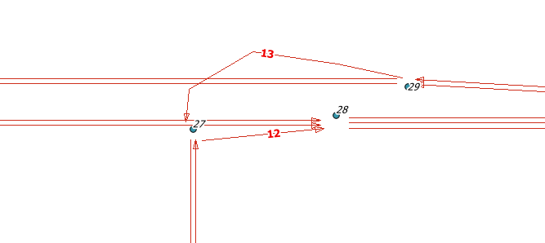

9

8

11

Figure 1 Example Links

Table 2 Example Links
LINK | NAME | NODE_A | NODE_B | LENGTH | SETBACK_A | SETBACK_B | BEARING_A | BEARING_B | TYPE | DIVIDED | AREA_TYPE | GRADE
8 | 0 | 24 | 28 | 1650 | 9.1 | 9.1 | 90 | 90 | FREEWAY | 0 | 2 | 0
9 | 0 | 29 | 21 | 1650 | 7.5 | 7.5 | 270 | 270 | FREEWAY | 0 | 2 | 0
11 | 0 | 16 | 27 | 1000 | 9.1 | 7.5 | 0 | 0 | MINOR | 0 | 2 | 0
12 | 0 | 27 | 28 | 110 | 7.5 | 9.1 | 84 | 84 | RAMP | 0 | 2 | 0
13 | 0 | 29 | 27 | 300 | 7.5 | 7.5 | 282 | 207 | RAMP | 0 | 2 | 0

Table 2 (continued) Example Links
LINK | LANES_AB | SPEED_AB | FSPD_AB | CAP_AB | LANES_BA | SPEED_BA | FSPD_BA | CAP_BA | USE | NOTES
8 | 2 | 97 | 96 | 4000 | 0 | 0 | 0 | 0 | AUTO|TRUCK|BUS
9 | 2 | 97 | 96 | 4000 | 0 | 0 | 0 | 0 | AUTO|TRUCK|BUS
11 | 1 | 43 | 43 | 800 | 1 | 43 | 43 | 800 | AUTO|TRUCK|BUS
12 | 1 | 72 | 71 | 1000 | 0 | 0 | 0 | 0 | AUTO|TRUCK|BUS
13 | 1 | 72 | 72 | 1000 | 0 | 0 | 0 | 0 | AUTO|TRUCK|BUS

LINK_NODE_LIST_FILE
LINK_NODE_LIST_FILE
LinkData
NEW_LINK_NODE_LIST_FILE
NetPrep

LINK_SUMMARY_FILE
NEW_LINK_SUMMARY_FILE
ArcSnapshot Default Control Ke

LINK_VOLUME_FILE
NEW_LINK_VOLUME_FILE
PlanSum

LOCATION_FILE
LOCATION_FILE
ArcNet
ArcPlan
ConvertTrips Default Control K
LinkSum
LocationData
Microsimulator
NewFormat
PathSkim
PlanSelect
ProblemSelect Default Control
Router
TransimsNet Default Control Ke
NEW_LOCATION_FILE
LocationData
NewFormat
TransimsNet Default Control Ke

MERGE_LINK_DELAY_FILE
MERGE_LINK_DELAY_FILE
LinkDelay

MERGE_PLAN_FILE
MERGE_PLAN_FILE
PlanPrep

MERGE_TRIP_FILE
MERGE_TRIP_FILE
TripPrep

NODE_FILE
Names: NODE_FILE, NEW_NODE_FILE

Used In:
ArcNet
ArcPlan
ArcSnapshot
ConvertTrips
IntControl
LinkDelay
LinkSum
LocationData
Microsimulator
NetPrep
NewFormat
PathSkim
PlanSelect
PlanSum
ProblemSelect
Router
TransimsNet

This is a list of nodes in the network. A typical field definition (.def) file is as follows:
TRANSIMS50, TAB_DELIMITED, 1
NODE, INTEGER, 1, 10
X_COORD, DOUBLE, 2, 14.1, METERS
Y_COORD, DOUBLE, 3, 14.1, METERS
Z_COORD, DOUBLE, 4, 14.1, METERS
SUBAREA, INTEGER, 5, 4
NOTES, STRING, 6, 128
Essential information includes the node number (an integer) and the X and Y coordinates. These are typically UTM coordinates.

A new field, not in version 4, is the subarea.

Node numbers do not have to be consecutive. However, for external links (zone connectors), the TransimsNet program assumes that the lower node number attached to a zone connector represents the external station zone number. The simplest way to meet this requirement is to assign numbers higher than the highest external zone number all nodes that are NOT associated with zone centroids (internal or external). For example, if the internal zones are in the range 1 – 500, and external zone numbers are in 600 - 620, the non-centroid nodes might be given node numbers of 700 or higher.

An example of a node file appears below:
NODE | X_COORD | Y_COORD | Z_COORD | SUBAREA | NOTES
600 | 180054.9 | 4768512.4 | 0.0 | 0 | External Node
601 | 179481.0 | 4767920.0 | 0.0 | 0 | External Node
602 | 179397.8 | 4767815.8 | 0.0 | 0 | External Node
3802 | 179740.0 | 4767650.0 | 0.0 | 0 | Subarea Node
3803 | 180724.8 | 4766966.0 | 0.0 | 0 | Subarea Node
3808 | 178366.1 | 4768820.6 | 0.0 | 0 | Subarea Node
4660 | 179865.9 | 4767545.0 | 0.0 | 0 | Subarea Node
4665 | 179620.0 | 4767750.0 | 0.0 | 0 | Subarea Node
8819 | 179705.0 | 4767730.0 | 0.0 | 0 | Subarea Node
9511 | 179685.0 | 4767705.0 | 0.0 | 0 | Subarea Node

OCCUPANCY_FILE
OCCUPANCY_FILE
ArcSnapshot Default Control Ke

ORIGIN_LOCATION_FILE
NEW_ORIGIN_LOCATION_FILE
PathSkim
ORIGIN_LOCATION_FILE
PathSkim

ORIGIN_ZONE_FILE
ORIGIN_ZONE_FILE
PathSkim

PARKING_FILE
NEW_PARKING_FILE
NewFormat
TransimsNet Default Control Ke
PARKING_FILE
ArcNet
ArcPlan
ConvertTrips Default Control K
Microsimulator
NewFormat
PathSkim
Router
TransimsNet Default Control Ke

PARKING_PENALTY_FILE
PARKING_PENALTY_FILE
Microsimulator
PathSkim
Router

PERFORMANCE_DATA_FILE
NEW_PERFORMANCE_DATA_FILE
LinkSum

PERFORMANCE_FILE
NEW_PERFORMANCE_FILE
NewFormat
PERFORMANCE_FILE
ArcPlan
LinkSum
NewFormat

PERSON_FILE
PERSON_FILE
NewFormat

PHASING_PLAN_FILE
NEW_PHASING_PLAN_FILE
IntControl Default Control Key
NewFormat
PHASING_PLAN_FILE
ArcNet
IntControl Default Control Key
Microsimulator
NewFormat

PLAN_FILE
NEW_PLAN_FILE
NewFormat
PathSkim
PlanCompare
PlanPrep
PlanSelect
Router
PLAN_FILE
ArcPlan
Microsimulator
NewFormat
PlanCompare
PlanPrep
PlanSelect
PlanSum
Router

POCKET_FILE
Names: POCKET_FILE, NEW_ POCKET_FILE

Used In:
ArcNet
ArcPlan
ArcSnapshot
IntControl
Microsimulator
NewFormat
PathSkim
Router
TransimsNet

This is a list of pocket lanes in the network. A typical field definition (.def) file is as follows:
TRANSIMS50, TAB_DELIMITED, 1
LINK, INTEGER, 1, 10
DIR, INTEGER, 2, 1
TYPE, STRING, 3, 12, POCKET_TYPE
LANES, UNSIGNED, 4, 2
LENGTH, DOUBLE, 5, 8.1, METERS
OFFSET, DOUBLE, 6, 8.1, METERS
NOTES, STRING, 7, 128
The fields are defined as follows:

Table 1 Fields in the Pocket File
Field(s) | Description | Use | Default Units
LINK | The link number (an integer) | Key
DIR | Direction of the link AB=0, BA=1 | Opt.
TYPE |  | Req. | Note 1
LANES |  | Req.
LENGTH | Length of the pocket | Req. | m
OFFSET |  | Req. | m
NOTES | Character string for user notes | Opt.

Note 1: Pocket types include LEFT_TURN, RIGHT_TURN, LEFT_MERGE, RIGHT_MERGE, POCKET_LANE, AUX_LANE

Figure 1 and Table 2 illustrate a small example.

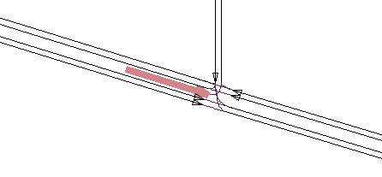
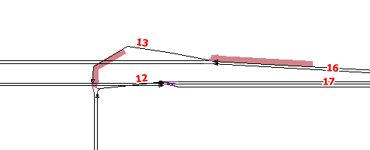
7

9
8

Figure 1 Example Pockets

Table 2 Example Pockets
LINK | DIR | TYPE | LANES | LENGTH | OFFSET | NOTES
7 | 0 | LEFT_TURN | 1 | 50.0 | 0.0 | Left Turn Lane
13 | 0 | LEFT_TURN | 1 | 100.0 | 0.0 | Left Turn Lane
16 | 0 | RIGHT_TURN | 1 | 200.0 | 0.0 | Pocket Lane for Right off-ramp

PROBLEM_FILE
NEW_PROBLEM_FILE
Microsimulator
NewFormat
PathSkim
Router
PROBLEM_FILE
ArcPlan
NewFormat
ProblemSelect Default Control

REPORT_FILE
REPORT_FILE
ArcNet
ArcPlan
ArcSnapshot Default Control Ke
ConvertTrips Default Control K
FileFormat Default Control Key
IntControl Default Control Key
LinkData
LinkDelay
LinkSum
LocationData
Microsimulator
NetPrep
NewFormat
PathSkim
PlanCompare
PlanPrep
PlanSelect
PlanSum
ProblemSelect Default Control
RandomSelect Default Control K
Router
TransimsNet Default Control Ke
TripPrep

RIDERSHIP_FILE
NEW_RIDERSHIP_FILE
NewFormat
RIDERSHIP_FILE
NewFormat

ROUTE_NODES_FILE
NEW_ROUTE_NODES_FILE
NewFormat
ROUTE_NODES_FILE
ArcNet

SELECTION_FILE
NEW_SELECTION_FILE
NewFormat
PlanCompare
PlanSelect
ProblemSelect Default Control
RandomSelect Default Control K
SELECTION_FILE
ArcPlan
NewFormat
PathSkim
PlanCompare
PlanPrep
PlanSum
ProblemSelect Default Control
Router
TripPrep

SHAPE_FILE

Names: SHAPE_FILE, NEW_SHAPE_FILE

Used In:
ArcNet
ArcPlan
ArcSnapshot
ConvertTrips
IntControl
LocationData
NetPrep
NewFormat
TransimsNet

This is the name of the TRANSIMS shape file within the network directory, which provides plain text lists of shape points for links in the network. The full path and name for the shape file is constructed by appending the value of this key to the value of the PROJECT_DIRECTORY key.

A typical field definition (.def) file is as follows:
TRANSIMS50, TAB_DELIMITED, 2, NESTED
LINK, INTEGER, 1, 10
POINTS, INTEGER, 2, 4, NEST_COUNT
NOTES, STRING, 3, 128
X_COORD, DOUBLE, 1, 14.1, FEET, NESTED
Y_COORD, DOUBLE, 2, 14.1, FEET, NESTED

An example of a shape file appears below. The first line contains the link number and the number of shape points (n) for that link. The next n lines contain the X and Y coordinates of the shape points. The process is then repeated for the next link:
62 10
6532.8 7935.0
6497.4 7870.7
6439.3 7832.0
6361.9 7822.2
6287.7 7838.2
6226.4 7883.5
6197.5 7938.3
6200.4 7996.4
6235.9 8070.5
6310.4 8109.2
63 11
6816.6 8115.8
6880.9 8093.2
6922.9 8044.6
6948.8 7977.0
6942.2 7912.7
6903.5 7854.6
6842.2 7815.9
6768.0 7802.8
6684.4 7822.2
6632.5 7870.7
  - 7935.0

Table 1 Information for links 62 and 63
Link | Node A | Node B | Length | Bearing A | Bearing B | Type
62 | 123 | 132 | 656.2 | 196 | 73 | RAMP
63 | 133 | 123 | 656.2 | 103 | 346 | RAMP

Table 2 Information for nodes 123, 132, 133
Node | X_Coord | Y_Coord
123 | 6561.7 | 8038
132 | 6397.6 | 8136.5
133 | 6725.7 | 8136.5

This file indicates that link 62 and link 63 should be drawn as follows: Start at Node A for the link, go through the points in the shape file, end at Node B.

The link file indicates that link 62 runs from node 123 to 132, and that link 63 runs from node 133 to 123. The node file gives the location of these nodes. The end result is as follows (part of a cloverleaf freeway interchange):

Normally, TRANSIMS shape files are not created by hand, but are generated from ArcView shapefiles by programs such as GISNet. However, it might be necessary to clean-up a TRANSIMS shapefile by hand. In this case shape points are added, deleted or corrected. The total number of shapepoints for the link must then also be checked and updated.

Although shapefiles are not absolutely necessary to run TRANSIMS, they are helpful for two reasons:
- They enable a more realistic depiction of the network in a GIS
- They ensure that TRANSIMSNet has the correct connection angles between links when generating connections within a network

SIGN_FILE
NEW_SIGN_FILE
IntControl Default Control Key
NewFormat
TransimsNet Default Control Ke
SIGN_FILE
ArcNet
IntControl Default Control Key
Microsimulator
NewFormat
TransimsNet Default Control Ke

SIGNAL_FILE
NEW_SIGNAL_FILE
IntControl Default Control Key
NewFormat
TransimsNet Default Control Ke
SIGNAL_FILE
ArcNet
IntControl Default Control Key
Microsimulator
NewFormat
TransimsNet Default Control Ke

SKIM_FILE
NEW_SKIM_FILE
NewFormat
PathSkim
SKIM_FILE
ConvertTrips Default Control K
NewFormat

SNAPSHOT_FILE
NEW_SNAPSHOT_FILE
ArcSnapshot Default Control Ke
NewFormat
SNAPSHOT_FILE
ArcSnapshot Default Control Ke
NewFormat

STOP_EQUIVALENCE_FILE
STOP_EQUIVALENCE_FILE
ArcPlan
PlanSum

SUBZONE_DATA_FILE
SUBZONE_DATA_FILE
ArcNet

SUBZONE_ZONE_FACTOR_FILE
SUBZONE_ZONE_FACTOR_FILE
LocationData

TIME_DISTRIBUTION_FILE
NEW_TIME_DISTRIBUTION_FILE
PlanCompare

TIMING_PLAN_FILE
NEW_TIMING_PLAN_FILE
IntControl Default Control Key
NewFormat
TIMING_PLAN_FILE
ArcNet
IntControl Default Control Key
Microsimulator
NewFormat

TOLL_FILE
TOLL_FILE
NewFormat

TRANSIT_DRIVER_FILE
NEW_TRANSIT_DRIVER_FILE
NewFormat
TRANSIT_DRIVER_FILE
ArcNet
ArcPlan
Microsimulator
NewFormat

TRANSIT_FARE_FILE
NEW_TRANSIT_FARE_FILE
NewFormat
TRANSIT_FARE_FILE
Microsimulator
NewFormat
PathSkim
Router

TRANSIT_PENALTY_FILE
TRANSIT_PENALTY_FILE
Microsimulator
PathSkim
Router

TRANSIT_ROUTE_FILE
NEW_TRANSIT_ROUTE_FILE
NewFormat
TRANSIT_ROUTE_FILE
ArcNet
ArcPlan
LocationData
Microsimulator
NewFormat
PathSkim
Router

TRANSIT_SCHEDULE_FILE
NEW_TRANSIT_SCHEDULE_FILE
NewFormat
TRANSIT_SCHEDULE_FILE
ArcNet
LocationData
Microsimulator
NewFormat
PathSkim
Router

TRANSIT_STOP_FILE
NEW_TRANSIT_STOP_FILE
NewFormat
TRANSIT_STOP_FILE
ArcNet
ArcPlan
LocationData
Microsimulator
NewFormat
PathSkim
Router

TRIP_COST_GAP_FILE
NEW_TRIP_COST_GAP_FILE
PlanCompare

TRIP_FILE
NEW_TRIP_FILE
ConvertTrips Default Control K
NewFormat
TripPrep
TRIP_FILE
ConvertTrips Default Control K
NewFormat
RandomSelect Default Control K
Router
TripPrep

TRIP_TIME_FILE
NEW_TRIP_TIME_FILE
PlanSum

TRIP_TIME_GAP_FILE
NEW_TRIP_TIME_GAP_FILE
PlanCompare

TURN_PENALTY_FILE
NEW_TURN_PENALTY_FILE
NewFormat
TransimsNet Default Control Ke
TURN_PENALTY_FILE
ArcNet
Microsimulator
NewFormat
PathSkim
Router
TransimsNet Default Control Ke

TURN_VOLUME_FILE
NEW_TURN_VOLUME_FILE
LinkSum
TURN_VOLUME_FILE
IntControl Default Control Key

UPDATE_LINK_FILE
UPDATE_LINK_FILE
TransimsNet Default Control Ke

UPDATE_NODE_FILE
UPDATE_NODE_FILE
TransimsNet Default Control Ke

VEHICLE_FILE
NEW_VEHICLE_FILE
ConvertTrips Default Control K
NewFormat
VEHICLE_FILE
ConvertTrips Default Control K
Microsimulator
NewFormat
PathSkim
Router

VEHICLE_TYPE_FILE
NEW_VEHICLE_TYPE_FILE
NewFormat
VEHICLE_TYPE_FILE
ArcNet
ArcSnapshot Default Control Ke
ConvertTrips Default Control K
Microsimulator
NewFormat
PathSkim
Router

VERSION4_PLAN_FILE
VERSION4_PLAN_FILE
NewFormat

ZONE_BOUNDARY_FILE
ZONE_BOUNDARY_FILE
LocationData
TransimsNet Default Control Ke

ZONE_EQUIVALENCE_FILE
ZONE_EQUIVALENCE_FILE
ConvertTrips Default Control K
LinkSum
PathSkim
PlanSum

ZONE_FILE
Names: ZONE_FILE, NEW_ZONE_FILE
Used In:
ArcNet
ConvertTrips
LocationData
NetPrep
NewFormat
PathSkim
TransimsNet

The TRANSIMS zone file provides a list of zones in the network. The full path and file name for the zone table is constructed by appending the value of this key to the value of the PROJECT_DIRECTORY key.

A typical field definition (.def) file is as follows:
TRANSIMS50, TAB_DELIMITED, 1
ZONE, INTEGER, 1, 10
X_COORD, DOUBLE, 2, 14.1, FEET
Y_COORD, DOUBLE, 3, 14.1, FEET
Z_COORD, DOUBLE, 4, 14.1, FEET
AREA_TYPE, INTEGER, 5, 3
NOTES, STRING, 6, 128

Essential information includes the zone number (an integer) and the X and Y coordinates. These are typically UTM coordinates.

Zone numbers do not have to be consecutive. However, external zones are typically assigned higher numbers than internal zones.

An example of a zone file appears below:
ZONE | X_COORD | Y_COORD | Z_COORD | AREA_TYPE | NOTES
1 | 4921.3 | 14763.8 | 0.0 | 2 | Internal Zone
2 | 8202.1 | 14763.8 | 0.0 | 2 | Internal Zone
20 | 6561.7 | 17060.3 | 0.0 | 0 | External Zone
21 | 9842.5 | 17060.3 | 0.0 | 0 | External Zone

ZONE_LOCATION_MAP_FILE
NEW_ZONE_LOCATION_MAP_FILE
LocationData
ZONE_LOCATION_MAP_FILE
ConvertTrips Default Control K
PathSkim

ZONE_TRAVEL_FILE
NEW_ZONE_TRAVEL_FILE
LinkSum

