ArcNet

Version 5.0.7

Revision History

July 2011, June 2013 - Created by Volpe Center

The **ArcNet** program is used to:

1. Create ArcView shapefiles from TRANSIMS nodes, links, shape, lane-use, locations, parking, process links, pocket lanes, connections, turn prohibition, unsignalized nodes, signalized nodes, detector, transit routes, transit stop, transit driver, route header, and route nodes files.

2. Draw links and link-related attributes using individual lanes.

3. Draw transit routes using a different offset for each route.

4. Draw the network attributes associates with a specific time period.

Syntax is ArcNet [-flag] [control_file]

The control_file is the file name of an ASCII file that contains the control strings expected by the program. The control_file is optional. If a file name is not provided, the program will prompt the user to enter a file name. The flag parameters are also optional. Any combination of the following flag parameters can be included on the command line:

Optional Flags:

-Q[uiet] = execute without screen messages

-H[elp] = show program syntax and control keys

-C[ontrol] = create/update a default control file

-K[eyCheck] = list unrecognized control file keys

-P[ause] = pause before exiting

-N[oPause] = never pause before exiting

-D[etail] = execute with detailed status messages

-X[ML] = write an XML file with control keys

The program automatically creates a printout file based on the control_file name. If the file name includes an extension (e.g., “.ctl”), the extension is removed and “.prn” is added. The printout file will be created in the current working directory and will overwrite an existing file with the same name.

# Version 5 Features

1. Version 5 requires that the individual output files be specified, rather than just an output directory
2. At intersections, ArcNet now produces curved connections, making the output lane connectivity shapefile more readable.
3. The nested fields were dropped from the Route Nodes shape file.

# Control Key List

The list of control file keys appears in the table below:

* Req / Opt indicates whether the key is **req**uired or **opt**ional
* The types include **Text**, Input **File**name, **New** file, **Bool**ean, **Path** (to a file), **Time**, **Int**eger, **Dec**imal, **List** of items
* The Default is the default value, used if the key does not appear in the control file.
* I/O/P indicates Input, Output or Parameter.

For a more detailed description of the Parameter control keys, see the Parameter Reference. For a more detailed description of the Input or Output control keys, see the File Reference.

## Default Control Keys

|  |  |  |  |  |
| --- | --- | --- | --- | --- |
| **Control File Keys:** | **Req/Opt** | **Type** | **Default** | **I/O/P** |
| TITLE | Opt | Text |  | P |
| REPORT_FILE | Opt | File |  | O |
| REPORT_FLAG | Opt | Bool | FALSE | P |
| PROJECT_DIRECTORY | Opt | Path |  | P |
| DEFAULT_FILE_FORMAT | Opt | Text | TAB_DELIMITED | P |
| TIME_OF_DAY_FORMAT | Opt | Text | DAY_TIME | P |
| MODEL_START_TIME | Opt | Time | 0:00 | P |
| MODEL_END_TIME | Opt | Time | 24:00:00 | P |
| MODEL_TIME_INCREMENT | Opt | Time | 15 minutes |  |
| UNITS_OF_MEASURE | Opt | Text | METRIC | P |
| RANDOM_NUMBER_SEED | Opt | Int. | 0 | P |
| MAX_WARNING_MESSAGES | Opt | Int. | 100000 | P |
| MAX_WARNING_EXIT_FLAG | Opt | Bool | TRUE | P |
| MAX_PROBLEM_COUNT | Opt | Int. | 0 | P |
| NUMBER_OF_THREADS | Opt | Int. | 1 | P |

## System File Keys

| **Control File Keys:** | **Req/Opt** | **Type** | **Default** | **I/O/P** |
| --- | --- | --- | --- | --- |
| NODE_FILE | Opt | File |  | I |
| NODE_FORMAT | Opt | Text | TAB_DELIMITED | P |
| ZONE_FILE | Opt | File |  | I |
| ZONE_FORMAT | Opt | Text | TAB_DELIMITED | P |
| SHAPE_FILE | Opt | File |  | I |
| SHAPE_FORMAT | Opt | Text | TAB_DELIMITED | P |
| LINK_FILE | Opt | File |  | I |
| LINK_FORMAT | Opt | Text | TAB_DELIMITED | P |
| POCKET_FILE | Opt | File |  | I |
| POCKET_FORMAT | Opt | Text | TAB_DELIMITED | P |
| LANE_USE_FILE | Opt | File |  | I |
| LANE_USE_FORMAT | Opt | Text | TAB_DELIMITED | P |
| LOCATION_FILE | Opt | File |  | I |
| LOCATION_FORMAT | Opt | Text | TAB_DELIMITED | P |
| PARKING_FILE | Opt | File |  | I |
| PARKING_FORMAT | Opt | Text | TAB_DELIMITED | P |
| ACCESS_FILE | Opt | File |  | I |
| ACCESS_FORMAT | Opt | Text | TAB_DELIMITED | P |
| CONNECTION_FILE | Opt | File |  | I |
| CONNECTION_FORMAT | Opt | Text | TAB_DELIMITED | P |
| TURN_PENALTY_FILE | Opt | File |  | I |
| TURN_PENALTY_FORMAT | Opt | Text | TAB_DELIMITED | P |
| SIGN_FILE | Opt | File |  | I |
| SIGN_FORMAT | Opt | Text | TAB_DELIMITED | P |
| SIGNAL_FILE | Opt | File |  | I |
| SIGNAL_FORMAT | Opt | Text | TAB_DELIMITED | P |
| TIMING_PLAN_FILE | Opt | File |  | I |
| TIMING_PLAN_FORMAT | Opt | Text | TAB_DELIMITED | P |
| PHASING_PLAN_FILE | Opt | File |  | I |
| PHASING_PLAN_FORMAT | Opt | Text | TAB_DELIMITED | P |
| DETECTOR_FILE | Opt | File |  | I |
| DETECTOR_FORMAT | Opt | Text | TAB_DELIMITED | P |
| TRANSIT_STOP_FILE | Opt | File |  | I |
| TRANSIT_STOP_FORMAT | Opt | Text | TAB_DELIMITED | P |
| TRANSIT_ROUTE_FILE | Opt | File |  | I |
| TRANSIT_ROUTE_FORMAT | Opt | Text | TAB_DELIMITED | P |
| TRANSIT_SCHEDULE_FILE | Opt | File |  | I |
| TRANSIT_SCHEDULE_FORMAT | Opt | Text | TAB_DELIMITED | P |
| TRANSIT_DRIVER_FILE | Opt | File |  | I |
| TRANSIT_DRIVER_FORMAT | Opt | Text | TAB_DELIMITED | P |
| ROUTE_NODES_FILE | Opt | File |  | I |
| ROUTE_NODES_FORMAT | Opt | Text | TAB_DELIMITED | P |
| VEHICLE_TYPE_FILE | Opt | File |  | I |
| VEHICLE_TYPE_FORMAT | Opt | Text | TAB_DELIMITED | P |
| NOTES_AND_NAME_FIELDS | Opt | Bool | FALSE | P |

## Draw Service Keys

| **Control File Keys:** | **Req/Opt** | **Type** | **Default** | **I/O/P** |
| --- | --- | --- | --- | --- |
| DRAW_NETWORK_LANES | Opt | Bool | FALSE | P |
| LANE_WIDTH | Opt | Dec. | 3.5 meters | P |
| CENTER_ONEWAY_LINKS | Opt | Bool | FALSE | P |
| LINK_DIRECTION_OFFSET | Opt | Dec. | 0.0 meters | P |
| DRAW_AB_DIRECTION | Opt | Bool | FALSE | P |
| POCKET_SIDE_OFFSET | Opt | Dec. | 2.0 meters | P |
| PARKING_SIDE_OFFSET | Opt | Dec. | 3.0 meters | P |
| LOCATION_SIDE_OFFSET | Opt | Dec. | 10.0 meters | P |
| SIGN_SIDE_OFFSET | Opt | Dec. | 2.0 meters | P |
| SIGN_SETBACK | Opt | Dec. | 2.0 meters | P |
| TRANSIT_STOP_SIDE_OFFSET | Opt | Dec. | 2.0 meters | P |
| TRANSIT_DIRECTION_OFFSET | Opt | Dec. | 0.0 meters | P |
| TRANSIT_OVERLAP_FLAG | Opt | Bool | TRUE | P |
| DRAW_ONEWAY_ARROWS | Opt | Bool | FALSE | P |
| ONEWAY_ARROW_LENGTH | Opt | Dec. | 7.0 meters | P |
| ONEWAY_ARROW_SIDE_OFFSET | Opt | Dec. | 1.75 meters | P |
| CURVED_CONNECTION_FLAG | Opt | Bool | FALSE | P |

## ArcNet Control Keys

| **Control File Keys:** | **Req/Opt** | **Type** | **Default** | **I/O/P** |
| --- | --- | --- | --- | --- |
| SUBZONE_DATA_FILE | Opt | File |  | I |
| NEW_ARC_NODE_FILE | Opt | New |  | O |
| NEW_ARC_ZONE_FILE | Opt | New |  | O |
| NEW_ARC_LINK_FILE | Opt | New |  | O |
| NEW_ARC_CENTERLINE_FILE | Opt | New |  | O |
| NEW_ARC_POCKET_FILE | Opt | New |  | O |
| NEW_ARC_LANE_USE_FILE | Opt | New |  | O |
| NEW_ARC_LOCATION_FILE | Opt | New |  | O |
| NEW_ARC_PARKING_FILE | Opt | New |  | O |
| NEW_ARC_ACCESS_FILE | Opt | New |  | O |
| NEW_ARC_CONNECTION_FILE | Opt | New |  | O |
| NEW_ARC_TURN_PENALTY_FILE | Opt | New |  | O |
| NEW_ARC_SIGN_FILE | Opt | New |  | O |
| NEW_ARC_SIGNAL_FILE | Opt | New |  | O |
| NEW_ARC_TIMING_PLAN_FILE | Opt | New |  | O |
| NEW_ARC_PHASING_PLAN_FILE | Opt | New |  | O |
| NEW_ARC_DETECTOR_FILE | Opt | New |  | O |
| NEW_ARC_TRANSIT_STOP_FILE | Opt | New |  | O |
| NEW_ARC_TRANSIT_ROUTE_FILE | Opt | New |  | O |
| NEW_ARC_TRANSIT_DRIVER_FILE | Opt | New |  | O |
| NEW_ARC_ROUTE_NODES_FILE | Opt | New |  | O |
| NEW_ARC_SUBZONE_DATA_FILE | Opt | New |  | O |
| SELECT_TIME | Opt | Time | 0:00 | P |
| TRANSIT_TIME_PERIODS | Opt | Text | 0:00 | P |

## Coordinate Projection Keys

|  |  |  |  |  |
| --- | --- | --- | --- | --- |
| **Control File Keys:** | **Req/Opt** | **Type** | **Default** | **I/O/P** |
| INPUT_COORDINATE_SYSTEM | Opt | List |  | P |
| INPUT_COORDINATE_ADJUSTMENT | Opt | List |  | P |
| OUTPUT_COORDINATE_SYSTEM | Opt | List |  | P |
| OUTPUT_COORDINATE_ADJUSTMENT | Opt | List |  | P |
| OUTPUT_XYZ_SHAPES | Opt | Bool | FALSE | P |
| OUTPUT_XYM_SHAPES | Opt | Bool | FALSE | P |

# Example

A fairly typical control file, without transit, is as follows:

TITLE ArcNet Network City Street

PROJECT_DIRECTORY = ./

DEFAULT_FILE_FORMAT = TAB_DELIMITED

TIME_OF_DAY_FORMAT = HOUR_CLOCK

MODEL_START_TIME = 0:00

MODEL_END_TIME = 27:00

UNITS_OF_MEASURE = METRIC

RANDOM_NUMBER_SEED = 1345571629

NUMBER_OF_THREADS = 1

#ARCVIEW_DIRECTORY ../network/arcview //No longer used

NODE_FILE ../network/Node.txt

ZONE_FILE ../network/Zone.txt

SHAPE_FILE ../network/Shape.txt

LINK_FILE ../network/Link.txt

CONNECTION_FILE ../network/Connection.txt

PARKING_FILE ../network/Parking.txt

LOCATION_FILE ../network/Location.txt

POCKET_FILE ../network/Pocket.txt

#LANE_USE_FILE ../network/Lane_Use.txt

SIGNAL_FILE ../network/Signal.txt

TIMING_PLAN_FILE ../network/Timing_Plan.txt

PHASING_PLAN_FILE ../network/Phasing_Plan.txt

DETECTOR_FILE ../network/Detector.txt

SIGN_FILE ../network/Sign.txt

NEW_ARC_NODE_FILE ../network/arcview/node.shp

NEW_ARC_ZONE_FILE ../network/arcview/zone.shp

NEW_ARC_LINK_FILE ../network/arcview/link.shp

NEW_ARC_POCKET_FILE ../network/arcview/pocket.shp

NEW_ARC_CONNECTION_FILE ../network/arcview/connection.shp

NEW_ARC_PARKING_FILE ../network/arcview/parking.shp

NEW_ARC_LOCATION_FILE ../network/arcview/location.shp

NEW_ARC_SIGN_FILE ../network/arcview/sign.shp

NEW_ARC_SIGNAL_FILE ../network/arcview/signal.shp

NEW_ARC_TIMING_PLAN_FILE ../network/arcview/timing_plan.shp

NEW_ARC_PHASING_PLAN_FILE ../network/arcview/phasing_plan.shp

NEW_ARC_DETECTOR_FILE ../network/arcview/detector.shp

DRAW_NETWORK_LANES TRUE

LANE_WIDTH 12 feet

CENTER_ONEWAY_LINKS FALSE

LINK_DIRECTION_OFFSET 6 feet

DRAW_AB_DIRECTION FALSE

POCKET_SIDE_OFFSET 6 feet

PARKING_SIDE_OFFSET 60 feet

LOCATION_SIDE_OFFSET 100 feet

SIGN_SIDE_OFFSET 6 feet

SIGN_SETBACK 6 feet

DRAW_ONEWAY_ARROWS TRUE

ONEWAY_ARROW_LENGTH 20 feet

ONEWAY_ARROW_SIDE_OFFSET 6 feet

CURVED_CONNECTION_FLAG TRUE

INPUT_COORDINATE_SYSTEM UTM, 19N, METERS

INPUT_COORDINATE_ADJUSTMENT 0.0,0.0,1.0,1.0

OUTPUT_COORDINATE_SYSTEM UTM, 19N, METERS

OUTPUT_COORDINATE_ADJUSTMENT 0.0, 0.0, 1.0, 1.0

The resulting .prn file is as follows. The warning message arises because the pocket lane on link 26 is longer than the link itself.

********************************************

| |

| ArcNet - Version 5.0.7 |

| Copyright 2012 by TRANSIMS Open-Source |

| Tue Jun 25 13:07:53 2013 |

| |

********************************************

Control File = ArcNet.ctl

Report File = ArcNet.prn (Create)

ArcNet Network City Streets

Project Directory = ./

Default File Format = TAB_DELIMITED

Time of Day Format = HOUR_CLOCK

Model Start Time = 0:00

Model End Time = 27:00

Units of Measure = METRIC

Random Number Seed = 134557162

Number of Threads = 1

Input System Network Files:

Node File = ./../network/Node.txt

Zone File = ./../network/Zone.txt

Shape File = ./../network/Shape.txt

Link File = ./../network/Link.txt

Pocket File = ./../network/Pocket.txt

Connection File = ./../network/Connection.txt

Parking File = ./../network/Parking.txt

Location File = ./../network/Location.txt

Sign File = ./../network/Sign.txt

Signal File = ./../network/Signal.txt

Phasing Plan File = ./../network/Phasing_Plan.txt

Timing Plan File = ./../network/Timing_Plan.txt

Detector File = ./../network/Detector.txt

Notes And Name Fields = TRUE

Data Service Controls:

Input Coordinate System = UTM, 19N, METERS

Input Coordinate Adjustment = 0.0,0.0,1.0,1.0

Output Coordinate System = UTM, 19N, METERS

Output Coordinate Adjustment = 0.0, 0.0, 1.0, 1.0

ArcNet Output Files:

New Arc Node File = ./../network/arcview/node.shp

New Arc Zone File = ./../network/arcview/zone.shp

New Arc Link File = ./../network/arcview/link.shp

New Arc Pocket File = ./../network/arcview/pocket.shp

New Arc Location File = ./../network/arcview/location.shp

New Arc Parking File = ./../network/arcview/parking.shp

New Arc Connection File = ./../network/arcview/connection.shp

New Arc Sign File = ./../network/arcview/sign.shp

New Arc Signal File = ./../network/arcview/signal.shp

New Arc Timing Plan File = ./../network/arcview/timing_plan.shp

New Arc Phasing Plan File = ./../network/arcview/phasing_plan.shp

New Arc Detector File = ./../network/arcview/detector.shp

ArcNet Control Keys:

Draw Service Controls:

Draw Network Lanes = TRUE

Lane Width = 3.66 meters

Center Oneway Links = FALSE

Location Side Offset = 30.48 meters

Parking Side Offset = 18.29 meters

Sign Side Offset = 1.83 meters

Sign Setback = 1.83 meters

Draw Oneway Arrows = TRUE

Oneway Arrow Length = 6.10 meters

Oneway Arrow Side Offset = 1.83 meters

Curved Connection Flag = TRUE

Number of Node File Records = 25

Number of Zone File Records = 7

Number of Shape File Records = 61

Number of Link Shape Records = 15

Number of Link File Records = 26

Number of Directional Links = 41

Warning: Link 26 Pocket Length 109.1 is Too Long

Number of Pocket File Records = 5

Number of Connection File Records = 51

Number of Parking File Records = 80

Number of Location File Records = 80

Number of Sign File Records = 1

Number of Signal File Records = 12

Number of Detector File Records = 13

Number of Timing Plan File Records = 39

Number of Phasing Plan File Records = 150

Tue Jun 25 13:07:54 2013 -- Process Complete with 1 Warning (0:00:01)

# Using ArcNet for Visualization

ArcNet outputs are used by a Geographic Information System for network visualization, and are an essential tool for debugging a TRANSIMS network. The next few figures show some examples.

Figure 1, whose extent from left edge to right edge is about 1 mile, depicts a few city streets. The long brown lines are the links; the purple dots are the nodes, and the shorter blue lines are the pocket lanes. Signals and signs are also shown.

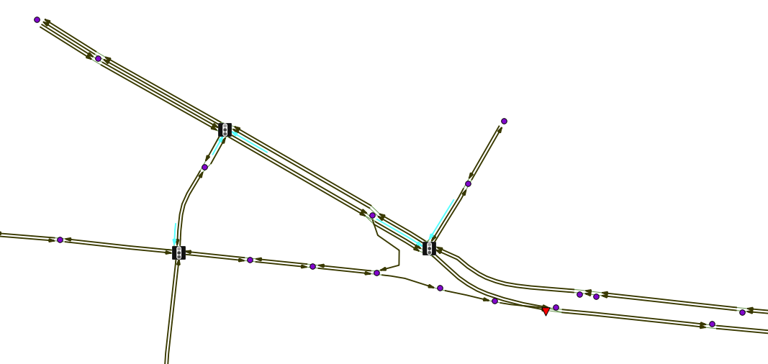

Figure 1 ArcNet Links, Nodes, Pockets, Connections, Signals and Signs

Figure 2 shows a close-up of one intersection.

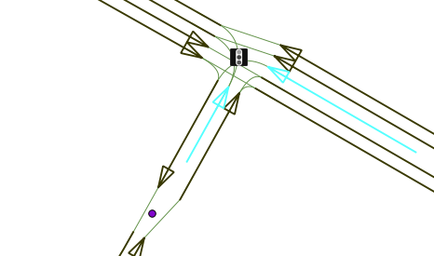

Figure 2 Close-up of one intersection

In it, the connections are seen as thin lines that connect the links and pocket lanes from one side of an intersection to another. Examination of individual intersections can reveal issues with multiple turn lanes, and the like.

Figure 3 adds the activity locations (green diamonds) and parking locations. It uses the default 3 locations on each side of each link, which may not correspond to reality.

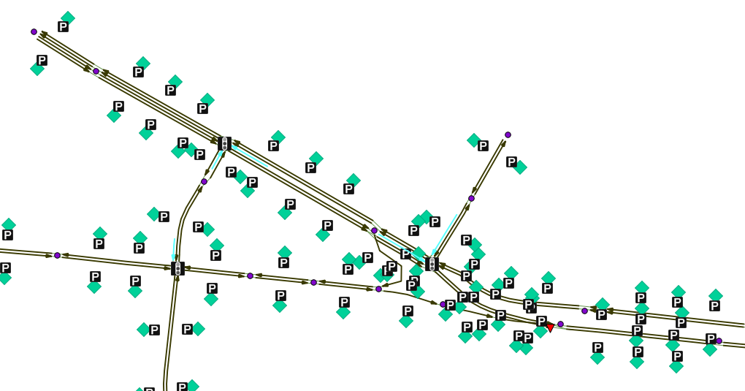

Figure 3 ArcNet Locations and Parking

Figure 4 and Figure 5 show the network along with an aerial overlay.

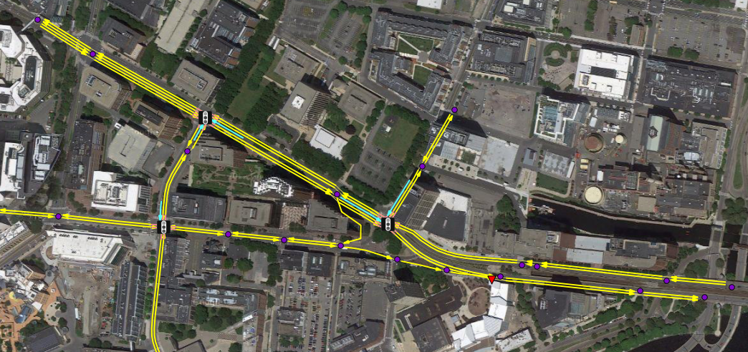

Figure 4 Network overview with aerial imagery

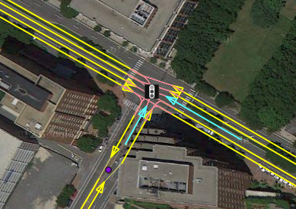

Figure 5 Network closeup with aerial imagery