IntControl Version 5 – Program Reference

Version 5.0.3

### Revision History

July 2012 - Created by Volpe Center

March 2013 – Revised by Volpe Center

The **IntControl** program is used to:

1. *Generate synthetic TRANSIMS sign and signal intersection control data (location, type of control) based on the sign and signal warrant files produced by TransimsNet.*
2. Generate synthetic TRANSIMS signal timing and phasing plans, detectors, and phase offsets.
3. *Append new signs and signals to an existing set of TRANSIMS traffic control files.*
4. *Update the signal timing plans for selected locations and time periods based on turning movement counts (TMC) or link delay data.*
5. *Delete signs or signal records from an existing set of TRANSIMS traffic control files.*
6. *Coordinate offsets for fixed-time signals and fixed-time signal groups.*

Syntax is IntControl [-flag] [control_file]

The control_file is the file name of an ASCII file that contains the control strings expected by the program. The control_file is optional. If a file name is not provided, the program will prompt the user to enter a file name. The flag parameters are also optional. Any combination of the following flag parameters can be included on the command line:

### Optional Flags:

-Q[uiet] = execute without screen messages

-H[elp] = show program syntax and control keys

-C[ontrol] = create/update a default control file

-K[eyCheck] = list unrecognized control file keys

-P[ause] = pause before exiting

-N[oPause] = never pause before exiting

-D[etail] = execute with detailed status messages

-X[ML] = write an XML file with control keys

The program automatically creates a printout file based on the control file name. If the filename includes an extension (e.g., “.ctl”), the extension is replaced with “.prn”. The printout file will be created in the current working directory and will overwrite an existing file with the same name.

# Version 5 Features

* Signal Changes
  + Signal group is now defined in TransimsNet Version 5
    - Signal groups may represent jurisdictions and/or areas with different signal standards
  + Signal type, rings, timing and phasing parameters vary by group
    - The * suffix for any control key indicates a “grouped” parameter (e.g., multiple keys may be of this form and certain combinations may be necessary to represent a signal group by area type)
  + Signal type and rings are now defined in IntControl 5 (previously defined in TransimsNet V4)
* Conceptual Changes
  + Multi-node intersections are now supported in TRANSIMS 5
    - Multi-node intersections supported but not recommended due to inherent complexity
  + Coordination of fixed-time signal offsets is now performed via IntControl rather than Progression
* File Structure Changes
  + Nested signal files
    - Signal time periods, timing plans, and phasing plans
    - Data nesting can be used to avoid sorting problems and record inconsistencies
* New Data Fields
  + Timing Plans – cycle length
  + Phasing Plans – movement
  + Detectors – use type

# Control Key List

The list of control file keys appears in the table below:

* Req / Opt indicates whether the key is **req**uired or **opt**ional
* The types include **Text**, Input **File**name, **New** file, **Bool**ean, **Path** (to a file), **Time**, **Int**eger, **Dec**imal, and **List** of items
* The Default is the default value, used if the key does not appear in the control file
* I/O/P indicates Input, Output or Parameter

For a more detailed description of the Parameter control keys, refer to the Parameter Reference. For a more detailed description of the Input or Output control keys, refer to the File Reference. These two documents also provide the possible values or range of values allowed for each control key listed below, as well as more detailed definitions. For instance, files can usually be output to numerous formats beyond TAB_DELIMITED for additional post-processing / file manipulation actions.

## Configuration Keys

|  |  |  |  |  |
| --- | --- | --- | --- | --- |
| **Control File Keys:** | **Req/Opt** | **Type** | **Default** | **I/O/P** |
| TITLE | Opt | Text |  | P |
| REPORT_DIRECTORY 1 | Opt | Path |  | P |
| REPORT_FILE | Opt | File |  | I |
| REPORT_FLAG | Opt | Bool | FALSE | P |
| PROJECT_DIRECTORY | Opt | Path |  | P |
| DEFAULT_FILE_FORMAT | Opt | Text | TAB_DELIMITED | P |
| TIME_OF_DAY_FORMAT | Opt | Text | DAY_TIME | P |
| MODEL_START_TIME | Opt | Time | 0:00 | P |
| MODEL_END_TIME | Opt | Time | 24:00 | P |
| MODEL_TIME_INCREMENT [1] | Opt | Time | 15 minutes | P |
| UNITS_OF_MEASURE | Opt | Text | METRIC | P |
| RANDOM_NUMBER_SEED | Opt | Int | 0 | P |
| MAX_WARNING_MESSAGES | Opt | Int | 100000 | P |
| MAX_WARNING_EXIT_FLAG | Opt | Bool | TRUE | P |
| MAX_PROBLEM_COUNT | Opt | Int | 0 | P |
| NUMBER_OF_THREADS | Opt | Int | 1 | P |
| INTCONTROL_REPORT_* [2] | Opt | Text |  | O |

## System File Keys

|  |  |  |  |  |
| --- | --- | --- | --- | --- |
| **Control File Keys:** | **Req/Opt** | **Type** | **Default** | **I/O/P** |
| NODE_FILE | Req | File |  | I |
| NODE_FORMAT | Opt | Text | TAB_DELIMITED | I |
| LINK_FILE | Req | File |  | I |
| LINK_FORMAT | Opt | Text | TAB_DELIMITED | I |
| POCKET_FILE | Req | File |  | I |
| POCKET_FORMAT | Opt | Text | TAB_DELIMITED | I |
| CONNECTION_FILE | Req | File |  | I |
| CONNECTION_FORMAT | Opt | Text | TAB_DELIMITED | I |
| SHAPE_FILE | Opt | File |  | I |
| SHAPE_FORMAT | Opt | Text | TAB_DELIMITED | I |
| LANE_USE_FILE | Opt | File |  | I |
| LANE_USE_FORMAT | Opt | Text | TAB_DELIMITED | I |
| SIGN_FILE | Opt | File |  | I |
| SIGN_FORMAT | Opt | Text | TAB_DELIMITED | I |
| SIGNAL_FILE | Opt | File |  | I |
| SIGNAL_FORMAT | Opt | Text | TAB_DELIMITED | I |
| TIMING_PLAN_FILE | Opt | File |  | O |
| TIMING_PLAN_FORMAT | Opt | Text | TAB_DELIMITED | O |
| PHASING_PLAN_FILE | Opt | File |  | O |
| PHASING_PLAN_FORMAT | Opt | Text | TAB_DELIMITED | O |
| DETECTOR_FILE | Opt | File |  | O |
| DETECTOR_FORMAT | Opt | Text | TAB_DELIMITED | O |
| NEW_SIGN_FILE | Opt | File |  | O |
| NEW_SIGN_FORMAT | Opt | Text | TAB_DELIMITED | O |
| NEW_SIGNAL_FILE | Opt | File |  | O |
| NEW_SIGNAL_FORMAT | Opt | Text | TAB_DELIMITED | O |
| NEW_TIMING_PLAN_FILE | Opt | File |  | O |
| NEW_TIMING_PLAN_FORMAT | Opt | Text | TAB_DELIMITED | O |
| NEW_PHASING_PLAN_FILE | Opt | File |  | O |
| NEW_PHASING_PLAN_FORMAT | Opt | Text | TAB_DELIMITED | O |
| NEW_DETECTOR_FILE | Opt | File |  | O |
| NEW_DETECTOR_FORMAT | Opt | Text | TAB_DELIMITED | O |
| LINK_DELAY_FILE | Opt | File |  | O |
| LINK_DELAY_FORMAT | Opt | Text | TAB_DELIMITED | O |

## File Service Keys

|  |  |  |  |  |
| --- | --- | --- | --- | --- |
| **Control File Keys:** | **Req/Opt** | **Type** | **Default** | **I/O/P** |
| NOTES_AND_NAME_FIELDS | Opt | Bool | FALSE | P |

## Data Service Keys

|  |  |  |  |  |
| --- | --- | --- | --- | --- |
| **Control File Keys:** | **Req/Opt** | **Type** | **Default** | **I/O/P** |
| SAVE_LANE_USE_FLOWS | Opt | Bool | FALSE | P |
| DAILY_WRAP_FLAG | Opt | Bool | FALSE | P |
| SUMMARY_TIME_RANGES | Opt | Text | ALL | P |
| SUMMARY_TIME_INCREMENT | Opt | Time | 15 minutes | P |

## Control Keys

|  |  |  |  |  |
| --- | --- | --- | --- | --- |
| **Control File Keys:** | **Req/Opt** | **Type** | **Default** | **I/O/P** |
| INPUT_SIGN_FILE | Opt | File |  | I |
| INPUT_SIGNAL_FILE | Opt | File |  | I |
| DELETE_NODE_CONTROL_FILE | Opt | File |  | I |
| PRINT_SIGN_WARNINGS | Opt | Bool | FALSE | P |
| PRINT_MERGE_WARNINGS | Opt | Bool | FALSE | P |
| SIGNAL_TYPE_CODE_* | Opt | List | TIMED | P |
| NUMBER_OF_RINGS_* | Opt | List | 1 | P |
| SIGNAL_TIME_BREAKS_* | Opt | List | NONE | P |
| SIGNAL_CYCLE_LENGTH_* | Opt | List | 60 seconds | P |
| MINIMUM_PHASE_TIME_* | Opt | List | 5 seconds | P |
| YELLOW_PHASE_TIME_* | Opt | List | 3 seconds | P |
| RED_CLEAR_PHASE_TIME_* | Opt | List | 1 second | P |
| SIGNAL_SPLIT_METHOD_* | Opt | List | CAPACITY | P |
| MINIMUM_LANE_CAPACITY_* | Opt | Int. | 500 | P |
| MAXIMUM_LANE_CAPACITY_* | Opt | Int. | 1500 | P |
| POCKET_LANE_FACTOR_* | Opt | List | 0.5 | P |
| SHARED_LANE_FACTOR_* | Opt | List | 0.5 | P |
| TURN_MOVEMENT_FACTOR_* | Opt | List | 0.9 | P |
| PERMITTED_LEFT_FACTOR_* | Opt | List | 0.5 | P |
| GENERAL_GREEN_FACTOR_* | Opt | List | 1.0 | P |
| EXTENDED_GREEN_FACTOR_* | Opt | List | 0.5 | P |
| MAXIMUM_GREEN_FACTOR_* | Opt | List | 2.0 | P |
| SIGNAL_DETECTOR_LENGTH_* | Opt | Dec. | 20 meters | P |
| TURN_VOLUME_FILE | Opt | File |  | O |
| SIGNAL_TIMING_UPDATES | Opt | File |  | O |

#### Notes

Each '_FILE' key has a corresponding '_FORMAT' key. The following file formats can be used for input and output files:

TEXT, BINARY, FIXED_COLUMN, COMMA_DELIMITED, SPACE_DELIMITED, TAB_DELIMITED, CSV_DELIMITED, DBASE, SQLITE3, VERSION3

# Control Key Changes in IntControl Version 5 – Files, Fields, Parameters, & Concepts

## New Group Concepts in TRANSIMS 5

* SIGNAL_DETECTOR_LENGTH _*[3]
  + * is the first area type value in the list
    - It is optional, defaults to 1
    - Supports up to 100 area types
* Application Options
  + SIGNAL_DETECTOR_LENGTH = 10
  + SIGNAL_DETECTOR_LENGTH _1 = 10
  + SIGNAL_DETECTOR_LENGTH _2 = 20
  + SIGNAL_DETECTOR_LENGTH _10 = 25

## Network File Name and Control Key Name Changes (IntControl 4.0 🡪 5.0)

Additional control key changes may be present in IntControl 5.0 that are not described in this section. Changes have been made to select control key and file and parameter names in many instances as can been seen from the list below. Additionally, file structures have been modified in some instances (e.g., file column heading names). New conceptual constructs have been introduced to improve overall performance and ease of use and robustness of TRANSIMS 5.0 as well. Lastly, new data fields have been added within some input and output files (e.g., SubArea). Refer to the File Reference and Parameter Reference documents for additional details. Some specific examples include the following control key and file name changes (V4 🡪 5):

* NET_NODE_TABLE 🡪 NODE_FILE
* NET_LINK_TABLE 🡪 LINK_FILE
* NET_PHASING_PLAN_TABLE 🡪 PHASING_PLAN_FILE
* NET_TIMING_PLAN_TABLE 🡪 TIMING_PLAN_FILE
* NET_DETECTOR_TABLE 🡪 DETECTOR_FILE
* NET_SIGNAL_COORDINATOR_TABLE 🡪 SIGNAL_FILE
* NET_TRANSIT_STOP_TABLE🡪 TRANSIT_STOP_FILE
* NET_TRANSIT_FARE_TABLE 🡪 TRANSIT_FARE_FILE
* NET_TRANSIT_ROUTE_TABLE 🡪 TRANSIT_ROUTE_FILE
* NET_TRANSIT_SCHEDULE_TABLE 🡪 TRANSIT_SCHEDULE_FILE
* NET_TRANSIT_DRIVER_TABLE 🡪 TRANSIT_DRIVER_FILE
* NEW_SIGNAL_COORDINATOR_TABLE 🡪 No TRANSIMS 5.0 equivalence
* ADD_NO_CONTROL_RECORDS 🡪 No TRANSIMS 5.0 equivalence
* PRINT_SIGN_WARNINGS (Signal Type) 🡪 Moved to IntControl 5.0; previously was in TransimsNet 4.0
* SIGNAL_TYPE_CODE_1 (The Number of Rings) 🡪 Moved to IntControl 5.0; previously was in TransimsNet 4.0

## Link Connection Impacts

In IntControl Version 4 (the prior version) lane numbers applied to both ends of a given link. Consequently, pocket lanes at one end impacted lane numbers at the other end. Thus, adding and deleting pocket lanes impacted all lane-related files. The user was required to make these network changes manually. The user also had to update the corresponding row entries in all lane-related files (phasing plan, timing plan, detectors, etc.) in order to keep the network data valid. Due to the complexity of making such updates, a manual database-driven approach, and other similar manual approaches were typically employed. The additional time required to perform manual updates to multiple interdependent files, as well as the tendency to introduce errors into the network files, made this approach less than ideal, and sometimes prone to failure.

## Pocket Lanes

Starting with TRANSIMS version 5, lane numbers are independent at each end of a given link. Therefore, pocket lane changes require comparatively fewer network changes than with Version 4. For example, adding a pocket lane to a link no longer causes the lane numbering to increment by one without corresponding updates to the other intersection configuration-dependent files such as the phasing and timing plans. Refer to the File Interdependencies section below for additional information. In TRANSIMS 5, pocket lane warrants are used to specify lists of multiple data fields. For additional discussion, refer to the Parameter and File Reference documents for definitions of the various TransimsNet 5 and IntControl 5 control keys.

## File Interdependencies

Starting with IntControl 5, the Signal Coordinator file has been removed. The signal file contains detailed signalized node information and additionally fulfills the functions previously associated with the Signal Coordinator file. Four cross-referenced files are present in TRANSIMS 5 and are of specific interest to IntControl 5. These four files are the Signal file, the Timing Plan file, the Phasing Plan file, and the Detector file. In TRANSIMS 5, changes made to any of these four files will automatically be reflected as updates in the remaining three files. Occasionally, a network artifact such as a detector at a previously signalized node will not be auto-updated and thus requires manual editing of the network. A graphical review of the network using GIS software and ArcNet-generated shape files after running IntControl will easily illuminate most of these problems. Also, all of the aforementioned files use nested structures, and they are all interrelated with either simple or compound primary keys in the flat text files used in TRANSIMS 5. Additional files and field values share indirect interdependencies with these four files as well. They are not hard-coded/programmatically-implemented relationships, but they are nonetheless affected or else can cause unintended effects in the context of an intersection signal configuration update (for example). Some of these relationships are documented and examined further in the Intersection Configuration How-To document.

## File Changes

Several file changes specific to IntControl have been introduced with TRANSIMS 5 and are briefly noted here. For more in-depth discussion, refer to the Network Files Training presentation (PowerPoint) and the File Reference document. Files with significant changes in IntControl 5 include the following: Access File, Lane Use File, Parking File, Signal File, Phasing Plan File, Timing Plan File, and Detector File. Refer to the File Reference document for in-depth detail on these files.

## Nested Data Files

TRANSIMS also supports nested files that include two record types. The first record is the master record that includes a field that identifies the number of nested records that follow. A phasing plan is a typical example of a nested data file (refer to example DEF file below), as are the Detector, Sign, Phasing Plan, and Timing Plan files. The master records define the signal, number of phases and detectors at the intersection while the nested records define the individual phases.

The definition file for a typical phasing plan file looks like the following:

TRANSIMS50, TAB_DELIMITED, 2, NESTED

SIGNAL, INTEGER, 1, 10

PHASING, INTEGER, 2, 3

PHASE, INTEGER, 3, 3

MOVEMENTS, INTEGER, 4, 2, NEST_COUNT

DETECTORS, STRING, 5, 128

MOVEMENT, STRING, 1, 10, MOVEMENT_TYPE, NESTED

LINK, INTEGER, 2, 10, NO, NESTED

DIR, INTEGER, 3, 1, NO, NESTED

TO_LINK, INTEGER, 4, 10, NO, NESTED

PROTECTION, STRING, 5, 12, PROTECTION_TYPE, NESTED

The first record indicates that the data file has two header records and includes the NESTED key word. The field specifications for the master record are exactly like any other definition file. The nested fields add the NESTED key word after the units field. Note that the record offsets restart from 1 as well. The field with the NEST_COUNT identifier is used to determine how many nested records follow each master record.

## Control File Parameter Groups

The file parameters without the “NEW_*” prefix correspond to the synthetic TransimsNet 5 files previously generated. There are two basic groups of control parameters provided by the IntControl program. The first group defines how a timing plan is developed for each phase. This group includes MINIMUM_PHASE_TIME_*, YELLOW_PHASE_TIME_*, RED_CLEAR_PHASE_TIME_*, and EXTENDED_GREEN_FACTOR_*. These parameters define how the minimum, maximum, and extended green times are computed for fixed-timed and demand-actuated phases.

The second group determines how the total cycle length is allocated to different phases. This group includes POCKET_LANE_FACTOR_*, GENERAL_GREEN_FACTOR_*, SIGNAL_SPLIT_METHOD_*, MINIMUM_LANE_CAPACITY_*, and MAXIMUM_LANE_CAPACITY_*. These parameters define how the number of lanes or lane capacity assigned to one phase is balanced against similar values from other phases to allocate a share of the total cycle time to each phase.

The algorithm discussion section from the IntControl Version 4 User Guide is presented in the following paragraphs:

The lane capacities are computed by dividing the directional capacity with the number of lanes. If the computed lane capacity is less than the minimum lane capacity defined by the MINIMUM_LANE_CAPACITY field, the software resets the computed lane capacity to be equal to the user specified minimum lane capacity. The numbers of approach and departure links are estimated before determining the phasing and the timing plans. For a given link the software identifies the thru link and then determines whether protected left turns are warranted. When left turns pockets are coded on both the approaches, the software assigns a protected left phase followed by general green. When left turn pockets are present on only one of the approaches, the software assigns a protected left and thru phase followed by the general green. If no left turns are present, the software assigns a general green phase with no turn protections.

When Left Turns are present on both the links, the phase time is computed by using the expressions below:

Thru Phase Time = General Green Factor * (Capacity of Link1 * (Number of Regular Lanes on Link1 +   
Number of Right Turn Pocket Lanes on Link1 * Pocket_Factor) + Capacity of Link2 * (Number of Regular Lanes on Link2 + Number of Right Turn Pocket Lanes on Link2 * Pocket_Factor))

IntControl previously generated only isolated signal control plans in TRANSIMS Version 4. If signals needed to be coordinated, a somewhat involved manual process was required to incorporate and coordinate groups of signal offsets. The Progression Version 4 program was used to coordinate larger groups of signal offsets in the prior version of TRANSIMS. However, the Progression program has been dropped from the TRANSIMS toolbox starting with Version 5. Instead, IntControl 5 now includes the necessary functionality to properly coordinate fixed-time signal offsets.

## Signal Parameter Control Keys

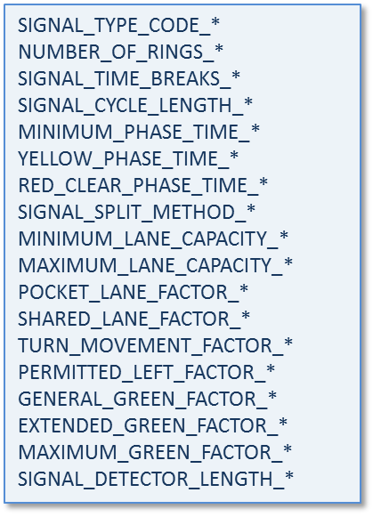

Figure IntControl Version 5 Signal Parameter Control Keys

As noted, signal groups are now available as control keys in TransimsNet 5 rather than IntControl. Figure 1 above shows the various IntControl 5 control keys that are used to define signal type, rings, and timing and phasing parameters. The * suffix is explained further in the New Group Concepts in TRANSIMS 5 and Control File Parameter Groups sections above. Essentially, the suffix is used in order to group related parameters. For instance, a TRANSIMS user would replace ‘*’ with 1, 2, 3, etc. for a given group of IntControl control file parameters, files, and data fields.

# Overview of IntControl 5

The IntControl program uses detailed intersection configuration and lane connectivity data to populate the traffic control files required by TRANSIMS. The Sign and Signal Warrant files identify the intersections and approach links that require traffic controls. IntControl first validates and then completes the sign/unsignalized node data and assigns each intersection control (Stop, Yield, None) and generates the corresponding data file. In other words, Unsignalized Nodes/Intersections data is produced and is located in the Sign file. IntControl then builds signal controls for each Signalized Node/Intersection and generates the associated Signal file data. For Signalized Intersections, IntControl also constructs a corresponding, relational record in the Timing Plan file, Phasing Plan file, and Detector file, all of which are related and interdependent. These relationships are discussed further elsewhere in this document.

IntControl generates Signalized and Unsignalized nodes which are recorded in the Signal and Sign files (respectively), and based on the corresponding Sign and Signal Warrant files previously produced by TransimsNet. Sign and Signal Warrant files should be reviewed and edited **before** and after running (or re-running, as needed) TransimsNet and before running IntControl. Alternatively, the Sign and Signal files produced by IntControl can be edited directly to modify Sign and Signal placement. However, this approach is not recommended as the Signal file has multiple file interdependencies, and this approach may inadvertently introduce coding errors into the network model. Consequently, editing the Sign and Signal Warrants and re-running IntControl is usually preferable to and safer than directly editing the Sign and Signal files produced by IntControl.

Iterative review and refinement of IntControl outputs will generally be necessary before proceeding to routing and simulating traffic flows. Since intersection configuration in TRANSIMS uses substantial, detailed information about the network, and re-configuration of intersections can be rather involved, this subject is briefly discussed below and further discussed in the Intersection Configuration How-To document.

The number of phases and the green time allocated to each phase is based on the intersection configuration and the number of lanes or lane capacity assigned to each phase. Fixed timed and demand-actuated signals are supported by IntControl, as is signal coordination. By default, signalized intersections are isolated and actuated.

It is imperative to make any necessary changes and confirm the correctness of various network artifacts, especially sign and signal warrant placement, lane connections at key intersections, and general intersection configuration-related parameters. A review process should be performed at each breakpoint in the network synthesis process that involves network file data transformation (e.g., NetPrep input and output files, TransimsNet input and output files, IntControl input and output files, etc.). Frequent review and iteration/reiteration when necessary will help to ensure that coding errors can be detected and eliminated as early in the process as possible. A combination of graphical and textual review is recommended (i.e., a text editor and a GIS program). Shape files for graphical review can be generated using ArcNet refer to the Program Reference of the same name for additional information.

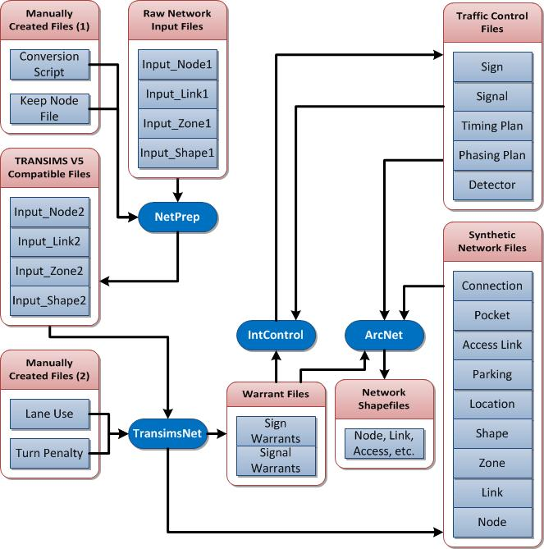

Figure : TRANSIMS 5 Network Synthesis File and Program Input/Output

Note that the specific input and output files that are actually used and produced by each program in a given traffic model and microsimulation implementation will vary somewhat based on the way in which the TRANSIMS programs are used (i.e., not all files shown in Figure 2: TRANSIMS 5 Network Synthesis File and Program Input/Output may be used; not all useable files are shown).

# IntControl – Signs and Signals in TRANSIMS 5

### IntControl Key Input Files

* Sign and Signal Warrant Files (TransimsNet 5 output files; IntControl 5 required input files)
  + The Sign and Signal Warrants produced by TransimsNet should be reviewed and edited (if necessary) prior to running IntControl to eliminate incorrect sign and signal placement. This process may need to be reiterated several times until the network model matches available sign and signal placement data.
* **Connection File (formerly Lane Connectivity)** 
  + Lane connectivity records specify all the movements allowed at each node/intersection in the network model. The Connection file contains detailed information on link and lane connections at each intersection (or node) in the network. Refer to the figure below (Figure 4) for an example TRANSIMS intersection visualized by using ArcNet to generate shape files and a GIS program to render them. Of particular note are instances in which lane-to-lane connections crisscross each other (thus suggesting a coding error). Failure to address such issues as early as possible will increase the cost and difficulty of addressing them during the later routing or microsimulation processes.
* Keep Node File (NetPrep 5 optional file)
  + A Keep Node File is discussed elsewhere (refer to the NetPrep 5 Program Reference) and is useful in preventing TRANSIMS from accidentally collapsing/pruning important network nodes. In some instances, TransimsNet may prune important intersections unexpectedly, so making or updating a Keep Node File may be necessary. Similarly, attempting to place a Sign Warrant at a previously signalized node that still has Signal file artifacts associated with it is likely to cause errors. Manually created files such as the Keep Node file and Delete Node file should be added to the network subdirectory of the TRANSIMS project prior during the iterative refinement process.
    - As discussed in the NetPrep 5 program reference (and elsewhere), many control keys have been moved to NetPrep 5. NetPrep introduces several new keys, but also contains many keys formerly associated with TransimsNet 4. Control key functionality largely remains the same for the ones moved from TransimsNet 4 to NetPrep 5.
* Delete Node File (TransimsNet 5 optional file)
  + This file is optional and if provided (similar to the Keep Node File), it specifies a series of node numbers where the lane connectivity, traffic control warrants, and node are deleted. Refer to the TransimsNet 5 PR and Parameter Reference for more information regarding this file.

### IntControl Key Output Files

* Sign and Signal Files
  + The Sign and Signal files produced by IntControl can be edited directly similar to the Sign and Signal Warrant files. However, important Signalized nodes may have already been pruned by TransimsNet, so a Keep Node File may be necessary (refer to next bullet below). Editing the Warrant files and then re-running IntControl is the preferred method instead of directly editing the Sign and Signal files. The latter can be successfully edited directly, but numerous interdependent file records would require manual updates as well (Detector, Phasing Plan, and Timing Plan files).
    - Note that as of IntControl 5.0, the Signal Coordinator file has been dropped. Its functionality is effectively replaced by the nested Signal file.
* **Detector File, Phasing Plan File, and Timing Plan File**
  + A visual review of the network using ArcNet and a GIS program can be used to identify obvious network inconsistencies. For instance, a detector record may still be present at an intersection/node which no longer has a signal associated with it. Failure to remove such artifacts is likely to cause system problems. For instance, an error will be generated by IntControl if a previously signalized node still has detectors and subsequently, someone attempts to place a sign at this node. These files are interdependent, souse **extreme caution** if editing them directly.

### IntControl Input Parameters

* Group 1 – Defines how a timing plan is developed for each phase
  + MINIMUM_PHASE_TIME, YELLOW_PHASE, RED_CLEAR_PHASE_TIME, and EXTENDED_GREEN FACTOR
  + These parameters define how the minimum, maximum, and extended green times are computed for fixed-time and demand-actuated signals
* Group 2 – Determines how the total cycle length is allocated to different phases
  + This group includes POCKET_LANE_FACTOR, GENERAL_GREEN_FACTOR, SIGNAL_SPLIT_METHOD, MINIMUM_LANE_CAPACITY, and MAXIMUM_LANE_CAPACITY
  + These parameters define how the number of lanes or lane capacity assigned to one phase is balanced against similar values from other phases to allocate a share of the total cycle time to each phase
* Other Relevant Parameters
  + Several, multi-field, warrant file control key parameters exist[4]

### IntControl Output Files

* IntControl provides as output the full set of network files. These files describe the highly detailed intersection configurations and data necessary for a microsimulation. This final step in the network synthesis and refinement process typically requires the most reiteration based on these output files.
* The files output by IntControl are described in detail in the File Reference document.

## TRANSIMS 5 Intersection Controls, Types, Sub-Types – Signalized and Unsignalized Nodes

### Unsignalized Nodes

Unsignalized nodes are relatively straightforward in IntControl and TRANSIMS 5. Among other reasons, the Sign file only depends on the associated node and link files. Available types of intersection controls include the following:

* 1. None
  2. Stop
  3. Yield

### Signalized Nodes

In contrast to Unsignalized nodes, Signalized nodes are relatively complicated to model accurately in TRANSIMS. This is primarily due to the use of nested data fields within each of the above four “Signal”-centric data files, coupled with the dependencies that exist among these files in TRANSIMS 5. Sign and Signal Warrants as the primary means of reviewing and adjusting sign and signal placements has been emphasized in this document for this reason. The primary reason for not directly editing the Sign and Signal files if possible is because of the complex interrelationships and dependencies between these files.

1. Interdependent files (see Figure 3)
   1. Signal file
   2. Phasing Plan file, which contains the allowed movements for each phase
   3. Timing Plan file, which contains the timings for each phase
   4. Detector file
2. Signals have phases
   1. Colloquially, the phasing plan describes who gets the green, who gets the red, and in what order
   2. The number of phases and the green time allocated to each phase is based on the intersection configuration and the number of lanes as well as the lane capacity assigned to each phase.
3. Signals have timings
4. Basics elements include  green time (may be variable or fixed), yellow, all-red
5. Two basic types of timing plans:  fixed time and actuated
   * 1. Fixed time - Timing plans may vary by time of day
     2. Actuated - makes use of detectors to vary the timings depending on real-time demand
        1. Parameters:  min green, max green, etc.[5]
        2. Fixed-timed and demand-actuated signals with one, two, or three rings, and block groups can be synthesized using IntControl based on the input Signal Warrant file data and the associated signal parameter values in the IntControl control file. The result is the output Sign and Signal files produced by TRANSIMS 5. Note that the number of rings is now specified in TransimsNet 5 rather than IntControl 5 while all other signal parameters are now specified in IntControl 5.
        3. Signals are also expressed in terms of time as the diagram below illustrates
     3. Variants, e.g., semi-actuated
6. Isolated and coordinated signals. A fixed time signal may be coordinated with other nearby signals to improve progression of vehicle along the road.



Figure : Signal file relational interdependencies as coded in TRANSIMS 5

Figure 4 shows an example of an actuated signal (signal number 2) located at Node 22. It has three timing and phasing plans, as is illustrated in the subsequent tables.

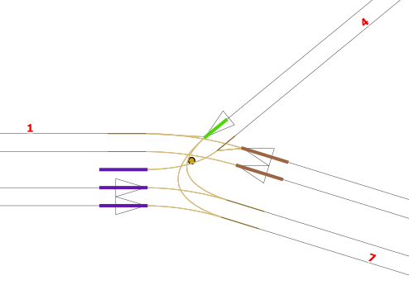

Figure Example of a signalized intersection

In these tables, the headers and content for the master record is shown in italics, the material for the inner nest is shown in plain text, with a lighter background shading.

The number of timing/phasing plans is given by the TIMES parameter in the master record (text in italics and shaded in blue). The node (or nodes) that the signal pertains to is specified in the NODES column. Plan 1 applies from 0:00 to 7:00. Plan 2 applies from 7:00 to 10:00. Plan 3 applies after 10:00.

Table Signal File

|  |  |  |  |
| --- | --- | --- | --- |
| *SIGNAL* | *GROUP* | *TIMES* | *NODES* |
| START | END | TIMING | PHASING |
| *2* | *1* | *3* | *22* |
| 0:00 | 7:00 | 1 | 1 |
| 7:00 | 10:00 | 2 | 2 |
| 10:00 | 27:00 | 3 | 3 |

Signal number 2 has three phasing plans (by time of day), and is associated with detectors 7, 8 and 9.

Consider the first 11 lines of Table 2. These include the headers and the first phasing plan (labeled “PHASING”), which applies from 0:00 to 7:00.

This phasing plan has two phases, numbered 1 and 2 (in italics). The first phase is actuated by detectors 7 and 9, and covers the through movements between 1 and 7, and indicates that the following moves are permitted:

- Westbound right turn from link 7 (direction 1) to link 4

- Westbound through movement from link 7 (direction 1) to link 1

- Eastbound through movement from link 1 (direction 0) to link 7

- Eastbound through movement (actually, a left turn) from link 1 (direction 0) to link 4

The second phase is actuated by detector 8, and covers traffic coming out of link 4 (plus right turn on red from 7 to 4):

- Westbound thru movement from link 4 to link 1 (aright-turn)

- Left turn from link 4 to link 7

- Right turn on red from link 7 to link 4.

The remainder of Table 2 is concerned with the second and third phasing plans, which apply after 7 AM. Note that. as a practical matter, these phases may not be realistic in the real-world.

Table Phasing plan

| *SIGNAL* | *PHASING* | *PHASE* | *MOVEMENTS* | *DETECTORS* |
| --- | --- | --- | --- | --- |
| MOVEMENT | LINK | DIR | TO_LINK | PROTECTION |
| ***2*** | ***1*** | ***1*** | ***4*** | ***7|9*** |
| **WB_RIGHT** | **7** | **1** | **4** | **PERMITTED** |
| **WB_THRU** | **7** | **1** | **1** | **PERMITTED** |
| **EB_THRU** | **1** | **0** | **7** | **PERMITTED** |
| **EB_THRU** | **1** | **0** | **4** | **PERMITTED** |
| ***2*** | ***1*** | ***2*** | ***3*** | ***8*** |
| **WB_THRU** | **4** | **1** | **1** | **PROTECTED** |
| **WB_LEFT** | **4** | **1** | **7** | **PROTECTED** |
| **WB_RIGHT** | **7** | **1** | **4** | **STOP_PERMIT** |
| *2* | *2* | *1* | *4* | *7|9* |
| WB_RIGHT | 7 | 1 | 4 | PERMITTED |
| WB_THRU | 7 | 1 | 1 | PERMITTED |
| EB_THRU | 1 | 0 | 7 | PERMITTED |
| EB_THRU | 1 | 0 | 4 | PERMITTED |
| *2* | *2* | *2* | *3* | *8* |
| WB_THRU | 4 | 1 | 1 | PROTECTED |
| WB_LEFT | 4 | 1 | 7 | PROTECTED |
| WB_RIGHT | 7 | 1 | 4 | STOP_PERMIT |
| *2* | *3* | *1* | *4* | *7|9* |
| WB_RIGHT | 7 | 1 | 4 | PERMITTED |
| WB_THRU | 7 | 1 | 1 | PERMITTED |
| EB_THRU | 1 | 0 | 7 | PERMITTED |
| EB_THRU | 1 | 0 | 4 | PERMITTED |
| *2* | *3* | *2* | *3* | *8* |
| WB_THRU | 4 | 1 | 1 | PROTECTED |
| WB_LEFT | 4 | 1 | 7 | PROTECTED |
| WB_RIGHT | 7 | 1 | 4 | STOP_PERMIT |

Signal number 2 also has three timing plans (by time of day). Consider the first 5 lines of Table 3, which correspond to Signal number 2, Timing plan number 1. The outer nest (in red) indicates that it is an actuated plan with a 90 second overall cycle, and no offset (i.e., no coordination with other signals). It includes 2 phases, which are detailed in the inner nest (in black).

Phase 1 has a min and max green of 5 seconds (not very realistic!), a 3 second yellow, and 1 second all red. Phase 2 has a min green of 39 seconds, and a max green of 77 seconds, with a 20 second possible extension.

Table Timing plan

| *SIGNAL* | *TIMING* | *TYPE* | *CYCLE* | *OFFSET* | *PHASES* |  |  |  |
| --- | --- | --- | --- | --- | --- | --- | --- | --- |
| PHASE | BARRIER | RING | POSITION | MIN_GREEN | MAX_GREEN | EXTENSION | YELLOW | ALL_RED |
| *2* | *1* | *ACTUATED* | *90* | *0* | *2* |  |  |  |
| **1** | **1** | **1** | **1** | **5** | **5** | **0** | **3** | **1** |
| **2** | **1** | **1** | **2** | **39** | **77** | **20** | **3** | **1** |
| *2* | *2* | *ACTUATED* | *90* | *0* | *2* |  |  |  |
| 1 | 1 | 1 | 1 | 5 | 5 | 0 | 3 | 1 |
| 2 | 1 | 1 | 2 | 39 | 77 | 20 | 3 | 1 |
| *2* | *3* | *ACTUATED* | *90* | *0* | *2* |  |  |  |
| 1 | 1 | 1 | 1 | 5 | 5 | 0 | 3 | 1 |
| 2 | 1 | 1 | 2 | 39 | 77 | 20 | 3 | 1 |

Finally, Table 4 shows the detectors. It simply indicates the detector number, the location (by link, direction, and offset). The length of the detector, the lanes covered, the type, and use are also described.

Table Detector

|  |  |  |  |  |  |  |  |
| --- | --- | --- | --- | --- | --- | --- | --- |
| DETECTOR | LINK | DIR | OFFSET | LENGTH | LANES | TYPE | USE |
| 7 | 7 | 1 | 1106.8 | 9.1 | 1..2 | PRESENCE | ANY |
| 8 | 4 | 1 | 981.8 | 9.1 | 1 | PRESENCE | ANY |
| 9 | 1 | 0 | 181.8 | 9.1 | 1..L1 | PRESENCE | ANY |

Detailed intersection configuration and updating at the level of detail required for a TRANSIMS 5 microsimulation can be a difficult process, depending on the network geometry, signal configuration, etc. For a more in-depth treatment of this subject, refer to the Intersection Configuration How-To document.

## Example 1: Using TransimsNet Output Files to Synthesize TRANSIMS 5 Traffic Controls – Tiny Network 5

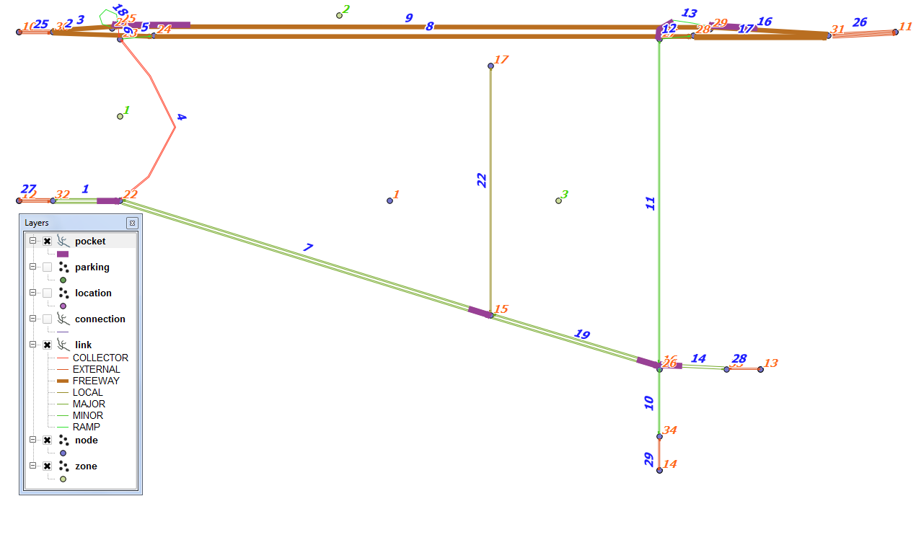

### **Figure 5: Tiny Network 5-TransimsNet Output-Nodes, Links, Zones, and Pocket Lanes Visible**GIS software rendering of all TransimsNet output files after conversion to shape files via ArcNet. Of particular note is the extensive amount of network data being displayed as well as the location-parking pairs (e.g., 27, 27; 28, 28).

Figure : Tiny Network 5-All TransimsNet Output Files Visible

### How to Synthesize Intersection Traffic Controls from TransimsNet Outputs

### Control File – Tiny Network 5

The control file for the IntControl program is typically located in the control directory for the network being synthesized. The file “IntControl.ctl” is a text file that can be reviewed and edited using a standard text editor. The file records for this file for an example network (Tiny Network) are listed below.

TITLE Synthesize Intersection Controls from TransimsNet Outputs

INPUT_SIGN_FILE ../network/sign_warrant.txt

INPUT_SIGNAL_FILE ../network/signal_warrant.txt

NODE_FILE ../network/node.txt

LINK_FILE ../network/link.txt

SHAPE_FILE ../network/shape.txt

POCKET_FILE ../network/pocket.txt

CONNECTION_FILE ../network/connection.txt

NEW_SIGN_FILE ../network/sign.txt

NEW_SIGNAL_FILE ../network/signal.txt

NEW_TIMING_PLAN_FILE ../network/timing_plan.txt

NEW_PHASING_PLAN_FILE ../network/phasing_plan.txt

NEW_DETECTOR_FILE ../network/detector.txt

SIGNAL_TYPE_CODE_1 ACTUATED

NUMBER_OF_RINGS_1 1

SIGNAL_TIME_BREAKS_1 7:00, 10:00

SIGNAL_CYCLE_LENGTH_1 90 seconds

MINIMUM_PHASE_TIME_1 5 seconds

YELLOW_PHASE_TIME_1 3 seconds

RED_CLEAR_PHASE_TIME_1 1 seconds

SIGNAL_SPLIT_METHOD_1 CAPACITY

MINIMUM_LANE_CAPACITY_1 500

MAXIMUM_LANE_CAPACITY_1 1500

POCKET_LANE_FACTOR_1 0.5

SHARED_LANE_FACTOR_1 0.5

TURN_MOVEMENT_FACTOR_1 0.9

PERMITTED_LEFT_FACTOR_1 0.5

GENERAL_GREEN_FACTOR_1 1.0

EXTENDED_GREEN_FACTOR_1 0.5

MAXIMUM_GREEN_FACTOR_1 2.0

SIGNAL_DETECTOR_LENGTH_1 30 feet

### Printout File – Tiny Network 5

********************************************

| |

| IntControl - Version 5.0.1 |

| Copyright 2011 by TRANSIMS Open-Source |

| Mon Aug 15 09:38:24 2011 |

| |

********************************************

Control File = IntControl.ctl

Report File = IntControl.prn (Create)

IntControl Test

Project Directory = ./

Default File Format = TAB_DELIMITED

Time of Day Format = HOUR_CLOCK

Model Start Time = 0:00

Model End Time = 27:00

Units of Measure = METRIC

Random Number Seed = 1313415504

Number of Threads = 1

Input System Network Files:

Node File = ./../network/node.txt

Shape File = ./../network/shape.txt

Link File = ./../network/link.txt

Pocket File = ./../network/pocket.txt

Connection File = ./../network/connection.txt

Output System Network Files:

New Sign File = ./../network/sign.txt

New Signal File = ./../network/signal.txt

New Phasing Plan File = ./../network/phasing_plan.txt

New Timing Plan File = ./../network/timing_plan.txt

New Detector File = ./../network/detector.txt

Notes And Name Fields = TRUE

Data Service Controls:

Number of Time Periods = 108

Input Sign File = ./../network/sign_warrant.txt

Input Signal File = ./../network/signal_warrant.txt

Signal Type Code #1 = ACTUATED

Number of Rings #1 = 1

Signal Time Breaks #1 = 7:00, 10:00

Signal Cycle Length #1 = 90 seconds

Minimum Phase Time #1 = 5 seconds

Yellow Phase Time #1 = 3 seconds

Red Clear Phase Time #1 = 1 seconds

Signal Split Method #1 = CAPACITY

Minimum Lane Capacity #1 = 500

Maximum Lane Capacity #1 = 1500

Pocket Lane Factor #1 = 0.5

Shared Lane Factor #1 = 0.5

Turn Movement Factor #1 = 0.9

Permitted Left Factor #1 = 0.5

General Green Factor #1 = 1

Extended Green Factor #1 = 0.5

Maximum Green Factor #1 = 2

Signal Detector Length #1 = 9.14 meters

Number of Node File Records = 23

Number of Shape File Records = 13

Number of Link Shape Records = 3

Number of Link File Records = 24

Number of Directional Links = 37

Number of Pocket File Records = 7

Number of Connection File Records = 49

Number of Input Signal File Records = 2

Number of New Signal Records = 2

Number of Input Sign File Records = 2

New Sign File Records = 2

New Signal File Records = 8

New Timing Plan File Records = 24

New Phasing Plan File Records = 99

New Detector File Records = 9

Mon Aug 15 09:38:24 2011 -- Process Complete (0:00:00)

### Reviewing the Results

The printout file “IntControl.prn” is created by the process along with the new data files stored in the network directory. The printout file will contain a number of warning messages about missing traffic controls and problematic intersections. It is advisable to review these warnings to ensure that a coding error has not been made.

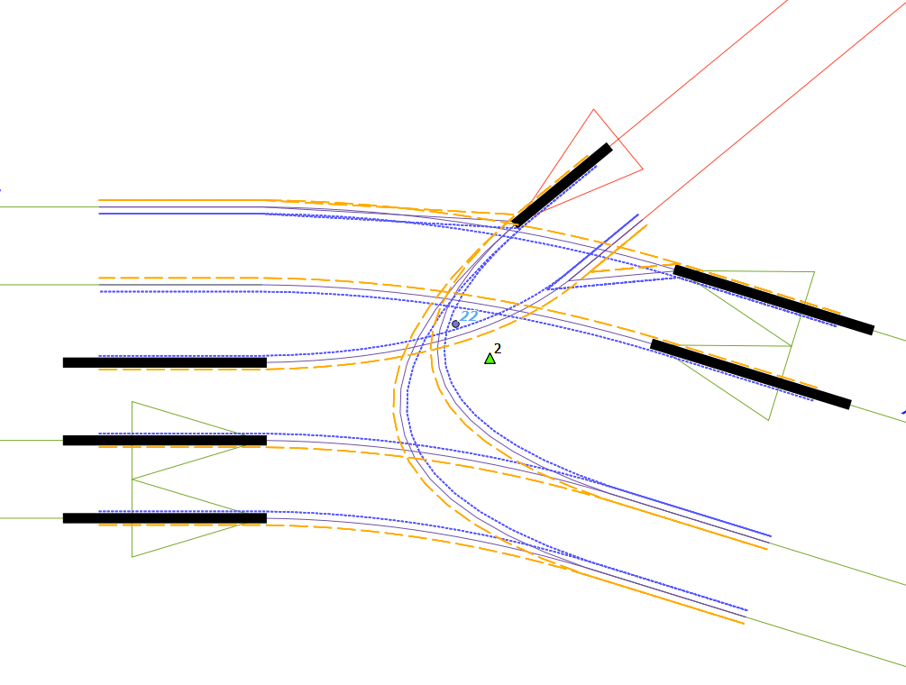

Figure : Signalized Node Intersection and Interdependent Intersection Files – TransimsNet and IntControl

The intersection configuration data level of detail required by TRANSIMS in order to produce a valid microsimulation is considerable. Traffic signal data can be hard to obtain as well. Shown in Figure 7 above are the detectors (black shaded bars at signalized intersections), the nodes (blue circle; node number 22), the signalized node/traffic signal (green triangle; numbered ‘2’; offset from the actual intersection node (22) via GIS software for ease of visual review), the phasing plan (orange dashed line; offset from link for better visibility), the timing plan (blue dotted line; offset from link and phasing plan for ease of viewing), the links, and the lane connectivity/connections associated with a single-node, signalized intersection (black in Figure 7, in the center of intersection and in between phasing and timing plan lines). Additionally, all of the aforementioned files are either directly or indirectly interdependent in that changes made to one file either produce changes automatically in some of the other files or necessitate manual changes in the other files. Configuring and updating intersections to accurately represent the corresponding physical network being modeled in TRANSIMS is both necessary and involved. Also, manual editing of lane connectivity is important to ensure correct representation of intersections. This topic is further discussed in the Intersection Configuration How To document.

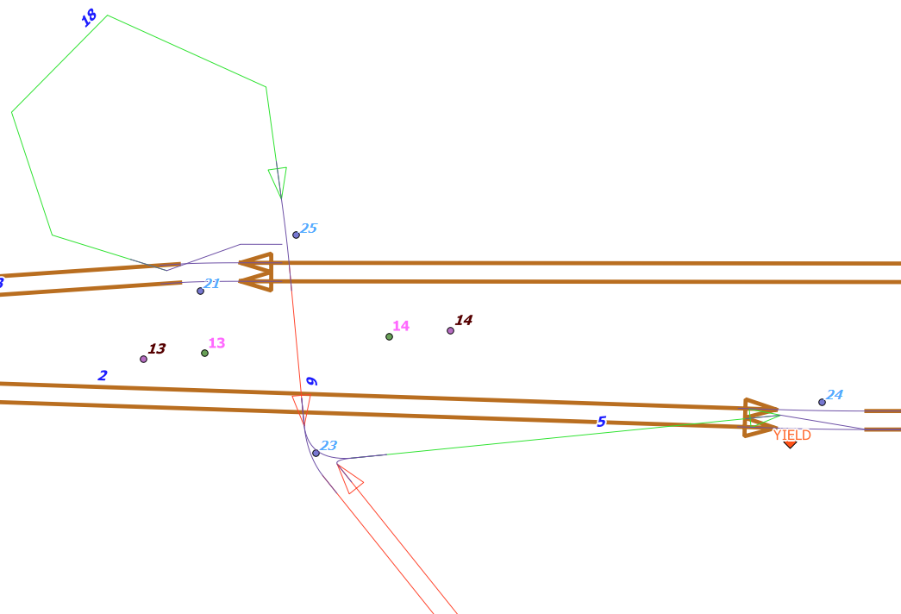

Figure : Synthetic Network Intersection Sign Data Produced by IntControl

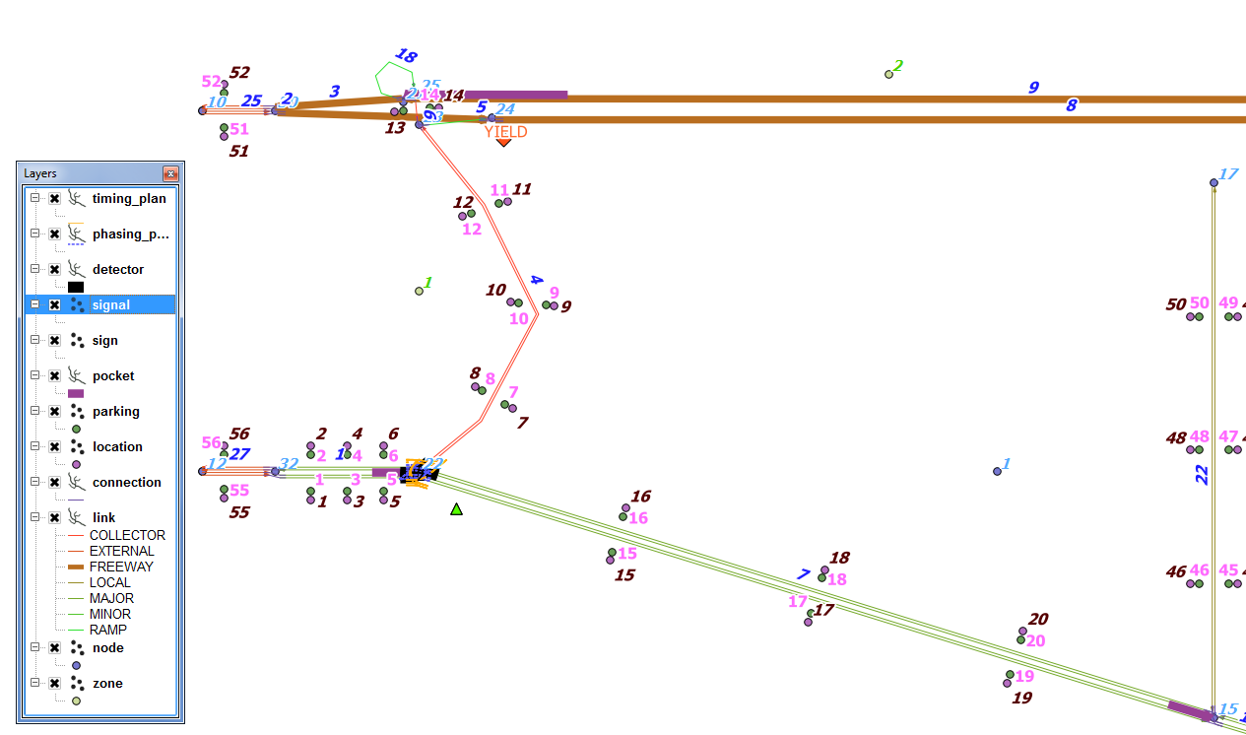

Figure : TransimsNet and IntControl Key Shape File Layers

The above three figures show Sign (e.g., YIELD Sign at Node 24 in Figure 8) and Signal (e.g., green triangle labeled ‘2’ at node 22 in Figure 7) file outputs from IntControl. ArcNet is used to convert these text files to ESRI shape files. The resultant shape files are displayed here graphically using GIS software. The Sign and Signal Warrants files produced as outputs by TransimsNet are used by IntControl as inputs to generate synthetic Sign and Signal files. Note that the Sign and Signal files produced by IntControl typically require manual pre- and post-processing in order to ensure that a valid network model results. For instance, some signals and signs may be missing which are present on the physical network being modeled due to the associated node being pruned or collapsed by the TRANSIMS pruning algorithm. In such a case, a keep node file can be used with TransimsNet to specify the node(s) of interest and the new TransimsNet outputs can be used to re-run IntControl. The Sign and Signal Warrants files produced by TransimsNet are ideally reviewed before using them as inputs to IntControl to reduce the amount of programmatic reiteration needed (and likewise for the Sign and Signal files produced by IntControl).

## Example 2: Deleting Intersection Controls Associated with Specific Signalized Nodes

The signalized node file in TRANSIMS Version 5 has multiple synthetic network file interdependencies. Specifically, the signal file contains corresponding records in the timing plan file, the phasing plan file, and the detector file. Consequently, TRANSIMS 5 provides a single control key to allow the user to delete intersection controls across all interdependent network files (except detectors) that are associated with a specified signalized node or list of nodes. This list of signalized nodes can be defined, specified by the control key, is provided by the user (if desired) via an optional, manual process outlined below. The DELETE_NODE_CONTROL_FILE control key and corresponding files (text file, definition file) are omitted by default.

Any detector artifacts left over after this update/delete process (example below) can be noted via conversion of network text files into ESRI shape files using ArcNet and the reviewing said files visually with a GIS program. Alternatively, the user may prefer to update the sign and signal warrants produced by TransimsNet and then re-run IntControl to update the synthetic intersection configuration files.

TRANSIMS 5 is able to generate a definition file in many cases, but does not do so for this particular file. The user must manually create both the text file and associated definition file to which the DELETE_NODE_CONTROL_FILE control key points. Refer to the File Reference document for additional information on this file key including an example of both of the aforementioned files.

### Control File 1 of 2 – Example Network 2

The control file for the IntControl program is typically located in the control directory for the network being synthesized. The file “IntControl.ctl” is a text file that can be reviewed and edited using a standard text editor. The file records for this file for an example network are listed below. Note that this control file is the first of two IntControl control files presented in this example. The second IntControl control file is provided below this one.

TITLE IntControl Test Case 2A – Example Network

INPUT_SIGN_FILE ../network/sign_warrant.txt

INPUT_SIGNAL_FILE ../network/signal_warrant.txt

NODE_FILE ../network/node.txt

LINK_FILE ../network/link.txt

SHAPE_FILE ../network/shape.txt

POCKET_FILE ../network/pocket.txt

CONNECTION_FILE ../network/connection.txt

##DELETE_NODE_CONTROL_FILE ../network/Delete_Node_Control.txt

SIGN_FILE ../network/sign.txt

SIGNAL_FILE ../network/signal.txt

TIMING_PLAN_FILE ../network/timing_plan.txt

PHASING_PLAN_FILE ../network/phasing_plan.txt

DETECTOR_FILE ../network/detector.txt

SIGNAL_TYPE_CODE_1 ACTUATED

NUMBER_OF_RINGS_1 1

SIGNAL_TIME_BREAKS_1 7:00, 10:00

SIGNAL_CYCLE_LENGTH_1 90 seconds

MINIMUM_PHASE_TIME_1 5 seconds

YELLOW_PHASE_TIME_1 3 seconds

RED_CLEAR_PHASE_TIME_1 1 seconds

SIGNAL_SPLIT_METHOD_1 CAPACITY

MINIMUM_LANE_CAPACITY_1 500

MAXIMUM_LANE_CAPACITY_1 1500

POCKET_LANE_FACTOR_1 0.5

SHARED_LANE_FACTOR_1 0.5

TURN_MOVEMENT_FACTOR_1 0.9

PERMITTED_LEFT_FACTOR_1 0.5

GENERAL_GREEN_FACTOR_1 1.0

EXTENDED_GREEN_FACTOR_1 0.5

MAXIMUM_GREEN_FACTOR_1 2.0

SIGNAL_DETECTOR_LENGTH_1 30 feet

### Printout File 1 of 2 – Example Network 2

********************************************

| |

| IntControl - Version 5.0.3 |

| Copyright 2012 by TRANSIMS Open-Source |

| Tue Aug 21 10:49:19 2012 |

| |

********************************************

Control File = I:\ProjectFiles\HW3G\@DocumentationProject\@Version5Documents\@01-TRANSIMS\@2-Version5 Documentation\2-Example Models\Example Network\control\IntControl.ctl

Report File = I:\ProjectFiles\HW3G\@DocumentationProject\@Version5Documents\@01-TRANSIMS\@2-Version5 Documentation\2-Example Models\Example Network\control\IntControl.prn (Create)

IntControl Test

Random Number Seed = 1345560559

Input System Network Files:

Node File = ../network/node.txt

Shape File = ../network/shape.txt

Link File = ../network/link.txt

Pocket File = ../network/pocket.txt

Connection File = ../network/connection.txt

Output System Network Files:

New Sign File = ../network/sign.txt

New Signal File = ../network/signal.txt

New Phasing Plan File = ../network/phasing_plan.txt

New Timing Plan File = ../network/timing_plan.txt

New Detector File = ../network/detector.txt

Data Service Controls:

Number of Time Periods = 96

Input Sign File = ../network/sign_warrant.txt

Input Signal File = ../network/signal_warrant.txt

Signal Type Code = ACTUATED

Number of Rings = 1

Signal Time Breaks = 7:00, 10:00

Signal Cycle Length = 90 seconds

Minimum Phase Time = 5 seconds

Yellow Phase Time = 3 seconds

Red Clear Phase Time = 1 seconds

Signal Split Method = CAPACITY

Minimum Lane Capacity = 500

Maximum Lane Capacity = 1500

Pocket Lane Factor = 0.5

Shared Lane Factor = 0.5

Turn Movement Factor = 0.9

Permitted Left Factor = 0.5

General Green Factor = 1

Extended Green Factor = 0.5

Maximum Green Factor = 2

Signal Detector Length = 9.14 meters

Number of Node File Records = 25

Number of Shape File Records = 59

Number of Link Shape Records = 15

Number of Link File Records = 26

Number of Directional Links = 41

Warning: Link 26 Pocket Length 109.1 is Too Long

Number of Pocket File Records = 5

Number of Connection File Records = 51

Number of Input Signal File Records = 3

Number of New Signal Records = 3

Number of Input Sign File Records = 1

New Sign File Records = 1

New Signal File Records = 12

New Timing Plan File Records = 39

New Phasing Plan File Records = 150

New Detector File Records = 13

Number of Sign Changes = 1

Number of Signal Changes = 3

Number of Timing Plan Changes = 9

Number of Phasing Plan Changes = 30

Number of Detector Changes = 13

Tue Aug 21 10:49:20 2012 -- Process Complete with 1 Warning (0:00:01)

### Reviewing the Results

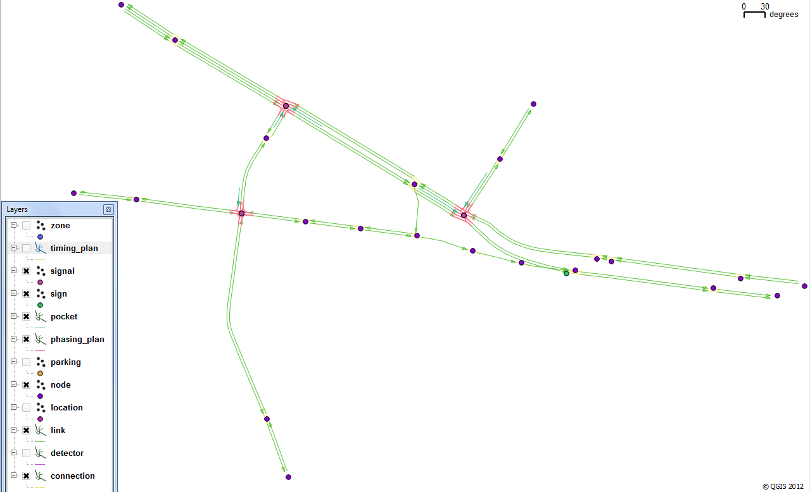

Figure : Example Network with Three Signalized Nodes and Associated Intersection Controls

Intersection controls for a small network were regenerated using IntControl. Note that all three signalized intersections are surrounded by detectors (thick purple lines in this example). This is the set of synthetic network files and intersection controls which are used in the delete signalized node operation described in the next section below.

### Control File 2 of 2 – Example Network 2

This is the second of two IntControl control files presented in this example. Note the changes in input and output files below relative to the first control and printout files previously noted. Also note that new shape files must be generated using ArcNet (for sign2.txt, signal 2.txt, etc.) and then loaded as vector shape files into a GIS program to note the changes visually. Visual review is highly recommended so that leftover artifacts such as detectors at unsignalized nodes can be identified and removed as necessary.

TITLE IntControl Test Case 2B – Example Network

SIGN_FILE ../network/sign.txt

SIGNAL_FILE ../network/signal.txt

TIMING_PLAN_FILE ../network/timing_plan.txt

PHASING_PLAN_FILE ../network/phasing_plan.txt

DETECTOR_FILE ../network/detector.txt

NODE_FILE ../network/node.txt

LINK_FILE ../network/link.txt

SHAPE_FILE ../network/shape.txt

POCKET_FILE ../network/pocket.txt

CONNECTION_FILE ../network/connection.txt

DELETE_NODE_CONTROL_FILE ../network/Delete_Node_Control.txt

NEW_SIGN_FILE ../network/sign2.txt

NEW_SIGNAL_FILE ../network/signal2.txt

NEW_TIMING_PLAN_FILE ../network/timing_plan2.txt

NEW_PHASING_PLAN_FILE ../network/phasing_plan2.txt

NEW_DETECTOR_FILE ../network/detector2.txt

SIGNAL_TYPE_CODE_1 ACTUATED

NUMBER_OF_RINGS_1 1

SIGNAL_TIME_BREAKS_1 7:00, 10:00

SIGNAL_CYCLE_LENGTH_1 90 seconds

MINIMUM_PHASE_TIME_1 5 seconds

YELLOW_PHASE_TIME_1 3 seconds

RED_CLEAR_PHASE_TIME_1 1 seconds

SIGNAL_SPLIT_METHOD_1 CAPACITY

MINIMUM_LANE_CAPACITY_1 500

MAXIMUM_LANE_CAPACITY_1 1500

POCKET_LANE_FACTOR_1 0.5

SHARED_LANE_FACTOR_1 0.5

TURN_MOVEMENT_FACTOR_1 0.9

PERMITTED_LEFT_FACTOR_1 0.5

GENERAL_GREEN_FACTOR_1 1.0

EXTENDED_GREEN_FACTOR_1 0.5

MAXIMUM_GREEN_FACTOR_1 2.0

SIGNAL_DETECTOR_LENGTH_1 30 feet

### Printout File 2 of 2 – Example Network 5

********************************************

| |

| IntControl - Version 5.0.3 |

| Copyright 2012 by TRANSIMS Open-Source |

| Tue Aug 21 13:40:37 2012 |

| |

********************************************

Control File = I:\ProjectFiles\HW3G\@DocumentationProject\@Version5Documents\@01-TRANSIMS\@2-Version5 Documentation\2-Example Models\Example Network\control\IntControl.ctl

Report File = I:\ProjectFiles\HW3G\@DocumentationProject\@Version5Documents\@01-TRANSIMS\@2-Version5 Documentation\2-Example Models\Example Network\control\IntControl.prn (Create)

IntControl Test Case 2 - Example Network

Random Number Seed = 1345570837

Input System Network Files:

Node File = ../network/node.txt

Shape File = ../network/shape.txt

Link File = ../network/link.txt

Pocket File = ../network/pocket.txt

Connection File = ../network/connection.txt

Sign File = ../network/sign.txt

Signal File = ../network/signal.txt

Phasing Plan File = ../network/phasing_plan.txt

Timing Plan File = ../network/timing_plan.txt

Detector File = ../network/detector.txt

Output System Network Files:

New Sign File = ../network/sign2.txt

New Signal File = ../network/signal2.txt

New Phasing Plan File = ../network/phasing_plan2.txt

New Timing Plan File = ../network/timing_plan2.txt

New Detector File = ../network/detector2.txt

Data Service Controls:

Number of Time Periods = 96

Delete Node Control File = ../network/Delete_Node_Control.txt

Signal Type Code = ACTUATED

Number of Rings = 1

Signal Time Breaks = 7:00, 10:00

Signal Cycle Length = 90 seconds

Minimum Phase Time = 5 seconds

Yellow Phase Time = 3 seconds

Red Clear Phase Time = 1 seconds

Signal Split Method = CAPACITY

Minimum Lane Capacity = 500

Maximum Lane Capacity = 1500

Pocket Lane Factor = 0.5

Shared Lane Factor = 0.5

Turn Movement Factor = 0.9

Permitted Left Factor = 0.5

General Green Factor = 1

Extended Green Factor = 0.5

Maximum Green Factor = 2

Signal Detector Length = 9.14 meters

Number of Node File Records = 25

Number of Shape File Records = 59

Number of Link Shape Records = 15

Number of Link File Records = 26

Number of Directional Links = 41

Warning: Link 26 Pocket Length 109.1 is Too Long*[6]*

Number of Pocket File Records = 5

Number of Connection File Records = 51

Number of Sign File Records = 1

Number of Signal File Records = 12

Number of Detector File Records = 13

Number of Timing Plan File Records = 39

Number of Phasing Plan File Records = 150

**Number of Delete Node Control File Records = 1**

**0 Signs Approaching 0 Nodes were Deleted**

**1 Nodes included in 1 Signals were Deleted[7]**

New Sign File Records = 1

New Signal File Records = 8

New Timing Plan File Records = 24

New Phasing Plan File Records = 78

New Detector File Records = 13

Number of Sign Changes = 0

Number of Signal Changes = 0

Number of Timing Plan Changes = 0

Number of Phasing Plan Changes = 0

Number of Detector Changes = 0

Tue Aug 21 13:40:38 2012 -- Process Complete with 1 Warning (0:00:01)

### Reviewing the Results

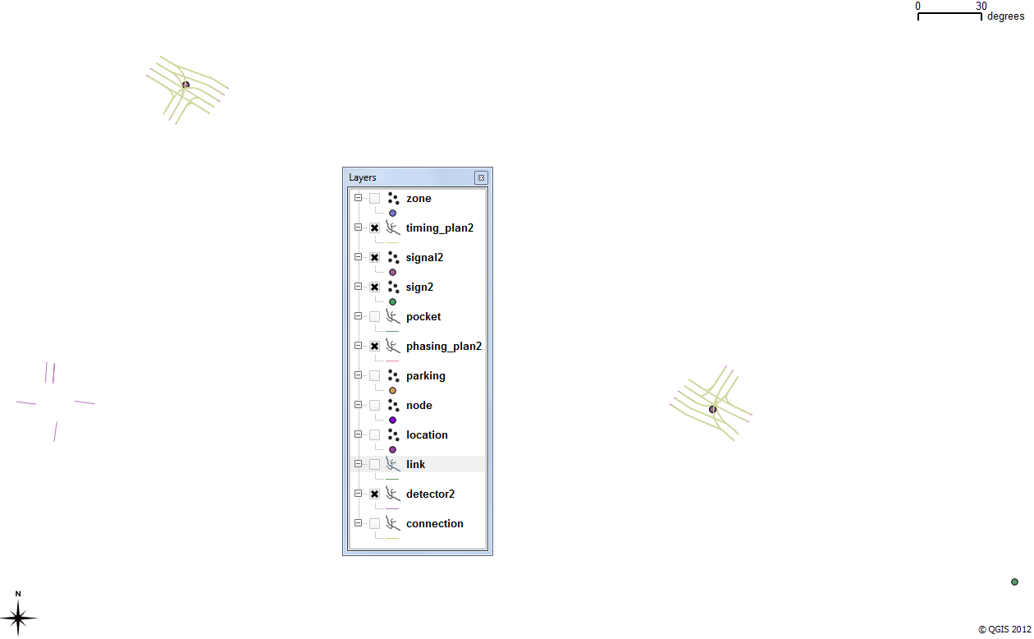

Figure : Intersection Controls Left After Deleting a Signalized Node (bottom-left; node 21; signal 1)

Note that the bolded text in the output printout (PRN) file above indicates that some changes were made to the network. In the DELETE_NODE_CONTROL text file, only node 1 was listed, and the results reflect this. The “Node” number header actually corresponds to the “Signal” number in this text file. After running IntControl using this method to remove this signalized node and the signal’s associated intersection control file data, everything except for the detector file data for signal 1 was successfully deleted. A review of the text files used to generate the above shape files confirms this. Since this orphan detector was not removed along with the other data for this signal (formerly located at node 21), the detector file must be edited manually to remove this associated data. In general, a graphical review using ArcNet and a GIS program is recommended when modifying the TRANSIMS network model, particularly signals and associated files (e.g., timing plan, phasing plan, detectors). In addition, adjusting signal placement by modifying the input sign and signal warrant files and re-running IntControl is still recommended over direct modification of the IntControl output signal-related files.

1. Control key is listed in the –h command line listing generated by IntControl, but the key is not listed in the associated Quick Reference document.
2. Control key is listed in the IntControl Quick Reference document, but the key is not listed in the associated –h command line listing generated by this program.
3. The * is appended to the end of grouped parameters
4. Refer to the Parameter and File References for a more comprehensive examination of these various IntControl parameters.
5. The reader is referred to the File and Parameter References for additional detail on the various signal-related parameters in IntControl (in addition to examples provided in this document).
6. Note that one warning is described above concerning pocket length. The italics were added for emphasis as warnings in TRANSIMS are written to the printout file at the time of their occurrence and placed in the text file immediately.
7. The bold formatting was added by the author of this document to emphasize the results of this delete node controls example. Note that, per the example on the next page, not all artifacts get deleted (as the textual output above also suggests). Hence, the review step is crucial at each stage of the network building process.