NetPrep

Version 5.0.11

Revision History

May 2012 - Created by Volpe Center

The **NetPrep** (Network Preparation Utility)program is used to:

1. *Combine GISNet, TPPlusNet, and EMME2Net features.*
   1. *Convert and edit source data to create Input Link and Node files.*
2. *Perform TransimsNet functions related to link and node selection.*
   1. *Review and edit link and node information/files.*
   2. *Reformat, merge, select, and collapse nodes and links.*
3. *Perform spatial network manipulations using new controls.*
4. *Develop a User Program script to manipulate link data fields.*
5. *Merge networks.*

Syntax is NetPrep [-flag] [control_file]

The control_file is the file name of an ASCII file that contains the control strings expected by the program. The control_file is optional. If a file name is not provided, the program will prompt the user to enter a file name. The flag parameters are also optional. Any combination of the following flag parameters can be included on the command line:

Optional Flags:

-Q[uiet] = execute without screen messages

-H[elp] = show program syntax and control keys

-C[ontrol] = create/update a default control file

-K[eyCheck] = list unrecognized control file keys

-P[ause] = pause before exiting

-N[oPause] = never pause before exiting

-D[etail] = execute with detailed status messages

-X[ML] = write an XML file with control keys

The program automatically creates a printout file based on the control file name. If the filename includes an extension (e.g., “.ctl”), the extension is replaced with “.prn”. The printout file will be created in the current working directory and will overwrite an existing file with the same name.

# Version 5 Features (as of Version 5.0.11)

* The speed-capacity lookup table logic was corrected when area type and facility type fields are provided.
* Route Nodes file processing was added. The new keys include TRANSIT_TIME_PERIODS, PERIOD_TRAVEL_TIMES, FIRST_ROUTE_NUMBER, INPUT_ROUTE_FORMAT, ROUTE_MODE_MAP, INPUT_ROUTE_FILE, ROUTE_PERIOD_MAP, and FLIP_ROUTE_FLAG.
* The Version 4 Time Format key also translates Router Header headways, offsets, and travel times.
* Network node and link selecting and collapsing moved to NetPrep (formerly part of TransimsNet)

# Control Key List

The list of control file keys appears in the table below:

* Req / Opt indicates whether the key is **req**uired or **opt**ional
* The types include **Text**, Input **File**name, **New** file, **Bool**ean, **Path** (to a file), **Time**, **Int**eger, **Dec**imal, and **List** of items
* The Default is the default value, used if the key does not appear in the control file.
* I/O/P indicates Input, Output or Parameter.

For a more detailed description of the Parameter control keys, refer to the Parameter Reference. For a more detailed description of the Input or Output control keys, refer to the File Reference. These two documents also provide the possible values or range of values allowed for each control key listed below. For instance, files can usually be output to numerous formats beyond TAB_DELIMITED for additional post-processing / file manipulation actions.

## Configuration Keys

|  |  |  |  |  |
| --- | --- | --- | --- | --- |
| **Control File Keys:** | **Req/Opt** | **Type** | **Default** | **I/O/P** |
| TITLE | Opt | Text |  | O |
| REPORT_FILE | Opt | File |  | O |
| REPORT_FLAG | Opt | Bool | FALSE | P |
| PROJECT_DIRECTORY | Opt | Path |  | P |
| DEFAULT_FILE_FORMAT 1 | Opt | Text | TAB_DELIMITED | P |
| TIME_OF_DAY_FORMAT 1 | Opt | Text | DAY_TIME | P |
| MODEL_START_TIME | Opt | Time | 0:00 | P |
| MODEL_END_TIME | Opt | Time | 24:00 | P |
| UNITS_OF_MEASURE | Opt | Text | METRIC | P |
| RANDOM_NUMBER_SEED | Opt | Int. | 0 | P |
| MAX_WARNING_MESSAGES | Opt | Int. | 100000 | P |
| MAX_WARNING_EXIT_FLAG | Opt | Bool | TRUE | P |
| MAX_PROBLEM_COUNT | Opt | Int. | 0 | P |
| NUMBER_OF_THREADS | Opt | Int. | 1 | P |
| NETPREP_REPORT_* | Opt | Text |  | P |

## System File Keys

|  |  |  |  |  |
| --- | --- | --- | --- | --- |
| **Control File Keys:** | **Req/Opt** | **Type** | **Default** | **I/O/P** |
| NODE_FILE | Opt | File |  | I |
| NODE_FORMAT | Opt | Text | TAB_DELIMITED | P |
| ZONE_FILE | Opt | File |  | I |
| ZONE_FORMAT | Opt | Text | TAB_DELIMITED | P |
| SHAPE_FILE | Opt | File |  | I |
| SHAPE_FORMAT | Opt | Text | TAB_DELIMITED | P |
| LINK_FILE | Opt | File |  | I |
| LINK_FORMAT | Opt | Text | TAB_DELIMITED | P |
| NEW_NODE_FILE | Opt | File |  | O |
| NEW_NODE_FORMAT | Opt | Text | TAB_DELIMITED | P |
| NEW_ZONE_FILE | Opt | File |  | O |
| NEW_ZONE_FORMAT | Opt | Text | TAB_DELIMITED | P |
| NEW_SHAPE_FILE | Opt | File |  | O |
| NEW_SHAPE_FORMAT | Opt | Text | TAB_DELIMITED | P |
| NEW_LINK_FILE | Req | File |  | O |
| NEW_LINK_FORMAT | Opt | Text | TAB_DELIMITED | P |

## File Service Keys

|  |  |  |  |  |
| --- | --- | --- | --- | --- |
| **Control File Keys:** | **Req/Opt** | **Type** | **Default** | **I/O/P** |
| NOTES_AND_NAME_FIELDS | Opt | Bool | FALSE | P |

## Projection, Smooth Data, Difference Data Keys

|  |  |  |  |  |
| --- | --- | --- | --- | --- |
| **Control File Keys:** | **Req/Opt** | **Type** | **Default** | **I/O/P** |
| INPUT_COORDINATE_SYSTEM | Opt | List |  | P |
| INPUT_COORDINATE_ADJUSTMENT | Opt | List |  | P |
| OUTPUT_COORDINATE_SYSTEM | Opt | List |  | P |
| OUTPUT_COORDINATE_ADJUSTMENT | Opt | List |  | P |
| OUTPUT_XYZ_SHAPES | Opt | Bool | FALSE | P |
| OUTPUT_XYM_SHAPES | Opt | Bool | FALSE | P |

## Control Keys

|  |  |  |  |  |
| --- | --- | --- | --- | --- |
| **Control File Keys:** | **Req/Opt** | **Type** | **Default** | **I/O/P** |
| INPUT_LINK_FILE | Opt | File |  | I |
| INPUT_LINK_FORMAT | Opt | Text | TAB_DELIMITED | I |
| INPUT_NODE_FILE | Opt | File |  | P |
| INPUT_NODE_FORMAT | Opt | Text | TAB_DELIMITED | P |
| INPUT_ZONE_FILE | Opt | File |  | I |
| INPUT_ZONE_FORMAT | Opt | Text | TAB_DELIMITED | P |
| INPUT_SPDCAP_FILE | Opt | File |  | I |
| INPUT_SPDCAP_FORMAT | Opt | Text | TAB_DELIMITED | P |
| INPUT_UNITS_OF_MEASURE | Opt | Text | METRIC | P |
| FACILITY_INDEX_FIELD | Opt | Text | METRIC | P |
| AREA_TYPE_INDEX_FIELD | Opt | Text |  | P |
| CONVERSION_SCRIPT | Opt | File |  | I |
| CONVERSION_STACK 1 | Opt | File |  | I |
| INTERNAL_ZONE_RANGE | Opt | List | 0 | P |
| KEEP_ZONE_CONNECTORS_AS_LOCALS | Opt | Bool | FALSE | P |
| FIRST_NODE_NUMBER | Opt | Int. | 1 | P |
| FIRST_LINK_NUMBER | Opt | Int. | 1 | P |
| SPEED_FACTOR_BY_FACILITY | Opt | List | 1.0 | P |
| SPEED_ROUNDING_INCREMENT | Opt | Dec. | 7.5 mps | P |
| COORDINATE_RESOLUTION | Opt | Dec. | 1.0 meters | P |
| MAXIMUM_LENGTH_TO_XY_RATIO | Opt | Dec. | 1.2 | P |
| MAXIMUM_SHAPE_ANGLE | Opt | Int. | 90 degrees | P |
| MINIMUM_SHAPE_LENGTH | Opt | Int. | 10 meters | P |
| DROP_DEAD_END_LINKS | Opt | Int. | 0 meters | P |
| DROP_SHORT_LINKS | Opt | Dec. | 37.5 meters | P |
| SPLIT_LARGE_LOOPS | Opt | Int. | 100 meters | P |
| COLLAPSE_SHAPE_NODES | Opt | Bool | FALSE | P |
| COLLAPSE_DIVIDED_ARTERIALS | Opt | Bool | FALSE | P |
| LOCAL_THRU_SEGMENT_LENGTHS_* | Opt | List |  | P |
| LOCAL_SELECTION_SPACING_* | Opt | List |  | P |
| KEEP_NODE_RANGE | Opt | List | ALL | P |
| KEEP_NODE_FILE | Opt | File |  | I |
| KEEP_LINK_RANGE | Opt | List | ALL | P |
| KEEP_LINK_FILE | Opt | File |  | I |
| DELETE_NODE_RANGE | Opt | List | NONE | P |
| DELETE_NODE_FILE | Opt | File |  | I |
| DELETE_LINK_RANGE | Opt | List | NONE | P |
| DELETE_LINK_FILE | Opt | File |  | I |
| NEW_LINK_DETAIL_FILE 2 | Opt | File |  | O |
| NEW_LINK_NODE_LIST_FILE 2 | Opt | File |  | O |

#### Notes

Each '_FILE' key has a corresponding '_FORMAT' key. The following file formats can be used for input and ouput files:

TEXT, BINARY, FIXED_COLUMN, COMMA_DELIMITED, SPACE_DELIMITED, TAB_DELIMITED, CSV_DELIMITED, DBASE, SQLITE3, VERSION3

1-Control key is listed in the –h command line listing generated by NetPrep, but the key is not listed in the associated Quick Reference document.

2-Control key is listed in the NetPrep Quick Reference document, but the key is not listed in the associated –h command line listing generated by this program.

# Control Key Notes for NetPrep Version 5

## TransimsNet 4.0 to NetPrep 5.0 File Name and Control Key Mappings for TRANSIMS 5.0

* NET_NODE_TABLE 🡪 NODE_FILE
* NET_ZONE_TABLE 🡪 ZONE_FILE
* NET_SHAPE_TABLE 🡪 SHAPE_FILE
* NET_LINK_TABLE 🡪 LINK_FILE
* NEW_NODE_TABLE 🡪 NEW_NODE_FILE
* NEW_ZONE_TABLE 🡪 NEW_ZONE_FILE
* NEW_SHAPE_TABLE 🡪 NEW_SHAPE_FILE
* NEW_LINK_TABLE 🡪 NEW_LINK_FILE
* CREATE_NOTES_AND_NAMES_FIELDS 🡪 NOTES_AND_NAME_FIELDS
* NET_DIRECTORY 🡪 [No equivalent key in Version 5.0]
* MINIMUM_LINK_LENGTH 🡪 DROP_SHORT_LINKS
* COLLAPSE_NODES_FLAG 🡪 COLLAPSE_SHAPE_NODES
* MAXIMUM_LENGTH_TO_XY_RATIO 🡪 MAXIMUM_LENGTH_TO_XY_RATIO
* KEEP_NODE_LIST 🡪 KEEP_NODE_FILE
* CELL_SIZE (Microsimulator V4.0) 🡪 SPEED_ROUNDING_INCREMENT

## New File and Parameter Control Keys in the TRANSIMS 5.0 Software Suite (NetPrep 5.0)

* DROP_DEAD_END_LINKS
* DROP_SHORT_LINKS
* SPLIT_LARGE_LOOPS
* COLLAPSE_SHAPE_NODES
* COLLAPSE_DIVIDED_ARTERIALS
* LOCAL_THRU_SEGMENT_LENGTHS_*
* LOCAL_SELECTION_SPACING_*
* TRANSIT_TIME_PERIODS
* PERIOD_TRAVEL_TIMES
* FIRST_ROUTE_NUMBER
* INPUT_ROUTE_FORMAT
* ROUTE_MODE_MAP
* INPUT_ROUTE_FILE
* ROUTE_PERIOD_MAP
* FLIP_ROUTE_FLAG
* SPEED_FACTOR_BY_FACILITY

# TransimsNet Version 5 Network Conversion Process

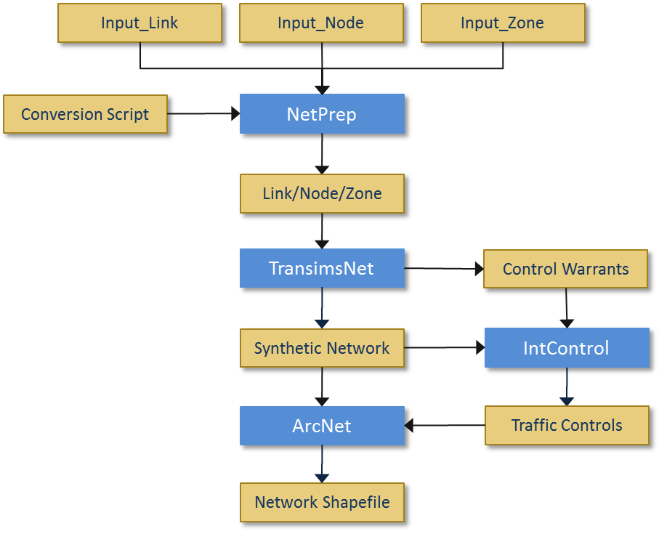

### Figure 1: Network Conversion Process (High-Level)

The above flowchart shows the typical execution sequence of TRANSIMS 5.0 network programs and file inputs and outputs relative to each program, and relative to the overall process. Starting with TRANSIMS 5.0, NetPrep (a new part of the TRANSIMS program suite) is used instead of TransimsNet to convert input network files (nodes, links, and zones) into TRANSIMS 5.0 network format compatible files.

The raw input files may be from an existing TRANSIMS 4.0 network, from raw network files exported from commercial traffic modeling software such as TransCAD®, or may be manually created given that the file names, file types/formats/extensions, location, layout (header row in particular), and contents are consistent with what is expected by TRANSIMS 5.0 and the relevant control files for each program noted above.

The initial network input files and the TRANSIMS 5.0 network format files that result from the process are show in Figure 1 above at a relatively high level. The combined file output of NetPrep, TransimsNet, and IntControl comprise the majority of the synthetic network files which will be used for subsequent trip table generation, trip routing, and finally trip simulation. The use of NetPrep is optional while TransimsNet and IntControl must be used. However, many TRANSIMS 5 users will benefit from the multiple functions performed by NetPrep. Since TRANSIMS 5 field names have been updated or moved in many instances, the use of NetPrep with a simple conversion script will reduce the need for numerous manual file operations.

For a more detailed look at this process, refer to the Highway Network How-To document. Also refer to the Network Edit How-To document for additional details on using NetPrep in tandem with TransimsNet, IntControl, and ArcNet to synthesize and verify/validate a TRANSIMS 5 network.

Some associated tasks and notes not readily apparent from Figure 1 are the iterative nature of the process, subsequent review, manipulation, and generation of the remaining TRANSIMS network files. The process depicted in Figure 1 indicates the proper order for sequentially synthesizing the network. However, the overall process of network generation actually employed (within certain constraints) to develop a TRANSIMS 5.0 implementation varies based on the available network input data as well as the complexity of the implementation and its objectives.

Additional methods will typically be needed in order to generate a valid and verifiable TRANSIMS 5.0 synthetic network suitable for trip table generation, and eventually, for accurate simulation of traffic flows. This includes both pre- and post-processing methods to review, edit, and reiterate a process step or steps as needed. Errors and warnings should be addressed as they arise, and resolved whenever feasible. Warnings do not necessarily prevent subsequent creation and population of or use of a file or group of files by another program. Batch files can be used to good effect in iterating some repetitive tasks such as regenerating the network from scratch using updated files. Additionally, scripting methods (e.g., Visual Basic®, VBA®, Python, Perl, etc.) can also prove quite useful for automating many repetitive tasks (iterative program execution, file manipulation, file input/output, etc.), especially with larger scale efforts.

These methods are discussed in greater detail in the TransimsNet, IntControl, and ArcNet program references and quick references and training documents, as well as in the Highway Network How-To and Network Edit How-To documents. The Highway Network How-To document also provides a more detailed discussion of the aforementioned supply/network-side TRANSIMS 5.0 programs in the context of the sequential, iterative, network synthesis process.

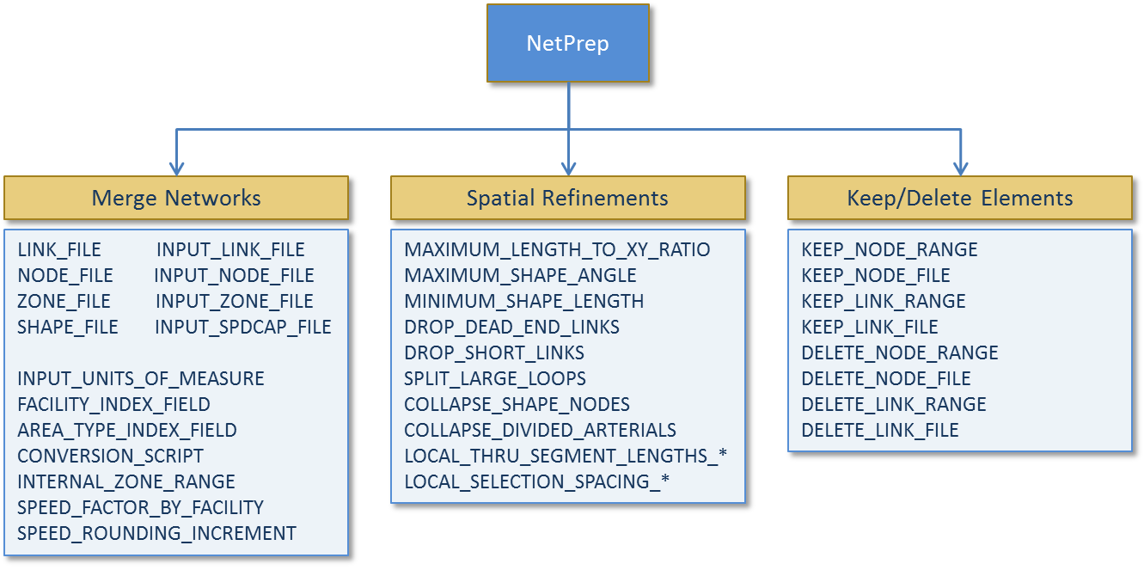

### Figure 2: NetPrep Control Keys Grouped by Associated Function

# Update and Delete Applications

The NetPrep program is also used to update or delete records in an existing TRANSIMS 5 network. This was previously accomplished using TransimsNet 4. The update and delete node and/or link ranges or files specify the records to be processed. Input network table keys are needed to define the existing network for TransimsNet 5. NetPrep 5 can be used to generate these necessary input files using a network shape file if one exists. Alternatively, these tasks can still be accomplished manually similar to TRANSIMS 4, taking into account the changes in file and control key names and locations introduced in TRANSIMS 5. The records in the input file are read and copied to the output network if not included in one of the update or delete lists. If the record is associated with a link or a node that is updated or deleted, the record is not copied to the output file. The new records generated by the update option are added to the end of the output file. As a result, records for a given location (link or node) will have different record numbers in the output file than in the input file.

The link-related data types include the pocket lanes (POCKET_FILE), activity locations (LOCATION_FILE), parking lots (PARKING_FILE), and process links (ACCESS_FILE). The reader is referred to the TRANSIMS 5 Training Material and the TransimsNet 5 Program Reference for additional information on the changes in naming conventions present in version 5, as well as the functional significance of these link-related data type changes. Since the input link file may include changes to the number of lanes for an updated link, the lane connectivity (CONNECTION_FILE) records at both ends of the link are also regenerated. In all cases, the methods used to regenerate pocket lanes, locations, and other link attributes utilized the parameters specified for the application. In other words, the rules for generating synthetic data may be different than the rules used to generate the original network. This enables the user to customize the synthetic generate process for specific links or subareas within the network. The node-related data types include the lane connections and the traffic controls (sign and signal warrants (SIGN_FILE, SIGNAL_FILE)). The node update option is typically used for applying different signal and sign warrant (SIGN_FILE, SIGNAL_FILE) parameters for different areas or subareas within the region or to simply remove signals or signs that are not wanted.

The delete options are intended to physically remove link and nodes from the system. It is not possible to remove a node without also removing all of the links attached to the node. Deleting a link will automatically update the lane connections at the nodes at both ends of the deleted link.

# Creating and Using Conversion Scripts

The conversion script key is a file name that includes a TRANSIMS User Program script. The programming language for the script is described in the User Programs documentation and the reader is referred there for more comprehensive discussion of writing user programs or scripts for TRANSIMS. By default, the data field names in the shape file are copied to the corresponding field names in the TRANSIMS link file. If a shape file (.shp) of the network exists and was created using ArcNet, this means the data from the GIS file will automatically be copied to the TRANSIMS fields (provided the input and output files are in the same general file structure (i.e., Version 4 vs. Version 5)). If the GIS file includes different field names or different units of measure, a conversion script is typically used to manipulate the data or map the input field names to the output field names. The input GIS link fields are referenced as “Link.*field*” and the TRANSIMS link fields are referenced as “NewLink.*field*”. The conversion script itself is typically a standalone ANSI text file named “Script.txt” or “GIS.cfg”. The path to the location of the script file must be appended to the front of the associated control key value in the “NetPrep.ctl” control file.

An example of a conversion script appears below:

NewLink.USE = "ANY"

NewLink.LINK = Link.ID

NewLink.LENGTH = 1609 * Link.LENGTH

NewLink.LANES_AB = Link.AB_LANE

NewLink.LANES_BA = Link.BA_LANE

NewLink.SPEED_AB = Link.AB_PKSPD

NewLink.SPEED_BA = Link.BA_PKSPD

NewLink.FSPD_AB = Link.SPDLIM

NewLink.FSPD_BA = Link.SPDLIM

NewLink.CAP_AB = Link.AB_CAP

NewLink.CAP_BA = Link.BA_CAP

IF (Link.FT == 1) THEN

NewLink.TYPE = "FREEWAY"

ELSE IF (Link.FT == 2) THEN

NewLink.TYPE = "Expressway"

ELSE IF (Link.FT == 3) THEN

NewLink.TYPE = "Principal"

ELSE IF (Link.FT == 4) THEN

NewLink.TYPE = "Major"

ELSE IF (Link.FT == 5) THEN

NewLink.TYPE = "Minor"

ELSE IF (Link.FT == 6) THEN

NewLink.TYPE = "Collector"

ELSE IF (Link.FT == 7) THEN

NewLink.TYPE = "Local"

ELSE IF (Link.FT == 8) THEN

NewLink.TYPE = "Local"

ELSE IF (Link.FT == 9) THEN

NewLink.TYPE = "Frontage"

ELSE IF (Link.FT == 20) THEN

NewLink.TYPE = "External"

ENDIF ENDIF ENDIF ENDIF ENDIF ENDIF ENDIF ENDIF ENDIF ENDIF

RETURN (1)

END

# Example 1–Collapse Divided Arterials Using NetPrep

It is often useful to collapse divided arterials in a highway network early in the network synthesis and subsequent simulation process. Raw network data provided by MPOs and other project stakeholders is often provided in a divided arterial format. For simplicity, it is recommended that the decision to collapse divided arterials be made and implemented early in the TRANSIMS modeling effort process as subsequent file processing will in turn be simplified.

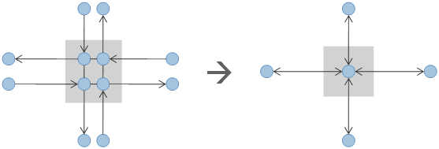

### ****Figure 3: Collapsing Divided Arterials-Conceptual Diagram****

### Example Input File / Control File (NetPrep.ctl) – Alexandria V5 Network

//---- Use NetPrep to implement Node Keep/Collapse and Link Length adjustments from TransimsNet 4.0 ----

TITLE Network Preparation

DEFAULT_FILE_FORMAT TAB_DELIMITED

PROJECT_DIRECTORY ../

//---- Input Files ----

NODE_FILE inputs/Input_Node.txt

LINK_FILE inputs/Input_Link.txt

SHAPE_FILE inputs/Input_Shape.txt

ZONE_FILE inputs/Input_Zone.txt

KEEP_NODE_FILE inputs/Keep_Node_List.txt

//---- Output Files ----

NEW_NODE_FILE inputs/Input_Node2.txt

NEW_LINK_FILE inputs/Input_Link2.txt

NEW_SHAPE_FILE inputs/Input_Shape2.txt

NEW_ZONE_FILE inputs/Input_Zone2.txt

//---- Parameters ----

SPLIT_LARGE_LOOPS 100 meters

DROP_SHORT_LINKS 7.5

MAXIMUM_LENGTH_TO_XY_RATIO 1.2

COLLAPSE_SHAPE_NODES TRUE

NOTES_AND_NAME_FIELDS YES

SPEED_FACTOR_BY_FACILITY 1.0, 1.0, 1.05, 1.05, 1.08, 1.1, 1.1, 1.1, 1.05, 1.05, 1.05, 1.0

SPEED_ROUNDING_INCREMENT 7.5 mps

### Example Output File / Results of Running NetPrep (NetPrep.prn) – Alexandria V5 Network

********************************************

| |

| NetPrep - Version 5.0.0 |

| Copyright 2010 by TRANSIMS Open-Source |

| Fri Jan 21 08:22:32 2011 |

| |

********************************************

Control_File = ../control/Alex.2005.Net.NetPrep.ctl

Report_File = ../control/Alex.2005.Net.NetPrep.prn (Create)

Network Preparation

Project Directory = ../

Default File Format = TAB_DELIMITED

Time of Day Format = HOUR_CLOCK

Model Start Time = 0:00

Model End Time = 27:00

Units of Measure = METRIC

Random Number Seed = 1295616152

Number of Threads = 2

Warning: NetPrep is Not Thread Enabled

Input System Network Files:

Node File = ../inputs/Input_Node.txt

Zone File = ../inputs/Input_Zone.txt

Shape File = ../inputs/Input_Shape.txt

Link File = ../inputs/Input_Link.txt

Output System Network Files:

New Node File = ../inputs/Input_Node2.txt

New Zone File = ../inputs/Input_Zone2.txt

New Shape File = ../inputs/Input_Shape2.txt

New Link File = ../inputs/Input_Link2.txt

Notes And Name Fields = TRUE

Data Service Controls:

NetPrep Control Keys:

Speed Factor By Facility = 1, 1, 1.05, 1.05, 1.08, 1.1, 1.1, 1.1, 1.05, 1.05, 1.05, 1

Speed Rounding Increment = 7.50 mps

Maximum Length to XY Ratio = 1.2

Drop Short Links = 7.50 meters

Split Large Loops = 100 meters

Collapse Shape Nodes = TRUE

Keep Node File = ../inputs/Keep_Node_List.txt

Number of Node File Records = 2620

Number of Zone File Records = 85

Highest Zone Number = 92

Number of Shape File Records = 18072

Number of Link Shape Records = 2369

Number of Link File Records = 3653

Number of Directional Links = 6852

Number of Collapsed Nodes = 46

Number of Short Links Dropped = 2

Number of Collapsed Nodes = 1

New Node File Records = 2572

New Zone File Records = 85

Highest Zone Number = 92

New Shape File Records = 18285

New Link File Records = 3606

Fri Jan 21 08:22:32 2011 -- Process Complete with 1 Warning (0:00:00)

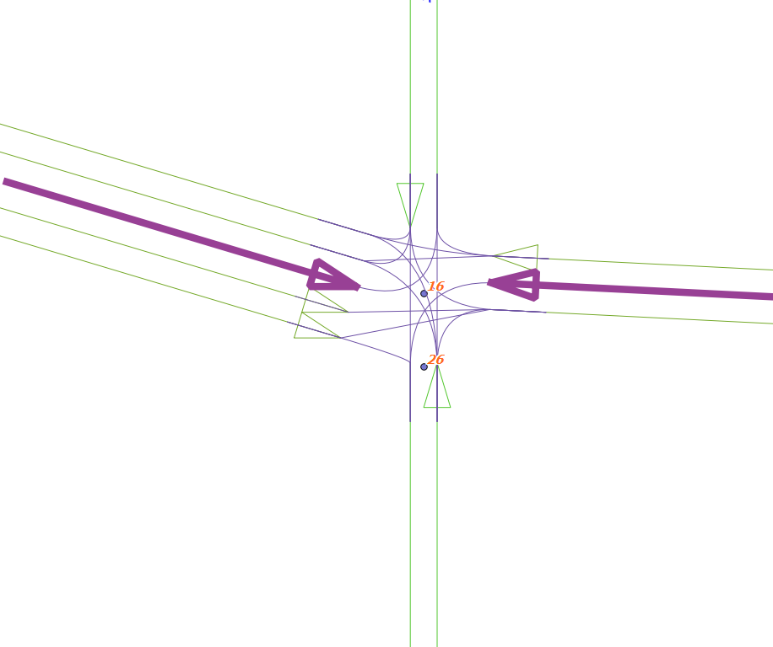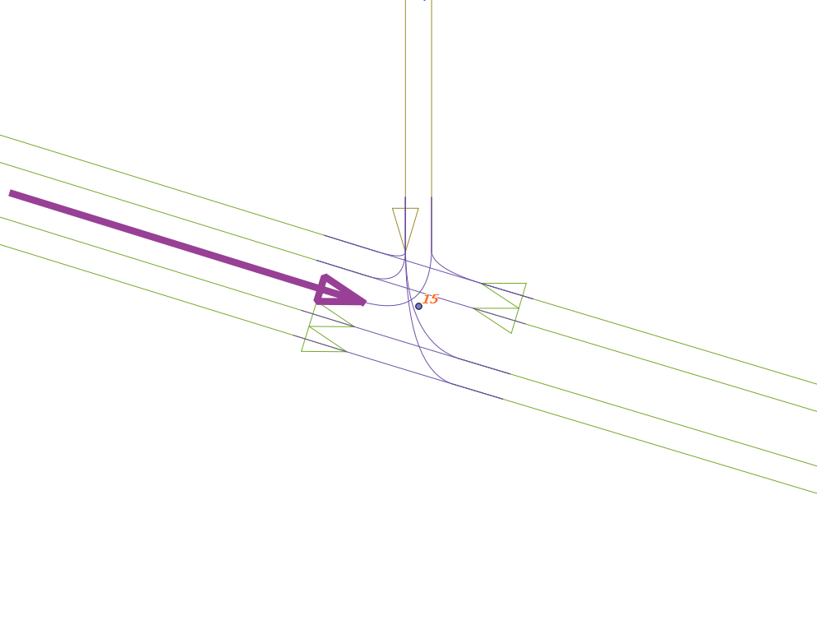

### Figure 4: QGIS Visual Comparison of Divided Arterials and Collapsed Arterials in TRANSIMS 5.0

The top-left figure (Figure 4) illustrates a divided or 2-node arterial intersection in TRANSIMS 5. In contrast, the top-right figure (Figure 4) shows another intersection from the same network model that utilizes a single node/collapsed node arterial intersection. These images were produced by creating shape files from the TRANSIMS 5 network files using ArcNet 5 and loading the shape files as layers into a standalone GIS program. The reader is referred to the ArcNet Program Reference and Highway Network How-To Guide for more in-depth discussion of generating shape files using ArcNet 5.

# Example 2–Using NetPrep to Convert Shape Files to TRANSIMS Network Input Files

Note that NetPrep 5.0 replaces GISNet 4.0 entirely. GISNet is no longer a part of the TRANSIMS 5.0 traffic microsimulation suite. In addition, NetPrep 5.0 includes many features that were previously incorporated into TransimsNet 4.0. The example below illustrates how to convert a GIS shape file into Input_Link.txt, Input_Node.txt, and Input_Shape.txt files which can be used as inputs into TransimsNet 5.0. Additional functionality has been incorporated into TransimsNet 5.0, and the reader is referred to the TransimsNet documentation for additional information.

### Example Input File / Control File (NetPrep.ctl) – A Large Network

TITLE NetPrep – Shape File to Network Files Conversion

PROJECT_DIRECTORY ../

UNITS_OF_MEASURE METRIC

//---- The INPUT_LINK_FILE key requires a shape file with a .shp extension to create TRANSIMS network input files ----

INPUT_LINK_FILE inputs/arcview/Large.shp

//---- A conversion script is required for this and is similar to the type used by GISNet in TRANSIMS 4.0 ----

CONVERSION_SCRIPT RTE/Script.txt

NEW_NODE_FILE network/Input_Node.txt

NEW_LINK_FILE network/Input_Link.txt

NEW_SHAPE_FILE network/Input_Shape.txt

//---- The correct INPUT_COORDINATE_SYSTEM key value (UTM meters, LATLONG, etc.) corresponding to the shape ----

//---- file included above must be used to avoid NetPrep processing errors ----

INPUT_COORDINATE_SYSTEM UTM, 15N, METERS

OUTPUT_COORDINATE_SYSTEM UTM, 15N, METERS

NETPREP_REPORT_1 CONVERSION_SCRIPT

NETPREP_REPORT_2 CONVERSION_STACK

### Example Output File / Results of Running NetPrep (NetPrep.prn) – A Large Network

********************************************

| |

| NetPrep - Version 5.0.9 |

| Copyright 2012 by TRANSIMS Open-Source |

| Tue May 15 07:38:16 2012 |

| |

********************************************

Control File = ../control/NetPrep.ctl

Report File = ../control/NetPrep.prn (Create)

NetPrep – Shape File to Network Files Conversion

Project Directory = ../

Units of Measure = METRIC

Random Number Seed = 1337081896

Output System Network Files:

New Node File = ../network/Input_Node.txt

New Shape File = ../network/Input_Shape.txt

New Link File = ../network/Input_Link.txt

Data Service Controls:

Input Coordinate System = UTM, 15N, METERS

Output Coordinate System = UTM, 15N, METERS

NetPrep Control Keys:

Input Link Shapefile = ../inputs/arcview/Large.shp

Conversion Script = ../RTE/Script.txt

NetPrep Reports: 1. CONVERSION_SCRIPT

2. CONVERSION_STACK

##### Conversion Script

NewLink.USE = "ANY"

IF (Link.DIR == 0) THEN

NewLink.LANES_BA = Link.LANES * 0.5

NewLink.LANES_AB = Link.LANES * 0.5

ELSE IF (Link.DIR == 1) THEN

NewLink.LANES_BA = 0

NewLink.LANES_AB = Link.LANES

ELSE IF (Link.DIR == -1) THEN

NewLink.LANES_AB = 0

NewLink.LANES_BA = Link.LANES

ELSE IF (Link.DIR == 2) THEN

NewLink.LANES_AB = Link.PERMLANESB

NewLink.LANES_BA = Link.PERMLANESA

ENDIF ENDIF ENDIF ENDIF

NewLink.SPEED_AB = Link.SPEED_AB

NewLink.SPEED_BA = Link.SPEED_BA

NewLink.FSPD_AB = 0.8 * NewLink.SPEED_AB

NewLink.FSPD_BA = 0.8 * NewLink.SPEED_BA

IF (Link.FUNCL == 1) THEN

NewLink.TYPE = "FREEWAY"

ELSE IF (Link.FUNCL == 2) THEN

NewLink.TYPE = "Expressway"

ELSE IF (Link.FUNCL == 3) THEN

NewLink.TYPE = "Principal"

ELSE IF (Link.FUNCL == 4) THEN

NewLink.TYPE = "Major"

ELSE IF (Link.FUNCL == 5) THEN

NewLink.TYPE = "Minor"

ELSE IF (Link.FUNCL == 6) THEN

NewLink.TYPE = "Collector"

ELSE IF (Link.FUNCL == 7) THEN

NewLink.TYPE = "Local"

ELSE IF (Link.FUNCL == 8) THEN

NewLink.TYPE = "Local"

ELSE IF (Link.FUNCL == 9) THEN

NewLink.TYPE = "Frontage"

ELSE IF (Link.FUNCL == 10) THEN

NewLink.TYPE = "Ramp"

ELSE IF (Link.FUNCL == 20) THEN

NewLink.TYPE = "External"

ENDIF ENDIF ENDIF ENDIF ENDIF ENDIF ENDIF ENDIF ENDIF ENDIF ENDIF

RETURN (1)

END

##### Conversion Stack

1) String "ANY"

2) Assign =

3) String NewLink.USE

4) Integer Link.DIR

5) Integer 0

6) Relation EQ

7) Logical If False, Jump to 19

8) Integer Link.LANES

9) Real 0.500000

10) Math *

11) Assign =

12) Integer NewLink.LANES_BA

13) Integer Link.LANES

14) Real 0.500000

15) Math *

16) Assign =

17) Integer NewLink.LANES_AB

18) Logical Jump to 52

19) Integer Link.DIR

20) Integer 1

21) Relation EQ

22) Logical If False, Jump to 30

23) Integer 0

24) Assign =

25) Integer NewLink.LANES_BA

26) Integer Link.LANES

27) Assign =

28) Integer NewLink.LANES_AB

29) Logical Jump to 52

30) Integer Link.DIR

31) Integer 1

32) Math Negative

33) Relation EQ

34) Logical If False, Jump to 42

35) Integer 0

36) Assign =

37) Integer NewLink.LANES_AB

38) Integer Link.LANES

39) Assign =

40) Integer NewLink.LANES_BA

41) Logical Jump to 52

42) Integer Link.DIR

43) Integer 2

44) Relation EQ

45) Logical If False, Jump to 52

46) Real Link.PERMLANESB

47) Assign =

48) Integer NewLink.LANES_AB

49) Real Link.PERMLANESA

50) Assign =

51) Integer NewLink.LANES_BA

52) Integer Link.SPEED_AB

53) Assign =

54) Real NewLink.SPEED_AB

55) Integer Link.SPEED_BA

56) Assign =

57) Real NewLink.SPEED_BA

58) Real 0.800000

59) Real NewLink.SPEED_AB

60) Math *

61) Assign =

62) Real NewLink.FSPD_AB

63) Real 0.800000

64) Real NewLink.SPEED_BA

65) Math *

66) Assign =

67) Real NewLink.FSPD_BA

68) Integer Link.FUNCL

69) Integer 1

70) Relation EQ

71) Logical If False, Jump to 76

72) String "FREEWAY"

73) Assign =

74) String NewLink.TYPE

75) Logical Jump to 155

76) Integer Link.FUNCL

77) Integer 2

78) Relation EQ

79) Logical If False, Jump to 84

80) String "Expressway"

81) Assign =

82) String NewLink.TYPE

83) Logical Jump to 155

84) Integer Link.FUNCL

85) Integer 3

86) Relation EQ

87) Logical If False, Jump to 92

88) String "Principal"

89) Assign =

90) String NewLink.TYPE

91) Logical Jump to 155

92) Integer Link.FUNCL

93) Integer 4

94) Relation EQ

95) Logical If False, Jump to 100

96) String "Major"

97) Assign =

98) String NewLink.TYPE

99) Logical Jump to 155

100) Integer Link.FUNCL

101) Integer 5

102) Relation EQ

103) Logical If False, Jump to 108

104) String "Minor"

105) Assign =

106) String NewLink.TYPE

107) Logical Jump to 155

108) Integer Link.FUNCL

109) Integer 6

110) Relation EQ

111) Logical If False, Jump to 116

112) String "Collector"

113) Assign =

114) String NewLink.TYPE

115) Logical Jump to 155

116) Integer Link.FUNCL

117) Integer 7

118) Relation EQ

119) Logical If False, Jump to 124

120) String "Local"

121) Assign =

122) String NewLink.TYPE

123) Logical Jump to 155

124) Integer Link.FUNCL

125) Integer 8

126) Relation EQ

127) Logical If False, Jump to 132

128) String "Local"

129) Assign =

130) String NewLink.TYPE

131) Logical Jump to 155

132) Integer Link.FUNCL

133) Integer 9

134) Relation EQ

135) Logical If False, Jump to 140

136) String "Frontage"

137) Assign =

138) String NewLink.TYPE

139) Logical Jump to 155

140) Integer Link.FUNCL

141) Integer 10

142) Relation EQ

143) Logical If False, Jump to 148

144) String "Ramp"

145) Assign =

146) String NewLink.TYPE

147) Logical Jump to 155

148) Integer Link.FUNCL

149) Integer 20

150) Relation EQ

151) Logical If False, Jump to 155

152) String "External"

153) Assign =

154) String NewLink.TYPE

155) Integer 1

156) Return Integer

157) End 1

Warning: Duplicate Link Direction Number = 25602

Warning: Duplicate Link Direction Number = 25625

Warning: Duplicate Link Direction Number = 25682

Warning: Duplicate Link Direction Number = 25687

Warning: Duplicate Link Direction Number = 25696

Warning: Duplicate Link Direction Number = 25859

Warning: Duplicate Link Direction Number = 26110

Number of Input Link Shapefile Records = 26244

Number of Short Loops Deleted = 1

New Node File Records = 20043

New Shape File Records = 74182

New Link File Records = 26228

Tue May 15 07:38:34 2012 -- Process Complete with 7 Warnings (0:00:18)

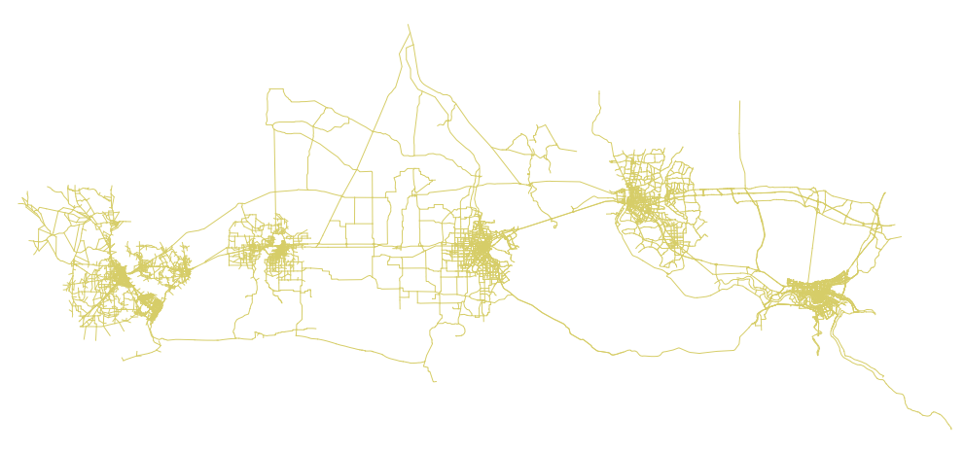

### Figure 5: QGIS View of the Shape File used as Input in the Network Conversion Example