TransimsNet Version 5 – Program Reference

Version 5.0.10

Revision History

May 2012 – Created by Volpe Center

June 2012 – Updated by Volpe Center

The **TransimsNet** program is used to:

1. Synthesize TRANSIMS network files from generic node and link information.
2. Generate Node, Link, Activity Location, Parking, Process Link, Lane Connectivity, and Pocket Lane files.
3. Generate Sign and Signal Warrant files that can be used as inputs to the IntControl program to synthesize the TRANSIMS Unsignalized Node, Signalized Node, Timing Plan, Phasing Plan, Detector and Signal Coordinator files.
4. Copy an existing network and update or delete network components associated with selected links or nodes.

Syntax is TransimsNet [-flag] [control_file]

The control_file is the file name of an ASCII file that contains the control strings expected by the program. The control_file is optional. If a file name is not provided, the program will prompt the user to enter a file name. The flag parameters are also optional. Any combination of the following flag parameters can be included on the command line:

Optional Flags:

-Q[uiet] = execute without screen messages

-H[elp] = show program syntax and control keys

-C[ontrol] = create/update a default control file

-K[eyCheck] = list unrecognized control file keys

-P[ause] = pause before exiting

-N[oPause] = never pause before exiting

-D[etail] = execute with detailed status messages

-X[ML] = write an XML file with control keys

The program automatically creates a printout file based on the control file name. If the filename includes an extension (e.g., “.ctl”), the extension is replaced with “.prn”. The printout file will be created in the current working directory and will overwrite an existing file with the same name.

# Version 5 Features

* Version 5 includes additional data manipulation and update/delete tools, and tools for selecting a subset of links from an all-streets network.
* TransimsNet now includes much finer controls of synthetic data generation:
* Pocket lanes, link connections (previously lane connectivity in Version 4), activity locations, traffic controls, parking details, speeds, and other attributes.
* Lane numbers and pocket lanes, multi-node signals, toll lanes and lane processing rates, access links (formerly process links), link offsets, and additional refinements.
* Apply warrants/rules to synthesize TRANSIMS network details
* Pocket lanes, lane connectivity, activity locations, parking lots, access links, lane use, turn prohibitions, and signal and sign warrants
* Conceptual Changes
  + Lane numbers and pocket lanes
  + Multi-node signals
  + Toll lanes and lane processing rates
  + Process links 🡪 Access links
  + Link offsets
* File Structure Changes
  + Lane ranges
  + Link direction
    - Link-Node 🡪 Link-Dir
  + Parking time period nests
* New Data Fields
  + Node – subarea
  + Link – area type, grade, divided
  + Location – XY 🡪 link, offset, setback
  + Parking – time-in, time-out
  + Lane Use – toll, fixed and variable processing rates

# Control Key List

The list of control file keys appears in the table below:

* Req / Opt indicates whether the key is **req**uired or **opt**ional
* The types include **Text**, Input **File**name, **New** file, **Bool**ean, **Path** (to a file), **Time**, **Int**eger, **Dec**imal, and **List** of items
* The Default is the default value, used if the key does not appear in the control file.
* I/O/P indicates Input, Output or Parameter.

For a more detailed description of the Parameter control keys, refer to the Parameter Reference. For a more detailed description of the Input or Output control keys, refer to the File Reference. These two documents also provide the possible values or range of values allowed for each control key listed below. For instance, files can usually be output to numerous formats beyond TAB_DELIMITED for additional post-processing / file manipulation actions.

## Configuration Keys

|  |  |  |  |  |
| --- | --- | --- | --- | --- |
| **Control File Keys:** | **Req/Opt** | **Type** | **Default** | **I/O/P** |
| TITLE | Opt | Text |  | P |
| REPORT_FILE | Opt | File |  | O |
| REPORT_FLAG | Opt | Bool | FALSE | P |
| PROJECT_DIRECTORY | Opt | Path |  | P |
| DEFAULT_FILE_FORMAT 1 | Opt | Text | TAB_DELIMITED | P |
| TIME_OF_DAY_FORMAT 1 | Opt | Text | DAY_TIME | P |
| MODEL_START_TIME | Opt | Time | 0:00 | P |
| MODEL_END_TIME | Opt | Time | 24:00:00 | P |
| UNITS_OF_MEASURE | Opt | Text | METRIC | P |
| RANDOM_NUMBER_SEED | Opt | Int. | 0 | P |
| MAX_WARNING_MESSAGES | Opt | Int. | 100000 | P |
| MAX_WARNING_EXIT_FLAG | Opt | Bool | TRUE | P |
| MAX_PROBLEM_COUNT | Opt | Int. | 0 | P |
| NUMBER_OF_THREADS | Opt | Int. | 1 | P |
| TRANSIMSNET_REPORT_* | Opt | Text |  | P |

## System File Keys

|  |  |  |  |  |
| --- | --- | --- | --- | --- |
| **Control File Keys:** | **Req/Opt** | **Type** | **Default** | **I/O/P** |
| NODE_FILE | Req | File |  | I |
| NODE_FORMAT | Opt | Text | TAB_DELIMITED | P |
| ZONE_FILE | Req | File |  | I |
| ZONE_FORMAT | Opt | Text | TAB_DELIMITED | P |
| LINK_FILE | Req | File |  | I |
| LINK_FORMAT | Opt | Text | TAB_DELIMITED | P |
| NEW_LINK_FILE | Req | File |  | O |
| NEW_LINK_FORMAT | Opt | Text | TAB_DELIMITED | P |
| NEW_LOCATION_FILE | Req | File |  | O |
| NEW_LOCATION_FORMAT | Opt | Text | TAB_DELIMITED | P |
| NEW_PARKING_FILE | Req | File |  | O |
| NEW_PARKING_FORMAT | Opt | Text | TAB_DELIMITED | P |
| NEW_POCKET_FILE | Req | File |  | O |
| NEW_POCKET_FORMAT | Opt | Text | TAB_DELIMITED | P |
| NEW_CONNECTION_FILE | Req | File |  | O |
| NEW_CONNECTION_FORMAT | Opt | Text | TAB_DELIMITED | P |
| NEW_SIGN_FILE | Req | File |  | O |
| NEW_SIGN_FORMAT | Opt | Text | TAB_DELIMITED | P |
| NEW_SIGNAL_FILE | Req | File |  | O |
| NEW_SIGNAL_FORMAT | Opt | Text | TAB_DELIMITED | P |
| SHAPE_FILE | Opt | File |  | I |
| SHAPE_FORMAT | Opt | Text | TAB_DELIMITED | P |
| TURN_PENALTY_FILE | Opt | File |  | I |
| TURN_PENALTY_FORMAT | Opt | Text | TAB_DELIMITED | P |
| LOCATION_FILE | Opt | File |  | I |
| LOCATION_FORMAT | Opt | Text | TAB_DELIMITED | P |
| PARKING_FILE | Opt | File |  | I |
| PARKING_FORMAT | Opt | Text | TAB_DELIMITED | P |
| ACCESS_FILE | Opt | File |  | I |
| ACCESS_FORMAT | Opt | Text | TAB_DELIMITED | P |
| POCKET_FILE | Opt | File |  | I |
| POCKET_FORMAT | Opt | Text | TAB_DELIMITED | P |
| CONNECTION_FILE | Opt | File |  | I |
| CONNECTION_FORMAT | Opt | Text | TAB_DELIMITED | P |
| SIGN_FILE | Opt | File |  | I |
| SIGN_FORMAT | Opt | Text | TAB_DELIMITED | P |
| SIGNAL_FILE | Opt | File |  | I |
| SIGNAL_FORMAT | Opt | Text | TAB_DELIMITED | P |
| LANE_USE_FILE 2 | Opt | File |  | I |
| LANE_USE_FORMAT 2 | Opt | Text | TAB_DELIMITED | P |
| NEW_LANE_USE_FILE 2 | Opt | File |  | O |
| NEW_LANE_USE_FORMAT 2 | Opt | Text | TAB_DELIMITED | P |
| NEW_NODE_FILE | Opt | File |  | O |
| NEW_NODE_FORMAT | Opt | Text | TAB_DELIMITED | P |
| NEW_ZONE_FILE | Opt | File |  | O |
| NEW_ZONE_FORMAT | Opt | Text | TAB_DELIMITED | P |
| NEW_SHAPE_FILE | Opt | File |  | O |
| NEW_SHAPE_FORMAT | Opt | Text | TAB_DELIMITED | P |
| NEW_ACCESS_FILE | Opt | File |  | O |
| NEW_ACCESS_FORMAT | Opt | Text | TAB_DELIMITED | P |
| NEW_TURN_PENALTY_FILE | Opt | File |  | O |
| NEW_TURN_PENALTY_FORMAT | Opt | Text | TAB_DELIMITED | P |

## File Service Keys

|  |  |  |  |  |
| --- | --- | --- | --- | --- |
| **Control File Keys:** | **Req/Opt** | **Type** | **Default** | **I/O/P** |
| NOTES_AND_NAME_FIELDS | Opt | Bool | FALSE | P |

## Projection, Smooth Data, Difference Data Keys

|  |  |  |  |  |
| --- | --- | --- | --- | --- |
| **Control File Keys:** | **Req/Opt** | **Type** | **Default** | **I/O/P** |
| INPUT_COORDINATE_SYSTEM | Opt | List |  | P |
| INPUT_COORDINATE_ADJUSTMENT | Opt | List |  | P |
| OUTPUT_COORDINATE_SYSTEM | Opt | List |  | P |
| OUTPUT_COORDINATE_ADJUSTMENT | Opt | List |  | P |
| OUTPUT_XYZ_SHAPES | Opt | Bool | FALSE | P |
| OUTPUT_XYM_SHAPES | Opt | Bool | FALSE | P |

## Control Keys

|  |  |  |  |  |
| --- | --- | --- | --- | --- |
| **Control File Keys:** | **Req/Opt** | **Type** | **Default** | **I/O/P** |
| DEFAULT_LINK_SETBACK | Opt | Dec. | 7.5 meters | P |
| DEFAULT_LOCATION_SETBACK | Opt | Dec. | 30 meters | P |
| MAXIMUM_CONNECTION_ANGLE | Opt | Int. | 120 degrees | P |
| ADD_UTURN_TO_DEAD_END_LINKS | Opt | Bool | FALSE | P |
| SIGNAL_ID_AS_NODE_ID 2 | Opt | Bool | FALSE | P |
| EXTERNAL_ZONE_RANGE | Opt | List | 0 | P |
| EXTERNAL_STATION_OFFSET | Opt | Int. | 30 meters | P |
| ZONE_BOUNDARY_FILE | Opt | File |  | I |
| ZONE_FIELD_NAME | Opt | Text |  | P |
| POCKET_LANE_WARRANT_* | Opt | Text |  | P |
| TRAFFIC_CONTROL_WARRANT_* | Opt | Text |  | P |
| FACILITY_ACCESS_WARRANT_* | Opt | Text |  | P |
| PARKING_DETAILS_WARRANT_* | Opt | Text |  | P |
| STREET_PARKING_WARRANT_* | Opt | Text |  | P |
| UPDATE_NODE_RANGE | Opt | List | ALL | P |
| UPDATE_LINK_RANGE | Opt | List | ALL | P |
| UPDATE_NODE_FILE | Opt | File |  | I |
| UPDATE_LINK_FILE | Opt | File |  | I |
| LINK_DETAIL_FILE 2 | Opt | File |  | I |

#### Notes

Each '_FILE' key has a corresponding '_FORMAT' key. The following file formats can be used for input and output files:

TEXT, BINARY, FIXED_COLUMN, COMMA_DELIMITED, SPACE_DELIMITED, TAB_DELIMITED, CSV_DELIMITED, DBASE, SQLITE3, VERSION3

1-Control key is listed in the –h command line listing generated by TransimsNet, but the key is not listed in the associated Quick Reference document.

2-Control key is listed in the TransimsNet Quick Reference document, but the key is not listed in the associated –h command line listing generated by this program.

# Control Key Changes in TransimsNet Version 5

## KEEP_NODE_LIST 🡪 KEEP_NODE_FILE (NetPrep 5.0)

The KEEP_NODE_LIST file control key has no equivalent control key in TransimsNet 5.0. Instead, the key is included in the NetPrep program (new in TRANSIMS 5.0) as KEEP_NODE_FILE. Refer to the NetPrep Program Reference and Highway Network How-To Guide for TRANSIMS 5.0 for additional information on these control key.

## ACTIVITY_LOCATION_TABLE 🡪 LOCATION_FILE

The ACTIVITIY_LOCATION_TABLE file control key (and associated file format key) from TransimsNet 4.0 is replaced by the LOCATION_FILE key in TransimsNet 5.0. Refer to the File Reference mentioned above for additional details on the programmatic changes made to the LOCATION_FILE control key in TRANSIMS 5.0. These changes also apply to the NEW_ACTIVITY_LOCATION_FILE control key and associated file output format control key.

## LINK_NODE_EQUIVALENCE 🡪 (Not yet implemented)

The LINK_NODE_EQUIVALENCE file control key has not yet been implemented in TransimsNet 5.0.

## MINIMUM_LINK_LENGTH 🡪 (Not implemented; see DROP_SHORT_LINKS in NetPrep 5.0)

The MINIMUM_LINK_LENGTH parameter control key is not implemented in TransimsNet 5.0.

## MAXIMUM_LENGTH_TO_XY_RATIO 🡪 (NetPrep 5.0)

The MAXIMUM_LENGTH_TO_XY_RATIO control key parameter from TransimsNet 4.0 is now included in NetPrep 5.0 instead and retains the same name as before. Refer to the NetPrep 5.0 Program Reference and Quick Reference documents for additional information on this control key.

## COLLAPSE_NODES_FLAG 🡪 COLLAPSE_SHAPE_NODES (NetPrep 5.0)

The COLLAPSE_NODES_FLAG in TransimsNet 4.0 is now included in NetPrep 5.0 instead as COLLAPSE_SHAPE_NODES. Refer to the NetPrep 5.0 Program Reference and Quick Reference documents for additional information on this control key.

## EXTERNAL_STATION_OFFSET (New in TransimsNet 5.0)

The EXTERNAL_STATION_OFFSET parameter control key is a new addition to TransimsNet 5.0. This parameter is hardcoded with a value of 30 meters in TransimsNet 4.0. Refer to the Highway Network How-To Guide for additional information on this control key.

# Network File Name and Control Key Name Changes (TransimsNet 4.0 🡪 5.0)

Additional control key changes are present in TransimsNet 5.0 that are not described in this section. Changes have been made to select control key and file and parameter names in many instances as can been seen from the list below. Additionally, file structures have been modified in some instances. New conceptual constructs have been introduced to improve overall performance and ease of use and robustness of TRANSIMS 5.0 as well. Lastly, new data fields have been added within some input and output files (e.g., SubArea). Refer to the File Reference and Parameter Reference documents for additional details. Some specific examples include the following control key and file name changes (V4 🡪 V5):

* NET_NODE_TABLE 🡪 NODE_FILE
* NET_ZONE_TABLE 🡪 ZONE_FILE
* NET_SHAPE_TABLE 🡪 SHAPE_FILE
* NET_LINK_TABLE 🡪 LINK_FILE
* NET_POCKET_LANE_TABLE 🡪 POCKET_FILE
* NET_LANE_USE_TABLE 🡪 LANE_USE_FILE
* NET_TOLL_TABLE 🡪 LANE_USE_FILE
* NET_LANE_CONNECTIVITY_TABLE 🡪 CONNECTION_FILE
* NET_TURN_PROHIBITION_TABLE 🡪 TURN_PENALTY_FILE
* NET_PARKING_TABLE 🡪 PARKING_FILE
* NET_ACTIVITY_LOCATION_TABLE 🡪 LOCATION_FILE
* NET_PROCESS_LINK_TABLE 🡪 ACCESS_FILE
* NET_UNSIGNALIZED_NODE_FILE 🡪 SIGN_FILE
* NET_SIGNALIZED_NODE_TABLE 🡪 SIGNAL_FILE

# TransimsNet Version 5 Network Conversion Process

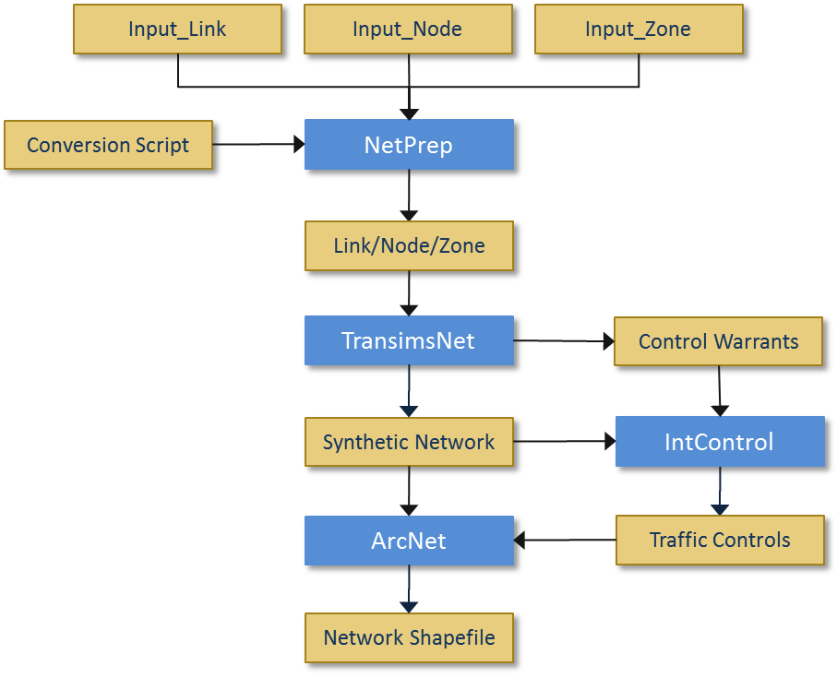

### Figure 1: Network Conversion Process (High-Level)

The above flowchart shows the typical execution sequence of TRANSIMS 5.0 network programs and file inputs and outputs relative to each program, and relative to the overall process. NetPrep is discussed further in a separate document and is new to TRANSIMS 5.0. Starting with TRANSIMS 5.0, NetPrep is used instead of TransimsNet to convert input network files (nodes, links, and zones) into TRANSIMS 5.0 network format compatible files.

The raw input files may be from an existing TRANSIMS 4.0 network, from raw network files exported from commercial traffic modeling software such as TransCAD®, or may be manually created given that the file names, file types/formats/extensions, location, layout (header row in particular), and contents are consistent with what is expected by TRANSIMS 5.0 and the relevant control files for each program noted above. The initial network input files and the TRANSIMS 5.0 network format files that result from the process are show in Figure 1 above at a relatively high level. The combined file output of TransimsNet and IntControl comprise the majority of the synthetic network files which will be used for subsequent trip table generation, trip routing, and finally trip simulation.

For a more detailed look at this process, refer to the Highway Network How-To document.

Some associated tasks and notes not readily apparent from Figure 1 are the iterative nature of the process, subsequent review, manipulation, and generation of the remaining TRANSIMS network files. The process depicted in Figure 1 indicates the proper order for sequentially synthesizing the network. However, the overall process of network generation actually employed (within certain constraints) to develop a TRANSIMS 5.0 implementation varies based on the available network input data as well as the complexity of the implementation and its objectives.

Additional pre- and post-processing methods will typically be needed in order to generate a valid TRANSIMS 5.0 network model. The network model is produced by the iterative, sequential use of TransimsNet and IntControl at a minimum (performing and may optionally include NetPrep, ArcNet, and NewFormat. The resultant network suitable for trip table generation, and eventually, for accurate simulation of traffic flows. This includes pre- and post-processing methods. business rules to review, edit, and reiterate a process step or steps as needed. Errors and warnings should be addressed as they arise, and resolved whenever feasible. Warnings don’t necessarily prevent subsequent use of a file by another program. Batch files can be used to good effect in iterating some repetitive tasks such as regenerating the network from scratch using updated files. Additionally, scripting methods (e.g., Python) can also prove quite useful for automating many repetitive tasks (iterative program execution, file manipulation, file input/output, etc.), especially with larger-scale efforts.

These methods are discussed in greater detail in the NetPrep, TransimsNet, IntControl, and ArcNet program references and quick references and training documents, as well as in the Highway Network How-To and Network Edit How-To documents. The Highway Network How-To document also provides a more detailed discussion of the aforementioned supply/network-side TRANSIMS 5.0 programs in the context of the sequential, iterative, network synthesis process.

# Examples

#### TransimsNet Input Control File with Required Keys Only*

Input System Network Files:

Node File = ./../../input/Input_node.txt

Zone File = ./../../input/Input_zone.txt

Link File = ./../../input/Input_link.txt

Output System Network Files:

New Node File = ./../network/node.txt

New Zone File = ./../network/zone.txt

New Link File = ./../network/link.txt

New Pocket File = ./../network/pocket.txt

New Connection File = ./../network/connection.txt

New Parking File = ./../network/parking.txt

New Location File = ./../network/location.txt

New Sign File = ./../network/sign_warrant.txt

New Signal File = ./../network/signal_warrant.txt

*The above example is conceptual. Refer to the example below for actual control file syntax.

#### Example Input File / Control File (TransimsNet.ctl)

TITLE TransimsNet Test

LINK_FILE ../../input/Input_link.txt

NODE_FILE ../../input/Input_node.txt

SHAPE_FILE ../../input/Input_shape.txt

ZONE_FILE ../../input/Input_zone.txt

NEW_NODE_FILE ../network/node.txt

NEW_ZONE_FILE ../network/zone.txt

NEW_LINK_FILE ../network/link.txt

NEW_SHAPE_FILE ../network/shape.txt

NEW_LOCATION_FILE ../network/location.txt

NEW_PARKING_FILE ../network/parking.txt

NEW_POCKET_FILE ../network/pocket.txt

NEW_CONNECTION_FILE ../network/connection.txt

NEW_SIGN_FILE ../network/sign_warrant.txt

NEW_SIGNAL_FILE ../network/signal_warrant.txt

POCKET_LANE_WARRANT_1 FREEWAY, ALL, 1, RIGHT, 100 meters, 1

[Pocket Lane Warrants #2 through #19 omitted for simplicity]

POCKET_LANE_WARRANT_20 RAMP, ALL, 4, LEFT, 200 meters, 1

TRAFFIC_CONTROL_WARRANT_1 PRINCIPAL..MAJOR, PRINCIPAL..COLLECTOR, ALL, SIGNAL, 30 feet, 1

TRAFFIC_CONTROL_WARRANT_2 FREEWAY..EXPRESSWAY, RAMP, ALL, YIELD, 30 feet

TRAFFIC_CONTROL_WARRANT_3 PRINCIPAL..MAJOR, RAMP, ALL, YIELD, 30 feet

MAXIMUM_CONNECTION_ANGLE 150

FACILITY_ACCESS_WARRANT_1 PRINCIPAL..LOCAL, ALL, 50 feet, 150 feet, 3

EXTERNAL_ZONE_RANGE 10..15

#### Example Output File / Results of Running TransimsNet (TransimsNet.prn)

********************************************

| |

| TransimsNet - Version 5.0.3 |

| Copyright 2011 by TRANSIMS Open-Source |

| Tue Feb 21 13:43:34 2012 |

| |

********************************************

Control File = TransimsNet.ctl

Report File = TransimsNet.prn (Create)

TransimsNet Test

Project Directory = ./

Default File Format = TAB_DELIMITED

Time of Day Format = HOUR_CLOCK

Model Start Time = 0:00

Model End Time = 27:00

Units of Measure = METRIC

Random Number Seed = 1329849814

Number of Threads = 1

Input System Network Files:

Node File = ./../../input/Input_node.txt

Zone File = ./../../input/Input_zone.txt

Shape File = ./../../input/Input_shape.txt

Link File = ./../../input/Input_link.txt

Output System Network Files:

New Node File = ./../network/node.txt

New Zone File = ./../network/zone.txt

New Shape File = ./../network/shape.txt

New Link File = ./../network/link.txt

New Pocket File = ./../network/pocket.txt

New Connection File = ./../network/connection.txt

New Parking File = ./../network/parking.txt

New Location File = ./../network/location.txt

New Sign File = ./../network/sign_warrant.txt

New Signal File = ./../network/signal_warrant.txt

Notes And Name Fields = TRUE

Data Service Controls:

TransimsNet Control Keys:

Maximum Connection Angle = 150 degrees

External Zone Range = 10..15

Pocket Lane Warrant #1 = FREEWAY, FREEWAY..EXTERNAL, 1, RIGHT_TURN, 100.0 meters, 1 lane

[Pocket Lane Warrants #2 through #19 omitted for simplicity]

Pocket Lane Warrant #20 = RAMP, FREEWAY..EXTERNAL, 4, LEFT_TURN, 200.0 meters, 1 lane

Traffic Control Warrant #1 = PRINCIPAL..MAJOR, PRINCIPAL..COLLECTOR, 0..100, SIGNAL, 9.1 meters, 1

Traffic Control Warrant #2 = FREEWAY..EXPRESSWAY, RAMP, 0..100, YIELD, 9.1 meters, 1

Traffic Control Warrant #3 = PRINCIPAL..MAJOR, RAMP, 0..100, YIELD, 9.1 meters, 1

Facility Access Warrant #1 = PRINCIPAL..LOCAL, 0..100, 15.2 meters, 45.7 meters, 3 points

Number of Node File Records = 23

Number of Zone File Records = 8

Highest Zone Number = 14

Number of Shape File Records = 13

Number of Link Shape Records = 3

Number of Link File Records = 24

Number of Directional Links = 37

New Location File Records = 60

New Parking File Records = 60

Warning: No Exit from Link 22 at Node 17

New Sign File Records = 2

New Signal File Records = 2

New Pocket File Records = 7

New Connection File Records = 49

New Node File Records = 23

New Zone File Records = 8

Highest Zone Number = 14

New Shape File Records = 13

New Link File Records = 24

Number of Input Node Records = 23

Number of Input Link Records = 24

Number of Input Zone Records = 8

Highest Zone Number = 14

Number of New Node Records = 23

Number of New Zone Records = 8

Number of New Link Records = 24

Number of New Link Shapes = 3

Number of New Shape_Records = 13

Number of New Location Records = 60

Number of New Parking Lot Records = 60

Number of New Access Link Records = 0

Number of New Pocket Lane Records = 7

Number of New Connection Records = 49

Number of New Sign Records = 2

Number of New Signal Records = 2

Number of Yield Signs = 2

Tue Feb 21 13:43:34 2012 -- Process Complete with 1 Warning (0:00:00)

# Transims 5 Network Shape File Review using GIS Software

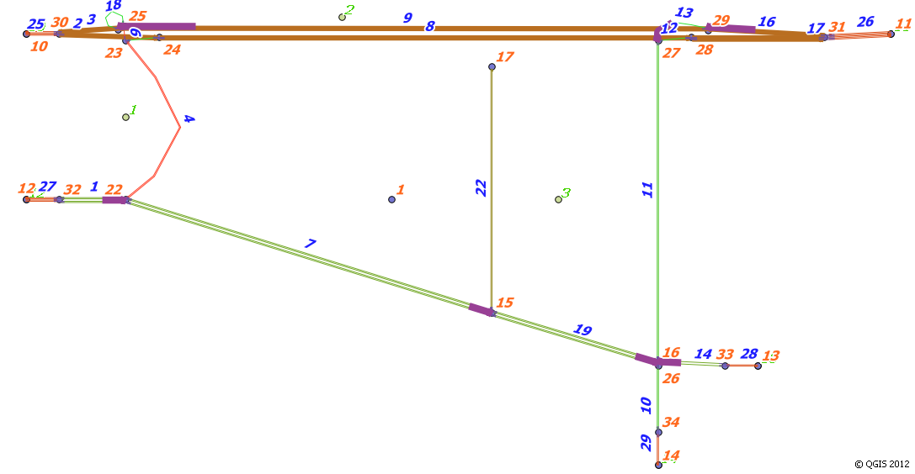

### Figure 2: A Transims Test Network Visualization using Shape Files and GIS Software

The Transims 5 test network shown in Figure 2 and elsewhere in this document is rendered using 3rd party GIS software. Select TransimsNet 5 file outputs are displayed by converting the output text files to ESRI shape files (i.e., .shp, .shpx) using ArcNet 5.0. This conversion process is discussed further in the ArcNet 5.0 Program Reference and Highway Network How-To documents. Displayed above are vector layers corresponding to TransimsNet-produced links (green lines with blue labels), nodes (blue points with red labels), zones, connections (not visible in this view; represents connections between links at intersections), and pocket lanes (thick, purple shaded lines centered at specific intersections). Note that the node, link, and zone shape file labels reflect the numbering assigned by TransimsNet. This is a very simple network but still quite sufficient to show many of the various features of Transims 5. The process of reviewing output network files (further described elsewhere as noted) is a key element of the Transims network iterative review and refinement process. For instance, network coding errors can be identified visually in many cases, corrections can be made, and the network can then be re-synthesized. This iterative process is a fundamental step toward producing a valid, verified network that is both representative of the traffic network being modeled and suitable for subsequent routing and simulation.

Note that all the network graphics presented in this document use the Tiny Example Network, updated for TRANSIMS 5.0.

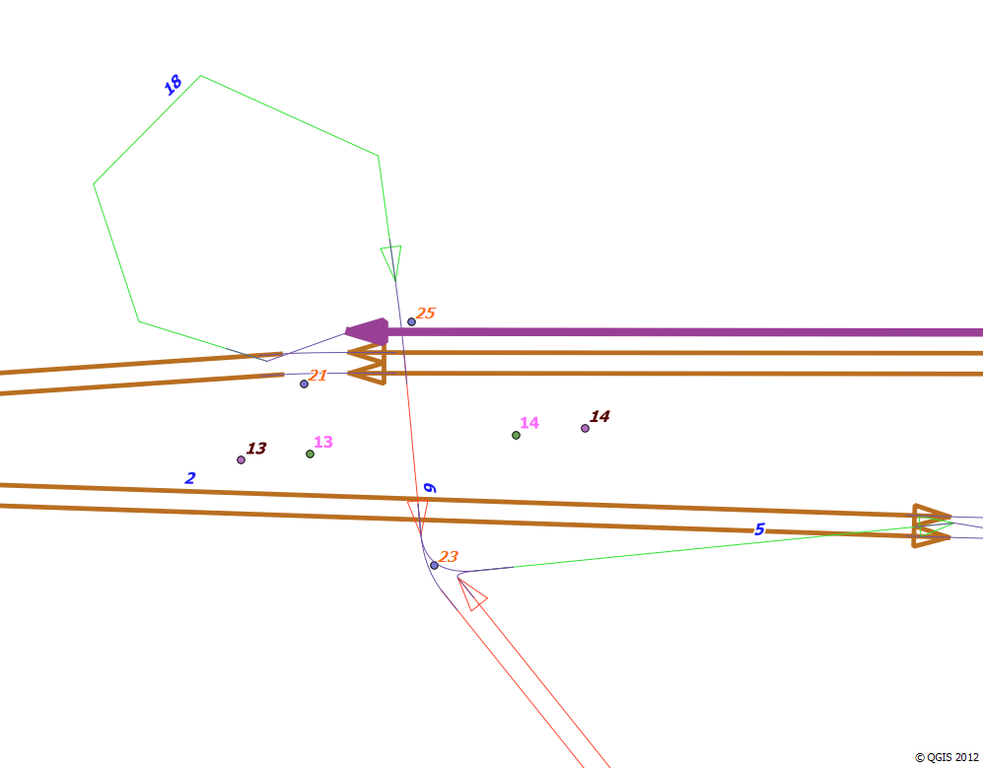

### Figure 3: Transims Test Network Upper-Left Corner-Links, Nodes, and Pocket Lanes

The above graphic is a zoomed in view of the upper-left corner of the test network shown in Figure 2 that shows a highway onramp/off-ramp network structure. A few items are worth noting here. First, link directionality is indicated for links and pocket lanes in the network. As noted above, the thick, purple, shaded link (and arrow) indicate a pocket line (and directionality as visible here). The different color links correspond to the various functional classes or types of links (major arterial, minor arterial, etc.) The link type is an attribute present in the Link shape file (produced by ArcNet, or other methods), and this attribute can be used to stratify the various link types visually using most of the common GIS packages (ArcGIS©, TransCAD©, QuantumGIS©-which is used above, etc.)

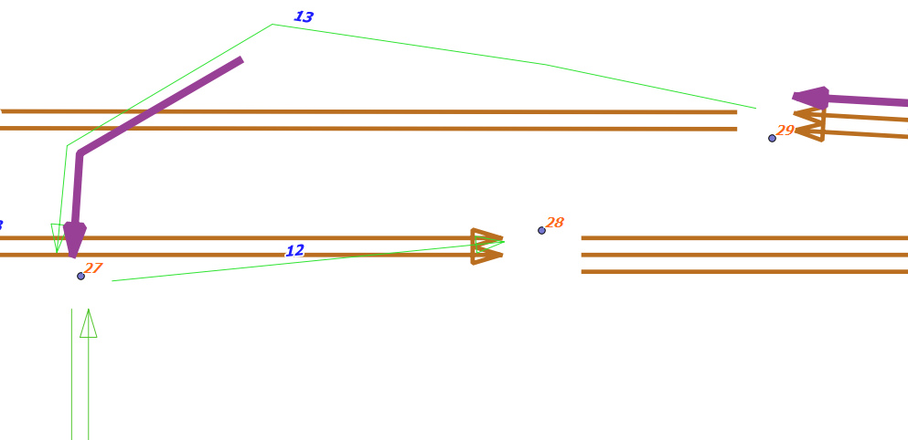

### Figure 4: Transims Test Network Upper-Right Corner-Lane Connection Shape File Hidden

The above figure shows a zoomed in view of the upper right corner of the test network without the Connection shape file layer included. The nodes (numbered in red) are clearly visible and are anchored in the center of links connected at each respective node. The inclusion of the Connection shape file layer is very helpful, as illustrated in the screenshots below. However, hiding the connection shape file may be beneficial at times in the iterative network review and correction process.

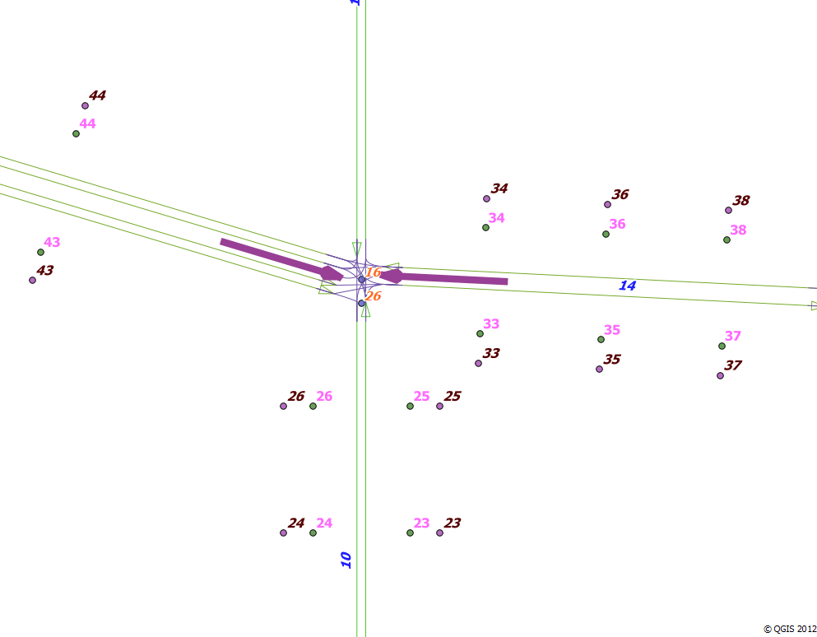

### Figure 5: Transims Test Network Lower-Right Corner-Parking and Location Shape Files Visible

Note the purple and green nodes that have corresponding numbers and are offset from and parallel to the nearby network links both vertically (e.g., 23, 23…26, 26) and horizontally (e.g., 33, 33…38, 38; 43, 43…44, 44). These nodes represent the Parking file (green nodes) and Location file shape files (purples nodes), respectively. These files/nodes also represent the means by which Transims loads vehicles onto the network to initiate a trip and off of the network to end a trip. They are discussed further in the Highway Network How-To Guide.

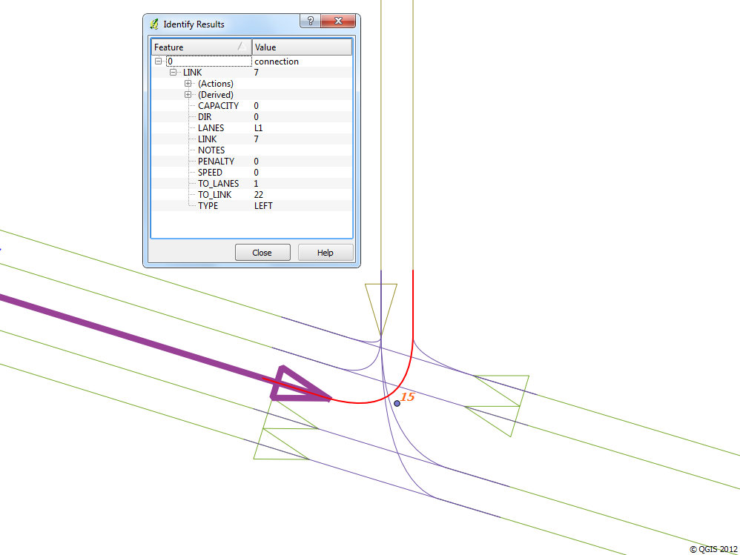

### Figure 6: Transims Test Network Lower-Middle Intersection-Lane Connections and Textual Attributes

Figure 6 shows a zoomed in view of the lower-middle test network intersection. At this level of detail, the user can select an individual link, node, or connection quite easily. An initially suspect looking left turn connection shape is highlighted in red above. Note that the attributes associated with it are listed in the popup table also pictured. This combination of textual network data validation in tandem with graphical review of the final network is crucial to creating a network that is free of significant coding errors. Whenever are found, the previously mentioned pre- and post-processing methods and business rules can be applied to quickly correct the issues in many cases, regenerate the network, and confirm the result is correct. Complicated intersection geometries should be given particular attention.

Also note that starting in TRANSIMS 5.0, the program ArcNet 5.0 generates smoothed/curved shape file links at intersections rather than angled ramps for instance. This provides for easier accessibility in the graphical review process and a more realistic representation of the network. ArcNet 5.0 is discussed further in its respective program reference.