Camera Validation Report
Full-spectrum spectrometer comparison with filtered camera measurements

Main conclusion
The camera produces structured, wavelength-dependent data and tracks the spectrometer well in several matched sample series. The current dataset supports a credible proof of concept, especially with per-sample normalized fingerprints. It is not yet a calibration-grade proof across every sample because exposure/reference control appears inconsistent.
Measurement | Value
Paired camera-spectrum measurements | 28
Per-sample fingerprint comparisons | 5
Median camera/spectrometer fingerprint correlation | 0.603
Full-spectrum classifier accuracy | 41.7%
PCA variance explained by PC1 + PC2 | 61.0%

Executive Summary
- The new TXT files contain real spectrometer data: each spectrum has 2048 wavelength-intensity points across the full measured range.
- The analysis intentionally uses the complete spectrum for full-spectrum area, normalized curve shape, centroid, PCA, and similarity calculations.
- The strongest camera-vs-spectrometer evidence is the per-sample fingerprint comparison: several sample series show moderate to strong tracking between camera response and spectrometer full-spectrum response.
- The median per-sample normalized camera/spectrometer correlation is 0.603.
- The global raw correlation is weak, which is expected if camera exposure, white balance, sample placement, or reference conditions changed between captures.
- A naive full-spectrum healthy/unhealthy classifier is weak in this dataset, so the report does not claim disease classification is solved. The defensible claim is that the camera captures useful wavelength-dependent signal that can be aligned to spectrometer measurements under controlled conditions.

Most Useful Evidence For Your App
Sample | Condition | Filters | Camera vs spectrum r | Interpretation
Set frunze 1/frunza nesanatoasa | unhealthy | 5 | 0.772158 | strong match
Set frunze 1/frunza verde | healthy | 6 | 0.62609 | moderate match
Set frunze 2/nesanatoasa | unhealthy | 5 | -0.139189 | weak or inconsistent
Set frunze 2/sanatoasa | healthy | 6 | 0.603096 | moderate match
frunza sanatoasa dar galbena | healthy_yellow | 6 | -0.540308 | weak or inconsistent

Method
The analysis parsed all available spectrometer TXT files and camera JPG files from the real data folder. For every matched camera/spectrum pair, the matching key was sample folder plus filter label. The spectra were smoothed with a Savitzky-Golay filter, but no wavelength range was removed; the full measured curve was kept for full-spectrum features.
Feature | Meaning
Full-spectrum area | Integral of the smoothed, dark-corrected positive signal over the entire measured wavelength range.
Normalized spectrum | Z-normalized smoothed curve using all 2048 points.
Camera brightness | Mean leaf-pixel brightness from the segmented camera image.
Fingerprint correlation | Correlation across filters between camera response and spectrometer full-spectrum area within the same sample.
PCA | Dimensionality reduction of the complete normalized spectrum, not selected bands.

Findings

1. The camera signal is structured, not random
The filtered camera images produce repeatable changes across filter labels. This is visible in the fingerprint plots and camera feature heatmap. The signal is not merely noise; it changes with filter, sample, and condition.

2. The spectrometer confirms strong wavelength-dependent structure
The spectrometer curves show strong filter-dependent peaks and broad full-spectrum differences. This makes them suitable as a reference instrument for validating the camera response.

3. Per-sample comparison is the right proof strategy
Raw global correlation is weak because the dataset combines different leaves, conditions, references, and likely camera exposure states. When each sample is normalized internally and compared as a response fingerprint, several samples show useful agreement.
- Set frunze 1/frunza nesanatoasa: r=0.772, R^2=0.596.
- Set frunze 1/frunza verde: r=0.626, R^2=0.392.
- Set frunze 2/sanatoasa: r=0.603, R^2=0.364.

4. The present dataset does not prove universal calibration yet
Some sample series are weak or inverted, and the full-spectrum classifier does not separate healthy/unhealthy reliably (accuracy 41.7%). This does not mean the camera is useless; it means the proof should be framed as a working, wavelength-sensitive camera prototype, not a finished calibrated instrument.

Core Figures
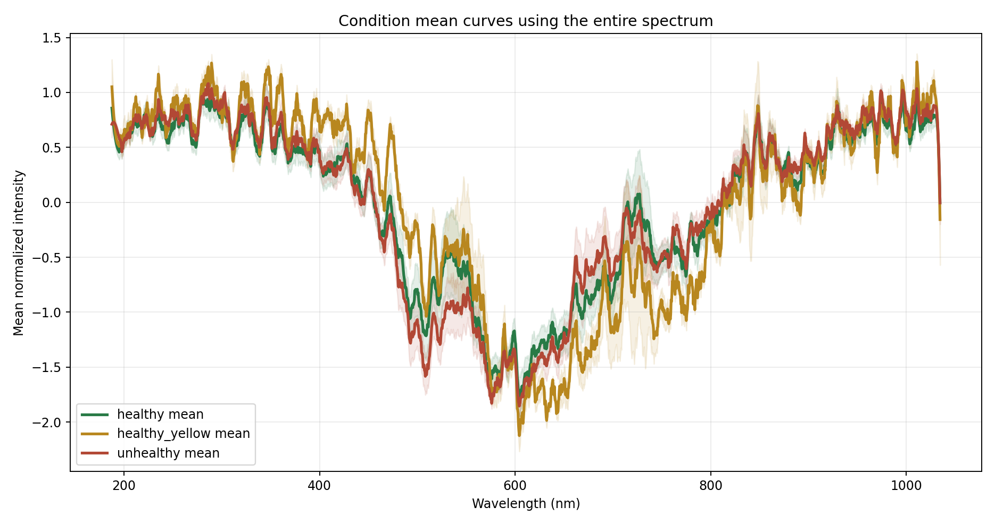
Figure 1. Mean full-spectrum curves by condition.
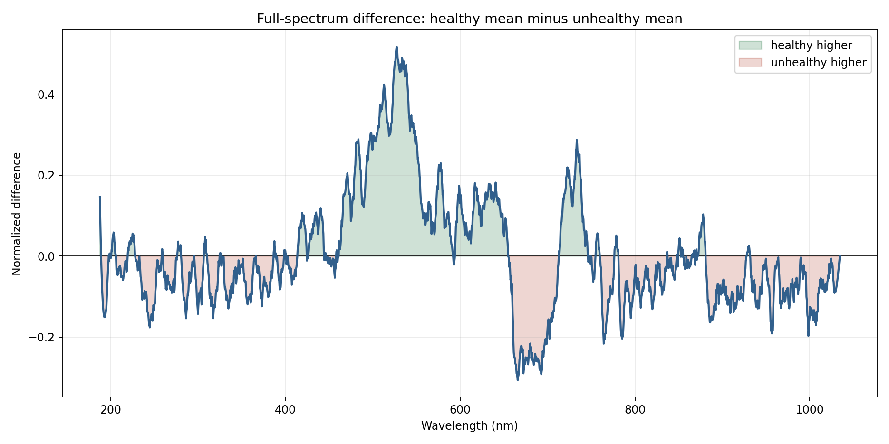
Figure 2. Full-spectrum difference curve: healthy minus unhealthy.
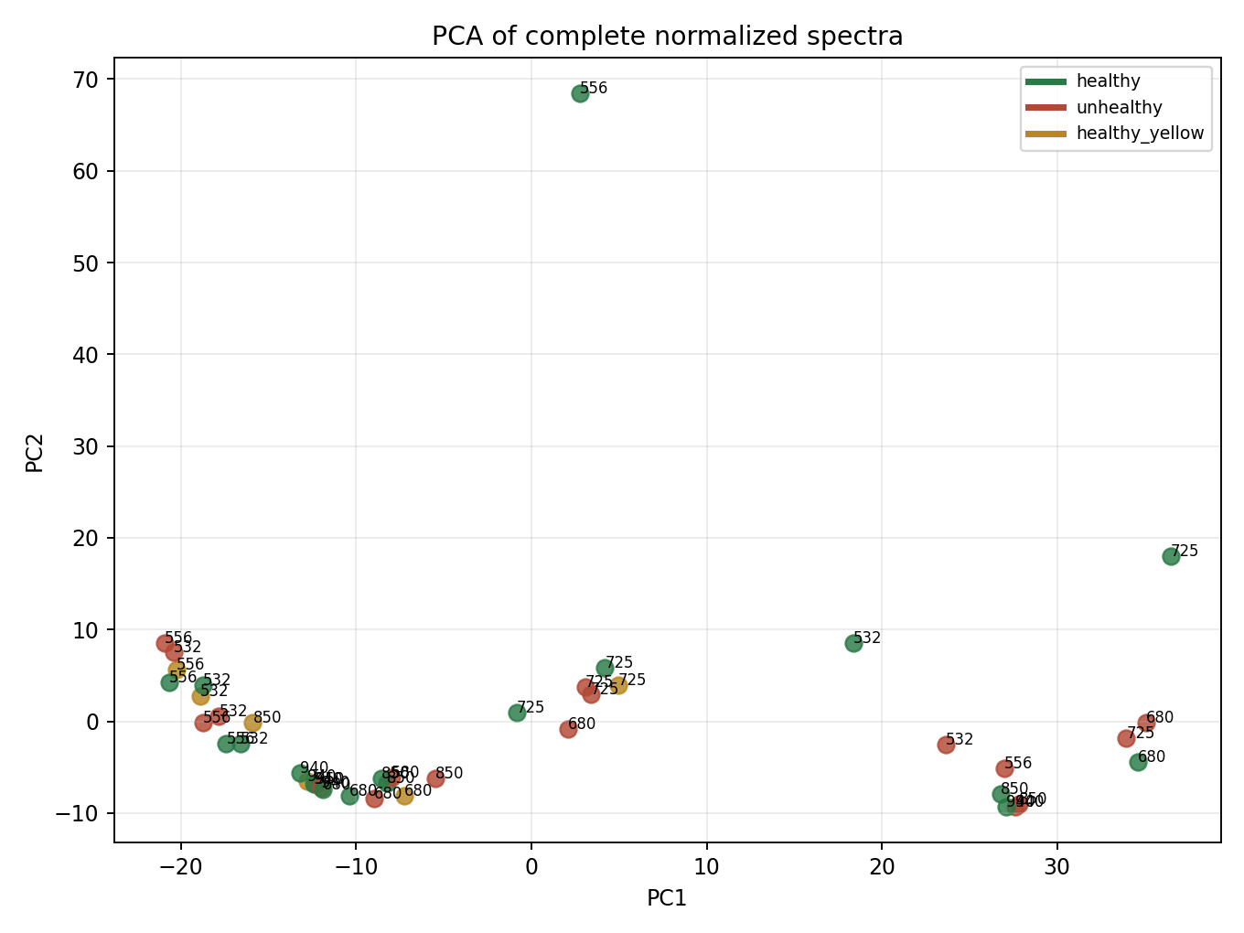
Figure 3. PCA of complete normalized spectra.
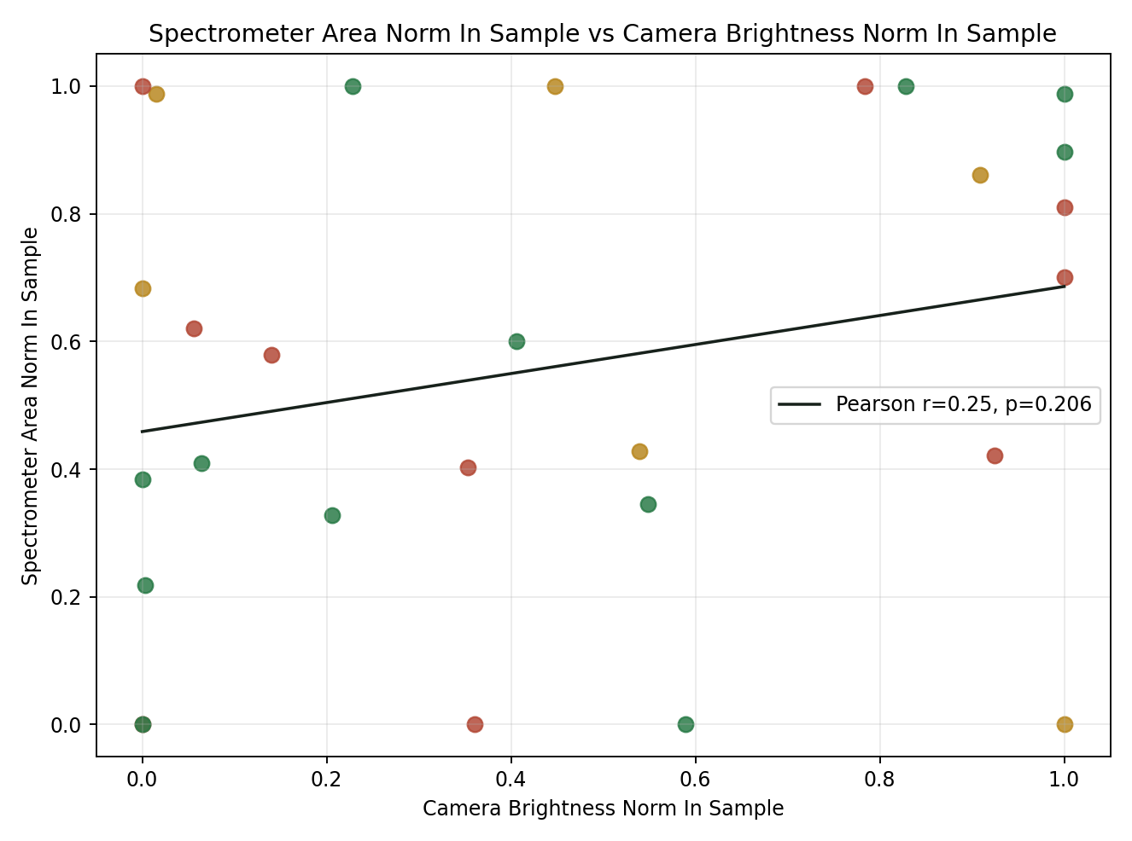
Figure 4. Within-sample normalized camera response versus spectrometer full-spectrum response.
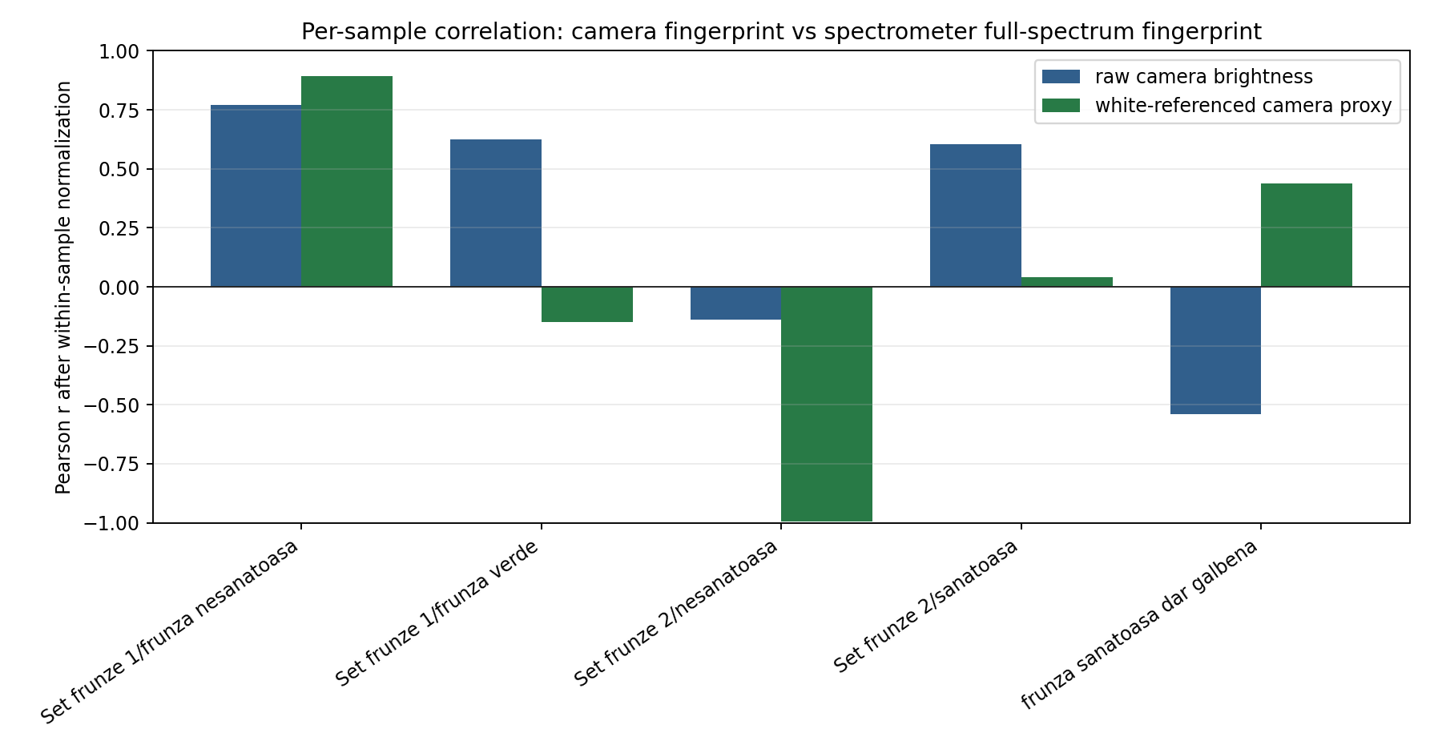
Figure 5. Per-sample correlation between camera and spectrometer fingerprints.
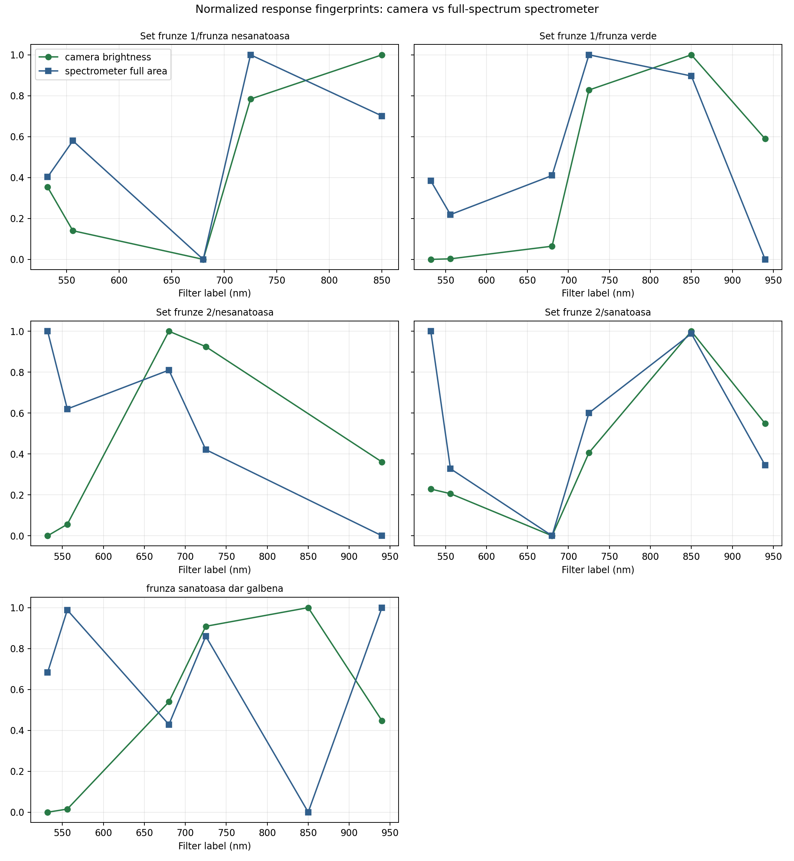
Figure 6. Camera and spectrometer response fingerprints by sample.
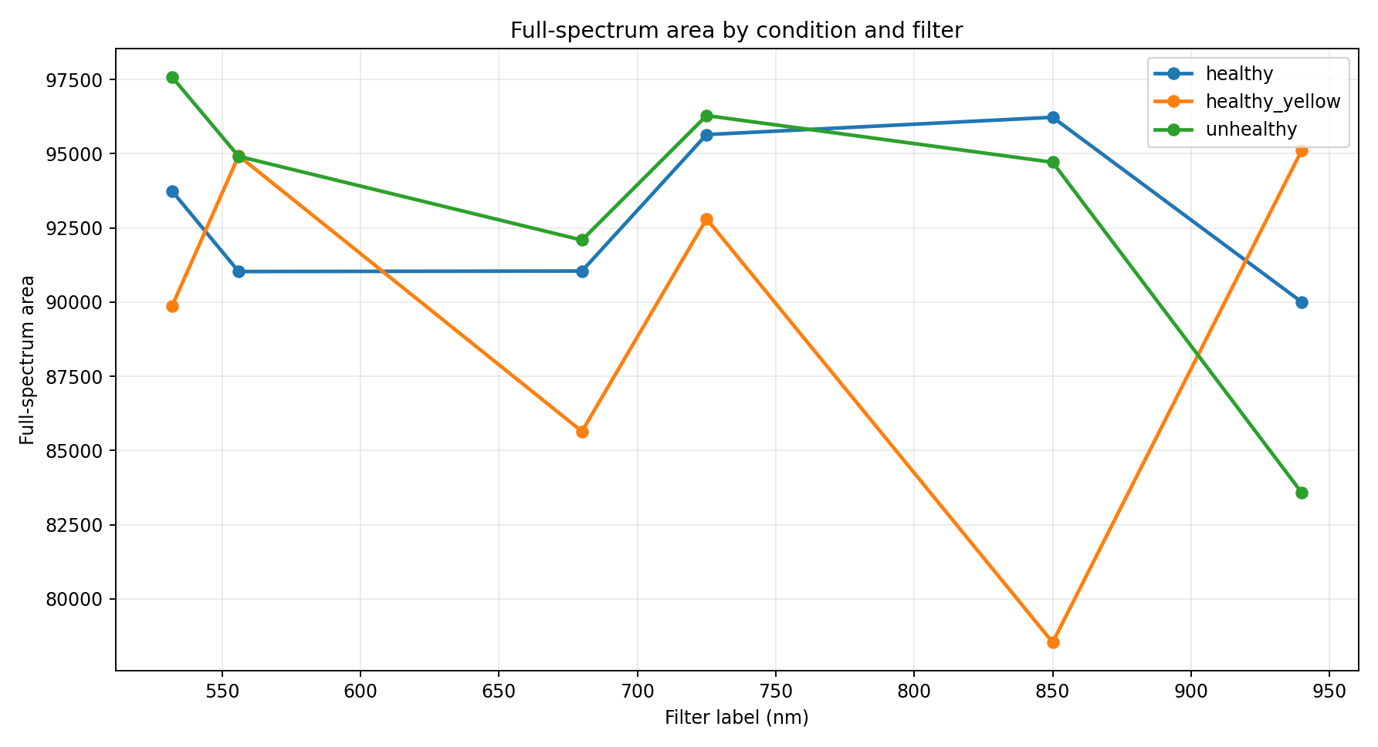
Figure 7. Spectrometer full-spectrum area by condition and filter.
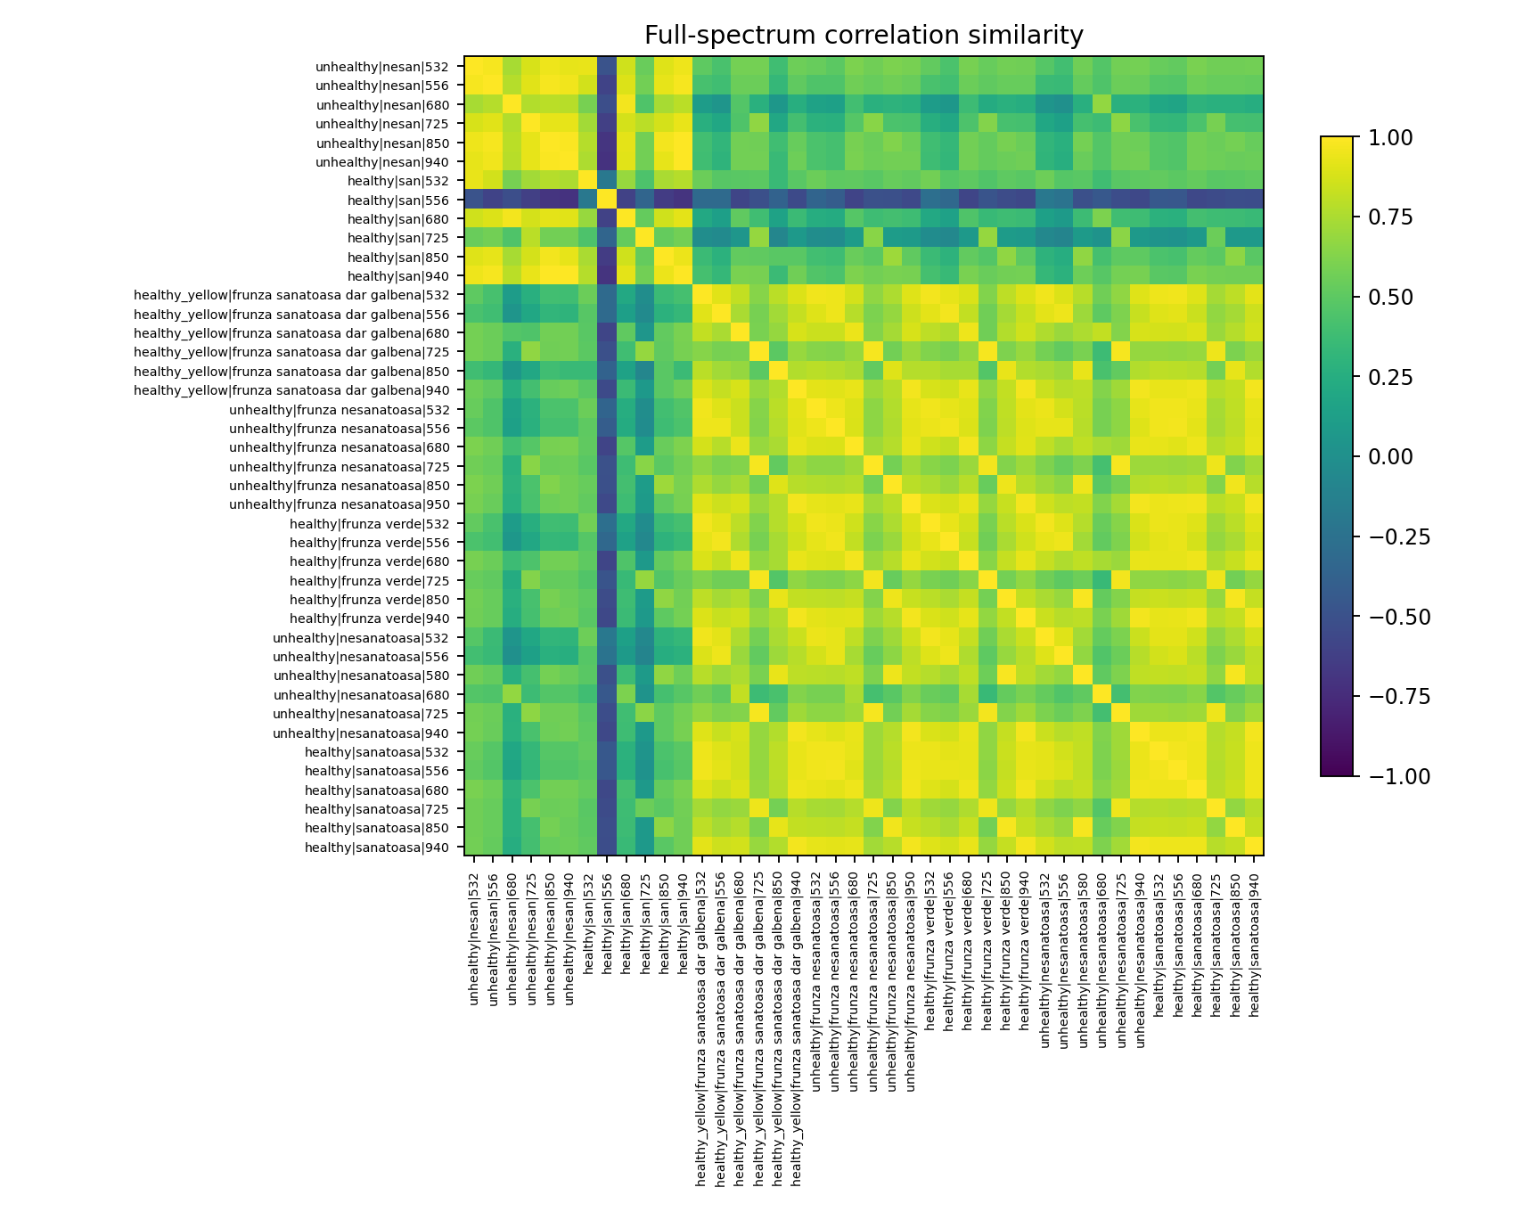
Figure 8. Full-spectrum similarity heatmap.

How To Use This In The App
Use the camera as a multispectral response sensor by comparing response fingerprints rather than isolated raw brightness values. In the app, every sample should produce both a camera fingerprint and, when available, a spectrometer fingerprint.
- Segment the leaf in each filtered camera image.
- Compute camera brightness, saturation, GCC, and other image features.
- Normalize those features within the sample across filters.
- For spectrometer validation, compute full-spectrum area and normalized full-spectrum shape using all wavelengths.
- Report camera/spectrometer fingerprint correlation as a confidence score.
- Flag low-correlation samples for retake or calibration review.
Best proof-of-concept claim
The camera captures wavelength-dependent leaf response patterns that can be compared to a spectrometer. Under controlled sample series, the camera fingerprint moderately to strongly tracks the spectrometer full-spectrum fingerprint.

Limitations And Next Measurements
- The JPG files do not expose useful EXIF exposure metadata, so changing exposure/white balance cannot be corrected after the fact.
- White-reference correction helps some samples but hurts others, suggesting the reference setup was not fully matched to every sample.
- The camera and spectrometer likely do not observe exactly the same spatial region of the leaf.
- Some classes are confounded with filter and environment. A naive classifier should not be used as the headline proof.

Recommended retake protocol
- Lock camera exposure, ISO, focus, and white balance.
- Capture white and dark references for every filter in the same session.
- Use the same leaf ROI for camera and spectrometer measurements.
- Take at least three repeats per condition/filter.
- Keep filenames machine-readable: sample_condition_filter_repeat.

Graph Appendix
All candidate graphs were generated as separate PNG files in the graphs folder. Use this list to choose which ones to include in a final presentation or app documentation.
Graph file | Title
01_full_spectrum_raw_all.png | Raw full spectra, all samples
02_full_spectrum_normalized_by_condition.png | Smoothed normalized full spectra by condition
03_condition_mean_full_spectrum.png | Condition mean full-spectrum curves
04_healthy_minus_unhealthy_difference.png | Healthy minus unhealthy full-spectrum difference
05_full_spectrum_pca.png | Full-spectrum PCA score plot
06_camera_vs_spectrometer_full_area.png | Camera brightness vs full-spectrum area
07_camera_vs_spectrometer_normalized.png | Within-sample normalized camera vs spectrometer response
08_camera_reflectance_proxy_vs_spectrometer.png | White-referenced camera proxy vs spectrometer response
09_per_sample_correlation_bars.png | Per-sample camera/spectrometer fingerprint correlations
10_fingerprint_overlays_by_sample.png | Camera and spectrometer response fingerprints by sample
11_camera_feature_heatmap.png | Camera feature heatmap
12_spectrometer_feature_heatmap.png | Spectrometer feature heatmap
13_reference_spectra.png | White/dark/source reference spectra
14_peak_and_centroid_by_filter.png | Peak and centroid by filter
15_classifier_confusion_matrix.png | Full-spectrum nearest-centroid classifier confusion matrix
16_condition_camera_separation.png | Camera feature separation by condition
17_spectrum_area_by_condition_filter.png | Full-spectrum area by condition and filter
18_full_spectrum_similarity_heatmap.png | Full-spectrum similarity heatmap
19_camera_contact_sheet.png | Camera contact sheet

