International Event

s12350130, 黃祥偉, David

1. Introduction

Tunghai University is planning to host a major international event, welcoming university presidents from around the world. As one of the largest universities in Taiwan, Tunghai regularly accommodates a high volume of vehicles. Many faculty members and staff drive their own vehicles to campus, and visitors also contribute to the number of vehicles entering daily. However, with this increase in vehicle traffic, the risk of accidents on campus rises. To ensure the safety of attendees during the event, I, as a data analyst, aim to identify the optimal time for hosting the event by analyzing vehicle entry data. The goal is to select a date when vehicle traffic on campus is at its lowest, thereby minimizing the risk of accidents during the event.

1. Data

To conduct this analysis, I require data on all the vehicles that entered Tunghai University over the course of a week. This will help determine the best day to hold the event with minimal traffic. I obtained the data from Tunghai University's website, which provides information about campus traffic. The dataset includes the number of cars and motorcycles entering the university from October 10, 2020 (109年) to October 16, 2020 (109年).

Source:　<https://general.thu.edu.tw/web/course/detail.php?cid=13&id=17>

1. Result

Code:

main_gate <- read.csv('David_Vehicle_data_main_gate.csv')

main_gate_longer <- main_gate %>% pivot_longer(cols = c('Car', 'Motorcycle', 'Sum'),

names_to = 'Vehicle', values_to = 'Count')

ggplot(main_gate_longer, aes(x = as.factor(Day), y = Count, fill = Vehicle)) +

labs(title = "Tunghai University Vehicles Main Gate 2020",

x = "Day",

y = "Numbers",

caption = "By David, Data Visualization Course, Tunghai University, 2024") +

theme(plot.title = element_text(hjust = 0.5, size = 20)) +

geom_bar(position = 'dodge', stat = 'identity')

second_gate <- read.csv('David_Vehicle_data_second_gate.csv')

second_gate_longer <- second_gate %>% pivot_longer(cols = c('Car', 'Motorcycle', 'Sum'), names_to = 'Vehicle', values_to = 'Count')

ggplot(second_gate_longer, aes(x = as.factor(Day), y = Count, fill = Vehicle)) +

labs(title = "Tunghai University Vehicles Second Gate 2020",

x = "Day",

y = "Numbers",

caption = "By David, Data Visualization Course, Tunghai University, 2024") +

theme(plot.title = element_text(hjust = 0.5, size = 20)) +

geom_bar(position = 'dodge', stat = 'identity')

all_gate <- read.csv('David_Vehicle_all_data.csv')

all_gate_longer <- all_gate %>% pivot_longer(cols = c('Car', 'Motorcycle', 'Sum'), names_to = 'Vehicle', values_to = 'Count')

ggplot(all_gate_longer, aes(x = as.factor(Day), y = Count, fill = Vehicle)) +

labs(title = "Tunghai University All Vehicles 2020",

x = "Day",

y = "Numbers",

caption = "By David, Data Visualization Course, Tunghai University, 2024") +

theme(plot.title = element_text(hjust = 0.5, size = 20)) +

geom_bar(position = 'dodge', stat = 'identity')

Souce code photo:

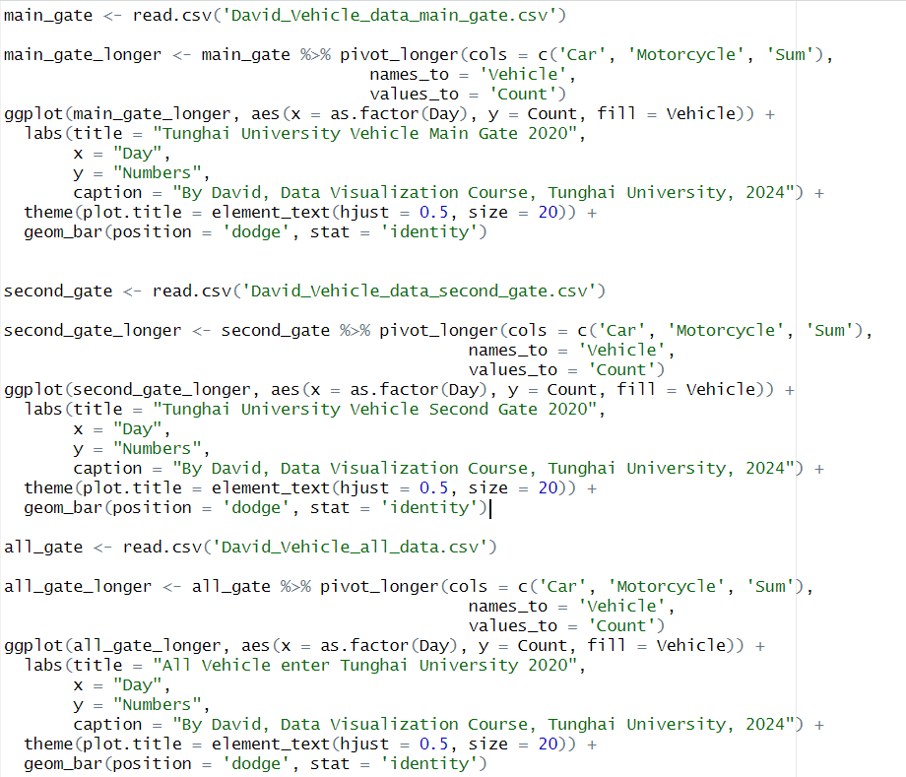

CSV file:

These are the CSV file about vehicles that enter campus from the main gate and the second gate.

This is the CSV file for the sum all the vehicles that enter Tunghai in one week

Result:

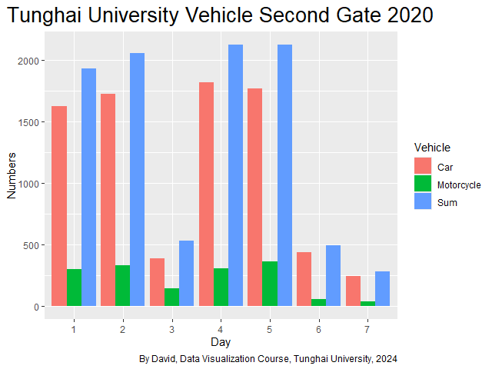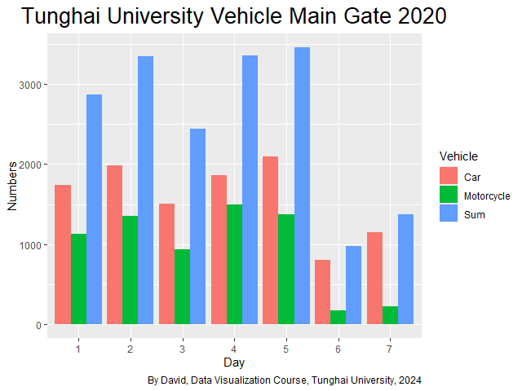

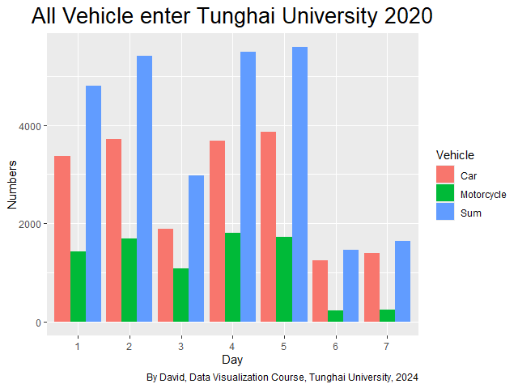

1. Conclusion:

From the data and the graph generated in RStudio, we can observe that the fewest vehicles enter the campus is on Saturday. This is evident can be taken from the graph, where the blue bar representing sum of the vehicle and Saturday blue bar is the shortest compared to the other days. The second-lowest vehicle count is on Sunday, as shown by the second-shortest blue bar. Based on this, we can conclude that Saturday has the lowest number of vehicles entering the campus. Therefore, holding the international event on Saturday will help minimize the risk of accidents caused by campus traffic.