Axes

David

2024-11-25

Table of contents

## 1. Box plot

* Draw a boxplot using PlantGrowth dataset.
* x axis represents group, y axis represents weight.
* Use geom_boxplot() function to draw boxplot.
* labs() function is to add title, axis labels, and caption.
* Use theme() function to center the title.

library(ggplot2)  
ggplot(PlantGrowth, aes(x = group, y = weight)) +  
 geom_boxplot() +  
 labs(title = "Group VS Weight",  
 caption = "By David, DV, THU, 2024") +  
 theme(plot.title = element_text(hjust = 0.5, size = 20))

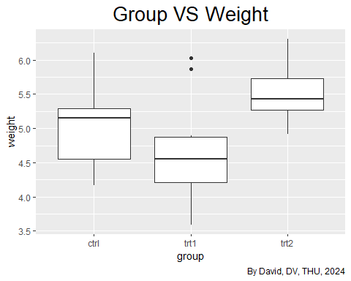

## 2. Swap x and y axes

* Use coord_flip() function to swap x and y axes.

library(ggplot2)  
ggplot(PlantGrowth, aes(x = group, y = weight)) +  
 geom_boxplot() +  
 coord_flip()+  
 labs(title = "Weight VS Group",  
 caption = "By David, DV, THU, 2024") +  
 theme(plot.title = element_text(hjust = 0.5, size = 20))

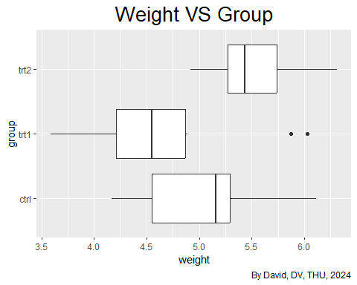

## 3. Arrange two plots side by side

* Install gridExtra library.
* Prepare two plots: p1, p2.
* Use grid.arrange() function to arrange plots and add title.

library(ggplot2)  
library(gridExtra)  
  
p1 <- ggplot(PlantGrowth, aes(x = group, y = weight)) +  
 geom_boxplot() +  
 labs(title = "Group VS Weight",  
 caption = "By David, DV, THU, 2024") +  
 theme(plot.title = element_text(hjust = 0.5, size = 20))  
  
p2 <- ggplot(PlantGrowth, aes(x = group, y = weight)) +  
 geom_boxplot() +  
 coord_flip()+  
 labs(title = "Weight VS Group",  
 caption = "By David, DV, THU, 2024") +  
 theme(plot.title = element_text(hjust = 0.5, size = 20))  
  
grid.arrange(p1, p2, ncol = 2,  
 top = 'Arrange two plots side by side')

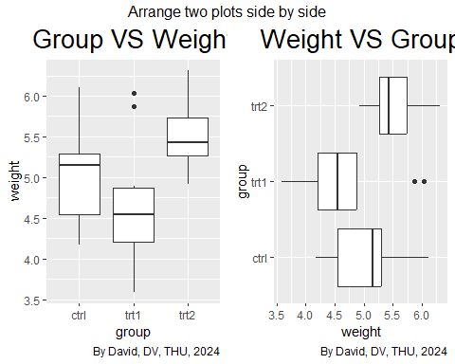

## 4. Setting the Range of a Continuous Axis

* ylim(): Sets the limits of the y-axis.

library(ggplot2)  
library(gridExtra)  
  
p1 <- ggplot(PlantGrowth, aes(x = group, y = weight)) +  
 geom_boxplot() +  
 labs(title = "Group VS Weight",  
 caption = "By David, DV, THU, 2024") +  
 theme(plot.title = element_text(hjust = 0.5, size = 20))  
  
p2 <- ggplot(PlantGrowth, aes(x = group, y = weight)) +  
 geom_boxplot() +  
 labs(title = "Group VS Weight",  
 caption = "By David, DV, THU, 2024") +  
 theme(plot.title = element_text(hjust = 0.5, size = 20)) +  
 ylim(0, max(PlantGrowth$weight))  
  
grid.arrange(p1, p2, ncol = 2,  
 top = 'Setting the Range of a Continuous Axis')

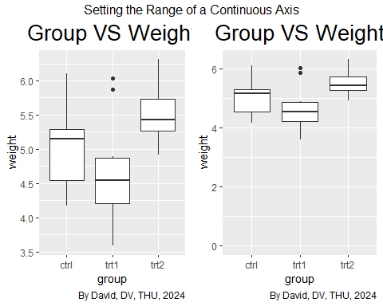

## 5. Reversing a Continuous Axis

* scale_y_reverse() reverses the direction of the y-axis on a plot. So, what was previously the highest value on the y-axis becomes the lowest, and vice-versa.

library(ggplot2)  
library(gridExtra)  
  
p1 <- ggplot(PlantGrowth, aes(x = group, y = weight)) +  
 geom_boxplot() +  
 labs(title = 'Group vs Weight',   
 x = 'Group',   
 y = 'Weight',  
 caption = 'By David, DV, THU, 2024') +  
 theme(plot.title = element_text(hjust = 0.5))  
  
p2 <- ggplot(PlantGrowth, aes(x = group, y = weight)) +  
 geom_boxplot() +  
 scale_y_reverse() +  
 labs(title = 'Group vs Weight',   
 x = 'Group',   
 y = 'Weight',  
 caption = 'By David, DV, THU, 2024') +  
 theme(plot.title = element_text(hjust = 0.5))  
  
p3 <- ggplot(PlantGrowth, aes(x = group, y = weight)) +  
 geom_boxplot() +  
 scale_y_reverse() +  
 ylim(6.5, 3.5) +  
 labs(title = 'Group vs Weight',   
 x = 'Group',   
 y = 'Weight',  
 caption = 'By David, DV, THU, 2024') +  
 theme(plot.title = element_text(hjust = 0.5))

Scale for y is already present.  
Adding another scale for y, which will replace the existing scale.

Scale for y is already present. Adding another scale for y, which will replace the existing scale.

grid.arrange(p1, p2, p3, ncol = 3,  
 top = 'Reversing a Continuous Axis')

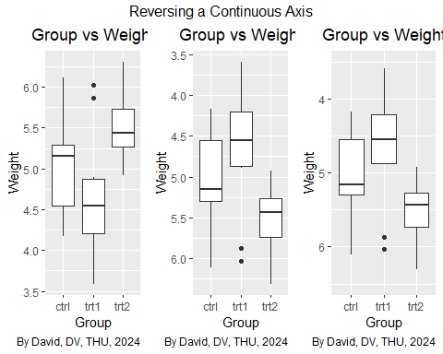

## 6. Practice: Multiple charts from Iris

* grid.arrange() function from the gridExtra package in R to arrange four plots (named plot1, plot2, plot3, and plot4) into a single figure.

plot1<-ggplot(iris, aes(x = Species, y = Sepal.Length)) +  
 geom_boxplot() +  
 labs(title = "Species VS Sepal Length",  
 caption = "By David, DV, THU, 2024") +  
 theme(plot.title = element_text(hjust = 0.5, size = 12))  
plot2<-ggplot(iris, aes(x = Species, y = Sepal.Width)) +  
 geom_boxplot() +  
 labs(title = "Species VS Sepal Length",  
 caption = "By David, DV, THU, 2024") +  
 theme(plot.title = element_text(hjust = 0.5, size = 12))  
plot3<-ggplot(iris, aes(x = Species, y = Petal.Length)) +  
 geom_boxplot() +  
 labs(title = "Species VS Sepal Length",  
 caption = "By David, DV, THU, 2024") +  
 theme(plot.title = element_text(hjust = 0.5, size = 12))  
plot4<-ggplot(iris, aes(x = Species, y = Petal.Width)) +  
 geom_boxplot() +  
 labs(title = "Species VS Sepal Length",  
 caption = "By David, DV, THU, 2024") +  
 theme(plot.title = element_text(hjust = 0.5, size = 12))  
  
grid.arrange(plot1, plot2, plot3, plot4, ncol=4,  
 top = 'David: Species and Features')

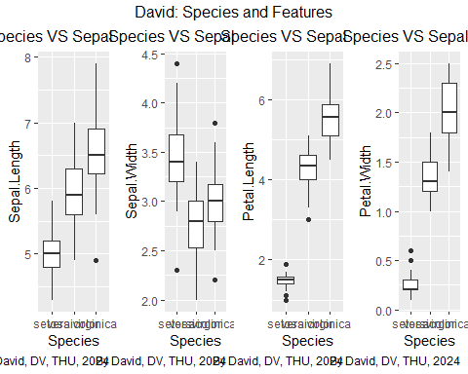

## 7. Setting the Scaling Ratio of the X- and Y-Axes

* coord_fixed() is a function that fixes the aspect ratio of the plot. This means that the units on the x-axis and y-axis will be of equal length.

library(gcookbook)   
  
plot1 <- ggplot(marathon, aes(x=Half,y=Full)) +  
 geom_point() +  
 labs(title = "Half VS Full",  
 caption = "By David, DV, THU, 2024") +  
 theme(plot.title = element_text(hjust = 0.5, size = 20))  
  
plot2 <- ggplot(marathon, aes(x=Half,y=Full)) +  
 geom_point() +  
 coord_fixed() +  
 labs(title = "Half VS Full",  
 caption = "By David, DV, THU, 2024") +  
 theme(plot.title = element_text(hjust = 0.5, size = 20))  
  
grid.arrange(plot1, plot2, ncol=2,   
 top = 'Setting the Scaling Ratio of the X- and Y-Axes')

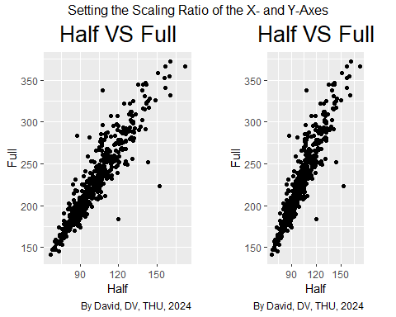

## 8. Setting the Positions of Tick Marks

* scale_y_continuous() is a function used to control the y-axis of a plot when the y-axis variable is continuous (meaning it can take on any value within a range, like temperature, weight, or time).

p1 <- ggplot(PlantGrowth, aes(x = group, y = weight)) +  
 geom_boxplot() +  
 labs(title = "Group VS Weight",  
 caption = "By David, DV, THU, 2024") +  
 theme(plot.title = element_text(hjust = 0.5, size = 20))  
  
p2 <- ggplot(PlantGrowth, aes(x = group, y = weight)) +  
 geom_boxplot() +  
 scale_y_continuous(breaks = c(4, 4.25, 4.5, 5, 6, 8)) +  
 labs(title = "Group VS Weight",  
 caption = "By David, DV, THU, 2024") +  
 theme(plot.title = element_text(hjust = 0.5, size = 20))  
  
# Add title  
grid.arrange(p1, p2, ncol = 2,  
 top = 'Setting the Positions of Tick Marks')

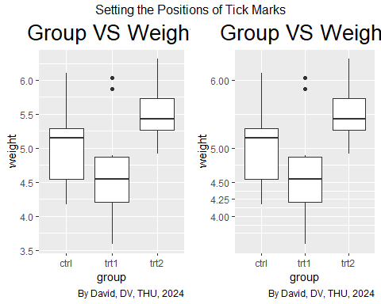

## 9. Removing Tick Marks and Labels

* To remove the tick marks, use theme(axis.ticks=element_blank()). This will remove the tick marks on both axes.
* To remove the tick marks, the labels, and the grid lines, set breaks to NULL

p1 <- ggplot(PlantGrowth, aes(x = group, y = weight)) +  
 geom_boxplot() +  
 labs(title = "Group VS Weight",  
 caption = "By David, DV, THU, 2024") +  
 theme(plot.title = element_text(hjust = 0.5, size = 12))  
  
p2 <- ggplot(PlantGrowth, aes(x = group, y = weight)) +  
 geom_boxplot() +  
 theme(axis.text.y = element_blank()) +  
 labs(title = "Group VS Weight",  
 caption = "By David, DV, THU, 2024") +  
 theme(plot.title = element_text(hjust = 0.5, size = 12))  
  
p3 <- ggplot(PlantGrowth, aes(x = group, y = weight)) +  
 geom_boxplot() +  
 theme(axis.ticks = element_blank(), axis.text.y = element_blank()) +  
 labs(title = "Group VS Weight",  
 caption = "By David, DV, THU, 2024") +  
 theme(plot.title = element_text(hjust = 0.5, size = 12))  
  
p4 <- ggplot(PlantGrowth, aes(x = group, y = weight)) +  
 geom_boxplot() +  
 scale_y_continuous(breaks = NULL) +  
 labs(title = "Group VS Weight",  
 caption = "By David, DV, THU, 2024") +  
 theme(plot.title = element_text(hjust = 0.5, size = 12))  
  
grid.arrange(p1, p2, p3, p4, ncol = 4,  
 top = 'David: Removing Tick Marks and Labels')

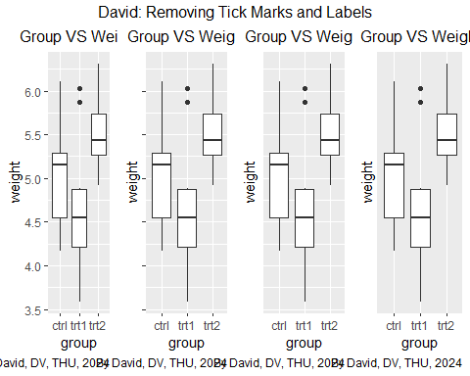

## 10. Changing the Text of Tick Labels

* breaks: Specifying the locations of the tick marks and labels on the y-axis (breaks = seq(min, max, by = interval)). This gives you more control over the spacing and readability of the axis labels.
* labels: Customizing the text of the axis labels (labels = function(x) …). This allows for formatting, unit specification, or abbreviation of the labels.

library(gcookbook)  
  
p1 <- ggplot(heightweight, aes(x = ageYear, y = heightIn)) +  
 geom_point() +  
 labs(title = "Age VS Height",  
 caption = "By David, DV, THU, 2024") +  
 theme(plot.title = element_text(hjust = 0.5, size = 20))  
  
p2 <- ggplot(heightweight, aes(x = ageYear, y = heightIn)) +  
 geom_point() +  
 scale_y_continuous(  
 breaks = c(50, 56, 60, 66, 72),  
 labels = c("Tiny", "Really\nshort", "Short", "Medium", "Tallish")  
 ) +  
 labs(title = "Age VS Height",  
 caption = "By David, DV, THU, 2024") +  
 theme(plot.title = element_text(hjust = 0.5, size = 20))  
  
# Add title  
grid.arrange(p1, p2, ncol = 2,  
 top = 'Changing the Text of Tick Labels')

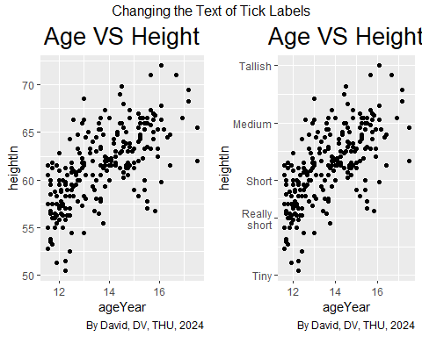

## 11. Lower ‘Tallish’ to include 6 people

* Use scale_y_continuous() to change the text of the axis labels
* Use breaks = c() to break the axis labels
* Use labels = c() to add a name in axis labels

p1 <- ggplot(heightweight, aes(x = ageYear, y = heightIn)) +  
 geom_point() +  
 labs(title = "Age VS Height",  
 caption = "By David, DV, THU, 2024") +  
 theme(plot.title = element_text(hjust = 0.5, size = 20))   
  
p2 <- ggplot(heightweight, aes(x = ageYear, y = heightIn)) +  
 geom_point() +  
 scale_y_continuous(  
 breaks = c(50, 56, 60, 66, 69),  
 labels = c("Tiny", "Really\nshort", "Short", "Medium", "Tallish")  
 ) +  
 labs(title = "Age VS Height",  
 caption = "By David, DV, THU, 2024") +  
 theme(plot.title = element_text(hjust = 0.5, size = 20))  
  
# Add title  
grid.arrange(p1, p2, ncol = 2,  
 top = 'Lower Tallish to include 6 people')

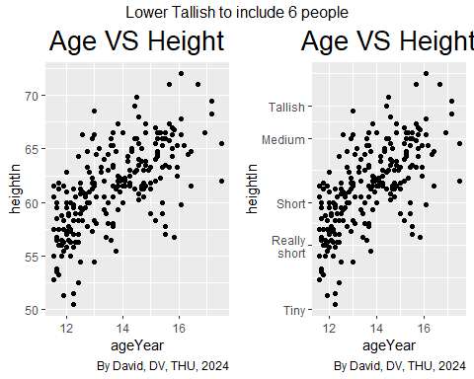

## 12. Changing the Appearance of Tick Labels

* axis.text.x = element_text(...): This part specifically targets the text elements of the x-axis. element_text is a function that controls the formatting of text within the plot.
* angle = 30: This rotates the x-axis labels by 30 degrees. This is often useful when labels are long and overlapping.

library(ggplot2)  
library(gridExtra)  
pg_plot <- ggplot(PlantGrowth, aes(x = group, y = weight)) +  
 geom_boxplot() +  
 scale_x_discrete(  
 breaks = c("ctrl", "trt1", "trt2"),  
 labels = c("Control", "Treatment 1", "Treatment 2")  
 ) +  
 labs(title = "Group VS Weight",  
 caption = "By David, DV, THU, 2024") +  
 theme(plot.title = element_text(hjust = 0.5, size = 16))  
p1 <- pg_plot  
p2 <- pg_plot +  
 theme(axis.text.x = element_text(angle = 90, hjust = 1, vjust = .5))  
p3 <- pg_plot +  
 theme(axis.text.x = element_text(angle = 30, hjust = 1, vjust = 1))  
  
grid.arrange(p1, p2, p3, ncol = 3,  
 top = 'Changing the Appearance of Tick Labels')

