Hello, Quarto

## Meet Quarto

Quarto enables you to weave together content and executable code into a finished document. To learn more about Quarto see <https://quarto.org>.

## Meet the penguins

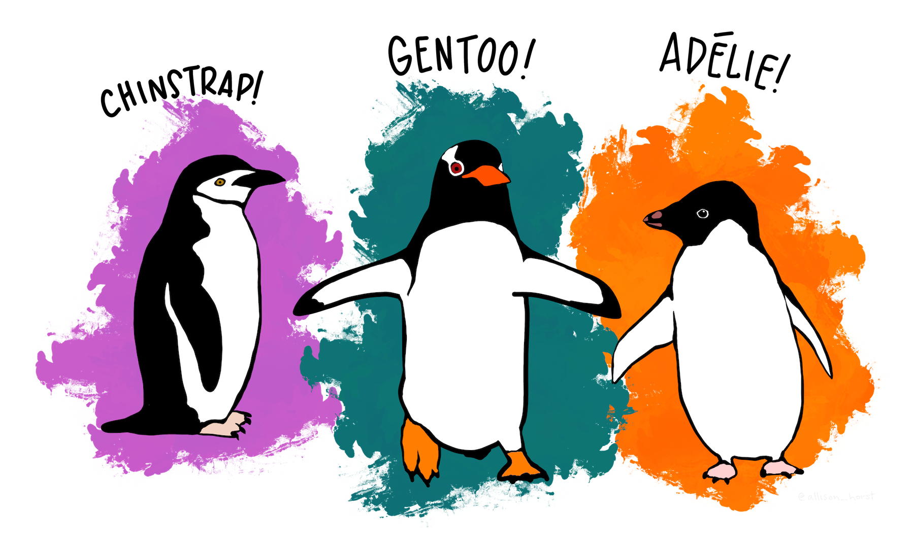

The penguins data from the [**palmerpenguins**](https://allisonhorst.github.io/palmerpenguins) package contains size measurements for 344 penguins from three species observed on three islands in the Palmer Archipelago, Antarctica.

The plot below shows the relationship between flipper and bill lengths of these penguins.

ggplot(penguins,   
 aes(x = flipper_length_mm, y = bill_length_mm)) +  
 geom_point(aes(color = species, shape = species)) +  
 scale_color_manual(values = c("darkorange","purple","cyan4")) +  
 labs(  
 title = "Flipper and bill length",  
 subtitle = "Dimensions for penguins at Palmer Station LTER",  
 x = "Flipper length (mm)", y = "Bill length (mm)",  
 color = "Penguin species", shape = "Penguin species"  
 ) +  
 theme_minimal()

