Continuing Education Program

Centre for Computing and Information Technology

Faculty of Engineering – University of Indonesia

Tel: 021-7863508 Mail: ccit.@eng.ui.ac.id

**PROJECT**

**Baljid Game Store Application Using Java Netbeans and SQL Server**

|  |  |
| --- | --- |
| Name : | * Fakhrizal Syaiful Mustofa |
|  | * Rivaldy Fernando A.A * David Ardian Alim |
| Faculty : | Mr. Ramadhan |
| Quarter : | 4 |
| Class : | 2NAP 2 |

Continuing Education Center for Computing and Information Technology Faculty of Engineering, University of Indonesia

2019

**PROJECT ON**

Baljid GameStore

**Developed by :**

1. Fakhrizal Syaiful Mustofa
2. Rivaldy Fernando A
3. David Ardian Alim



**BALJID GAMESTORE**

Batch Code : 2 NAP 2

Start Date : July 10,2019

End Date : July 18, 2019

Date of Submission : April 19,2019

Name of Faculty : Mr. Ramadhan

Name of Developer : David Ardian Alim

Fakhrizal Syaiful Mustofa

Rivaldy Fernando A. A.



**CERTIFICATE**

This is to certify that this report titled “**Baljid GameStore”** embodies the original work done by Fakhrizal Syaiful Mustofa, Rivaldy Fernando A.A, David Ardian Alim In partial fulfillment of their course requirement at NIIT.

Coordinator

Mr. Ramadhan

**ACKNOWLEDGEMENT**

In this era, technological growth is increasingly rapid, human needs and desires are increasing and developing, pushing for technological progress, especially in the field of Games Sales Services. Games Sales Services are increasingly developing in this digital era, first Games Sales Services were only as a time saver, so someone does not need to buy cassette

At the same time the Games Sales Services has grown and often used to downloading games for Customer. Especially Games Shop

**SYSTEM ANALYSIS**

**SYSTEM SUMMARY :**

Baljid GameStore is Baljid's digital content service that covers online stores for products such as Games Sales. This service can be accessed both through the web, and android application

**ERD**

This ERD is responsible for all tables, for example this ERD. And is Connected to all tables

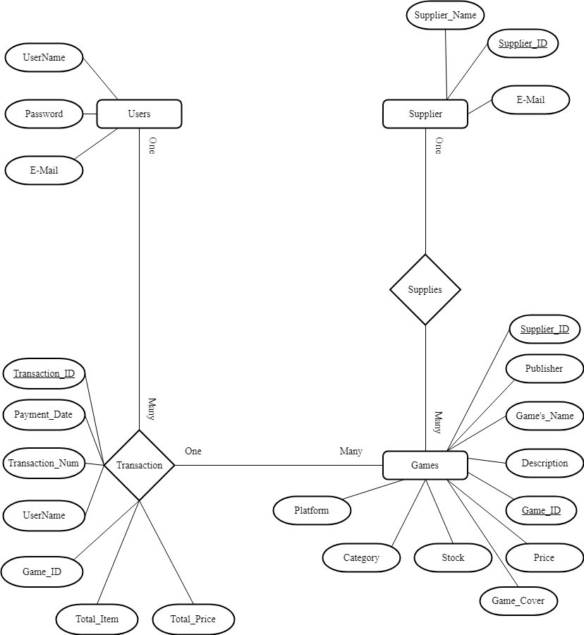

**Login Display**

In this Form The employee can enter the Dashboard menu by logging in first, the employee must enter her Username and Password Correctly.



**Dashboard Display**

In this Form the employee can choose the form which are desired to used.

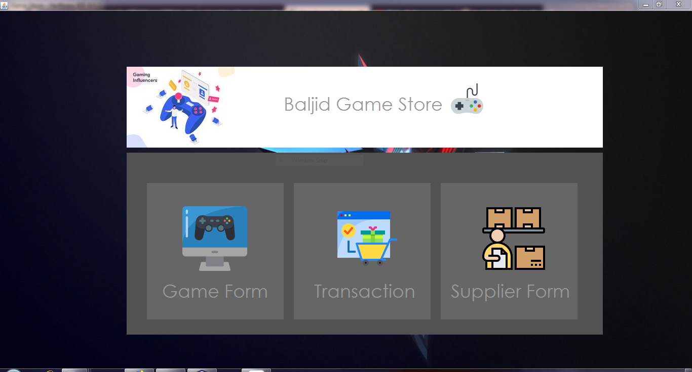

**Game Form Display**

In this Form The employee can enter the game what the customer want to buy, set game prices according to selling prices , and then employees can add games depending on existing suppliers.

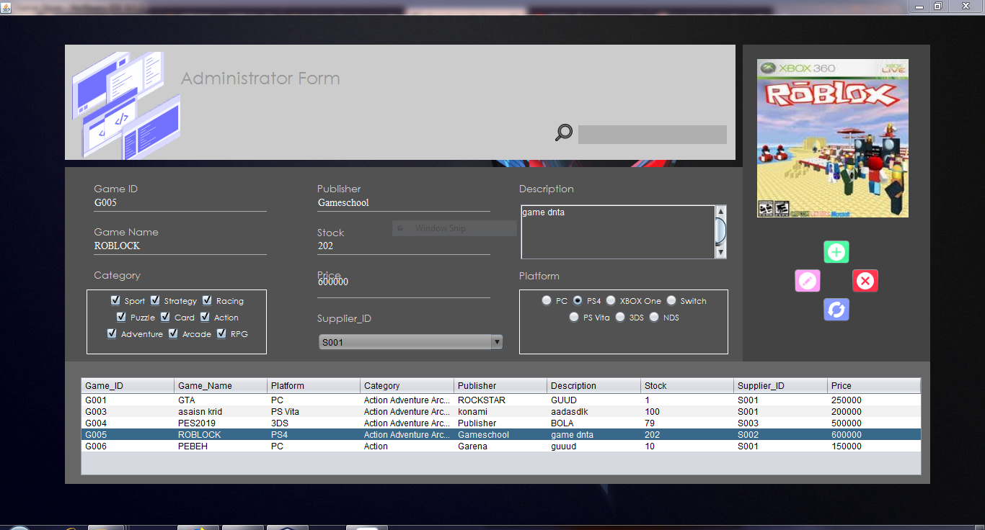

**Transaction Form Display**

In this Form to start work, the employee must login first for doing the transaction with customer.

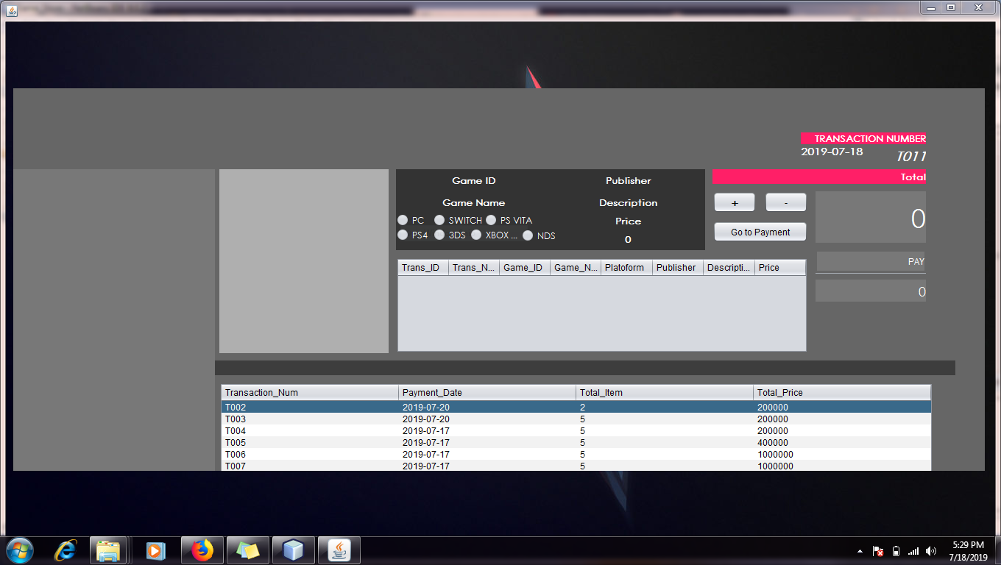

**Supplier Form Display**

This Form used to add stock games in the application

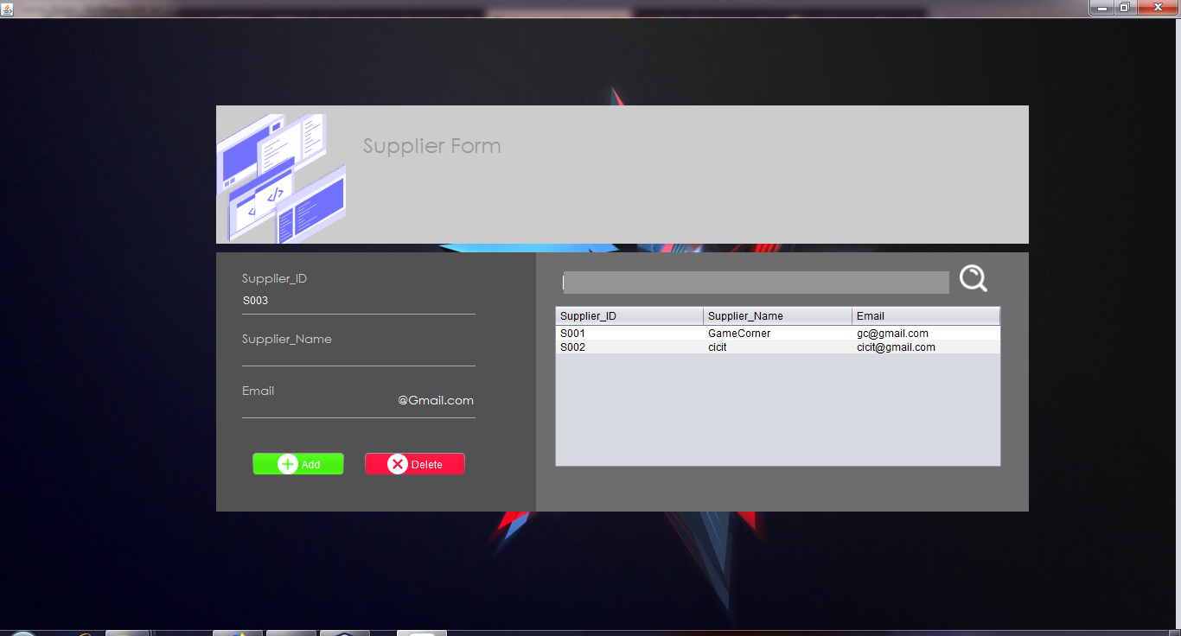

**CONFIGURATION**

**Hardware : Asus Vivo Book x540b**

* **4gb ram**
* **2gb vga Radeon R5**
* **Amd A9 Processor**

**HP Notebook 14**

* **4gb ram**
* **Amd A8 Processor**

**Asus X441UA**

* **4gb ram**
* **2gb vga Intel HD**
* **IntelCore i3 Processor**

**Operating system :** Windows 10 64-bit

**Software :** Netbeans IDE 8.2, SQL Server 2017