CE/CS/SE 3354 Software Engineering Team Final Project Report
Study Room Booking System
Deliverables #2 Report
Task 2 – Diego Mireles
Team Member Tasks
Diego Mireles: Reports the delegation of tasks for each team member. Summarizes all information that was reported in Team Project Deliverable 1. Creates the project’s objective along with the proposed application design and prototype.
David Aiyeyemi: Responsible for creating and executing unit tests for the software in our project. They will develop a test plan, write and test a program unit using Junit, and document the test case results to ensure it is working properly. They will also demonstrate both true and false test-case executions from the test plan.
Maryam Ahmed: Develops the project schedule and estimates the project’s duration, staffing, cost, effort, and pricing using the approved cost modeling technique. They will also prepare the project cost estimation and create the project timeline for the proposed system.
Cameron Yousif: Responsible for estimating the costs associated with the project which include the hardware and software products along with the personnel expenses. They will determine the resources and staffing needed to develop and create the final project.
Anjali Ayyappan: Responsible for researching and comparing the proposed system with similar existing designs. Evaluates the final project and any changes made during development. They also documented the challenges and lessons learned from the project while also compiling the project’s references.

Task 3 – Diego Mireles
Deliverable # 1
GitHub Repository
https://github.com/DavidA-software/3354-Team2.git
Project Assumptions
- The system will only be accessible to currently enrolled students or administration with valid university credentials.
- Each room will have a max capacity and list of equipment available for each room stored in the database.
- The reservations can only be made for four hours maximum.
- A user can only have one active reservation at a time for a specific time slot and cannot overlap other reservations.
- Users can make reservations for the study rooms up to a week in advance.
- Administration has access to edit room information and cancel reservations as needed.
- The university will provide an internet connection that allows users to access the system through a web browser.

Deliverable #1 Feedback
Our team did not receive any specific feedback on the project. We will continue with the original
project plan and make minor improvements as needed.

Project Software Process Model
The software process model that we employed in our project for the study room booking system
is The Incremental Model. This model is the best for our project because it allows the team to
develop the system in increments rather than building the system all at once. It also will allow
users to use the booking system early in development while we develop and add more features.
Since each team member is responsible for different parts of the system, the Incremental Model
let's us develop simultaneously and individually we can plug in our components to the final
product. Ultimately, this software process model allows our team to work collaboratively while still being flexible enough to make improvements during development.

Software Requirements
Functional Requirements
- The system shall allow all users to view available study rooms based on capacity and equipment.
- The system shall allow admin users to add, delete, and update study rooms from the database.
- The system shall allow all users to add a study room for reservation, including the day of the week in which it is booked as well as the start and end time.
- The system shall allow all users to delete and modify their existing study room reservations.
- The system shall allow all users to register their account and authenticate as either a student or an administration.
- The system shall allow all users to view their past and future reservations.
Non-Functional Requirements
- Product
  - Performance
    - The system shall display available study rooms within 2 seconds of the user submitting specific filters.
  - Reliability
    - The system shall maintain an uptime of 99% of the time, every day of the week at all hours.
  - Security
    - The system shall encrypt all users' passwords in the database.
  - Usability
    - The system shall color code whether a room is available in green and occupied in red.
- Organizational
  - Operational Process
    - The system shall restrict all users to a maximum of 5 hours when booking a study room.
  - Development Process
    - The system shall be developed with Java Spring boot in the backend and react in the frontend.
  - Environment
    - The system shall be compatible with all modern web browsers.
- External
  - Regulatory
    - The system shall comply with all rules and regulations expressed by The University of Texas at Dallas.
  - Legislative
    - The system shall comply with all FERPA laws concerning the storage of user information.
  - Ethical
    - The system shall allow all users despite their roles and equal and fair chance to reserve study rooms.

Case Diagram
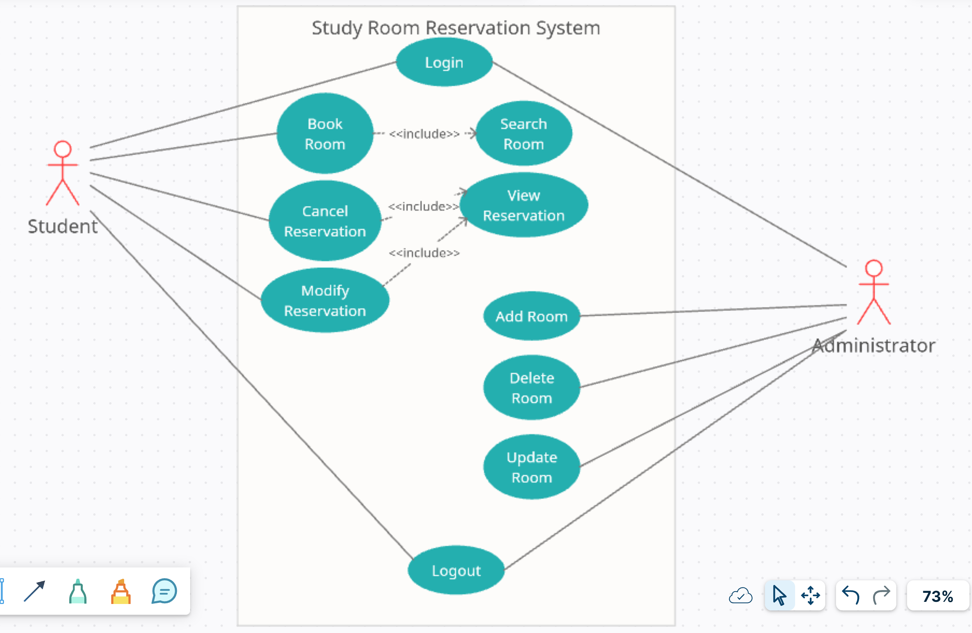
Sequence Diagram
Book Study Room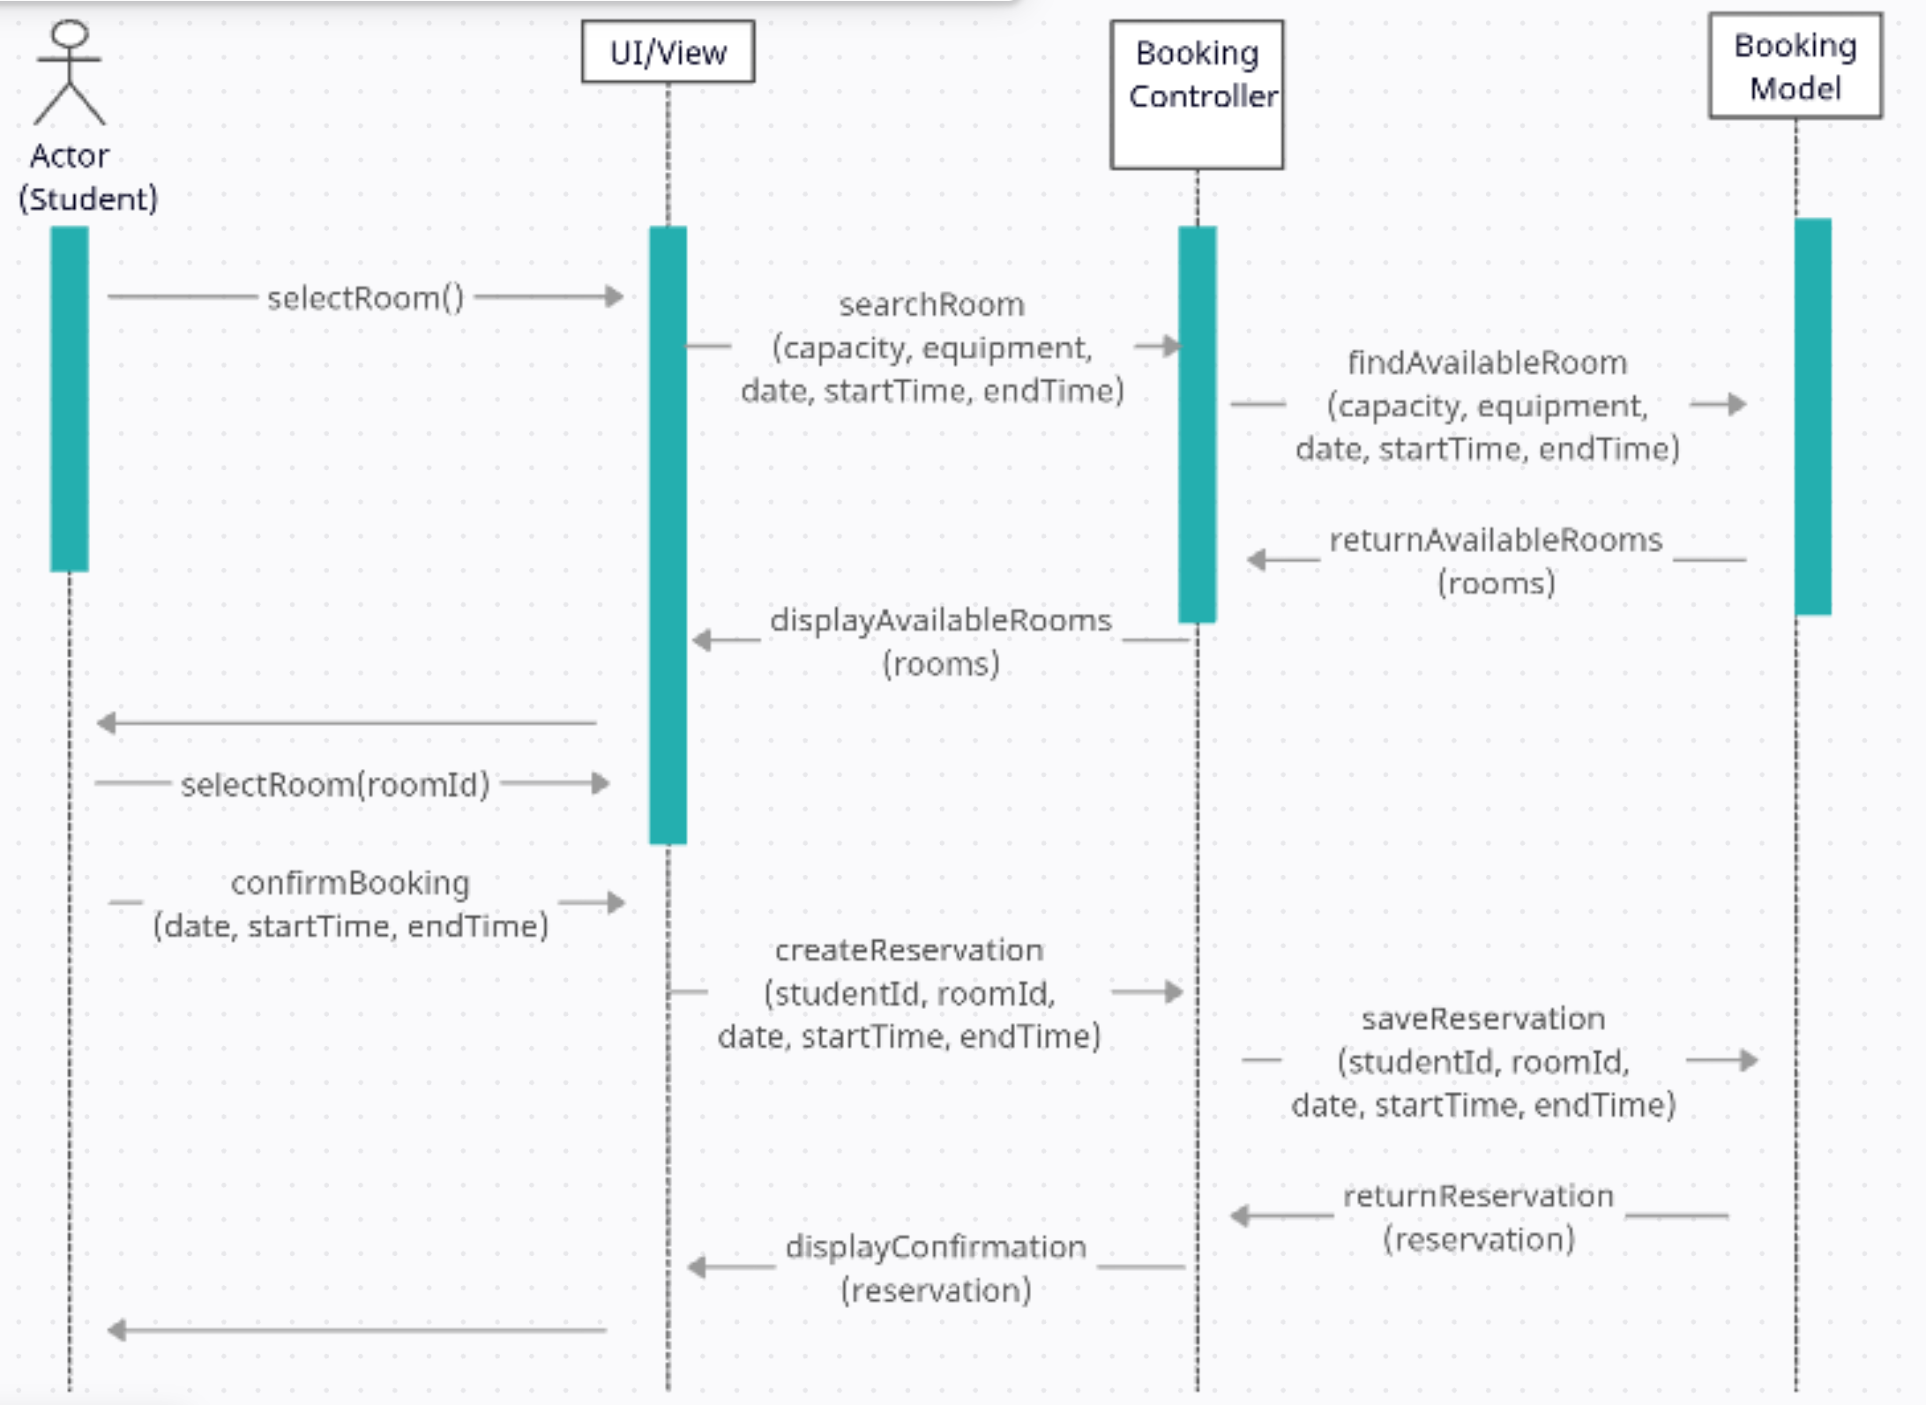
Modify Reservations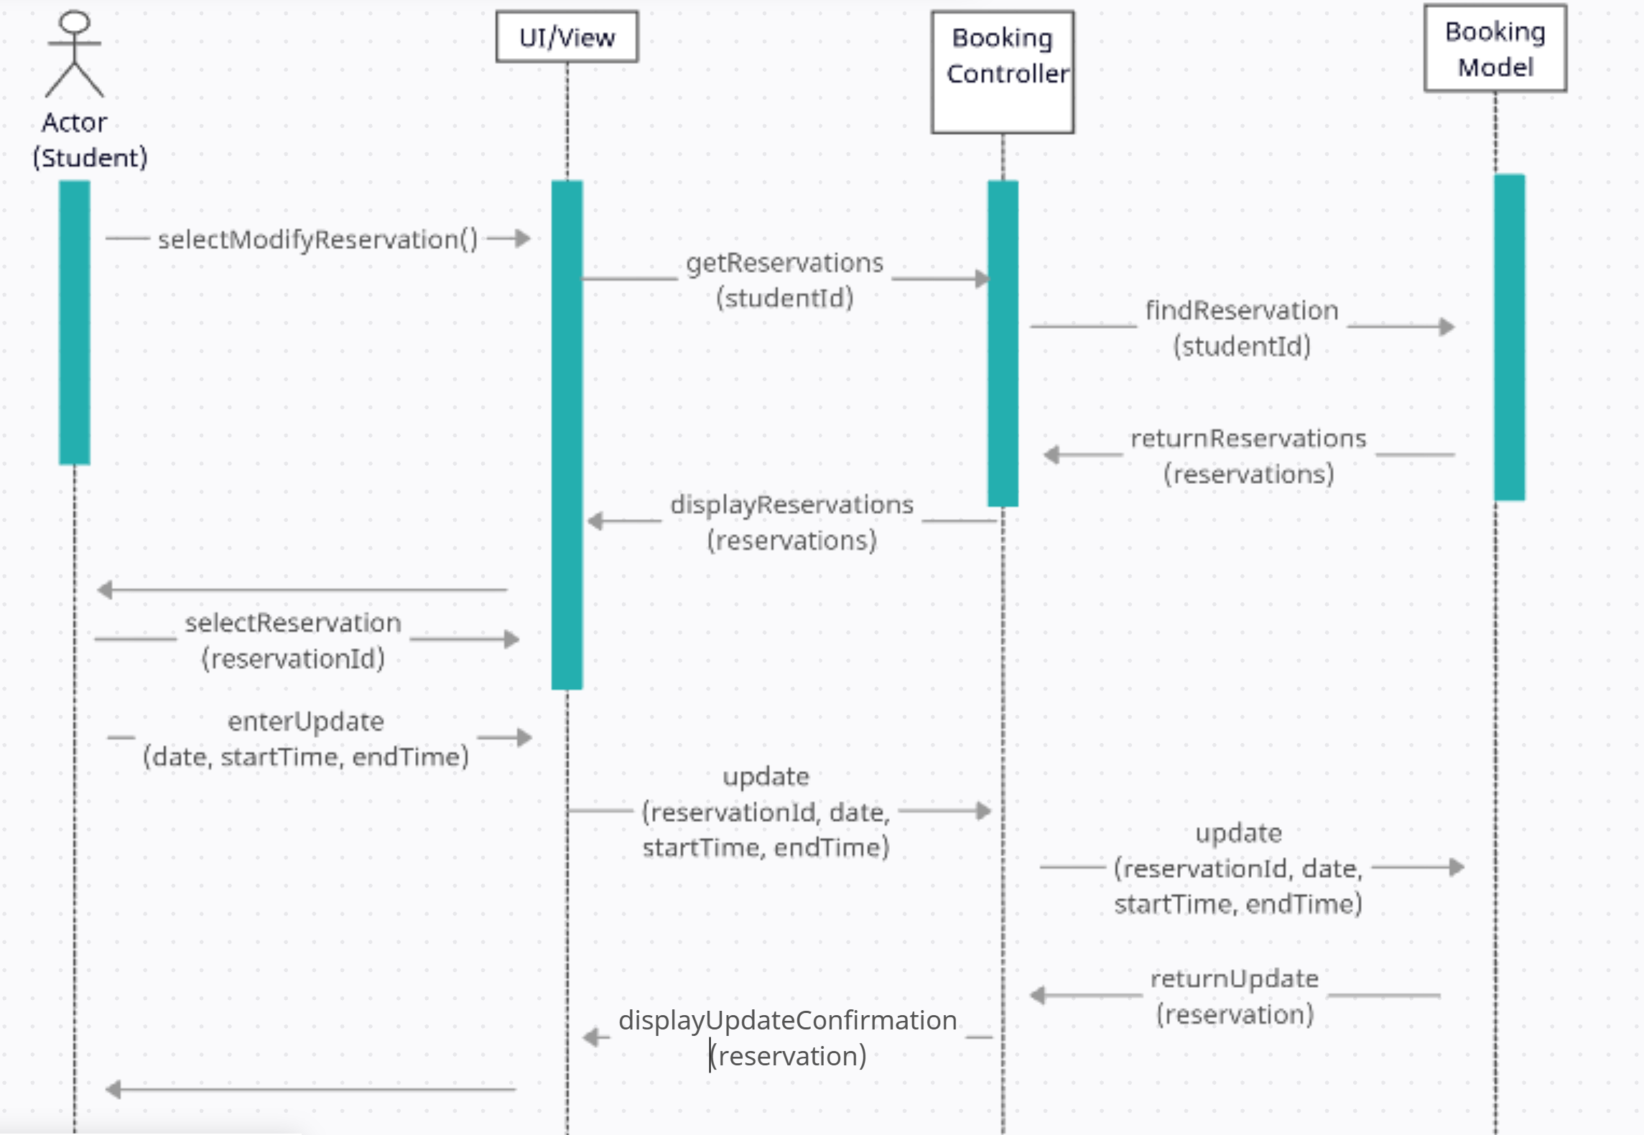
Cancel Reservations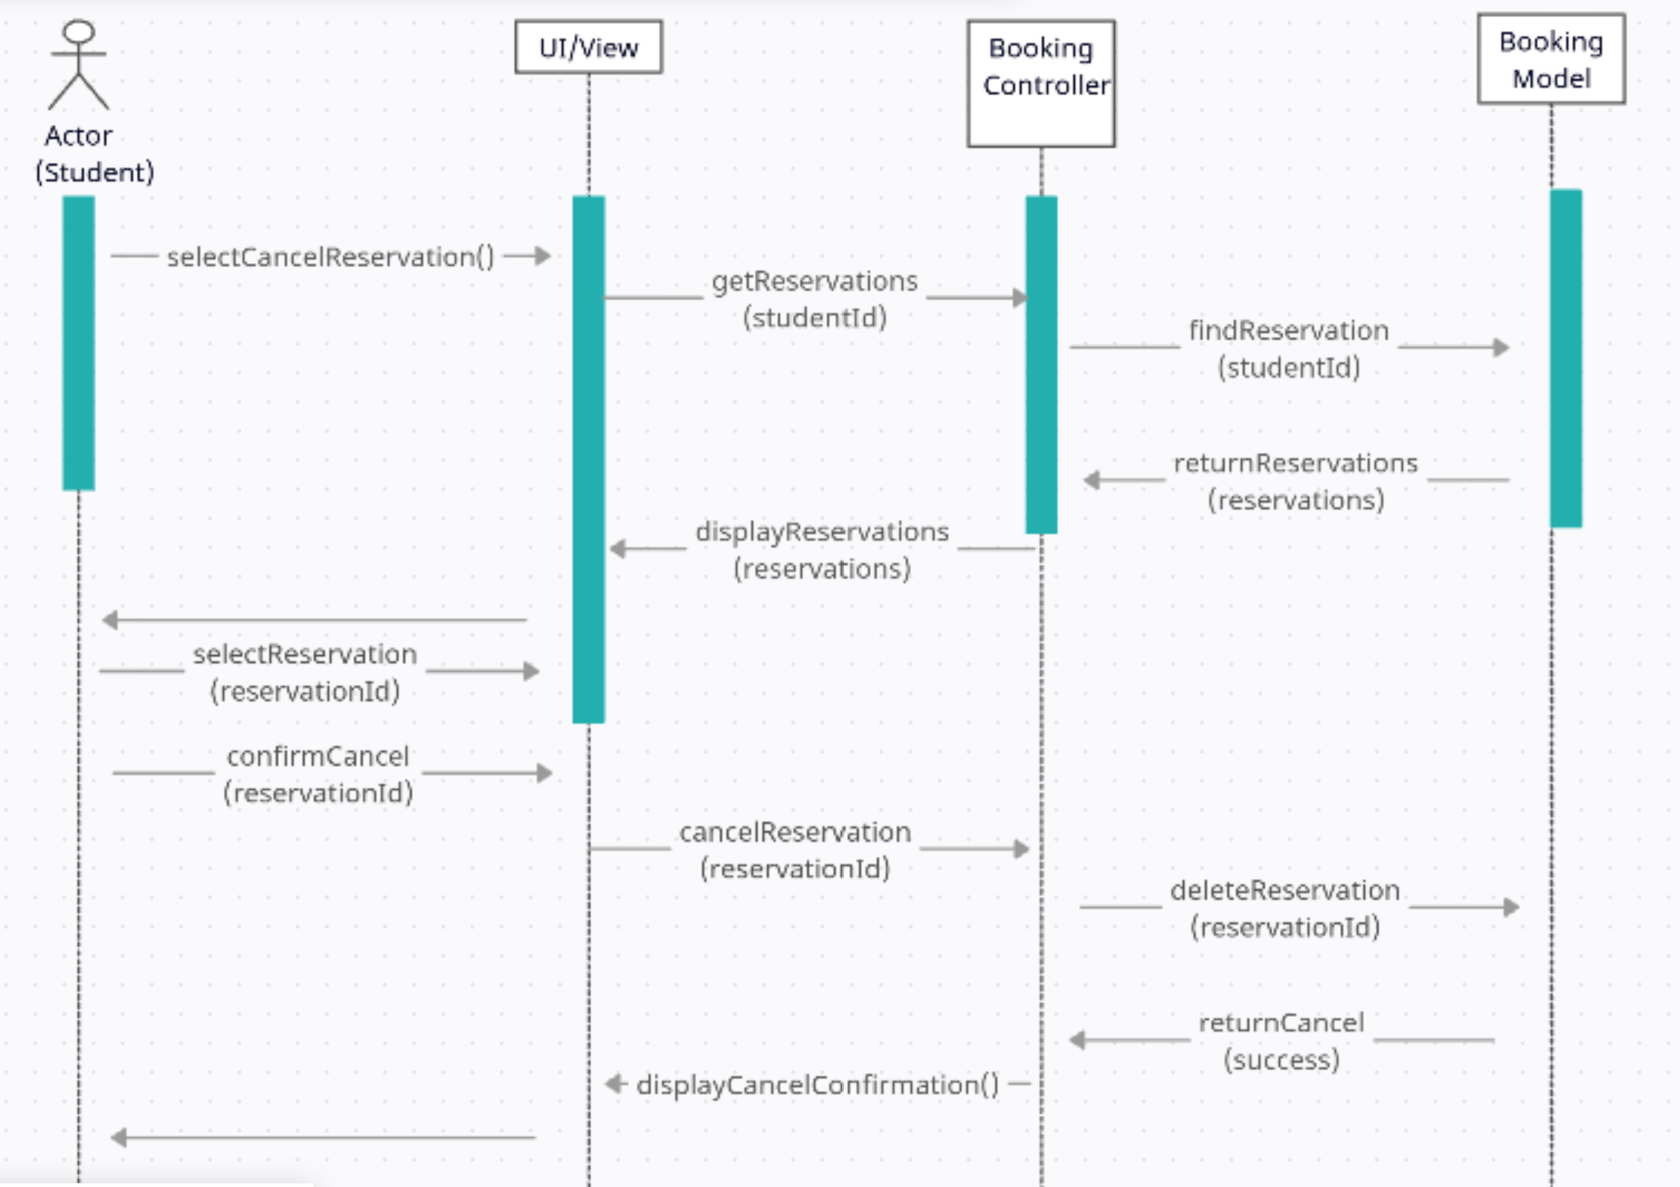

Class Diagram
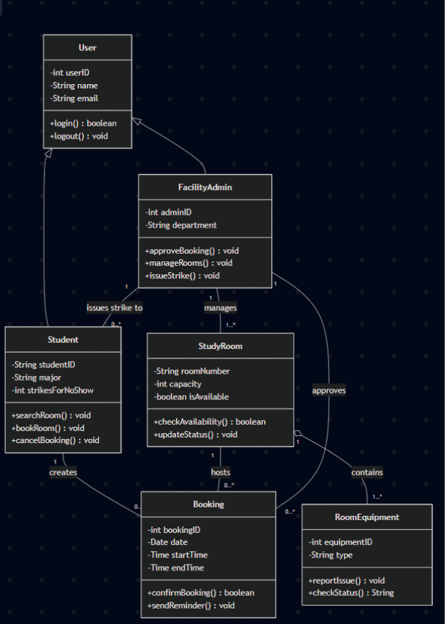

Architectural Design
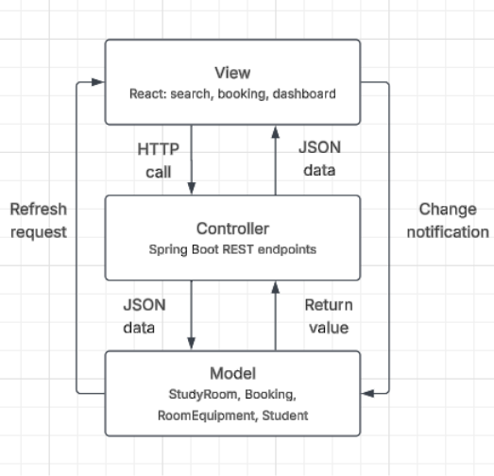

The MVC pattern was chosen for this project because it works better for a team project, and it allows members to work on both the front and the back end for the project independently. The controller is the Spring boot backend, and it receives HTTP requests coming from the React frontend. An example is a student searching for a room or an admin approving a booking, validates the incoming data, and calls the appropriate methods on the model classes before sending a response back. The view is the React frontend which generates the pages that the user interacts with. When a user submits an action in the view, such as booking a room, the request travels to the controller, the controller updates the model, and the model's change is reflected in the view once the update is confirmed.

Task 4A – Maryam Ahmed
- The estimated start and end date of the project is June 29 till September 14. The duration of the project would last approximately twelve weeks. The project would require a React frontend, Spring Boot backend, PostgreSQL database, authentication, room searching, room reservations, reservation modification and cancellation, and administrative room management. These responsibilities would be split up among our five team members with ample time for testing, debugging, and integration.
- Weekends are not included in this estimate, and the project schedule will operate Monday through Friday. I would recommend that each group member work four hours per day during the assigned work week. Based on five team members working four hours per day, five days per week, for twelve weeks, the estimated total effort for the project is 1,071 total hours.
Task 4B – Maryam Ahmed
- The Function Point method is the most relevant to our project because of its functionality. The project has several clear, distinct functions including user authentication, searching for available study rooms, creating reservations, modifying reservations, canceling reservations, viewing reservations, and administrative management of study rooms.
Using an estimated productivity of 10 function points per person-month, the project would require approximately 6.7 person-months, or about 1,071 hours of development effort. With an estimated wage of $20 per hour, the estimated labor cost is approximately $21,417.
- As an alternative to the Function Point method, we could also use the Line of Code method instead. This method relies more upon the amount of source code needed to implement the system. Using this method we can estimate around 12,000 lines of code, with an estimated productivity of 10 lines of code per hour resulting in 1,200 total hours. Then, with a $20 wage, the estimated cost for labor would be $24,000.

Task 4C - Cameron Yousif
For the study room booking system, hardware needs are minimal since it is not a large commercial product and is instead limited to a single university campus. We assume the system will run on a basic cloud server rather than physical hardware the team needs to buy.

- Server hosting: A small cloud instance, such as through a $10–$20/month tier on AWS, is sufficient to run the Spring Boot backend and PostgreSQL database for student and admin traffic.
- Database storage: Database storage is generally included in low tier cloud hosting plans. Thus, there is no added cost for this project need.
- Estimated total hardware cost: Around $15–$25 per month, or about $180–$300 per year.

Task 4D - Cameron Yousif
Our tech stack, which consists of Spring Boot, React, PostgreSQL, is entirely free and open-source. Therefore, there are no licensing fees for the software.

- Framework/database licenses: The total cost for these licenses is $0. Spring Boot, React, and PostgreSQL are all free to use.
- Optional costs: If the system is deployed for real use outside the classroom, optional costs may include a domain name, which costs approximately $10–$15/year, and an SSL certificate, which is often free through services like Let’s Encrypt.
- Estimated total software cost: Under $20/year, assuming no additional paid tools are used.

Task 4E - Cameron Yousif
We assume a small team will maintain the system after it’s built, since it will be used only on a single university campus and not a large company.

- Development team size: 2 developers would be enough to maintain and update the system after the initial launch. This would consist of one backend developer, and one frontend developer.
- Estimated personnel cost: Assuming a part-time student developer rate of about $20/hour, 10 hours/week per developer, that equates to $1,600 per month combined for 2 developers.
- Training cost: Since the stack uses common tools like Spring Boot and React, we estimate about 1 week of training time per new developer. We expect negligible to no added costs beyond their regular pay during that period.

Task 5 - David Aiyeyemi
- We plan to test one module: Reservation Service. In this module, we have a public method that will check if a reservation booked by user is at most 5 hours in length. To test this, we will have two test cases. The first case will be a valid reservation duration; the second will be an invalid one. We will use Junit to run these test cases since our backend is Java Spring Boot.
- Necessary files have been added to GitHub.
- Test cases we ran:
- Test case 1: The user will book a reservation with a start time at 9:30am on July 22nd and an end time at 2:30pm on July 22^{nd.} This is a valid test case since the duration is exactly 5 hours long (300 minutes).
- Test case 2: The user will book a reservation with a start time at 9:30am on July 22nd and an end time at 2:31pm on July 22nd. This is an invalid test case since the duration is 5hrs and 1 min (301 minutes), over 5 hours long.

Task 6– Anjali Ayyappan
- One example of a study room booking system that is used across other universities is LibCal. LibCal lets students book a room themselves without needing help from staff, lets them check in when they arrive, tracks how often each room gets used, and lets students log in with their normal school account [1], [3]. These are close to the same features this project is trying to offer, so LibCal is a useful system to compare against. One difference is that LibCal is more expensive compared to the system that we are trying to implement [2]. The system in this project uses free and open source tools instead, so there are no ongoing fees to keep the system running once it is built. This means more work has to go into building the system from the ground up, but it avoids the recurring costs that come with a service like LibCal, and it gives full control over which features get added and how they work, such as a color system that shows a room as green when it is open and red when it is taken, or the ability to filter rooms based on what equipment is inside.Another alternative that other universities have is using Google Calendar for the students to book study rooms. Using the Google Calendar method was cheap and worked well but library staff had to spend more time managing the system compared to other systems [4]. The study room system we built is more independent and does not need as much staff involvement, since the system itself checks for double bookings, enforces the five hour limit automatically, and tells the difference between a student and an administrator account without anyone needing to review it manually. This makes the system a stronger middle ground between a costly ready-made service like LibCal and a low effort but staff heavy option like Google Calendar.
Task 7– Anjali Ayyappan
a. The project produced a design for a study room booking system meant for students and staff at a university, using a Spring Boot backend and a React frontend built around the MVC pattern. The main goals of the project stayed the same from the first proposal all the way through this stage, letting users search for rooms, make and change reservations, and log in as either a student or an admin. Testing on the booking time limit showed that the system correctly tells the difference between a five hour reservation and one that goes just one minute over the limit, which supports the reliability goals set out earlier in the report. Overall, the finished design met the goals the team set out to build.
i. The one change made during this stage was picking MVC instead of the layered or client-server designs that were considered earlier in the project. Other than this, the plan did not deviate much from what was proposed in the first deliverable, and the core features and requirements stayed the same.
ii. MVC was chosen because it splits the work more clearly between the frontend and the backend, which matches how the team members are already split into different roles. This made it easier for each person to work on their own part of the system without getting in the way of someone else's work, so the change was made to fit how the team was already organized rather than to fix a problem with the original plan.
Task 8– Anjali Ayyappan
References
[1] LMU Library News, "Reserving Study Rooms in LibCal," Loyola Marymount University, Oct. 8, 2021. [Online]. Available: https://librarynews.lmu.edu/2021/10/reserving-study-rooms-in-libcal/. [Accessed: Jul. 25, 2026].

[2] University of Rhode Island Libraries, "LibCal - University of Rhode Island." [Online]. Available: https://uri.libcal.com/. [Accessed: Jul. 25, 2026].

[3] Springshare, "LibCal for Academic Libraries." [Online]. Available: https://www.springshare.com/academic-libraries/libcal. [Accessed: Jul. 25, 2026].

[4] S. Atkinson and K. Lee, "Design and Implementation of a Study Room Reservation System: Lessons from a Pilot Program Using Google Calendar," College & Research Libraries, Fordham University, 2018.

