BioComputation- Employing Evolutionary Computing approaches to solve dating mining sets.

David Cook, Student number: 15020729

1 INTRODUCTION

The task put forward is to implement an example of the evolutionary intelligence methods which have been previously covered in the module – in this case a GA (Genetic Algorithm) is to be used to solve a series of classification data mining problems and produce output which would match those found in an existing commercial environment.

More specifically the GA coded in Java, evaluates the fitness of an 8 bit binary string (0, 1), this string is the individual candidate or “genes” From this next step is to take our genes and create a set of rules from them to

Demonstrates learning and the effects such as mutation and population size of parameters on the input set.

The task is to evolve a system that correctly classifies a given set of input variables, that is, give the predicted variable as the output. To pass the assignment, you must implement a system that successfully evolves a classifier and demonstrate the effects of parameter changes, preferably through graphs and including your understanding of what is happening

2 BACKGROUND RESEARCH

//Intro into background research

Examples One:
- http://eprints.uwe.ac.uk/25798/1/EVCO_a_00144.pdf

Examples Two:
- https://pdfs.semanticscholar.org/1dda/f3c02774f56dba35334c48fbc62f19b9cc14.pdf

Examples Three:
- http://ieeexplore.ieee.org.ezproxy.uwe.ac.uk/document/6185531/
Evolutionary computing has been used in data mining in many ways. Give a brief summary of some examples you can find, connecting them to your assignment perhaps too. Use clear referencing and avoid including material directly unless carefully indicated as from another source. Half to a whole page expected.

3 EXPERIMENTATION

3.1 Data Set 1
Describe your basic algorithm so anyone who knows about basic GAs could hopefully repeat what you have done. Describe the representation, the parameters, the fitness calculation, etc.

Present your results as averaged behaviour over more than one run, eg (graph not of assignment):
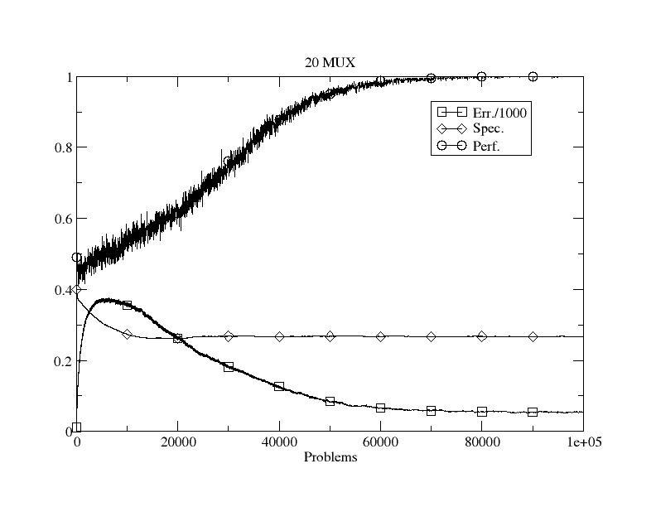
Figure 1: Initial performance on dataset 1.

Show the effects of varying parameters and give potential explanations as to why the behaviour/performance changes. Eg vary the mutation rate or population size.

3.2 Data Set 2
If not in the previous section, this should include how you allow generalisation in the representation. Again, show results from varying parameters/aspects and explain them. The use of evolution to learn how many rules to use would be good to include here and/or other modifications.

Explain the use of rules

3.3 Data Set 3 (and UCI data)
Clearly describe how you changed the representation to deal with real-valued data. And then present results from its use, with graphs and explanations.

For the very keen, it would be great to see comparative performance on the UCI dataset too and/or the use of another representation scheme, eg, evolving neural networks, or use of Weka, etc.

4 CONCLUSIONS
Concise summary of what you found and learned. Identification of ways you might do things differently next time, and why.

REFERENCES
Bernado Mansilla, E. & Garrell, J. (2003) Accuracy-Based Learning Classifier Systems: Models, Analysis and Applications to Classification Tasks. Evolutionary Computation 11(3): 209-238.

And please include either a link to your source code so that more than one person can access it over the next few months or as a full listing in an Appendix. The second marker and external examiner need to be able to see what you actually produced.

