BioComputation: Employing an Evolutionary Computing approach to solve Classification scenarios in Data Mining

David Cook, Student number: 15020729

1 INTRODUCTION:

The task put forward is to implement an example of the evolutionary intelligence methods which have been previously covered in the module – in this case a GA (Genetic Algorithm) is to be used to solve a series of classification data mining problems and produce output which would match those found in an existing commercial environments

More specifically the GA coded in Java, evaluates the fitness of an 8 bit binary string (0, 1), this string is the individual candidate or “genes” From this next step is to take our genes and create a set of rules from them to apply to a larger data set. The algorithm needs to demonstrate learning to the user to show that’s it has taken place and improved with time. The GA is built under a rules based- system of If< condition> Then <output> the success of task will be determined by whether the data sets, inputs and the know outputs, how much of the data can be correctly classified into said rules.

2 BACKGROUND RESEARCH:

Data Mining is the process of sifting through large amounts data in order to extract and Identify patterns and trends, this information is used to help inform the users in their decision making. The principles behind data mining have been around for a number of years, but nowadays with the rise of big data its use is becoming ever more prevalent. Fields such as Market research, Bio-Informatics and Banking are prime examples of examples of the application of data mining.

Taking banking as an example in the early 2000s Bentley (2000) created an application to analyse bank data to discover cases of fraud – to aid insurance applications. Due to the large numbers of numbers of applications it can be difficult to distinguish the fraudulent cases, by using evolutionary computation techniques you can generate rules from the existing data to identify fraud cases. The advantages of using evolutionary algorithms in general are usually due to their scalability and their flexibility- compared to other techniques, they have the ability to solve global optimization problems and adapt/optimize multiply criteria and parameters at once which can give evolutionary approaches an edge.

These benefits become particularly apparent in design, classification and simulation scenarios where you have multiple values to consider and manipulate. For instance in the research carried out by (Preen and Bull, 2016) who conducted research to design more efficient wind turbines by making alterations to blade shape (profile and twist), after multiple generations and prototypes a far more effective turbine was designed.

Genetic algorithms aren’t the only techniques used in data mining, artificial neural networks, decision trees and rule induction are all used though can be specialized to relatively small volumes of data. In a paper by (Parpinelli, Lopes and Freitas, 2002) into ant-colony based data mining- a methods which has been further expanded upon since publication, in this algorithm the system essentially a groups of agents (Ants) to find routes in the search space, however instead of relying on selection in GA’s case ACO relies on pheromone to produce better rules, constantly updating as it goes along. In evolutionary process, the quality of the rules in the population of the GA will improve gradually, producing better and better rules over time, until it converges to a good set of rules, See data set 2*.

3 EXPERIMENTATION:

3.1 Data Set 1

The produced GA (Source code in ref) is based on an early binary GA so contains all the common features you would expect in a normal, being having been coded in Java the functionality is split up modally into sections. Upon execution gaMain is ran which contains all the global variables and creates the initial random population, this population’s ‘fitness’ is then determined by the FitnessFunction class, the optimal fitness is determined and candidates form the population are Taken. The created offspring, which are added to the next generation of the population are passed through the evolve method which subjects them to elitism, crossover and mutation.

The fitness is calculated from Rules which form the baseline of the system, Made up of 5 condition bits, and 1 output bit, an array called Ruletype imports the data from the text files then runs the method evolves the rule by constantly setting the ruleset against the dataset, increasing the fitness each time the values “match” I.e. the bit values are in the same location as each other. If it correctly classifies a given set of input variables, the Fitness is then calculated based on how many of the data items given system correctly classify.

Now onto experimentation, unless otherwise stated assume the parameters are the same. For data set 1 there are a set of 32 rules with a size of 6 – 5 conditions, 1 output as stated above. The Parameters for consideration include Mutation (0.015) and Uniform rate (Crossover – 0.5) population size (50) and elitism (True). The GA can achieve the average fitness of 32 the majority of the time, with the occasion drop to 31 but still all things considered a satisfactory result.
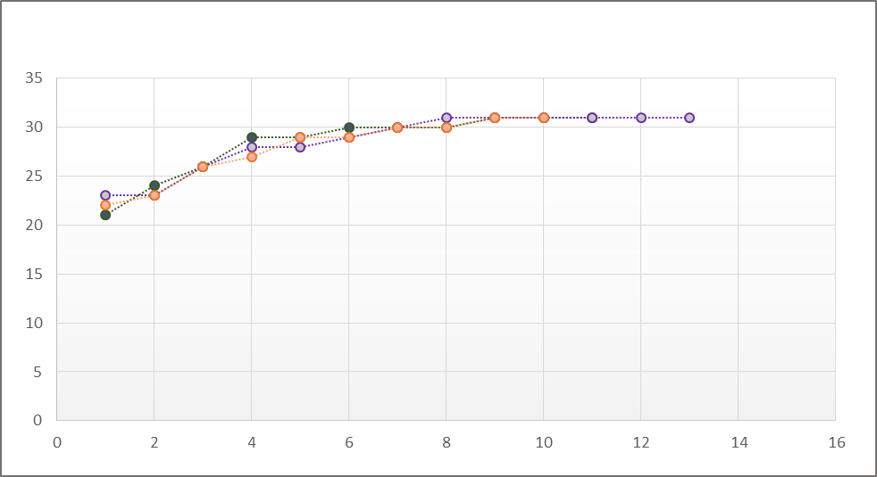

Figure 1.
Figure 1. Shows the taken with first data set across three runs each time- in this case, obtaining the mean optimal fitness of 32 is obtained, the parameters across each of the runs were; a populations size of 50, mutationRate at 0.015, tournamentSize at 5 and a uniform rate of 0.5 for crossover. From the graph can see tell the GA obtains the desired fitness within 12-13 generations.

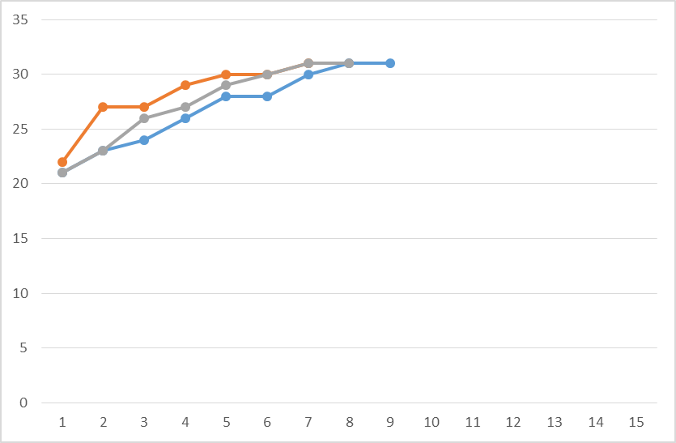
Figure 1.2

For comparison let’s change some of parameters. If we raise the mutation rate to 0.02 from 0.015 we find that we can achieve a peak fitness of 32 in fewer generations (7-9) then before with a smaller mutation rate. Suggesting a noticeable improvement to having a higher mutation rate –see figure 1.2

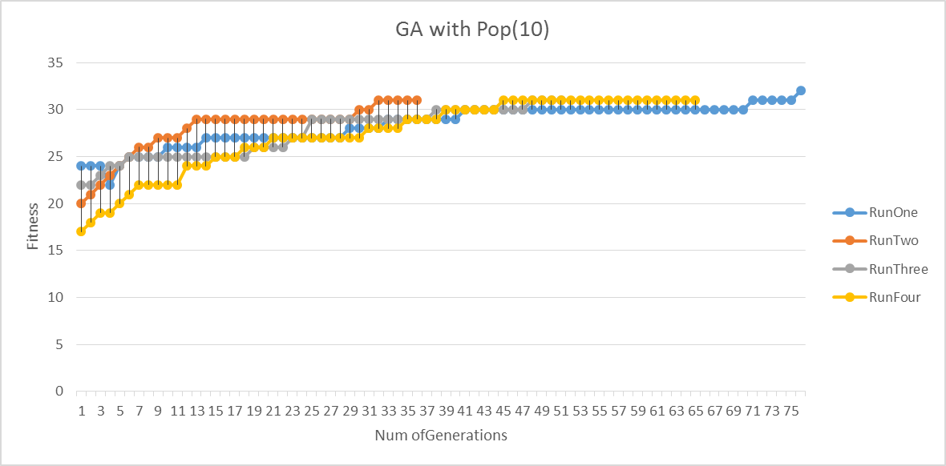

Figure 1.3

We can also have a go at manipulating the size of the population (pop) this leads to unsurprisingly significantly effecting the results, see figure 1.3; by reducing the pop by 1/5 from 50 to 10 results in the numbers of generations needed to reach the mean fitness significantly increasing, in some cases going into the hundreds, the results as a whole are also less consistent. Just having a large population, won’t solve any issues as it begins to take time For instance having a populations of >10000 slows the application to a crawl. So you need to find a balance, right now it can cope with the simple data sets but as soon as your start scaling the problem the time complexity begins to grow exponentially.

3.2 Data Set 2

A few edits were made to the original GA to cope with the second data set. This time compared to data set 1we have 64 rules- making the optimal fitness likewise 64 and each of them having a condition size of 7, still with a single output bit.

For data set 2 are initial parameters are slightly different, building upon the tests done on data set one(Population of 50, mutation rate of 0.02, Uniform rate of 0.5, tournamentSize at 5)

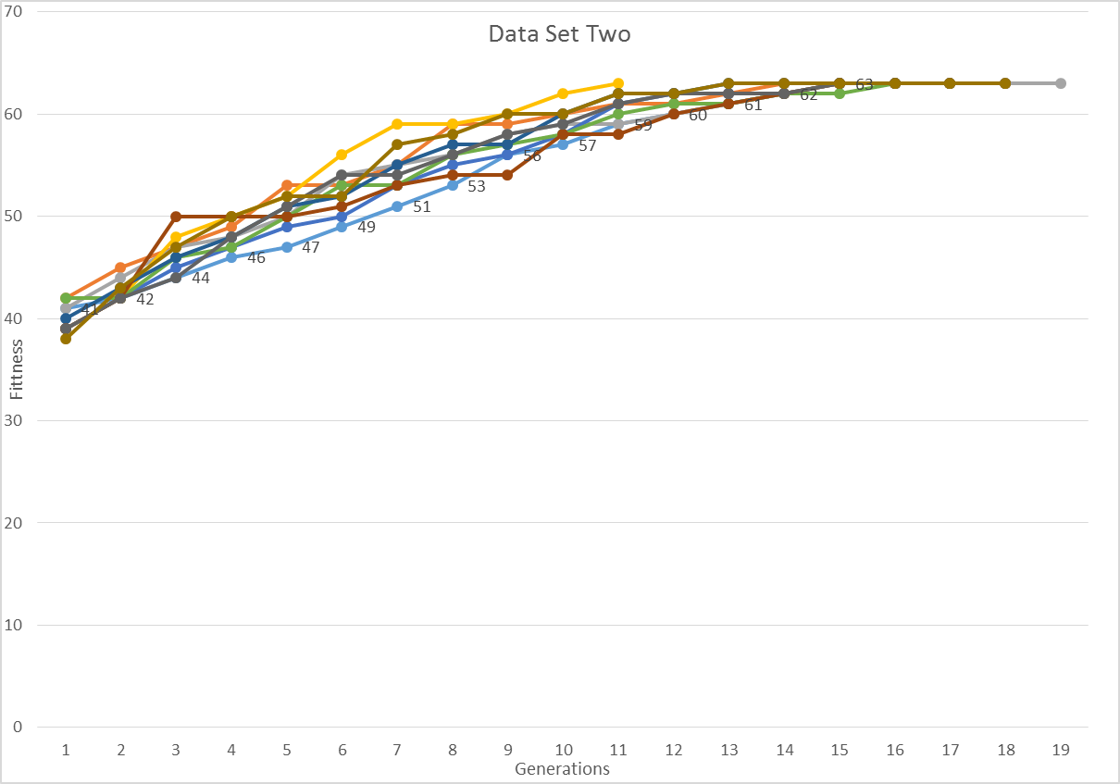
Figure 2.

For our first test case we ran with the default values for 10 runs with the average fitness coming in at about 62. Not quite the max fitness, however shows there’s still room for improvement, most One run took Generation 69 before a solution was found but due to issues of presentation the result has been omitted.

4 CONCLUSIONS:
In conclusion the application archive its objective of being able to classify the data sets into rules although not to the degree of which would have been desired. Data set two was hastily achieved so hasn’t been subjected to as experimentation and analysis as the first data set and produces outliers in its results. I would have liked to have done a detailed comparison between Mutation and Uniform rate especially on lower population of say 10 – 30.

In the course of this assessment I’ve learned about the uses and applications of data mining and how you would use evolutionary techniques such as a GA to go about them. I’ve obtained a greater understand of rules generation and it’s important if I had more time I would have liked to have added generalisation to improve performance but due lack of time my expertise this wasn’t implemented.

It would have been interesting to have been able to have gotten the 3rd data set working as well- which uses more real-valued data for comparison to see which variables might affect the systems performance overall and to get sense of actual data, additionally the data is represented by flouts which isn’t something I had considered used during development, so you can likely produce more accurate results

Exploring other examples of data mining and seeing if any of the techniques could be incorporated or learn from, I briefly covered ACO in the research section but it would have been ideal to have a comparison against other techniques such as Bayesian networks, decision trees and neural networks. The choice of Java, chosen for modular aspect was a factor it the sluggish of development, perhaps other languages should have been considered, such as Python or C with a more procedural approach. Python has library for the development of GA so on refection might have been the wiser option.

5 REFERENCES:
Preen, R. and Bull, L. (2016). Design Mining Interacting Wind Turbines. Evolutionary Computation, 24(1), pp.89-111.

Parpinelli, R., Lopes, H. and Freitas, A. (2002). Data mining with an ant colony optimization algorithm. IEEE Transactions on Evolutionary Computation, 6(4), pp.321-332.

Pierreval, h. and Tautou, l. (1997). IIE transactions, 29(3), pp.181-189.

Peter J. Bentley, "Evolutionary, my dear Watson" investigating committee-based evolution of fuzzy rules for the detection of suspicious insurance claims, Proceedings of the 2nd Annual Conference on Genetic and Evolutionary Computation, July 10-12, 2000, Las Vegas, Nevada

Jourdan L, Dhaenens-Flipo C and Talbi EG (2003) Discovery of genetic and environmental interactions in disease data using evolutionary computation. In: G.B. Fogel and D.W. Corne (Eds.) Evolutionary Computation in Bioinformatics, 297-316. Morgan Kaufmann.

6 APPRENDIX:

David, Genetic-Algorithm, (2017), GitHub repository, https://github.com/DavidACook - Report source code

