BioComputation- Employing an Evolutionary Computing approach to solve classification scenarios in relation to data mining

David Cook, Student number: 15020729

1 INTRODUCTION

The task put forward is to implement an example of the evolutionary intelligence methods which have been previously covered in the module – in this case a GA (Genetic Algorithm) is to be used to solve a series of classification data mining problems and produce output which would match those found in an existing commercial environment.

More specifically the GA coded in Java, evaluates the fitness of an 8 bit binary string (0, 1), this string is the individual candidate or “genes” From this next step is to take our genes and create a set of rules from them to an able to a larger data set, these rules. The algorithm needs to demonstrate learning tot the human user to show that’s it has taken place and through experimentation that alterations of mutation and population size of parameters on the input set.

2 BACKGROUND RESEARCH

//Outline

Data Mining is the process of sifting through large amounts data in order to extract helpful knowledge/ information. The information obtained needs to inform the human user

Talk about some of the most popular method so f date maining

An evolutionary approach

The following are some example of such;

//Intro into background research( Whole page so about 800 words)

Examples One:

The first example of an evolutionary approach is for the designing of efficient wind turbines, the experiment showed that …. To increase the performance of the turbines.
- http://eprints.uwe.ac.uk/25798/1/EVCO_a_00144.pdf

Examples Two:

The second example
- http://ieeexplore.ieee.org.ezproxy.uwe.ac.uk/document/6185531/

Examples Three:

Departing from the previous examples the paper by (Ref) is an optimation algorithm based on (Link) in contrast to my GA theirs makes use of
- https://pdfs.semanticscholar.org/1dda/f3c02774f56dba35334c48fbc62f19b9cc14.pdf

Evolutionary computing has been used in data mining in many ways. Give a brief summary of some examples you can find, connecting them to your assignment perhaps too. Use clear referencing and avoid including material directly unless carefully indicated as from another source. Half to a whole page expected.

3 EXPERIMENTATION

3.1 Data Set 1

Describe your basic algorithm so anyone who knows about basic GAs could hopefully repeat what you have done. Describe the representation, the parameters, the fitness calculation, etc.

How the GA works – basic structure

Present your results as averaged behaviour over more than one run, eg (graph not of assignment):
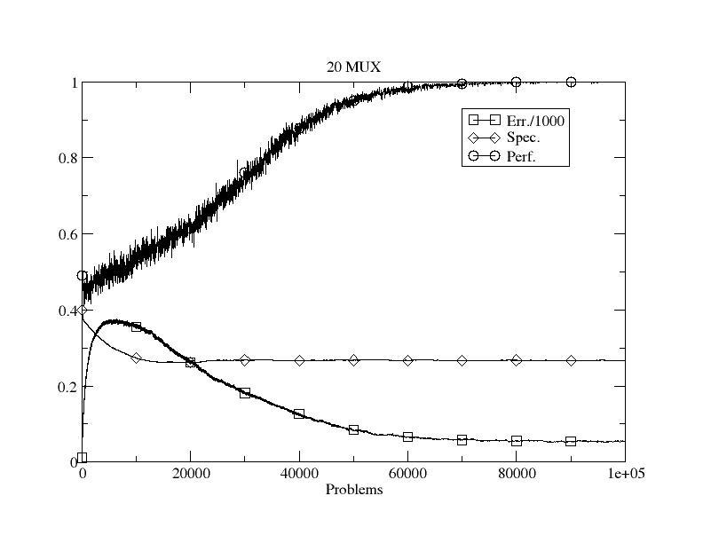
Figure 1: Initial performance on dataset 1.

Two Comparison of Population size 50 – 100
Two Comparisons of Mutation Rate 0.2 – 0.02 – 0.015
One chart limited the number of generation, this should lower the fitness if I only pass through 10(Gen) or something,

Show the effects of varying parameters and give potential explanations as to why the behaviour/performance changes. Eg vary the mutation rate or population size.

3.2 Data Set 2

Only a few edits are made to the original GA to cope with the second data set.
The son

Compare with the first data set

If not in the previous section, this should include how you allow generalisation in the representation. Again, show results from varying parameters/aspects and explain them. The use of evolution to learn how many rules to use would be good to include here and/or other modifications.

Explain the use of rules

4 CONCLUSIONS
Concise summary of what you found and learned. Identification of ways you might do things differently next time, and why.

REFERENCES
Bernado Mansilla, E. & Garrell, J. (2003) Accuracy-Based Learning Classifier Systems: Models, Analysis and Applications to Classification Tasks. Evolutionary Computation 11(3): 209-238.
-Link to all of the papers here!!!!!
- Link to Github Source Code

And please include either a link to your source code so that more than one person can access it over the next few months or as a full listing in an Appendix. The second marker and external examiner need to be able to see what you actually produced.

