Adbri Business Intelligence Technical Report
Excel-to-Databricks SQL Pipeline and Power BI Market Intelligence Dashboard

Abstract
This report documents an end-to-end Business Intelligence solution designed for an Adbri-style building materials organisation. The solution transforms four Australian Bureau of Statistics Excel time-series workbooks into a clean analytical dataset, stages the data through a Databricks Bronze/Silver/Gold architecture, and presents construction market insights through Power BI. The report focuses on South Australia and Adelaide, using building approvals as a future demand signal and Producer Price Index data as a cost-pressure signal.

1. Business Problem and Analytical Objective
Adbri operates in building materials markets where demand cycles and input cost pressure directly affect commercial decisions. The analytical objective is to build a reporting asset that helps business stakeholders understand future construction demand, price pressure, and data reliability.
- Demand signal: South Australia building approvals by dwelling type and sector.
- Cost signal: construction output PPI and house construction input PPI.
- Delivery goal: a governed data model that can be served through Power BI and explained in a BI Analyst interview.

2. Source Data and Transformation Method
The four Excel files are ABS time-series workbooks. The Data1 sheet contains metadata in the first ten rows and observations from row eleven onwards. Since the original format is wide, each series is stored as a separate column. The Python extraction process converts this into a long fact-table structure.
Source Workbook | Business Use
Building Approvals SA Table 04 | South Australia dwelling approvals by building type and sector
Building Approvals SA Table 15 | Detailed building approval categories
PPI Construction Output Table 17 | Construction output price pressure
PPI House Construction Input Table 18 | House construction input cost pressure by capital city

The combined output contains 43,726 fact observations, 206 unique series keys, and 685 date periods. The model uses series_key rather than series_id alone because the same ABS series identifier can appear in multiple datasets.

3. Databricks Medallion Architecture
The target Databricks implementation follows the medallion architecture. Bronze stores raw uploaded CSV data, Silver applies typing and cleaning, and Gold publishes a star schema for Power BI.
Layer | Purpose | Example Object
Bronze | Raw file ingestion with minimal transformation | raw.abs_ppi_long_raw
Silver | Typed and cleaned analytical fact table | silver.fact_abs_ppi_series
Gold | Power BI-ready fact and dimension tables | gold.fact_market_indicators, gold.dim_date, gold.dim_series

The Gold fact table grain is one row per series_key per period_start. The two key relationships are fact_market_indicators[date_key] to dim_date[date_key] and fact_market_indicators[series_key] to dim_series[series_key].

4. Power BI Report Design
The Power BI report contains four pages: Executive Market Pulse, Building Approvals Demand, Construction Cost Pressure, and Data Quality & Lineage. This structure balances executive summary, operational detail, cost analysis, and governance.
Report Page | Purpose
Executive Market Pulse | High-level view of market value, annual change, period change, and trend
Building Approvals Demand | Demand-side analysis of South Australia approvals by building type
Construction Cost Pressure | PPI trend analysis for Adelaide inputs and South Australia output prices
Data Quality & Lineage | Evidence of row counts, series counts, date coverage, and pipeline traceability

5. Power BI Proficiency Demonstration
The four report pages demonstrate practical Power BI capability beyond basic chart creation. The report uses a star schema, DAX measures, slicers, filter context, KPI cards, line charts, stacked column charts, page-level design, and data lineage communication. In an interview, these pages can be used to explain both technical Power BI skills and business reasoning.
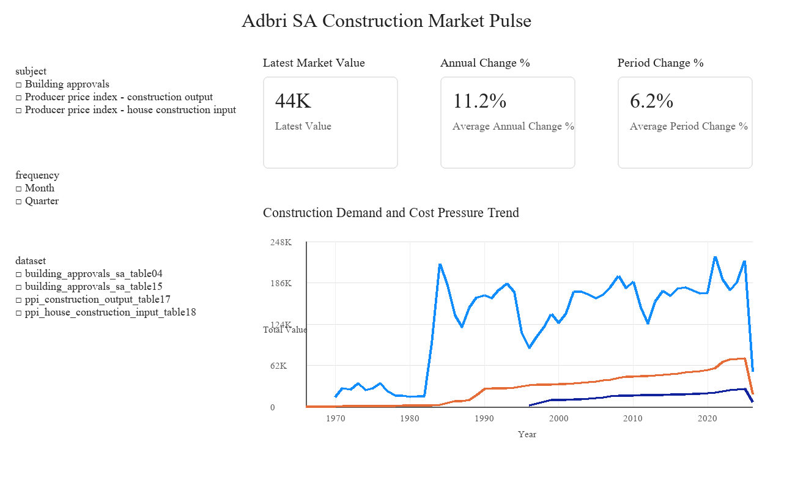
Figure 1. Executive Market Pulse page: KPI cards, slicers, subject-based trend analysis, and executive layout.
This page demonstrates my ability to create an executive dashboard page. I used KPI cards for latest value, annual change, and period change; slicers for subject, frequency, and dataset; and a trend chart to compare demand and cost-pressure indicators. This shows that I understand report navigation and high-level business consumption.
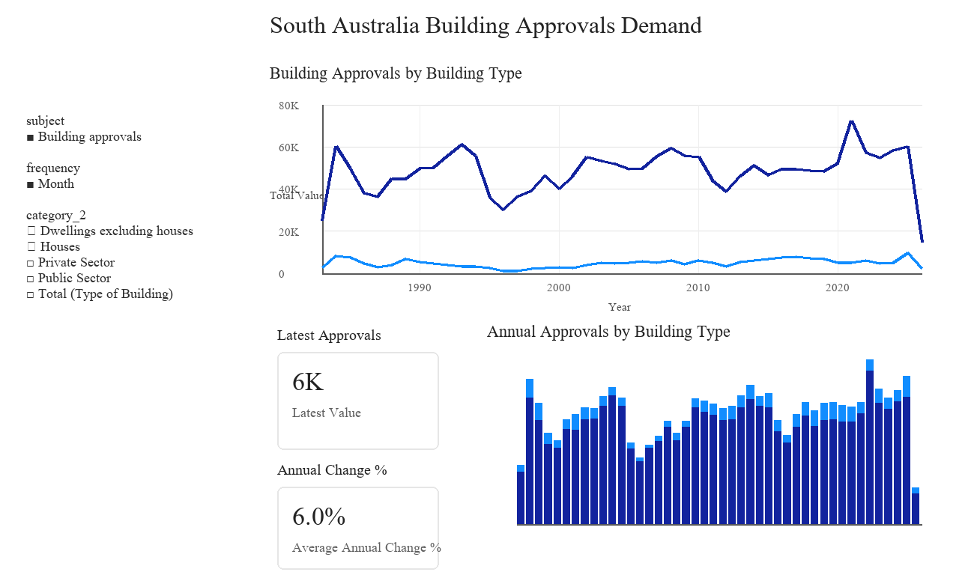
Figure 2. Building Approvals Demand page: focused demand analysis with slicers, line chart, stacked column chart, and KPI cards.
This page demonstrates dimensional analysis in Power BI. I used slicers to focus on Building approvals and Month frequency, then compared Houses with Dwellings excluding houses. The line chart shows trend over time, while the stacked column chart shows annual structure. This page is useful for explaining how Power BI can translate a star schema into business-facing demand analysis.
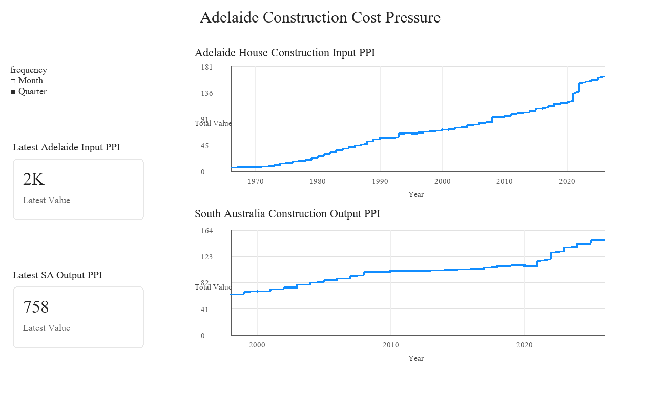
Figure 3. Construction Cost Pressure page: separate visuals for different geographic grains and PPI measures.
This page demonstrates that I understand filter context and data grain. The Adelaide input PPI is city-level, while the South Australia output PPI is state-level, so I separated them into two visuals rather than forcing them into one chart. This is a strong Power BI modelling point because it avoids mixing incompatible grains.
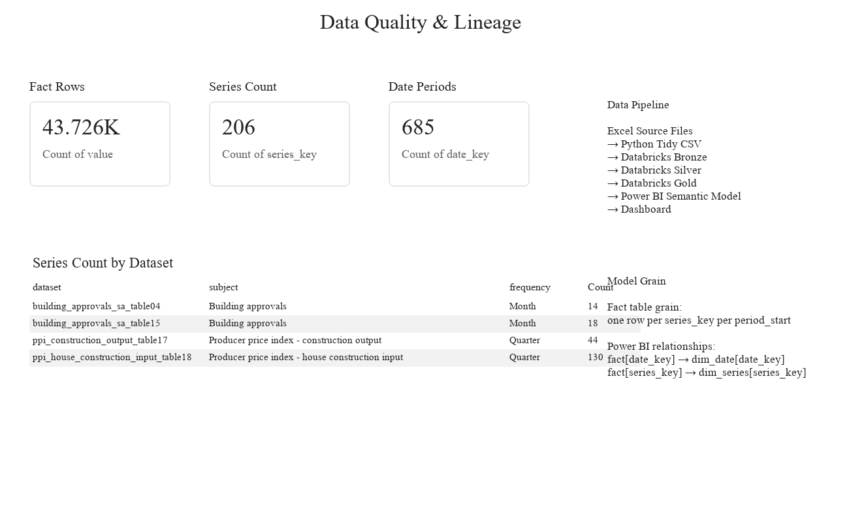
Figure 4. Data Quality & Lineage page: quality metrics, dataset-level series count, model grain, and pipeline explanation.
This page demonstrates report governance. I used cards and a table to show row count, distinct series count, date periods, and series count by dataset. I also documented the data pipeline and model grain directly in the report. This communicates that my Power BI work is auditable and explainable, not just visual.

6. PPI Report Figures
The figures below are regenerated from the same Power BI source tables. For the technical report, the PPI analysis uses specific index-number series rather than summing all PPI values, which is analytically cleaner for index data.
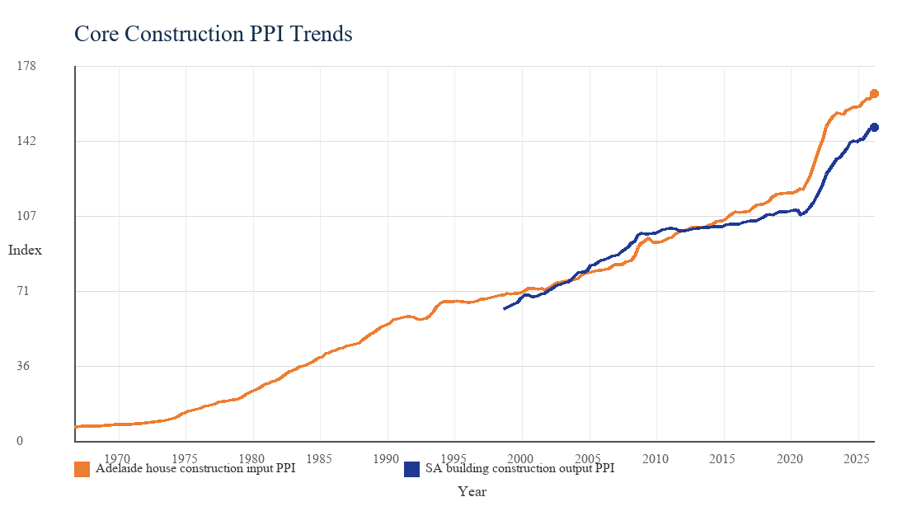
Figure 1. Core PPI trends for Adelaide input costs and South Australia construction output.
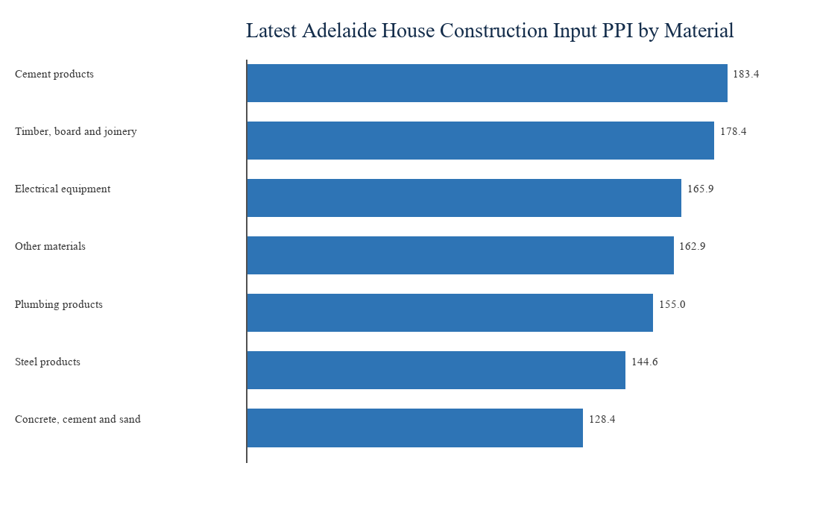
Figure 2. Latest Adelaide house construction input PPI by selected material category.
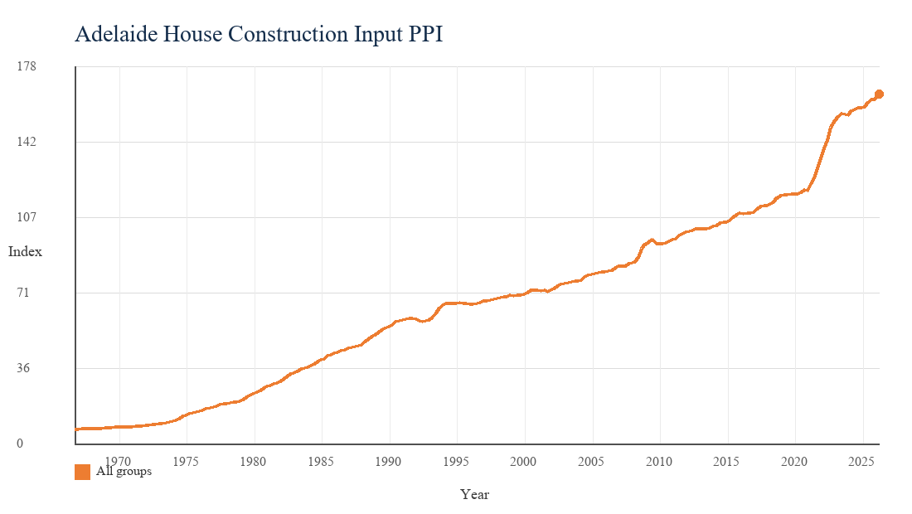
Figure 3. Adelaide house construction input PPI, all groups.
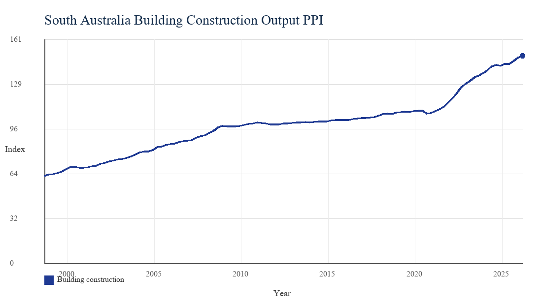
Figure 4. South Australia building construction output PPI.

7. Data Quality and Governance
The report includes data quality checks because BI assets should be explainable and auditable. Key checks include row counts by dataset, null critical fields, duplicate grain validation, date range coverage, and latest-period validation.
- Fact rows: 43,726 observations.
- Series count: 206 unique series keys.
- Date periods: 685 distinct periods.
- Duplicate grain check: series_key plus period_start should be unique.

8. Interview Positioning
This project can be presented as a full-stack BI case study. It demonstrates Python data preparation, SQL data modelling, Databricks architecture, Power BI semantic modelling, DAX measures, and business communication.
Suggested interview statement: I built an end-to-end BI solution that transforms ABS Excel time-series data into Databricks-ready tables and a Power BI market dashboard. The solution combines building approvals as a demand signal with PPI as a cost-pressure signal, and it includes a data quality page to make the report auditable.

Conclusion
The solution demonstrates more than dashboard construction. It shows data preparation, modelling discipline, governance awareness, and business interpretation for a building materials organisation. This makes it suitable as an interview portfolio artifact for a Business Intelligence Analyst role.

