A Power BI-Based Market Demand and Cost Pressure Study for Adbri
An applied business intelligence report using ABS building approvals and producer price index data

Abstract
This report presents a Power BI-based business intelligence study designed to evaluate construction market demand and cost pressure relevant to Adbri, a building materials company operating in South Australia. Four Australian Bureau of Statistics Excel time-series workbooks were transformed into an analytical dataset and modelled through a Databricks-style Bronze, Silver, and Gold architecture. Power BI was then used as the analytical and presentation layer to construct an executive market pulse, a demand analysis page, a cost pressure page, and a data quality and lineage page. The resulting report indicates that South Australia building approvals recovered in 2025 after softer conditions in 2022-2023, while construction PPI measures continued to show positive cost and price pressure into March 2026.

1. Introduction
The purpose of the report is not merely to demonstrate dashboard construction. The central question is whether Power BI can be used to derive a defensible market view for a building materials company. For Adbri, the relevant commercial question is whether construction activity is likely to support demand for materials such as cement, concrete, aggregates, lime, masonry, and related products, while also understanding whether construction cost pressure remains elevated.
The study therefore combines two categories of public market indicators: building approvals as a forward-looking demand proxy, and Producer Price Index measures as indicators of construction input and output price pressure.

2. Data and Methodology
The source data consists of four ABS Excel workbooks: two building approval tables for South Australia and two PPI tables covering construction output and house construction input costs. The original Excel files are not database-ready tables; each workbook stores series metadata in the first rows and observations in a wide time-series layout. A Python extraction process reshaped the workbooks into a long-format fact table suitable for SQL modelling and Power BI analysis.
Stage | Methodological Role
Excel source | ABS building approvals and PPI time-series workbooks
Python transformation | Wide-to-long reshaping, metadata extraction, creation of series_key
Databricks design | Bronze raw table, Silver typed fact table, Gold star-schema tables
Power BI analysis | Interactive visual analysis, DAX measures, slicers, KPI cards, demand and PPI interpretation

The Power BI model uses a star schema. The fact table grain is one observation per series_key per period_start. The series dimension stores dataset, subject, frequency, category, region, and city attributes; the date dimension stores year, quarter, month, and period labels. This model supports filtered analysis across demand, geography, frequency, and cost indicator type.

3. Power BI Analytical Framework
Power BI was used as the analytical layer, not simply as a charting tool. The report combines DAX measures, relationship-driven filter propagation, slicer-controlled context, and page-specific analytical designs. The following figures show the four pages used to derive and communicate the market findings.
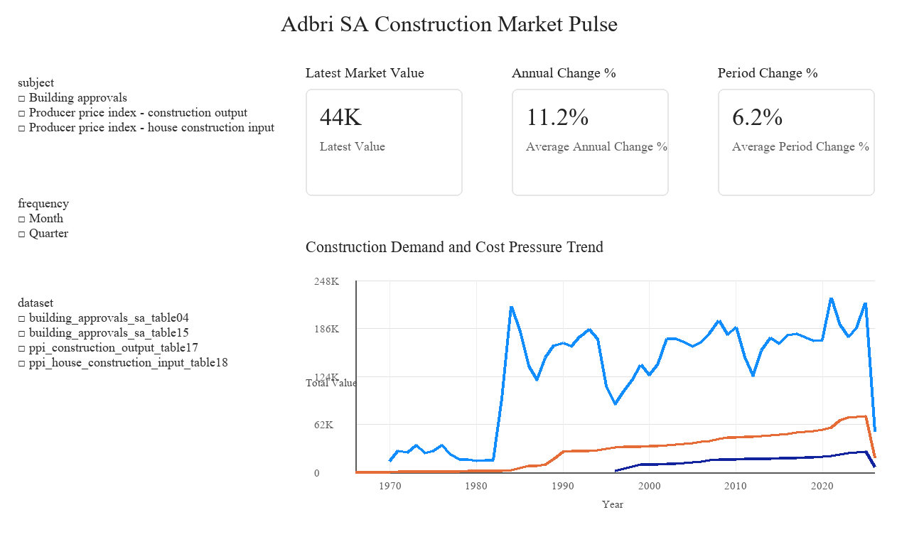
Figure 1. Executive Market Pulse page showing overall demand and cost-pressure indicators.
The Executive Market Pulse page consolidates latest market value, annual change, period change, and long-term trend analysis. This page is designed for a senior stakeholder who needs a fast view of whether the market is expanding, softening, or facing price pressure. The use of slicers for subject, frequency, and dataset allows the same model to support multiple analytical lenses.
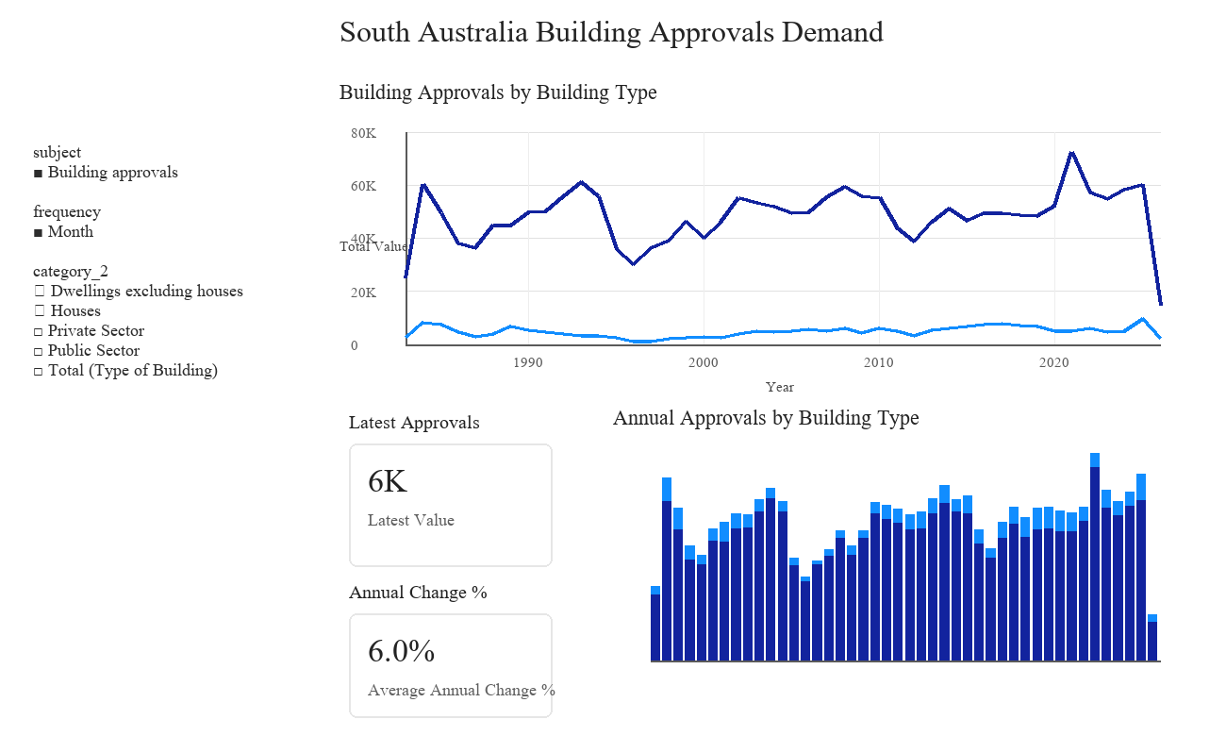
Figure 2. Building Approvals Demand page showing houses and dwellings excluding houses.
The Building Approvals Demand page isolates South Australia building approvals. By separating houses from dwellings excluding houses, the report identifies the composition of construction demand rather than presenting only a total. This page is the strongest evidence for market demand interpretation because building approvals are a leading indicator of future materials demand.
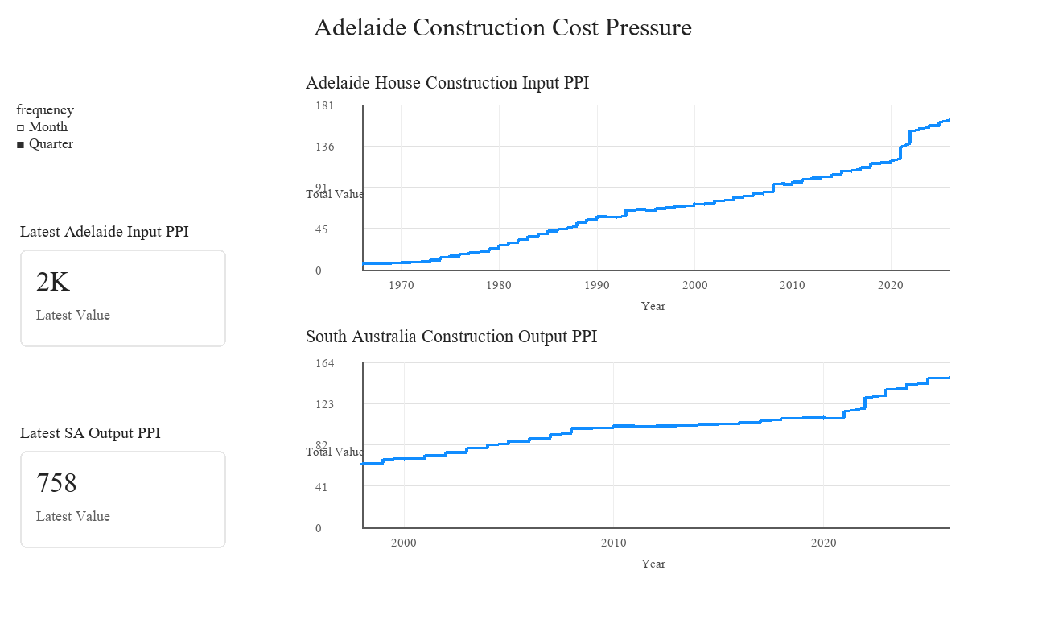
Figure 3. Construction Cost Pressure page showing Adelaide input PPI and South Australia output PPI.
The Construction Cost Pressure page separates two PPI series with different geographic grains: Adelaide house construction input PPI and South Australia construction output PPI. This design decision avoids mixing city-level and state-level measures in a single visual and demonstrates disciplined Power BI modelling.
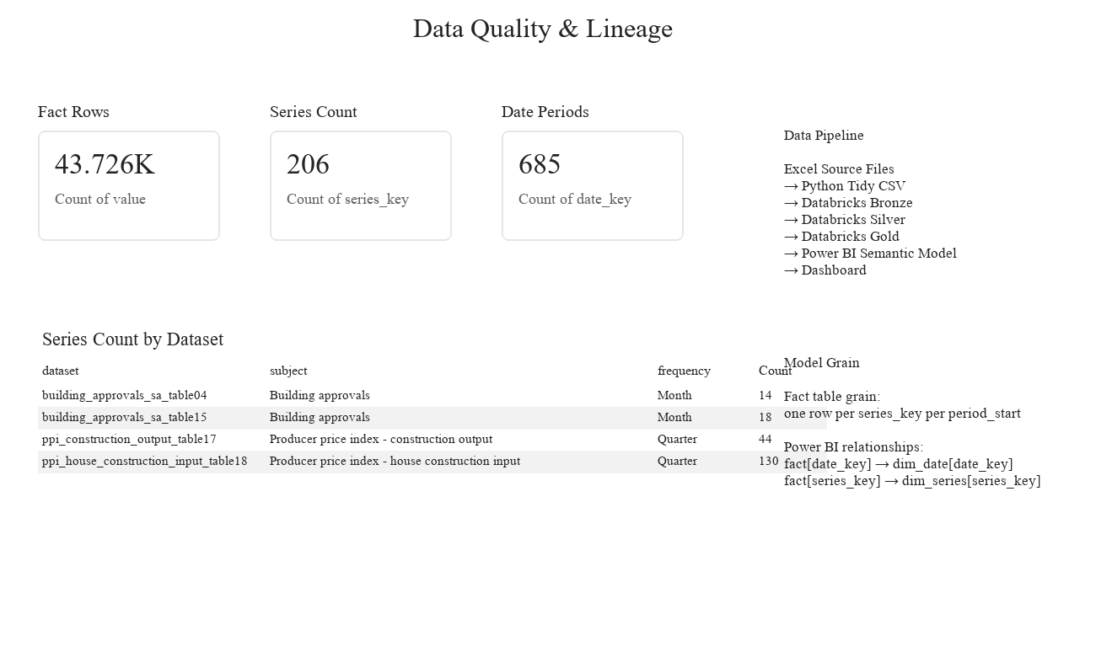
Figure 4. Data Quality & Lineage page documenting row counts, series counts, date coverage, and model grain.
The Data Quality & Lineage page makes the analytical report auditable. It shows fact rows, unique series count, date periods, source dataset counts, data pipeline steps, and the model grain. This gives the viewer confidence that the dashboard is supported by a traceable data process.

4. Results

4.1 Demand Conditions
The Power BI demand page indicates that South Australia building approvals recovered in 2025 after weaker annual totals in 2022 and 2023. Annual approvals for houses and dwellings excluding houses were approximately 24,474 in 2024 and 29,623 in 2025, indicating a material recovery in approval activity. At the latest monthly observation in March 2026, total approvals for the selected building-type categories were approximately 2,594, compared with 2,388 in March 2025, an increase of approximately 8.6%.
The composition of demand is uneven. Houses were slightly lower year-on-year in March 2026, while dwellings excluding houses were materially higher. This suggests that the demand signal is not uniformly house-led; multi-unit or non-house dwelling categories appear to be contributing more strongly to the latest improvement.

4.2 Cost and Price Pressure
The PPI page shows that cost and output price pressure remained positive into March 2026. Adelaide house construction input PPI reached 164.7 in March 2026, approximately 3.7% higher than March 2025. South Australia building construction output PPI reached 148.9, approximately 3.8% higher than March 2025. These results indicate that the market is not only showing demand recovery but also continued price pressure.

5. Discussion
For Adbri, the findings imply a cautiously positive demand environment. The recovery in 2025 approvals supports the view that construction-related materials demand may strengthen relative to the weaker 2022-2023 period. However, the demand mix matters. If growth is concentrated in dwellings excluding houses rather than detached houses, product mix and customer segment implications should be examined more closely.
The PPI evidence suggests that pricing and cost conditions remain important. A positive demand signal combined with persistent input and output price pressure means commercial teams should monitor both volume opportunity and margin risk. This is exactly where a Power BI report adds business value: it allows stakeholders to move from broad market questions to filtered evidence by subject, frequency, category, and geography.

6. Conclusion
The report demonstrates that a Power BI-driven BI workflow can convert complex ABS Excel workbooks into a business-ready market intelligence asset. The analysis suggests that South Australia construction demand improved in 2025 and remained supported into early 2026, while PPI indicators show continued construction cost and output price pressure. For an Adbri-style building materials business, the combined evidence points to recovering market demand with ongoing pricing pressure, requiring close monitoring of both volume and margin conditions.

Appendix: Interview Explanation
In an interview, I would explain that I used Power BI not only to build visuals, but to structure a market analysis. I created a star schema, wrote DAX measures, built slicers and KPI cards, separated visuals by business question, and included a data quality page. The report shows demand recovery, different demand composition between houses and other dwellings, and continued construction PPI pressure.

