BREAST CANCER ULTRASOUND CLASSIFICATION
USING MACHINE LEARNING
An auditable study of preprocessing, convolutional models,
and evidence integrity
A dissertation submitted to Manchester Metropolitan University
for the degree of Master of Science
Akerele David Damilola
Department of Computing and Mathematics
2026
EVIDENCE STATUS · PROVISIONAL
BrEaST and OASBUD pass the subject-level split audit; BUSI is excluded because its patient identifiers are unavailable.
This document makes no clinical-performance claim.

Abstract
Breast ultrasound is affected by speckle, acquisition settings, lesion context, and operator technique. This dissertation develops a reproducible research prototype for binary classification of breast-ultrasound images using EfficientNet-B0, ResNet-50, and a custom convolutional baseline. The implementation combines configurable CLAHE, aspect-ratio-preserving square padding, machine-readable evaluation artifacts, and a FastAPI research interface. Its principal contribution is methodological: training, evaluation, command-line prediction, and API inference share one preprocessing path, while a read-only audit checks subject-level split integrity before metrics are interpreted. The supplied OASBUD and BrEaST folders have been rebuilt into subject-level splits with no cross-partition identifiers. BUSI remains excluded because its renamed files do not retain enough provenance to verify patient separation. The fresh EfficientNet-B0 checkpoint achieved 67.74% accuracy, macro F1 0.6774, and ROC-AUC 0.7419 on 62 held-out BrEaST and OASBUD images. These are local-cohort research results only, not clinical or external validation.

Declaration
No part of this project has been submitted in support of an application for any other degree or qualification at this or any other institute of learning. Apart from those parts containing citations to the work of others, this project is my own unaided work. This work has been carried out in accordance with Manchester Metropolitan University research ethics procedures.
Signed: ____________________________________
Date: ______________________________________

Acknowledgements
I am grateful to my academic supervisor, department faculty, and fellow researchers at Manchester Metropolitan University for their guidance, encouragement, and technical insight during this MSc project.

Abbreviations
Abbreviation | Meaning
ACR | American College of Radiology
AUC-ROC | Area Under the Receiver Operating Characteristic Curve
BI-RADS | Breast Imaging-Reporting and Data System
BUSI | Breast Ultrasound Images Dataset
CLAHE | Contrast Limited Adaptive Histogram Equalisation
CNN | Convolutional Neural Network
Grad-CAM | Gradient-weighted Class Activation Mapping
OASBUD | Open Access Ultrasound Database
ROC-AUC | Area Under the Receiver Operating Characteristic Curve
ROI | Region of Interest

Contents
Abstract
Declaration
Acknowledgements
Abbreviations
Chapter 1: Introduction
Chapter 2: Background and Literature Review
Chapter 3: Methodology
Chapter 4: Implementation and Training Controls
Chapter 5: Results and Evaluation Status
Chapter 6: Discussion and Conclusion
References
Appendix A: Reproducibility checklist

Chapter 1: Introduction

1.1 Background
Breast ultrasound is a non-ionising imaging modality used alongside clinical assessment and other imaging. Its appearance varies with equipment, acquisition settings, anatomy, and operator technique. These differences, together with speckle and limited public sample sizes, make automated image classification a useful but difficult research problem.
Convolutional neural networks can learn image representations directly from pixels, while transfer learning can reduce the amount of task-specific data required. Nevertheless, a polished model result is not automatically a valid generalisation estimate. Related images from the same subject must remain in one partition, and the complete route from preprocessing to reported tables must be reproducible.
This dissertation develops a binary breast-ultrasound classification prototype with shared preprocessing, three CNN backbones, auditable evaluation outputs, and a local web interface. It is research software, not a diagnostic or clinical decision-support system.

1.2 Research problem
The project addresses three connected issues:
- Pipeline consistency: training, evaluation, command-line prediction, and API inference must apply the same preprocessing rules.
- Geometric preprocessing: direct rectangular-to-square resize changes apparent aspect ratios; padding permits isotropic resize, but any predictive benefit must be measured.
- Evidence integrity: subject identifiers, split manifests, seeds, configuration, checkpoints, and per-image predictions are necessary to support a defensible result.
The supplied OASBUD and BrEaST folders have now been rebuilt into subject-level splits with no cross-partition identifiers. The renamed BUSI files still do not preserve enough provenance to verify patient separation, so BUSI is excluded from validated training and evaluation. Current metrics are local-cohort research evidence only.

1.3 Research questions
- RQ1: Can one testable preprocessing and inference path support every executable project surface?
- RQ2: How should CLAHE and square padding be compared with simpler preprocessing under controlled partitions, seeds, and training budgets?
- RQ3: Which conclusions are justified by the present data audit, and what controls are required for a patient-independent evaluation?

1.4 Objectives and contributions
The implementation provides deterministic split and audit utilities, shared CLAHE and crop strategies, EfficientNet-B0, ResNet-50 and custom-CNN options, checkpoint metadata, per-image predictions, generated metrics and plots, regression tests, and a research-only FastAPI interface. The written and visual artifacts use the same current evidence status and withdraw unsupported historical benchmarks.

1.5 Scope
The configured task maps images to benign or malignant; images stored under normal are currently included in the non-malignant class. This is a modelling simplification. The project does not assign BI-RADS, recommend management, or establish clinical efficacy. No pseudo-labelling, preprocessing ablation, multi-seed comparison, external validation, or prospective reader study is claimed as completed.

Chapter 2: Background and Literature Review

2.1 Ultrasound image formation and speckle
B-mode ultrasound displays processed echo information produced by reflection, scattering, attenuation, beamforming, compression, and device-specific post-processing. A simplified observation model is:
I(x,y)=f(x,y)ηm(x,y)+ηa(x,y),
where f is an underlying reflectivity field, ηm is a multiplicative component, and ηa is an additive component. This abstraction motivates robustness tests but does not fully reproduce clinical acquisition.
Radiologists use descriptors such as shape, margin, orientation, echogenicity, and posterior acoustic behaviour within the BI-RADS ultrasound lexicon. These concepts explain why geometry and contrast can matter; they do not authorise this software to infer a BI-RADS category.

2.2 Geometric preprocessing
For an image of height H and width W resized to H' by W', s_y=H'/H and s_x=W'/W. Direct resize is anisotropic when s_x≠ s_y. Padding a crop to a square before resizing applies one final scale factor. This preserves crop aspect ratio by construction, but cropping and reflected boundaries can create their own biases. Predictive effects require a matched ablation.

2.3 CLAHE
Contrast Limited Adaptive Histogram Equalisation applies local histogram mappings and clips histogram mass before redistribution. The project applies OpenCV CLAHE to the LAB luminance channel with clip limit 2.0 and a 16×16 tile grid. This is a reproducible configuration, not proof of improved classification.

2.4 CNN architectures
The project compares two transfer-learning backbones with a compact custom model:
- ResNet-50 uses residual identity paths to support deep optimisation.
- EfficientNet-B0 uses mobile inverted bottlenecks, squeeze-and-excitation, and coordinated scaling.
- Custom CNN uses four convolutional stages, batch normalisation, pooling, adaptive average pooling, and dropout.
Softmax produces a mutually exclusive probability vector but does not guarantee calibration. Grad-CAM produces a coarse gradient-based localisation map but does not prove causal or clinically relevant reasoning.

2.5 Reproducibility gap
Public datasets such as BUSI and OASBUD make experimentation possible, but subject grouping and provenance determine whether an evaluation is interpretable. A complete evidence record includes source identifiers, grouping rules, checksums, exclusions, split manifest, preprocessing, model configuration, seeds, checkpoints, and per-image predictions.
The research gap addressed here is therefore practical integration: connecting a working classifier and user interface to an auditable evidence chain, while preventing illustrative interface values from being mistaken for measured findings.

2.6 Public breast-ultrasound datasets
The revised dissertation reviews five datasets discussed by Bristow and Yap: OASBUD, RODTOOK, UDIAT, BUSI, and BrEaST. They differ in country, scanner source, image formation, annotation, ground truth, and file organisation. Those differences affect both training and the meaning of a test result.
OASBUD and BrEaST were selected for the validated experiment because their local copies retain subject identifiers, paired lesion masks, and labels linked to biopsy or follow-up evidence. Their contrasting appearance also gives the local experiment some acquisition diversity. The study still has a narrow geographic base because both sources were collected in Poland.
RODTOOK and UDIAT were not in the supplied project data. Bringing them into the present experiment would require a fresh acquisition, licence review, curation pass, and frozen subject-level manifest. They are sensible external cohorts for later work.
BUSI was present only as a renamed 224 by 224 derivative. The generated sample_* identifiers cannot be traced back to the original cases, and the visible images show repeated banding. Published correspondence also reports duplicates and inconsistent cases in the public release. The local derivative is therefore illustrated in the report but excluded from validated training and evaluation.
The dataset plate is stored at [latex_university/figures/fig9_dataset_quality_examples.png](../../latex_university/figures/fig9_dataset_quality_examples.png). It shows benign and malignant examples from the three local folders while making the BUSI derivative status explicit.

Chapter 3: Methodology

3.1 Evidence design
The project distinguishes engineering evidence, which confirms that the software path executes consistently, from generalisation evidence, which estimates performance on independent subjects. The current local cohort supports only the first level because it fails the split-integrity audit.

3.2 Data audit
The validated loader uses BrEaST and OASBUD only and finds 302 training, 63 validation, and 62 test images after subject-level rebuilding. The audit reports no cross-partition identifiers in either dataset. BUSI patient separation cannot be reconstructed from its renamed files, so it is excluded by default; training still stops if any configured dataset fails its audit unless --allow-unaudited-data is supplied for an explicitly provisional run.
The subject-level splitter copies grouped files into deterministic class-stratified partitions and saves a JSON manifest. It never moves the source dataset.

3.3 Shared preprocessing
All executable surfaces call the same function. The sequence is RGB decoding, optional CLAHE, one selected crop/resize strategy, tensor conversion, and ImageNet normalisation.
Supported masks end with _mask.png, _tumor.png, or _lesion_mask.png. A valid mask defines a bounding box expanded by a 20% context margin. Without a mask, the central 80% is used as a deterministic fallback. For a crop of height h_c and width w_c, the square side is d=max(h_c,w_c); symmetric BORDER_REFLECT_101 padding is added and the result is resized to 224×224.
Training augmentation uses horizontal flips and rotations up to 15 degrees. Vertical flips are excluded because image depth has acquisition meaning.

3.4 Models and optimisation
EfficientNet-B0 and ResNet-50 use ImageNet initialisation during training; the custom CNN is trained from scratch. The default optimiser is AdamW with learning rate 10^-4 and weight decay 10^-4, cosine annealing, class-weighted cross-entropy, batch size 16, and early stopping. Python, NumPy, PyTorch, and CUDA are seeded; each checkpoint stores its run configuration and audit status.

3.5 Evaluation artifacts
evaluate.py writes predictions.csv, metrics.json, confusion_matrix.png, and roc_curve.png. The JSON record includes audit status and checksum, generation time, preprocessing configuration, sample count, summary metrics, and confusion matrix. Tables are generated from these outputs rather than entered manually.

3.6 Interface boundary
The FastAPI interface exposes research inference, model comparison where compatible checkpoints exist, batch evaluation, and seeded synthetic-noise demonstrations. It does not infer ground truth from filenames or provide diagnosis, BI-RADS, clinical priority, or management advice.

Chapter 4: Implementation and Training Controls

4.1 Repository structure
The executable code is separated into configuration, dataset, model, training, evaluation, prediction, and API modules. Thin root-level entry points keep commands stable. Generated evidence is written to outputs/, while the dissertation source, supporting documents, notebook, slides, and web interface remain version-controlled.

4.2 Training guard and checkpoint metadata
Before training, the pipeline regenerates outputs/data_audit.json. A failed audit stops the run unless the user explicitly supplies --allow-unaudited-data; this override does not convert the result into valid evidence. The best validation-loss checkpoint stores the model and optimiser states plus the model name, epoch, validation metrics, class names, seed, batch size, learning rate, epoch budget, dataset-combination flag, crop strategy, CLAHE flag, creation time, and audit status.

4.3 Evaluation implementation
Evaluation reconstructs the selected model without downloading pretrained weights and loads the checkpoint state. The test loader contains no stochastic augmentation. Per-image outputs are saved before aggregate metrics are calculated so every reported number can be regenerated.
The current EfficientNet-B0 checkpoint was retrained after rebuilding BrEaST and OASBUD subject-level splits. Its evaluation on the 62-image held-out test partition is reported as local-cohort research evidence in Chapter 5; BUSI is excluded because its source identifiers are unavailable.

4.4 Verification
The test suite checks output dimensions for every crop strategy, discovery of supported mask suffixes, explicit failure of the current data audit, and the API's no-clinical-action response. Syntax compilation, notebook validation, LaTeX compilation, browser checks, and render inspection of Word and PowerPoint outputs form separate release gates.

Chapter 5: Results and Evaluation Status
The repaired validated loader uses BrEaST and OASBUD only, with 302 training, 63 validation, and 62 held-out test images. The fresh EfficientNet-B0 checkpoint achieved 67.74% accuracy, macro F1 0.6774, and ROC-AUC 0.7419 on that test partition.
The split audit passes for BrEaST and OASBUD with no subject crossing partitions. BUSI remains excluded because its local files were renamed and patient-level independence cannot be verified. The result is therefore a local-cohort research finding, not a clinical-performance estimate. Do not make clinical inferences or claim external generalisation.
The corrected evaluator writes outputs/metrics.json, confusion_matrix.png, and roc_curve.png. All final tables and figures must be derived from per-run saved predictions after the cohort is reconstructed at subject level.
The revised results chapter also includes four image-level outcomes selected by a fixed rule from outputs/predictions.csv: the lowest-probability correct benign case, the highest-probability correct malignant case, the highest-probability false positive, and the lowest-probability false negative. The plate uses the same ROI crop and CLAHE path as evaluation. It supports transparent error review without claiming that visual inspection reveals why the network made a decision.
See [latex_university/figures/fig10_prediction_examples.png](../../latex_university/figures/fig10_prediction_examples.png) for the generated plate.

Generated evaluation figures
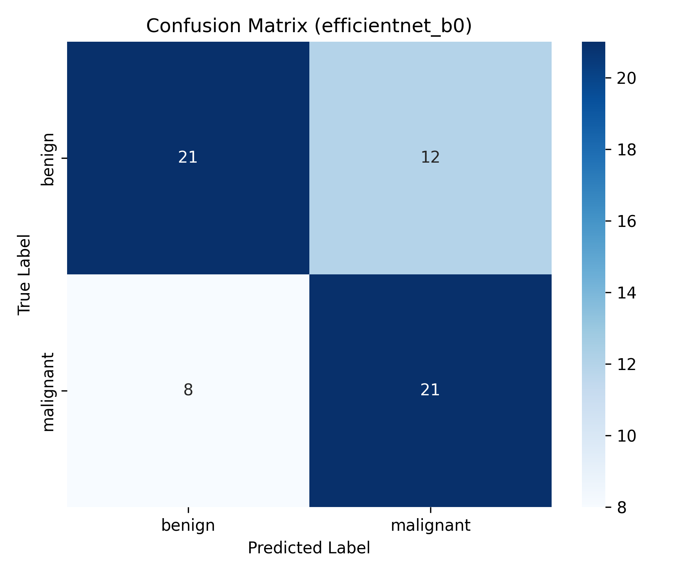
Figure 1. Confusion matrix for the audited 62-image checkpoint run.
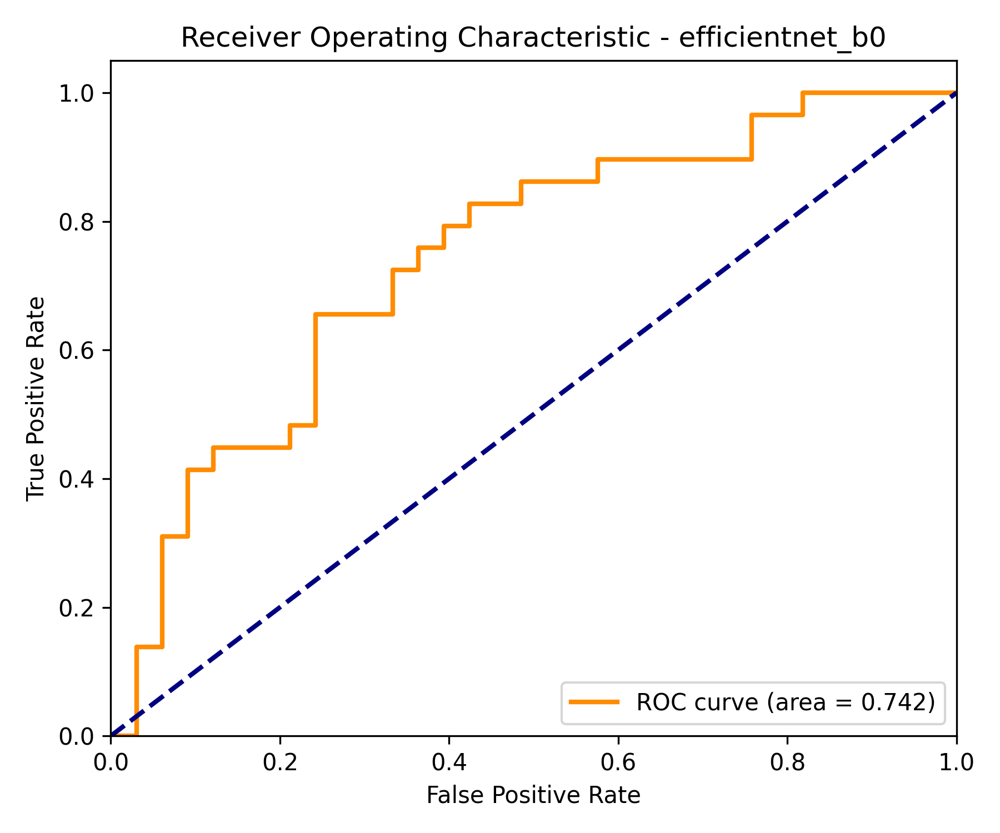
Figure 2. Receiver operating characteristic for the same audited run.

Chapter 6: Discussion and Conclusion
The project’s contribution is a reproducible research framework: shared preprocessing, mask discovery, versioned evaluation artifacts, and a non-destructive split audit. It is not a clinically validated classifier.
The immediate next step is to preserve original identifiers, group every patient’s views and masks in a single partition, freeze a test cohort before model selection, and rerun all experiments. The dashboard’s outputs are research visualisations rather than diagnosis, BI-RADS assignment, or clinical decision support.

References
Al-Dhabyani, Walid; Gomaa, Mohammed; Khaled, Heshmat; Fahmy, Aly (2020). Dataset of breast ultrasound images. Data in Brief. https://doi.org/10.1016/j.dib.2019.104863
Cheng, Jie-Zhi; Ni, Dong; Chou, Yi-Hong; Qin, Jing; Tiu, Chui-Mei; Chang, Yeun-Chung; Huang, Chiun-Sheng; Shen, Dinggang (2016). Computer-aided diagnosis with deep learning architecture: applications to breast lesions in US images and pulmonary nodules in CT scans. Scientific Reports. https://doi.org/10.1038/srep24454
Guo, Chuan; Pleiss, Geoff; Sun, Yu; Weinberger, Kilian Q. (2017). On Calibration of Modern Neural Networks. Proceedings of the 34th International Conference on Machine Learning (ICML).
He, Kaiming; Zhang, Xiangyu; Ren, Shaoqing; Sun, Jian (2016). Deep Residual Learning for Image Recognition. Proceedings of the IEEE Conference on Computer Vision and Pattern Recognition (CVPR).
Hu, Jie; Shen, Li; Sun, Gang (2018). Squeeze-and-Excitation Networks. Proceedings of the IEEE Conference on Computer Vision and Pattern Recognition (CVPR).
Jiang, Jiacheng; Zhang, Yanning; Liu, Xuan; Chen, Hao (2023). Noise-robustness test for ultrasound breast nodule neural network models as medical devices. Frontiers in Oncology. https://doi.org/10.3389/fonc.2023.1177225
Lee, Jong-Sen (1980). Digital image enhancement and noise filtering by use of local statistics. IEEE Transactions on Pattern Analysis and Machine Intelligence. https://doi.org/10.1109/TPAMI.1980.4766994
Litjens, Geert; Kooi, Thijs; Bejnordi, Babak Ehteshami; Setio, Arnaud Arindra Adiyoso; Ciompi, Francesco; Ghafoorian, Mohsen; van der Laak, Jeroen A.W.M.; van Ginneken, Bram; S'anchez, Clara I. (2017). A survey on deep learning in medical image analysis. Medical Image Analysis. https://doi.org/10.1016/j.media.2017.07.005
Mendelson, Ellen B.; B"ohm-V'elez, Marcela; Berg, Wendie A.; Whitman, Gary J.; Feldman, Marla I.; Madjar, Helmut; Rizzatto, Giorgio (2013). ACR BI-RADS Ultrasound. ACR BI-RADS Atlas, Breast Imaging Reporting and Data System.
Piotrzkowska-Wroblewska, Hanna; Litniewski, Jerzy; Szymanska, Karolina; Dobruch-Sobczak, Katarzyna (2017). Open Access Ultrasound Database (OASBUD) for breast lesion classification. Medical Physics. https://doi.org/10.1002/mp.12563
Selvaraju, Ramprasaath R.; Cogswell, Michael; Das, Abhishek; Vedaldi, Andrea; Parikh, Devi; Batra, Dhruv (2017). Grad-CAM: Visual Explanations from Deep Networks via Gradient-Based Localization. Proceedings of the IEEE International Conference on Computer Vision (ICCV).
Stavros, A. Thomas; Thickman, David; Rapp, Cindy L.; Dennis, Mark A.; Parker, Steve H.; Sisney, Gale A. (1995). Solid breast nodules: use of sonography to distinguish between benign and malignant lesions. Radiology. https://doi.org/10.1148/radiology.196.1.7784555
Sung, Hyuna; Ferlay, Jacques; Siegel, Rebecca L.; Laversanne, Mathieu; Soerjomataram, Isabelle; Jemal, Ahmedin; Bray, Freddie (2021). Global Cancer Statistics 2020: GLOBOCAN Estimates of Incidence and Mortality Worldwide for 36 Cancers in 185 Countries. CA: A Cancer Journal for Clinicians. https://doi.org/10.3322/caac.21660
Tan, Mingxing; Le, Quoc V. (2019). EfficientNet: Rethinking Model Scaling for Convolutional Neural Networks. Proceedings of the 36th International Conference on Machine Learning (ICML).
Yu, Yongjian; Acton, Scott T. (2002). Speckle reducing anisotropic diffusion. IEEE Transactions on Image Processing. https://doi.org/10.1109/TIP.2002.804276
Zuiderveld, Karel (1994). Contrast Limited Adaptive Histogram Equalization. Graphics Gems IV.

Appendix A: Reproducibility checklist
• Dataset licences, versions, checksums, exclusions, and label mapping recorded.
• Every subject and all associated views and masks assigned to one partition.
• Test manifest frozen before model selection.
• Seeds, environment, configuration, and checkpoint hashes saved.
• Per-image predictions retained for every reported run.
• Uncertainty, calibration, failure cases, and subgroup or site limitations reported.
• All written and visual artifacts regenerated from the final evidence files.

