
Report
Design of a Logic Circuit for Month Number Display

David Åkerlind

Department of mathematics and computer science DVGA28
Module 1-Digital electronics, 3 ETCS credits

Introduction

This assignment was about designing and constructing a logic device that displays the number of a month 1 to 12 on two seven-segment displays. The circuit is controlled only by one input signal X. When X = 1, the display loops sequentially from 1 to 12, incrementing its numbers accordingly to the clock pulse, and resetting to 1 after displaying the number 12. When X = 0, the display shows nothing and both displays are completely dark. The logic and memory elements. The design consists of two main parts:
- A sequential circuit using D flip-flops to store the current month number in binary form (states 0000 to 1100), with control logic for counting and resetting. It has 4 output signals that is the D3 D2 D1 and D0 from most significant bit (D3) to least significant bit (D0). Allowed elements for the sequential circuit are D flip-flops and logic gates (one-input NOT gates and two-input AND, OR, NAND, NOR, XOR and XNOR gates).
- A combinational circuit that converts the 4-bit binary state into the appropriate signals to light the fourteen segments of two seven-segment displays, so they show the binary number as a decimal number (base 10) on the displays. Allowed elements for the combinational circuit: logic gates (one-input NOT gates and two-input AND, OR, NAND, NOR, XOR and XNOR gates).

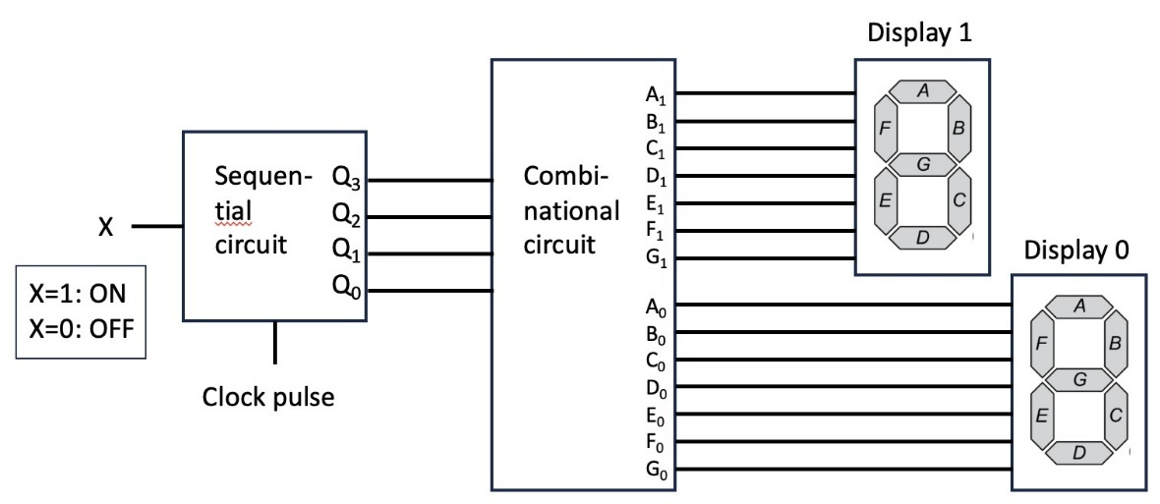

Figure 1. Overview of the circuit to design in this assignment

Sequential Circuit Design

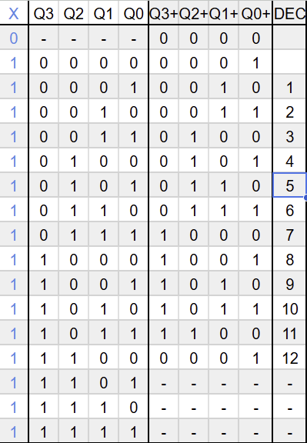
The sequential circuit has 4 D flip-flops, and their respective output is producing state bits $Q_{3},Q_{2},Q_{1},Q_{0}$. Valid states represent binary values 0000 (0) trough 1100 (12). The invalid states 1101-1111 are treated as don’t care values in the design. The design process started with making the Next state table for each D flip-flop input $D_{3},D_{2},D_{1},D_{0}$ as a function of the present state $Q_{3},Q_{2},Q_{1},Q_{0}$ and input X, figure 2.

Figure 2. Next state table for the inputs and outputs of all the D flip-flops

The normal Qs in the table are the inputs for the D flip-flops and the Q+’s are the nest state we want the D flip-flops to produce. The dashes (-) are do not care values and we never want them to appear in this circuit. From the table, we can see that when X = 0, the next state is always 0000 regardless of the present state. When X = 1, the circuit increments through the sequence 0001→0010→...→1100→0001.". Another thing to analyse is that we go from 0000 (0) to 0001 (1) but from 1100 (12) directly to 0001 (1) and we skip 0000 (0) when we are looping. From this table the Karnaugh tables for each Q+ output is made and the simplified Boolean expressions, see figure 3. A big help when making this table was that remembering that Q+ is what we want next and Q is just all the cases, and to keep this thought in my mind to avoid overthinking the process. And in this stage of the process not to think about “how” we get the next state of Q and just focus on what state we want, was a big help in the making of the table and, as said before, to avoid overthinking.
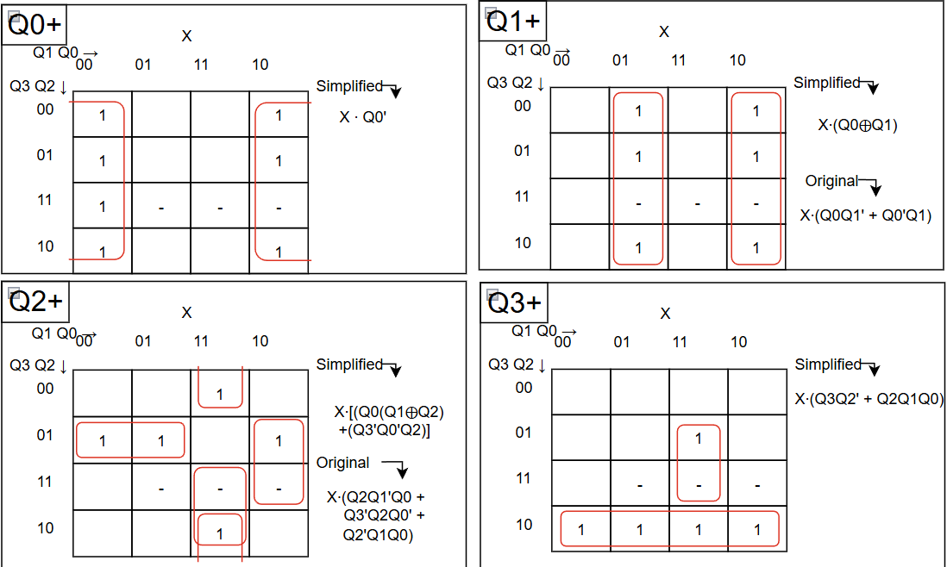
Figure 3. Karnaugh maps with grouping for the next states and the outputs of the D flip-flops

Above are the Karnaugh maps for the D flip-flops, in the specification of the assignment it stood that only 2 input logic gates were allowed for constructing both the circuit. This made the logic gate amount bigger, and some simplifications were made on the Boolean expressions that had 3 elements like $Q_{3}Q_{2}Q_{1}'$ had to be 2 “and-gates” and there fourth we need to write it like this $Q_{3}{(Q}_{2}Q_{1}')$ instead. Things to take away from these Karnaugh tables is that the $Q_{0}Q_{3}$ tables do not have the original expression, that is because the original expression for these are the same as the simplified expression, so they are not needed. Another thing to take away from this image is that these are the Karnaugh maps for when X = 1, because when X = 0 it does not matter what state before was, the next is always 0000 (0) so that’s why we only need the X = 1 Karnaugh maps. We can also see the groups made by the red rectangles in the different maps. After this we can take the simplified Boolean expressions for all the D flip-flops and construct the final sequential circuit schematic. As said before we were only allowed to have two input gates in the design, so we used simplified expressions to make the construction with these kinds of gates easier while also trying to reduce the number of gates needed.
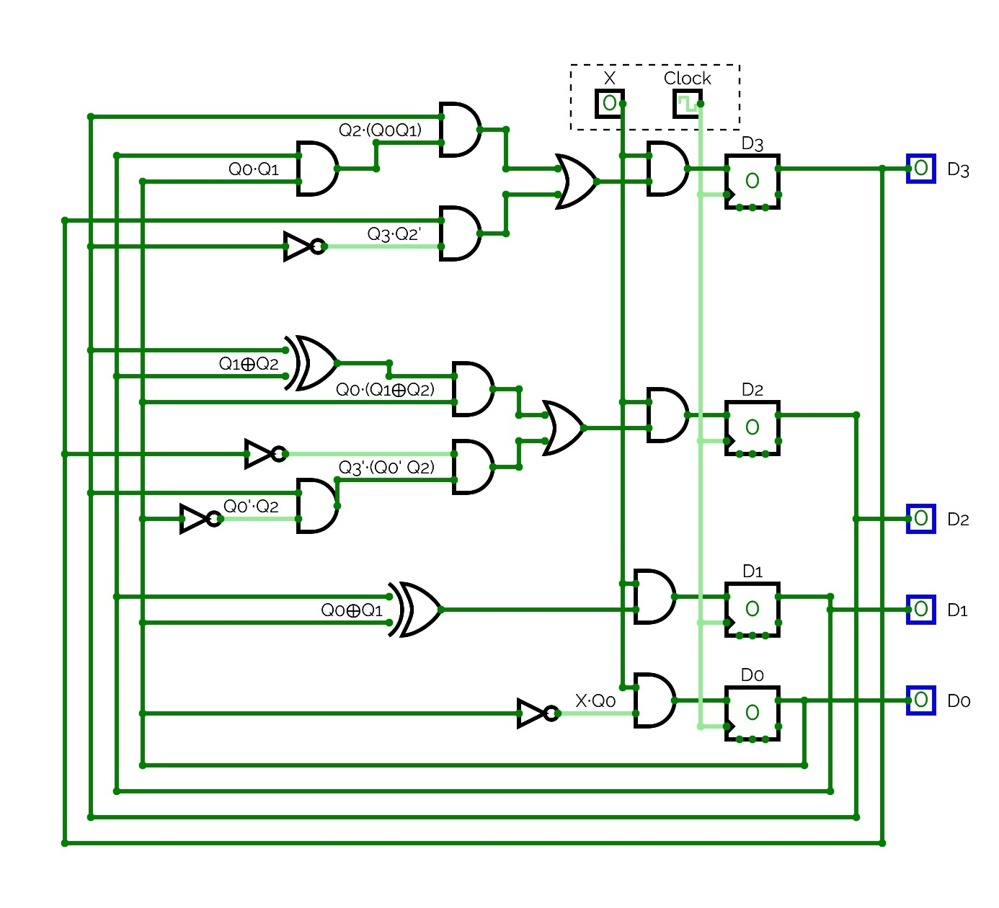
Figure 4. Final Sequential Circuit Schematic (made with www.circuitverse.org/simulator)

The creation of the sequential circuit schematic presented a significant design challenge: achieving an optimal balance between providing a clear, high-level overview and maintaining a functionally compact layout. The primary difficulty lay in organizing the logic gates and signal paths so that the circuit's operational flow—from the D flip-flops through the next-state logic—remained intuitively traceable, without sprawling into an unwieldy diagram. To prioritize this readability, a key design decision was made to exclusively use the standard (Q) outputs of the D flip-flops, deliberately omitting their complementary (Q') outputs. Technically, utilizing these inverted signals could have reduced the total number of gates in the combinational next-state logic, as certain NOT gates would have been rendered unnecessary. However, this theoretical efficiency would have come at the cost of practical clarity. Introducing the Q' signals would have required a dense network of additional connection lines crisscrossing the schematic back from the D flip-flops to the logic array, creating visual clutter and increasing the risk of confusion when tracing signal dependencies. This compromise—accepting a few extra gates for a far cleaner signal path—was deemed essential for a schematic meant to be understood and verified.
Furthermore, to bridge the gap between the abstract Boolean algebra and the concrete implementation, strategic labelling was employed throughout the schematic. Labels such as " Q1⊕Q2" or "Q0∙Q1" serve multiple critical functions. During the physical or digital construction phase, they provided unambiguous reference points, preventing wiring errors. In the context of this report, these labels act as a crucial navigational aid. They allow a reader to systematically cross-reference the minimized expressions from the Karnaugh maps (e.g., $D_{1}={X(Q}_{0}⊕Q_{1})$) with their physical instantiation in the circuit, making it possible to follow the logical transformation step-by-step from a truth table entry to a specific gate's output. Thus, the final schematic is not merely a drawing of components but a carefully structured document that elucidates the design process itself.

Combinational Circuit Design

The combinational circuit serves as a decoder of sorts, translating the 4-bit binary number $D_{3},D_{2},D_{1},D_{0}$ into signals that control the fourteen segments of the two seven-segment display (Display 1 for the tens digit and Display 0 for the units digit). The inputs we name $D_{3},D_{2},D_{1},D_{0}$ to maintain consistency with the sequential circuit's output naming, facilitating easier traceability between the two subsystems.
Truth Table Development
A comprehensive truth table (figure 5) was constructed, mapping all 16 possible input combinations (0000–1111) to the required outputs for the fourteen segments (A0–G0, A1–G1). The design specifications dictated the following behaviour:
- For months 1–9, the tens digit (Display 1) must be blank (all segments off).
- For months 10, 11, and 12, the tens digit must show '1' (segments B1 and C1 illuminated). They can have the same input because they lit up at the same moments.
- The units digit (Display 0) displays the corresponding digit 0–9, with digit patterns following the standard seven-segment encoding given in the instructions to the assignment.
- The invalid/undefined input states (1101, 1110, 1111) were treated as don't-care conditions (marked with '-' (dash) in the table) to maximize simplification potential.
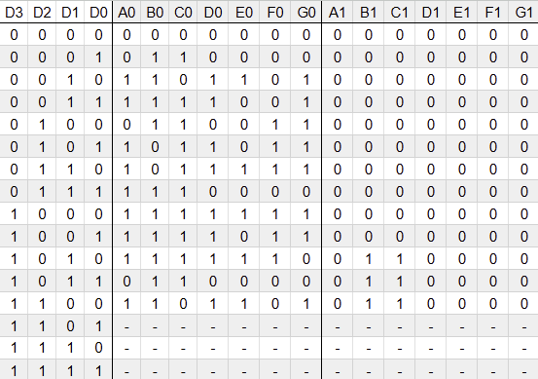
Figure 5. Truth table for the 14 segments of the two seven-segment displays
From this truth table we can see that most of the input signals to Display 1 are always going to be off (0) and then we can put in a constant 0 input for A1, D1, E1, F1 and G1 which are the segments that always will be off. We can also see that the B1 and C1 are the same so we can have the same signal input for both. Most of the work is going to be done on the Display 0 and A0 – G0 so the next step is to do Karnaugh maps for this part and the B1/C1. Also as said before, here we treat the 1101, 1110 and 1111 states as do not care states because they will never occur. The making of this was quite straight forward, I looked at what parts of the digit made up the different numbers that was needed and took it column by column. Starting with the question “when do we need A0 to be lit”, and putting a 1 in all these cases that proved the question right and a 0 in all other cases.
Karnaugh Map Minimization
For each of the 14 segment outputs, individual 4-variable Karnaugh maps were constructed by checking when they needed to be true according to the truth table (figure 5) and putting in 1 in the places this was true. The don't-care states proved particularly valuable for simplifying the units digit logic for higher numbers and it was quite easy to make large groups in the maps so in some cases the simplification of the Boolean expressions were easy to handle. But there were some longer expressions that were quite tricky to simplify such as the table for B0 and F0, and it was not easier to do since in this circuit we were only allowed 2-input gates like int the sequential part. The use of XOR-gates was a big help to this part and made a great difference in the number of gates needed in the final schematic of the circuit.
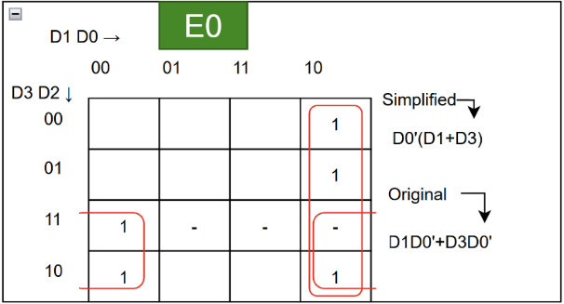
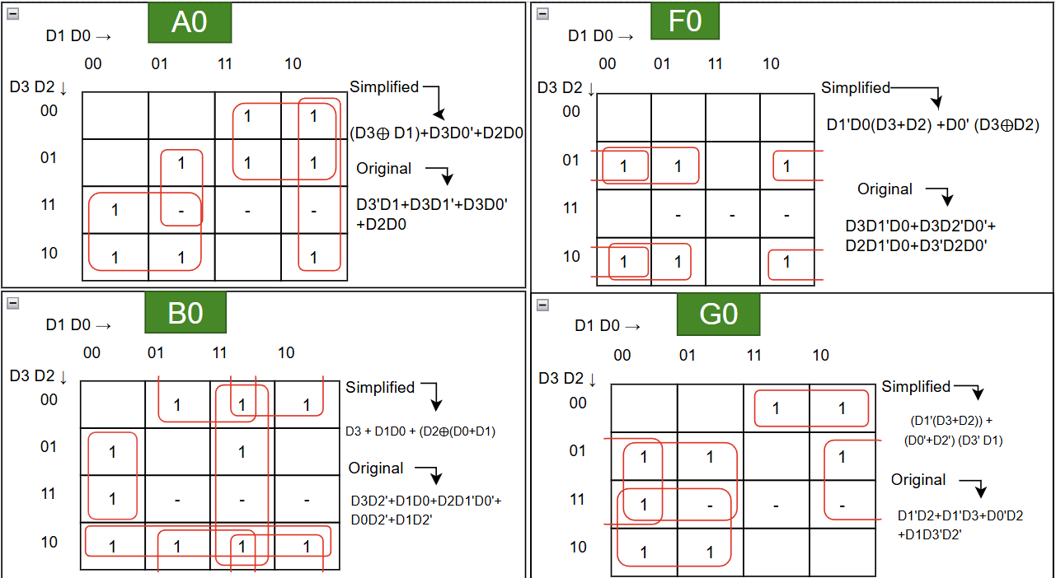
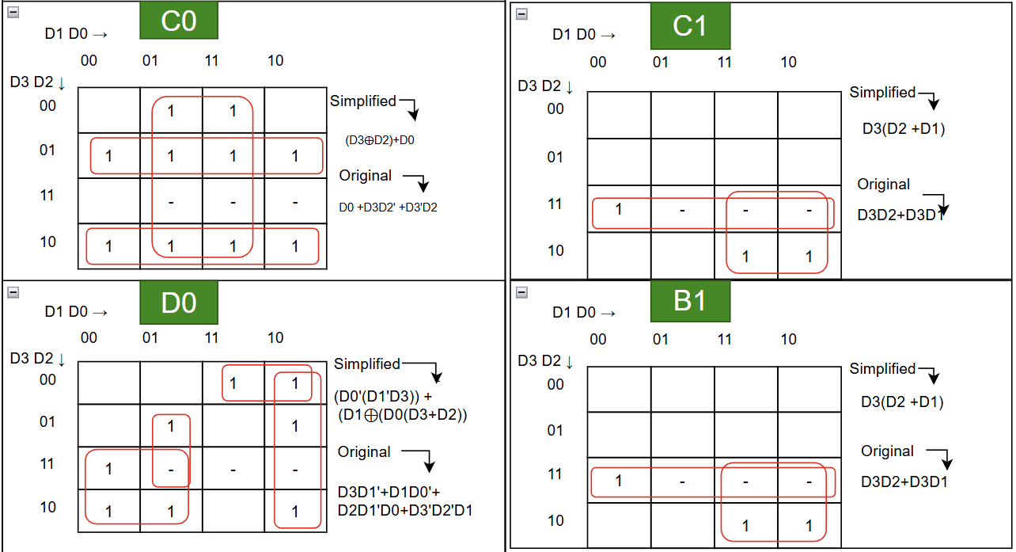
Figure 6. Karnaugh maps with grouping for 9 of the 14 inputs to the two seven-segment displays (A0, B0, C0, D0, E0, F0, G0 and B1, C1)
In figure 6 we se the Karnaugh maps for 9 of the 14 inputs to the two seven segment displays, why not all the 14 inputs have their respective maps is because the rest of them will never need a positive output and are always 0 / off. We can also see that the B1 and C1 are the same also here as in we have seen in the truth table before. We have the groups of all the maps and their original and simplified Boolean expression. I have also here made the simplification with the limitation of two-input gates in mind so that it would make the design and construction of the final schematic easier.
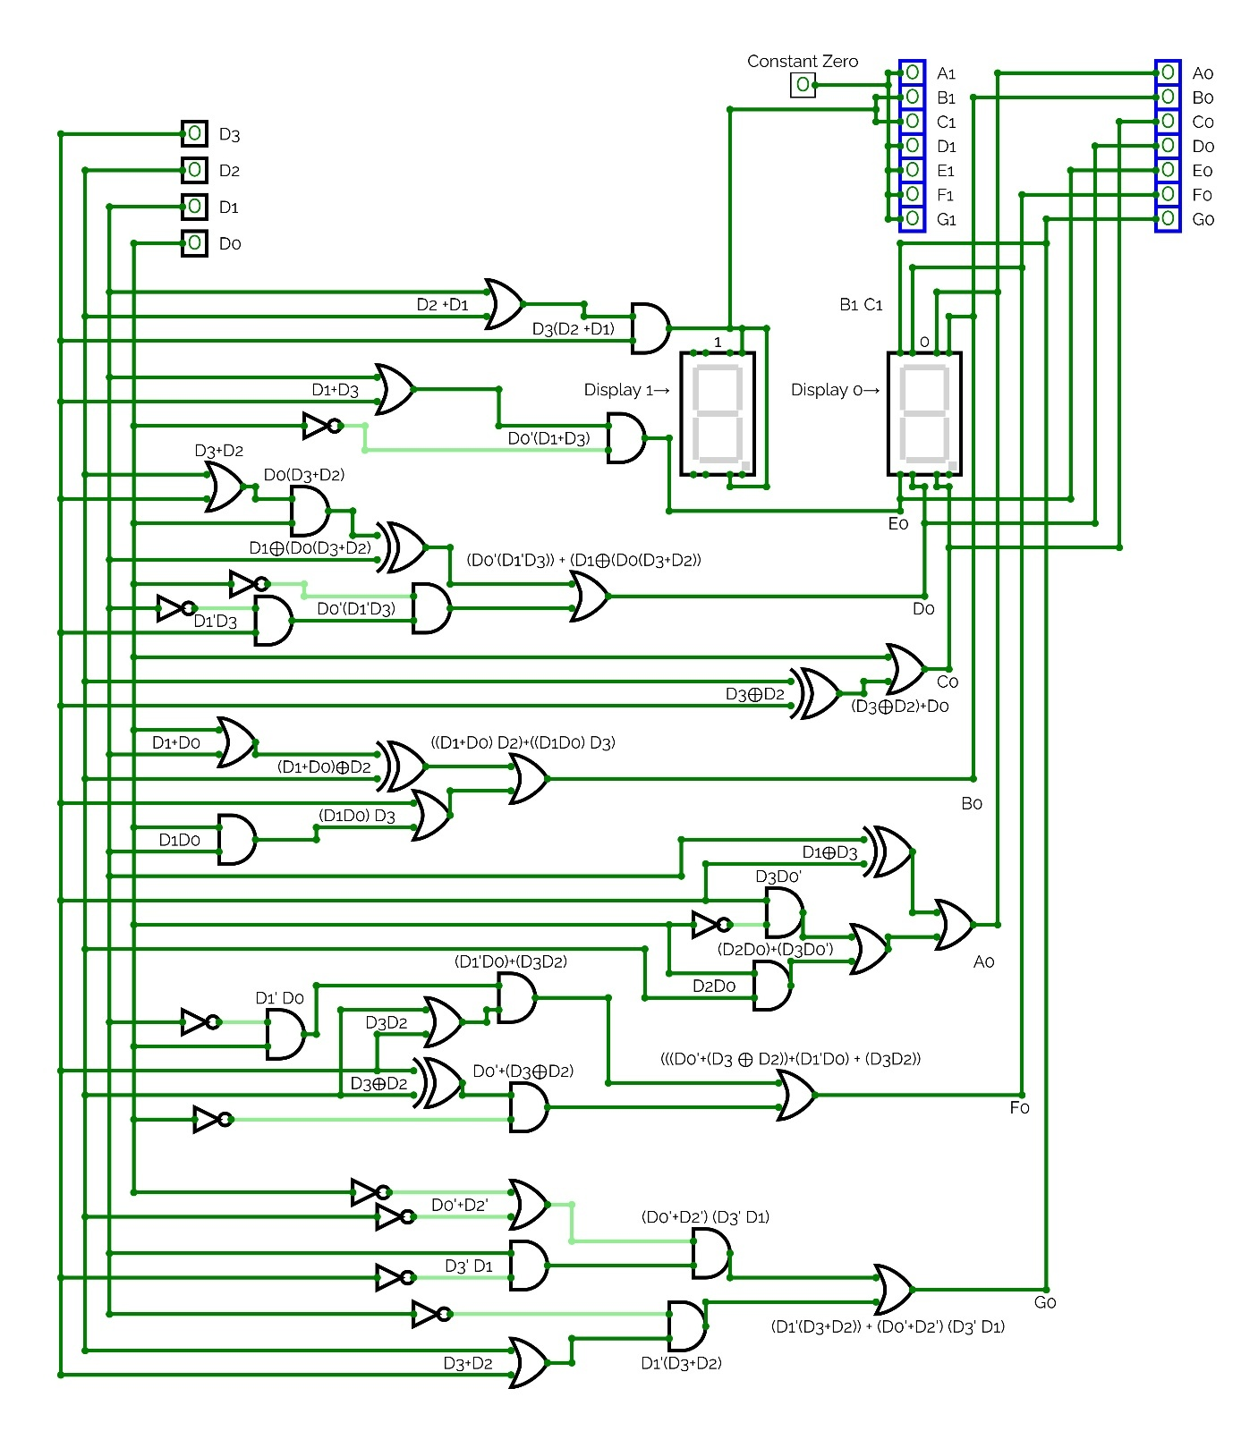
Figure 7. Final Combinational Circuit Schematic (made with www.circuitverse.org/simulator)
The combinational circuit was also using the tools of www.circuitverse.org/simulator like the sequential circuit was. The task was to realise that the gates where just the Boolean expressions and now I had to make sure that each input to the displays where correct and the same as the Karnaugh maps produced. I started of by taking the connections of the inputs from the D flip-flops and making them stretch down all the way, then i put the displays to the right and gave some space for the gates. As it was the first time making such a big circuit it was kind of hard to know how big everything would become once all the gates and connections were in place. But I took it one input signal at a time and then tried to spread them out as evenly as possible. The order and placing of the input signals are a bit weirdly placed and that is because the input-connections to the displays in this program (www.circuitverse.org/simulator) where a bit strange and because of that I tried my best at making it so that the connections and lines would be as easy as possible to follow. Also, in this circuit there are some labelling on some of the gates to make construction and overview easier. Lastly, I took these signals and put them to output signals (the 14 blue squares top right in figure 7) to make it clear what the output of each part really was.

Summary and Conclusions
This project successfully designed and documented a complete digital system that cyclically displays month numbers 1-12 on two seven-segment displays. The system demonstrates a classic finite state machine architecture with separate sequential control and combinational output decoding. It was great to design the whole circuit and seeing how the truth tables and Karnaugh maps really made the Boolean expressions easy to use. And to take these Boolean expressions and drawing the circuit and watching it work was so fun. A crucial early realization was that the state 0000 represents "display OFF" rather than the digit "0". This fundamentally shaped the truth table and subsequent logic design for the combinational circuit.
Usage of various websites and online-tools
I started this assignment on paper, doing the truth tables and Karnaugh maps for the sequential part, after a while I thought that it may exist websites and opensource tools to make this sort of stuff easier. Usually, I think of AI and chat bots for such tasks but in my experience making the exercises in this module I realized that AI was quite bad at doing this sort of tasks (truth tables and Karnaugh maps). So, I googled and found many tools that was pretty good. One tool I used was a Karnaugh map simplifier (https://www.boolean-algebra.com/kmap), where I could practice my grouping and see how the maps had a relation to the truth tables and also the Boolean expressions. This was a big help and made remembering that everything is connected make sense in a good way.
After I had designed the sequential circuit using draw.io I realised I couldn’t test this circuit in “reality” and see if it worked and then I asked Chat GPT if there were any useful tools to make functioning and testable computer circuits online, and I got this as a possible website to checkout, www.circuitverse.org/simulator. It would prove very useful to testing and seeing if my device really would work in “reality”. So, I redrew my previous design in this tool and could now test with a real input of X and with a clock pulse also.
But although these tools were to big help to get started and to learn I always double and triple checked the results it gave me to be 100% sure that my device would work. Another tool I used and have named before is the www.circuitverse.org/simulator.
Testing
A crucial part of making the final design was testing, testing to see that this circuit really produced the right output and to see if my truth tables and Boolean expressions really where right. The online tool www.circuitverse.org/simulator where a big life saver in this part of the process as said before. When I made my circuits in this tool I found could easily errors in my Boolean expressions because the results of my device could be viewed easily right on the spot. A fun part of testing was to see that it really was possible to make such a device only using gates and D flip-flops and nothing more. What at first seemed like magic now looked quite understandable since it was me who had designed it from scratch and had to understand the logics of the circuit to make it.
Don’t care variables
When making the truth table for the combinational circuit I was confused if it was allowed to take the don’t care variables into the table and use them in the making of Karnaugh tables. The confusion began with the thought that because these states of the D flip-flops will never occur in this device they couldn’t be used in the table because that will end with wrongful Boolean expressions for the inputs to the seven-segment displays. But I also thought that if I was allowed to use them it would make the expressions much smaller. After some researching, I found out that it was allowed and so that was a good insight to the usage of truth tables and Karnaugh maps, a thing I truly will remember for the future.
The final design meets all specifications: it sequences correctly, blanks displays when $X=0$, shows proper digits for months 1-12, and uses only permitted components. This project provided a great experience in digital system design from specification through to gate-level implementation, highlighting the importance of careful truth table construction and strategic use of don't-care conditions in logic minimization.
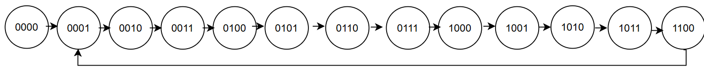
Figure 8. State diagram for the sequential circuit

Link to my circuit in circuitverse.com:
https://circuitverse.org/users/391695/projects/lab_1_data_systems

Instructions if you want to test the circuit in circuit verse:

- Go to the website: https://circuitverse.org/users/391695/projects/lab_1_data_systems
- Make sure you are in the “Main” tab (check top left of the circuit view)
- Make sure the Clock is toggled on, and Time is set to 500
- Zoom in on the red arrows and click on the cube with a 0 (labelled “X”) that the arrows point at
- Zoom out and watch the displays in the top right

Extra: The output of the D flip-flops is displayed with numbers and diodes in the bottom right.
In the other tabs (top left of the circuit view) you can view the different parts of the circuit and test them by their own.

