
Report
Analysis of Cache Hit-rate with MIPS and Merge Sort

David Åkerlind

Department of mathematics and computer science DVGA28
Module 2-

Introduction

This assignment was consistent of two parts; the first one was to convert a C-program to MIPS assembly code. This was done inside the MARS environment by coding several subroutines and a main program which imported said subroutines to complete the program. The program should print an array and sort it, using merge-sort and print the sorted array afterwards. The task of this part of the assignment was to complete three tests to analyse the usage of the cache memory when running just the merge sort part of the program in MIPS. The three test where:

- Use a direct-mapped cache with cache size 128 bytes. Determine the cache hit rates using the
cache block sizes 1, 2, 4, 8, 16 and 32 words, and the size of the array to be sorted equal to
- size = 10). Repeat the experiments using an array twice as large (size = 20).

- the Use a direct-mapped cache with cache block size 16 bytes. Determine the cache hit rates using the cache sizes 16, 32, 64, 128, 256, 512 and 1024 bytes, and the size of the array to be sorted equal to 10 (size = 10). Repeat the experiments using an array twice as large (size = 20).

- Use an N-way set-associative cache (LRU as block replacement policy). The cache size is 128
bytes and the cache block size is 16 bytes. Determine the cache hit rates for N equal to 1, 2, 4
and 8, and the size of the array to be sorted equal to 10 (size = 10). Repeat the experiments
using an array twice as large (size = 20).

After doing the last test there was a follow up question that was needed to be answered:
- How are the results affected by using random instead of LRU as block replacement policy?

I will down below present the results of the testing using graphs and tables.

Test One Block Size Hit Rages

The first test as to analyse the hit rates when changing the block size but having the same cache size, this test was as all the others, performed with the array size of 10 and then 20. In figure 1 we se the results of this test and can se that the results of hit rates are quite the same of both array sizes but the hit rate is a bit better with the smaller array, size 10. This is

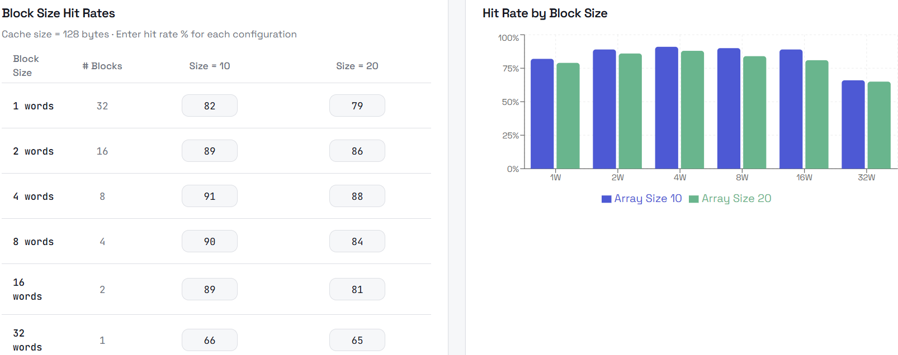

Figure 1. Results of test one in table and diagram (the numbers are in %)

Testing
A crucial part of making the final design was testing, testing to see that this circuit really produced the right output and to see if my truth tables and Boolean expressions really where right. The online tool www.circuitverse.org/simulator where a big life saver in this part of the process as said before. When I made my circuits in this tool I found could easily errors in my Boolean expressions because the results of my device could be viewed easily right on the spot. A fun part of testing was to see that it really was possible to make such a device only using gates and D flip-flops and nothing more. What at first seemed like magic now looked quite understandable since it was me who had designed it from scratch and had to understand the logics of the circuit to make it.

