DVGA28: Computer system I 17/3-2026
Lab Assignment 2
Cache Analysis
David Åkerlind

Contents
1 Introduction 3
2 Code conversion 3
3 Cache analysis 5
4 Problems 9
5 Summary 9

Introduction
This assignment consisted of two parts. The first part involved converting a C program to MIPS assembly code inside the MARS environment by implementing several subroutines and a main program. The program prints an array, sorts it using merge sort, and prints the sorted array afterwards.
The second part involved analysing the cache memory performance when running just the merge sort portion of the program. Three series of experiments were performed
- A direct-mapped cache with a fixed size of 128 bytes, varying block sizes (1, 2, 4, 8, 16 and 32 words), for array sizes 10 and 20.
- A direct-mapped cache with a fixed block size of 16 bytes, varying cache sizes (16, 32, 64, 128, 256, 512 and 1024 bytes), for array sizes 10 and 20.
- An N-way set-associative cache (LRU replacement policy) with cache size 128 bytes and block size 16 bytes, varying N (1, 2, 4, 8), for array sizes 10 and 20. The effect of using random instead of LRU replacement was also examined.
In this report, cache hit rate refers to the percentage of memory accesses that were found in the cache rather than requiring access to main memory (RAM).

Code conversion
The code conversion from C to MIPS assembly required careful planning of program structure, stack management, and register usage. The approach taken was to implement each C function as a separate MIPS subroutine, following the calling convention used by GCC.
The main program file contains the global variables (size and vec[]) in the .data section, along with the format strings used for printing. Each subroutine allocates shadow space on the stack at the start and saves any callee-saved registers ($s0-$s6, $ra) that it uses
Stack Management

Each subroutine begins by allocating stack space using subu $sp, $sp, N, where N accounts for shadow space and saved registers. For example, the merge subroutine allocates 52 bytes for 8 saved registers plus $ra:
1. merge:
2. subu $sp, $sp, 52
3. sw $ra, 48($sp)
4. sw $s0, 44($sp)
5. sw $s1, 40($sp)
6. sw $s2, 36($sp)
7. ...

The merge subroutine also dynamically allocates the local array b[] on the stack, calculating the required bytes as size * 4 and subtracting from $sp. This allocation happens after saving the registers, so the saved register offsets remain stable. The space is freed before returning by adding the same amount back to $sp.
Register Usage

The $s registers ($s0-$s6) were used to hold values that needed to persist across subroutine calls, such as the base addresses of arrays, loop counters (i, j, k), and the size and half variables. The $t registers were used for temporary calculations such as computing array offsets. Arguments were passed in $a0-$a3 and return values in $v0-$v1.
Array elements were accessed using offset addressing rather than incrementing base pointers, which avoided the need to restore base addresses after loops. For example, to access b[i]:
1. sll $t0, $s4, 2 # i * 4
2. addu $t0, $s3, $t0 # address of b[i]
3. lw $t1, 0($t0) # $t1 = b[i]

Recursive mergeSort

The mergeSort subroutine is recursive, which required saving $ra on the stack before each jal call and restoring it before returning. Without this, the return address would be overwritten on recursive calls, causing incorrect program flow.

Cache analysis
Series 1 — Varying Block Size (Direct-Mapped, 128 bytes)

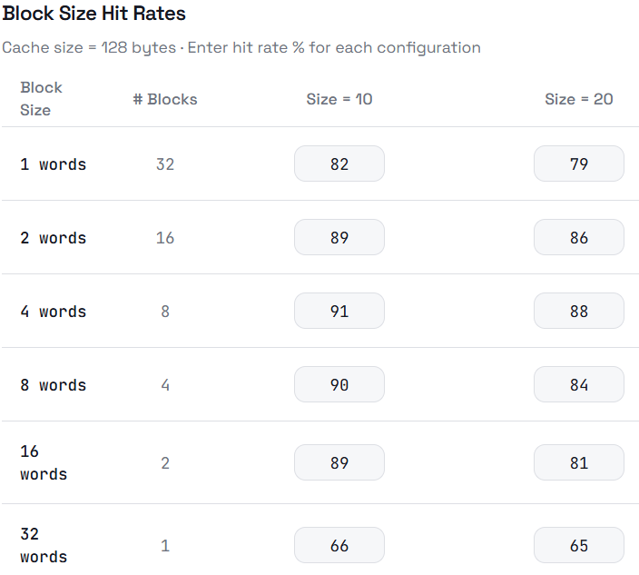
Settings: direct-mapped cache, cache size = 128 bytes, block sizes = 1, 2, 4, 8, 16, 32 words.

Table 1: Cache hit rates for varying block sizes (direct-mapped, 128 bytes)

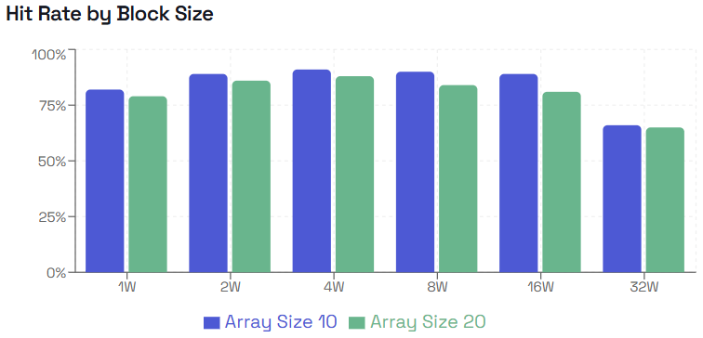
Graph 1: Cache hit rates for varying block sizes (direct-mapped, 128 bytes)

The results show that hit rate peaks at a block size of 4 words (91% for size=10, 88% for size=20), then decreases for larger blocks. Increasing block size improves spatial locality since more neighbouring array elements are loaded on each cache miss, which benefits the sequential access patterns in merge sort. However, with a fixed cache size of 128 bytes, larger blocks mean fewer total cache blocks. At 32 words per block only 1 block fits in the entire cache, causing a sharp drop to 66% and 65%. The larger array (size=20) consistently shows lower hit rates since it occupies more memory and increases the chance of evicting useful data.
Series 2 — Varying Cache Size (Direct-Mapped, 16-byte blocks)

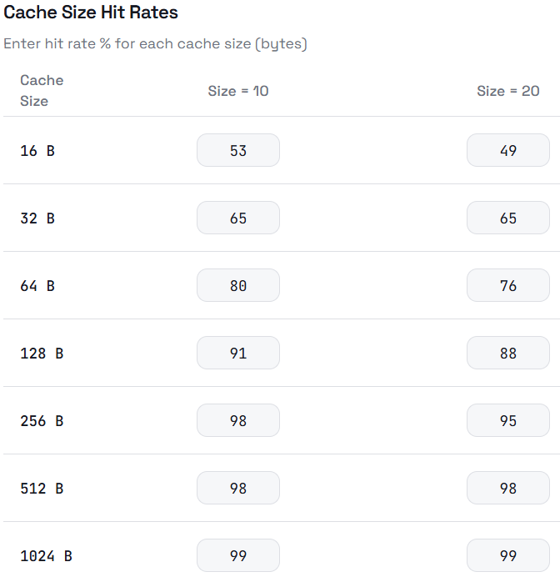
Settings: direct-mapped cache, block size = 16 bytes (4 words), cache sizes = 16 to 1024 bytes.

Table 2: Cache hit rates for varying cache sizes (direct-mapped, 4-word blocks)

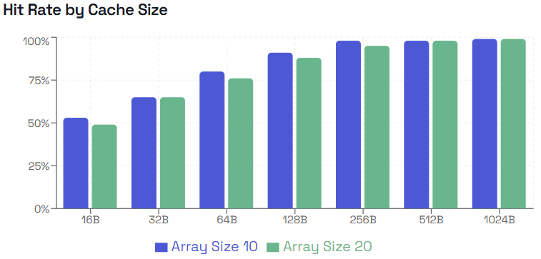

Graph 2: Cache hit rates for varying cache sizes (direct-mapped, 4-word blocks)
Hit rate increases steadily as cache size grows, rising from 53% at 16 bytes to 99% at 1024 bytes for size=10. This is expected since a larger cache holds more data simultaneously, reducing capacity and conflict misses. The improvement is steep at smaller sizes (16B to 128B) and flattens at larger sizes (512B and above), suggesting that at 512 bytes the cache is large enough to hold most of the working data for merge sort. The size=20 array shows lower hit rates at smaller cache sizes but catches up at 512B and 1024B where both arrays fit comfortably in cache.
Series 3 — Varying Associativity (N-way Set-Associative)

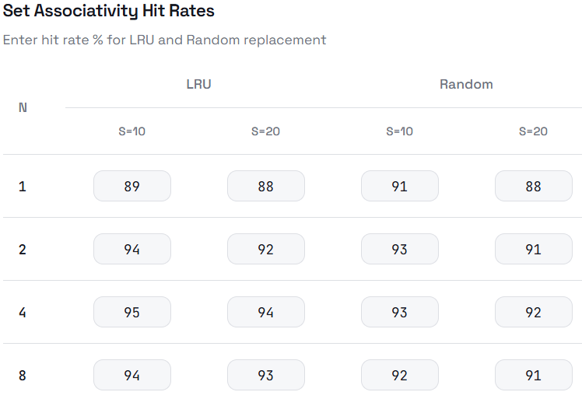
Settings: N-way set-associative, LRU replacement, cache size = 128 bytes, block size = 16 bytes (4 words).

Table 3: Cache hit rates for varying associativity N with LRU and Random replacement
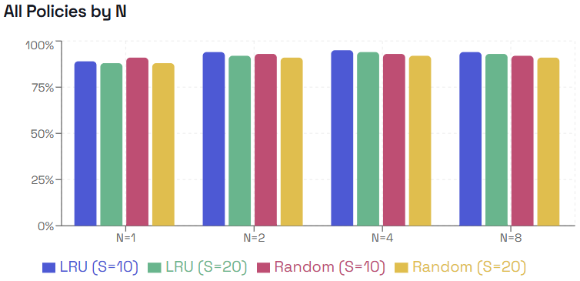
Graph 3: Cache hit rates for varying associativity N with LRU and Random replacement

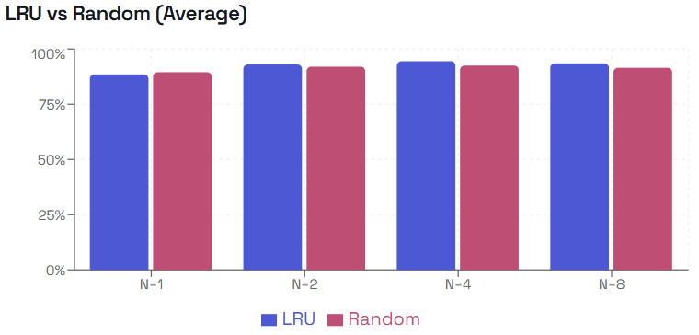
Graph 4: Average (size 10 and 20) cache hit rates for varying associativity N with LRU and Random replacement
Increasing associativity from N=1 to N=4 improves hit rate under LRU, rising from 89% to 95% for size=10. This is because higher associativity reduces conflict misses — more blocks can coexist in the same set without evicting each other. At N=8 the hit rate drops slightly to 94%, likely due to the overhead of managing more ways with a small working set. Comparing LRU and random replacement, the results are surprisingly close. At N=1 random actually scores slightly higher (91% vs 89% for size=10), but for N=2 and above LRU is equal or better. This suggests that for small N, LRU does not have a strong advantage, but as N grows the smarter eviction policy of LRU better preserves recently accessed data. The larger array (size=20) consistently shows slightly lower hit rates across all settings.

Problems
- Stack corruption: The most significant problem was a stack offset mismatch caused by allocating the dynamic b[] array on the stack after saving registers. This caused incorrect values to be loaded when restoring $ra, leading to an invalid program counter error (0x10010000). The fix was to save all registers first with stable offsets, then allocate b[] separately.
- Label errors: Some jump instructions referenced incorrect or mistyped labels, causing infinite loops or jumps to wrong locations. Careful naming conventions (m_while1, m_while2, m_while3) resolved this.
- Missing register saves: Initially $s2-$s6 were not saved on the stack, which caused their values to be corrupted across nested subroutine calls. Adding sw/lw for all used $s registers fixed this.
- More stack corruption: I had a lot of problems not setting enough shadow space for the different subroutines. I was new to how shadow space worked and how much shadow space I would really need.

Summary
In this lab assignment provided hands-on experience with MIPS assembly programming and cache memory analysis. The code conversion part reinforced understanding of calling conventions, stack management, and register usage in low-level programming.
The cache analysis demonstrated how block size, cache size, and associativity each affect cache performance. In general, larger block sizes improve spatial locality, larger caches reduce capacity misses, and higher associativity reduces conflict misses.

Appendix
The program was developed in MARS using four separate source files: the main program, and the subroutines merge_sort, merge, and print_array. In the main file, these are imported under the .text section using .include directives, alongside the provided print subroutine. For the purposes of this report, all subroutines have been consolidated into a single listing and placed after the .data section but before the main program, following the convention used in C. The code presented here has been tested and produces the expected output
1. .data
2. vector: .word 4,5,2,-2,1,6,7,9,-5,10,99,32,98,42,12,41,29,22,77,62
3. #vector: .word 4,5,2,-2,1,6,7,9,-5,10
4. size: .word 20
5. format: .asciiz "%d " # Format for print.s
6. new_line: .asciiz "\n"
7.
8.
9. .text
10. .globl main
11. .include "print.s"
12. .include "print_array.s"
13. .include "merge_sort.s"
14. .include "merge.s"
15.
16.
17. print_array:
18. li $t1, 36
19. subu $sp, $sp, $t1 # make some space for storing and printing
20.
21. sw $ra, 20($sp) # store the seach-subrutine (this one) return adress
22.
23. # Store all of the $s regitsters because they are not to be changed after subrutines
24. # and we can use them without fear of teh print subroutine to write over them
25. sw $s2, 24($sp)
26. sw $s3, 28($sp)
27. sw $s4, 32($sp)
28.
29. # Load the arguments in to safe regristers
30. li $s2, 0 # $s2 = start index
31. move $s3, $a0 # $s3 = base address of vector = $s3
32. move $s4, $a1 # $s4 = $a1 = vector size = $s4
33.
34. for:
35. bge $s2, $s4 end_loop # if gone trough all elements in vector now end
36.
37. la $a0, format # Load format string address
38. lw $a1, 0($s3) # Load the number to print = The next
39. jal print # Call the print subroutine
40.
41. addi $s2, $s2, 1 # index++
42. addi $s3, $s3, 4 # move to next number in array (4 bytes)
43.
44. j for
45.
46. end_loop:
47.
48. la $a0, new_line
49. jal print
50.
51. lw $ra, 20($sp) # restore return address
52. lw $s2, 24($sp) # restore saved registers
53. lw $s3, 28($sp)
54. lw $s4, 32($sp)
55.
56. addu $sp, $sp, 36 # restore stack pointer
57.
58. jr $ra
59.
60. merge_sort:
61. subu $sp, $sp, 32 # make space for some variables
62.
63. sw $ra, 28($sp) # store the seach-subrutine (this one) return adress
64. sw $s0, 24($sp) # save base adress for array to be able to use it in different calls
65. sw $s1, 20($sp)
66.
67. move $s0, $a0 # $s0 = base address of vector = $s0
68. move $s1, $a1 # $t1 = $a1 = vector size = $t1
69.
70. ble $s1, 1 ms_return # Compare the SIZE with 1 :: IF size > 1: continue, ELSE: end
71.
72. divu $t2, $s1, 2 # int half = size / 2 = $t2 = HALF
73.
74. # PREPARE mergeSort(a, half);
75. move $a0, $s0 # $t0 = base address of vector = $t0
76. move $a1, $t2 # $t2 = $a1 = size / 2
77.
78. jal merge_sort # mergeSort(a, half = $t2 );
79.
80. # PREPARE mergeSort(a + half, size - half);
81. divu $t2, $s1, 2 # recalculate half
82. mul $t3, $t2, 4 # byte offset = half * 4
83. addu $a0, $s0, $t3 # a + half (in bytes)
84. subu $a1, $s1, $t2 # size - half
85.
86. jal merge_sort # mergeSort(a + half, size - half);
87.
88. # PREPARE For MERGE
89. move $a0, $s0 # $s0 = base address of vector = $a0
90. move $a1, $s1 # $s1 = $a1 = size
91. jal merge # merge(a, size);
92.
93. j ms_return
94.
95.
96. ms_return:
97. lw $ra, 28($sp)
98. lw $s0, 24($sp)
99. lw $s1, 20($sp) # restore $s1
100. addu $sp, $sp, 32
101. jr $ra
102.
103.
104. merge:
105. subu $sp, $sp, 52
106. sw $ra, 48($sp)
107. sw $s0, 44($sp)
108. sw $s1, 40($sp)
109. sw $s2, 36($sp)
110. sw $s3, 32($sp)
111. sw $s4, 28($sp)
112. sw $s5, 24($sp)
113. sw $s6, 20($sp)
114.
115. move $s0, $a0 # base a[] = $s0
116. move $s1, $a1 # size = $s1
117.
118. # half = $s2
119. div $s2, $s1, 2 # half = $s2
120.
121. # b[] = $s3
122. sll $t0, $s1, 2 # $t0 = size * 4($t3 is teh size we need for b[])
123. subu $sp, $sp, $t0 # allocate $t0 space b[] on stack
124. move $s3, $sp # $s3 = base address of b[]
125.
126. # i = $t4
127. li $t4, 0
128.
129. m_for:
130. bge $t4, $s1, m_end_for
131. sll $t0, $t4, 2 # i * 4
132. addu $t1, $s0, $t0 # address of a[i]
133. lw $t2, 0($t1) # t2 = a[i]
134. addu $t3, $s3, $t0 # address of b[i]
135. sw $t2, 0($t3) # b[i] = a[i]
136. addi $t4, $t4, 1 # i++
137. j m_for
138.
139. # $s0 = base address of a[]
140. # $s1 = size
141. # $s2 = half
142. # $s3 = base address of b[]
143. # $s4 = i
144. # $s5 = j
145. # $s6 = k
146.
147.
148. # this restores some values to continue the merge
149. m_end_for:
150. li $s4, 0 # i = 0
151. move $s5, $s2 # j = half
152. li $s6, 0 # k = 0
153.
154. m_while1: # while (i < half && j < size)
155. bge $s4, $s2, m_while2 # i < half
156. bge $s5, $s1, m_while2 # j < size
157.
158. # Load b[i] = $s3[$s4] in to $t1
159. sll $t0, $s4, 2 # i * 4
160. addu $t0, $s3, $t0 # address of b[i]
161. lw $t1, 0($t0) # $t1 = b[i]
162.
163. # Load b[j] = $s3[$s5] in to $t3
164. sll $t2, $s5, 2 # j * 4
165. addu $t2, $s3, $t2 # address of b[j]
166. lw $t3, 0($t2) # $t3 = b[j]
167.
168. bgt $t1, $t3, m_else # if b[i] > b[j], go to else
169.
170.
171. m_if: # b[i] <= b[j]
172. move $t4, $s4 # i
173. addi $s4, $s4, 1 # i++
174. j m_end_if
175.
176.
177. m_else: # b[i] > b[j]
178. move $t4, $s5 # j
179. addi $s5, $s5, 1 # j++
180.
181. m_end_if:
182. sll $t0, $t4, 2 # index * 4
183. addu $t0, $s3, $t0
184. lw, $t1, 0($t0) # Load b[index]
185. sll $t2, $s6, 2 # k * 4
186. addu $t2, $s0, $t2
187. sw $t1, 0($t2) # a[k] = b[index]
188.
189. addi $s6, $s6, 1 # k++
190. j m_while1
191.
192.
193. # $s0 = base address of a[]
194. # $s1 = size
195. # $s2 = half
196. # $s3 = base address of b[]
197. # $s4 = i
198. # $s5 = j
199. # $s6 = k
200.
201. m_while2: # Task a[k] = b[i] IF: while (i < half)
202. bge $s4, $s2, m_while3
203.
204. sll $t0, $s4, 2 # calculate the index based i * 4 = $t0
205. addu $t0, $s3, $t0 # save the start adress of b[i]
206. lw $t1, 0($t0) # save value of int b[i] in $t1
207.
208. sll $t2, $s6, 2 # calculate the index k * 4 = $t2
209. addu $t2, $s0, $t2 # save the start adress of a[k]
210.
211. sw $t1, 0($t2) # a[k] = b[i] / copy the numbers over
212. addi $s4, $s4, 1 # i++
213. addi $s6, $s6, 1 # k++
214. j m_while2
215.
216.
217. m_while3: # TASK: a[k] = b[j] IF: while (j < size)
218. bge $s5, $s1, m_return
219.
220. sll $t0, $s5, 2 # calculate the index based j * 4 = $t0
221. addu $t0, $s3, $t0 # save the start adress of b[j]
222. lw $t1, 0($t0) # b[j] save the value of b[j]
223.
224. sll $t2, $s6, 2 # calculate the index based k * 4 = $t2
225. addu $t2, $s0, $t2 # save the start adress of a[k]
226.
227. sw $t1, 0($t2) # a[k] = b[j]
228. addi $s5, $s5, 1 # j++
229. addi $s6, $s6, 1 # k++
230. j m_while3
231.
232.
233. m_return:
234. sll $t3, $s1, 2 # calculate the size of b[] (to now how much we used9
235. addu $sp, $sp, $t3 # free b[] space
236.
237. lw $s6, 20($sp) # restore s0-s6 and $ra before returning
238. lw $s5, 24($sp)
239. lw $s4, 28($sp)
240. lw $s3, 32($sp)
241. lw $s2, 36($sp)
242. lw $s1, 40($sp)
243. lw $s0, 44($sp)
244. lw $ra, 48($sp)
245. addu $sp, $sp, 52 # remove shadow space
246. jr $ra
247.
248.
249.
250. main:
251. subu $sp, $sp, 16
252. # Call search function (passing 2 arguments) jal print_array
253. # Load vecor and size in to parameters
254. la $a0, vector # $a0 = base address of array
255. lw $a1, size
256. jal print_array
257.
258. # Merge sort call (int a[], int size)
259. la $a0, vector # $a0 = base address of array
260. lw $a1, size
261. jal merge_sort
262.
263. # Call search function (passing 2 arguments) jal print_array
264. # Print array call (int a[], int size)
265. la $a0, vector # $a0 = base address of array
266. lw $a1, size
267. jal print_array
268.
269. # End program
270. addu $sp, $sp, 16
271. li $v0, 10
272. syscall
273.
274.

