**QUESTION 66**

A company has a data ingestion workflow that includes the following components:

* An Amazon Simple Notation Service (Amazon SNS) topic that receives notifications about new data deliveries.
* An AWS Lambda function that processes and stores the data.

The ingestion workflow occasionally fails because of network connectivity issues.

When tenure occurs the corresponding data is not ingested unless the company manually reruns the job.

What should a solutions architect do to ensure that all notifications are eventually processed?

1. Configure the Lambda function for deployment across multiple Availability Zones.

1. Modify me Lambda functions configuration to increase the CPU and memory allocations tor the function.
2. Configure the SNS topic's retry strategy to increase both the number of retries and the wait time between retries.
3. Configure an Amazon Simple Queue Service (Amazon SQS) queue as the on failure destination.

Modify the Lambda function to process messages in the queue.

**Answer:** A

**QUESTION 78**

A corporation has recruited a new cloud engineer who should not have access to the CompanyConfidential Amazon S3 bucket. The cloud engineer must have read and write permissions on an S3 bucket named AdminTools.

Which IAM policy will satisfy these criteria?

[Exam AWS Certified Solutions Architect - Associate SAA-C02 topic 1 question 264 discussion - ExamTopics](https://www.examtopics.com/discussions/amazon/view/46383-exam-aws-certified-solutions-architect-associate-saa-c02/)

A company has hired a new cloud engineer who should not have access to an Amazon S3 bucket named CompanyConfidential. The cloud engineer must be able to read from and write to an S3 bucket called AdminTools.  
Which IAM policy will meet these requirements?  
A.  
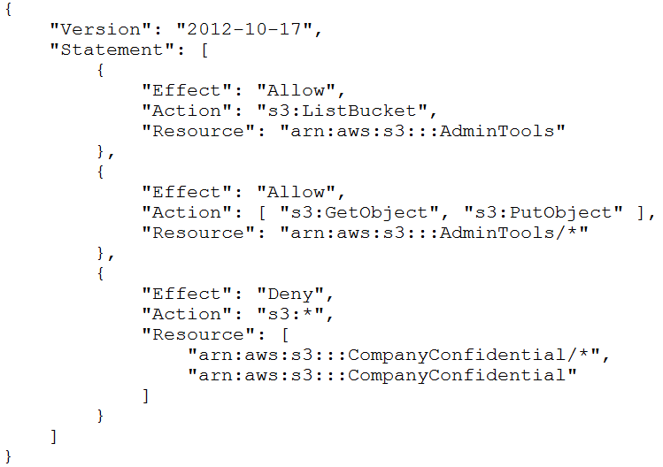  
B.  
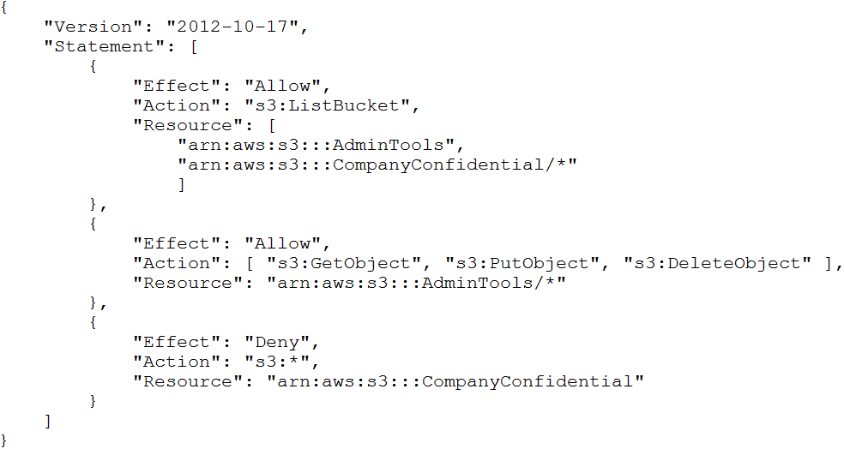  
{  
C.  
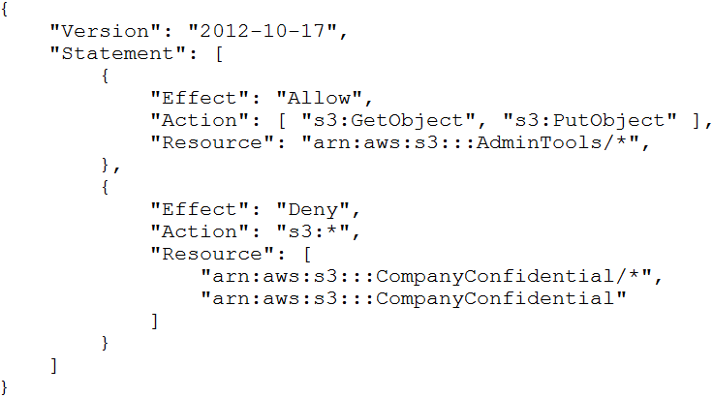  
D.  
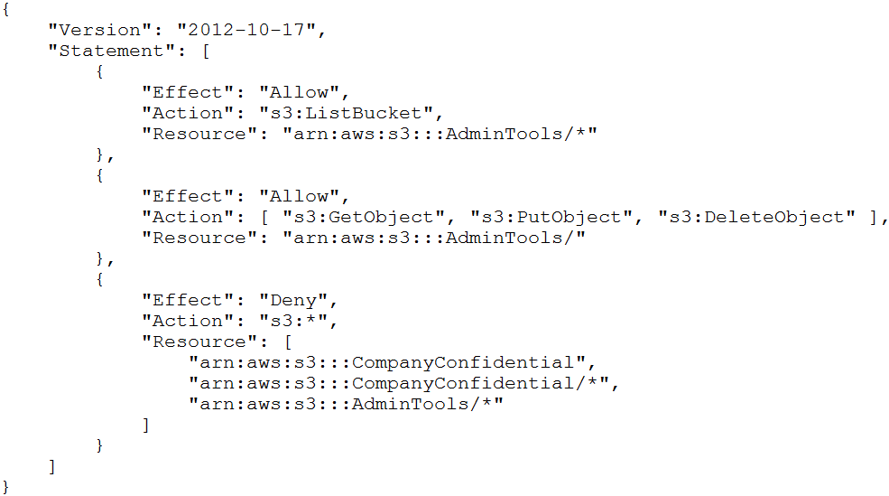

A.

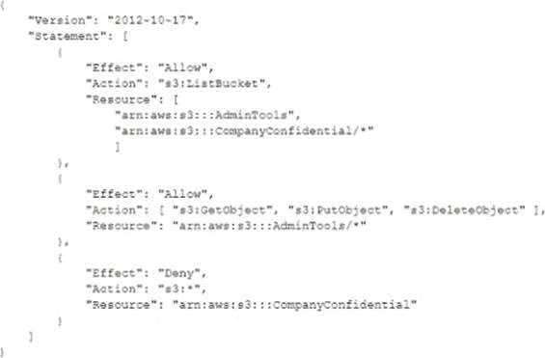

B.

C.

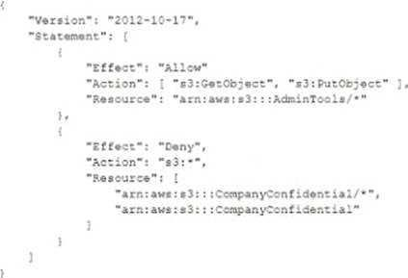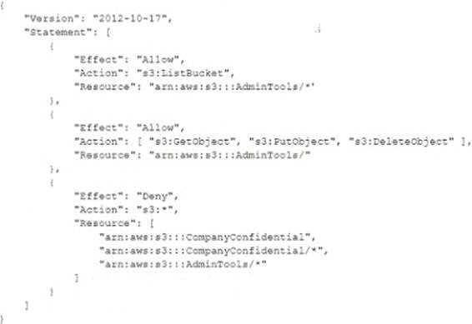

D.

**Answer:** A

**Explanation:** <https://docs.amazonaws.cn/en_us/IAM/latest/UserGuide/reference_policies_examples_s3_rwbucket.html>

**QUESTION 85**

A company has an ecommerce checkout workflow that writes an order to a database and calls a service to process the payment.

Users are experiencing timeouts during the checkout process.

When users resubmit the checkout form, multiple unique orders are created for the same desired transaction.

How should a solutions architect refactor this workflow to prevent the creation of multiple orders?

1. Configure the web application to send an order message to Amazon Kinesis Data Firehose.

Set the payment service to retrieve the message from Kinesis Data Firehose and process the order.

1. Create a rule in AWS CloudTrail to invoke an AWS Lambda function based on the logged application path request.

Use Lambda to query the database, call the payment service, and pass in the order information.

1. Store the order in the database.

Send a message that includes the order number to Amazon Simple Notification Service (Amazon SNS).

Set the payment service to poll Amazon SNS. retrieve the message, and process the order.

1. Store the order in the database.

Send a message that includes the order number to an Amazon Simple Queue Service (Amazon SQS) FIFO queue.

Set the payment service to retrieve the message and process the order.

Delete the message from the queue.

**Answer:** D

**QUESTION 92**

A company wants to measure the effectiveness of its recent marketing campaigns.

The company performs batch processing on csv files of sales data and stores the results in an Amazon S3 bucket once every hour.

The S3 bipetabytes of objects.

The company runs one-time queries in Amazon Athena to determine which products are most popular on a particular date for a particular region.

Queries sometimes fail or take longer than expected to finish.

Which actions should a solutions architect take to improve the query performance and reliability? (Select TWO)

1. Reduce the S3 object sizes to less than 126 MB.

1. Partition the data by date and region in Amazon S3.
2. Store the files as large, single objects in Amazon S3.
3. Use Amazon Kinosis Data Analytics to run the Queries as pan of the batch processing operation.

1. Use an AWS duo extract, transform, and load (ETL) process to convert the csv files into Apache Parquet format.

**Answer:** CE

**QUESTION 121**

A company's website uses an Amazon EC2 instance store for its catalog of items.

The company wants to make sure that the catalog is highly available and that the catalog is stored in a durable location.

What should a solutions architect do to meet these requirements?

1. Move the catalog to Amazon ElastiCache for Redis.

1. Deploy a larger EC2 instance with a larger instance store.
2. Move the catalog from the instance store to Amazon S3 Glacier Deep Archive.
3. Move the catalog to an Amazon Elastic File System (Amazon EFS) file system.

**Answer:** A

**QUESTION 221**

A company wants to manage Amazon Machine Images (AMIs).

The company currently copies AMIs to the same AWS Region where the AMIs were created.

The company needs to design an application that captures AWS API calls and sends alerts whenever the Amazon EC2 Createlmage API operation is called within the company's account.

Which solution will meet these requirements with the LEAST operational overhead?

1. Create an AWS Lambda function to query AWS CloudTrail logs and to send an alert when a Createlmage API call is detected.

1. Configure AWS CloudTrail with an Amazon Simple Notification Service (Amazon SNS) notification that occurs when updated logs are sent to Amazon S3.

Use Amazon Athena to create a new table and to query on Createlmage when an API call is detected.

1. Create an Amazon EventBridge (Amazon CloudWatch Events) rule for the Createlmage API call.

Configure the target as an Amazon Simple Notification Service (Amazon SNS) topic to send an alert when a Createlmage API call is detected.

1. Configure an Amazon Simple Queue Service (Amazon SQS) FIFO queue as a target for AWS CloudTrail logs.

Create an AWS Lambda function to send an alert to an Amazon Simple Notification Service (Amazon SNS) topic when a Createlmage API call is detected.

**Answer:** B

**QUESTION 222**

An online retail company has more than 50 million active customers and receives more than 25,000 orders each day.

The company collects purchase data for customers and stores this data in Amazon S3.

Additional customer data is stored in Amazon RDS.

The company wants to make all the data available to various teams so that the teams can perform analytics.

The solution must provide the ability to manage fine-grained permissions for the data and must minimize operational overhead.

Which solution will meet these requirements?

1. Migrate the purchase data to write directly to Amazon RDS.

Use RDS access controls to limit access.

1. Schedule an AWS Lambda function to periodically copy data from Amazon RDS to Amazon S3.

Create an AWS Glue crawler.

Use Amazon Athena to query the data. Use S3 policies to limit access.

1. Create a data lake by using AWS Lake Formation.

Create an AWS Glue JDBC connection to Amazon RDS.

Register (he S3 bucket in Lake Formation.

Use Lake Formation access controls to limit access.

1. Create an Amazon Redshift cluster.

Schedule an AWS Lambda function to periodically copy data from Amazon S3 and Amazon RDS to Amazon Redshift.

Use Amazon Redshift access controls to limit access.

**Answer:** D

**QUESTION 224**

A company needs to move data from an Amazon EC2 instance to an Amazon S3 bucket.

The company must ensure that no API calls and no data are routed through public internet routes.

Only the EC2 instance can have access to upload data to the S3 bucket.

Which solution will meet these requirements?

1. Create an interface VPC endpoint for Amazon S3 in the subnet where the EC2 instance is located.

Attach a resource policy to the S3 bucket to only allow the EC2 instance's IAM role for access.

1. Create a gateway VPC endpoint for Amazon S3 in the Availability Zone where the EC2 instance is located.

Attach appropriate security groups to the endpoint.

Attach a resource policy lo the S3 bucket to only allow the EC2 instance's IAM role for access.

1. Run the nslookup tool from inside the EC2 instance to obtain the private IP address of the S3 bucket's service API endpoint.

Create a route in the VPC route table to provide the EC2 instance with access to the S3 bucket.

Attach a resource policy to the S3 bucket to only allow the EC2 instance's IAM role for access.

D. Use the AWS provided, publicly available ip-ranges.json tile to obtain the private IP address of the S3 bucket's service API endpoint.

Create a route in the VPC route table to provide the EC2 instance with access to the S3 bucket. Attach a resource policy to the S3 bucket to only allow the EC2 instance's IAM role for access.

**Answer:** B

**QUESTION 226**

A company has two applications: a sender application that sends messages with payloads to be processed and a processing application intended to receive the messages with payloads.

The company wants to implement an AWS service to handle messages between the two applications.

The sender application can send about 1.000 messages each hour.

The messages may take up to 2 days to be processed.

If the messages fail to process, they must be retained so that they do not impact the processing of any remaining messages.

Which solution meets these requirements and is the MOST operationally efficient?

1. Set up an Amazon EC2 instance running a Redis database.

Configure both applications to use the instance.

Store, process, and delete the messages, respectively.

1. Use an Amazon Kinesis data stream to receive the messages from the sender application. Integrate the processing application with the Kinesis Client Library (KCL).

1. Integrate the sender and processor applications with an Amazon Simple Queue Service (Amazon SQS) queue.

Configure a dead-letter queue to collect the messages that failed to process.

1. Subscribe the processing application to an Amazon Simple Notification Service (Amazon SNS) topic to receive notifications to process.

Integrate the sender application to write to the SNS topic.

**Answer:** C

**Explanation:**

<https://aws.amazon.com/blogs/compute/building-loosely-coupled-scalable-c-applications-withamazon-sqs-and-amazon-sns/>

<https://docs.aws.amazon.com/AWSSimpleQueueService/latest/SQSDeveloperGuide/sqs-deadletter-queues.html>

**QUESTION 228**

A company has a legacy data processing application that runs on Amazon EC2 instances.

Data is processed sequentially, but the order of results does not matter.

The application uses a monolithic architecture.

The only way that the company can scale the application to meet increased demand is to increase the size of the instances.

The company's developers have decided to rewrite the application to use a microservices architecture on Amazon Elastic Container Service (Amazon ECS).

What should a solutions architect recommend for communication between the microservices?

1. Create an Amazon Simple Queue Service (Amazon SQS) queue.

Add code to the data producers, and send data to the queue.

Add code to the data consumers to process data from the queue.

1. Create an Amazon Simple Notification Service (Amazon SNS) topic.

Add code to the data producers, and publish notifications to the topic.

Add code to the data consumers to subscribe to the topic.

1. Create an AWS Lambda function to pass messages.

Add code to the data producers to call the Lambda function with a data object.

Add code to the data consumers to receive a data object that is passed from the Lambda function.

1. Create an Amazon DynamoDB table.

Enable DynamoDB Streams.

Add code to the data producers to insert data into the table.

Add code to the data consumers to use the DynamoDB Streams API to detect new table entries and retrieve the data.

**Answer:** A

**Explanation:**

Queue has Limited throughput (300 msg/s without batching, 3000 msg/s with batching whereby up-to 10 msg per batch operation; Msg duplicates not allowed in the queue (exactly-once delivery); Msg order is preserved (FIFO); Queue name must end with .fifo

**QUESTION 229**

A hospital wants to create digital copies for its large collection of historical written records.

The hospital will continue to add hundreds of new documents each day.

The hospital's data team will scan the documents and will upload the documents to the AWS Cloud.

A solutions architect must implement a solution to analyze the documents, extract the medical information, and store the documents so that an application can run SQL queries on the data.

The solution must maximize scalability and operational efficiency.

Which combination of steps should the solutions architect take to meet these requirements? (Select TWO)

1. Write the document information to an Amazon EC2 instance that runs a MySQL database.

1. Write the document information to an Amazon S3 bucket.

Use Amazon Athena to query the data.

1. Create an Auto Scaling group of Amazon EC2 instances to run a custom application that processes the scanned files and extracts the medical information.
2. Create an AWS Lambda function that runs when new documents are uploaded.

Use Amazon Rekognition to convert the documents to raw text.

Use Amazon Transcribe Medical to detect and extract relevant medical information from the text.

1. Create an AWS Lambda function that runs when new documents are uploaded. Use Amazon Textract to convert the documents to raw text.

Use Amazon Comprehend Medical to detect and extract relevant medical information from the text.

**Answer:** DE

**QUESTION 239**

A company is running a publicly accessible serverless application that uses Amazon API Gateway and AWS Lambda.

The application's traffic recently spiked due to fraudulent requests from botnets.

Which steps should a solutions architect take to block requests from unauthorized users?

(Select TWO)

1. Create a usage plan with an API key that is shared with genuine users only.
2. Integrate logic within the Lambda function to ignore the requests from fraudulent IP addresses.
3. Implement an AWS WAF rule to target malicious requests and trigger actions to filter them out.
4. Convert the existing public API to a private API.

Update the DNS records to redirect users to the new API endpoint.

1. Create an IAM role for each user attempting to access the API.

A user will assume the role when making the API call.

**Answer:** AC

**Explanation:** <https://docs.aws.amazon.com/apigateway/latest/developerguide/api-gateway-api-usageplans.html>

**QUESTION 240**

A solutions architect is designing the architecture of a new application being deployed to the AWS Cloud.

The application will run on Amazon EC2 On-Demand Instances and will automatically scale across multiple Availability Zones.

The EC2 instances will scale up and down frequently throughout the day.

An Application Load Balancer (ALB) will handle the load distribution.

The architecture needs to support distributed session data management.

The company is willing to make changes to code if needed.

What should the solutions architect do to ensure that the architecture supports distributed session data management?

1. Use Amazon ElastiCache to manage and store session data.
2. Use session affinity (sticky sessions) of the ALB to manage session data.
3. Use Session Manager from AWS Systems Manager to manage the session.
4. Use the GetSessionToken API operation in AWS Security Token Service (AWS STS) to manage the session.

**Answer:** A

**Explanation:**

<https://aws.amazon.com/vi/caching/session-management/>

In order to address scalability and to provide a shared data storage for sessions that can be accessible from any individual web server, you can abstract the HTTP sessions from the web servers themselves.

A common solution to for this is to leverage an In-Memory Key/Value store such as Redis and Memcached. ElastiCache offerings for In-Memory key/value stores include ElastiCache for Redis, which can support replication, and ElastiCache for Memcached which does not support replication.

**QUESTION 243**

A company has a web application that is based on Java and PHP.

The company plans to move the application from on-premises to AWS.

The company needs the ability to test new site features trequenlty.

The company also needs a highly available and managed solution that requires minimum operational overhead.

Which solution will meel these requirements?

1. Create an Amazon S3 bucket.

Enable static web hosting on the S3 bucket.

Upload the static content to the S3 bucket.

Use AWS Lambda to process all dynamic content.

1. Deploy the web application to an AWS Elastic Beanstalk environment.

Use URL swapping to switch between multiple Elastic Beanstalk environments for feature testing.

1. Deploy the web application lo Amazon EC2 instances that are configured with Java and PHP.

Use Auto Scaling groups and an Application Load Balancer to manage the website's availability.

1. Containerize the web application.

Deploy the web application to Amazon EC2 instances.

Use the AWS Load Balancer Controller to dynamically route traffic between containers thai contain the new site features for testing.

**Answer:** B

**QUESTION 244**

A company has a Microsoft .NET application that runs on an on-premises Windows Server Trie application stores data by using an Oracle Database Standard Edition server.

The company is planning a migration to AWS and wants to minimize development changes while moving the application.

The AWS application environment should be highly available.

Which combination ol actions should the company take to meet these requirements?

(Select TWO)

1. Refactor the application as serverless with AWS Lambda functions running .NET Code.
2. Rehost the application in AWS Elastic Beanstalk with the NET platform in a Mulft-AZ deployment.
3. Replatform the application to run on Amazon EC2 with the Amazon Linux Amazon Machine Image (AMI).
4. Use AWS Database Migration Service (AWS DMS) to migrate trom the Oracle database to Amazon DynamoDB in a Multi-AZ deployment.
5. Use AWS Database Migration Service (AWS DMS) to migrate from the Oracle database to Oracle on Amazon RDS in a Multi-AZ deployment.

**Answer:** AC (?)

**QUESTION 246**

A company’s order system sends requests from clients to Amazon EC2 instances.

The EC2 instances process ttie orders and men store the orders in a database on Amazon RDS Users report that they must reprocess orders when the system fails.

The company wants a resilient solution that can process orders automatically it a system outage occurs.

What shoukl a solutions architect do to meet these requirements?

1. Move the EC2 Instances into an Auto Scaling group.

Create an Amazon EventBhdge (Amazon CloudWatch Events) rule to target an Amazon Elastic Container Service (Amazon ECS) task.

1. Move the EC2 instances into an Auto Scaling group behind an Application Load Balancer (ALB). Update the order system to send messages to the ALB endpoint.

1. Move the EC2 instances into an Auto Scaling group.

Configure the order system to send messages to an Amazon Simple Queue Service (Amazon SQS) queue.

Configure the EC2 instances to consume messages from the queue.

1. Create an Amazon Simple Notification Service (Amazon SNS) topic.

Create an AWS Lambda function, and subscribe the function to the SNS topic.

Configure the order system to send messages to the SNS topic.

Send a command to the EC2 instances to process the messages by using AWS Systems Manager Run Command.

**Answer:** C

**QUESTION 247**

A company runs an applcalion on a large heel of Amazon EC2 instances.

The application leads and write entries into an Amazon DynamoDB table.

The size of the DynamoDB table continuously grows, but the application needs only data from the last 30 days.

The company needs a solution that minimize cost and development effort.

Which solution meets these requirements?

1. Use an AWS CloudFomiahon template to deploy the complete solution.

Redeploy the CloudFormation stack every 30 days and delete the original stack.

1. Use an EC2 Instance that runs a monitonng application from AWS Marketplace.

Configure the monitoring application to use Amazon DynamoDB Streams to store the timestamp when a new item is created in the table.

Use a scnpt that runs on the EC2 instance to delele items that have a timestamp that is older than 30 days.

1. Configure Amazon DynamoDB Streams to invoke an AWS Lambda function when a new item is created in the table.

Configure the Lambda function to delete items in the table that are older than 30 days.

1. Extend the application to add an attribute that has a value of the current timestamp plus 30 days to each new item that is created in the table.

Configure DynamoDB to use the attribute as the TTL attribute

**Answer:** D

**Explanation:**

Amazon DynamoDB Time to Live (TTL) allows you to define a per-item timestamp to determine when an item is no longer needed. Shortly after the date and time of the specified timestamp, DynamoDB deletes the item from your table without consuming any write throughput.

TTL is provided at no extra cost as a means to reduce stored data volumes by retaining only the items that remain current for your workload's needs.

TTL is useful if you store items that lose relevance after a specific time.

The following are example TTL use cases:

* Remove user or sensor data after one year of inactivity in an application.
* Archive expired items to an Amazon S3 data lake via Amazon DynamoDB Streams and AWS Lambda.
* Retain sensitive data for a certain amount of time according to contractual or regulatory obligations.

<https://docs.aws.amazon.com/amazondynamodb/latest/developerguide/TTL.html>

**QUESTION 249**

A company selves a dynamic website from a fleel of Amazon EC2 instances behind an Application Load Balancer (ALB).

The website needs to support multiple languages to serve customers around the world.

The website's architecture is running in the us-west-1 Region and is exhibiting high request lalency tor users that are located in other parts ot the world.

The website needs to serve requests quickly and efficiently regardless of a user's location.

However the company does not want to recreate the existing architecture across multiple Regions.

What should a solutions architect do to meet these requirements?

1. Replace the existing architecture with a website that is served from an Amazon S3 bucket.

Configure an Amazon CloudFront distribution with the S3 bucket as the ongin.

Set the cache behavior settings to cache based on the Accept-Languege request header.

1. Configure an Amazon CloudFront distribution with the ALB as the origin.

Set Ihe cache behavior settings to cache based on the Accept-Language request header.

1. Create an Amazon API Gateway API that is integrated with the ALB.

Configure the API to use the HTTP integration type.

Set up an API Gateway stage to enable the API cache based on the Accept-Language request header.

1. Launch an EC2 instance in each additional Region and configure NGINX to act as a cache server for that Region.

Put all the EC2 instances and the ALB behind an Amazon Route 53 record set with a geotocation routing policy.

**Answer:** B

**QUESTION 250**

A telemarketing company is designing its customer call center functionality on AWS.

The company needs a solution that provides multiple speaker recognition and generates transcript files. The company wants to query the transcript files to analyze the business patterns. The transcript files must be stored for 7 years for auditing purposes.

Which solution will meet these requirements?

1. Use Amazon Rekognition for multiple speaker recognition. Store the transcript files in Amazon S3.

Use machine teaming models for transcript file analysis.

1. Use Amazon Transcribe for multiple speaker recognition.

Use Amazon Athena tot transcnpt file analysts.

1. Use Amazon Translate lor multiple speaker recognition.

Store the transcript files in Amazon Redshift.

Use SQL queues lor transcript file analysis.

1. Use Amazon Rekognition for multiple speaker recognition. Store the transcnpt files in Amazon S3.

Use Amazon Textract for transcnpt file analysis.

**Answer:** C

**QUESTION 251**

A company is running a batch applicalton on Amazon EC2 instances.

The application consists of a backend with multiple Amazon RDS databases.

The application is causing a high number of leads on the databases.

A solutions architect must reduce the number of database reads while ensuring high availability.

What should the solutions architect do to meet this requirement?

1. Add Amazon RDS read replicas.

1. Use Amazon ElastiCache for Redls.
2. Use Amazon Route 53 DNS caching.
3. Use Amazon ElastiCache for Memcached.

**Answer:** A