University of Greater Manchester
Master of Research in Applied Artificial Intelligence
Smartphone-Based Tick Identification and
Geospatial Risk Mapping in Europe
An offline, on-device deep-learning tool integrating tick species
classification with climate-based geospatial risk mapping
Module: MRS7016 Research Project
Student Number: 2446023
Marking Tutor: Prof. Celestine Iwendi
2026

Abstract
Tick-borne diseases are the most common vector-borne illnesses in Europe and their incidence is rising as a warming climate extends the ranges of the ticks that transmit them. Identifying the species involved in a bite is fundamental to assessing risk, yet reliable identification depends on entomological expertise or on postal surveillance schemes, neither of which is available at the point of encounter. This study developed and evaluated an offline, on-device smartphone tool that combines deep-learning identification of European tick species with geospatial risk mapping, addressing that bottleneck directly.
A licence-tracked dataset of 10,466 research-grade citizen-science images across five European tick species was assembled and partitioned at observation level to prevent data leakage. Three lightweight convolutional neural network architectures were fine-tuned under an identical class-weighted regime and compared. EfficientNet-B0 achieved the highest validation macro-F1 at 0.716, significantly exceeding MobileNetV3-Small and ResNet-18 under McNemar's test at p < 0.001, and the largest architecture performed worst of the three. On a held-out test set the selected model achieved a macro-F1 of 0.660, with a 95 per cent confidence interval of 0.605 to 0.705, and an overall accuracy of 0.858, with performance strongly conditioned by class imbalance. Half-precision conversion halved the stored model size, and the model was deployed as a working Android application performing classification entirely offline, verified on a physical device. Maximum-entropy species distribution models for all five species achieved spatially cross-validated AUC values between 0.76 and 0.95 and produced climatic suitability surfaces consistent with the known European ranges of the species. Gradient-weighted class activation mapping confirmed that the classifier attended to the body of the tick rather than to image background.
The study contributes an integration and an honest evaluation. It demonstrates reproducibly that lightweight offline deep learning can identify European ticks and be coupled with geospatial risk mapping in a single network-independent tool, while identifying the obstacles that must be addressed before such a tool could be considered dependable, namely data scarcity for rare vectors, the gap between model compression and on-device execution, and poor probability calibration.
Keywords: tick identification, deep learning, EfficientNet, edge AI, model quantisation, species distribution modelling, MaxEnt, Grad-CAM, One Health, citizen science.

Table of Contents
Abstract 2
Chapter 1 Introduction 4
1.1 Background to the Study 4
1.2 Rationale for the Study 5
1.3 Statement of the Problem 5
1.4 Aim of the Study 6
1.5 Research Questions 6
1.6 Research Objectives 6
1.7 Significance and Contribution 7
1.8 Scope and Delimitations 7
1.9 The One Health Framing 7
1.10 Structure of the Dissertation 8
Chapter 2 Literature Review 9
2.1 Introduction and Scope 9
2.2 Review Methodology 9
2.3 Conceptual and Theoretical Foundations 10
2.3.1 One Health and the structure of the problem 10
2.3.2 Hazard, exposure and the components of risk 10
2.3.3 Fine-grained visual classification 11
2.3.4 Transfer learning and the small-data regime 11
2.3.5 Ecological niche theory and its computational expression 11
2.3.6 Edge computing and the offline constraint 12
2.4 Deep Learning for Tick and Arthropod Identification 12
2.4.1 From morphometric keys to learned representations 12
2.4.2 Comparative analysis of the principal studies 13
2.4.3 European work and the state of the art 13
2.4.4 The central contradiction and its resolution 14
2.4.5 What the identification literature leaves unresolved 14
2.5 Edge Artificial Intelligence and Model Compression 15
2.5.1 Lightweight architectures 15
2.5.2 Families of compression technique 15
2.5.3 Methodological distinctions within quantisation 16
2.5.4 The gap between reported and achieved compression 16
2.6 Class Imbalance and Evaluation Methodology 17
2.7 Species Distribution Modelling for European Tick Vectors 18
2.7.1 The methodological consensus and its foundations 18
2.7.2 Maximum entropy against ensemble approaches 18
2.7.3 Background points and the sampling problem 19
2.7.4 The spatial autocorrelation controversy 19
2.7.5 Predictor selection and resolution 19
2.7.6 Where this literature stops 20
2.8 Citizen Science, Surveillance and Data Governance 20
2.9 Explainability and Trust in Deployed Models 21
2.10 Comparative Critique Across the Four Areas 22
2.11 SEND Literature Matrix 22
2.12 The Research Gap and Justification for the Present Study 24
Chapter 3 Methodology 25
3.1 Introduction 25
3.2 Conceptual Framework 25
3.3 Research Philosophy and Paradigm 28
3.4 Phase 1: Dataset Construction 30
3.4.1 Data sources and licensing 30
3.4.2 Species selection and the sample-size decision 31
3.4.3 Cleaning and integrity 31
3.4.4 Partitioning and the prevention of data leakage 31
3.4.5 Preprocessing and augmentation 32
3.4.6 Characterisation and limitations of the dataset 32
3.5 Phase 2: Model Development and Benchmarking 33
3.5.1 Transfer learning 33
3.5.2 Candidate architectures 33
3.5.3 Handling class imbalance 34
3.5.4 Training procedure 35
3.5.5 Model comparison and significance testing 35
3.6 Phase 3: Model Compression through Quantisation 36
3.7 Phase 4: Geospatial Risk Modelling 36
3.8 Phase 5: Integrated Evaluation 38
3.9 Evaluation Metrics 38
3.10 Ethical Considerations 39
3.11 Summary 39
Chapter 4 Results 41
4.1 Introduction 41
4.2 The constructed dataset 41
4.3 RQ1: Architecture comparison and classification performance 42
4.3.1 Training behaviour 42
4.3.2 Architecture comparison 43
4.3.3 Held-out test performance 44
4.3.4 Error structure 45
4.4 RQ2: Quantisation and model compression 46
4.5 On-device deployment 47
4.6 RQ3: Geospatial risk modelling 48
4.7 RQ4: Integrated evaluation and interpretability 50
4.8 Summary 52
Chapter 5 Discussion 53
5.1 Introduction 53
5.2 Return to the aim and research questions 53
5.3 Interpretation of the findings 54
5.3.1 Design matters more than scale 54
5.3.2 Class imbalance as the dominant constraint 54
5.3.3 The gap between laboratory and deployment 54
5.3.4 Ecological coherence of the distribution models 55
5.3.5 Interpretability and trust 55
5.4 Discussion against the literature 55
5.5 Theoretical and methodological contribution 56
5.6 Practical, clinical and public-health implications 57
5.7 The divergences between plan and execution 58
5.8 Unexpected, mixed and negative findings 59
5.9 Strength of evidence and limitations 59
5.10 Chapter summary 59
Chapter 6 Conclusion 61
6.1 Introduction 61
6.2 Restatement of the study 61
6.3 Recapitulation of the method 61
6.4 Summary of key findings 61
6.5 Answers to the research questions 61
6.6 Contribution of the study 62
6.7 Implications 62
6.8 Limitations 63
6.9 Reflection on the research process and professional development 63
6.10 Recommendations for future work 63
6.11 Reflection on the aim 64
6.12 Concluding statement 64
References 65
Appendix Overview 69
Appendix A Code Listings 70
A.1 Observation-Level Dataset Splitting (Python) 70
A.2 Class-Weighted Training with Early Stopping (Python / PyTorch) 70
A.3 Held-Out Evaluation and McNemar's Test (Python) 71
A.4 Model Conversion and Quantisation (Python) 72
A.5 Species Distribution Modelling (R) 72
A.6 Grad-CAM Interpretability (Python) 73
A.7 On-Device Inference (Dart / Flutter) 73
Appendix B Dataset Documentation 75
B.1 Species and Image Counts 75
B.2 Licence Breakdown 75
B.3 Data-Retrieval Parameters 75
Appendix C Reproducibility Configuration 77
C.1 Training Hyperparameters 77
C.2 Software and Hardware Environment 77
Appendix D Supplementary Figures and Tables 79
D.1 Dataset Distribution 79
D.2 Full Grad-CAM Panel (All Five Species) 80
D.3 Quantisation Summary 80
D.4 Species Distribution Suitability Maps 81
D.5 Architecture Benchmark Summary (Raw Values) 81
D.5.1 MobileNetV3-Small: full per-epoch training log 81
D.5.2 EfficientNet-B0: full per-epoch training log 82
D.5.3 ResNet-18: full per-epoch training log 83
D.6 Full Confusion Matrix (Raw Counts) 84
D.7 Species Distribution Model Results (Raw Values) 84
Appendix E Mathematical Formulations 85
E.1 Training Objective 85
E.2 Significance Testing 85
E.3 Quantisation 85
E.4 Grad-CAM 85
E.5 Evaluation Metrics 85
Appendix F Glossary and Abbreviations 86
Appendix G Ethics and Governance Documentation 88
G.1 Ethical Approval 88
G.2 Data Governance Summary 88
G.3 Generative AI Use Declaration 88
Appendix H Software, Data, and Resource Links 89
H.1 Key Software Packages 89

Chapter 1 Introduction

1.1 Background to the Study
Ticks are blood-feeding arthropods that attach to mammals, birds and reptiles, and while feeding they take up and pass on a wide range of pathogens of medical and veterinary importance. Only mosquitoes carry a greater variety of pathogens, and in temperate regions ticks are the leading vectors of zoonotic disease. Tick-borne illnesses are now the most common group of vector-borne diseases reported across Europe, and their recorded incidence has climbed steadily over the past two decades (Sormunen et al., 2023; ECDC, 2024). No single factor explains that rise. Warmer conditions, changes in land use, growing deer populations and greater recreational use of tick habitat have all contributed, and they interact with one another.
Lyme borreliosis accounts for most of the case burden. The disease is caused by bacteria in the Borrelia burgdorferi sensu lato complex, is carried principally by Ixodes ricinus, and produces an estimated tens of thousands of confirmed cases across Europe each year, with the real figure almost certainly higher because so many infections go unreported (Burn et al., 2023). Tick-borne encephalitis presents a different kind of problem. It is a viral infection of the central nervous system that has moved beyond its historic endemic areas into countries where it was previously absent, and the United Kingdom recorded its first locally acquired human cases between 2019 and 2023 (ECDC, 2024). European ticks also transmit anaplasmosis, babesiosis and rickettsioses. In the south of the continent, Crimean-Congo haemorrhagic fever has become a growing concern, since the case-fatality rate is high.
Climate is a substantial driver of this expanding burden. Milder winters lengthen the questing season, so the period in which people and animals can be bitten now stretches well past the traditional spring and autumn peaks. Warming has also opened up ground that was previously too cold, allowing species to establish further north and at higher elevations (Medlock et al., 2013; Voyiatzaki et al., 2022). Species that were not previously established in northern Europe are appearing more often. Hyalomma marginatum, a large and mobile tick capable of transmitting Crimean-Congo haemorrhagic fever virus, is increasingly recorded in southern Europe and turns up intermittently on hosts in the United Kingdom, carried north by migratory birds (Jameson et al., 2012; Celina and Černý, 2025). Conventional laboratory-based surveillance cannot track changes at this pace, which leaves a gap between how quickly the ecology is shifting and how quickly institutions can observe it.
Species identity matters clinically because different ticks carry different pathogens. A bite from Ixodes ricinus does not carry the same risk profile as a bite from Rhipicephalus sanguineus or Hyalomma marginatum, and the advice that follows, whether that is watchful waiting, prophylaxis or urgent investigation, depends on which species was involved and where the encounter took place. Reliable identification currently depends on entomological expertise, which is scarce and unevenly distributed, or on posting the specimen to a scheme such as the United Kingdom Health Security Agency Tick Surveillance Scheme. Neither route is available at the point of encounter. The delay of days or weeks that follows limits how useful identification actually is to the person who has been bitten, since the decisions that matter to them usually have to be made within hours. This combination of a rising health burden, rapid ecological change and an identification bottleneck at the point of need is the setting in which the present study is located.

1.2 Rationale for the Study
Three developments have converged to make a new approach worth attempting. The public-health need is now acute and well evidenced, as the preceding section sets out. Smartphones have become common in exactly the outdoor settings where ticks are encountered, which supplies a delivery platform that did not realistically exist ten years ago. Most importantly for feasibility within a postgraduate project, the technical components have each matured to a point where combining them is a practical proposition rather than a speculative one.
Deep learning for fine-grained arthropod identification is well established. Justen et al. (2021) showed that a convolutional neural network could classify publicly submitted tick photographs to species level with accuracy approaching that of trained human identifiers, and later work extended similar methods across broader arthropod groups (Bjerge et al., 2023). On the deployment side, lightweight architectures built for mobile hardware, including MobileNetV3 (Howard et al., 2019) and EfficientNet (Tan and Le, 2019), together with post-training quantisation (Han, Mao and Dally, 2015; Wu et al., 2016), now allow a model to run on a handset at an accuracy and speed sufficient for practical use (Shahriar, 2025). Species distribution modelling for European tick vectors has developed along a parallel track and has become methodologically robust, with maximum-entropy approaches validated against high-resolution climate data and increasingly careful about statistical problems such as spatial autocorrelation that once weakened this literature (Noll et al., 2023; Bald, Gottwald and Zeuss, 2023; Kass et al., 2021). What has not been done is to bring these mature but disconnected components together into one accessible tool that addresses the identification bottleneck where and when it actually occurs.

1.3 Statement of the Problem
No European smartphone application currently combines on-device deep-learning identification of tick species with offline geospatial risk mapping, despite the maturity of the individual technologies. Existing tick-related applications tend to illustrate the gap rather than close it. The Finnish Punkkilive system (Sormunen et al., 2023) supports structured public reporting and has demonstrated that citizens will engage with tick surveillance, but identification within it still depends on a human assessor and is therefore delayed. Other applications supply regional risk information drawn from climate or surveillance data without identifying the species at all, which means the risk information they present cannot be tailored to the tick the user is actually looking at. Three limitations recur. Most tools require an active internet connection, which is frequently unavailable in the rural environments where ticks are encountered. Few perform identification on the device itself, relying instead on remote processing or expert assessment. None combine species identification with species-specific, climate-based risk mapping in a single interface.
Three groups feel the consequences. Members of the public who encounter ticks where connectivity is poor have no quick way of establishing which species is involved or what risk it carries, and must either wait for expert help or act on incomplete information. Clinicians and veterinary surgeons presented with a tick or a bite have no decision support at the point of consultation and fall back on their own familiarity with tick morphology, which varies considerably between practitioners. Surveillance systems lose access to timely, geolocated species records contributed by the public, and with them a potentially valuable stream of early warning about range shifts and incursions. The problem this study addresses is therefore the absence of an integrated, offline, on-device tool capable of delivering species identification alongside geospatial risk information at the moment a tick is found.

1.4 Aim of the Study
The aim of this study is to develop and evaluate an offline, on-device smartphone application that combines deep-learning identification of European tick species with geospatial risk mapping, in order to support public, veterinary and clinical decision-making at the point of tick encounter.

1.5 Research Questions
Four research questions give the study its structure:
- Which lightweight convolutional neural network architecture, among MobileNetV3, EfficientNet-Lite and ResNet-18, achieves the best balance of classification accuracy and inference cost for European tick species identification?
- What level of classification accuracy is retained, and what inference time is achievable, when the selected model is quantised to eight-bit integer precision and deployed on a mid-range Android device?
- Can species-specific, climate-based risk surfaces generated through maximum entropy modelling be packaged as offline assets within the application without exceeding the storage constraints of a typical mobile device?
- How accurately does the integrated tool classify and risk-map ticks on a held-out test set, and what failure modes are revealed through gradient-weighted class activation mapping?

1.6 Research Objectives
The following objectives were set in order to address the aim and the research questions:
- To curate a labelled dataset of at least 8,000 European tick images covering six priority species, drawn from research-grade citizen-science observations, with stratified training, validation and test partitions.
- To train and benchmark three lightweight convolutional neural network architectures, reporting macro-averaged F1 score, per-species recall and confusion matrices, and to select the best-performing model on the basis of the accuracy-to-cost trade-off.
- To quantise the selected model, deploy it within an Android application, and measure inference behaviour and accuracy retention against the full-precision baseline.
- To construct maximum entropy species distribution models for the priority species using bioclimatic data, to validate them through spatial block cross-validation, and to integrate the resulting risk surfaces as offline assets.
- To evaluate the integrated tool end-to-end on a held-out test set and to analyse its failure modes using explainability techniques.

1.7 Significance and Contribution
What is original here is the integration rather than any new algorithm. Deep-learning classifiers, model quantisation and species distribution models all exist in mature form, but they have not previously been combined into a single offline, on-device tool for European ticks, and that combination is where the contribution lies.
Four contributions follow from the work. Methodologically, the study provides the first systematic benchmark of three lightweight convolutional neural network architectures on European tick species trained under identical conditions, and reports the accuracy lost to compression openly rather than presenting only the headline figures. In practical terms it delivers a working Android application that performs species identification on the device and pairs it with offline, climate-based risk mapping, in a form usable by the public, by clinicians and veterinary professionals, and by surveillance agencies. As a resource, the project releases a curated and openly licensed dataset together with a reproducible processing pipeline, so that other researchers can adapt or extend the work. Conceptually, the tool operationalises the One Health framework, which treats human, animal and environmental health as interdependent, within a single artefact that serves all three constituencies at once.

1.8 Scope and Delimitations
Several boundaries were set deliberately, and they should be read as design decisions rather than as omissions. The geographical scope is European, since both the image data and the climate predictors are restricted to that extent. The methods would transfer elsewhere, but the specific trained models would not. Species were selected on three grounds: public-health and veterinary relevance, the availability of enough research-grade imagery to support training, and whether a non-expert could plausibly distinguish them using a phone camera. Classification is restricted to adult ticks, whose morphological features are most distinct and whose citizen-science photographs are clearest. Larval and nymphal stages matter epidemiologically but are usually too small and too feature-poor for reliable photographic identification. Android was chosen as the deployment target for its openness and its prevalence among the intended users. The tool is positioned as educational and decision-supporting. It is not a diagnostic medical device, it offers no clinical advice, and it is intended to complement existing expert surveillance rather than displace it.

1.9 The One Health Framing
The conceptual framework within which the work sits shapes both the choice of problem and the reading of the results, so it is set out here. One Health treats human, animal and environmental health as a single connected system rather than as separate domains, and holds that problems sitting at their intersection are best approached in a way that spans all three. Tick-borne disease is a clear instance. Ticks feed on animals, their distribution is governed by climate and environment, and the diseases they carry affect people, so an intervention that addresses only one of those aspects will be partial.
The tool developed here was designed to sit at that intersection. Its classifier is trained on images of the animals themselves, its risk surfaces are driven by environmental and climatic predictors, and its purpose is to inform decisions about human health. The framing does more than describe the work. It justifies combining image classification and species distribution modelling, two techniques that are normally kept apart, on the grounds that the problem they jointly address is itself unified. It also sets the standard by which the contribution should be judged, which is not whether any individual technique has been advanced but whether the combination genuinely serves a problem that crosses all three domains.

1.10 Structure of the Dissertation
Chapter Two reviews the literature across four areas: deep learning for tick and arthropod identification, edge artificial intelligence and on-device deployment, species distribution modelling for European tick vectors, and citizen-science platforms for vector surveillance. It closes by drawing those areas together into a statement of the gap. Chapter Three presents the methodology, establishing the research paradigm before working through the five phases of the study, namely dataset construction, model training and benchmarking, quantisation and deployment, species distribution modelling, and integrated evaluation. Chapter Four reports the results of the architecture benchmark, the compression analysis, the on-device deployment, the geospatial modelling and the integrated evaluation. Chapter Five interprets those findings against the research questions and the wider literature, considers the implications, and states the limitations that bound the work. Chapter Six concludes by summarising the contributions, answering each research question directly, reflecting on the research process, and setting out what would be needed to develop the tool further.

Chapter 2 Literature Review

2.1 Introduction and Scope
This review establishes where the present study sits within existing research and why the space it occupies remains unoccupied. It is not an exhaustive catalogue of everything written about ticks and machine learning, and it does not proceed source by source. It makes an argument, developed through comparison of what different research traditions have established, where they disagree, and what none of them has yet attempted. The argument can be stated simply. Every technical component the project requires already exists and has been demonstrated to work. Classifiers that identify ticks from photographs have been built and tested. Neural networks have been compressed to run within the constraints of ordinary handsets. Climate-driven models of where tick species can live have been produced and validated. Public participation in tick surveillance has been shown to be both achievable and useful. What has not been done is to combine these into one offline tool for Europe, and closing that gap is what the study claims as its contribution.
Establishing that claim requires more than showing that nobody has published the combination. It requires demonstrating that the combination is worth making, that the components are compatible, and that the obstacles at their interfaces are real problems rather than trivial engineering. The review is therefore organised to build towards a justification rather than to summarise a field. Section 2.2 sets out how sources were identified and assessed. Section 2.3 develops the conceptual and theoretical foundations on which the whole project rests, since the choices made later in the dissertation follow from positions taken here about risk, classification, learning and ecological niches. Sections 2.4 to 2.9 examine each technical area in turn, comparing studies on the dimensions along which they actually differ, drawing out the strengths and weaknesses of competing approaches, and identifying the contradictions that the literature has not resolved. Section 2.10 draws the areas together into a comparative critique, Section 2.11 condenses that comparison into a synthesis matrix, and Section 2.12 states the research gap and the justification for the present work.

2.2 Review Methodology
Sources were identified by searching IEEE Xplore, Scopus, ScienceDirect, SpringerLink, PubMed and Google Scholar, using combinations of terms covering tick identification, convolutional neural networks, model quantisation, edge deployment, species distribution modelling, maximum entropy and citizen science. Backward and forward citation chaining from the most relevant papers supplemented the initial searches, bringing in both the foundational work a paper builds on and the later work that builds on it. Priority went to material published from 2019 onwards, since both the neural network architectures central to the project and the epidemiological picture of tick-borne disease in Europe have changed considerably within that period. Older papers were retained where they remain the standard reference for a method, as with the original architecture and compression papers that still define the techniques in current use.
Each source was assessed on what it actually did rather than on what it claimed, with attention to the study design, the data underlying the results, the metrics chosen, the limitations acknowledged and those left unstated, and the relevance to the present project. Where studies reported headline accuracy figures, particular attention went to how those figures were obtained, since the comparability of reported performance across the tick-identification literature turns almost entirely on evaluation design rather than on model quality. That analytical focus shaped the review as much as the search strategy did, and it explains why the sections below compare studies along methodological dimensions rather than presenting them in sequence.

2.3 Conceptual and Theoretical Foundations
Four conceptual foundations underpin the project, and setting them out first clarifies why the technical choices made in later chapters follow as they do. Each belongs to a different discipline, which is itself part of the challenge the work addresses.

2.3.1 One Health and the structure of the problem
The One Health framework treats human, animal and environmental health as a single interdependent system rather than as separate domains managed in isolation. Tick-borne disease is close to a paradigm case for the framework. The pathogen circulates in wildlife reservoirs, the vector feeds on animals, the vector's distribution is governed by climate and habitat, and the consequence falls on people. An intervention that addresses only one of those aspects is necessarily partial. The framework is invoked widely in the vector-borne disease literature, and the surveillance work reviewed later in this chapter is generally framed in its terms, but it is more often used as organising rhetoric than operationalised in a specific artefact. This matters for the present study because the framework supplies the justification for combining components that would otherwise belong to different research traditions. Image classification belongs to computer vision, species distribution modelling belongs to spatial ecology, and risk communication belongs to public health. The argument for joining them is not technical convenience but that the problem they jointly address is itself unified.

2.3.2 Hazard, exposure and the components of risk
Vector-borne disease risk is conventionally decomposed into hazard, exposure and vulnerability. Hazard concerns the presence and infectivity of the vector, exposure concerns the likelihood of contact between vector and host, and vulnerability concerns the consequences of that contact for the individual affected. This decomposition explains why species identification alone is an incomplete answer to the question a user actually has. Knowing that a tick is Ixodes ricinus establishes something about hazard, since that species is the principal vector of Lyme borreliosis in Europe (Voyiatzaki et al., 2022; Medlock et al., 2013), but it says nothing about whether the encounter occurred somewhere that species is established, or how likely infection is at that location. Conversely, a risk map alone establishes something about where hazard is high without identifying what the user is holding. The two components address different parts of the same risk structure, which is the conceptual reason for combining them rather than treating either as sufficient. Burn et al. (2023) document the incidence of Lyme borreliosis across Europe from national surveillance data, and Davidson et al. (2025) situate that burden within its wider epidemiological context, but the surveillance systems that generate such figures operate at a population scale that cannot inform an individual decision at the point of encounter.

2.3.3 Fine-grained visual classification
Tick identification belongs to the class of problems known as fine-grained visual classification, which differs from ordinary object recognition in ways that shape every subsequent methodological decision. In ordinary recognition the categories are visually distinct, so a model separating cars from bicycles can rely on gross differences in shape and context. In fine-grained classification the categories share a common structure and differ only in localised details, which for ticks means the shape of the scutum, the presence or absence of ornamentation, the relative proportions of the capitulum and the colouring of the legs. Two consequences follow. Within-class variation can exceed between-class variation, since a photograph of an engorged Ixodes ricinus looks less like an unfed member of its own species than an unfed Ixodes ricinus looks like an unfed Ixodes hexagonus. The features that discriminate are also small relative to the image, so information is easily lost to resolution, focus or occlusion. These properties explain why the tick-identification literature converges on transfer learning from large pre-trained backbones, why data volume rather than architecture emerges repeatedly as the binding constraint, and why morphologically similar species remain confusable regardless of how much data is supplied. They also explain why the present study restricts itself to adult ticks, since the diagnostic features on larval and nymphal stages fall below what a phone camera can reliably resolve.

2.3.4 Transfer learning and the small-data regime
Transfer learning rests on the observation that the early layers of a convolutional network learn general visual primitives, meaning edges, textures, colours and simple shapes, which are not specific to the categories the network was trained on. A network trained on ImageNet has learned representations that transfer to domains sharing nothing with the original categories, and fine-tuning adapts the later, more specialised layers to the new task while retaining that general foundation. The theoretical justification concerns sample complexity. Learning useful visual representations from scratch requires data on a scale that specialised biological datasets never reach, whereas learning to recombine existing representations requires far less. This is what makes a dataset of roughly ten thousand images sufficient to train a competitive tick classifier when training from random initialisation would require orders of magnitude more. Every study reviewed in Section 2.4 depends on this, which is worth stating explicitly because it means the tick-classification literature is not really testing whether convolutional networks can learn tick morphology from scratch. It is testing whether ImageNet representations transfer adequately to arthropod morphology, and the consistency of the answer across studies suggests they do.

2.3.5 Ecological niche theory and its computational expression
Species distribution modelling rests on niche theory, and specifically on the distinction between the fundamental and the realised niche. The fundamental niche describes the full range of environmental conditions under which a species could persist in the absence of competition, predation, dispersal barriers and other constraints. The realised niche describes the conditions under which it actually occurs. Occurrence records document the realised niche, so a model fitted to them estimates something narrower than physiological tolerance. The distinction matters directly for interpreting the results reported in Chapter Four. A species whose realised range is shaped strongly by non-climatic factors, such as host availability or land use, will be modelled less well by climate predictors than a species whose distribution tracks climate closely, and this is not a defect of the model but a property of the species. Cunze et al. (2022) encounter exactly this in projecting the ranges of three European tick species, and the difficulty of modelling Dermacentor reticulatus recurs across the literature, with Springer et al. (2022) documenting a nationwide expansion in Germany that climate alone does not explain. Niche theory also explains why presence-only methods are appropriate here, since absence records for ticks are almost never verified. A location without a record may be genuinely unoccupied, or simply unvisited by anyone who submits observations.

2.3.6 Edge computing and the offline constraint
The edge computing paradigm relocates computation from remote servers to the device where data originates. The motivations are usually given as latency, bandwidth, and privacy, and all three apply here, though with different weight than in most applications. Latency matters less than availability, since the binding problem in a tick encounter is not that a server round trip is slow but that in woodland or moorland there may be no connection at all. Privacy matters considerably, because an image of a bite on a person's body combined with a precise geolocation is sensitive in a way that a photograph of a landscape is not, and the mobile-health governance literature reviewed in Section 2.8 treats such combinations as requiring specific safeguards. The constraint that follows is that the entire pipeline, meaning the classifier, the risk surfaces and the interface logic, must fit within the storage and memory budget of a mid-range handset and execute on its processor without specialised acceleration. That constraint drives the compression work reviewed in Section 2.5 and it is the reason the study benchmarks lightweight architectures rather than adopting the most accurate model available.

2.4 Deep Learning for Tick and Arthropod Identification

2.4.1 From morphometric keys to learned representations
Identification of ticks was for most of its history a matter of dichotomous morphological keys applied under magnification by a trained entomologist. The approach is accurate in expert hands but does not scale, and it depends on a workforce that is small and unevenly distributed. Estrada-Peña et al. (2017) provide a useful corrective to any assumption that expert identification represents a fixed standard, having conducted a comparative test across a network of European tick specialists and found that trained experts do not always agree with one another. The finding matters for two reasons. It establishes that perfect agreement is not the appropriate benchmark against which to judge an automated system, and it indicates that some proportion of the label noise in any tick dataset originates with the identifiers rather than with the images. Automated approaches preceding deep learning relied on handcrafted features, meaning measurements and shape descriptors extracted according to rules specified in advance. Such methods required the analyst to know which features mattered, which is precisely the knowledge that is scarce, and they generalised poorly to photographs taken outside controlled conditions. Convolutional networks replaced this with learned representations, in which the discriminative features are induced from data rather than specified, and it is this shift that made identification from ordinary photographs feasible.

2.4.2 Comparative analysis of the principal studies
The tick-classification literature is small enough to compare study by study, and doing so reveals that the studies differ less in the models they use than in the conditions under which they evaluate them. Omodior et al. (2021) established basic feasibility, demonstrating that a convolutional network could distinguish tick species from user-submitted images at rates well above chance. Justen et al. (2021) produced what remains the most cited demonstration, with TickIDNet reaching 87.8 per cent accuracy across three human-biting species in the United States. The significance of that study lies less in the figure than in the data behind it, since the model was trained on the imperfect photographs the public actually produces, varying in lighting, focus and framing, rather than on standardised laboratory images. Luo et al. (2022) built a comparable classifier using standard architectures including ResNet and Inception, confirming that the result was not an artefact of one particular network design. Kurbis et al. (2025) contribute further to the identification literature from a machine-learning perspective.
Three characteristics unite these studies. All depend on transfer learning from large pre-trained models, for the reasons set out in Section 2.3.4. All encounter the difficulty that closely related species are visually similar, and report their worst performance on the most similar pairs. All conclude that the binding constraint on performance is the quantity and quality of data rather than the capacity of the model. That convergence is itself a finding, and it is the strongest justification available for the present study's emphasis on data characterisation and honest per-class reporting rather than on architectural innovation.
The wider arthropod-identification literature supports the same conclusions from a different direction. Bjerge et al. (2023) classified insects from camera-trap images, working with a far larger number of classes and a correspondingly harder discrimination problem, and encountered the same pattern of strong aggregate performance masking weak performance on rare categories. Alfeus, Irish and Birkhofer (2024) address a question that the classification studies mostly leave implicit, namely how complete and representative citizen-science datasets actually are, and provide methods for assessing it. Their work matters here because it makes explicit that the dataset available to any citizen-science-driven classifier is a sample shaped by human behaviour rather than a sample of the underlying biological reality.

2.4.3 European work and the state of the art
The field was for some years almost entirely North American, which limited its direct relevance to European vectors, though that has begun to change. Marzec et al. (2025) trained a convolutional network to classify the developmental stages of Ixodes ricinus from high-resolution microscope images and reached 95 per cent accuracy. Two features of that study bear on the present work. The imaging conditions were controlled and the magnification high, which means the reported figure describes what is achievable when image quality is not a limiting factor, and it therefore functions as an upper bound rather than as a comparable benchmark for field photographs. The authors also used gradient-weighted class activation mapping to verify that the model attended to biologically meaningful regions rather than to artefacts of image capture, which is the same verification strategy adopted in the present study and for the same reason.
Ame et al. (2026) moved European identification closer to practice by building a working web tool distinguishing Hyalomma from Rhipicephalus, demonstrating that genus-level identification can be operationalised in a form users can access. The tool operates at genus rather than species level and requires a network connection, which locates precisely the two respects in which the present study attempts to go further. Omazic et al. (2025) provide what is arguably the most important single study for calibrating expectations. Working with the Swedish Veterinary Agency, they assembled more than 15,000 publicly submitted tick photographs across seven species and evaluated on genuinely unseen public images, where the best model achieved a macro recall of only 0.60. That figure is the honest measure of what the field currently achieves under realistic conditions, and it is the appropriate yardstick against which the results reported in Chapter Four should be read.

2.4.4 The central contradiction and its resolution
The literature contains an apparent contradiction that is worth confronting directly, because resolving it justifies several of the methodological choices made in this study. Reported accuracies in tick classification range from above 95 per cent to around 0.60 macro recall, a spread far too wide to be explained by differences in model architecture, particularly since the studies at both ends use closely related convolutional networks. The explanation lies in evaluation design, and specifically in four dimensions along which the studies differ.
The first is image provenance. Marzec et al. (2025) worked with controlled microscope imagery, whereas Omazic et al. (2025) worked with photographs submitted by members of the public. The second is the number and similarity of classes, since a three-class problem across visually distinct species is substantially easier than a seven-class problem including confusable congeners. The third is the metric reported, because overall accuracy on an imbalanced dataset is dominated by the abundant classes and can remain high while performance on rare classes collapses, whereas macro-averaged recall weights all classes equally and exposes exactly that failure. The fourth, and the most consequential, is the partitioning strategy. Where multiple photographs of the same individual organism exist, splitting at the image level allows near-duplicates to appear in both training and test partitions, so the model can succeed by recognising the individual rather than by learning the species. This inflates the reported figure without improving genuine generalisation.
Once these four dimensions are held in view, the contradiction dissolves. The high figures and the low figures are measuring different things, and the low figures are the ones that describe deployment. This analysis has a direct bearing on the present study. It is the reason the dataset is partitioned at observation level rather than image level, the reason macro-averaged F1 rather than accuracy is adopted as the headline metric, and the reason the results in Chapter Four are reported per class rather than only in aggregate. These are not arbitrary methodological preferences. They are responses to a documented weakness in how the field has evaluated itself.

2.4.5 What the identification literature leaves unresolved
Two limitations recur across this body of work and neither has been resolved. The first is that performance on rare species remains poor, and the studies that report honestly on this are in the minority. Many studies address scarcity by excluding the affected classes or by merging them into coarser categories, which improves the reported figures while removing precisely the species about which users would most need reliable information. The second is that identification is treated as the terminal output in every study reviewed. The classifier produces a species label and the work stops there. No study reviewed connects that label to what the user should do with it, or to the geographic context that determines whether the identification implies meaningful risk. This is the point at which the present study departs from the field, and the departure lies not in the method of classification but in what the classification is ultimately for.

2.5 Edge Artificial Intelligence and Model Compression

2.5.1 Lightweight architectures
The architecture literature offers two broad strategies for producing networks that run within mobile constraints. The first designs efficiency into the architecture from the outset. MobileNetV2 (Sandler et al., 2018) established several of the principles on which later designs rest, particularly the use of depthwise separable convolutions, which factorise a standard convolution into a spatial filtering step and a channel mixing step and thereby reduce computation substantially for a modest cost in representational capacity. MobileNetV3 (Howard et al., 2019) refined this using architecture search, tuning the design against latency measured on target hardware rather than against parameter count, which is a meaningful distinction because the two correlate imperfectly. The second strategy scales a well-designed base architecture systematically. EfficientNet (Tan and Le, 2019) introduced compound scaling, in which network depth, width and input resolution are scaled together according to fixed ratios rather than independently, on the argument that scaling any one dimension alone yields diminishing returns. Against both, the residual networks of He et al. (2016) serve as the standard reference architecture, being neither designed for mobile deployment nor especially large by contemporary standards.
The comparative question of which strategy performs better on constrained hardware is addressed directly by Shahriar (2025), whose evaluation of lightweight models on memory-limited devices frames the accuracy-against-cost trade-off that the present study must navigate. The literature does not deliver a single answer, and this is precisely why the present study benchmarks three architectures under identical conditions rather than selecting one on the basis of reported performance elsewhere. Architecture rankings established on ImageNet do not transfer reliably to fine-grained biological tasks with limited data, and the result reported in Chapter Four, where the largest model performs worst, illustrates why the empirical comparison was necessary.

2.5.2 Families of compression technique
Compression techniques divide into four families that differ in what they remove and in what they cost. Quantisation reduces the numerical precision at which weights and activations are stored and computed, typically from 32-bit floating point to 8-bit integer, which reduces memory proportionally and can accelerate inference on hardware with integer support. Pruning removes parameters or structures judged unimportant, either individually, which produces sparse networks that require specialised support to accelerate, or in structured groups such as entire channels, which produces smaller dense networks that run faster on ordinary hardware. Knowledge distillation trains a smaller network to reproduce the outputs of a larger one, transferring behaviour rather than parameters. Neural architecture search designs an efficient network directly against hardware constraints, as in MobileNetV3.
The foundational contributions remain central to current practice. Han, Mao and Dally (2015) combined pruning, quantisation and Huffman coding into a deep-compression pipeline and demonstrated compression ratios that seemed implausible at the time, establishing that substantial redundancy exists in trained networks. Wu et al. (2016) quantised convolutional networks specifically for mobile deployment, addressing the practical question of how to preserve accuracy when both weights and activations are reduced in precision. Saxena et al. (2024) survey the field as it now stands, covering the interaction between techniques and the optimisation problems that arise when they are combined.

2.5.3 Methodological distinctions within quantisation
Two distinctions within quantisation bear directly on what the present study attempted and on what it achieved. The first separates post-training quantisation from quantisation-aware training. Post-training quantisation converts an already-trained model, which is simple and requires no retraining but can lose accuracy where the weight distribution is poorly suited to the reduced numeric range. Quantisation-aware training simulates the effects of reduced precision during training so the model adapts to them, which typically preserves accuracy better at the cost of a full retraining cycle. The second distinction separates dynamic from static quantisation. Dynamic quantisation stores weights at reduced precision but computes activation ranges at inference time, which is straightforward to apply but leaves much of the computation in floating point. Static quantisation determines activation ranges in advance using a calibration dataset, which permits fully integer computation but requires that calibration step to succeed for every operation in the network.
These distinctions explain the results reported in Chapter Four rather than merely providing background. Dynamic quantisation was straightforward to apply and preserved accuracy almost perfectly, but produced negligible size reduction because it left the convolutional layers, which constitute the bulk of the model, in floating point. Full static integer quantisation, which would have delivered the theoretical fourfold reduction, failed at the calibration step on an unsupported operation. The failure is therefore not a general finding about quantisation but a specific consequence of the interaction between a particular architecture and a particular toolchain, and it is reported as such.

2.5.4 The gap between reported and achieved compression
One study sits considerably closer to this project than the rest. Liu et al. (2025) compared pruning and quantisation for citizen-driven tick and mosquito surveillance on mobile devices, which is almost exactly the task at hand, and found quantisation more efficient than pruning and more efficient still when the two were combined. That amounts to a proof of concept for the deployment component of the present study. It also carries a warning that runs through the edge-AI literature, namely that quantisation rarely costs accuracy evenly across classes. Uneven degradation is a minor issue in generic object recognition. In vector identification it is serious, because confusing two tick species does not carry the same consequences as confusing two breeds of dog, and an error of that kind can contribute to a missed diagnosis. The present study therefore reports accuracy species by species, before and after compression, rather than hiding uneven degradation behind an aggregate figure.
A more general weakness of the compression literature is that reported compression ratios are frequently theoretical, derived from the numeric format rather than measured on deployed models running on target hardware. The distinction is not pedantic. A model may convert successfully to a compressed format, occupy the expected reduced storage, and still fail to execute on a specific device because the runtime lacks support for the numeric format in question. Saxena et al. (2024) document that float16 execution in TensorFlow Lite depends on a GPU delegate while integer paths depend on dedicated integer acceleration, neither of which is guaranteed on mid-range hardware. This is precisely the obstacle encountered in Chapter Four, where the half-precision model converted correctly and halved in size but would not execute under the device's CPU runtime. The literature acknowledges this dependency but rarely foregrounds it, and studies reporting compression success without reporting execution on target hardware leave the most operationally important question unanswered.

2.6 Class Imbalance and Evaluation Methodology
Class imbalance runs through every part of this project and deserves treatment as a methodological topic in its own right rather than as an incidental property of the dataset. Buda, Maki and Mazurowski (2018) provide the systematic evidence, examining the effect of imbalance on convolutional network performance across multiple datasets and imbalance ratios and finding the effect consistently detrimental and increasing with the severity of the imbalance. Their work also compares the principal remedies. Oversampling the minority classes, by duplicating or augmenting examples, is generally effective but risks overfitting to the duplicated examples. Undersampling the majority classes discards information and performs poorly where the majority class is itself heterogeneous. Cost-sensitive learning, which weights the loss function by class frequency, avoids both problems but, as the present study's results demonstrate, mitigates the effect of imbalance without eliminating it.
The choice of evaluation metric is inseparable from the imbalance question and is the subject of genuine disagreement in the literature. Overall accuracy is the most widely reported metric and the least informative under imbalance, since a model that classifies every example as the majority class achieves an accuracy equal to that class's prevalence while being useless. Macro-averaged metrics weight each class equally regardless of frequency, which surfaces poor performance on rare classes but treats a class with twenty test examples as equally informative as one with nine hundred, giving high variance on the rare classes. Weighted averaging returns to prevalence weighting and reintroduces the original problem. There is no metric that resolves the tension, and the appropriate response is to report several and to explain the divergence between them. The gap between an accuracy of 0.858 and a macro-F1 of 0.660 reported in Chapter Four is not an inconsistency to be explained away but a measurement of how uneven the model's competence is across species.
Data leakage in image datasets deserves separate treatment because it is the most consequential methodological pitfall in this area and the least consistently addressed. Where a dataset contains multiple images of the same individual organism, partitioning at the image level allows near-duplicates to fall on both sides of the train-test boundary. The model can then achieve high test performance by recognising individuals it has memorised rather than by generalising to the species, and the resulting estimate is optimistically biased by an amount that cannot be determined after the fact. Citizen-science platforms are especially prone to this because a single observation typically comprises several photographs of one specimen. The remedy is straightforward, requiring only that partitioning occur at the level of the observation rather than the image, but it is applied inconsistently in the published literature and is frequently not reported at all, which makes it impossible to judge whether a given reported figure is affected.

2.7 Species Distribution Modelling for European Tick Vectors

2.7.1 The methodological consensus and its foundations
Geospatial modelling is the most mature and internally consistent of the areas reviewed here. A substantial body of work has applied ecological niche and species distribution models to European tick vectors, and these studies largely agree on both method and message. Maximum-entropy modelling driven by bioclimatic variables is the dominant method, and the recurring finding is that a warming climate is displacing the major vectors northward and to higher elevations. Alkishe, Peterson and Samy (2017) produced an early continental projection for Ixodes ricinus, while Porretta et al. (2013) and Medlock et al. (2013) had already connected climate and land-use change to shifting tick ranges. Cunze et al. (2022) extended the analysis to three species and projected eastward as well as northward expansion. Voyiatzaki et al. (2022) linked the distributional shifts to their epidemiological consequences by relating range expansion to rising incidence of Lyme borreliosis and tick-borne encephalitis, and further continental projections and methodological assessments come from Alkishe et al. (2022) and Williams et al. (2015). Kopsco, Smith and Halsey (2022) mapped the methodological landscape in a scoping review, which is useful for establishing what the field considers standard practice as distinct from what individual studies happen to do.

2.7.2 Maximum entropy against ensemble approaches
The most substantive methodological disagreement in this literature concerns whether a single well-tuned model or an ensemble of several algorithms produces better predictions. Noll et al. (2023) compared several modelling approaches for Ixodes ricinus and Dermacentor reticulatus and concluded that ensemble methods outperform any single technique, which is consistent with a broader pattern in predictive modelling where averaging across algorithms reduces the variance attributable to any one of them. Against this, maximum entropy retains three practical advantages that explain its continued dominance. It is designed for presence-only data, which is what occurrence records provide. Its outputs are interpretable in terms of environmental response curves, which matters when a model must be defended ecologically rather than merely evaluated statistically. It has an established tuning framework in ENMeval (Kass et al., 2021), which makes the modelling and tuning process reproducible in a way that ad hoc ensemble construction is not.
The present study adopts maximum entropy rather than an ensemble, and the reasoning follows from the deployment constraint rather than from a judgement that ensembles are inferior. An ensemble requires either that multiple models be bundled with the application, which multiplies the storage cost, or that predictions be pre-computed and stored as rasters, which is what the study does with a single model in any case. Since the deployed artefact is a static suitability surface rather than a live model, the marginal predictive gain from an ensemble would have to be weighed against the additional complexity of producing and validating it, and for a study whose contribution lies in integration rather than in geospatial methodology the simpler approach is defensible. Stating this reasoning matters because it distinguishes a considered choice from an unexamined default.

2.7.3 Background points and the sampling problem
Presence-only modelling requires a characterisation of the environmental conditions available across the study region, against which the conditions at presence locations can be contrasted. These background points, sometimes called pseudo-absences, are not absences in any meaningful sense, and the way they are selected materially affects the resulting model. Selecting background points uniformly across the study region assumes that survey effort was uniform, which it never is. Selecting them from the same regions where presences were recorded corrects for survey bias but risks removing genuine environmental signal along with the bias. The number selected also matters, since too few fail to characterise the available environmental space and too many increase computation without improving the model. The literature offers guidance rather than consensus on these choices, which is why the present study documents its own decisions explicitly, sampling ten thousand background points across the European extent under a fixed random seed.

2.7.4 The spatial autocorrelation controversy
The most important methodological development in recent years concerns a flaw that quietly undermines a substantial portion of the earlier literature. Environmental conditions at nearby locations are correlated, so occurrence points close together are not independent observations. Random cross-validation, which assigns points to folds without regard to their location, therefore allows a point and its near neighbours to fall on both sides of the train-test boundary, and the model is evaluated partly on locations it has effectively already seen. The resulting performance estimates are inflated, sometimes substantially, and the inflation is invisible in the reported figures. Bald, Gottwald and Zeuss (2023) address this directly and propose a spatial approach to maximum-entropy modelling that mitigates it, and spatial block cross-validation, which partitions data into geographically contiguous blocks so that training and testing locations are separated, has become the recommended practice.
This has an uncomfortable implication that the literature has not fully absorbed. AUC values reported in older studies using random cross-validation are not directly comparable with those from studies using spatial partitioning, and the latter will appear worse while being more honest. The present study uses spatial block cross-validation, and the AUC values between 0.76 and 0.95 reported in Chapter Four should be read in that light. They are conservative estimates of the ability to predict into unseen regions, which is the task the deployed tool actually faces, rather than the higher figures a naive partition would have produced.

2.7.5 Predictor selection and resolution
Two further methodological questions concern what environmental data the models are given. Kuyucu and Hekimoglu (2024) showed that supplying microclimate rather than coarse macroclimate data materially improves predictions for Ixodes ricinus, which is ecologically unsurprising since ticks occupy the near-ground layer where conditions differ substantially from those recorded at standard meteorological height. The finding establishes that predictor resolution is a genuine constraint on model quality rather than a detail, though microclimate data at continental extent remains largely unavailable, so the improvement it offers is not generally realisable. On the choice of climate product, Karger et al. (2023) produced the high-resolution CHELSA layers now widely used as predictors, which offer advantages in mountainous terrain where interpolation methods differ most. The present study specified CHELSA and used WorldClim at comparable resolution as a pre-authorised alternative, and since both supply the same bioclimatic variables the substitution does not affect the interpretation of the results.

2.7.6 Where this literature stops
No attempt is made in the present study to improve on this well-developed methodology, and the point of departure is not the modelling but its destination. In every study reviewed above the output is something an academic consumes, whether a figure in a paper, a projection in a report, or a layer in a geographic information system. Springer et al. (2022) supply exactly the kind of ground-truth range data against which such models can be validated, and the validation loop between modelled and observed distributions is well established within the research community. None of this work places the risk information in front of the person who has just found a tick on their skin. That is what the present study does, by treating the distribution model not as a final research output but as a compact file bundled inside an application and consulted at the moment of encounter.

2.8 Citizen Science, Surveillance and Data Governance
The fourth area concerns the people and institutions among which a tool of this kind would operate. The consistent and encouraging finding is that the public will engage with structured tick-reporting tools and that the resulting data has genuine surveillance value. The Finnish Punkkilive platform described by Sormunen et al. (2023) demonstrates this most clearly, providing a real-time and citizen-fed picture of tick-risk areas. Antonelli, Dhanjal-Adams and Silvestro (2022) and Gillespie, Ruffley and Exposito-Alonso (2024) show more broadly that pairing citizen science with machine learning is reshaping biodiversity monitoring, and both note that the combination is more powerful than either component alone, since machine learning can process volumes of citizen-contributed data that expert verification could not.
The known biases of citizen-science data qualify this enthusiasm and must be carried into any interpretation of results derived from it. Geurts, Reynolds and Starzomski (2023) document the spatial and taxonomic biases characteristic of such datasets, which cluster near roads, paths and population centres and favour taxa that are conspicuous, charismatic or commonly encountered. For the present study this has two consequences. The image dataset is not a uniform sample of European ticks, so the class distribution reflects what people photograph rather than what exists. The occurrence records used for distribution modelling carry the same bias, which is the reason spatial thinning is applied before modelling. Neither problem is soluble within the constraints of the project, and the appropriate response is to document them and to interpret the results as a description of what citizen-science data currently supports.
Two themes emerge with force from the surveillance literature. The first is urgency. Crimean-Congo haemorrhagic fever virus has been detected in Hyalomma marginatum ticks in southern France (Bernard et al., 2024), a systematic review documents the spread of Hyalomma across Europe (Celina and Černý, 2025), and older evidence records migratory birds importing Hyalomma into the United Kingdom (Jameson et al., 2012). Together these establish that the threat is present and growing rather than hypothetical, and Springer et al. (2022) track how the underlying vector distribution continues to shift. The European Centre for Disease Prevention and Control (2024) documents the parallel expansion of tick-borne encephalitis into previously unaffected regions. The second theme is governance. Carmi, Zohar and Riva (2022) and Rezaee et al. (2023) set out the obligations a mobile-health application must meet under data-protection law, particularly around data minimisation, purpose limitation and informed consent, and their requirements shaped the privacy-by-design decisions taken in this project.
A structural observation connects these themes. Existing reporting platforms operate on a submit-and-wait model in which the user uploads a photograph and an expert may respond some time later. That architecture creates both the latency problem, since the response arrives after the decisions that mattered have been made, and the privacy exposure, since images and locations must be transmitted and stored. The arrangement adopted here inverts it. Identification happens on the device, immediately, and nothing is transmitted. One architectural decision therefore addresses two problems that the literature treats separately, which is an argument for the offline design that goes beyond the practical matter of connectivity.

2.9 Explainability and Trust in Deployed Models
A theme cutting across the identification and deployment literatures bears directly on any tool intended to inform health decisions. The question is not only whether a model is accurate but whether its accuracy rests on sound reasoning, and the distinction matters because a model can achieve high test performance by exploiting spurious correlations that will not hold in deployment. Gradient-weighted class activation mapping, introduced by Selvaraju et al. (2017), gave the field a practical means of inspecting where a convolutional network looks when it makes a prediction, and the technique has become a standard component of responsible model evaluation. Marzec et al. (2025) applied it to tick-stage classification and used it to confirm that their model attended to biologically meaningful structures rather than to artefacts of image capture, which is the same use made of it in the present study.
The literature is careful not to overstate what such methods deliver, and the caution is warranted. Suara et al. (2024) examined the reliability of gradient-based localisation in medical imaging and concluded that these maps are indicative rather than definitive. They show which regions influenced a prediction without fully explaining the model's internal reasoning, they can vary with implementation details, and they can mislead if read uncritically. The appropriate position is that explainability provides evidence about trustworthiness without settling the question, and the present study uses it accordingly, as a check that the classifier attends to the organism rather than as a claim to have explained its decisions.
A related concern receives less attention in the tick-specific literature than it deserves. Probability calibration describes how closely a model's stated confidence corresponds to its actual reliability, and networks trained with cross-entropy loss are known to produce systematically overconfident probabilities. For a research model reported as an accuracy figure this is largely immaterial. For a deployed tool that displays a confidence percentage to a non-expert user it is a substantive problem, because the user has no independent means of judging whether the figure is trustworthy and may reasonably treat a stated 99 per cent as meaning what it appears to mean. The calibration problem observed in Chapter Four is therefore not an incidental defect but an instance of a known and predictable failure mode that the deployment literature has not adequately confronted.

2.10 Comparative Critique Across the Four Areas
Drawing the areas together produces a coherent picture with a conspicuous absence at its centre. The deep-learning literature establishes that a tick can be identified from a photograph, with performance under realistic conditions around 0.60 macro recall and the binding constraint being data for rare species rather than model capacity. The edge-AI literature establishes that such a model can be compressed to run on a phone, with the qualification that reported compression and achieved execution are different things and that the second is rarely demonstrated. The distribution-modelling literature has produced robust climate-based risk maps for the species that matter, with methodology now mature enough that the main remaining disputes concern validation strategy rather than modelling technique. The citizen-science literature establishes that the public will participate, that the resulting data carries documented biases, and that the associated privacy obligations are well specified. None of this is speculative, since each component has been built and tested independently.
Comparing the areas also reveals shared weaknesses that a combined system would inherit and must therefore address. All four depend on data whose distribution reflects human behaviour rather than biological reality, and none has resolved the problem this creates for rare species. All four report performance in aggregate terms that conceal variation across classes or regions. Three of the four, with the partial exception of the citizen-science work, evaluate under conditions more favourable than deployment, whether through curated imagery, theoretical compression ratios, or spatially naive cross-validation. A study combining these components without confronting those weaknesses would produce a tool whose reported performance systematically overstated its usefulness.
There is also a methodological contradiction worth naming. The identification literature and the distribution-modelling literature have converged on opposite conventions for handling the dependence structure in their data. Spatial ecology now recognises that geographically proximate observations are not independent and has adopted block cross-validation accordingly, whereas image classification frequently still partitions at the image level despite the analogous dependence between photographs of the same individual. The two problems are structurally identical, in that both involve non-independent observations inflating performance estimates when split naively, yet the solution developed in one field has not transferred to the other. The present study applies the spatial-ecology insight to the image data through observation-level partitioning, which is a small methodological transfer but one the literature has not made.

2.11 SEND Literature Matrix
Table 2.1 condenses the comparative analysis of the preceding sections into a synthesis matrix. For each of the four research areas it records what the studies share, which work is foundational or exceptional within that area, what is novel in the present study, and the point at which this work diverges from what came before. The matrix is included because a review that only describes sources leaves the reader to infer the positioning, whereas setting the four dimensions side by side makes the argument of the chapter explicit and testable.
Table 2.1 SEND literature matrix summarising similarity, exceptional work, novelty and divergence across the four research areas.
Research area | Similarity: what the studies share | Exceptional or foundational work | Novelty in this study | Divergence
Tick and arthropod identification | All rely on transfer learning; all report worst performance on visually similar species; all conclude data rather than architecture is the binding constraint | Justen et al. (2021) for the first realistic demonstration; Omazic et al. (2025) for honest out-of-distribution reporting | First benchmark of three mobile-ready architectures on European species under identical conditions | Identification treated as an input to risk mapping rather than as the end point
Edge AI and compression | Agreement that trained models are too large for handsets and that compression preserves accuracy disproportionately well | Han, Mao and Dally (2015) and Wu et al. (2016) as foundations; Liu et al. (2025) for the closest task match | Per-class accuracy reported before and after compression rather than an aggregate figure | Executability on target hardware reported as a result, not assumed from successful conversion
Species distribution modelling | Maximum entropy with bioclimatic predictors dominates; consistent finding of northward and upward range shift | Bald, Gottwald and Zeuss (2023) on spatial autocorrelation; Kass et al. (2021) for reproducible tuning | Risk surfaces produced as compact assets sized for offline bundling | Model output delivered to the user at the point of encounter rather than to a research audience
Citizen science and governance | Public participation is achievable and useful; datasets carry documented spatial and taxonomic bias; privacy duties are well specified | Sormunen et al. (2023) for the working platform; Geurts et al. (2023) for bias characterisation | Identification performed on the device, so no image or location is transmitted | Submit-and-wait architecture inverted, which addresses latency and privacy through one design decision

Read across the rows, the matrix shows that the four areas fail in the same way at the same point. Each has produced work that is technically sound within its own boundary and each stops at that boundary. Read down the divergence column, the pattern is that this study's departures are consistently about destination rather than method, since the classifier, the compression technique and the distribution model are all established approaches applied to a different endpoint. That observation is what the closing section develops into a statement of the gap.

2.12 The Research Gap and Justification for the Present Study
No single study brings the components together. There is no European smartphone tool that identifies a tick on the device and, at the same moment and without a network connection, presents a map of the risk that species carries at the user's location. The identification studies stop at the model, the compression studies stop at the benchmark, the mapping studies stop at the map, and the citizen-science platforms stop at the report. The gap does not sit inside any one method. It sits in the joints between them, in the absence of a single deployable and privacy-preserving artefact that serves human, animal and environmental health at once.
The nature of this contribution is worth stating precisely, since integration is sometimes undervalued next to methodological novelty. The claim is not that any component technique has been improved. It is that combining them into a working and honestly evaluated offline tool for European ticks is itself a research contribution, because doing so requires solving problems that appear only at the interfaces. Compressing a model so that it actually runs on target hardware is one such problem, and Chapter Four shows it to be non-trivial. Packaging continuous risk surfaces as assets small enough to bundle with an application is another. Evaluating the result in a way that neither overstates its readiness nor conceals its weakest points is a third, and the analysis in Section 2.4.4 shows how frequently the field has failed at it.
Three further considerations justify the study. The public-health need is documented and increasing, with tick-borne disease incidence rising across Europe and vector ranges expanding into regions with no history of them. The technical components have reached a maturity that makes integration feasible within a postgraduate project rather than speculative. The specific weaknesses identified in this review, concerning evaluation design, per-class reporting, the leakage problem and the gap between compression and execution, are addressable within the scope of a single study and produce a more honest account of what such a tool can currently achieve. The review has shown that each ingredient exists. What remains is to demonstrate that they can be combined, and to document what is gained and what stays difficult when they are.

Chapter 3 Methodology

3.1 Introduction
This chapter sets out how the study was designed and carried out. Its purpose is to turn the aim and research questions from Chapter One into a defensible sequence of methods, described in enough detail that another researcher could repeat the work. The research paradigm and overall design are established first, since those commitments are what justify the techniques that follow. The study is then described in five sequential phases: dataset construction, model development and benchmarking, compression through quantisation, geospatial risk modelling, and integrated evaluation. Each phase is presented with the reasoning behind its design choices, the mathematics of the techniques used, the algorithmic procedures where these help reproducibility, and the criteria by which its outputs are judged. Two principles run through the whole design. Every analytical decision has to serve a research question, and evidence has to be quantified rather than asserted.
Figure 3.1 shows the overall workflow, with the five phases, their principal outputs and their mapping to the research questions. The phases depend on one another in sequence, since each consumes the output of the one before it. Geospatial modelling is the exception, being methodologically independent of the classification work and developed alongside it.
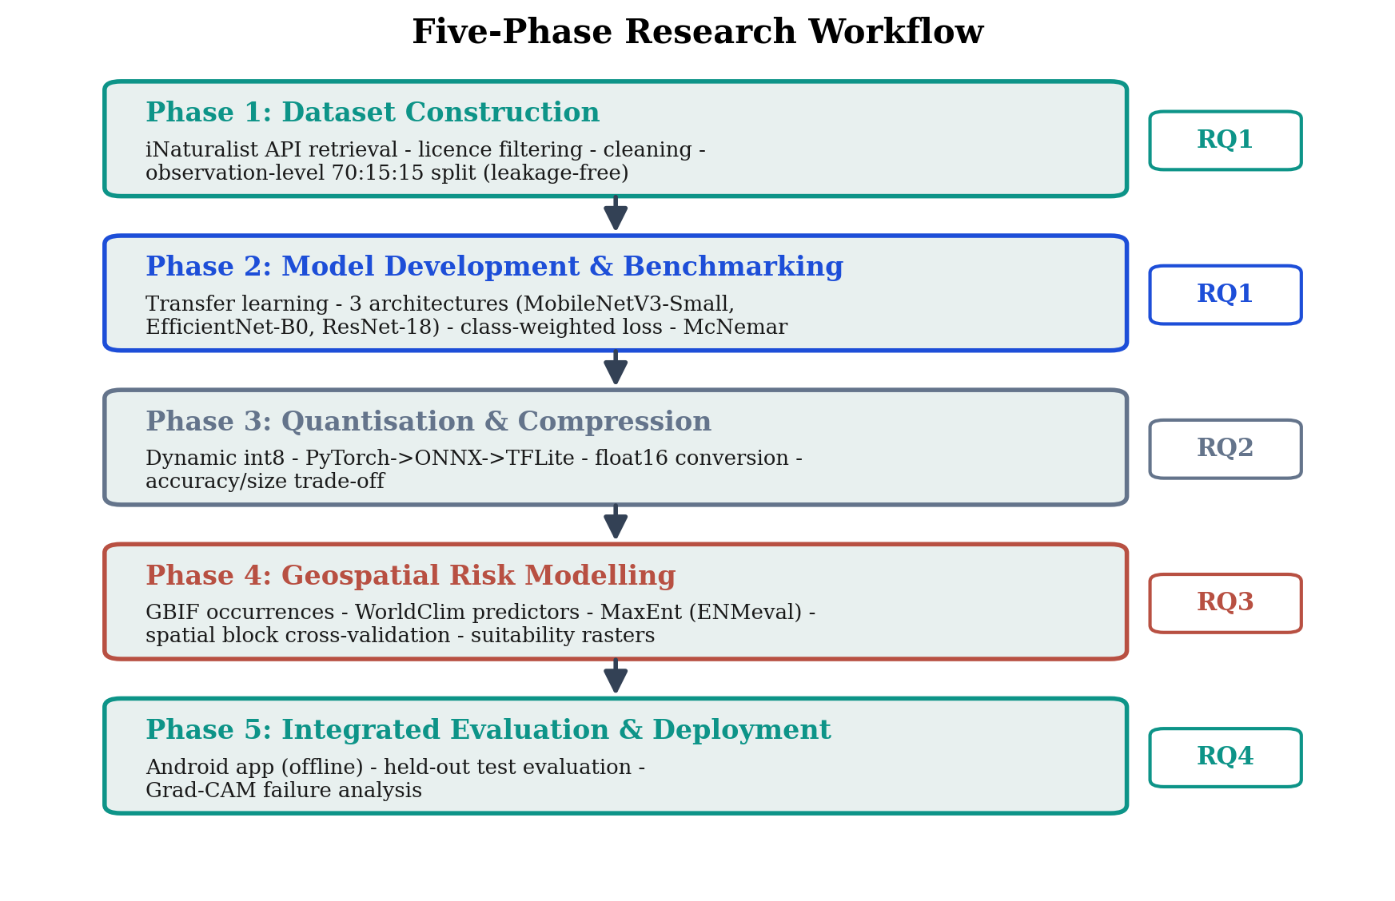
Figure 3.1 The five-phase research workflow, showing the principal activities of each phase and its alignment to the research questions.

3.2 Conceptual Framework
The literature reviewed in Chapter Two supplies a set of concepts drawn from four different disciplines, and the methodology that follows only makes sense once the relationships between those concepts are set out explicitly. This section states the conceptual framework that connects them, showing how the problem is structured, which technical constructs address which part of it, what constrains the whole, and how each strand terminates in a research question. Figure 3.2 presents the framework, and the discussion below explains the relationships it depicts rather than restating its contents.
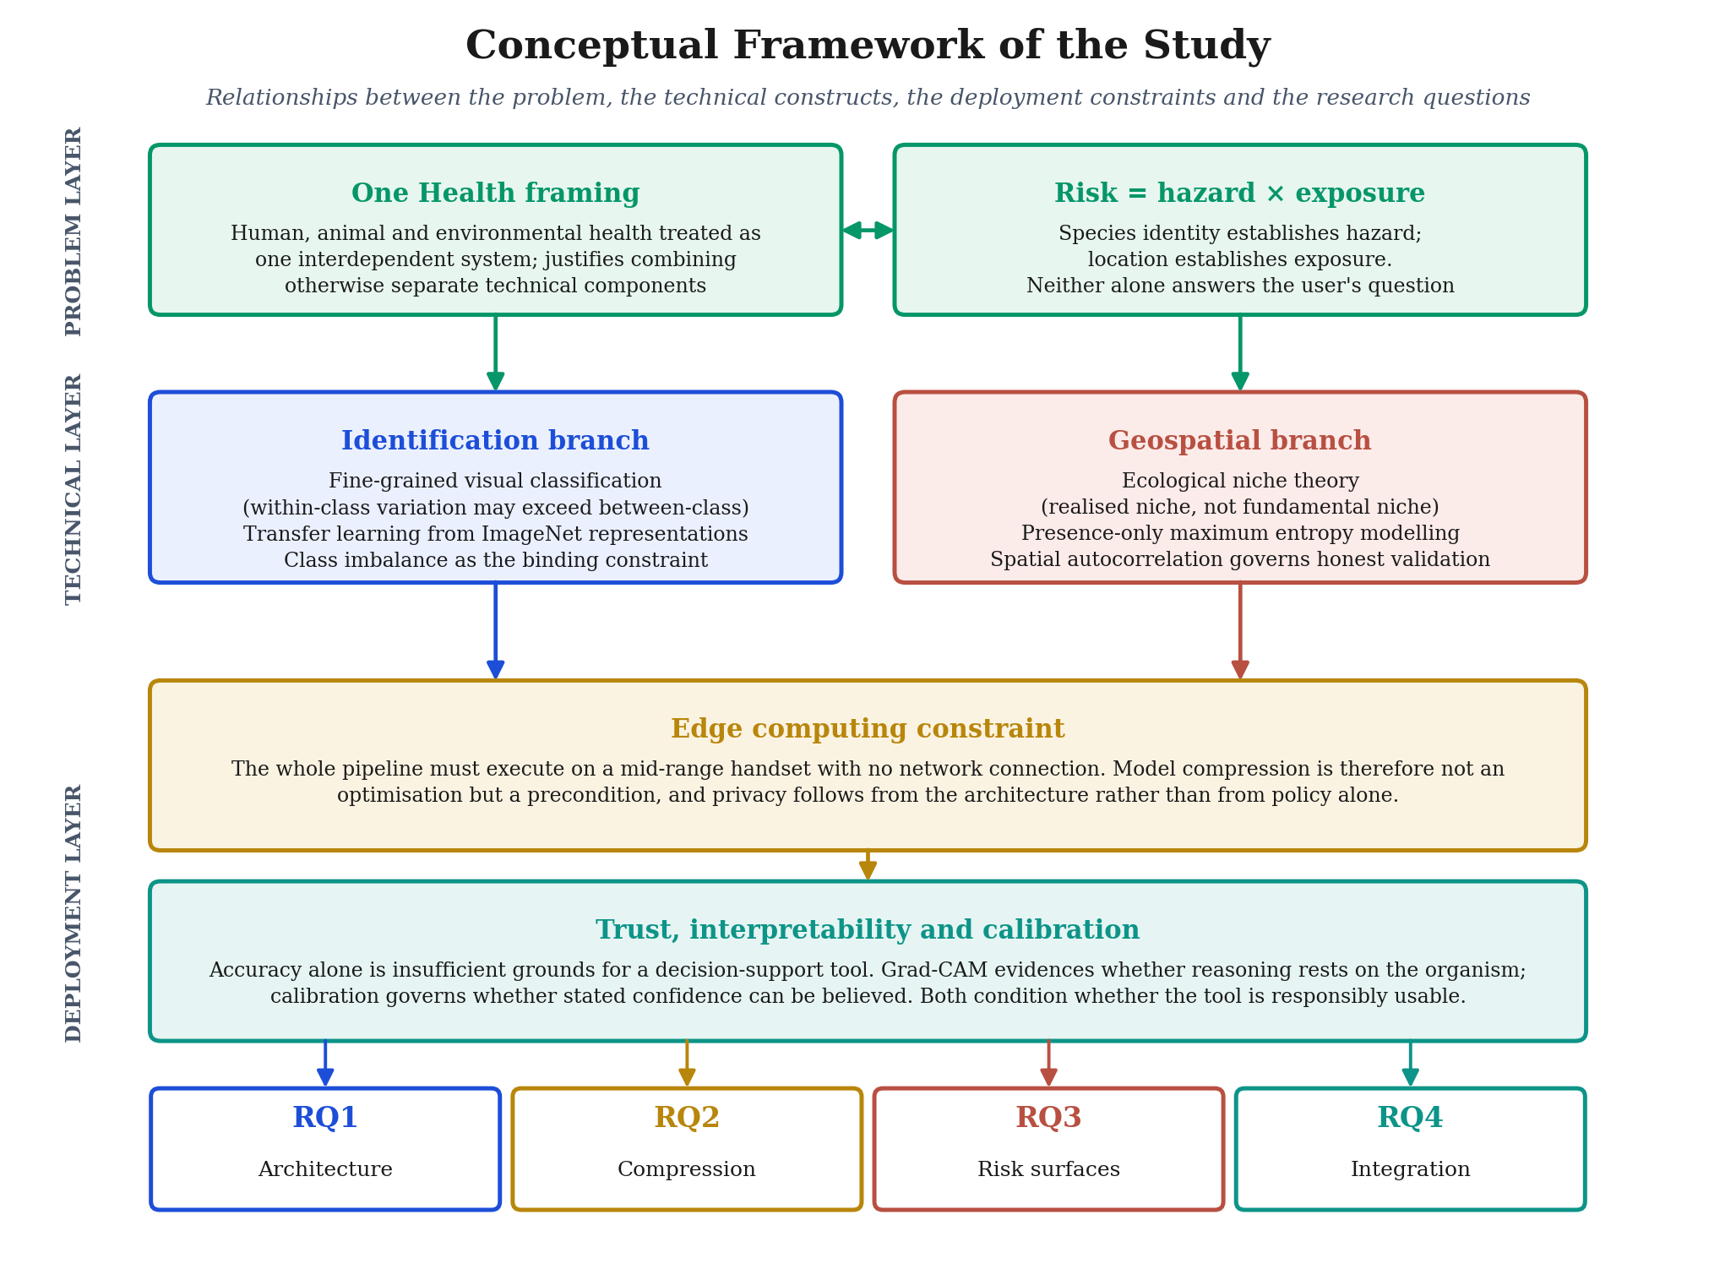
Figure 3.2 Conceptual framework of the study, showing the relationships between the problem layer, the technical constructs, the deployment constraints and the four research questions.
At the problem layer sit two propositions that together define what the tool has to do. The One Health framing establishes that human, animal and environmental health form one interdependent system, which is what licenses the combination of components that would otherwise belong to separate research traditions. The decomposition of risk into hazard and exposure then establishes why a single component would be insufficient. Identifying the species establishes something about hazard, since different ticks carry different pathogens, while knowing where the encounter took place establishes something about exposure, since a species may be identified correctly in a location where it is not established. Neither answers the question a user actually has on its own, and this is the conceptual reason for building an integrated tool rather than a better classifier.
Two technical branches descend from that problem structure. The identification branch rests on fine-grained visual classification, in which categories share a common body plan and differ in localised detail, so that within-class variation can exceed between-class variation. Transfer learning follows from this, since learning such distinctions from scratch would require data on a scale that no citizen-science dataset reaches, and class imbalance follows as the binding constraint because the distribution of available images reflects what people photograph rather than what exists. The geospatial branch rests on ecological niche theory, and specifically on the distinction between the fundamental and the realised niche, which is what makes presence-only maximum entropy modelling the appropriate method and what explains why species whose ranges are governed by non-climatic factors will always be modelled less well. Spatial autocorrelation enters this branch as a methodological constraint, since it determines whether reported performance is honest.
The deployment layer cuts across both branches rather than sitting beneath either. Because the entire pipeline must execute on a mid-range handset without a network connection, model compression is a precondition of the project rather than an optimisation applied at the end, and it is this constraint that turns compression into a research question in its own right. Privacy follows from the same architecture. When identification happens on the device, no image and no location need to be transmitted, so data minimisation is achieved structurally rather than through policy assurances. Beneath the deployment constraint sits a further condition. Accuracy alone does not make a decision-support tool usable, since a model may be accurate for the wrong reasons or may state a confidence that its performance does not justify. Interpretability analysis addresses the first of these and calibration addresses the second, and together they determine whether the tool can responsibly be placed in front of a non-expert.
Each strand of the framework terminates in one of the four research questions, which is what makes the framework operational rather than descriptive. The identification branch produces RQ1, which asks which lightweight architecture best balances accuracy against inference cost. The deployment constraint produces RQ2, which asks what accuracy survives compression and what inference speed is achievable on the target device. The geospatial branch produces RQ3, which asks whether climate-based risk surfaces can be packaged within a handset's storage limits. The trust condition, taken together with the integration of both branches, produces RQ4, which asks how the combined tool performs on held-out data and what its failure modes are. Table 3.1 records this mapping directly, and the five methodological phases described in the remainder of this chapter are the means by which each construct is operationalised.
Table 3.1 Mapping of conceptual constructs to their operationalisation and to the research questions they serve.
Construct | Operationalised as | Phase | Serves
Fine-grained classification | Three lightweight CNNs fine-tuned and compared on five species | Phase 2 | RQ1
Transfer learning | ImageNet-pretrained backbones with a resized classification head | Phase 2 | RQ1
Class imbalance | Inverse-frequency weighted loss; macro-averaged F1 as headline metric | Phases 1 and 2 | RQ1, RQ4
Edge computing constraint | Quantisation and conversion to a mobile runtime; on-device deployment | Phase 3 | RQ2
Ecological niche theory | Presence-only maximum entropy models with bioclimatic predictors | Phase 4 | RQ3
Spatial autocorrelation | Spatial block cross-validation rather than random partitioning | Phase 4 | RQ3
Interpretability and trust | Grad-CAM localisation on correctly classified test images | Phase 5 | RQ4
Hazard and exposure | Classifier output combined with per-species risk surface at the user's location | Phase 5 | RQ4

3.3 Research Philosophy and Paradigm
All research rests on assumptions about what counts as knowledge and how it can legitimately be obtained. Stating those assumptions is not a formality, because they determine whether the chosen methods actually suit the questions. This study adopts a positivist philosophy, which holds that valid knowledge comes from observable and measurable phenomena obtained through reproducible procedures, with the researcher standing apart from the object of study rather than shaping it through interpretation. That position suits the research questions here, which concern measurable properties of computational systems such as classification accuracy, inference cost, compression ratio and predictive performance, rather than the interpretation of human experience or social context. Properties of this kind exist independently of the observer, can be measured with instruments whose behaviour is understood, and are open to statistical inference. The epistemological commitment is therefore objectivist and the logic deductive, since the research questions were set in advance and structured the collection of data rather than emerging from it.
A qualitative or mixed-methods design was considered and rejected. The reasoning is worth recording, because rejecting a design is itself a methodological decision. No human participants were recruited, no interview or observational data was gathered, and no textual corpus requiring thematic interpretation was produced. Adding qualitative methods would have answered none of the research questions and would have broken the coherence between question, data form and analytical technique. Appending a user-experience survey, for instance, would not have addressed anything the study actually asks. What results is a quantitative, mono-method experimental study of the design-and-build type, in which computational artefacts are constructed and then evaluated against quantitative benchmarks using data withheld from their construction. Table 3.2 sets out the layered methodological choices from philosophy through to technique, following the research-onion framework commonly used to organise decisions of this kind.
Table 3.2 Layered methodological choices and their justifications.
Layer | Choice adopted | Justification
Philosophy | Positivism | Knowledge comes from reproducible measurement and statistical inference rather than interpretation.
Approach | Deductive | The research questions are set before data collection and give it structure.
Methodological choice | Quantitative, mono-method | Every variable of interest is numerically measurable, so qualitative data would serve no question.
Strategy | Experiment, design and build | Artefacts are constructed and then tested against benchmarks on held-out data.
Time horizon | Cross-sectional | The system is built and evaluated at one point rather than tracked over time.
Techniques | CNN benchmarking, quantisation, MaxEnt, Grad-CAM | Each technique answers a specific research question.

Three quality criteria govern experimental research of this type. Validity, meaning whether the study measures what it claims to measure, is protected by aligning each metric to its research question and by evaluating on a held-out test set that plays no part in building the models. Reliability, meaning whether the same procedures would give the same result again, is protected by fixing random seeds, documenting hyperparameters and using established versioned software. Reproducibility is pursued more strongly still by releasing the dataset and the processing pipeline so that the study can be re-executed in full. Generalisability is treated cautiously. The models are specific to European ticks and to the data that was available, and Chapter Five in particular avoids claiming performance beyond what the held-out evaluation supports.
Table 3.3 sets out the five phases and the research questions they serve.
Table 3.3 The five methodological phases and their alignment to the research questions.
# | Phase | Principal output | Serves
1 | Dataset construction | Labelled, split, licence-tracked image dataset | RQ1
2 | Model development and benchmarking | Best classifier selected among three architectures | RQ1
3 | Quantisation | Compressed, deployable model | RQ2
4 | Geospatial risk modelling | Per-species risk surfaces | RQ3
5 | Integrated evaluation | End-to-end performance and failure analysis | RQ4

3.4 Phase 1: Dataset Construction
Everything in the classification results rests on the quality of the dataset, so its construction received corresponding attention. Figure 3.3 summarises the pipeline from retrieval through to the final partitioned dataset.
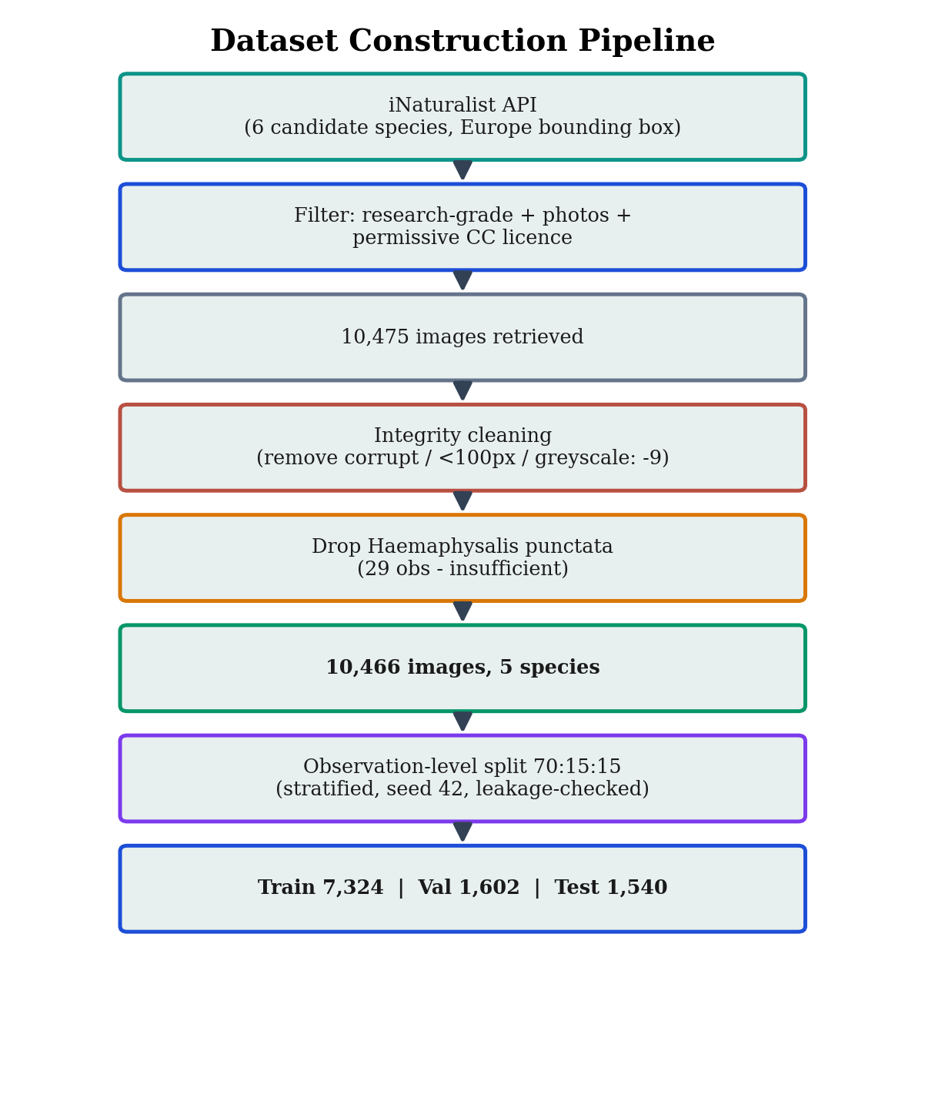
Figure 3.3 The dataset construction pipeline, from API retrieval through cleaning and species selection to the leakage-checked partition.

3.4.1 Data sources and licensing
The classification dataset was assembled from research-grade observations on iNaturalist, a citizen-science platform where members upload photographs and identify them collaboratively. An observation qualifies as research-grade when at least two-thirds of identifying users agree on the species and the record carries a date and a location. Restricting retrieval to research-grade records meant that label reliability was established at the point of acquisition rather than assumed afterwards. Images were obtained programmatically through the iNaturalist public application programming interface, filtered by taxon, by a European bounding box and by the presence of photographs. For every observation retrieved, the contributing observer, the Creative Commons licence, the date and the coordinates were written to a manifest so that provenance was preserved and attribution possible. Only images under permissive Creative Commons licences were kept, namely CC0, CC BY, CC BY-NC, CC BY-SA and CC BY-NC-SA. All-rights-reserved images were excluded at the point of download so that the resulting dataset could be used lawfully and, subject to the non-commercial and share-alike terms it inherits, released.

3.4.2 Species selection and the sample-size decision
Six European species were targeted initially on grounds of public-health and veterinary relevance. A defensible classifier needs a reasonable number of distinct examples per class, and citizen-science data is not evenly distributed, since common species are photographed often and uncommon ones rarely. A count of available research-grade European observations was therefore carried out before any images were downloaded, so that the viability of each class could be judged in advance. Haemaphysalis punctata proved unviable. Only 29 research-grade European records existed, rising to 31 when the search was widened globally, and the species was excluded, leaving five for analysis. The decision is reported openly because the scarcity of data for an epidemiologically important species is itself a finding about the limits of citizen-science data, and it returns in the interpretation of the results.

3.4.3 Cleaning and integrity
Retrieved images were checked for integrity and suitability. Files that were corrupt, smaller than 100 pixels on the shorter side, or greyscale were removed, since none of these provide the colour and detail that fine-grained morphological classification depends on. The step is deliberately conservative, on the reasoning that discarding a marginal image costs less than training on one that could teach the model a spurious association.

3.4.4 Partitioning and the prevention of data leakage
One physical tick can appear in several photographs within a single iNaturalist observation, taken from different angles or under different lighting. Splitting those near-duplicates across training and test partitions would let the model memorise an individual tick during training and then recognise it at test time, which produces an optimistically biased estimate that does not reflect genuine generalisation. This is a form of data leakage, and it is easy to overlook in citizen-science image work. To prevent it the dataset was partitioned by observation rather than by image, so that every photograph belonging to one observation went into the same partition. Observations were divided into training, validation and test partitions in approximately a 70:15:15 ratio, stratified by species so that each partition preserved the overall class proportions, under a fixed random seed. A verification step confirmed that no observation appeared in more than one partition. Figure 3.4 shows the difference between the rejected image-level split and the observation-level split actually used, and Algorithm 3.1 gives the procedure.
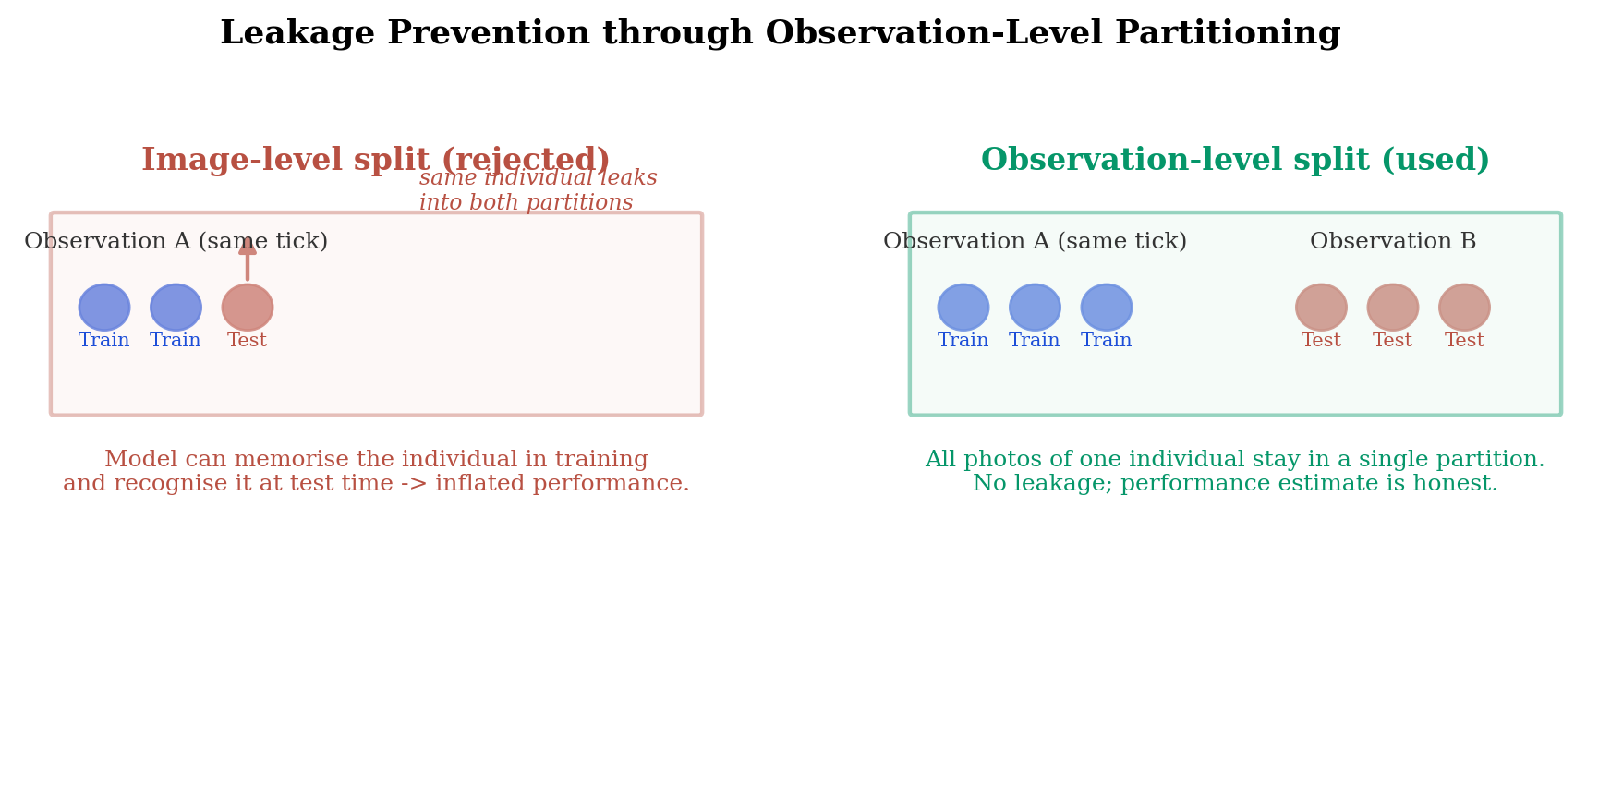
Figure 3.4 Observation-level partitioning prevents the data leakage that image-level partitioning would introduce.
Algorithm 3.1 Observation-level stratified partitioning
Input : manifest M of images, each with (observation_id, species)
ratios (0.70, 0.15, 0.15); random seed s
Output: disjoint train / val / test partitions

1 group M by observation_id -> set O of observations
2 for each species c:
3 O_c <- observations of species c
4 shuffle O_c using seed s
5 split O_c into train/val/test by the given ratios
6 assign every image to the partition of its observation
7 assert: no observation_id appears in more than one partition
8 return train, val, test

Chapter Four reports the resulting partition sizes and per-species counts, and analyses the pronounced class imbalance they reveal.

3.4.5 Preprocessing and augmentation
Images were resized to 224 by 224 pixels and normalised using the channel means and standard deviations of the ImageNet dataset, which matches what the pre-trained networks in the next phase expect. Normalising to the statistics of the pre-training data is not cosmetic. The pre-trained convolutional filters were learned on inputs standardised this way, so supplying inputs on a different scale would weaken the transfer of those features. Augmentation was applied during training to improve generalisation, using random resized cropping, horizontal flipping, rotation and colour jitter. Each of these exposes the model to plausible variation and discourages it from memorising incidental detail. The particular augmentations were chosen to reflect variation that genuinely occurs in citizen photographs, where ticks appear at different scales and orientations and under different lighting, while avoiding transformations that would produce implausible images or destroy diagnostic features. Validation and test images were resized and normalised without augmentation, so that evaluation reflects performance on unaltered images of the kind the tool would actually meet. Restricting augmentation to the training partition is deliberate, since augmenting the evaluation data would distort the performance estimate.

3.4.6 Characterisation and limitations of the dataset
The properties of the dataset condition every result that follows, so its limitations are characterised here at the point of construction rather than left to the discussion. Three limitations come with the data source and were accepted as the cost of using openly available real-world imagery. Class imbalance is the first. Citizen-science observations are dominated by the species people encounter most often, and no amount of careful retrieval can manufacture images of a species that has rarely been photographed, so the imbalance is a property of the underlying phenomenon rather than an artefact of collection. It is addressed through the class-weighting and evaluation choices described below rather than ignored. The second is spatial and observer bias, since citizen observations cluster around population centres, roads and paths and reflect the interests and locations of the contributing community, which means the dataset is not a uniform sample of European ticks. The third is variable image quality, because photographs come from many different devices under uncontrolled conditions, and although cleaning removes the worst cases the retained images still vary in focus, lighting, scale and background. None of these are defects to be hidden. They define the conditions under which the deployed tool would actually operate, and a model evaluated on cleaner data than it will meet in use would give a misleadingly optimistic picture of its readiness.

3.5 Phase 2: Model Development and Benchmarking
The second phase trains and compares candidate classifiers and selects the strongest, which answers RQ1. Figure 3.5 shows the transfer-learning architecture shared by all three candidates.
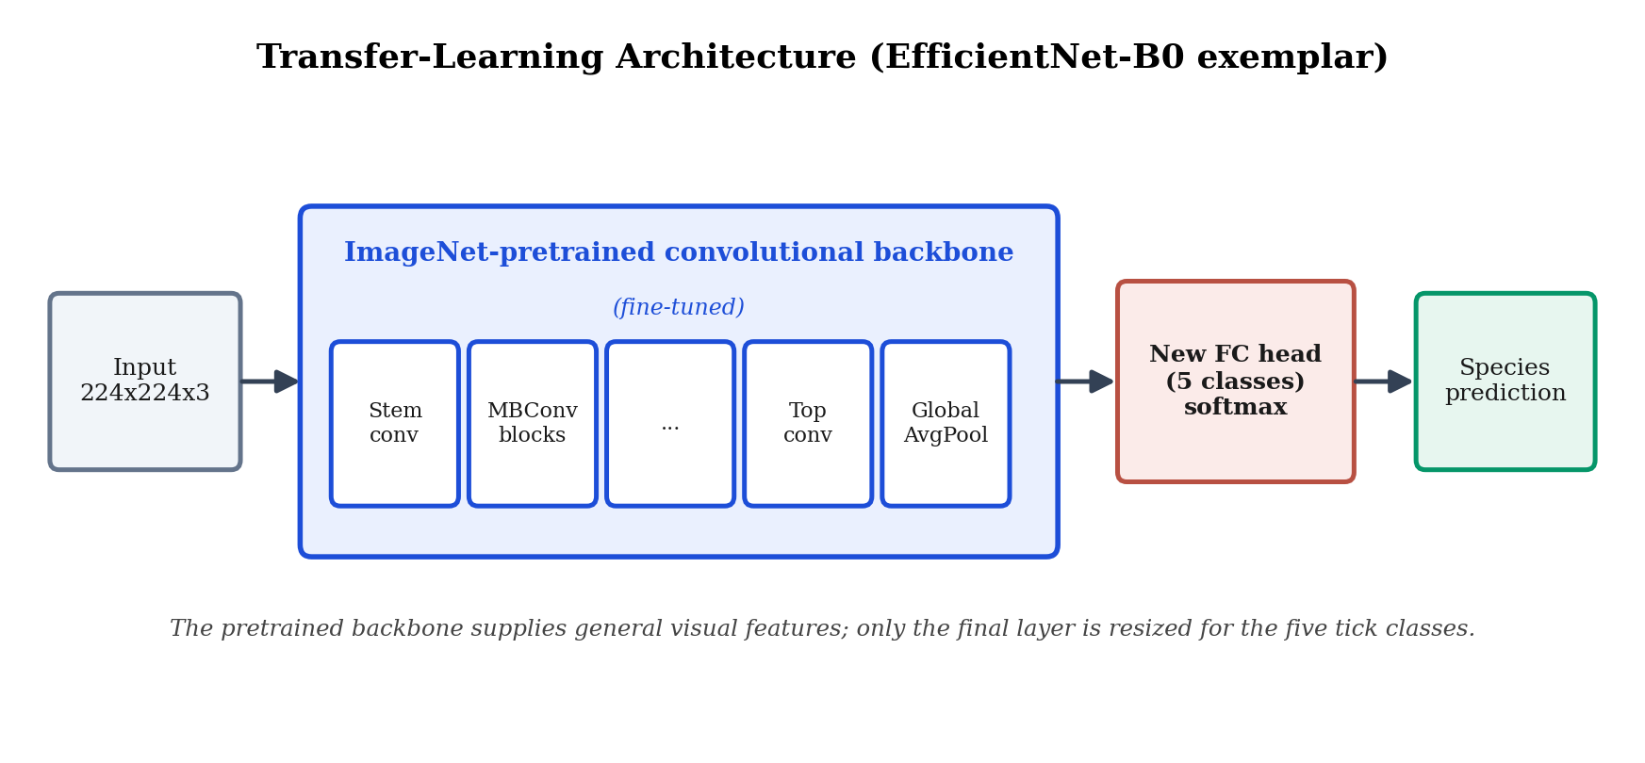
Figure 3.5 The transfer-learning architecture, illustrated for EfficientNet-B0. An ImageNet-pretrained backbone is fine-tuned and only the final classification layer is resized to the five tick classes.

3.5.1 Transfer learning
Training a deep network from random initialisation needs far more data than was available and would almost certainly overfit. Transfer learning was used instead. Each architecture is initialised with weights pre-trained on ImageNet, a dataset of roughly 1.2 million images across a thousand categories, and the final classification layer is replaced with one sized for five tick classes. The pre-trained convolutional layers already encode general visual features such as edges, textures and shapes and the ways these combine, and those features transfer to tick identification and are refined during fine-tuning. The approach is standard wherever labelled data is limited, and it is what allows a dataset of around ten thousand images to train a competitive classifier.

3.5.2 Candidate architectures
Three lightweight architectures were selected because the deployment target is a mobile device, where model size and inference cost are constrained. MobileNetV3-Small is optimised aggressively for mobile inference. EfficientNet-B0 is the smallest member of the compound-scaled EfficientNet family and the framework-available equivalent of the EfficientNet-Lite architecture named in RQ1. ResNet-18 was included as a heavier reference point against which the lightweight designs could be judged. Benchmarking all three under identical conditions, rather than adopting one on reputation, allows the final choice of model to be justified empirically in direct answer to RQ1.

3.5.3 Handling class imbalance
The dataset is severely imbalanced, with the most abundant class exceeding the rarest by a factor of more than fifty. A model trained naively to minimise overall error would learn to favour the majority class and would score well on aggregate accuracy while performing poorly on the rare but epidemiologically important species, which is precisely the wrong trade-off for this application. Two measures counter it. The primary evaluation metric is the macro-averaged F1 score, which weights every class equally regardless of frequency and therefore cannot be inflated by strong performance on the common classes alone; Section 3.9 defines it formally. The training objective is then a class-weighted cross-entropy loss that penalises errors on rare classes more heavily. For a problem with C classes, a training example with true class y contributes the loss
L = − w_y · log p̂_y , (3.1)
where p̂_y is the predicted probability assigned to the true class and w_y is the weight of that class. Predicted probabilities come from the network's raw output scores, or logits, z_1 to z_C, through the softmax function,
p̂_i = exp(z_i) / Σ_j exp(z_j) , i = 1, …, C. (3.2)
Weights were set by inverse frequency, so that a class contributes to the loss in inverse proportion to how abundant it is. With n_i training examples in class i and N examples in total,
w_i = N / (C · n_i) . (3.3)
Equation (3.3) gives a weight near one for a class of average size, below one for over-represented classes and a large weight for rare ones. Table 3.4 lists the resulting weights. The rarest class receives a weight roughly fifty-four times that of the most abundant, and this is the mechanism that stops training from collapsing onto the majority class.
Table 3.4 Training-set class counts and inverse-frequency weights from Equation (3.3).
Species | Train count | Weight
Ixodes ricinus | 4,170 | 0.35
Dermacentor reticulatus | 2,132 | 0.69
Rhipicephalus sanguineus | 684 | 2.14
Hyalomma marginatum | 260 | 5.63
Ixodes hexagonus | 78 | 18.78

3.5.4 Training procedure
All three architectures were trained under an identical procedure so that any difference in performance could be attributed to architecture rather than to differences in optimisation. Optimisation used AdamW with a learning rate of 5 × 10⁻⁴ and weight decay of 10⁻⁴, a batch size of 32, and the class-weighted loss of Equation (3.1). Models trained for up to 40 epochs with early stopping. Validation macro-F1 was computed after each epoch, the parameters achieving the highest value were retained, and training halted once six consecutive epochs passed without improvement. Early stopping guards against overfitting by returning the best-generalising model rather than the most-trained one. Algorithm 3.2 states the procedure in full. Training ran in PyTorch on a Google Colab environment with a single graphics processing unit.
Algorithm 3.2 Training with early stopping
Input : model f, train loader, val loader, max_epochs E, patience p
Output: parameters at the best validation macro-F1

1 best_f1 <- 0 ; best_state <- none ; no_improve <- 0
2 for epoch = 1 .. E:
3 for each batch (x, y) in train loader:
4 z <- f(x) # forward pass
5 L <- weighted_cross_entropy(z, y) # Eq. (3.1)
6 update f by AdamW on gradient of L
7 v <- macro_F1(f, val loader)
8 if v > best_f1:
9 best_f1 <- v ; best_state <- copy(f) ; no_improve <- 0
10 else:
11 no_improve <- no_improve + 1
12 if no_improve == p: break # early stopping
13 return best_state

3.5.5 Model comparison and significance testing
Choosing the best architecture on validation macro-F1 alone risks mistaking sampling noise for a real difference. McNemar's test was therefore applied to each pair of models to establish whether the leading model's advantage was statistically significant. The test suits comparisons between two classifiers evaluated on the same items because it works from the pattern of disagreements between them. For models A and B, let b be the number of items A classifies correctly and B does not, and c the number B classifies correctly and A does not. With continuity correction the statistic is
χ² = ( |b − c| − 1 )² / ( b + c ) , (3.4)
which follows a chi-squared distribution with one degree of freedom under the null hypothesis of equal performance. A probability value below 0.05 provides evidence that the two models genuinely differ. Because the test conditions on the items both models see and uses only the discordant cases, it is both more powerful and more appropriate than comparing independent accuracy figures.

3.6 Phase 3: Model Compression through Quantisation
A model intended to run on the device has to be small and fast enough for a mid-range smartphone, and compression is how that is achieved. Quantisation reduces size and computational cost by representing weights at lower numerical precision than the 32-bit floating-point format used in training. RQ2 concerns the trade-off involved, meaning how much accuracy survives and how much size is saved. The principal method considered is eight-bit integer quantisation, in which a floating-point weight r maps to an eight-bit integer q through an affine transformation defined by a scale factor s and a zero-point z:
q = round( r / s ) + z , r ≈ s ( q − z ). (3.5)
The scale maps the range of real values into the integer range from −128 to 127, and the zero-point ensures that real zero is represented exactly, which matters because zero-padding is used throughout convolutional networks. Since int8 values occupy a quarter of the memory of 32-bit floats, Equation (3.5) offers a theoretical fourfold reduction in size along with faster inference on hardware that supports integer arithmetic. Figure 3.6 shows the conversion route from the trained model to a deployable mobile format together with the alternative half-precision representation. Chapter Four reports which procedures were actually applied and what practical limits were met.
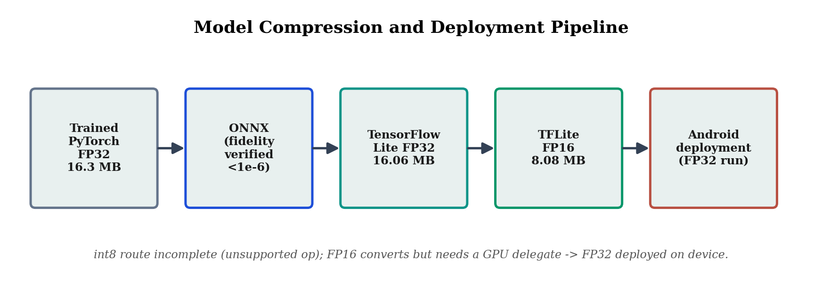
Figure 3.6 The model compression and deployment pipeline, from the trained PyTorch model through the interchange and mobile formats to on-device deployment.

3.7 Phase 4: Geospatial Risk Modelling
The geospatial component models where each species is climatically suited to occur and produces the risk surfaces that the application overlays on the user's location. Occurrence records were obtained from the Global Biodiversity Information Facility as georeferenced presence points, then cleaned by removing spatial duplicates and low-precision records and thinned to reduce the sampling bias that arises when observations cluster around population centres and roads. The environmental predictors were the standard set of bioclimatic variables, which summarise the temperature and precipitation patterns relevant to a species' physiological tolerances. CHELSA version 2.1 was specified, with WorldClim version 2.1 at comparable resolution retained as a pre-authorised alternative, and Chapter Four reports which was used.
Maximum entropy, usually abbreviated to MaxEnt, was the modelling method. It estimates a species' distribution as the most uniform probability distribution consistent with the constraints imposed by the environmental values observed at known presence locations. Two reasons make it appropriate here. Citizen-science and museum occurrence data are presence-only and lack verified absences, which is exactly the data type MaxEnt was designed for, and it is the established standard in European tick distribution modelling, which helps comparability with earlier work. Models were fitted and tuned reproducibly using the ENMeval 2.0 framework in R, which evaluates combinations of feature classes and regularisation settings systematically. Validation used spatial block cross-validation, in which the data is divided into geographically contiguous blocks so that training and testing locations are not near neighbours, avoiding the optimistic bias that spatial autocorrelation introduces into randomly partitioned data. Figure 3.7 illustrates the difference between this and naive random cross-validation. Predictive performance is reported per species as the area under the receiver-operating-characteristic curve, and the per-species suitability rasters were exported and compressed for offline use in the application.
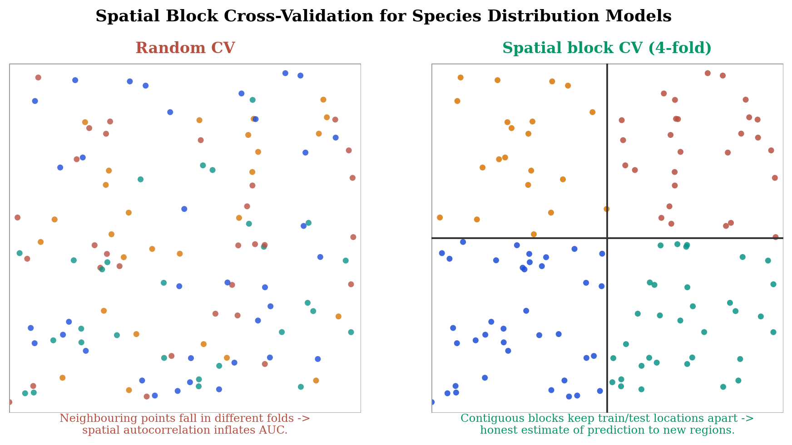
Figure 3.7 Spatial block cross-validation partitions occurrence data into geographically contiguous blocks, avoiding the inflated performance estimates that random cross-validation produces under spatial autocorrelation.
Two decisions in this phase need explicit justification because they affect how credible the resulting surfaces are. The first concerns background points, sometimes called pseudo-absences, which characterise the environmental conditions available across the study region so that conditions at presence locations can be contrasted against them. Ten thousand background points were sampled across the European extent under a fixed random seed. That number is large enough to characterise the available environmental space reliably while remaining computationally manageable, and fixing the seed keeps the sampling reproducible. The second concerns the tuning of model complexity. Maximum-entropy models can be made arbitrarily flexible by admitting more feature classes and lowering the regularisation that penalises complexity, but a more flexible model is likelier to overfit the idiosyncrasies of sparse presence data. ENMeval was used to evaluate a grid of feature-class and regularisation settings for each species, and the final configuration was chosen with explicit attention to the omission rate under spatial cross-validation rather than solely by the model that optimised an information criterion, so that robustness was preferred to a marginally better fit. For the species with the fewest records this trade-off proved decisive, and Chapter Four documents the reasoning.

3.8 Phase 5: Integrated Evaluation
The final phase evaluates the complete tool and analyses its failure modes, answering RQ4. The selected quantised classifier and the geospatial risk surfaces were integrated, and the system was evaluated end-to-end on the held-out test partition defined in Section 3.4.4, which had been kept untouched throughout model development so that it could give a genuinely independent estimate of generalisation. Classification performance on the test set is reported using the full metric suite of Section 3.9, including per-class recall and the confusion matrix, so that performance on each individual species is visible rather than only the aggregate.
Counting errors says nothing about why they occur, so gradient-weighted class activation mapping, known as Grad-CAM, was applied to interpret them. Grad-CAM produces a heat map over the input image showing which regions were most responsible for a prediction, which reveals whether the model is attending to the organism or to incidental features of the background. For a target class c, the importance weight of feature map A^k is the global average of the gradient of the class score y^c with respect to that map,
α_k^c = (1/Z) Σ_i Σ_j ( ∂y^c / ∂A_ij^k ) , (3.6)
and the localisation map is the positive part of their weighted combination,
L_Grad-CAM^c = ReLU( Σ_k α_k^c A^k ) , (3.7)
where Z is the number of spatial locations and the rectified linear unit, ReLU(x) = max(0, x), keeps only regions with a positive influence on the class score. Algorithm 3.3 states the procedure. Applying Equations (3.6) and (3.7) to test images allows failures to be categorised, for instance as attention directed at the background rather than the tick or as genuine morphological similarity between species. That is what separates a diagnostic evaluation from a bare accuracy figure, and it addresses the failure-mode component of RQ4 directly.
Algorithm 3.3 Grad-CAM localisation for a test image
Input : trained model f, image x, target class c,
target convolutional layer ell
Output: heat map over x for class c

1 forward x through f; capture activations A^k at layer ell
2 compute class score y^c (logit for class c)
3 backpropagate to get gradients d y^c / d A^k
4 for each channel k:
5 alpha_k <- global average of the gradient over i, j # Eq.(3.6)
6 M <- ReLU( sum_k alpha_k * A^k ) # Eq.(3.7)
7 upsample M to the size of x and overlay
8 return heat map

3.9 Evaluation Metrics
Classification performance is quantified using metrics derived from the counts of true positives, false positives and false negatives for each class, written TP, FP and FN. Precision and recall for a class are
Precision = TP / (TP + FP) , Recall = TP / (TP + FN) , (3.8)
where precision is the proportion of images predicted as a class that truly belong to it, and recall is the proportion of images truly belonging to a class that were correctly found. The two capture different kinds of failure, false alarms in the first case and misses in the second, and their harmonic mean is the F1 score,
F1 = 2 · ( Precision · Recall ) / ( Precision + Recall ). (3.9)
The headline metric is macro-averaged F1, the unweighted mean of the per-class F1 scores across all C classes,
macro-F1 = (1/C) Σ_i F1^(i) . (3.10)
Macro-averaging was chosen over overall accuracy deliberately, because it weights every species equally and so cannot be inflated by strong performance on the abundant classes alone. Given the imbalance documented in Section 3.5.3 and Table 3.4, that property is essential. Per-class recall and the confusion matrix are reported alongside the macro-F1 so that the strength of evidence for each class can be judged individually, and McNemar's test from Equation (3.4) establishes whether differences between models are statistically significant. The geospatial models are evaluated by the area under the receiver-operating-characteristic curve under spatial block cross-validation, as described in Section 3.6, which summarises how well a model ranks suitable locations above unsuitable ones.

3.10 Ethical Considerations
The study received institutional ethical approval under the auto-approval route for low-risk research, certificate AUTONOHP001009, on the basis that it recruits no human participants, uses no human tissue and involves no animals. All data used is publicly available secondary data. Three governance measures follow from the design and were observed throughout. Image licences are respected, since only permissively licensed images were used and every contributing observer is recorded in the manifest for attribution, which honours the terms under which the images were shared. Personal data is minimised by design, because the geolocation the application uses to place the user on the risk map is processed entirely on the device and never transmitted, consistent with the data-minimisation principle of the United Kingdom General Data Protection Regulation and with the mobile-health governance guidance reviewed in Chapter Two. The tool is framed as educational and decision-supporting rather than diagnostic, so that it does not overstate its authority or displace professional judgement. Use of generative artificial-intelligence tools during the project is declared in accordance with University of Greater Manchester academic-integrity policy.

3.11 Summary
This chapter has presented a quantitative experimental methodology grounded in a positivist paradigm and structured in five phases, each aligned to the study's research questions. It has justified the philosophical and design choices underpinning the work and described how a clean, licence-tracked and leakage-free dataset was constructed, how three lightweight architectures were trained under an identical class-weighted procedure and compared with statistical significance testing, how the selected model was compressed and the accuracy-to-size trade-off measured, how the geospatial models were fitted and validated against spatial autocorrelation, and how the integrated tool was evaluated end-to-end with its failures diagnosed through explainability analysis. The mathematics behind each technique has been made explicit, the key procedures stated as algorithms, and the evaluation metrics defined and justified with reference to the imbalance in the dataset. Chapter Four reports the results this methodology produced.

Chapter 4 Results

4.1 Introduction
This chapter reports what the methodology of Chapter Three produced. It is organised by research question rather than chronologically, so that all the evidence bearing on a given question appears together. Section 4.2 describes the dataset that was built, since its properties, and its class imbalance above all, condition how everything after it should be read. Sections 4.3 to 4.7 then address RQ1 to RQ4 in turn, with Section 4.5 documenting the on-device application, and Section 4.8 draws the findings together. Interpretation here stays close to what the evidence directly supports, and the broader implications are held back for Chapter Five.

4.2 The constructed dataset
Dataset construction produced 10,466 usable images across five European tick species, which exceeds the target of 8,000 set in Chapter One. The sixth candidate species, Haemaphysalis punctata, was excluded during construction because only 29 research-grade European observations existed, and widening the search globally raised that only to 31, confirming genuine scarcity rather than a retrieval problem. Of the 10,475 images retrieved, nine were discarded during cleaning, one for falling below the minimum dimension and eight for being greyscale. A further 1,565 observations were excluded at the point of download for carrying all-rights-reserved licences. Most of the retained images are licensed CC BY-NC (7,899), with smaller numbers under CC BY (1,652), CC0 (610), CC BY-NC-SA (244) and CC BY-SA (61).
Figure 4.1 shows how the images are distributed across species and partitions. The imbalance is severe. The training partition holds 4,170 images of Ixodes ricinus against 78 of Ixodes hexagonus, a ratio of roughly 53 to 1. This is the single most consequential property of the dataset and it recurs throughout the interpretation below.
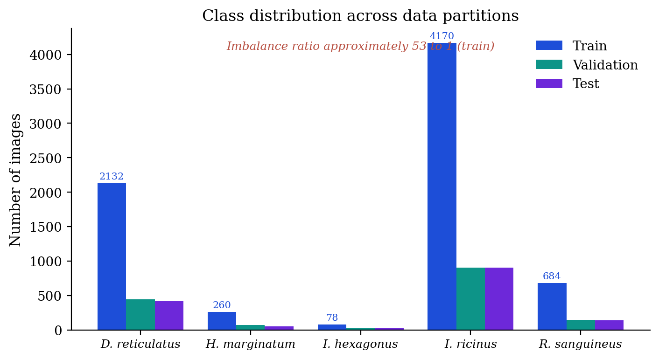
Figure 4.1 Distribution of images across the five species and the three data partitions. The training imbalance ratio between the most and least represented classes is approximately 53:1.
Partitioning was carried out at observation level rather than image level, so multiple photographs of the same individual tick could not be split across partitions. Verification confirmed that no observation appeared in more than one partition, which rules out data leakage inflating the performance estimates. Table 4.1 gives the per-species partition sizes.
Table 4.1 Image counts per species across the training, validation and test partitions.
Species | Train | Validation | Test | Total
Dermacentor reticulatus | 2132 | 446 | 420 | 2998
Hyalomma marginatum | 260 | 72 | 54 | 386
Ixodes hexagonus | 78 | 29 | 23 | 130
Ixodes ricinus | 4170 | 906 | 907 | 5983
Rhipicephalus sanguineus | 684 | 149 | 136 | 969
Total | 7,324 | 1,602 | 1,540 | 10,466

4.3 RQ1: Architecture comparison and classification performance

4.3.1 Training behaviour
All three architectures were trained under the identical procedure specified in Chapter Three, differing only in the architecture itself. Figure 4.2 plots validation macro-F1 by epoch. Each improved quickly over the first five epochs before levelling off, and each was halted by early stopping. EfficientNet-B0 reached its best validation performance at epoch 11 and stopped at epoch 17, while MobileNetV3-Small and ResNet-18 both peaked at epoch 12 and stopped at epoch 18.
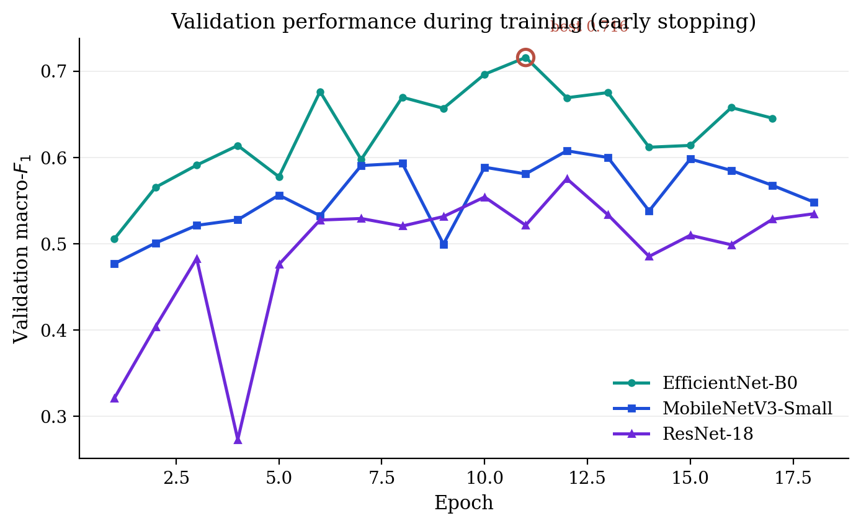
Figure 4.2 Validation macro-F1 by epoch for the three architectures. The best epoch for EfficientNet-B0 is circled. All runs terminated by early stopping.
Two features of the curves are worth comment. ResNet-18 showed much greater variance from epoch to epoch, with validation macro-F1 moving between 0.273 and 0.575, which suggests less stable convergence on this dataset. All three models also showed a widening gap between training and validation scores in the later epochs, the usual indication of overfitting, and early stopping is what kept the parameters from the best-generalising epoch rather than the final one.

4.3.2 Architecture comparison
Table 4.2 and Figure 4.3 give validation macro-F1 for the three architectures. EfficientNet-B0 scored highest at 0.716, ahead of MobileNetV3-Small at 0.608 and ResNet-18 at 0.575.
Table 4.2 Architecture comparison on the validation partition. Parameter counts are approximate.
Architecture | Parameters (M) | Validation macro-F1
EfficientNet-B0 | 5.3 | 0.716
MobileNetV3-Small | 2.5 | 0.608
ResNet-18 | 11.7 | 0.575

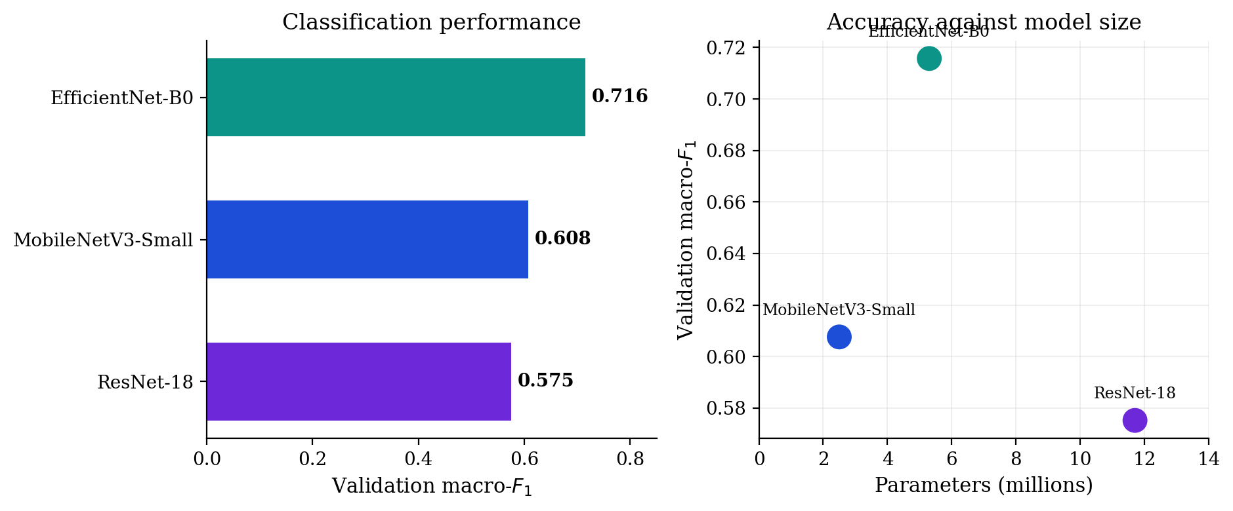
Figure 4.3 Left: validation macro-F1 by architecture. Right: macro-F1 against parameter count, showing that the largest model did not produce the best performance.
Performance did not rise with model size. ResNet-18 holds roughly 11.7 million parameters, more than twice as many as EfficientNet-B0, and recorded the lowest score of the three. For this task, then, architectural design matters more than parameter count. McNemar's test was applied to the paired predictions to check whether the differences reflected genuine performance rather than sampling variation, and Table 4.3 reports the result. EfficientNet-B0 classified 246 items correctly that MobileNetV3-Small got wrong, against 80 in the opposite direction, giving a chi-squared value of 83.51 at p < 0.001. Against ResNet-18 the counts were 284 and 82, with chi-squared 110.39 at p < 0.001. Both comparisons support selecting EfficientNet-B0.
Table 4.3 McNemar's test comparing EfficientNet-B0 with each alternative architecture on paired validation predictions. Here b is the number of items EfficientNet classified correctly and the comparison model did not, and c is the reverse.
Comparison | b | c | chi-sq (1) | p
EfficientNet-B0 vs. MobileNetV3-Small | 246 | 80 | 83.51 | < 0.001
EfficientNet-B0 vs. ResNet-18 | 284 | 82 | 110.39 | < 0.001

4.3.3 Held-out test performance
The selected model was evaluated once on the test partition of 1,540 images. Test macro-F1 came out at 0.660, with a bootstrap 95 per cent confidence interval of 0.605 to 0.705 from 1,000 resamples, and overall accuracy at 0.858. The drop from the validation estimate of 0.716 to the test estimate of 0.660 is expected, since the validation partition informed both model and epoch selection. More interesting is the divergence between accuracy and macro-F1. Accuracy is dominated by the abundant classes, whereas macro-F1 exposes weak performance on the rarer ones, and the gap between 0.858 and 0.660 is a direct measure of how uneven the model's competence is across species. Table 4.4 and Figure 4.4 give the per-class results.
Table 4.4 Per-class performance on the held-out test partition (n = 1,540).
Species | Precision | Recall | F1 | Support
Ixodes ricinus | 0.924 | 0.914 | 0.919 | 907
Dermacentor reticulatus | 0.844 | 0.914 | 0.878 | 420
Hyalomma marginatum | 0.507 | 0.685 | 0.583 | 54
Rhipicephalus sanguineus | 0.650 | 0.478 | 0.551 | 136
Ixodes hexagonus | 0.467 | 0.304 | 0.368 | 23
Macro average | 0.678 | 0.659 | 0.660 | 1,540
Weighted average | 0.857 | 0.858 | 0.855 | 1,540

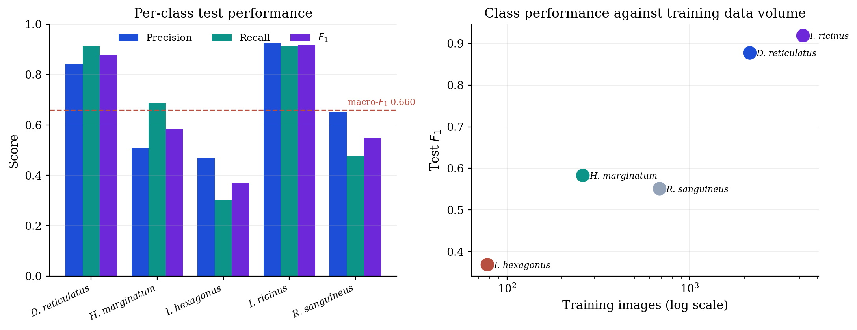
Figure 4.4 Left: precision, recall and F1 by species on the test partition, with the macro-F1 shown as a dashed line. Right: test F1 against the number of training images per class on a logarithmic scale.
Performance varies a great deal between species. The best-represented classes did well, with Ixodes ricinus at F1 0.919 and Dermacentor reticulatus at 0.878, while the rarest, Ixodes hexagonus, reached an F1 of 0.368 on a recall of 0.304. The right-hand panel of Figure 4.4 shows per-class F1 rising with the volume of training data, which is consistent with data scarcity being the principal constraint, though image quality and morphological similarity are plausible contributors that this analysis cannot separate out. With only 78 training images derived from roughly 45 distinct individual ticks, the Ixodes hexagonus result is better understood as a measurement of what citizen-science data currently supports for that species than as a limitation of the architecture.

4.3.4 Error structure
The confusion matrix in Figure 4.5 shows an error structure that can be read rather than merely counted. Ixodes ricinus, the majority class, acts as the main attractor for misclassifications and receives 22 Dermacentor reticulatus images, 34 Rhipicephalus sanguineus and 4 Ixodes hexagonus, which is the residual signature of class imbalance surviving the class-weighted loss. Rhipicephalus sanguineus was confused most often of any class, with 46 per cent of its test images misassigned, mostly to Ixodes ricinus and Dermacentor reticulatus. Ixodes hexagonus was most often confused with Hyalomma marginatum, in 9 of 23 images, which is a larger share than were classified correctly.
Reading the errors closely separates two mechanically different sources of confusion. The pull towards Ixodes ricinus is a frequency effect. Class weighting raises the cost of misclassifying a rare-class example but cannot fully offset the sheer volume of majority-class evidence seen during training, so the decision boundary stays biased towards the abundant class. The confusion between Ixodes hexagonus and Hyalomma marginatum is unlikely to work the same way, since Hyalomma marginatum is itself uncommon. It more plausibly reflects genuine visual overlap between the two species as they appear in citizen photographs, made worse by how few Ixodes hexagonus examples were available for the model to learn distinguishing features from. The practical consequence is that the two error types need different remedies. The first would respond to rebalancing or richer sampling of the majority class, while the second needs more images, and more varied images, of the specific species being confused. Chapter Five develops this distinction into the recommendation that any data enlargement should be targeted rather than uniform.
What the error structure does not show is also informative. There is no sign of systematic confusion between Ixodes ricinus and Dermacentor reticulatus, the two most abundant and most morphologically distinct species, in the direction that would indicate a fundamental failure of the visual representation. The errors between them are modest and about what image-quality variation alone would produce. That absence is reassuring, since it suggests the model's difficulties concentrate where the data is thin or where species genuinely resemble one another, rather than scattering unpredictably across the classes. The pattern fits a model that has learned sound features but lacks sufficient evidence for the rarer categories.
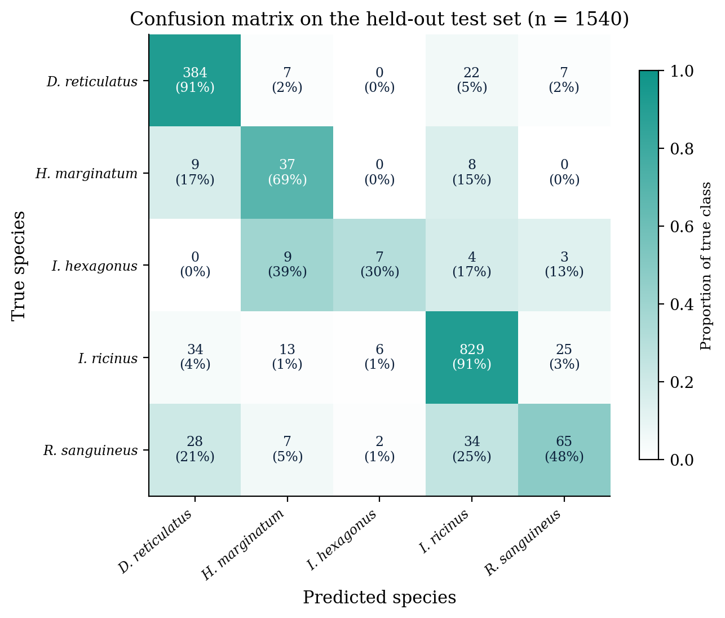
Figure 4.5 Confusion matrix on the held-out test partition. Cell values give the number of images and, in parentheses, the proportion of the true class. Shading is scaled to the row proportion.

4.4 RQ2: Quantisation and model compression
Two compression routes were evaluated. Post-training dynamic int8 quantisation retained 99.9 per cent of the baseline validation macro-F1, moving from 0.716 to 0.715, with per-class recall essentially unchanged. It produced almost no reduction in size, however, because dynamic quantisation leaves the convolutional layers in floating point, and those layers are the bulk of EfficientNet-B0, while the evaluation hardware lacked integer acceleration. The second route converted the model through PyTorch to ONNX to TensorFlow to TensorFlow Lite, with conversion fidelity verified at the ONNX stage where the maximum absolute difference stayed below 10⁻⁶. The 32-bit TensorFlow Lite model reached a validation macro-F1 of 0.708, within 0.008 of the baseline, and a 16-bit variant halved the stored size from 16.06 MB to 8.08 MB. Table 4.5 summarises both routes.
Table 4.5 Model size and retained accuracy under each compression route. Accuracy is validation macro-F1.
Model variant | Size (MB) | Macro-F1 | Retention
PyTorch FP32 (baseline) | 16.3 | 0.716 | n/a
PyTorch dynamic int8 | 16.3 | 0.715 | 99.9%
TensorFlow Lite FP32 | 16.06 | 0.708 | 98.9%
TensorFlow Lite FP16 | 8.08 | not verified | not verified

Two limitations have to be stated alongside those figures. Full int8 conversion, which would have quantised the convolutional layers and realised the fourfold size reduction, was not completed, because the calibration step failed on an unsupported operation during export. The accuracy of the float16 variant could not be verified in the conversion environment either, since the model declares a float16 input type but its convolution kernels in that runtime accept only 32-bit input, which produces a runtime incompatibility. The size reduction is therefore established while the accuracy retention remains unverified, and it is reported as such. Within those limits, the evidence for RQ2 is that quantisation preserves accuracy to within roughly one percentage point of macro-F1 and that 16-bit conversion halves the stored size of the model.

4.5 On-device deployment
The selected model was deployed as a working Android application, which demonstrates on-device offline inference and delivers the mobile application specified in the aim rather than the desktop prototype used during development. The application was built with Flutter and bundles the TensorFlow Lite model inside the application package, so classification runs entirely on the handset with no network connection. Pre-processing replicates the training pipeline exactly. Each classification returns a predicted species, the full probability distribution across the five classes, a short epidemiological note and a disclaimer directing the user to clinical or veterinary advice. The application was installed and run on a physical mid-range device, a Samsung SM-A055F running Android 15, and offline operation was verified directly by enabling aeroplane mode and confirming that classification still proceeded, as Figure 4.6 shows.
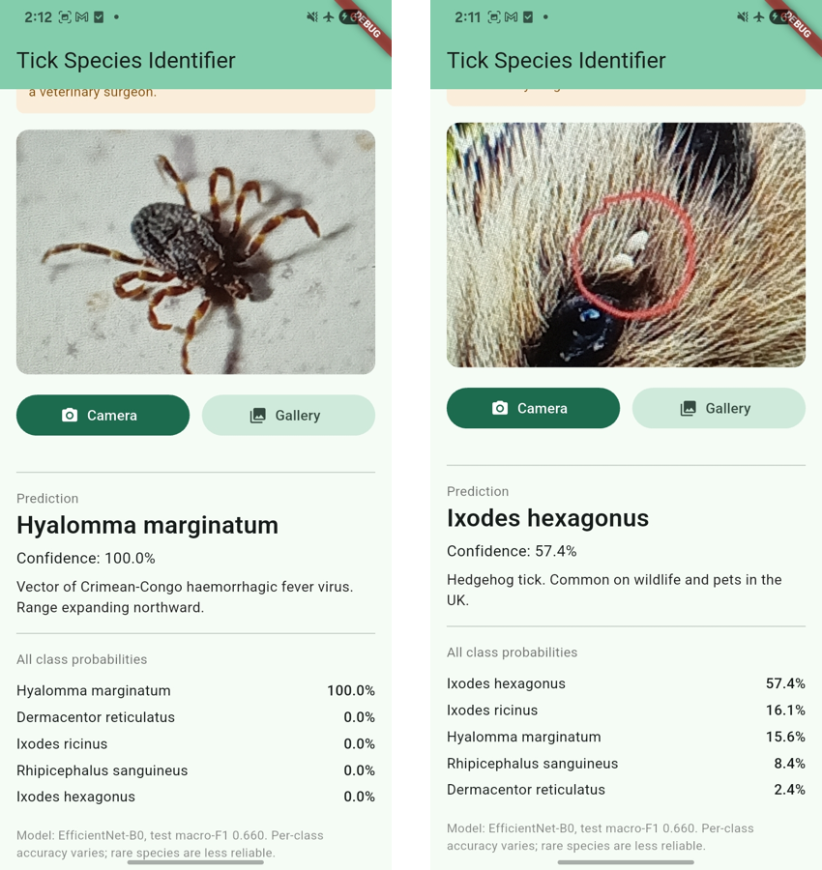
Figure 4.6 The deployed Android application classifying tick photographs with the device in aeroplane mode, indicated in the status bar. Left: a confident correct identification. Right: a lower-confidence case in which the model expresses genuine uncertainty.
Deployment produced a finding about which numeric format will actually run on the device. Consistent with the runtime behaviour described in Section 4.4, the float16 model raised a failed-precondition error and did not execute under the device's CPU runtime, which needs a hardware delegate for half-precision inference that was not reliably available. The float32 model executed correctly and became the deployed model. A compression that succeeds as a conversion but will not run on the target hardware under the available runtime is a genuine result about the distance between laboratory compression and production deployment, and it is recorded here as such. On-device inference latency was not formally benchmarked. Single-image latency measured on a server CPU during the compression experiments was approximately 72 ms, and formal on-device measurement remains outstanding work.
The deployment exercise also surfaced a behavioural finding about the model's output that bears directly on whether the tool is fit for its intended use. In representative operation the application often reported very high confidence, with several predictions above 99 per cent and one reaching 100 per cent after rounding, despite a held-out test macro-F1 of 0.660. That mismatch between stated confidence and demonstrated reliability is the poor probability calibration characteristic of networks trained with cross-entropy loss, observed here as an empirical property of the deployed system rather than inferred from theory. For a decision-support tool aimed at non-expert users this is a material weakness. Someone shown a confidence of 99 per cent has no way of knowing the figure overstates the evidence, and may place more trust in an incorrect identification than is warranted. Chapter Five takes this up as a substantive limitation and as the basis for treating calibration as a requirement of any future deployed version rather than an optional refinement.
The interface itself carries several of the governance commitments set out in Chapter Three. Rather than showing only the single most probable species, the application presents the full probability distribution across all five classes, so a user or professional can see when the model is genuinely uncertain, which is when probability spreads across several species instead of concentrating on one. Every prediction carries a short epidemiological note and an explicit disclaimer directing the user to clinical or veterinary advice, which reinforces the tool's status as an educational aid rather than a diagnostic instrument. All inference happens on the device, with neither the image nor the user's location transmitted anywhere, which puts the data-minimisation principle from the ethical considerations into practice. None of these choices changes the model's accuracy, but they shape how its output is presented and understood, and they are as much part of the deployed result as the classification figures.

4.6 RQ3: Geospatial risk modelling
Species distribution models were fitted for all five species. Georeferenced occurrence records came from the Global Biodiversity Information Facility for the period 2015 to 2025, restricted to Europe and to records carrying coordinates with no flagged geospatial issues, then cleaned down to 6,303 modelling-ready records. Bioclimatic predictors were taken from WorldClim version 2.1 at 2.5 arc-minute resolution, used as the pre-authorised alternative to the source named in Chapter Three. Since the two provide the same bioclimatic variables at comparable resolution, the substitution does not affect how the results should be interpreted. Models were fitted by maximum entropy using the maxnet implementation within ENMeval, tuned across feature-class and regularisation settings, and evaluated by four-fold spatial block cross-validation. Table 4.6 reports the selected configuration and the spatially cross-validated AUC for each species.
Table 4.6 Selected species distribution model configuration, number of presence records, and spatially cross-validated AUC per species. Feature classes are L for linear, Q for quadratic and H for hinge. RM denotes the regularisation multiplier.
Species | Configuration | Records | AUC
Ixodes hexagonus | LQH, RM 0.5 | 1,013 | 0.95
Ixodes ricinus | LQH, RM 0.5 | 1,879 | 0.89
Hyalomma marginatum | LQH, RM 1.0 | 587 | 0.85
Rhipicephalus sanguineus | LQ, RM 0.5 | 393 | 0.84
Dermacentor reticulatus | LQH, RM 1.0 | 2,431 | 0.76

All five models achieved AUC above 0.75, which indicates useful discrimination that has not been inflated by spatial autocorrelation. Performance was highest for Ixodes hexagonus at 0.95 and Ixodes ricinus at 0.89, and lowest for Dermacentor reticulatus at 0.76. For Rhipicephalus sanguineus a slightly less complex configuration was preferred over the model that optimised the information criterion, since the latter showed signs of overfitting on limited records, with a ten-percentile omission of 0.377 against 0.200. The projected suitability surfaces shown in Figure 4.7 are compact enough to serve as offline assets, which satisfies the offline-packaging condition in RQ3.
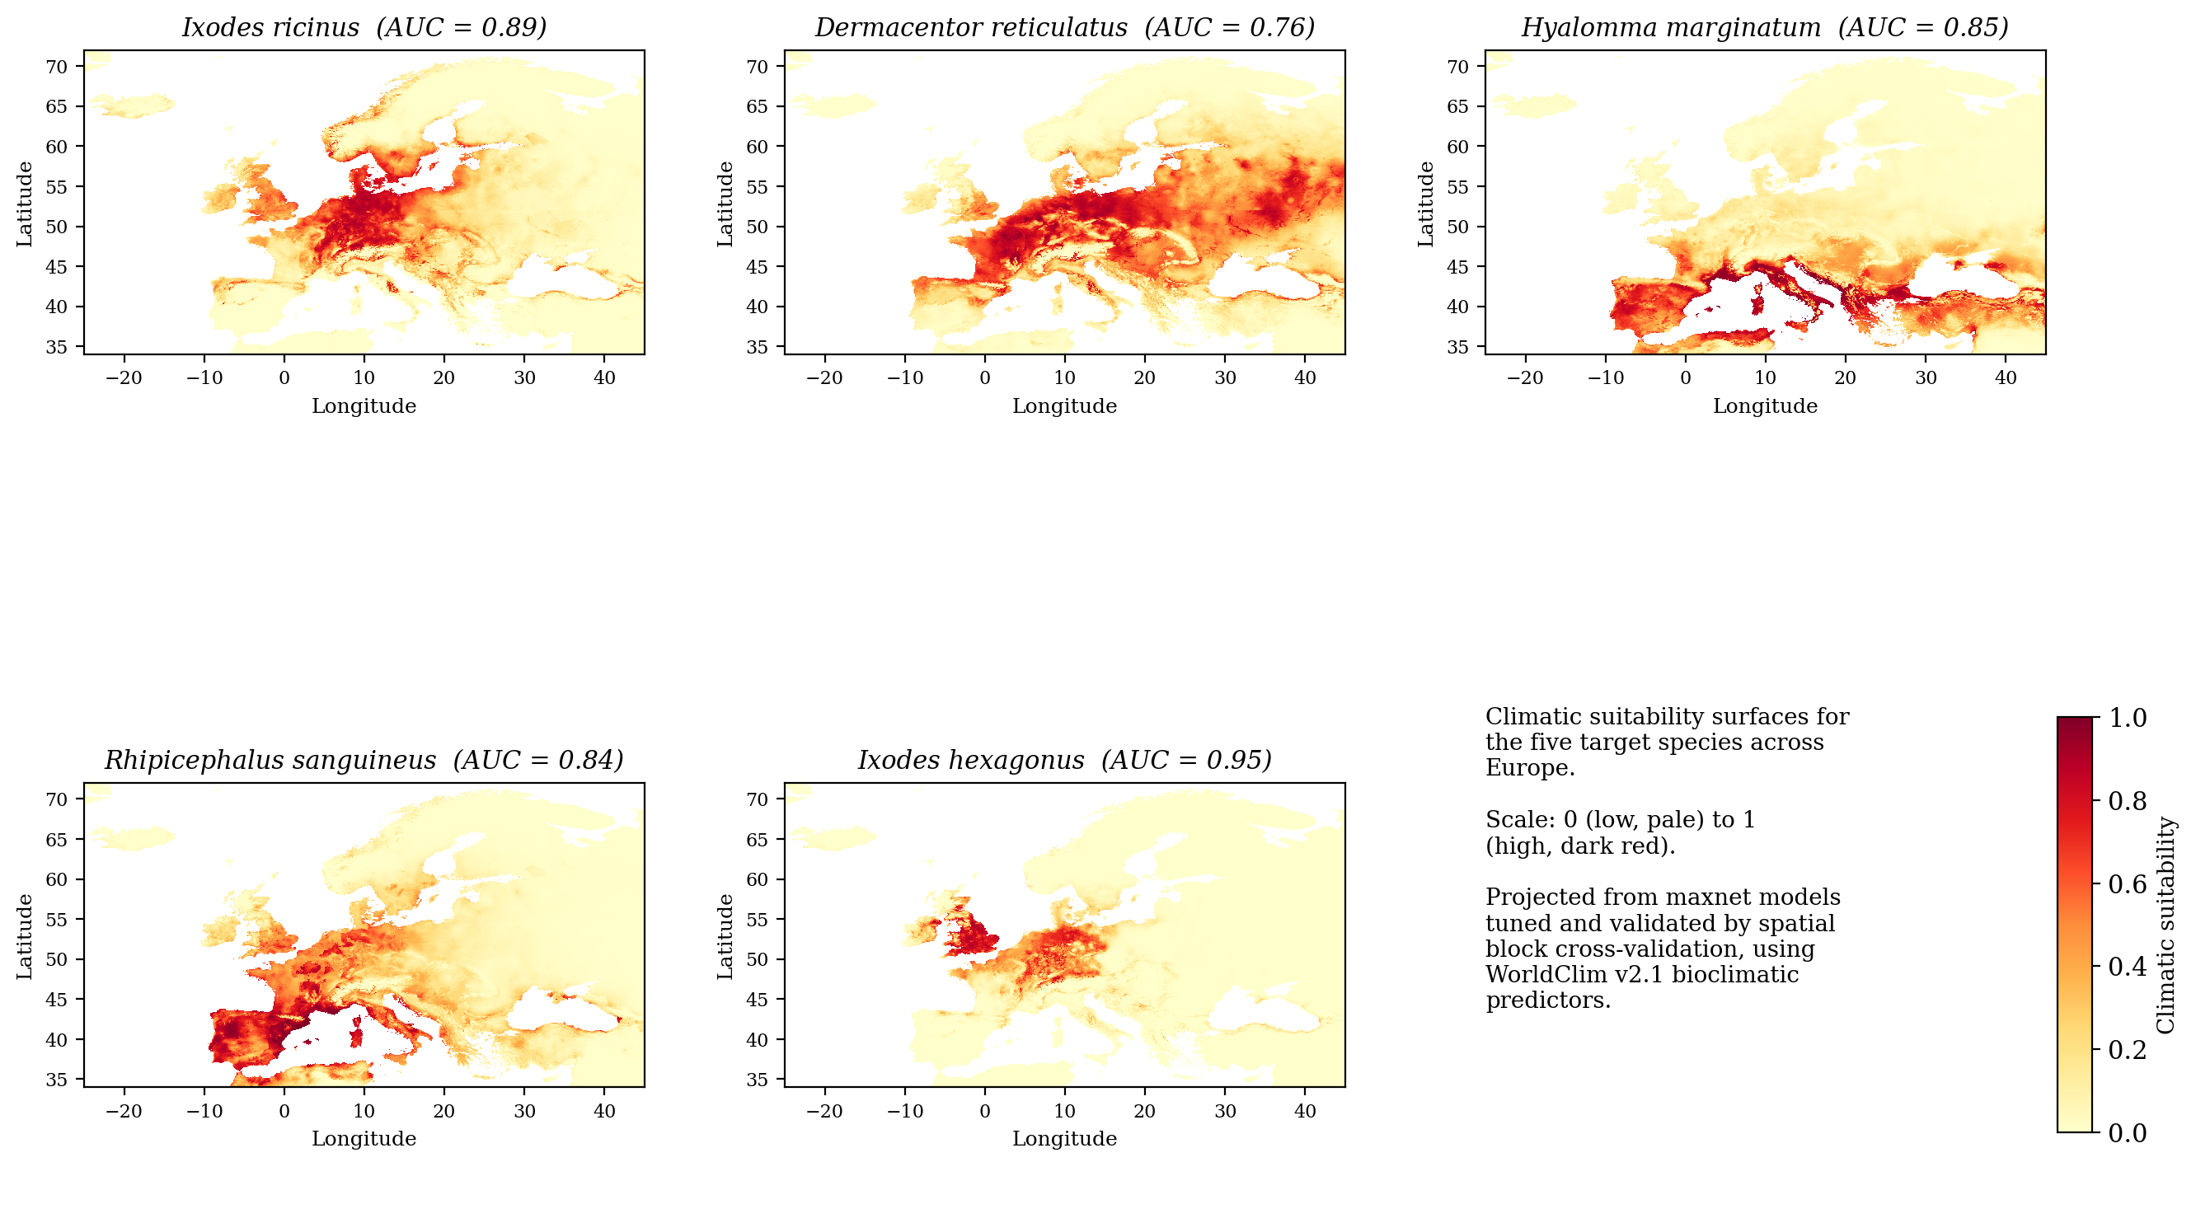
Figure 4.7 Climatic suitability surfaces for the five target species across Europe, on a common scale from low (pale) to high (dark red) suitability, with each species' spatially cross-validated AUC. Projected from maxnet models validated by spatial block cross-validation using WorldClim v2.1 predictors.
The projected surfaces line up with known biogeography. Ixodes ricinus showed broad temperate suitability. Hyalomma marginatum and Rhipicephalus sanguineus concentrated in the south around the Mediterranean. Ixodes hexagonus showed a western and central pattern, and Dermacentor reticulatus a more diffuse central and eastern one that was the least sharply defined of the five, which is consistent with its lower AUC. This qualitative agreement supports the models alongside the quantitative figures.
The relationship between discrimination and the number of available records mirrors, on the geospatial side, the relationship between per-class accuracy and image count seen in the classification work. The correspondence is not simply monotonic, though. Ixodes hexagonus was modelled from a moderate number of records and achieved the highest AUC, while Dermacentor reticulatus had the most records and achieved the lowest. The apparent paradox resolves once it is recognised that AUC measures how sharply a species' occurrences separate from the background in climate space, not how much data went into the model. A species occupying a narrow, well-defined climatic niche is easy to discriminate even from modest data. A climatic generalist whose realised range is shaped by non-climatic factors such as host availability, land use and ongoing range expansion is intrinsically harder to model however many records are supplied. The gradient across the five species therefore says as much about their ecology as about data quantity, and it should be read that way when the surfaces are used to communicate risk.
One methodological point affects how much confidence the AUC values warrant. These figures come from spatial block cross-validation rather than random cross-validation, which makes them systematically lower than a naive partition would have produced, and more honest. Random cross-validation allows occurrence points and their near neighbours to fall into both training and testing folds, so spatial autocorrelation inflates the apparent ability of the model to predict, and the resulting figures can look impressive while being substantively misleading. Partitioning into geographically contiguous blocks tests each model's ability to predict into regions it has not seen, which is exactly the task the deployed tool would face. The values between 0.76 and 0.95 should therefore be read as conservative estimates of genuine predictive ability.

4.7 RQ4: Integrated evaluation and interpretability
The classification component of the integrated evaluation is the held-out test result reported in Section 4.3, a macro-F1 of 0.660 at an accuracy of 0.858. For the explainability component, gradient-weighted class activation mapping was applied to the final convolutional layer of the trained model, using correctly classified test images, one per species. Figure 4.8 shows the result.
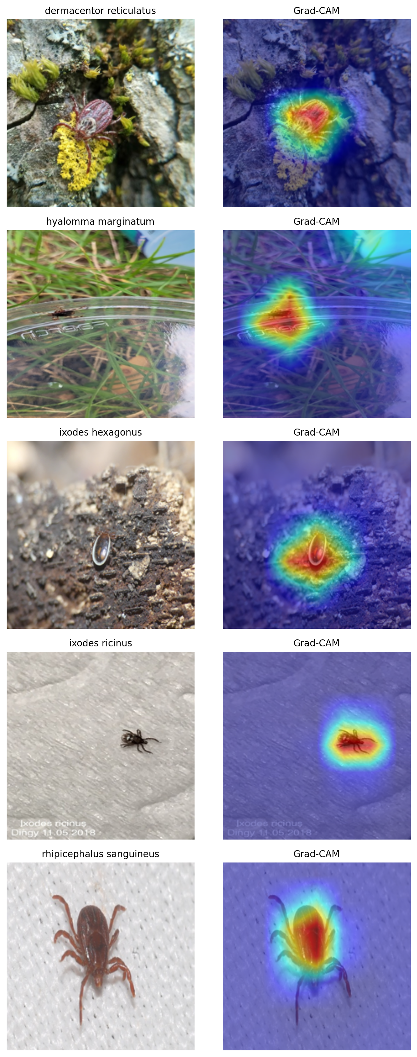
Figure 4.8 Grad-CAM activation maps for one correctly classified test image per species. Warmer colours indicate regions of greater influence on the model's prediction.
Across all five species the regions of greatest activation fell on the body of the tick rather than on the background. For four of the five, activation concentrated cleanly on the organism, including for Ixodes hexagonus photographed against cluttered bark. For Hyalomma marginatum the activation centred on the tick but showed some sensitivity to a nearby container edge and text, which indicates a minor degree of background influence. Read together with the confusion structure in Section 4.3.4, this completes the failure-mode analysis RQ4 called for. The tool's errors arise from class imbalance, from occasional background sensitivity, and from genuine morphological similarity between certain species.

4.8 Summary
Among three lightweight architectures trained under identical conditions, EfficientNet-B0 achieved the highest validation macro-F1 at 0.716, significantly ahead of both alternatives at p < 0.001, with the largest model performing worst of the three. On the held-out test set the selected model reached a macro-F1 of 0.660, with a 95 per cent confidence interval of 0.605 to 0.705, and an accuracy of 0.858, with per-class F1 ranging from 0.919 down to 0.368. Quantisation retained accuracy to within one percentage point and 16-bit conversion halved the stored size, although full int8 was not completed and the float16 model would not execute under the deployment runtime, so the model was deployed at full precision inside a working Android application whose offline operation was verified on a physical device. The species distribution models achieved spatially cross-validated AUC between 0.76 and 0.95 with ecologically plausible suitability surfaces, and Grad-CAM confirmed that the classifier attends to the tick rather than to the background. Chapter Five interprets these findings.

Chapter 5 Discussion

5.1 Introduction
Chapter Four reported the findings as evidence and deliberately held back interpretation. This chapter supplies it. What follows explains what the findings mean, places them against existing research on tick identification and distribution modelling, draws out their implications, and states plainly the limitations that bound them. The results are not restated here. The chapter reasons from them, working outwards from the specific findings to what they imply more generally. Figure 5.1 summarises the argument by mapping each research question to the answer reached and to the principal limitation that qualifies it, and the sections below develop each in turn.
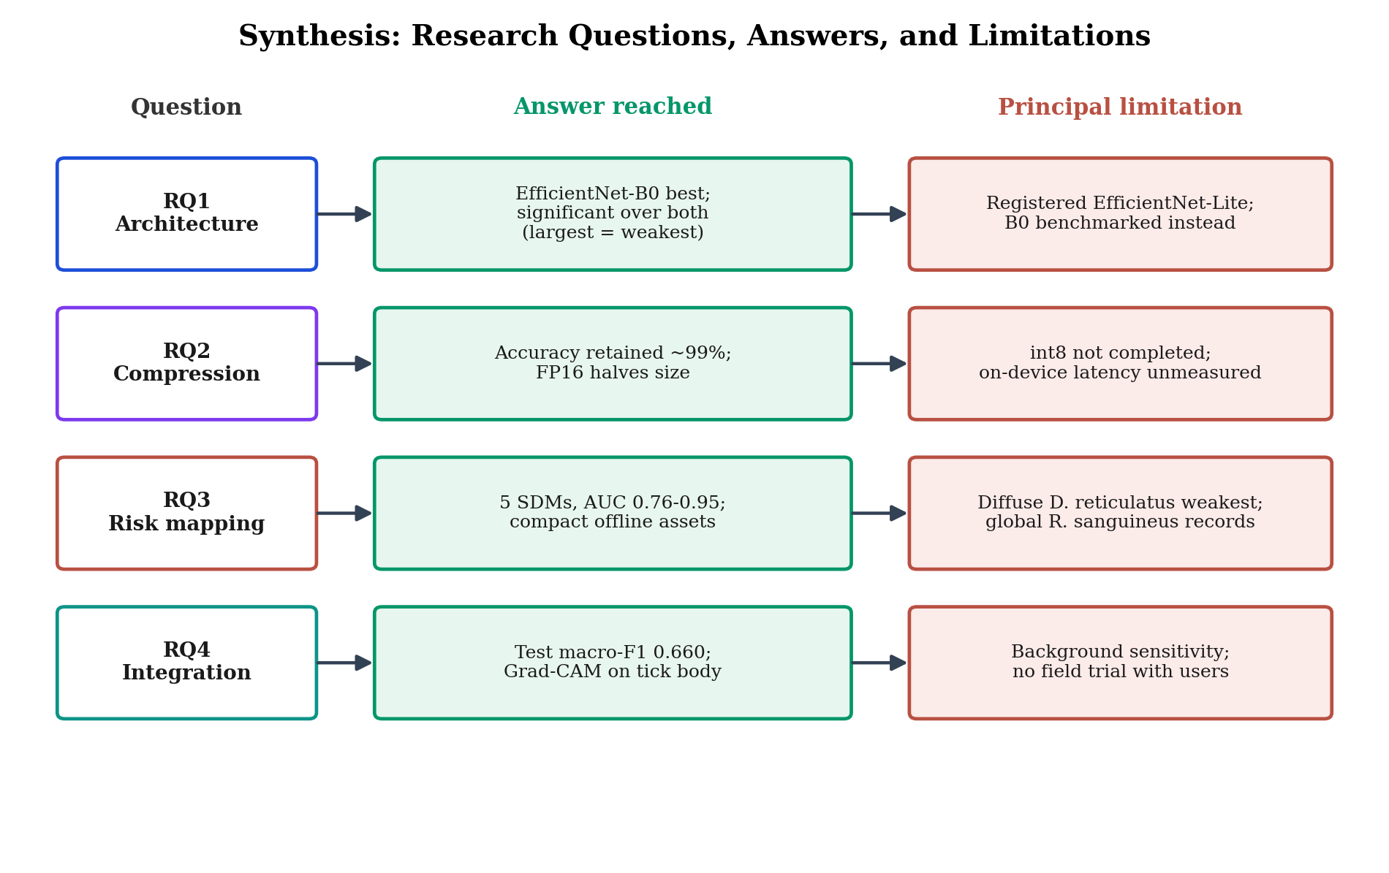
Figure 5.1 Synthesis of the four research questions, the answers reached, and the principal limitation qualifying each.

5.2 Return to the aim and research questions
The aim was to develop and evaluate an offline, on-device smartphone application combining deep-learning identification of European tick species with geospatial risk mapping. Two points of alignment between the questions as posed and the work as carried out should be stated before anything else. RQ1 named EfficientNet-Lite, whereas the architecture actually benchmarked was EfficientNet-B0, the closest equivalent available in the training framework. RQ2 framed compression in terms of eight-bit integer quantisation and on-device inference time, whereas the compression that proved deployable was half-precision conversion and on-device latency was never formally benchmarked. Neither divergence is hidden here, because both say something about the distance between what is easy to specify and what is achievable on constrained hardware. Sections 5.7 and 5.9 examine them directly.

5.3 Interpretation of the findings

5.3.1 Design matters more than scale
The most instructive result from the benchmark was that performance did not rise with model size. ResNet-18, the largest of the three, was the weakest. For a fine-grained biological task trained on limited data, the compound-scaled and mobile-oriented design of EfficientNet evidently matters more than raw parameter count, which is consistent with the design philosophy that motivated the EfficientNet family in the first place (Tan and Le, 2019). The extra capacity in ResNet-18 looks to have been a liability rather than an asset, most plausibly because a larger parameter count overfits more readily when the number of distinct training examples in the rare classes is small.

5.3.2 Class imbalance as the dominant constraint
Recognition reliability tracked the amount of training data available per species, and misclassifications were pulled disproportionately towards the majority class even though the loss had been class-weighted to counteract precisely that tendency. The fact that imbalance still left this signature despite inverse-frequency weighting shows that loss re-weighting reduces the effect of extreme imbalance without removing it, which aligns with the systematic evidence that imbalance consistently damages convolutional-network performance (Buda, Maki and Mazurowski, 2018). One qualification belongs with this reading. The confusion between Ixodes hexagonus and Hyalomma marginatum points to genuine morphological similarity contributing to the error structure, so scarcity is not the whole explanation.

5.3.3 The gap between laboratory and deployment
The compression findings tell a story in two parts, which Figure 5.2 summarises. Judged as a laboratory result, quantisation worked. Dynamic quantisation retained 99.9 per cent of macro-F1 and float16 conversion halved the stored size. Judged as a deployment result the picture was less comfortable. Dynamic quantisation produced no reduction in stored size, full integer quantisation could not be completed, and the float16 model would not execute under the available runtime because its convolution kernels required a hardware delegate that was not reliably present. The substantive lesson lies in that distinction between a compression that succeeds on paper and one that runs on the target device, and it matches the documented behaviour of TensorFlow Lite, where float16 execution depends on a GPU delegate and integer paths depend on dedicated integer acceleration (Saxena et al., 2024). Deploying the float32 model gave up the size benefit in exchange for reliable execution, which for a decision-support tool is the more important of the two properties.
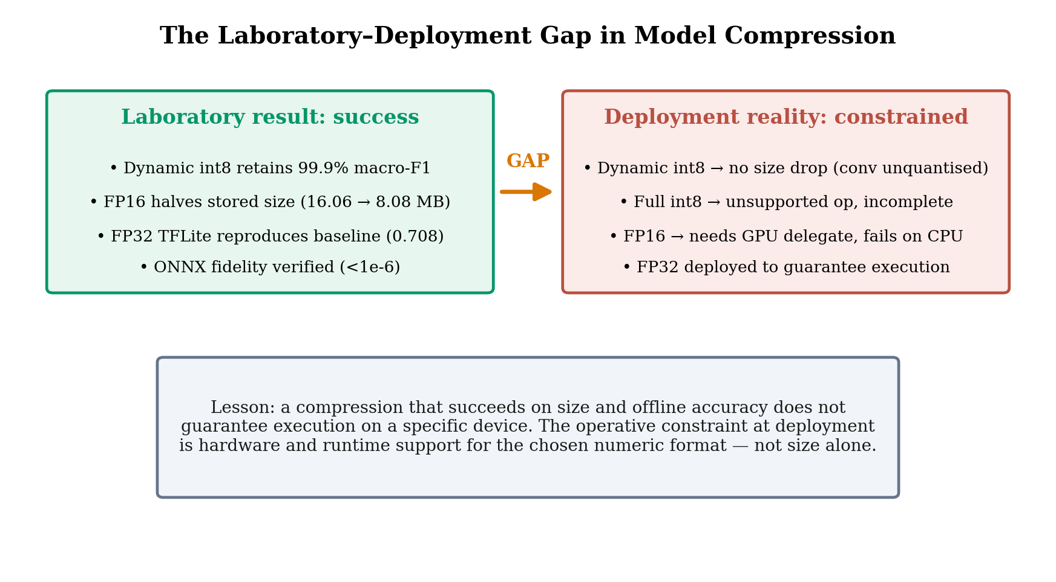
Figure 5.2 The gap between laboratory compression success and on-device executability, and the lesson it carries for deployment.

5.3.4 Ecological coherence of the distribution models
The distribution models produced discrimination that was statistically respectable and ecologically coherent at the same time. The gradient of performance across species can be read directly. Models were strongest for species with sharply defined climatic niches and weakest for Dermacentor reticulatus, whose diffuse and expanding range is shaped strongly by host availability and land use rather than by climate alone, which matches the recognised difficulty of modelling a species undergoing active range expansion (Cunze et al., 2022; Springer et al., 2025). That the suitability surfaces reproduced the known biogeography of all five species supplies a qualitative validation to sit alongside the AUC figures (Kopsco, Smith and Halsey, 2022).

5.3.5 Interpretability and trust
The Grad-CAM analysis answered a question that accuracy figures cannot address, which is whether the model attends to the organism or to incidental context. Activation concentrated on the tick's body across all five species, and that is reassuring evidence that the classifier learned biologically meaningful features rather than shortcuts. The single partial exception, where some activation fell on the image background, shows that background sensitivity is present without being dominant, and it could degrade performance on images whose backgrounds differ systematically from those in training. Explainability functions here as a check on trustworthiness, which is the role gradient-based localisation was introduced to play (Selvaraju et al., 2017), and the cautious literature noting that such maps are indicative rather than definitive applies equally to this use of it (Suara et al., 2024).

5.4 Discussion against the literature
A held-out macro-F1 of 0.660 on out-of-sample citizen-science images sits within the range that comparable studies report when evaluation is conducted on realistic, out-of-distribution data. A recent large-scale citizen-science study reported a macro recall of 0.60 for an EfficientNet-family model on out-of-distribution submissions (Omazic et al., 2025), which is the same order as the present figure and was obtained under similar conditions of imbalance and image heterogeneity. Earlier proof-of-concept work established that convolutional networks could distinguish ticks in citizen images (Omodior et al., 2021; Luo et al., 2022; Justen et al., 2021), and smartphone-oriented systems showed that mobile identification was feasible (Ame et al., 2026). What the present study adds is a five-species European panel evaluated with observation-level partitioning and honest per-class reporting, which corroborates the emerging view that the principal barrier is not architecture but the scarcity and imbalance of training data for the less common species.
On the geospatial side the results align with a substantial European literature. Maximum-entropy and related approaches have repeatedly found climate to be a strong predictor of Ixodes ricinus distribution while noting how much harder Dermacentor reticulatus is to model (Noll et al., 2023; Kuyucu and Hekimoglu, 2024; Cunze et al., 2022), and the ENMeval framework used here is the established tool for reproducible and properly tuned modelling (Kass et al., 2021). Recovering documented range patterns (Medlock et al., 2013; Springer et al., 2025; Alkishe, Peterson and Samy, 2017) places this work within that body of evidence, and its distinct contribution lies in coupling such modelling to an identification tool built for offline mobile use. The study also inherits the known biases of citizen-science data, which cluster near roads and population centres and favour commonly encountered taxa (Geurts et al., 2023). That places the results in their proper context as a description of what citizen-science data currently supports rather than of what is ecologically true in general.
The treatment of the rare, poorly performing class offers a further point of comparison. Much of the tick-classification literature reports on species for which ample data exists, and studies that meet genuinely scarce classes often deal with them by exclusion or by merging them into coarser categories. The Swedish study of Omazic et al. (2025) stands out precisely because it reports out-of-distribution performance honestly and does not conceal the difficulty. The present study takes the same position by retaining Ixodes hexagonus despite a recall of 0.304 and reporting that figure prominently. The value of the choice is that it locates the real frontier of the method. It makes visible that data availability for uncommon species is the binding constraint, and it avoids a flattering aggregate figure that would misrepresent the tool's readiness for exactly the rare vectors about which users would most need dependable advice. In that respect the contribution concerns the standard of evidence as much as the result.

5.5 Theoretical and methodological contribution
The contribution is primarily methodological, and it has three parts. The study demonstrates that observation-level partitioning is a necessary safeguard against the data leakage to which citizen-science image data is prone. It shows that reporting the rarest class honestly, instead of excluding it to improve the headline metric, produces a more informative account of what the method can and cannot do. It also illustrates the value of pairing a quantitative metric suite with explainability analysis, so that the question of whether a model is right is joined by the question of whether it is right for the right reasons. Set against the wider movement to integrate machine learning with citizen science for biodiversity and health surveillance (Antonelli, Dhanjal-Adams and Silvestro, 2022; Bjerge et al., 2023), the study offers a concrete and honestly evaluated instance aimed at a specific public-health problem.
These commitments sit within a broader position on how applied machine-learning research ought to be conducted and reported, one the field has been articulating in response to a history of over-optimistic results. Three principles underpin the work. Evaluation should reflect the conditions of deployment, so a model destined to classify public photographs is evaluated on public photographs it has never seen, partitioned so that nothing leaks from training into test, rather than on a curated internal benchmark. Aggregate metrics conceal as much as they reveal, so per-class reporting becomes essential rather than optional wherever the classes carry unequal real-world consequences, which tick species plainly do. Accuracy without interpretability is not sufficient grounds for trust in a decision-support setting, so explainability analysis should accompany the reporting of performance rather than follow it. None of these principles originates with this study. What the study offers is a worked example of applying all three together to a concrete public-health problem, which is a standard the wider literature advocates but does not always meet.
There is also something to say, modestly, about the One Health framework introduced in Chapter One. One Health asserts the interdependence of human, animal and environmental health, but it is often invoked as organising rhetoric rather than built into a single artefact. Combining a classifier trained on animal imagery, a distribution model driven by environmental data, and an interface intended to inform human health decisions makes the tool a small but concrete instantiation of the framework, in which the three domains are computationally linked rather than merely discussed alongside one another. This is not a theoretical advance in One Health. It does demonstrate one way the framework's integrative ambition can be realised in practice, and it suggests that similar combinations of identification, environmental modelling and user-facing risk communication could work as a template in other vector-borne disease contexts.

5.6 Practical, clinical and public-health implications
Lyme borreliosis is the most common vector-borne disease in Europe and its incidence is increasing alongside climatic and behavioural change (Burn et al., 2023; Davidson et al., 2025). Its principal vector is Ixodes ricinus (Voyiatzaki et al., 2022; Medlock et al., 2013), which happens to be the species the model identifies most reliably. A tool that helps a member of the public, a clinician or a veterinarian identify a tick at the point of encounter could therefore support earlier awareness of risk, and the offline design suits field use well. These implications need stating carefully, because the tool is weakest for some of the less common but medically significant vectors. Hyalomma marginatum is the clearest example, being a vector of Crimean-Congo haemorrhagic fever virus whose incursion into Europe is of growing concern (Celina and Černý, 2025; Bernard et al., 2024; Jameson et al., 2012). A tool that is least reliable for a rare but severe threat has to be presented as an aid to awareness rather than as a diagnostic instrument, which makes the application's educational framing an ethical requirement rather than a legal precaution. Processing location data on the device aligns the design with data-protection expectations for mobile health tools (Carmi, Zohar and Riva, 2022; Rezaee et al., 2023).
Communicating these findings responsibly means tailoring the message to each audience without distorting the evidence behind it. For the general public the appropriate message is that the tool raises awareness and prompts sensible caution, such as checking for bites, monitoring for symptoms and seeking advice, while remaining no substitute for professional assessment. For clinicians and veterinary surgeons the tool is better framed as a triage aid whose species-level output should be weighted by the per-class reliability reported in Chapter Four, with particular caution around the rarer vectors. For public-health and surveillance stakeholders the relevant message is that the approach can supply timely, geolocated and citizen-contributed signals of range shifts, provided its known biases are taken into account. Presenting the same underlying evidence differently to these audiences, without altering what the evidence says, is part of what responsible communication of complex findings requires.
The tension between usefulness and over-reach deserves particular attention, since it is the central ethical challenge in deploying a tool of this kind. The public-health rationale for making identification support widely available is genuine, because earlier awareness can lead to earlier care-seeking and a tool that reaches people at the point of encounter could contribute to that. Against this, a tool that is uneven in reliability and weakest for some of the most serious vectors could do harm if it were trusted beyond its competence, for instance if a falsely confident identification of a benign species led someone to dismiss a bite that warranted attention. The resolution adopted here was to design the framing and the outputs to communicate uncertainty honestly, to position the tool explicitly as educational rather than diagnostic, and to direct users consistently towards professional advice. Responsible deployment of an imperfect but useful tool depends on its limitations being as visible to the user as its capabilities. Seen in that light, the insistence on per-class reporting, on honest treatment of the rare classes and on the calibration problem is not only methodological rigour but a precondition for deploying the tool without misleading the people it is meant to help.
One implication for surveillance policy is worth drawing out. Tick surveillance in Europe currently relies on expert-mediated schemes that are authoritative but slow and geographically uneven. A tool of the kind demonstrated here could complement those schemes by generating a high-volume, geolocated and near real-time stream of citizen observations, functioning as an early-warning layer that indicates where expert attention might usefully be directed rather than as a replacement for expert confirmation. Realising that would require careful attention to the biases documented throughout this study and to the governance of the resulting data, but demonstrating that on-device identification is feasible removes one of the main technical obstacles. The policy implication is that investment in data infrastructure for rare and emerging vectors, and in frameworks for bringing citizen-generated identifications into formal surveillance, could yield disproportionate returns as the underlying identification technology matures.

5.7 The divergences between plan and execution
One distinctive feature of this study is the set of divergences between the research questions as registered and the work as it was finally carried out, and these are better examined directly than buried. RQ1 named EfficientNet-Lite while the benchmarked model was EfficientNet-B0. RQ2 asked about eight-bit integer quantisation and on-device latency, while the deployable compression turned out to be half-precision and latency was measured only as a server-side proxy. The geospatial modelling used WorldClim rather than the climate source originally specified. It would have been possible to obscure all three, or to present the work as though it had proceeded exactly as planned. Reporting them plainly reflects a position on research integrity, namely that a registered plan is a hypothesis about what will prove feasible, and that when execution departs from it the honest course is to say so, explain why, and assess what the departure means for the answer.
Looked at closely the divergences fall into two kinds, and separating them is itself useful. Some are substitutions that leave the substance of the answer intact. EfficientNet-B0 belongs to the same architectural family as EfficientNet-Lite and was what the framework made available, and WorldClim supplies the same bioclimatic variables as the originally specified source at comparable resolution, so in both cases the research question is answered in spirit if not in the exact letter of its wording. Others are genuine gaps. Full integer quantisation was not achieved and on-device latency was not formally measured, so those components of RQ2 remain open rather than answered. Being clear about which divergences are cosmetic and which are substantive is a matter of intellectual honesty, and it lets a reader judge precisely how much of each research question the study has actually settled.

5.8 Unexpected, mixed and negative findings
Several findings complicate any simple success narrative. The first is the deployment failure of the compressed models, where the int8 route did not complete and the float16 model would not run on the target hardware. This is more than a setback. It is an instructive negative result showing that quantisation success measured by size and offline accuracy does not guarantee executability on a specific device. The second is the model's poor calibration, since the prototype frequently returned predictions above 99 per cent confidence despite a test macro-F1 of 0.660, which substantially overstates the certainty the evidence warrants. Overconfidence is a recognised property of networks trained with cross-entropy loss, but it is a material weakness in a tool meant to inform public decisions. The third is the divergence between the registered questions and the work as realised, already discussed and carried forward into the limitations below.

5.9 Strength of evidence and limitations
The evidence has genuine strengths. A held-out test set was reserved throughout development, observation-level partitioning precludes leakage, a confidence interval and significance testing are reported, and the distribution models were validated by spatial block cross-validation. The limitations fall into four groups. On data, the dataset is severely imbalanced and for the rarest species small in absolute terms, and its citizen-science provenance imports spatial and taxonomic bias (Geurts et al., 2023), while sourcing Rhipicephalus sanguineus records globally rather than from Europe limits the geographical specificity of that species. On deployment, full integer quantisation was not achieved, the float16 model did not execute on the device, and on-device latency, which RQ2 explicitly asked about, was not formally measured. On calibration, the overconfident outputs mean the tool's expressed certainty cannot presently be taken at face value. On scope, a full end-to-end field evaluation with real users lay outside what the project could cover. Taken together these bound the findings as a rigorous demonstration of feasibility rather than as the delivery of a finished clinical instrument.

5.10 Chapter summary
This chapter has interpreted the findings and placed them against the literature. Architectural design outweighed model scale. Class imbalance was the dominant constraint on per-class performance. Quantisation succeeded as a laboratory result while exposing a real gap between compression and on-device executability. The distribution models proved both statistically sound and ecologically plausible. Explainability analysis supported the trustworthiness of the classifier's reasoning, with one qualification about background sensitivity. The chapter has also set out the study's contribution, its implications for different audiences, and the unexpected and negative findings, deployment failure and poor calibration foremost among them, that temper an uncritical reading. Chapter Six draws these threads together, answers each research question directly, reflects on the research process, and sets out what would carry the work towards a dependable tool.

Chapter 6 Conclusion

6.1 Introduction
This chapter brings the study to a close. It restates what the work set out to achieve, recalls briefly how it was conducted, and summarises what it found. Each research question is then answered directly, the contribution and implications are stated, the limitations are acknowledged, the research process is reflected on, and recommendations are set out for the work that should follow.

6.2 Restatement of the study
The study set out to develop and evaluate an offline, on-device smartphone application combining deep-learning identification of European tick species with geospatial risk mapping, in order to support public, veterinary and clinical decision-making at the point of tick encounter. The motivation was a concrete public-health problem. Tick-borne diseases are increasing across Europe, the ticks that transmit them are difficult for non-specialists to tell apart, and the places where ticks are encountered frequently have no network connectivity.

6.3 Recapitulation of the method
A quantitative experimental design was executed in five sequential phases. A labelled image dataset was assembled from research-grade citizen-science observations and partitioned at observation level to prevent leakage. Three lightweight architectures were fine-tuned under an identical class-weighted regime and compared using macro-F1 and McNemar's test. The selected model was compressed for mobile deployment. Species distribution models were fitted by maximum entropy and validated by spatial block cross-validation. The selected model was then integrated into a working offline application and examined both quantitatively and through gradient-weighted class activation mapping. All computational work was carried out reproducibly, with fixed random seeds and documented procedures.

6.4 Summary of key findings
Four principal findings emerged. EfficientNet-B0 was the most accurate of the three architectures, with a validation macro-F1 of 0.716 and a held-out test macro-F1 of 0.660, its advantage was statistically significant, and the largest architecture performed worst. Compression preserved accuracy to within roughly one percentage point of macro-F1 and half-precision conversion halved the stored size, although full integer quantisation was not realised and the half-precision model would not execute under the deployment runtime. Maximum-entropy models for all five species achieved spatially cross-validated AUC above 0.75 with ecologically consistent suitability surfaces. Explainability analysis showed that predictions were driven predominantly by the body of the tick. Underlying all four findings was the severe class imbalance of the dataset, which shaped both the strong aggregate performance and the weak recognition of the rarest species.

6.5 Answers to the research questions
The four research questions can now be answered directly, including where an answer is only partial.
RQ1 asked which lightweight architecture achieves the best balance of accuracy and inference cost. Among those compared, EfficientNet-B0 did so, significantly outperforming both MobileNetV3-Small and ResNet-18. The question named EfficientNet-Lite, and the closest available equivalent, EfficientNet-B0, was benchmarked in its place.
RQ2 asked what accuracy is retained and what inference time is achievable under quantisation on a mid-range Android device. Compression preserved classification accuracy almost entirely, with dynamic quantisation retaining 99.9 per cent of macro-F1 and the full-precision conversion reproducing the baseline to within 0.01, while half-precision conversion halved the stored size. The question is only partly answered. Eight-bit integer quantisation was not completed, on-device inference time was not formally measured, the deployable compression was half-precision, and the latency figure reported is a server-side proxy. The accuracy-retention component is answered while the integer-precision and on-device-latency components remain open.
RQ3 asked whether climate-based risk surfaces could be packaged as offline assets within a phone's storage limits. Species-specific surfaces were generated successfully through maximum-entropy modelling and are compact enough to be held offline, which satisfies the storage condition the question set.
RQ4 asked how accurately the integrated tool classifies on held-out data and what failure modes Grad-CAM reveals. On the held-out test set the integrated classifier achieved a macro-F1 of 0.660 and an overall accuracy of 0.858, and its failure modes were characterised through both the confusion matrix and Grad-CAM, showing a systematic attraction of misclassifications towards the majority class together with a minor sensitivity to image background. The question is answered, with the qualification that a full field evaluation involving real users lay beyond the scope of the project.

6.6 Contribution of the study
The contribution is principally methodological and integrative. The study provides a rigorously and honestly evaluated demonstration that lightweight offline deep learning can identify European tick species from ordinary photographs, and it couples that identification with geospatial risk modelling inside a single network-independent tool, an integration the identification and distribution-modelling literatures have generally pursued separately. Three methodological features distinguish the work: observation-level partitioning to prevent leakage, the deliberate retention and honest reporting of the hardest and rarest class, and the pairing of quantitative metrics with explainability analysis. Together these amount to a template for methodologically honest evaluation of citizen-science-driven biological classification.

6.7 Implications
For researchers, the study reinforces that architectural design and honest evaluation matter more than model scale, and that the real test of a compressed model is whether it executes on the target hardware. For practitioners and the public, the tool illustrates how identification support might be brought to the point of encounter without connectivity, while making clear that it aids awareness rather than providing diagnosis. For public-health and policy stakeholders, the work demonstrates that accessible identification and risk mapping can be combined in a form suited to field use, and it points to the value of investing in data for the rarer but medically significant vectors.

6.8 Limitations
Four limitations bound the conclusions. The dataset was severely imbalanced and, for the rarest species, small, and its citizen-science provenance brings spatial and taxonomic bias with it. On deployment, full integer quantisation was not achieved, the half-precision model did not execute on the device, and on-device latency was not formally measured. The model's probability outputs were poorly calibrated and frequently expressed unwarranted near-certainty. The evaluation did not extend to a full end-to-end field trial with real users. Together these define the study as a demonstration of feasibility rather than the delivery of a finished instrument.

6.9 Reflection on the research process and professional development
Beyond its technical outcomes the project was a substantial exercise in professional development, and reflecting on that process forms part of the learning. The work required the integration of four ordinarily separate disciplines, namely deep learning, mobile engineering, spatial ecology and public-health context, and the central challenge throughout was not any single technique but the discipline of making them cohere into one defensible artefact. Moving between a PyTorch training notebook, an R modelling environment and a Flutter mobile project while keeping the scientific claims consistent across all three developed a capacity for managing technical breadth that transfers directly to professional data-science practice.
Several episodes proved formative precisely because they did not go to plan. The deployment failure of the compressed models was initially a source of frustration and became one of the most valuable lessons of the project, in that an engineering result is not complete until it runs on the target hardware, and a negative result reported honestly can be more instructive than a success. Confronting the severe class imbalance in the data had a similar effect. Resisting the temptation to discard the difficult rare class in order to improve the headline figure reinforced a commitment to methodological honesty over presentational convenience. Managing the divergences between the registered research questions and what proved feasible, rather than concealing them, developed the judgement needed to distinguish a genuine limitation from a reframing, and the confidence to say which is which.
The project also strengthened a set of transferable competencies. These include planning and sequencing a large body of interdependent work against a fixed deadline, maintaining reproducible and well-documented pipelines, and communicating complex and uncertain findings responsibly to non-specialist audiences without overstating them. If the work were begun again, the principal change would be to instrument on-device performance from the outset and to treat probability calibration as a first-class requirement rather than a later refinement. Taken together these experiences have shaped a more careful and more accountable approach to applied research, which is among the more durable outcomes of the study.

6.10 Recommendations for future work
Five recommendations follow directly from the findings. The most pressing is that the probability outputs should be calibrated, for example through temperature scaling, so that expressed confidence corresponds to actual reliability. For a public-facing health tool calibration is a requirement rather than an enhancement. Second, the representation of the rarest and most significant species should be enlarged through targeted collection or expert-verified augmentation, and the analysis of error structure in Chapter Four indicates that this enlargement should be targeted at the confusable species rather than applied uniformly. Third, the deployment path should be completed, which means full integer quantisation with a compatible toolchain, half-precision execution where a hardware delegate is available, and direct measurement of on-device latency. Fourth, the integrated tool should undergo an end-to-end field evaluation with real users. Fifth, the framing and safeguards should develop in step with the tool's capability, communicating its uncertainty and its species-specific reliability clearly to each category of user. Each recommendation addresses a specific and evidenced limitation of the present work, which makes the set a development roadmap rather than a list of abstract suggestions.

6.11 Reflection on the aim
Returning to the aim stated in Chapter One, which was to develop and evaluate an offline, on-device smartphone application combining deep-learning identification of European tick species with geospatial risk mapping, it is possible to assess candidly how fully that aim was met. The development component was achieved. A working application exists, runs entirely offline on a physical device, and integrates a trained classifier with climate-derived risk surfaces. The evaluation component was achieved rigorously for the classification and distribution models, which were assessed on held-out and spatially cross-validated data respectively, and partially for the integrated system, whose end-to-end performance with real users in the field remains to be established. The aim was therefore substantially but not completely realised. The honest accounting of what remains, covering on-device performance measurement, probability calibration, richer data for rare species and a user-facing field trial, is not an admission of failure but a specification of the distance still to travel. A study claiming to deliver a finished and dependable clinical tool would have overreached. Establishing feasibility and mapping the remaining obstacles with this degree of specificity is what a research project of this scope can properly be expected to do.

6.12 Concluding statement
This study set out to bring the identification of European ticks and the mapping of their risk into a single tool that works in the field, without a connection, at the moment a tick is found. It has shown that this is achievable. A lightweight model can identify five European tick species from ordinary photographs with usable accuracy, can be compressed for a mobile device, can run entirely offline, and can be complemented by geospatial risk surfaces that reflect the actual distribution of those species. It has shown just as clearly where the obstacles lie, in the scarcity of data for the rarest vectors, in the distance between compressing a model and running it on real hardware, and in the model's tendency to express more certainty than it has earned. The value of the work is not that it delivers a finished instrument but that it establishes, honestly and reproducibly, both that the approach is feasible and what must be done to make it dependable. In a Europe where tick-borne disease continues to spread, bringing reliable identification and risk awareness to the point of encounter is a goal worth the further work this study has mapped out.

References
Alfeus, M., Irish, J. and Birkhofer, K. (2024). Recognition and completeness metrics from iNaturalist and GBIF can inform future citizen science and research projects: a case study on arthropods in Namibia. Biodiversity and Conservation, 34(2), pp.467–480. doi:10.1007/s10531-024-02981-z.
Alkishe, A., Cobos, M.E., Osorio-Olvera, L. and Peterson, A.T. (2022). Ecological niche and potential geographic distributions of Dermacentor marginatus and Dermacentor reticulatus (Acari: Ixodidae) under current and future climate conditions. Web Ecology, 22(2), pp.33–45. doi:10.5194/we-22-33-2022.
Alkishe, A.A., Peterson, A.T. and Samy, A.M. (2017). Climate change influences on the potential geographic distribution of the disease vector tick Ixodes ricinus. PLOS ONE, 12(12), p.e0189092. doi:10.1371/journal.pone.0189092.
Ame, I.A., Umar, A.I., Ozverel, C.S., Şanlıdağ, E., Seyer, A., Al-Turjman, F. and Sanlidag, T. (2026). A new era in identification of tick genera; artificial intelligence for precision and speed. PeerJ Computer Science, 12, p.e3291. doi:10.7717/peerj-cs.3291.
Antonelli, A., Dhanjal-Adams, K.L. and Silvestro, D. (2022). Integrating machine learning, remote sensing and citizen science to create an early warning system for biodiversity. Plants, People, Planet, 5(3), pp.307–316. doi:10.1002/ppp3.10337.
Bald, L., Gottwald, J. and Zeuss, D. (2023). spatialMaxent: adapting species distribution modeling to spatial data. Ecology and Evolution, 13(10), e10635. doi:10.1002/ece3.10635.
Bernard, C., Joly Kukla, C., Rakotoarivony, I. et al. (2024). Detection of Crimean–Congo haemorrhagic fever virus in Hyalomma marginatum ticks, southern France, May 2022 and April 2023. Eurosurveillance, 29(6), 2400023. doi:10.2807/1560-7917.ES.2024.29.6.2400023.
Bjerge, K., Alison, J., Dyrmann, M., Frigaard, C.E., Mann, H.M.R. and Høye, T.T. (2023). Accurate detection and identification of insects from camera trap images with deep learning. PLOS Sustainability and Transformation, 2(3), p.e0000051. doi:10.1371/journal.pstr.0000051.
Buda, M., Maki, A. and Mazurowski, M.A. (2018). A systematic study of the class imbalance problem in convolutional neural networks. Neural Networks, 106, pp.249–259. doi:10.1016/j.neunet.2018.07.011.
Burn, L., Tran, T.M.P., Pilz, A., Vyse, A., Fletcher, M.A., Angulo, F.J., Gessner, B.D., Moïsi, J.C., Jodar, L. and Stark, J.H. (2023). Incidence of Lyme borreliosis in Europe from national surveillance systems (2005–2020). Vector-Borne and Zoonotic Diseases, 23(4), pp.156–171. doi:10.1089/vbz.2022.0071.
Carmi, L., Zohar, M. and Riva, G.M. (2022). The European General Data Protection Regulation (GDPR) in mHealth: theoretical and practical aspects for practitioners' use. Medicine, Science and the Law, 63(1). doi:10.1177/00258024221118411.
Celina, S.S. and Černý, J. (2025). Hyalomma marginatum in Europe: the past, current status, and future challenges—a systematic review. Transboundary and Emerging Diseases, 2025(1). doi:10.1155/tbed/7771431.
Cunze, S., Glock, G., Kochmann, J. and Klimpel, S. (2022). Ticks on the move—climate change-induced range shifts of three tick species in Europe. Parasitology Research, 121(8), pp.2241–2252. doi:10.1007/s00436-022-07556-x.
Davidson, A., Davis, J., Brestrich, G., Moisi, J.C., Jodar, L. and Stark, J.H. (2025). Lyme borreliosis incidence across Europe, 2015–2023: a surveillance-based review and analysis. Vector-Borne and Zoonotic Diseases. doi:10.1177/15303667251363125.
Estrada-Peña, A., D'Amico, G., Palomar, A.M. et al. (2017). A comparative test of ixodid tick identification by a network of European researchers. Ticks and Tick-borne Diseases, 8(4), pp.540–546. doi:10.1016/j.ttbdis.2017.03.001.
European Centre for Disease Prevention and Control (2024). Tick-borne encephalitis — annual epidemiological report for 2022. [online] Available at: https://www.ecdc.europa.eu/en/publications-data/tick-borne-encephalitis-annual-epidemiological-report-2022.
Geurts, E.M., Reynolds, J.D. and Starzomski, B.M. (2023). Turning observations into biodiversity data: broadscale spatial biases in community science. Ecosphere, 14(6), e4582. doi:10.1002/ecs2.4582.
Gillespie, L.E., Ruffley, M. and Exposito-Alonso, M. (2024). Deep learning models map rapid plant species changes from citizen science and remote sensing data. Proceedings of the National Academy of Sciences, 121(37). doi:10.1073/pnas.2318296121.
Han, S., Mao, H. and Dally, W.J. (2015). Deep compression: compressing deep neural networks with pruning, trained quantization and Huffman coding. arXiv:1510.00149. doi:10.48550/arxiv.1510.00149.
He, K., Zhang, X., Ren, S. and Sun, J. (2016). Deep residual learning for image recognition. 2016 IEEE Conference on Computer Vision and Pattern Recognition (CVPR), pp.770–778. doi:10.1109/cvpr.2016.90.
Howard, A., Sandler, M., Chen, B. et al. (2019). Searching for MobileNetV3. 2019 IEEE/CVF International Conference on Computer Vision (ICCV). doi:10.1109/ICCV.2019.00140.
Jameson, L.J., Morgan, P.J., Medlock, J.M., Watola, G. and Vaux, A.G.C. (2012). Importation of Hyalomma marginatum, vector of Crimean-Congo haemorrhagic fever virus, into the United Kingdom by migratory birds. Ticks and Tick-borne Diseases, 3(2), pp.95–99. doi:10.1016/j.ttbdis.2011.12.002.
Justen, L., Carlsmith, D., Paskewitz, S.M., Bartholomay, L.C. and Bron, G.M. (2021). Identification of public submitted tick images: a neural network approach. PLOS ONE, 16(12), p.e0260622. doi:10.1371/journal.pone.0260622.
Karger, D.N., Lange, S., Hari, C., Reyer, C.P.O., Conrad, O., Zimmermann, N.E. and Frieler, K. (2023). CHELSA-W5E5: daily 1 km meteorological forcing data for climate impact studies. Earth System Science Data, 15(6), pp.2445–2464. doi:10.5194/essd-15-2445-2023.
Kass, J.M., Muscarella, R., Galante, P.J., Bohl, C.L., Pinilla-Buitrago, G.E., Boria, R.A., Soley-Guardia, M. and Anderson, R.P. (2021). ENMeval 2.0: redesigned for customizable and reproducible modeling of species' niches and distributions. Methods in Ecology and Evolution, 12(9), pp.1602–1608. doi:10.1111/2041-210x.13628.
Kopsco, H.L., Smith, R.L. and Halsey, S.J. (2022). A scoping review of species distribution modeling methods for tick vectors. Frontiers in Ecology and Evolution, 10. doi:10.3389/fevo.2022.893016.
Kurbis, A.G., Kuzmenko, D., Bogdan, I.-S., Mihailidis, A. and Laschowski, B. (2023). StairNet: visual recognition of stairs for human-robot locomotion. arXiv:2310.20666.
Kuyucu, A.C. and Hekimoglu, O. (2024). Predicting the distribution of Ixodes ricinus in Europe: integrating microclimatic factors into ecological niche models. Parasitology, pp.1–12. doi:10.1017/s003118202400132x.
Liu, Y., Dufourq, E., Fransson, P. and Rocklöv, J. (2025). A comparison of deep neural network compression for citizen-driven tick and mosquito surveillance. SSRN. doi:10.2139/ssrn.5203078.
Luo, C.-Y., Pearson, P., Xu, G. and Rich, S.M. (2022). A computer vision-based approach for tick identification using deep learning models. Insects, 13(2), p.116. doi:10.3390/insects13020116.
Marzec, A., Filipowska, A., Humeniuk, O., Filipowski, W. and Raif, P. (2025). A deep learning approach for classifying developmental stages of Ixodes ricinus ticks on images captured using a microscope's high-resolution CMOS sensor. Sensors, 25(16), p.5038. doi:10.3390/s25165038.
Medlock, J.M., Hansford, K.M., Bormane, A. et al. (2013). Driving forces for changes in geographical distribution of Ixodes ricinus ticks in Europe. Parasites & Vectors, 6(1). doi:10.1186/1756-3305-6-1.
Noll, M., Wall, R., Makepeace, B.L. et al. (2023). Predicting the distribution of Ixodes ricinus and Dermacentor reticulatus in Europe: a comparison of climate niche modelling approaches. Parasites & Vectors, 16(1). doi:10.1186/s13071-023-05959-y.
Omazic, A., Grandi, G., Widgren, S., Rocklöv, J., Wallin, J., Semenza, J.C. and Abiri, N. (2025). Automated tick classification using deep learning and its associated challenges in citizen science. Scientific Reports, 15(1). doi:10.1038/s41598-025-10265-x.
Omodior, O., Saeedpour-Parizi, M.R., Rahman, Md.K., Azad, A. and Clay, K. (2021). Using convolutional neural networks for tick image recognition – a preliminary exploration. Experimental and Applied Acarology, 84(3), pp.607–622. doi:10.1007/s10493-021-00639-x.
Porretta, D., Mastrantonio, V., Amendolia, S. et al. (2013). Effects of global changes on the climatic niche of the tick Ixodes ricinus inferred by species distribution modelling. Parasites & Vectors, 6(1), p.271. doi:10.1186/1756-3305-6-271.
Rezaee, R., Khashayar, M., Saeedinezhad, S., Nasiri, M. and Zare, S. (2023). Critical criteria and countermeasures for mobile health developers to ensure mobile health privacy and security: mixed methods study. JMIR mHealth and uHealth, 11, p.e39055. doi:10.2196/39055.
Saxena, A., Kumar, B.A., Ashok, M.A. and Armstrong, R. (2024). Comprehensive study on performance evaluation and optimization of model compression: bridging traditional deep learning and large language models. arXiv:2407.15904.
Selvaraju, R.R., Cogswell, M., Das, A., Vedantam, R., Parikh, D. and Batra, D. (2017). Grad-CAM: visual explanations from deep networks via gradient-based localization. 2017 IEEE International Conference on Computer Vision (ICCV), pp.618–626. doi:10.1109/iccv.2017.74.
Shahriar, T. (2025). Comparative analysis of lightweight deep learning models for memory-constrained devices. arXiv:2505.03303.
Sormunen, J.J., Kulha, N., Alale, T.Y., Klemola, T., Sääksjärvi, I.E. and Vesterinen, E.J. (2023). For the people by the people: citizen science web interface for real-time monitoring of tick risk areas in Finland. Ecological Solutions and Evidence, 4(4). doi:10.1002/2688-8319.12294.
Springer, A., Lindau, A., Probst, J., Drehmann, M., Fachet, K., Thoma, D., Rose Vineer, H., Noll, M., Dobler, G., Mackenstedt, U. and Strube, C. (2022). Update and prognosis of Dermacentor distribution in Germany: nationwide occurrence of Dermacentor reticulatus. Frontiers in Veterinary Science, 9. doi:10.3389/fvets.2022.1044597.
Suara, S., Jha, A., Sinha, P. and Sekh, A.A. (2024). Is Grad-CAM explainable in medical images? Communications in Computer and Information Science, pp.124–135. doi:10.1007/978-3-031-58181-6_11.
Tan, M. and Le, Q. (2019). EfficientNet: rethinking model scaling for convolutional neural networks. Proceedings of the 36th International Conference on Machine Learning, PMLR 97.
Voyiatzaki, C., Papailia, S.I., Venetikou, M.S., Pouris, J., Tsoumani, M.E. and Papageorgiou, E.G. (2022). Climate changes exacerbate the spread of Ixodes ricinus and the occurrence of Lyme borreliosis and tick-borne encephalitis in Europe. International Journal of Environmental Research and Public Health, 19(11), p.6516. doi:10.3390/ijerph19116516.
Williams, H.W., Cross, D.E., Crump, H.L., Drost, C.J. and Thomas, C.J. (2015). Climate suitability for European ticks: assessing species distribution models against null models and projection under AR5 climate. Parasites & Vectors, 8(1). doi:10.1186/s13071-015-1046-4.
Wu, J., Leng, C., Wang, Y., Hu, Q. and Cheng, J. (2016). Quantized convolutional neural networks for mobile devices. 2016 IEEE Conference on Computer Vision and Pattern Recognition (CVPR), pp.4820–4828. doi:10.1109/CVPR.2016.521.

Appendix Overview
These appendices provide the supporting material referenced in the main dissertation. They are organised as follows. Appendix A contains representative code listings for the principal components of the pipeline. Appendix B documents the dataset, including species counts, licensing, and the data-retrieval parameters. Appendix C records the full reproducibility configuration: hyperparameters, software versions, hardware, and random seeds. Appendix D presents supplementary figures and tables, including raw confusion-matrix counts, the architecture benchmark, the species distribution results, and the suitability maps. Appendix E collects the mathematical formulations. Appendix F is a glossary and list of abbreviations. Appendix G holds the ethics and governance documentation. Appendix H lists the software and provides the project resource links. The complete source code is available in the project repository referenced in Appendix H; the listings reproduced here are the excerpts most relevant to understanding and reproducing the study.

Appendix A Code Listings
The following listings reproduce the core implementation. They are presented in the logical order of the pipeline: dataset splitting, model training, evaluation and significance testing, quantisation and conversion, species distribution modelling, Grad-CAM interpretability, and on-device inference. Full source is in the project repository (Appendix H).

A.1 Observation-Level Dataset Splitting (Python)
Partitioning at the observation level prevents multiple photographs of the same individual tick from being divided across partitions, which would cause data leakage.
Listing A.1 Leakage-free stratified split by observation.
import pandas as pd
from sklearn.model_selection import train_test_split

SEED = 42 # fixed for reproducibility
manifest = pd.read_csv(BASE / 'dataset_manifest.csv')

# one row per OBSERVATION (not per image) for splitting
obs = manifest.groupby('observation_id').agg(
folder=('folder', 'first'),
n_images=('filename', 'count'),
).reset_index()

# stratified 70 / 15 / 15 split of OBSERVATIONS by species
train_obs, temp_obs = train_test_split(
obs, test_size=0.30, stratify=obs['folder'], random_state=SEED)
val_obs, test_obs = train_test_split(
temp_obs, test_size=0.50, stratify=temp_obs['folder'], random_state=SEED)

split_map = {}
for oid in train_obs['observation_id']: split_map[oid] = 'train'
for oid in val_obs['observation_id']: split_map[oid] = 'val'
for oid in test_obs['observation_id']: split_map[oid] = 'test'
manifest['split'] = manifest['observation_id'].map(split_map)

# leakage check: every observation must be in exactly one split
leak = manifest.groupby('observation_id')['split'].nunique()
assert (leak > 1).sum() == 0, "leakage detected"
manifest.to_csv(BASE / 'dataset_split.csv', index=False)

A.2 Class-Weighted Training with Early Stopping (Python / PyTorch)
All three architectures were trained under this identical procedure, differing only in the model. Inverse-frequency class weights counter the severe imbalance; early stopping returns the best-generalising epoch.
Listing A.2 Training loop with class weighting and early stopping.
import torch, torch.nn as nn, numpy as np, copy
from torchvision import models
from sklearn.metrics import f1_score

# inverse-frequency class weights (Eq. 3.3)
counts = split_df[split_df['split']=='train']['folder'].value_counts()
freq = np.array([counts[c] for c in CLASSES], float)
CLASS_WEIGHTS = torch.tensor(freq.sum()/(len(CLASSES)*freq),
dtype=torch.float).to(device)

# example: EfficientNet-B0 with a resized head
model = models.efficientnet_b0(
weights=models.EfficientNet_B0_Weights.IMAGENET1K_V1)
model.classifier[1] = nn.Linear(model.classifier[1].in_features, len(CLASSES))
model = model.to(device)

criterion = nn.CrossEntropyLoss(weight=CLASS_WEIGHTS)
optimizer = torch.optim.AdamW(model.parameters(), lr=5e-4, weight_decay=1e-4)

best_f1, best_state, no_improve = 0.0, None, 0
MAX_EPOCHS, PATIENCE = 40, 6

for epoch in range(1, MAX_EPOCHS+1):
model.train()
for imgs, labels in train_loader:
imgs, labels = imgs.to(device), labels.to(device)
optimizer.zero_grad()
loss = criterion(model(imgs), labels) # Eq. 3.1
loss.backward(); optimizer.step()
# validation macro-F1
model.eval(); preds, ys = [], []
with torch.no_grad():
for imgs, labels in val_loader:
out = model(imgs.to(device))
preds += out.argmax(1).cpu().tolist(); ys += labels.tolist()
va_f1 = f1_score(ys, preds, average='macro', zero_division=0)
if va_f1 > best_f1 + 1e-4:
best_f1, best_state, no_improve = va_f1, copy.deepcopy(model.state_dict()), 0
else:
no_improve += 1
if no_improve >= PATIENCE: break # early stopping
model.load_state_dict(best_state)

A.3 Held-Out Evaluation and McNemar's Test (Python)
The held-out test set is evaluated once. McNemar's test establishes whether the architecture differences are statistically significant.
Listing A.3 Test evaluation, bootstrap CI, and McNemar's test.
import numpy as np
from sklearn.metrics import f1_score, classification_report, confusion_matrix
from statsmodels.stats.contingency_tables import mcnemar

# test macro-F1 with a bootstrap 95% CI
preds, labels = predict(model, test_loader) # arrays of ints
test_f1 = f1_score(labels, preds, average='macro', zero_division=0)
rng = np.random.default_rng(42); boots = []
for _ in range(1000):
idx = rng.integers(0, len(labels), len(labels))
boots.append(f1_score(labels[idx], preds[idx], average='macro',
zero_division=0))
ci_low, ci_high = np.percentile(boots, [2.5, 97.5])

# McNemar (Eq. 3.4): b = A right & B wrong, c = A wrong & B right
def mcnemar_test(pA, pB, y):
b = int(np.sum((pA==y) & (pB!=y)))
c = int(np.sum((pA!=y) & (pB==y)))
res = mcnemar([[0, b],[c, 0]], exact=False, correction=True)
return b, c, res.statistic, res.pvalue

A.4 Model Conversion and Quantisation (Python)
The trained model was exported through ONNX to TensorFlow Lite. Dynamic int8 quantisation was applied in PyTorch; float16 and float32 TFLite variants were produced through the conversion toolchain.
Listing A.4 Dynamic int8 quantisation and ONNX export.
import torch, torch.nn as nn

# post-training dynamic int8 quantisation (Linear + Conv2d)
quant = torch.quantization.quantize_dynamic(
fp32_model, {nn.Linear, nn.Conv2d}, dtype=torch.qint8).eval()

# export FP32 model to ONNX (fidelity verified downstream)
dummy = torch.randn(1, 3, 224, 224)
torch.onnx.export(model, dummy, str(BASE/'efficientnet_b0.onnx'),
input_names=['input'], output_names=['output'],
dynamic_axes={'input': {0:'batch'}, 'output': {0:'batch'}},
opset_version=13, dynamo=False)

# ONNX -> TensorFlow -> TFLite (float32 and float16) via onnx2tf:
# onnx2tf -i efficientnet_b0.onnx -o efficientnet_tf
# produces efficientnet_b0_float32.tflite (16.06 MB)
# and efficientnet_b0_float16.tflite (8.08 MB)

A.5 Species Distribution Modelling (R)
Occurrence records from GBIF were modelled with maximum entropy using maxnet within the ENMeval framework, tuned across feature classes and regularisation multipliers, and validated with spatial block cross-validation.
Listing A.5 MaxEnt tuning and spatial block cross-validation (ENMeval 2.0).
library(ENMeval); library(terra)

# occ: cleaned presence coordinates; bg: 10,000 background points
# env: WorldClim v2.1 bioclimatic predictors (2.5 arc-min)
res <- ENMevaluate(
occs = occ, envs = env, bg = bg,
algorithm = "maxnet",
partitions = "block", # spatial block CV (4 folds)
tune.args = list(
fc = c("L","LQ","LQH"), # feature classes
rm = c(0.5, 1, 2) # regularisation multipliers
),
raster.preds = FALSE
)

# select by cross-validated performance and parsimony (low omission)
best <- res@results[order(-res@results$auc.val.avg,
res@results$or.10p.avg), ][1, ]

# project the selected model to a Europe-wide suitability raster
suit <- predict(env, res@models[[best$tune.args]], type = "cloglog")
writeRaster(suit, "suitability/<species>_suitability.tif",
overwrite = TRUE)

A.6 Grad-CAM Interpretability (Python)
Grad-CAM was applied to the final convolutional layer of the trained EfficientNet-B0, on correctly classified test images, to verify that predictions rest on the tick rather than the background.
Listing A.6 Grad-CAM on the final convolutional block.
from pytorch_grad_cam import GradCAM
from pytorch_grad_cam.utils.model_targets import ClassifierOutputTarget
from pytorch_grad_cam.utils.image import show_cam_on_image

target_layers = [model.features[-1]] # torchvision EfficientNet-B0
cam = GradCAM(model=model, target_layers=target_layers)

# t: normalised input tensor; rgb: 0-1 float image for overlay
targets = [ClassifierOutputTarget(class_index)]
grayscale = cam(input_tensor=t, targets=targets)[0] # Eqs. 3.6-3.7
overlay = show_cam_on_image(rgb, grayscale, use_rgb=True)

A.7 On-Device Inference (Dart / Flutter)
The Flutter application performs inference entirely on the device. Pre-processing replicates the training pipeline (224×224, ImageNet normalisation); logits are converted to probabilities with softmax.
Listing A.7 On-device TFLite inference (simplified).
import 'package:tflite_flutter/tflite_flutter.dart';

// load bundled model (assets/model.tflite = float32, 15.3 MB)
final interpreter = await Interpreter.fromAsset('assets/model.tflite');

// ImageNet normalisation
const mean = [0.485, 0.456, 0.406];
const std = [0.229, 0.224, 0.225];

List<List<List<List<double>>>> preprocess(Image img) {
final resized = copyResize(img, width: 224, height: 224);
return [ List.generate(224, (y) => List.generate(224, (x) {
final p = resized.getPixel(x, y);
return [ (p.rNormalized - mean[0]) / std[0],
(p.gNormalized - mean[1]) / std[1],
(p.bNormalized - mean[2]) / std[2] ];
})) ];
}

final output = List.filled(1*5, 0.0).reshape([1, 5]);
interpreter.run(input, output);
final probs = softmax(output[0]); // 5-way probability distribution

Appendix B Dataset Documentation

B.1 Species and Image Counts
The final dataset comprised 10,466 licence-tracked images across five species after cleaning and the exclusion of Haemaphysalis punctata for insufficient data. Counts per species and partition are given in Table B.1.
Table B.1 Final image counts per species and partition.
Species | Train | Val | Test | Total
Dermacentor reticulatus | 2132 | 446 | 420 | 2998
Hyalomma marginatum | 260 | 72 | 54 | 386
Ixodes hexagonus | 78 | 29 | 23 | 130
Ixodes ricinus | 4170 | 906 | 907 | 5983
Rhipicephalus sanguineus | 684 | 149 | 136 | 969
Total | 7,324 | 1,602 | 1,540 | 10,466

B.2 Licence Breakdown
Only permissively licensed images were retained. Because non-commercial licences form the majority, any released derivative inherits a non-commercial restriction.
Table B.2 Creative Commons licence distribution of retained images.
Licence | Images | Share
CC BY-NC | 7,899 | 75.5%
CC BY | 1,652 | 15.8%
CC0 | 610 | 5.8%
CC BY-NC-SA | 244 | 2.3%
CC BY-SA | 61 | 0.6%

B.3 Data-Retrieval Parameters
The image dataset was retrieved from the iNaturalist API and the occurrence records from GBIF, with the parameters below, so that the dataset can be reconstructed.
Parameter | Value
Image source | iNaturalist public API (/v1/observations)
Quality filter | research-grade; must have photos
European bounding box | nelat 71, nelng 40, swlat 35, swlng -11
Rhipicephalus sanguineus | retrieved globally (European yield insufficient)
Licences retained | CC0, CC BY, CC BY-NC, CC BY-SA, CC BY-NC-SA
Occurrence source (SDM) | GBIF, 2015-2025, Europe, with coordinates, no geospatial issues
Cleaning | remove corrupt, <100px, greyscale; spatial thinning of occurrences
Random seed | 42 (splitting and background sampling)

Appendix C Reproducibility Configuration

C.1 Training Hyperparameters
Table C.1 Training configuration, identical across all three architectures.
Hyperparameter | Value
Optimiser | AdamW
Learning rate | 5 x 10^-4
Weight decay | 1 x 10^-4
Batch size | 32
Max epochs | 40
Early-stopping patience | 6 epochs (val macro-F1)
Loss | class-weighted cross-entropy (inverse frequency)
Input size | 224 x 224
Normalisation | ImageNet mean/std
Augmentation (train only) | random resized crop, h-flip, rotation, colour jitter
Initialisation | ImageNet-pretrained weights (transfer learning)
Random seed | 42

C.2 Software and Hardware Environment
The following environment was used. Recording versions is essential for reproducibility, since behaviour can change across releases.
Table C.2 Software versions and hardware.
Component | Version / detail
Training platform | Google Colab (T4 GPU)
Deep-learning framework | PyTorch / torchvision
Model export | ONNX (opset 13); onnx2tf
Mobile runtime | TensorFlow Lite
Interpretability | pytorch-grad-cam
SDM environment | R 4.6.0; ENMeval 2.0.5; maxnet; terra
Climate predictors | WorldClim v2.1 (2.5 arc-min)
Occurrence source | GBIF (via rgbif)
Mobile app | Flutter; tflite_flutter 0.12.1
Deployment device | Samsung SM-A055F (Android 15)
Deployed model | efficientnet_b0_float32.tflite (15.3 MB)
Note: exact patch versions of Python libraries should be confirmed against the environment file (requirements.txt / pip freeze) in the project repository before submission.

Appendix D Supplementary Figures and Tables
This appendix collects supporting figures referenced in, or complementary to, the main text. The dataset distribution and the full Grad-CAM panel are reproduced here at larger size for inspection; additional model-comparison and quantisation figures support Chapter Four.

D.1 Dataset Distribution

Figure D.1 Image counts per species and partition, showing the ~53:1 training imbalance.

D.2 Full Grad-CAM Panel (All Five Species)

Figure D.2 Grad-CAM activation maps for one correctly classified test image per species. Activation concentrates on the tick body across all five species; Hyalomma marginatum shows minor background sensitivity.

D.3 Quantisation Summary
The size and accuracy outcomes of each compression route are reproduced in Table D.1 for reference.
Table D.1 Model size and retained accuracy under each compression route.
Model variant | Size (MB) | Macro-F1 | Retention
PyTorch FP32 (baseline) | 16.3 | 0.716 | n/a
PyTorch dynamic int8 | 16.3 | 0.715 | 99.9%
TensorFlow Lite FP32 | 16.06 | 0.708 | 98.9%
TensorFlow Lite FP16 | 8.08 | n/a | not verified

D.4 Species Distribution Suitability Maps
The five per-species climatic suitability surfaces are reproduced here at full size for inspection, with the spatially cross-validated AUC for each species.

Figure D.3 Climatic suitability surfaces for the five target species across Europe (WorldClim v2.1 predictors; maxnet; spatial block cross-validation).

D.5 Architecture Benchmark Summary (Raw Values)
Table D.2 reproduces the validation macro-F1, parameter counts, and best/stopping epochs for the three benchmarked architectures. The full per-epoch validation curves are plotted in Figure 4.2 of the main text; the epoch-by-epoch numeric log should be inserted from the training notebook where a complete raw table is required.
Table D.2 Architecture benchmark: validation macro-F1, parameters, and early-stopping epochs.
Architecture | Val macro-F1 | Params (M) | Best ep. | Stop ep.
EfficientNet-B0 | 0.716 | 5.3 | 11 | 17
MobileNetV3-Small | 0.608 | 2.5 | 12 | 18
ResNet-18 | 0.575 | 11.7 | 12 | 18

D.5.1 MobileNetV3-Small: full per-epoch training log
The complete per-epoch training record for MobileNetV3-Small is reproduced below, as produced by the training loop of Listing A.2. Training halted by early stopping at epoch 18, retaining the epoch-12 checkpoint (best validation macro-F1 0.608). The first epoch's elevated duration reflects one-time image caching from Google Drive; subsequent epochs ran at approximately 90 seconds.
Table D.5 MobileNetV3-Small per-epoch training log. F1 is macro-averaged. Asterisk marks a new best-checkpoint epoch.
Epoch | Train F1 | Val F1 | Val loss | Time (s)
1 | 0.392 | 0.477 * | 0.788 | 3641
2 | 0.539 | 0.501 * | 0.976 | 90
3 | 0.580 | 0.521 * | 0.751 | 92
4 | 0.632 | 0.528 * | 0.803 | 90
5 | 0.715 | 0.556 * | 0.857 | 89
6 | 0.674 | 0.532 | 0.856 | 88
7 | 0.736 | 0.591 * | 0.735 | 90
8 | 0.755 | 0.593 * | 0.784 | 91
9 | 0.783 | 0.500 | 1.106 | 91
10 | 0.779 | 0.589 | 0.756 | 91
11 | 0.806 | 0.581 | 0.848 | 91
12 | 0.804 | 0.608 * | 0.913 | 90
13 | 0.851 | 0.600 | 0.812 | 89
14 | 0.816 | 0.538 | 0.955 | 90
15 | 0.839 | 0.598 | 0.790 | 92
16 | 0.847 | 0.585 | 0.883 | 91
17 | 0.853 | 0.568 | 0.858 | 90
18 | 0.824 | 0.548 | 1.097 | 91
Best validation macro-F1 was 0.608 at epoch 12, and early stopping triggered at epoch 18 after six epochs without improvement. The widening gap between training and validation scores in the later epochs, with training F1 reaching 0.85 while validation F1 remained near 0.60, is the expected signature of overfitting under class imbalance. It is what motivated the early-stopping criterion that returns the best-generalising checkpoint rather than the final one.

D.5.2 EfficientNet-B0: full per-epoch training log
The complete per-epoch record for EfficientNet-B0, the selected architecture, is reproduced below. Training reached its best validation macro-F1 of 0.716 at epoch 11 and was halted by early stopping at epoch 17. The validation curve climbed steadily to its peak before the train–validation gap widened, at which point the best-generalising checkpoint was retained.
Table for EfficientNet-B0: per-epoch training log. F1 is macro-averaged. Asterisk marks a new best-checkpoint epoch.
Epoch | Train F1 | Val F1 | Val loss
1 | 0.428 | 0.506 * | 0.802
2 | 0.565 | 0.565 * | 0.740
3 | 0.639 | 0.591 * | 0.706
4 | 0.642 | 0.614 * | 0.707
5 | 0.648 | 0.578 | 0.685
6 | 0.704 | 0.676 * | 0.559
7 | 0.754 | 0.597 | 0.707
8 | 0.763 | 0.670 | 0.566
9 | 0.823 | 0.657 | 0.579
10 | 0.829 | 0.696 * | 0.585
11 | 0.867 | 0.716 * | 0.613
12 | 0.906 | 0.669 | 0.805
13 | 0.779 | 0.675 | 0.628
14 | 0.799 | 0.612 | 0.692
15 | 0.791 | 0.614 | 0.712
16 | 0.776 | 0.658 | 0.646
17 | 0.872 | 0.645 | 0.648

D.5.3 ResNet-18: full per-epoch training log
The complete per-epoch record for ResNet-18 is reproduced below. It reached its best validation macro-F1 of 0.575 at epoch 12 and stopped at epoch 18. This run showed the greatest epoch-to-epoch instability of the three architectures, including a sharp drop to 0.273 at epoch 4, which is consistent with the less stable convergence noted in the main text.
Table for ResNet-18: per-epoch training log. F1 is macro-averaged. Asterisk marks a new best-checkpoint epoch.
Epoch | Train F1 | Val F1 | Val loss
1 | 0.332 | 0.321 * | 1.135
2 | 0.404 | 0.404 * | 1.017
3 | 0.440 | 0.483 * | 0.779
4 | 0.476 | 0.273 | 1.711
5 | 0.473 | 0.476 | 0.881
6 | 0.515 | 0.527 * | 0.826
7 | 0.531 | 0.529 * | 0.775
8 | 0.551 | 0.520 | 0.774
9 | 0.568 | 0.531 * | 0.724
10 | 0.576 | 0.554 * | 0.728
11 | 0.586 | 0.521 | 0.772
12 | 0.593 | 0.575 * | 0.750
13 | 0.605 | 0.533 | 0.761
14 | 0.604 | 0.485 | 0.979
15 | 0.639 | 0.510 | 0.900
16 | 0.623 | 0.499 | 0.931
17 | 0.645 | 0.528 | 0.800
18 | 0.691 | 0.535 | 0.780

D.6 Full Confusion Matrix (Raw Counts)
Table D.3 gives the raw confusion-matrix counts on the held-out test partition, complementing the shaded matrix of Figure 4.5. Rows are the true species; columns are the predicted species.
Table D.3 Confusion matrix on the held-out test set (raw counts). Rows: true; columns: predicted. DR = D. reticulatus, HM = H. marginatum, IH = I. hexagonus, IR = I. ricinus, RS = R. sanguineus.
True \ Pred | DR | HM | IH | IR | RS
DR (D. reticulatus) | 384 | 7 | 0 | 22 | 7
HM (H. marginatum) | 9 | 37 | 0 | 8 | 0
IH (I. hexagonus) | 0 | 9 | 7 | 4 | 3
IR (I. ricinus) | 34 | 13 | 6 | 829 | 25
RS (R. sanguineus) | 28 | 7 | 2 | 34 | 65

D.7 Species Distribution Model Results (Raw Values)
Table D.4 reproduces the selected configuration, presence-record count, and spatially cross-validated AUC for each species distribution model. The complete ENMeval tuning grid (every feature-class and regularisation combination evaluated, with cross-validated AUC and omission rates) should be inserted from the modelling notebook where a full raw grid is required.
Table D.4 Selected SDM configuration and spatially cross-validated AUC per species.
Species | Configuration | Records | AUC
Ixodes hexagonus | LQH, RM 0.5 | 1,013 | 0.95
Ixodes ricinus | LQH, RM 0.5 | 1,879 | 0.89
Hyalomma marginatum | LQH, RM 1.0 | 587 | 0.85
Rhipicephalus sanguineus | LQ, RM 0.5 | 393 | 0.84
Dermacentor reticulatus | LQH, RM 1.0 | 2,431 | 0.76

Appendix E Mathematical Formulations
This appendix collects, for reference, the mathematical definitions used in the study. Equation numbers correspond to those in Chapter Three.

E.1 Training Objective
Class-weighted cross-entropy loss for a single example with true class y (Eq. 3.1):
L = − w_y · log p̂_y (3.1)
Softmax mapping from logits z_1, …, z_C to probabilities (Eq. 3.2):
p̂_i = exp(z_i) / Σ_j exp(z_j) , i = 1, …, C (3.2)
Inverse-frequency class weights, with n_i examples in class i and N the total (Eq. 3.3):
w_i = N / (C · n_i) (3.3)

E.2 Significance Testing
McNemar's statistic with continuity correction, where b and c are the discordant counts between two models (Eq. 3.4):
χ² = ( |b − c| − 1 )² / ( b + c ) (3.4)

E.3 Quantisation
Affine int8 quantisation of a weight r to integer q, with scale s and zero-point z (Eq. 3.5):
q = round( r / s ) + z , r ≈ s ( q − z ) (3.5)

E.4 Grad-CAM
Importance weight of feature map A^k for target class c (Eq. 3.6):
α_k^c = (1/Z) Σ_i Σ_j ( ∂y^c / ∂A_ij^k ) (3.6)
Localisation map as the rectified weighted combination (Eq. 3.7):
L_Grad-CAM^c = ReLU( Σ_k α_k^c A^k ) (3.7)

E.5 Evaluation Metrics
Precision and recall from true/false positives and false negatives (Eq. 3.8):
Precision = TP / (TP + FP) , Recall = TP / (TP + FN) (3.8)
F1 score as their harmonic mean (Eq. 3.9):
F1 = 2 · ( Precision · Recall ) / ( Precision + Recall ) (3.9)
Macro-averaged F1 over C classes (Eq. 3.10):
macro-F1 = (1/C) Σ_i F1^(i) (3.10)

Appendix F Glossary and Abbreviations
The following terms and abbreviations are used throughout the dissertation.
Term | Definition
AUC | Area Under the receiver-operating-characteristic Curve; a threshold-independent measure of a model's ability to rank suitable locations (or positive cases) above unsuitable ones.
CNN | Convolutional Neural Network; a deep-learning architecture specialised for image data.
Class imbalance | A dataset property in which some classes have far more examples than others; here approximately 53:1 between the most and least represented training species.
Data leakage | Contamination of the test set with information from training, here prevented by observation-level partitioning.
ENMeval | An R framework for reproducible tuning and evaluation of ecological niche / species distribution models.
FP16 / FP32 | 16-bit and 32-bit floating-point numeric formats for model weights.
GBIF | Global Biodiversity Information Facility; source of georeferenced species occurrence records.
Grad-CAM | Gradient-weighted Class Activation Mapping; an explainability method producing a heat map of the image regions most influential to a prediction.
int8 | 8-bit integer numeric format; used in quantisation to reduce model size and cost.
Macro-F1 | The unweighted mean of per-class F1 scores; weights every species equally regardless of frequency.
MaxEnt | Maximum Entropy modelling; a presence-only species distribution modelling method.
McNemar's test | A statistical test for comparing two classifiers on the same items using their discordant predictions.
ONNX | Open Neural Network Exchange; an interchange format used to convert models between frameworks.
One Health | A framework recognising the interdependence of human, animal, and environmental health.
Quantisation | Reducing the numerical precision of model weights to shrink size and computational cost.
Research-grade | An iNaturalist observation for which at least two-thirds of identifiers agree on the species, with date and location.
Spatial block cross-validation | A validation scheme partitioning geographic data into contiguous blocks to avoid inflation of performance by spatial autocorrelation.
TFLite | TensorFlow Lite; a runtime for on-device machine-learning inference.
Transfer learning | Initialising a model with weights pre-trained on a large dataset (ImageNet) and fine-tuning on the task data.

Appendix G Ethics and Governance Documentation

G.1 Ethical Approval
The study received institutional ethical approval under the auto-approval route for low-risk research (certificate reference AUTONOHP001009), on the basis that it recruits no human participants, uses no human tissue, and involves no animals, and that all data used is publicly available secondary data. The approval certificate is reproduced below.


G.2 Data Governance Summary
Three governance measures followed from the study design and were observed throughout: (1) image licences were respected, with only permissively licensed images used and every contributing observer recorded for attribution; (2) personal data was minimised, with the application's geolocation processed entirely on the device and never transmitted, consistent with the UK General Data Protection Regulation; and (3) the tool was framed as educational and decision-supporting rather than diagnostic. The use of generative artificial-intelligence tools during the project is declared in accordance with University of Greater Manchester academic-integrity policy.

G.3 Generative AI Use Declaration
In accordance with University of Greater Manchester academic integrity policy, the use of generative artificial intelligence tools during this project is declared below.
Claude (Anthropic), was used during the preparation of this dissertation in the following capacities: as a support tool for improving the clarity, structure, and academic register of prose drafted from the author's own research, data, and analysis; to assist with the verification of Python and R code for data processing, model training, quantisation, and species distribution modelling, under the author's direction and subject to the author's testing and verification; to assist with formatting of equations.
All empirical work reported in this dissertation, including dataset construction, model training, quantisation, species distribution modelling, and application development, was carried out using the author's own accounts, computing resources, and data, and all results verified by the author. All research questions, methodological decisions, interpretations, and conclusions are the author's own.

Appendix H Software, Data, and Resource Links
The complete source code, dataset-building pipeline, and trained model artefacts supporting this dissertation are available at the locations below. The listings in Appendix A are excerpts; the repository contains the full implementation.
Resource | Location
Project code repository | Available on request from the author.
Trained model artefacts | Available on request from the author.
Dataset / manifest | Available on request from the author.
Deployed application | Not publicly released; functionality verified on a physical Android device during development.
ORCID | 0009-0008-7428-6650

H.1 Key Software Packages
PyTorch and torchvision (model training); ONNX and onnx2tf (model conversion); TensorFlow Lite (mobile runtime); pytorch-grad-cam (interpretability); R with ENMeval 2.0.5, maxnet, and terra (species distribution modelling); rgbif (occurrence retrieval); Flutter with tflite_flutter (mobile application). Full version details are listed in Appendix C.2 and in the repository environment file.

