Methodological Appendix
A Municipal Economic Complexity Index for Mexico, 2003–2023: Construction, Validation and Spatial Patterns

Team 1
Andoni Garritz Ayala – A01663282
Elid Sebastián López Pineda – A01654141
Andrés Felipe Gutiérrez – A01710308
David Arteaga Zumaya – A01067617

Economía aplicada y ciencia de datos para el bien público

Professor: Nayeli Noyolitzin Salgado Granados

October 2026

1. Context and rationale for the index
The Economic Complexity Index (ECI) approximates the productive capabilities of a territory from what it produces rather than how much it produces (Hidalgo & Hausmann, 2009; Hausmann et al., 2013). It starts from a bipartite network that links territories with activities: a municipality participates significantly in an activity when its relative specialization in that activity exceeds the national average. Two measures follow from this network: the diversity of a municipality (the number of activities in which it participates) and the ubiquity of an activity (the number of municipalities that perform it). The underlying intuition is that activities requiring many capabilities are rare (low ubiquity) and are performed only by territories that combine many capabilities (high diversity). The ECI combines both dimensions recursively and summarizes, in a single number, the relative sophistication of each municipality's productive structure; its counterpart for activities is the Product Complexity Index (PCI).
The same network yields the product space (Hidalgo et al., 2007), a proximity network between activities that measures how likely two activities are to coexist in the same territory. From it we compute density (how close a municipality is to an activity it has not yet developed), its complement, technological distance, and the Complexity Outlook Index (COI), which summarizes how close a municipality is to complex activities it does not yet have. These measures matter because the productive structure shapes the employment opportunities, skill requirements and learning possibilities available in a territory (Hartmann et al., 2017).
Rationale for an original estimate. Computing the ECI from census microdata, instead of using a pre-computed index, was necessary for four reasons. First, structural analysis requires the full bipartite network (the municipality × industry matrix of comparative advantages) and the matrix of proximities between industries for every year; densities, technological distances, COI and COG at the municipal level cannot be recovered from an aggregate index. Second, the analysis requires a homogeneous five-year series (2003, 2008, 2013, 2018 and 2023) expressed in a single municipal geography (that of 2023), so that the spatial distribution of complexity can be compared over two decades. Third, every methodological decision (variable, level of aggregation, inclusion thresholds, treatment of new municipalities) had to be explicit, justified and subjected to sensitivity tests; with a third-party index those decisions remain hidden. Fourth, reproducibility: the index is generated end to end with open code and verified against the reference implementation (py-ecomplexity, Growth Lab at Harvard University).
Figure 1 shows the product space of industries in 2023, built from our bipartite network. The most complex industries (in red: financial services, information, air transportation, electronics manufacturing) form a cluster separated from traditional retail and service activities (in blue), which are ubiquitous and have many establishments. This structure is what allows us to measure the distance of each municipality to complex activities.
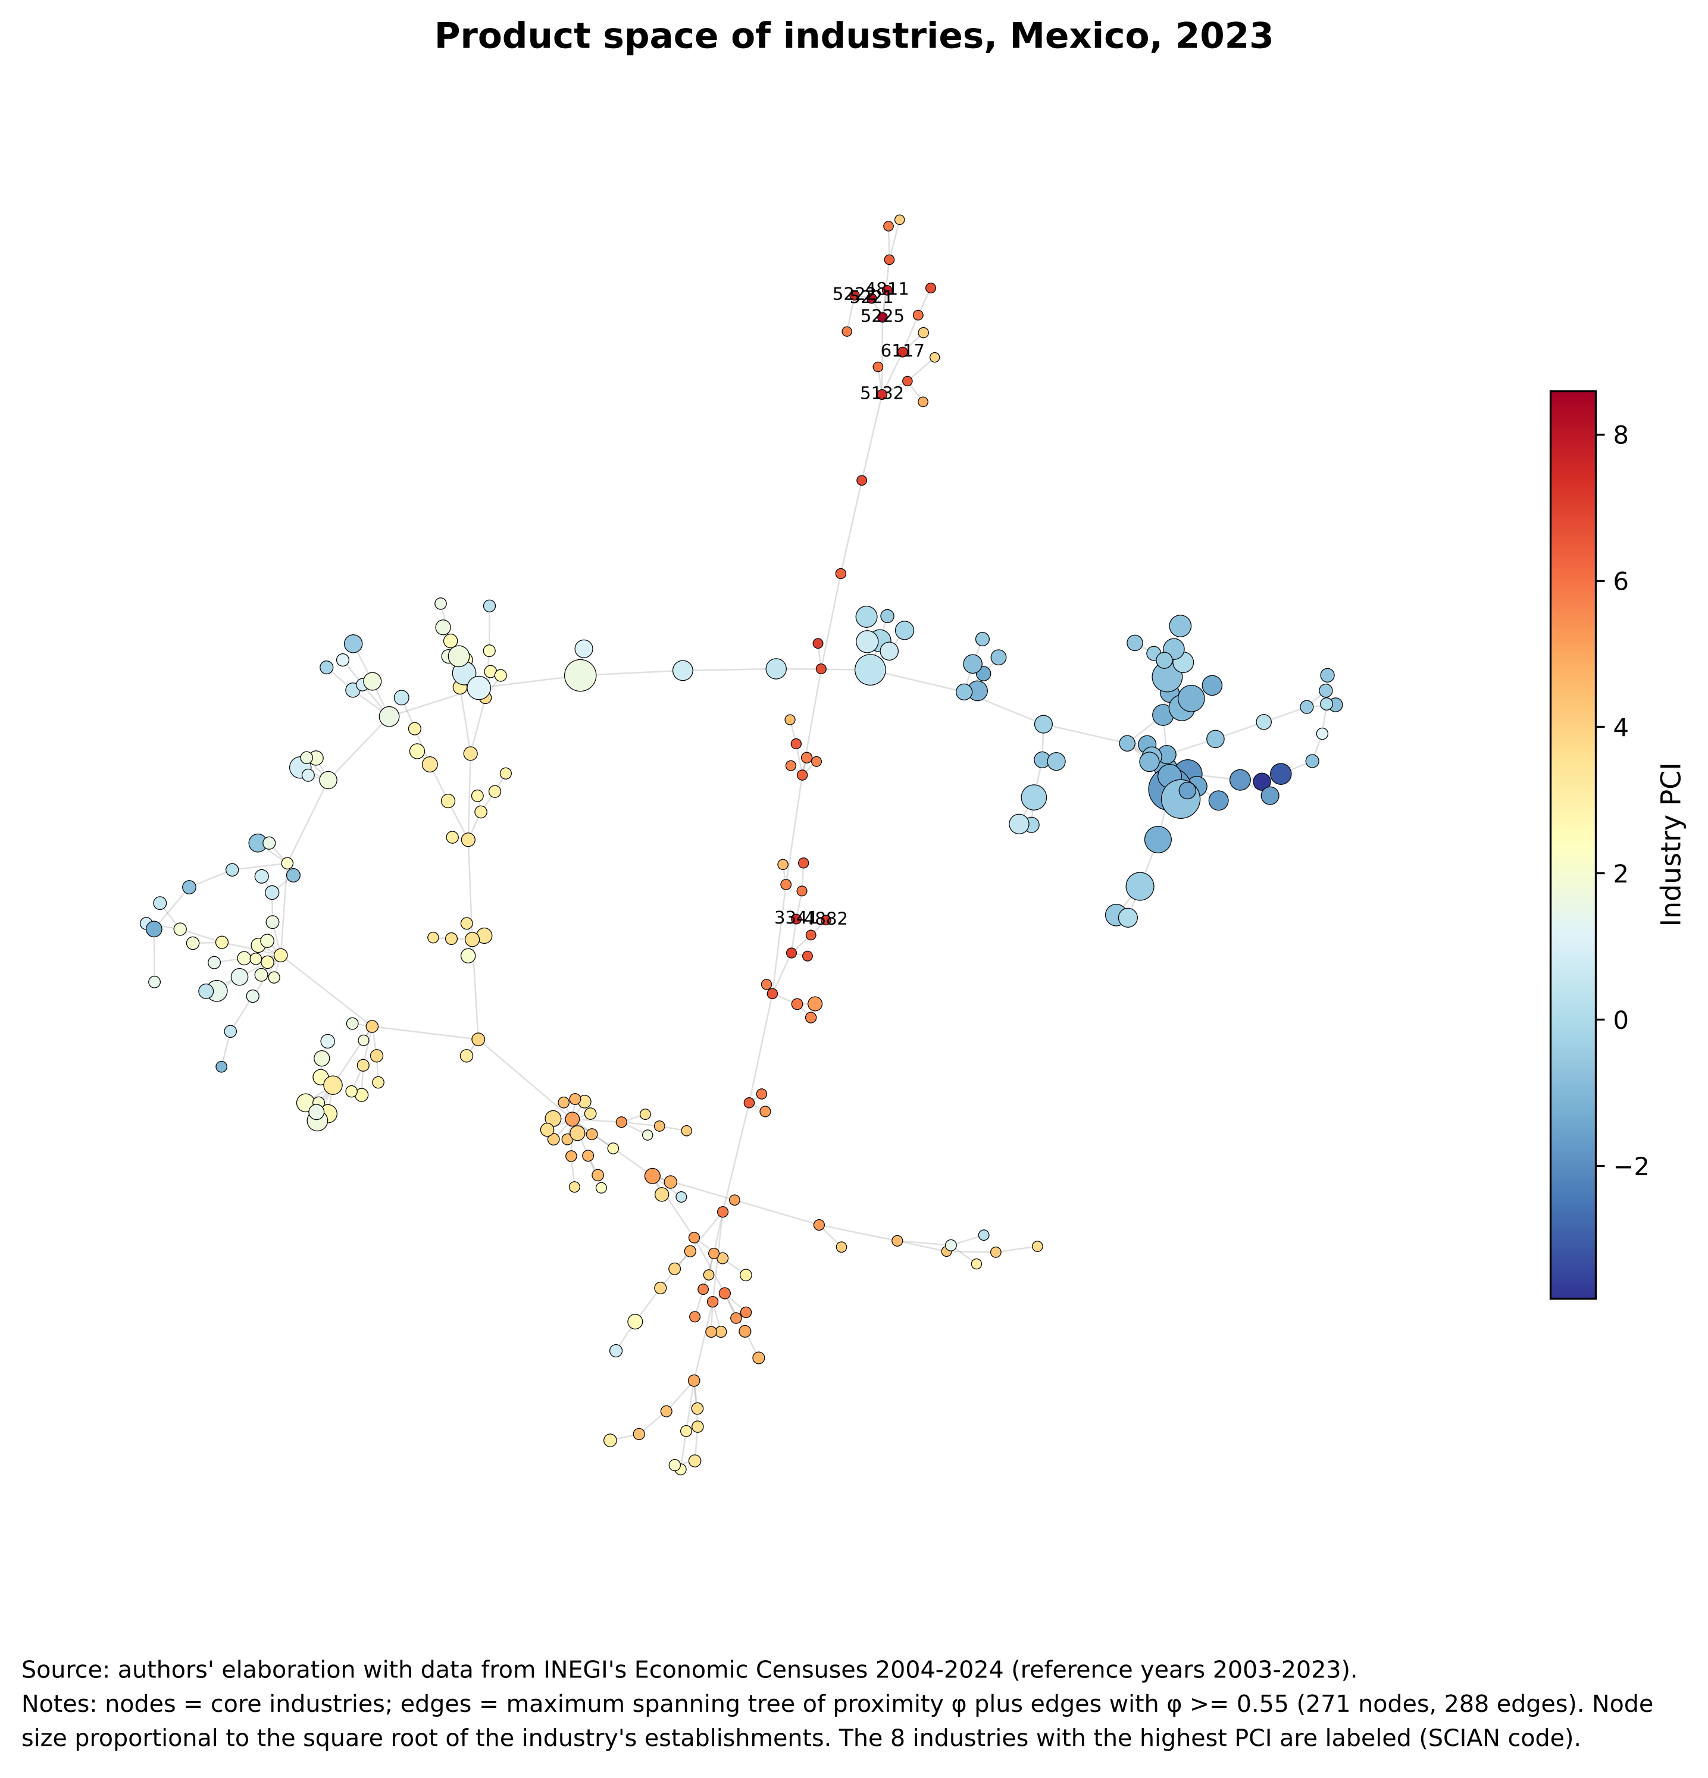
Figure 1: Product space of industries, Mexico, 2023

1.1 Prior complexity estimates for Mexico and contribution
Municipal complexity indices for Mexico already exist, and some of them use establishment counts, as we do. Table 1 summarizes the closest antecedents. State-level indices were first estimated from Economic Census employment (Chávez et al., 2017). At the municipal level, Gómez-Zaldívar and Gómez-Zaldívar (2023) computed the ECI from the 2009, 2014 and 2019 Economic Censuses at the 6-digit level using persons employed and output- and value-added-based variables; they note that, because of confidentiality, the 2019 census allows the index to be computed for only 1,490 municipalities. González Sierra et al. (2023) estimated a municipal index for 2018 from SAIC gross output per person employed by 6-digit class. The closest precedent is Gómez-Zaldívar et al. (2024), who propose computing municipal and industry complexity from the number of establishments by activity reported in the National Statistical Directory of Economic Units (DENUE), precisely to obtain more frequent and robust estimates, and who report a close correspondence with census-based indices. Gómez Zaldívar and Gómez Zaldívar (2026) use the number of economic units from the 2004 and 2019 Economic Censuses for 86 manufacturing industry groups in 2,459 municipalities. The Ministry of Economy's DataMéxico platform also publishes complexity indicators for states, metropolitan areas and municipalities based on DENUE.
Table 1: Prior economic complexity estimates for Mexico at the subnational level
Study | Geographic unit | Data and variable | Period | Activity detail
Chávez et al. (2017) | 32 states | Economic Censuses; employment | Census rounds 1999–2014 | SCIAN activities
Gómez-Zaldívar & Gómez-Zaldívar (2023) | Municipalities (1,490 in 2019 because of confidentiality) | Economic Censuses; persons employed, output and value added per worker | Census rounds 2009, 2014, 2019 | 6-digit SCIAN
González Sierra et al. (2023) | 2,464 municipalities | SAIC; gross output per person employed | Reference year 2018 | 6-digit SCIAN (870 classes)
Gómez-Zaldívar et al. (2024) | Municipalities | DENUE; number of establishments | 2014 and 2019 | 6-digit SCIAN
Gómez Zaldívar & Gómez Zaldívar (2026) | 2,459 municipalities | Economic Censuses; number of economic units (persons employed as robustness) | Census rounds 2004 and 2019 | 4-digit SCIAN, manufacturing only (86 groups)
This appendix | 2,447–2,469 municipalities (core of 2,085–2,337) | SAIC; number of economic units | Reference years 2003, 2008, 2013, 2018, 2023 | 4-digit SCIAN, all census sectors (261–271 core industries)
Source: authors' elaboration based on the cited studies. Note: census rounds are labeled by the year of the census (e.g., the 2019 census refers to 2018).
Therefore, neither the municipal level nor the use of establishment counts is new. The contribution of this appendix lies elsewhere. (i) It provides a homogeneous series of five census rounds (2003–2023) covering all sectors enumerated by the Economic Censuses at the 4-digit level, in a single 2023 municipal geography. (ii) It separates estimation from coverage: the PCI is estimated on a core of municipalities and industries with sufficient size, and the ECI is projected to every municipality with registered establishments. (iii) It gives a formal spectral diagnosis of why indices built on suppressed variables, such as gross output, degenerate (Section 4), which explains the loss of coverage noted in earlier census-based estimates. (iv) It quantifies how much of the ECI is explained by scale and validates the scale-independent component against wages and labor productivity measured in the census (Section 5.3). (v) It publishes the complete set of product-space variables (RCA, density, distance, COI, COG and proximities) for every year, with code verified against py-ecomplexity.

2. Data and sources
The main input is the Economic Censuses of the National Institute of Statistics and Geography (INEGI), retrieved from the Automated System of Census Information (SAIC) in the series of the 2024 Economic Censuses, final results. Five files were downloaded on September 8, 2026, one per reference year (2003, 2008, 2013, 2018 and 2023). Each reports, by municipality and by SCIAN industry group (rama, 4 digits) and class (clase, 6 digits), the number of economic units (UE, establishments) and total gross output (PBT). INEGI homologates the series to a common SCIAN version. The establishment counts are the input of the ECI; gross output is used to diagnose the alternative specification (Section 4), and the class level is used for the aggregation test (Section 5).
The municipal totals of the same census series, downloaded from SAIC on October 4, 2026, report for every municipality the number of establishments, total and paid employment, total remuneration and gross census value added. They are used exclusively for external validation, through average remuneration per paid worker and labor productivity (value added per person employed).
The municipal geography comes from three INEGI products. The 2023 Geostatistical Framework provides the polygons and geostatistical keys of 2,478 municipalities, including the three created in 2024; it is used for the maps, for municipal names and for the crosswalk with the GADM polygons. The 2003 and 2023 versions of the Single Catalog of Geostatistical Keys list municipal keys and localities with coordinates and population; they define the municipal universe of each year, identify municipalities created after 2003 and their parent municipality, and yield population-weighted centroids. The decrees of the state congresses of San Luis Potosí and Sinaloa (and press reports, for Juan José Ríos) identify the parent municipality of the three municipalities created in 2024 (Villa de Pozos, Eldorado and Juan José Ríos).
Municipal population for 2000–2020 comes from INEGI's Population Censuses and Counts (through its API), completed with projections of the National Population Council (CONAPO), and is expressed in the 2023 geography; it is interpolated log-linearly to the census reference years and used as a scale control. Finally, municipal GDP per capita (PPP) for 1990–2022 from Kummu et al. (2025), available for 2,457 GADM v4.1 units, is reported only descriptively, for the reasons given in Section 5.3.
Two candidate sources were discarded. Employment by industry and municipality is subject to the same confidentiality rule as gross output and would display the same pattern of suppression. A municipal database of social indicators was discarded because its source and year are undocumented and it lacks 540 of Oaxaca's 570 municipalities. All inputs are kept unmodified in the project folder (data/raw/ice/); every transformation is performed in code.
Two features of the SAIC files condition all processing. First, a blank cell has an explicit meaning: the footnote of each file states that in blank cells “the absolute values of the economic variables were omitted in order to guarantee the principle of confidentiality and reserve.” Second, SAIC records the geography in force at each census round, so the number of municipalities changes between rounds as new municipalities are created.

3. Methodology: step by step
The computation was implemented in Python 3.13 (numpy 2.5.3, pandas 3.0.5, scipy 1.18.1) as a sequence of eight modules executed with a single command. Every module writes a log with counts before and after each filter and checks its results with assertions. The steps are as follows.

3.1 Cleaning the census data
The five SAIC files were read (removing the trailing null-byte padding and the headers), only municipal rows at the industry-group and class levels were kept, and the five-digit municipal key was built. Each cell was classified as value, zero or suppressed (blank). We verified that establishment counts are never suppressed or zero at the industry-group level, and that the set of industry groups in each year matches the expected coverage (a union of 279 industry groups over 2003–2023). The three municipalities created in 2024 that appear in the 2023 census were added to their parent municipality, so that the 2023 ECI is expressed in the 2023 municipal geography (Villa de Pozos → San Luis Potosí; Eldorado → Culiacán; Juan José Ríos → Guasave, its main parent municipality).

3.2 Input matrix and estimation core
For each year t we build the matrix X_{cp} with the number of establishments of municipality c in industry p. The PCI is estimated on a core of municipalities and industries of sufficient size, because with few establishments comparative advantage is noise: a municipality with ten establishments obtains a comparative advantage in any industry in which it has one. The core is defined with raw size measures, not with diversity or ubiquity (which depend on the computation itself):
- municipalities with at least 30 establishments in total and presence (at least one establishment) in at least 5 industries;
- industries present in at least 10 municipalities.
The filters are applied iteratively (first municipalities, then industries) until neither removes observations; in every year they converged in two iterations.

3.3 Revealed comparative advantage, diversity and ubiquity
With the core data we compute Balassa's revealed comparative advantage and the binary presence matrix:
RCA_{cp} = (X_{cp} / Σ_{p} X_{cp}) / (Σ_{c} X_{cp} / Σ_{c}Σ_{p} X_{cp}), M_{cp} = 1 if RCA_{cp} ≥ 1; 0 otherwise
k_{c} = Σ_{p} M_{cp} (diversity), k_{p} = Σ_{c} M_{cp} (ubiquity)

3.4 Industry complexity (PCI): eigenvectors and the choice of the second one
The method of reflections of Hidalgo and Hausmann (2009) refines diversity and ubiquity iteratively: the ubiquity of an industry is replaced by the average diversity of the municipalities that have it, and the diversity of a municipality by the average ubiquity of its industries. Substituting one step into the other gives a recursion over industries only:
k_{p,N} = Σ_{p′} M̃_{pp′} k_{p′,N−2}, M̃_{pp′} = (1 / k_{p}) Σ_{c} M_{cp} M_{cp′} / k_{c}, i.e., M̃ = K_{p}⁻¹ M′ K_{c}⁻¹ M
where K_{c} and K_{p} are diagonal matrices with diversity and ubiquity. Each element M̃_{pp′} has a simple reading: it is the probability of going from industry p to industry p′ in two steps, first choosing at random one of the municipalities with an advantage in p, and then choosing at random one of that municipality's industries. Consequently, every row of M̃ sums to one, and every two reflections amount to one more multiplication by M̃.
What an eigenvector is in this context. An eigenvector of M̃ is a vector v of scores, one per industry, that the matrix only rescales: M̃v = λv, where the number λ is its eigenvalue. Since each row of M̃ is an average over industries that share municipalities, an eigenvector is a scoring of industries that is self-consistent with the network: the score of each industry is proportional to the average score of the industries with which it co-occurs. Because M̃ is similar to the symmetric matrix S = K_{p}^{-1/2} M′ K_{c}⁻¹ M K_{p}^{-1/2} = A′A, with A = K_{c}^{-1/2} M K_{p}^{-1/2}, all its eigenvalues are real and lie between zero and one, and they can be ordered as 1 = λ₁ ≥ λ₂ ≥ λ₃ ≥ … ≥ 0.
Why the first eigenvector is discarded. Since every row of M̃ sums to one, multiplying M̃ by a vector of ones returns the same vector of ones: the constant vector is always an eigenvector, with the largest possible eigenvalue, λ₁ = 1. This eigenvector assigns the same score to every industry. It is a mechanical consequence of the row normalization, not a feature of the data, and it carries no information to rank industries. It is also the point to which the reflections converge if they are iterated indefinitely: repeated averaging erases all differences between industries.
Why the second eigenvector ranks complexity. Any initial vector of scores can be written as a combination of eigenvectors, and after n multiplications by M̃ (2n reflections) the weight of each eigenvector is multiplied by λ_{i}^{n}. All components with eigenvalue below one shrink, and, provided that λ₂ > λ₃ and the initial vector has some weight on it, the one that shrinks most slowly after the constant is the eigenvector associated with λ₂. Once the constant is removed (which standardization does), what remains of the reflections is the second eigenvector; it is therefore the limit of the ranking produced by the method of reflections. Substantively, it is the non-constant scoring most consistent with the network: it is orthogonal to the constant vector in the inner product weighted by ubiquity (its ubiquity-weighted mean is zero) and it assigns similar scores to industries that tend to appear in the same municipalities. Mealy et al. (2019) show that it is the relaxed solution of a normalized-cut spectral clustering problem: thresholding it splits industries into the two groups that are most similar internally and most different from each other in terms of the municipalities in which they are present. One end of this axis groups industries located in diversified municipalities that also host other rare industries (complex industries); the other groups industries present in municipalities with few and ubiquitous industries (simple industries). The third and subsequent eigenvectors describe additional, weaker partitions of the network.
Two conditions are required for the second eigenvector to be informative, and both are checked every year (Section 3.8). The network must be connected: if it splits into several disconnected components, the eigenvalue one is repeated as many times as there are components and the “second” eigenvector merely indicates the component to which each industry belongs. In addition, λ₂ must be clearly separated from λ₃: if they coincide, any combination of the two eigenvectors is an equally valid solution, and if they are merely close the eigenvector is ill-conditioned, because its sensitivity to small perturbations of the matrix grows with 1/(λ₂ − λ₃), so that the ranking is not reliably identified. Section 4.2 shows that gross output violates both conditions. For numerical stability, the problem is solved on the symmetric form S (with numpy.linalg.eigh), whose eigenvalues coincide with those of M̃:
S = K_{p}^{-1/2} M′ K_{c}⁻¹ M K_{p}^{-1/2}, PCI_{p} ∝ K_{p}^{-1/2} v₂
where v₂ is the eigenvector of S associated with λ₂; the transformation K_{p}^{-1/2} recovers the corresponding eigenvector of M̃. An eigenvector has no natural sign, so the sign is oriented so that the ECI correlates positively with diversity. The municipal ECI is the analogous eigenvector of the municipality-to-municipality matrix and, as shown in Section 3.5, equals the average PCI of each municipality's industries.

3.5 Projection of the ECI to all municipalities
Municipalities outside the core are not dropped. For every municipality we compute comparative advantage with its own structure in the numerator and the national shares of the core in the denominator, over the core industries, and define the ECI as the average PCI of the industries in which the municipality has an advantage:
ECI_{c} = (1 / k_{c}) Σ_{p} M_{cp} PCI_{p}
For core municipalities this expression reproduces exactly the ECI eigenvector (correlation of 1.000000 in all five years). As a result, every municipality with registered establishments has an ECI, while the PCI is not contaminated by the noise of very small municipalities.

3.6 Standardization
In each year the ECI is standardized with the mean and standard deviation of the ECI of core municipalities, and the PCI is transformed with the same parameters (the convention of Hidalgo and Hausmann). Consequently, the ECI measures the relative position of a municipality within each year: a difference between years is a change in position, not in absolute complexity.

3.7 Proximity, density, distance and outlook
φ_{pp′} = min{ P(M_{cp}=1 | M_{cp′}=1), P(M_{cp′}=1 | M_{cp}=1) }
density_{cp} = Σ_{p′} M_{cp′} φ_{pp′} / Σ_{p′} φ_{pp′}, distance_{cp} = 1 − density_{cp}
COI_{c} = Σ_{p} (1 − M_{cp}) · density_{cp} · PCI_{p}
Proximity is computed with the core matrix. The COI is standardized with the core, and the complexity outlook gain (COG) follows the py-ecomplexity formula. The six variables of the final database (mcp, ECI, PCI, density, COI and COG) coincide with py-ecomplexity 0.5.3 on the core, with a correlation of 1.000000 in all five years.

3.8 Diagnostics of each run
Table 2 summarizes the mandatory diagnostics. The core retains between 85% and 95% of municipalities and practically all establishments (between 0.05% and 0.20% of establishments remain outside the core). The bipartite network is a single connected component in every year, only one eigenvalue equals one, and the second eigenvalue (0.33–0.35) is clearly separated from the third (0.12–0.13): the eigenvector that defines the ECI is well identified.
Table 2: Diagnostics of the ECI computation by year (baseline specification: establishments, industry group)
Year | Municipalities (core / total) | Industries (core / total) | λ2 | λ3 | Components | Corr. with py-ecomplexity | Spearman ECI–diversity
2003 | 2,085 / 2,447 | 261 / 272 | 0.354 | 0.131 | 1 | 1.000000 | 0.896
2008 | 2,205 / 2,455 | 269 / 277 | 0.344 | 0.134 | 1 | 1.000000 | 0.890
2013 | 2,266 / 2,456 | 267 / 276 | 0.338 | 0.128 | 1 | 1.000000 | 0.891
2018 | 2,320 / 2,465 | 269 / 278 | 0.333 | 0.125 | 1 | 1.000000 | 0.891
2023 | 2,337 / 2,469 | 271 / 278 | 0.326 | 0.121 | 1 | 1.000000 | 0.893
Source: authors' elaboration with data from INEGI's Economic Censuses 2004–2024.

4. Technical defense I: choice of variable (economic units vs. gross output)

4.1 The central argument: establishment counts are the only uncensored variable
Establishment counts are the only SAIC variable that INEGI publishes in full at the municipality × industry level. Economic variables (gross output, employment, remuneration) are withheld whenever their publication would allow an establishment to be identified. Among cells with at least one establishment, gross output is suppressed in 65.6% (2003), 64.2% (2008), 62.8% (2013), 61.8% (2018) and 60.8% (2023) of cases. Moreover, suppression is not random: as Figure 2 shows, it affects 93–98% of the cells of the smallest municipalities and 49–54% of those of the largest. By sector, it reaches 98–100% in network utilities (sector 22) and 88–93% in information (sector 51).
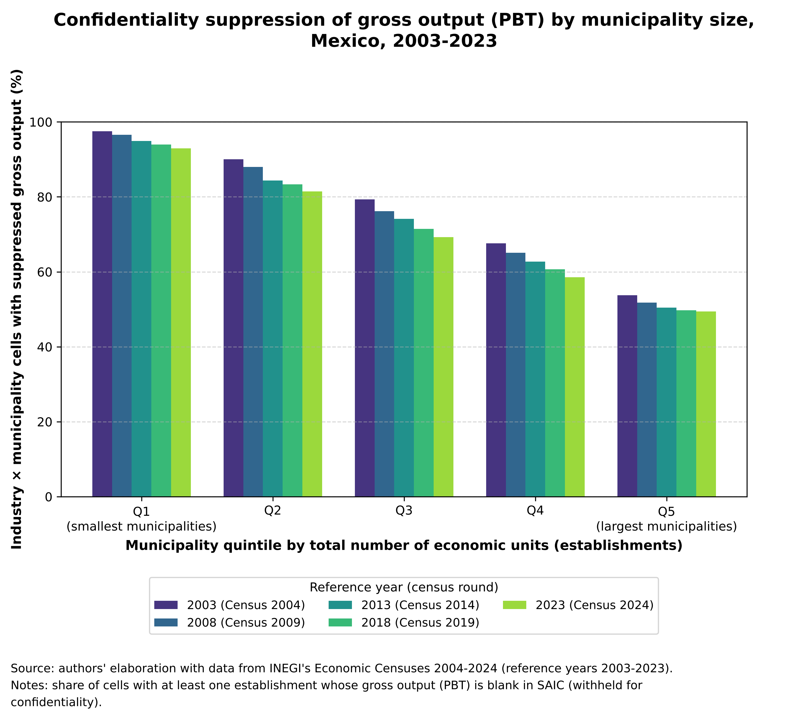
Figure 2: Confidentiality suppression of gross output by municipality size, Mexico, 2003–2023

4.2 Why suppression collapses the complexity matrix
The complexity computation does not admit missing cells: the standard implementation treats a blank cell as zero. This produces three chained effects.
(i) Biased comparative advantages. With suppressed cells, the municipal total and the national total of each industry are computed only with what is observed. The RCA no longer compares the true structure of the municipality with the national structure; it compares the structure of what survived suppression. Between 9% and 21% of municipalities have no observed gross-output cell at all and drop out of the computation.
(ii) Disconnection of the bipartite network. The matrix M̃_{cc} = K_{c}⁻¹ M K_{p}⁻¹ M′ is row-stochastic, so its largest eigenvalue is one, and the multiplicity of that eigenvalue equals the number of connected components of the municipality–industry network (Section 3.4). When suppression removes the links that connect a group of municipalities with the rest, the network splits into blocks: the second eigenvalue becomes one (λ₂ = 1) and its eigenvector no longer ranks municipalities by complexity, because it becomes an indicator of the block to which each municipality belongs. This is exactly what happens with gross output in 2023: two components, λ₂ = 1 and 99.95% of municipalities with the same ECI.
(iii) Unidentified eigenvector. Even without full disconnection, if the second and third eigenvalues almost coincide, the second eigenvector becomes ill-conditioned: small perturbations of the matrix, such as those introduced by suppression, rotate it toward the third, and the ranking of municipalities is no longer reliably determined. In 2018 gross output yields λ₂ = 0.439 and λ₃ = 0.429; with establishments, λ₂ = 0.333 and λ₃ = 0.125.
The concentration of output amplifies the problem. Summing the observed industries, the top 1% of municipalities by gross output concentrates between 51% and 63% of published output, compared with 24–29% for establishments. Because suppression removes mostly the cells of small municipalities, what remains of gross output is dominated by a few large cities and the matrix loses the information of the periphery. Figure 3 and Table 3 document the result: with gross output the index takes extreme values of 7 to 47 standard deviations, between 11% and 100% of ties, and its correlation with diversity, and even with the establishment-based ECI, changes sign from one year to another. With establishments the spectral gap is stable (≈ 0.21) in every year.
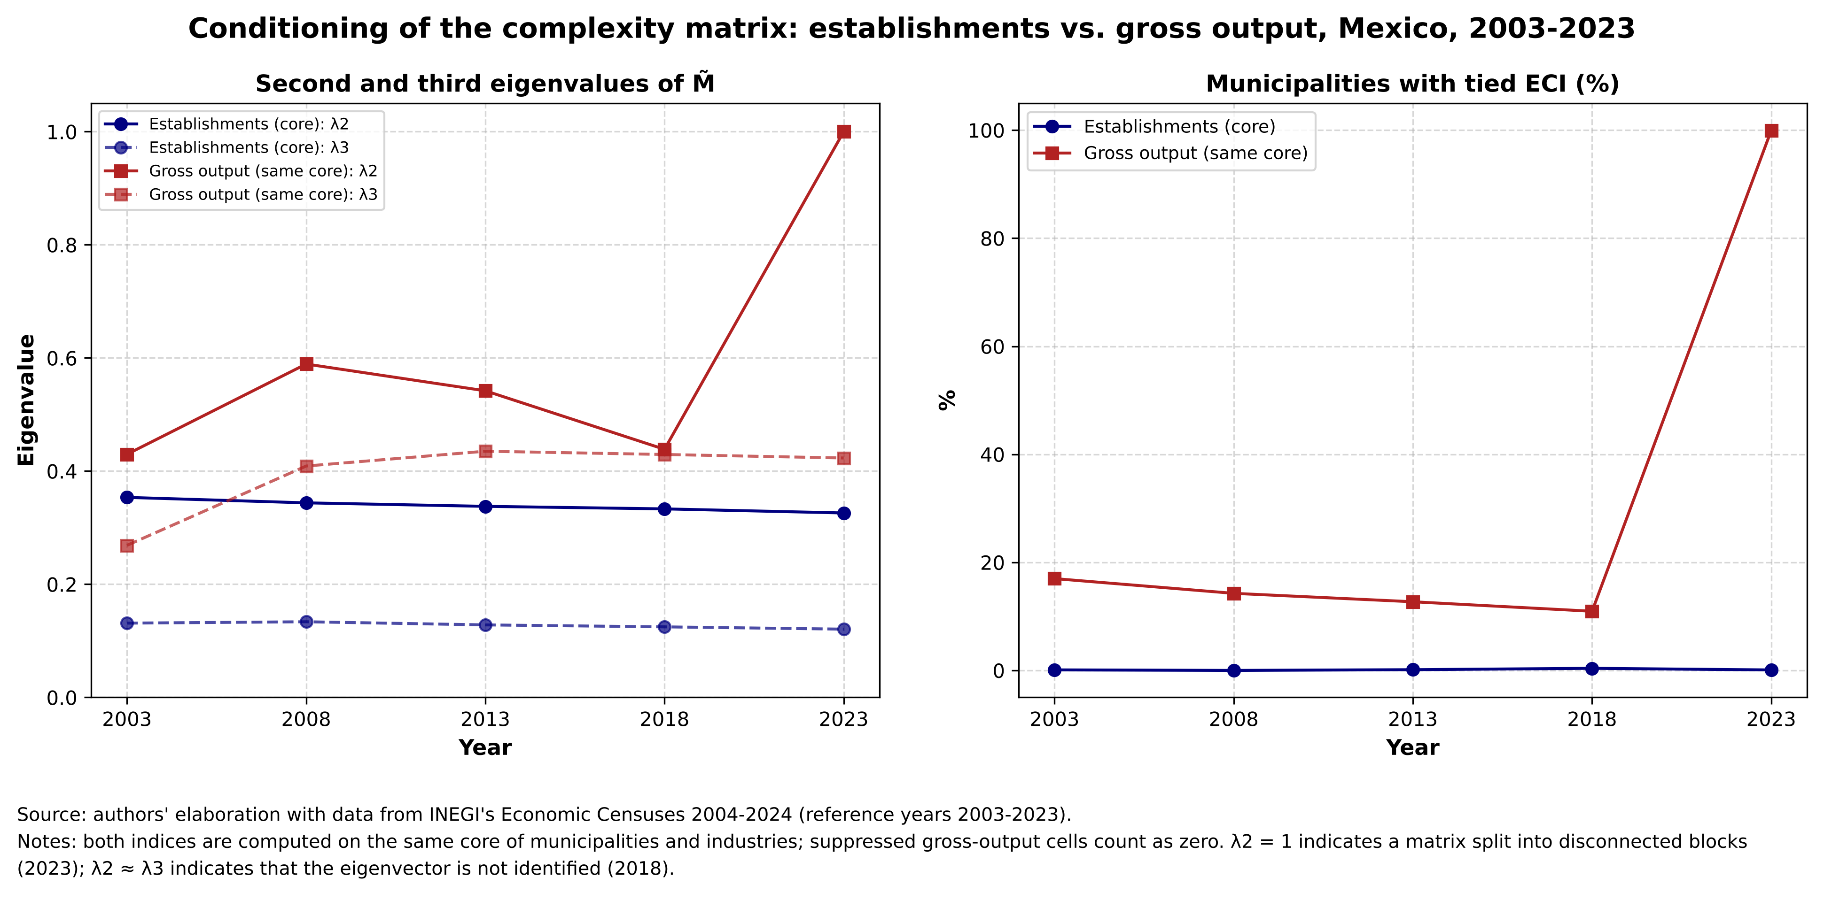
Figure 3: Conditioning of the complexity matrix: establishments vs. gross output, Mexico, 2003–2023
Table 3: Diagnostics of the ECI computed with establishments and with gross output on the same core
Year | Variable | Municipalities | Components | λ2 | λ3 | Ties (%) | Spearman with diversity | Max |ECI| (s.d.) | Spearman with UE-based ECI
2003 | UE | 2,085 | 1 | 0.354 | 0.131 | 0.1 | 0.90 | 3.5 | —
2003 | PBT | 1,895 | 1 | 0.430 | 0.269 | 17.0 | 0.69 | 6.8 | 0.70
2008 | UE | 2,205 | 1 | 0.344 | 0.134 | 0.0 | 0.89 | 3.7 | —
2008 | PBT | 2,026 | 1 | 0.589 | 0.409 | 14.3 | -0.77 | 44.3 | -0.79
2013 | UE | 2,266 | 1 | 0.338 | 0.128 | 0.1 | 0.89 | 3.8 | —
2013 | PBT | 2,133 | 1 | 0.542 | 0.435 | 12.7 | -0.03 | 41.0 | 0.02
2018 | UE | 2,320 | 1 | 0.333 | 0.125 | 0.4 | 0.89 | 3.4 | —
2018 | PBT | 2,192 | 1 | 0.439 | 0.429 | 10.9 | 0.77 | 20.2 | 0.79
2023 | UE | 2,337 | 1 | 0.326 | 0.121 | 0.1 | 0.89 | 3.4 | —
2023 | PBT | 2,222 | 2 | 1.000 | 0.423 | 100.0 | -0.62 | 47.1 | -0.65
Source: authors' elaboration with data from INEGI's Economic Censuses 2004–2024. Note: UE = economic units (establishments); PBT = gross output. In PBT, suppressed cells count as zero, as in py-ecomplexity. Ties: percentage of core municipalities whose ECI is identical to that of another municipality.
Therefore, the choice of establishments is not based on the shape of the distribution of the index (normality is not a validity criterion for the ECI), but on the fact that it is the only variable with which the complexity matrix is well defined. Employment by industry is not an alternative: INEGI's confidentiality rule applies to all economic variables and would produce the same pattern of suppression.
The counterpart of using establishments is conceptual: the index measures specialization in the number of establishments, not in output, and a one-person establishment weighs the same as a plant with thousands of workers. This is mitigated in two ways. The RCA compares shares, not levels, so what matters is the composition of the establishment base. Moreover, Section 5 shows that the establishment-based ECI predicts measured wages and productivity beyond municipal size.

4.3 Filters and information loss: municipalities
Table 4 presents the counts by year. Every municipality with at least one registered establishment has an ECI: the core filter only determines which municipalities take part in the estimation of the PCI, and the others receive a projected ECI (Section 3.5). Between 362 municipalities (2003) and 132 (2023) remain outside the core, almost all because they have fewer than 30 establishments, and most of them in Oaxaca (251 of 362 in 2003 and 89 of 132 in 2023), a state with many very small municipalities.
Table 4: Municipalities included in the ECI computation by year
Year | With establishments (have ECI) | In the core | Outside the core (projected ECI) | Outside: < 30 establishments | Outside: < 5 industries | INEGI catalog | In catalog, no establishments
2003 | 2,447 | 2,085 | 362 | 361 | 1 | 2,446 | 1
2008 | 2,455 | 2,205 | 250 | 250 | 0 | — | —
2013 | 2,456 | 2,266 | 190 | 188 | 2 | — | —
2018 | 2,465 | 2,320 | 145 | 145 | 0 | — | —
2023 | 2,469 | 2,337 | 132 | 131 | 1 | 2,475 | 6
Source: authors' elaboration with data from SAIC and the Single Catalog of Geostatistical Keys (INEGI). Note: catalogs are available for 2003 and 2023 only; for 2008, 2013 and 2018 changes are described relative to the previous census. The 2023 total already includes the reassignment of the three municipalities created in 2024.
The number of municipalities changes between years for three technical reasons:
- Newly created municipalities. Between the 2003 and 2023 catalogs, 29 municipalities were created. They appear in the census following their creation: 8 in 2008 (for example, Tulum and Cochoapa el Grande), 1 in 2013 (Bacalar), 8 in 2018 (five in Chiapas, two in Morelos and Puerto Morelos) and 9 in 2023 (among them San Quintín and San Felipe, in Baja California). José Joaquín de Herrera and Tonanitla already appear in 2003, although they are not in that year's catalog, because they were created before the census was taken.
- Changes in geostatistical keys. The three municipalities created in 2024 (Villa de Pozos, Eldorado and Juan José Ríos) appear in the 2023 census with keys that do not exist in the 2023 catalog; they were added to their parent municipality (in the maps, their polygons appear without data). For municipalities created after 2003, the parent municipality was identified by matching their localities with those of the 2003 catalog by coordinates and name (28 of 29 resolved; Iliatenco requires manual assignment).
- No registered activity. Some municipalities exist in the catalog but have no establishments in a given census: Nicolás Ruíz (Chiapas) in 2003, and Amatenango de la Frontera, Bejucal de Ocampo, Bella Vista, La Grandeza, Capitán Luis Ángel Vidal and Honduras de la Sierra (all in Chiapas) in 2023. Without establishments there is no productive structure to measure, so they have no ECI in that year. With the available data it is not possible to distinguish whether the absence reflects a true lack of activity or problems in the census enumeration of that area.

5. Technical defense II: level of aggregation (industry group)

5.1 Decision rule
The choice between the industry group (rama, 4-digit SCIAN, about 270 activities) and the class (clase, 6 digits, about 880) is governed by a rule fixed before estimation. The metric is the partial R² of the ECI in a regression of municipal average remuneration (in logs, relative to the national value) that controls for log population, log establishments, diversity and state fixed effects, for 2003 and 2013. The class would be the baseline specification only if the 95% bootstrap interval (resampling states, 1,999 replications) of the difference class − industry group excluded zero in favor of the class in both years. In any other case the industry group is used, for parsimony and because the industry-group matrix has fewer empty cells.
Table 5: Industry group vs. class rule: partial R² of the ECI in the average remuneration regression
Year | Municipalities | Partial R² (industry group) | Partial R² (class) | Difference (class − group) | 95% bootstrap CI | Class preferred?
2003 | 2,272 | 0.068 | 0.061 | −0.007 | [−0.018, 0.012] | No
2013 | 2,361 | 0.062 | 0.067 | +0.005 | [−0.009, 0.018] | No
Source: authors' elaboration with data from INEGI's Economic Censuses 2004–2024. Note: controls for log population, log establishments, diversity and state fixed effects; bootstrap by state with 1,999 replications and a fixed seed.
Neither interval excludes zero, so the baseline specification is the industry group. Both levels have equivalent predictive power; the choice rests on the decision rule, on parsimony and on the fact that the conclusions do not depend on it (Section 5.2).

5.2 Robustness of the specification
Table 6 compares the baseline with 33 alternatives. The core thresholds and the exclusion of industries whose location does not reflect local capabilities leave the ranking of municipalities practically unchanged (Spearman ≥ 0.992). The class level and the alternative Fitness-Complexity method (Tacchella et al., 2012) keep high correlations (0.97 and 0.95) but move between 22% and 30% of municipalities across quintiles; for this reason all alternatives are exported, so that any analysis using the index can be replicated with each of them.
Table 6: Sensitivity of the ECI to alternative specifications (2003–2023)
Alternative | Description | Spearman with baseline | % changing quintile
Threshold grid (26 + baseline) | Minimum establishments ∈ {10, 30, 100}; minimum industries ∈ {3, 5, 10}; minimum municipalities per industry ∈ {5, 10, 20} | 0.992–1.000 | 0.0–10.5
R1 | Excludes industries located by state mandate or monopoly (5211 central banking, 5232 securities exchanges, 2111 oil and gas extraction) | ≥ 0.9998 | 0.1–0.2
R2 | Excludes network utilities (subsector 221: electric power, natural gas distribution, water) | 0.997–0.998 | 3.8–6.5
R3 | Excludes mining (sector 21), located by natural resources | 0.999–1.000 | 0.8–2.0
R4 | R1 + R2 + R3 | 0.996–0.998 | 4.0–6.7
Class | 6-digit SCIAN, same core and method | 0.968–0.971 | 21.8–24.0
Fitness-Complexity | Tacchella et al. (2012), same core | 0.945–0.958 | 27.7–29.8
Common industries | Only the 272 industries present in all five years | ≥ 0.9995 | 0.0–1.5
Source: authors' elaboration with data from INEGI's Economic Censuses 2004–2024.

5.3 Defense against circularity and the scale effect (Soloaga critique)
The contribution relative to Soloaga et al. (2025) rests on the ECI measuring the productive content of a territory rather than its scale. The critique raises two risks: that the ECI specification could be selected for its ability to predict GDP per capita, and that the count of establishments grows with municipal size. This matters because, if the ECI were merely a proxy for income or urban size, the contribution would disappear. The response has five parts.
(a) The specification is not selected on GDP. The rule of Section 5.1 uses remuneration measured in the censuses, with scale controls. The available municipal GDP (Kummu et al., 2025) is, within each state, the prediction of a machine-learning model whose explanatory variables are the degree of urbanization and travel time to the nearest city. Validating the ECI against that GDP would amount to validating it against scale, which is precisely what the critique questions. GDP is therefore reported only descriptively (correlation of 0.49 to 0.51 with the ECI) and is not used as evidence.
(b) The level of establishments does not enter the index. The RCA is essentially scale invariant: if all the establishments of a municipality are multiplied by a constant a, its share in each industry does not change; the national shares in the denominator change only marginally for a single municipality, and not at all for municipalities outside the core, whose denominator is fixed by the core. Its ECI is therefore unaffected. Size can only influence the index through diversity, because a municipality with more establishments tends to be present in more industries. That channel exists and is strong, and Table 7 quantifies it.
Table 7: Share of the variance of the ECI explained by scale and diversity (R²)
Year | Municipalities | log population | + log establishments | + diversity | + state fixed effects | Size categories
2003 | 2,447 | 0.69 | 0.80 | 0.88 | 0.90 | 0.68
2008 | 2,455 | 0.69 | 0.77 | 0.86 | 0.89 | 0.69
2013 | 2,456 | 0.70 | 0.76 | 0.86 | 0.88 | 0.67
2018 | 2,465 | 0.72 | 0.76 | 0.85 | 0.88 | 0.67
2023 | 2,469 | 0.71 | 0.75 | 0.85 | 0.88 | 0.66
Source: authors' elaboration with data from INEGI's Economic Censuses and INEGI and CONAPO population. Note: municipal population size categories: fewer than 15 thousand, 15–50 thousand, 50–350 thousand, and 350 thousand or more inhabitants, in the spirit of the urban size cut-offs of Soloaga et al. (2025).
Scale and diversity explain between 85% and 88% of the variance of the ECI, and between 88% and 90% when state fixed effects are added. The ECI and size are not the same thing, but they overlap substantially. Within each size category the ECI retains considerable dispersion (standard deviation of 0.45 to 0.80): municipalities of similar size have very different productive structures. The component of the ECI not explained by scale, 10% to 12% of its variance, is the one that must sustain the contribution, and parts (c) and (d) show that it has content.
(c) The scale-independent component predicts wages and productivity. Table 8 shows the regression of municipal average remuneration (in logs, relative to the national value) on the ECI, adding controls progressively. With all controls (scale, diversity and state fixed effects), a one-standard-deviation increase in the ECI is associated with remuneration between 24 and 37 log points higher in every year, with p ≤ 0.0001 (the smallest value attainable with 9,999 replications) in the restricted wild cluster bootstrap by state. For labor productivity (value added per person employed) the coefficient ranges from 0.55 to 0.63 (p ≤ 0.0001). The result holds with size categories instead of the continuous controls, and with both at once (0.25–0.40). The ECI also predicts the subsequent growth of relative remuneration (0.07 over 2003–2023; 0.15 in the panel of five-year periods) with all controls.
Table 8: The ECI and municipal average remuneration with scale controls: ECI coefficient (standard error) and partial R²
Specification | 2003 | 2008 | 2013 | 2018 | 2023
(1) ECI only | 0.322 (0.017); pR² 0.33 | 0.349 (0.019); pR² 0.35 | 0.304 (0.013); pR² 0.34 | 0.282 (0.012); pR² 0.37 | 0.243 (0.020); pR² 0.36
(2) + log population + log establishments | 0.408 (0.031); pR² 0.15 | 0.425 (0.032); pR² 0.16 | 0.384 (0.037); pR² 0.17 | 0.380 (0.039); pR² 0.22 | 0.288 (0.029); pR² 0.17
(3) + diversity | 0.454 (0.041); pR² 0.12 | 0.411 (0.047); pR² 0.09 | 0.391 (0.053); pR² 0.11 | 0.385 (0.050); pR² 0.15 | 0.285 (0.038); pR² 0.11
(4) + state fixed effects | 0.365 (0.039); pR² 0.07 | 0.339 (0.034); pR² 0.06 | 0.310 (0.039); pR² 0.06 | 0.310 (0.034); pR² 0.08 | 0.239 (0.030); pR² 0.07
(5) Size categories + all controls in (4) | 0.398 (0.045); pR² 0.07 | 0.361 (0.036); pR² 0.06 | 0.319 (0.042); pR² 0.06 | 0.316 (0.035); pR² 0.08 | 0.249 (0.029); pR² 0.07
Source: authors' elaboration with data from INEGI's Economic Censuses and INEGI and CONAPO population. Note: dependent variable: log(remuneration / paid employees) minus its national value. Standard errors clustered by state. All coefficients have p ≤ 0.0001 in the restricted wild cluster bootstrap (Webb weights, 9,999 replications); those in (1)–(4) are also significant with Conley standard errors (100 km). pR²: partial R² of the ECI. Municipalities: 2,272 to 2,432 per year.
(d) The ECI is not a substitute for income. The correlation of the ECI with relative average remuneration is 0.57 to 0.61 (R² of 0.33 to 0.37): the index shares information with income but is not a measure of it. In part (c), the partial R² falls from about 0.35 without controls to 0.06–0.08 with all of them. A large share of the raw correlation was indeed scale, but a stable independent association remains in all five years.
(e) Circularity. The association is not mechanical: the ECI is computed only from establishment counts by industry, while the validator uses wages and value added. They do share the source (the Economic Censuses) and hence its coverage (no agriculture or government), so circularity cannot be ruled out entirely; it is, however, not built into the construction. In any application in which the ECI is used as an explanatory variable, the decisive test of the critique is that its coefficient survives controlling for the log population of the municipality. Since only 10–12% of the variance of the ECI is independent of scale, this also determines the statistical power with which an effect can be detected.

5.4 Filters and information loss: industries
Table 9 summarizes how many industries enter the computation each year, and Table 10 lists those excluded. There are two reasons for exclusion. The first is census coverage: relative to the union of 279 industries, some do not exist in certain years (for example, waste management before 2018 or support activities for agriculture in 2003). The second is the core threshold: industries present in fewer than 10 municipalities do not take part in the estimation, because their PCI would depend on one or two municipalities. They include central banking, securities exchanges, rail and pipeline transportation, and coal mining.
Table 9: Industries included in the ECI computation by year
Year | Industries present in the census | Industries in the core | Excluded: present in < 10 municipalities | Not covered that year
2003 | 272 | 261 | 11 | 7
2008 | 277 | 269 | 8 | 2
2013 | 276 | 267 | 9 | 3
2018 | 278 | 269 | 9 | 1
2023 | 278 | 271 | 7 | 1
Source: authors' elaboration with data from INEGI's Economic Censuses 2004–2024.
Table 10: Industries excluded from the core or not covered, by year
Industry | Name | Outside the core: years (municipalities with establishments) | Not covered by the census
1151 | Support activities for crop production | — | 2003
1152 | Support activities for animal production | — | 2003
1153 | Support activities for forestry | — | 2003
2121 | Coal mining | 2003 (11), 2008 (10), 2013 (10), 2023 (8) | —
2211 | Electric power generation, transmission, distribution and retail | 2013 (7) | —
2212 | Natural gas distribution by pipeline to final consumers | 2008 (6), 2013 (9), 2018 (6), 2023 (9) | —
3346 | Manufacturing and reproducing magnetic and optical media | 2018 (9), 2023 (9) | —
3365 | Railroad rolling stock manufacturing | 2003 (9) | —
4811 | Scheduled air transportation | 2003 (8) | —
4821 | Rail transportation | 2003 (5), 2008 (5), 2013 (4), 2018 (5), 2023 (6) | —
4853 | Taxi and limousine service | 2003 (8) | —
4861 | Pipeline transportation of crude oil | 2008 (5) | 2003, 2013, 2018, 2023
4862 | Pipeline transportation of natural gas | 2003 (9) | —
4869 | Other pipeline transportation | 2003 (1), 2013 (5), 2018 (6), 2023 (8) | —
4879 | Other scenic and sightseeing transportation | 2003 (2), 2008 (2), 2013 (3), 2018 (7) | —
5174 | Satellite telecommunications | 2003 (9) | —
5211 | Central banking | 2003 (1), 2008 (1), 2013 (1), 2018 (1), 2023 (1) | —
5222 | Development finance institutions | 2003 (7), 2008 (6), 2013 (6), 2018 (5) | —
5225 | Activities related to nondepository credit intermediation | 2018 (9) | —
5232 | Securities exchanges | 2008 (1), 2013 (1), 2018 (2), 2023 (2) | 2003
5622 | Waste treatment and disposal | — | 2003, 2008, 2013
5629 | Remediation and other waste management services | — | 2003, 2008, 2013
Source: authors' elaboration with data from INEGI's Economic Censuses 2004–2024. Note: industry names are the authors' translation of the SCIAN titles.
In addition to these mechanical exclusions, four exclusion rules were defined only as robustness tests (not in the baseline, to avoid discretionary decisions). They cover industries whose location does not reflect local productive capabilities: state mandate or monopoly (R1), network utilities with compulsory presence (R2), geology (R3, reported separately because the trade literature does include mining) and their combination (R4). Some of these industries are already outside the core because of the presence threshold (5211 and 5232, as well as 2121 and 2212 in several years). As Table 6 shows, excluding them does not alter the ranking of municipalities.

6. Limitations of the index: endogeneity and measurement
The ECI is a descriptive measure of productive structure, and any use of it as an explanatory variable is associational unless it is combined with an identification strategy. The main limitations are the following.
Endogeneity. The complexity of a municipality is correlated with other characteristics that also shape territorial outcomes: infrastructure, the quality of schools and health services, local institutions, accumulated human capital or connectivity. None of them is in the index, and if any is omitted from a model that uses the ECI, its coefficient will absorb it. Moreover, as shown in Section 5.3, the ECI overlaps by 85–90% with scale and diversity, so the component that can be identified separately is small. Reverse causality is also plausible at the territorial level: the accumulation of human capital and local demand attracts more complex activities, so complexity and income are jointly determined.
Spatial units. Municipalities are administrative units, not economic ones. Neighboring municipalities often share a labor market, so the productive structure that matters for a municipality may extend beyond its borders, and the spatial dependence between neighbors must be taken into account in any inference.
Measurement of the index.
- Establishment counts measure the number of establishments, not output or employment (Section 4.2).
- The Economic Censuses do not cover agriculture (of sector 11 only aquaculture, fishing and support activities appear), government or street commerce. In rural municipalities the ECI describes only part of the economy.
- The ECI is relative to each year. Interpolation between census years combines relative positions, and industries whose coverage changes are controlled for with the common-industries variant (Spearman ≥ 0.9995 with the baseline).
- Between 132 and 362 municipalities per year have a projected rather than estimated ECI, and municipalities with very few industries display ties (up to 2.5% of all municipalities in 2003, compared with 0.1% within the core).
- The geography changes between censuses (29 municipalities created between 2003 and 2023 and 3 in 2024), and the ECI of a municipality that ceded territory to a new one is not strictly comparable before and after the split.
Validation. Average remuneration and productivity come from the same source as the ECI. Moreover, they cannot be computed for 462 municipality-years without paid employees (with a median of 18 establishments, and 71% of them outside the core), so the validation describes municipalities with salaried employment. In growth regressions, if the initial level is measured with error, the ECI may absorb part of the mean reversion; those coefficients are therefore interpreted as associations, not as evidence of convergence.
Inference. The ECI is an estimated regressor, and its uncertainty (for example, with respect to the thresholds) does not propagate automatically to the standard errors of a model that uses it. This uncertainty is addressed by re-estimating with the 33 alternative specifications. Spatial dependence between neighboring municipalities is addressed with standard errors clustered by state and, as a robustness check, with Conley standard errors.

7. Results: Mexico in context (2003–2023)

7.1 Territorial distribution of complexity
Map 1 shows the municipal ECI in 2023. The highest values are concentrated in the metropolitan areas of the north (Monterrey and its conurbation, Ciudad Juárez, Reynosa, Tijuana), the Bajío (Querétaro), Guadalajara and the Valley of Mexico. The ten most complex municipalities in 2023 are Apodaca, Álvaro Obregón, Querétaro, Miguel Hidalgo, Reynosa, Juárez, Benito Juárez, Monterrey, San Pedro Garza García and Tlalnepantla de Baz. At the opposite end, 45 of the 50 least complex municipalities are in Oaxaca, and the rest in Guerrero, Chiapas, Puebla and Yucatán.
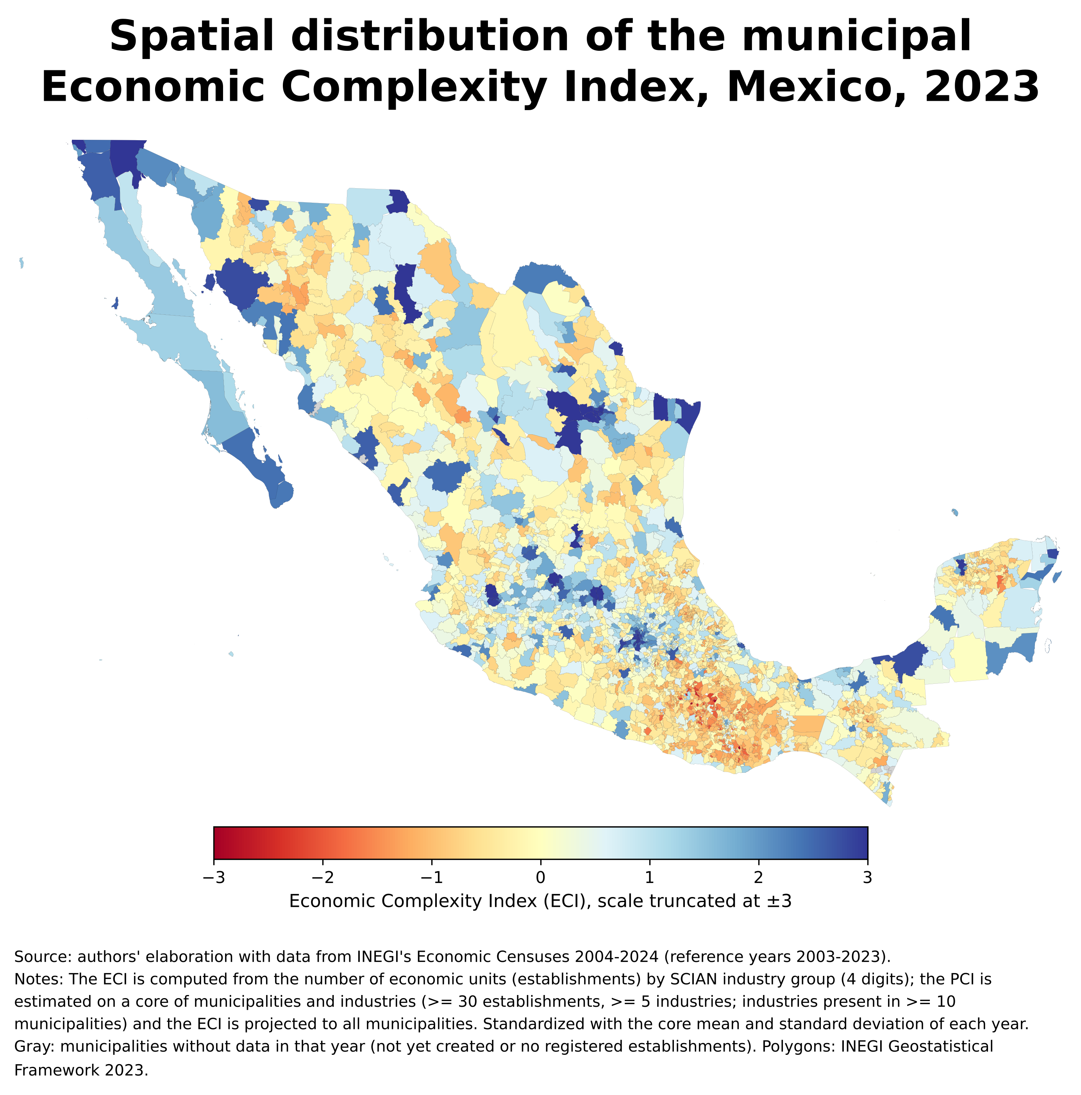
Map 1: Spatial distribution of the municipal ECI, Mexico, 2023
Figures 4 and 5 compare the distribution by CEEY region (the five-region classification of Mexican states of the Centro de Estudios Espinosa Yglesias) in 2003 and 2023. The median ECI of the South rose from −0.80 to −0.65 standard deviations, while that of the other regions is around zero (Center 0.10, Center-North 0.11, North-West 0.05 and North −0.07 in 2023). In 2023, 79% of the South's municipalities are below the core mean, and 35.5% of them belong to the lowest national quintile, compared with 3% to 9% in the other regions. The North displays a polarized pattern: 34% of its municipalities are in the top quintile (the urban and industrial centers), but its median is negative because of the rural municipalities of the interior of Sonora and Chihuahua. The territorial fracture therefore separates the South from the rest of the country rather than following a continuous north–south gradient.
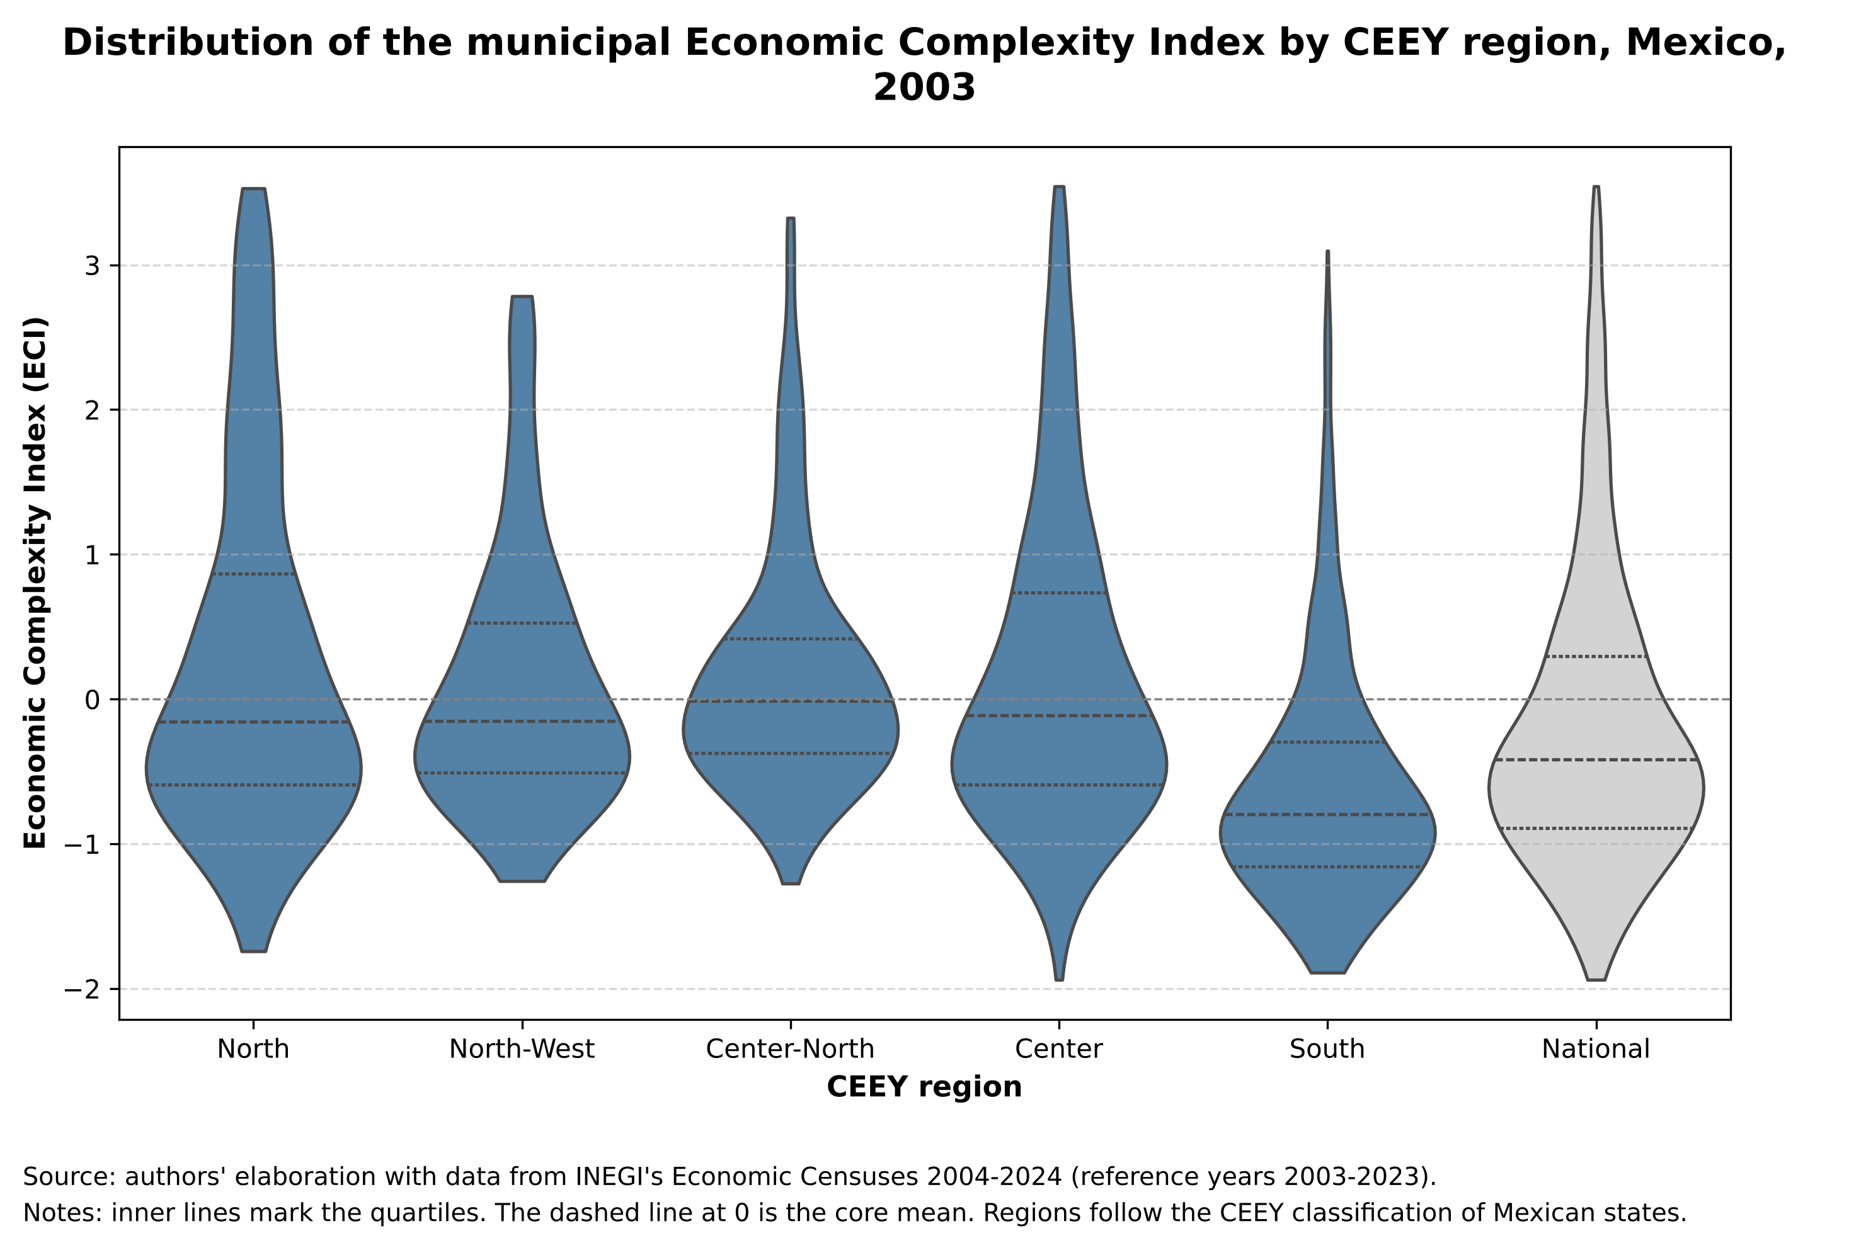
Figure 4: Distribution of the municipal ECI by CEEY region, Mexico, 2003
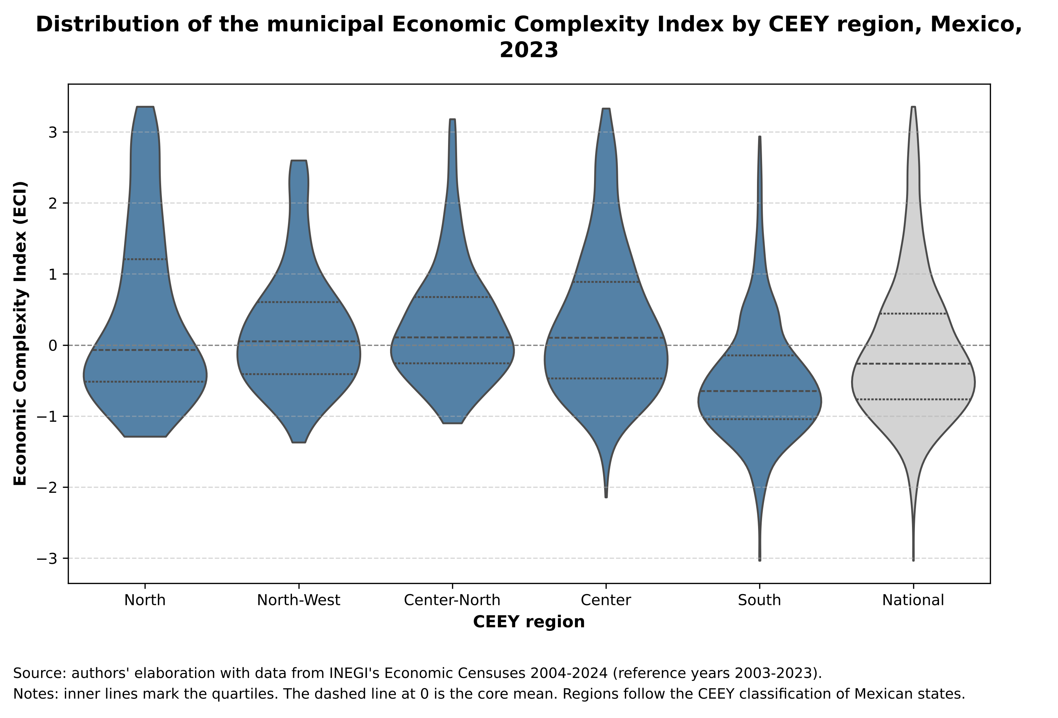
Figure 5: Distribution of the municipal ECI by CEEY region, Mexico, 2023

7.2 Current complexity and diversification potential
Figure 6 relates the ECI to the COI. The South combines low current complexity with low diversification potential (median COI of −0.70 in 2023): its municipalities not only have few capabilities but are also far from the complex activities into which they could diversify. In general, the COI increases with the ECI: municipalities with more capabilities are also closer to new complex activities, which tends to reproduce the gap. In the North the median COI is also low (−0.32), but because of the region's polarization: its rural municipalities have a very low COI, while its urban centers in the top quintile have a median of 1.90.
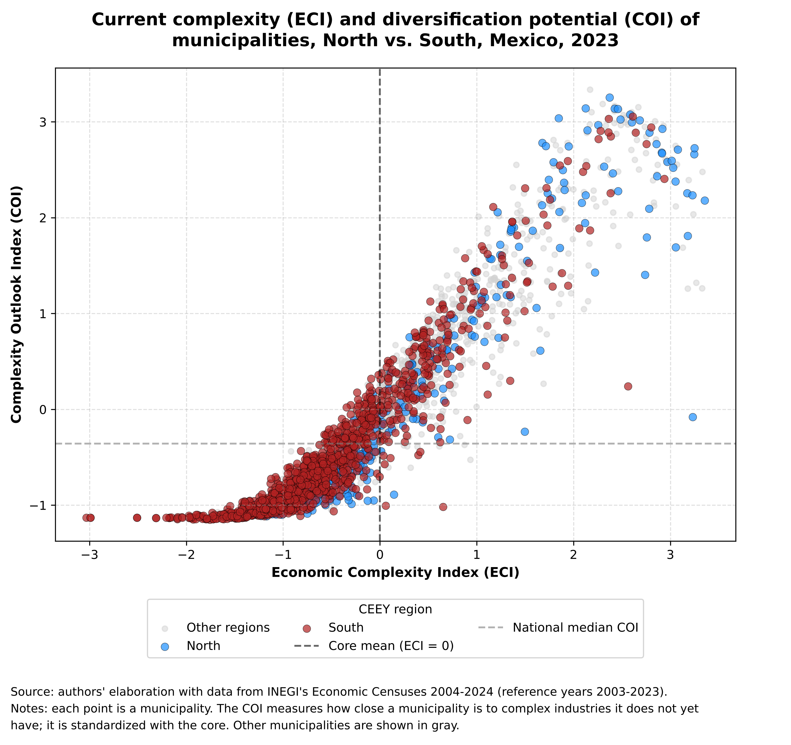
Figure 6: Current complexity (ECI) and diversification potential (COI), North vs. South, Mexico, 2023

7.3 Technological barriers to entry
The most complex industries in 2023 are financial services, scheduled air transportation and computer manufacturing (Figure 7), and they are located in few municipalities (ubiquity of 10 to 28). Technological distance to these activities reveals marked barriers to entry. Among municipalities in the two lowest ECI quintiles, none has a comparative advantage in any of the 20 most complex industries, and their average distance to them is 0.98 to 0.99 (on a 0–1 scale). In the top quintile, 42% have an advantage in at least one of those industries and the average distance is 0.80.
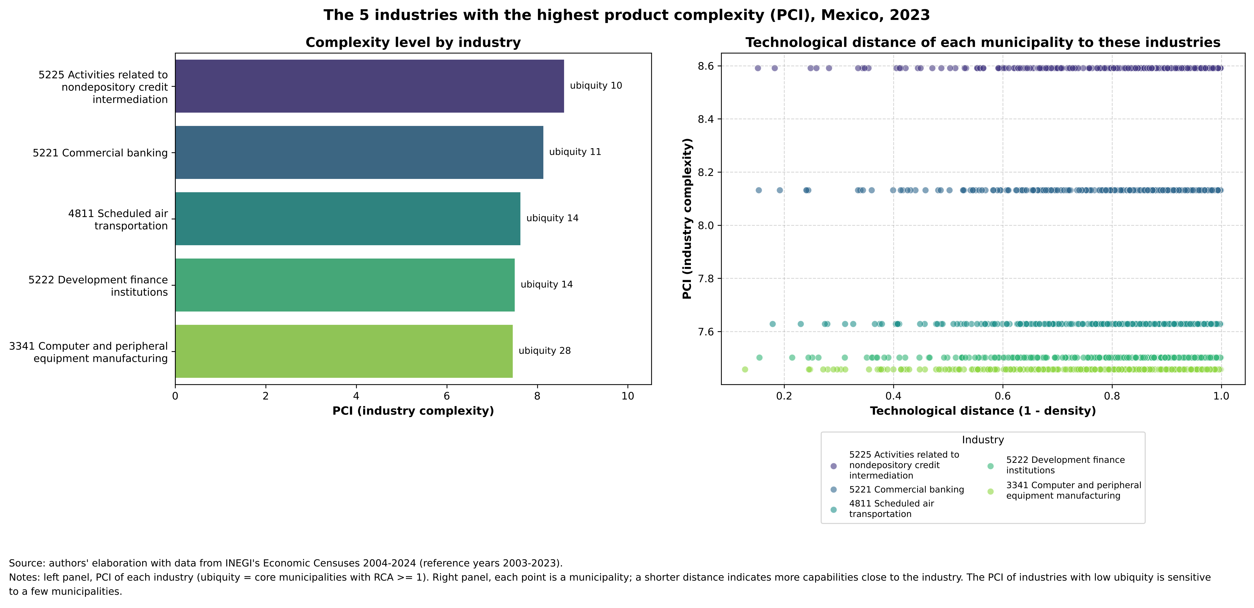
Figure 7: The five industries with the highest product complexity (PCI), Mexico, 2023
Figures 8 and 9 contrast the five most and least complex municipalities. The former have comparative advantages in many high-PCI industries, at short distances; the latter have them only in low-complexity industries (grocery retail, food preparation, basic services) and face distances close to one from any complex activity. For these municipalities, gradual diversification into nearby industries does not reach complex activities, because there are no intermediate industries close to them.
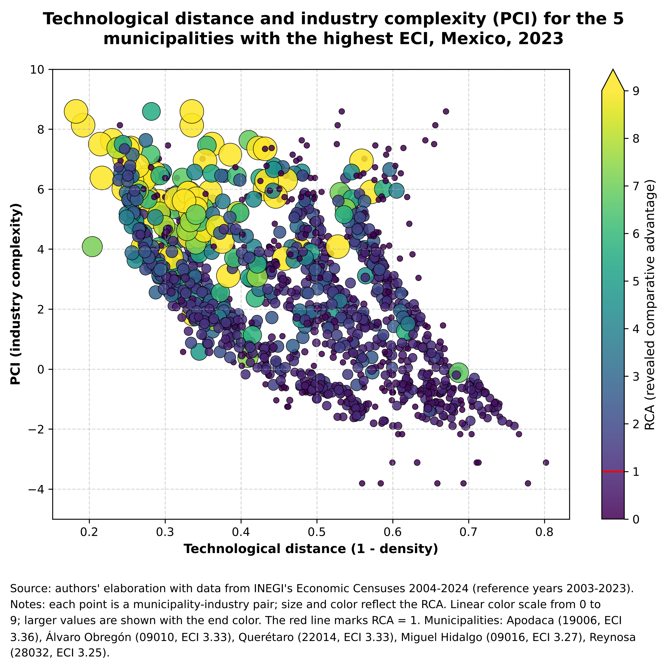
Figure 8: Technological distance and PCI of the five municipalities with the highest ECI, Mexico, 2023
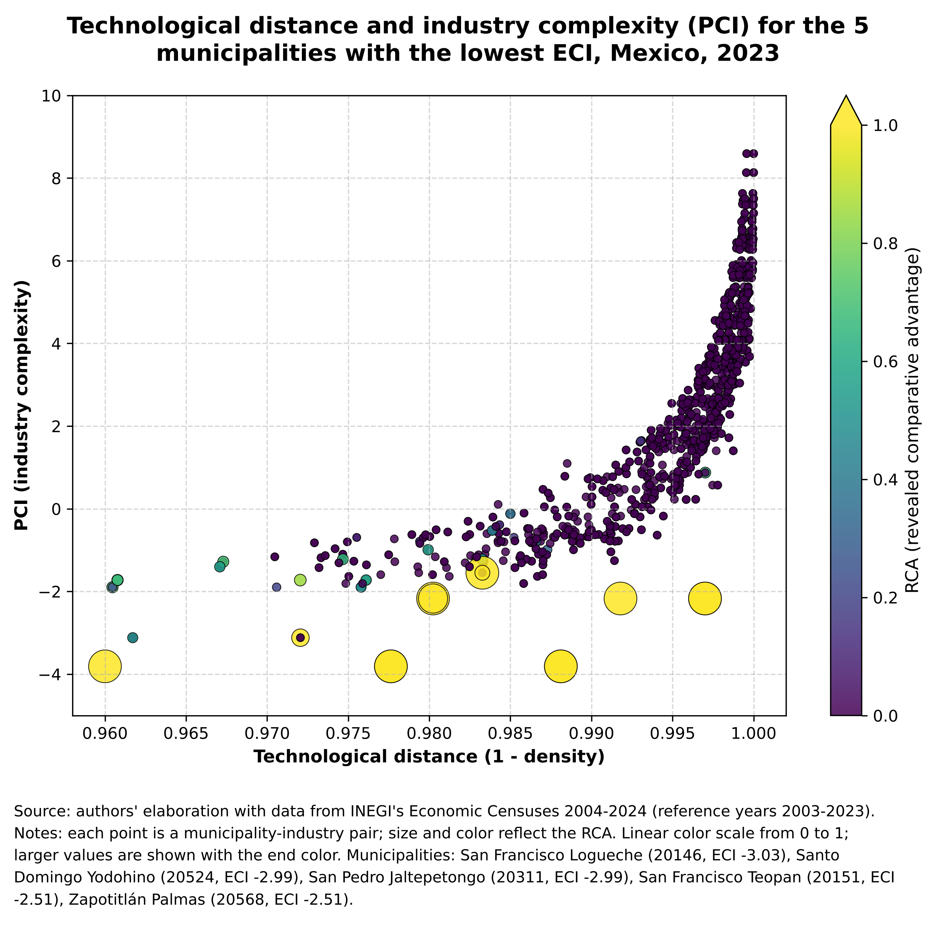
Figure 9: Technological distance and PCI of the five municipalities with the lowest ECI, Mexico, 2023

7.4 Structural immobility: sticky floors and ceilings
Matrix 1 documents the persistence of the relative position of municipalities between 2003 and 2023 (2,443 municipalities present in both years). In total, 60.7% remained in the same quintile and 96.2% moved at most one quintile; only 0.5% moved three or more quintiles. The extremes are the most persistent: 69.7% of the municipalities in the lowest quintile in 2003 were still there in 2023 (sticky floor), and 83.4% of those in the top quintile kept their position (sticky ceiling). Only 5 municipalities moved from the lowest quintile to the top two, and none fell from the top quintile to the bottom two. The rank correlation between both years is 0.91.
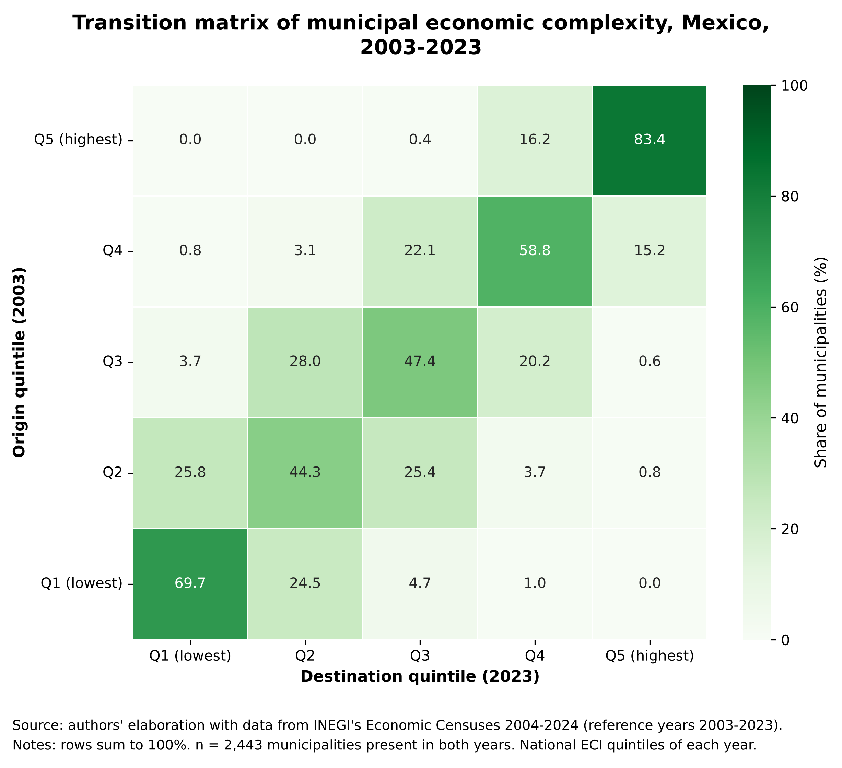
Matrix 1: Transition matrix of municipal ECI quintiles, Mexico, 2003–2023
By region (Matrix 2), the sticky floor is strongest in the North-West (75.0%) and the South (72.5%), and the sticky ceiling reaches 88–90% in the North, Center-North and Center. The South is the only region where the ceiling is less firm (68.2%): its few complex municipalities tend to lose position. Map 2 summarizes these dynamics: 803 municipalities remained in the two lowest quintiles in both years (persistent lag), concentrated in Oaxaca (427), Puebla (88), Veracruz (61), Yucatán (49) and Chiapas (42); 695 remained in the top two without changing quintile, mostly in the north and center; 350 moved up and 363 moved down.
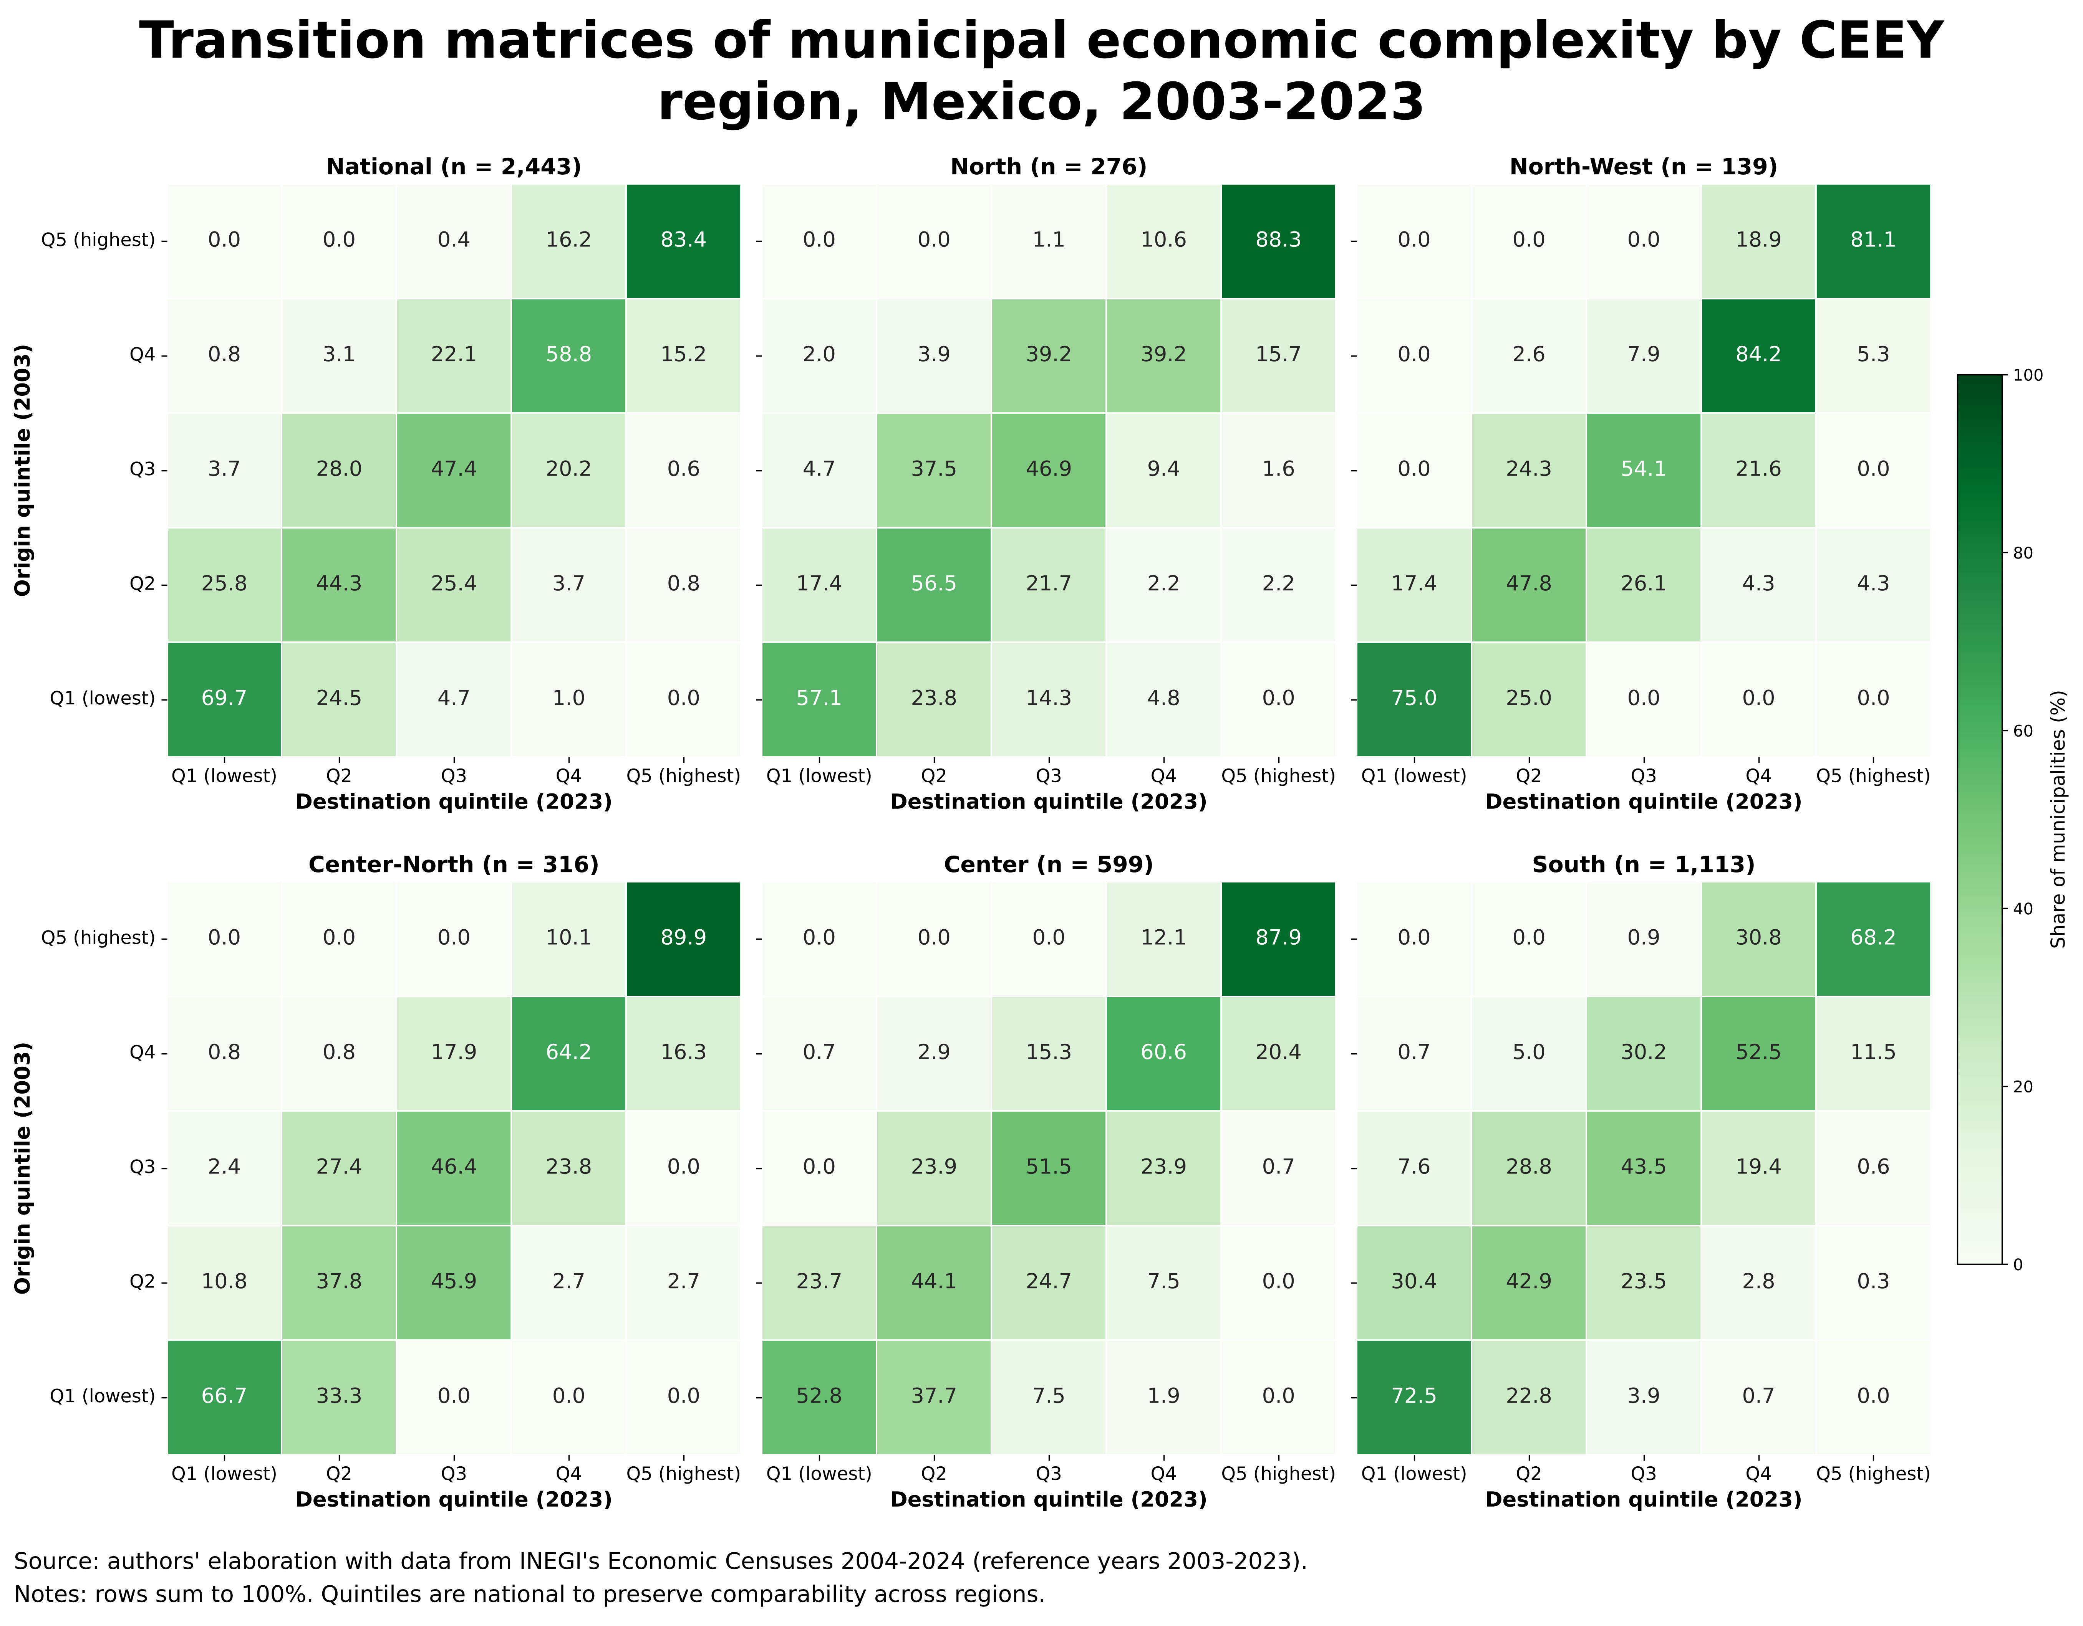
Matrix 2: Transition matrices of municipal ECI quintiles by CEEY region, Mexico, 2003–2023
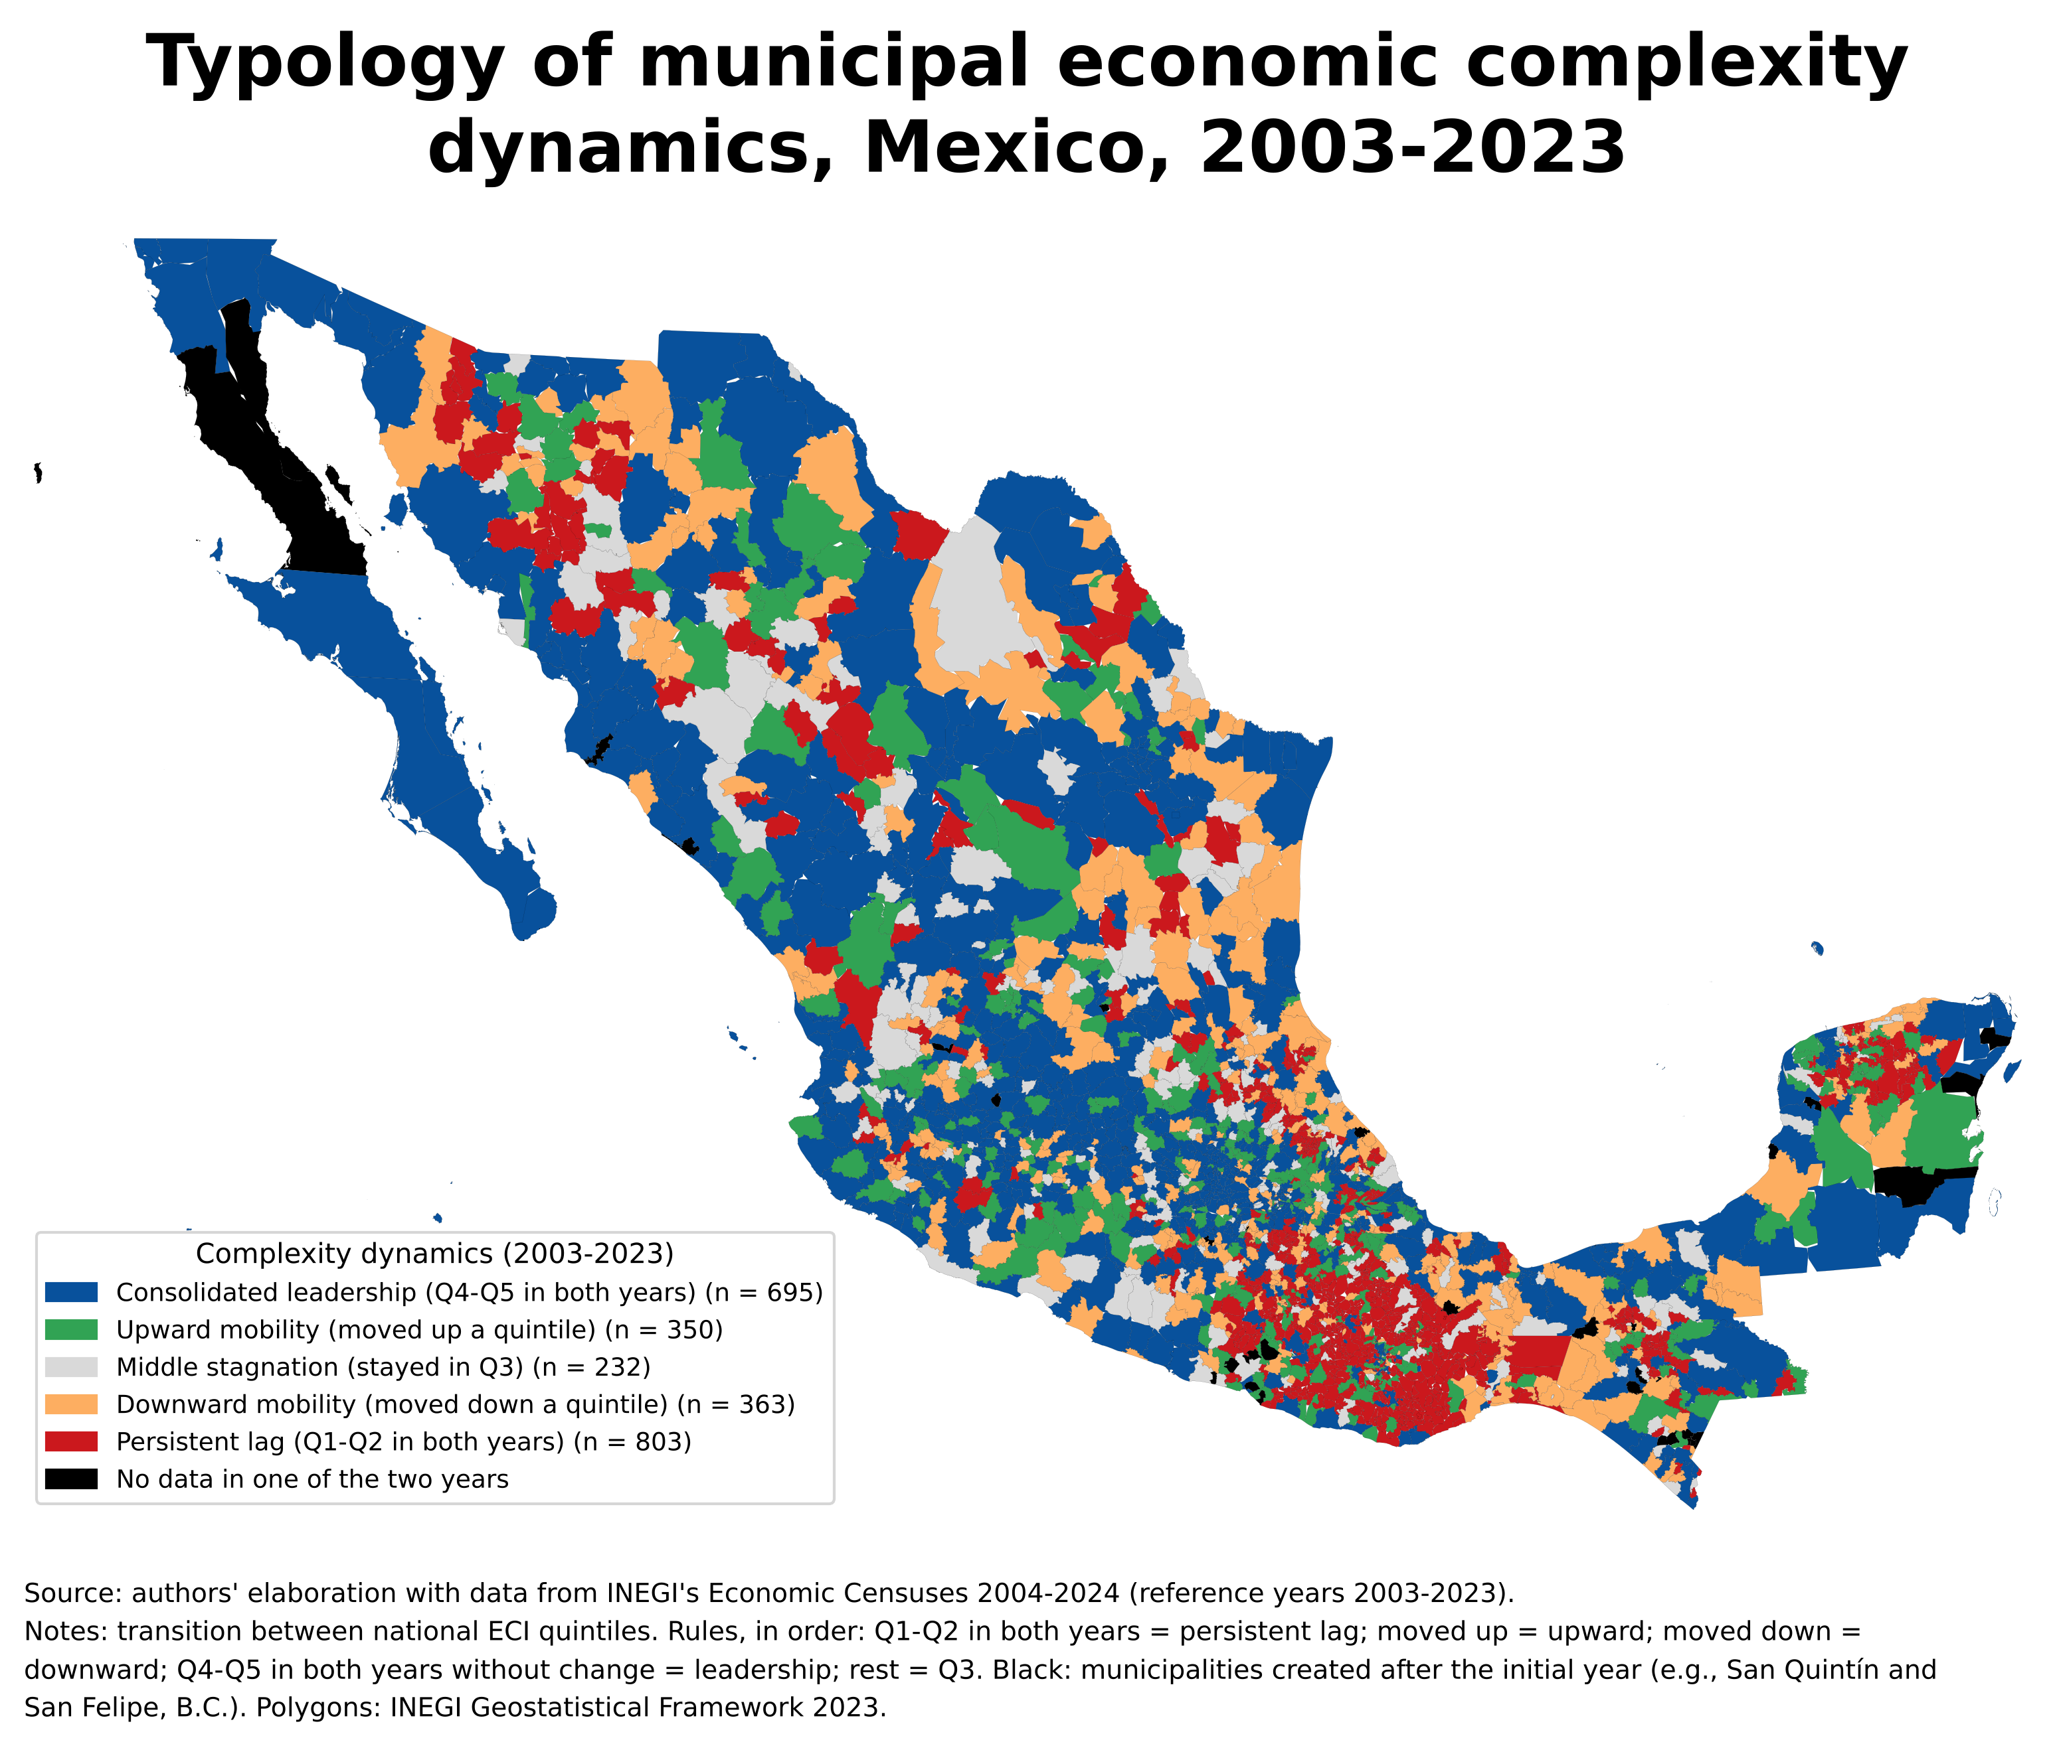
Map 2: Typology of municipal economic complexity dynamics, Mexico, 2003–2023
Two clarifications are needed to interpret these matrices. First, because the ECI is standardized in each year, persistence refers to relative positions: a municipality may have gained capabilities and still remain in its quintile if the rest advanced at the same pace. Second, the matrices are descriptive: they document immobility but do not identify its causes.

7.5 Spatial findings
The North–South fracture. The complexity gap separates the South from the rest of the country and persisted over two decades. The South has the lowest median ECI (−0.65 in 2023), concentrates more than a third of its municipalities in the lowest national quintile and has the lowest diversification potential. The North is not homogeneously complex: it combines high-complexity urban-industrial poles with a low-complexity rural interior.
Structural immobility. The municipal productive structure is highly persistent (rank correlation of 0.91 over twenty years, 96% of municipalities within one quintile of their original position), with sticky floors and ceilings. Initial territorial gaps in productive capabilities are largely reproduced over time.
Technological barriers to entry. Complex activities lie at an almost maximal distance from the capabilities of low-complexity municipalities, with no intermediate industries that would allow gradual diversification. In product-space terms, these municipalities are on the periphery of the network, far from the core where complex activities are located.
These findings are descriptive and must be read with the limitations of Section 6. In particular, the overlap between complexity and scale implies that the geography of complexity is, to a large extent, also the geography of urbanization. Any analysis that uses the ECI to explain territorial outcomes must therefore rest on its scale-independent component.

REFERENCES
Chávez, J. C., Mosqueda, M. T., & Gómez-Zaldívar, M. (2017). Economic complexity and regional growth performance: Evidence from the Mexican economy. Review of Regional Studies, 47(2), 201–219.
Gómez-Zaldívar, M., & Gómez-Zaldívar, F. (2023). Municipal economic complexity in Mexico: Productive capabilities, wealth, economic growth, and business sophistication. Review of Regional Studies, 53(1), 1–22.
Gómez-Zaldívar, M., Gómez-Zaldívar, F., & Carrillo Ramírez, J. L. (2024). Cálculo de los índices de complejidad en México: Propuesta para una estimación más periódica y robusta. Investigaciones Regionales – Journal of Regional Research, 59, 213–228. https://doi.org/10.38191/iirr-jorr.24.018
Gómez Zaldívar, M., & Gómez Zaldívar, F. (2026). The importance of specializing in complex manufacturing industries: Evidence from Mexican regions, 2004–2019. Investigaciones Regionales – Journal of Regional Research. https://doi.org/10.38191/iirr-jorr.26.005
González Sierra, J. A., Pérez Hernández, C. C., & Mendoza Moheno, J. (2023). Inclusión financiera y complejidad económica en México. Revista Mexicana de Economía y Finanzas Nueva Época, 18(2), 1–25. https://doi.org/10.21919/remef.v18i2p8
Hartmann, D., Guevara, M. R., Jara-Figueroa, C., Aristarán, M., & Hidalgo, C. A. (2017). Linking economic complexity, institutions, and income inequality. World Development, 93, 75–93. https://doi.org/10.1016/j.worlddev.2016.12.020
Hausmann, R., Hidalgo, C. A., Bustos, S., Coscia, M., Simoes, A., & Yıldırım, M. A. (2013). The Atlas of Economic Complexity: Mapping Paths to Prosperity. MIT Press.
Hidalgo, C. A., & Hausmann, R. (2009). The building blocks of economic complexity. Proceedings of the National Academy of Sciences, 106(26), 10570–10575. https://doi.org/10.1073/pnas.0900943106
Hidalgo, C. A., Klinger, B., Barabási, A.-L., & Hausmann, R. (2007). The product space conditions the development of nations. Science, 317(5837), 482–487. https://doi.org/10.1126/science.1144581
Instituto Nacional de Estadística y Geografía (INEGI). (2025). Censos Económicos 2024. Resultados definitivos. Sistema Automatizado de Información Censal (SAIC) [Data set]. INEGI. Retrieved September 8 and October 4, 2026.
Instituto Nacional de Estadística y Geografía (INEGI). (2023). Marco Geoestadístico 2023 and Catálogo Único de Claves de Áreas Geoestadísticas Estatales, Municipales y Localidades [Data sets]. INEGI.
Kummu, M., Kosonen, M., & Masoumzadeh Sayyar, S. (2025). Downscaled gridded global dataset for gross domestic product (GDP) per capita PPP over 1990–2022. Scientific Data, 12, 178. https://doi.org/10.1038/s41597-025-04487-x
Mealy, P., Farmer, J. D., & Teytelboym, A. (2019). Interpreting economic complexity. Science Advances, 5(1), eaau1705. https://doi.org/10.1126/sciadv.aau1705
Soloaga, I., Plassot, T., & Cazzuffi, C. (2025). A Common Framework to Analyze Social Mobility and Inequality of Opportunity in Functional Territories: Chile, Colombia and Mexico.
Tacchella, A., Cristelli, M., Caldarelli, G., Gabrielli, A., & Pietronero, L. (2012). A new metrics for countries' fitness and products' complexity. Scientific Reports, 2, 723. https://doi.org/10.1038/srep00723
The Growth Lab at Harvard University. (2025). py-ecomplexity (Version 0.5.3) [Computer software]. https://github.com/cid-harvard/py-ecomplexity

