Customer Support Operations Performance Review

Executive Summary
Customer support operations were analyzed to assess if agents are beaching SLA and what’s the cause in backlog of tickets, service efficiency, and agent performance.
Key findings:
- Ticket demand is stable and predictable, averaging ~66K tickets annually, over 5k tickets monthly and an average of 160 – 220 tickets daily.
- SLA breaches are not driven by demand spikes, but by resolution inefficiencies and poor first response time by agents
- Backlog growth is due a general pattern of agents attending to 50% of tickets handled by them and leaving the rest unresolved. This inefficincy is not due to issue complexity as tickets with low complexity till have an average 50% still unresolved.
- Agent performance is consistent more like a pattern among agents with is bads,with clear gaps in efficiency and SLA adherence
Primary conclusion:
Operational challenges are driven more by execution and efficiency than by demand growth.

Business Questions
This analysis focused on answering:
- Is support demand increasing or stable?
- Are we keeping up with incoming tickets?
- Where are SLA breaches concentrated?
- What is driving resolution delays?
- How do agents perform across workload and efficiency?

Data & Methodology

Data Scope
- 200K+ support tickets
- Time range covering 3 years
- Includes ticket lifecycle, SLA indicators, and resolution metrics

Key Metrics Defined
- Ticket Volume → total tickets created
- Resolution Output → tickets resolved
- SLA Compliance (%) → % of tickets resolved within SLA
- SLA Breach (%) → % of tickets resolved and unresolved that breached SLA
- Avg Resolution Time (hrs) → efficiency metric
- Avg First. Time Response (hrs) → efficiency metric
- Backlog → unresolved tickets

Approach
- Time-based trend analysis (daily, monthly, yearly)
- Category-level breakdown
- SLA and performance segmentation
- Agent-level efficiency evaluation

Findings

1. Demand is Stable
- Daily ticket volume ranges between 160–220 tickets
- Yearly volume remains consistent (~66K tickets)
Interpretation:
Demand is predictable and not the primary operational issue.
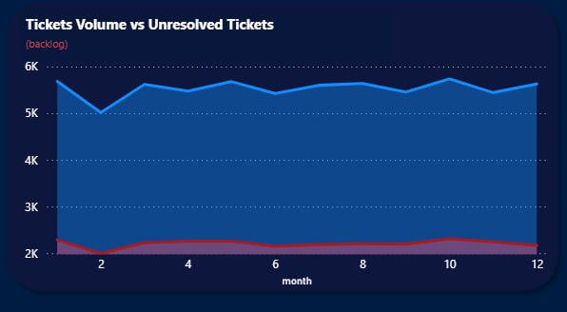

2. Resolution Capacity is the Constraint
- Periods where tickets created > tickets resolved result in backlog growth, which is soley caused by agents, all agents have approximately 50% resolution rate which keeps 50% of tickets unresolved attended to by each agent
Interpretation:
Operational inefficiencies, not demand spikes, are driving performance gaps.
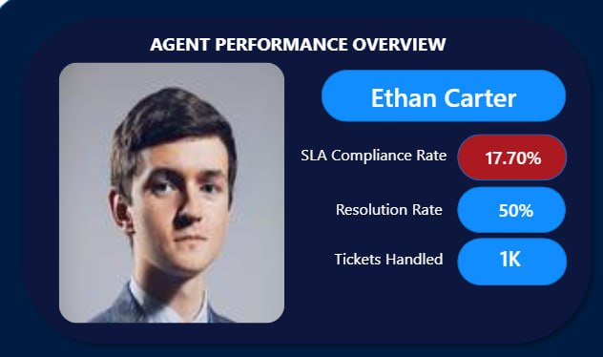

3. SLA Breaches are Concentrated
- Breaches are high All categories and for all agents which shows that Interpretation:
SLA issues are caused by workers and not a systematic problem. For each category no agent has a SLA complaince rate of over 30%, which shows poor performance by agents and not an issue complexity issue
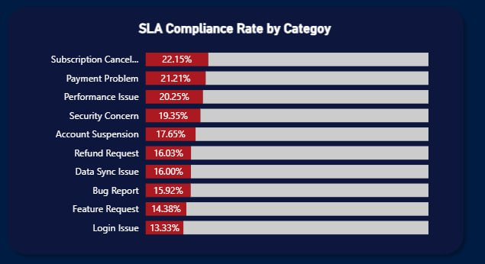

4. Category Concentration
- A small number of categories generate a large share of tickets
Interpretation:
Addressing root causes in these categories will significantly reduce workload.

5. Agent Performance Consistency
- Some agents handle:
  - High volume efficiently
- Others show:
  - Higher resolution times at lower volumes
- Each agent resolves an averae of 80 tickets monthly withstanding number of tickets assigned to them

Interpretation:
There is clear inefficiency and imbalance in workload distribution

6. Resolution Time and First Response Time Drives Performance
- Resolution time strongly correlates with:
  - SLA breaches
  - backlog accumulation
Agents have an average of responding to tickets after 33hrs and resolving them after approximaty 120 hrs which breaches SLA complinace rate and shows why all agents have a very low complinace rate with SLA.
Interpretation:
Improving resolution efficiency is the highest-impact lever.

Operational Insights
- Demand is not the problem → execution is
- Performance gaps are agent-specific and category-specific
- Workload is unevenly distributed
- SLA failures are predictable and preventable

Recommendations

1. Rebalance Workload
- Distribute tickets more evenly across agents
- Prevent overloading high performers

2. Focus on High-Impact Categories
- Investigate root causes
- Reduce repeat issues

3. Improve Resolution Efficiency
- Identify slow resolution patterns
- Introduce process improvements

4. Targeted Agent Coaching
- Support underperforming agents
- Focus training on problematic categories

5. Optimize Staffing Strategy
- Align staffing with weekday demand patterns
- Increase coverage during peak periods

6. Implement Performance Monitoring
- Track:
  - SLA compliance
  - resolution time
  - workload
- Use composite performance scoring

Conclusion
Support operations are not constrained by demand, but by how effectively tickets are handled.
By improving:
- resolution efficiency
- workload distribution
- category-level processes
the organization can significantly improve:
- SLA compliance
- customer experience
- operational efficiency
Customer support operations generate large volumes of tickets daily. However, without structured analysis, it is difficult to answer critical questions such as:

Is support demand increasing or stable?
Are agents keeping up with incoming tickets?
Where are SLA breaches occurring?
Which areas are driving workload and delays?
Which agents are performing efficiently, and which need support?

The lack of visibility into these areas can lead to:

Poor customer experience
Increased backlog
Inefficient staffing decisions
Missed SLA targets
2. Objective

The goal of this project is to build a data-driven support analytics system that:

Tracks ticket demand and trends
Measures SLA compliance
Evaluates agent performance
Identifies operational bottlenecks
Supports decision-making for staffing and process improvement
3. Dataset Overview

The dataset contains over 200,000 customer support tickets, including:

Ticket details: category, priority, channel
Time metrics: first response time, resolution time
Status: open, in progress, closed, pending customer
SLA indicator: breached or not
Customer attributes
Agent assignment (engineered for analysis)
4. Data Preparation & Feature Engineering

To enable meaningful analysis, several transformations were applied:

Agent Assignment
Simulated realistic agent allocation using:
ticket complexity
priority
escalation logic
Created structured tiers:
Tier 1
Tier 2
Escalation
Time Features
Extracted:
Year
Month
Year-Month
Day of week
SLA Recalculation
SLA thresholds defined based on priority:
Urgent → 6 hours
High → 8 hours
Medium → 24 hours
Low → 48 hours
Created:
SLA breached (True/False)
SLA compliance %
Performance Metrics
Tickets handled
Tickets resolved
Tickets unresolved
Average resolution time
First response time
5. Tools Used
Python (Pandas, NumPy)
Data cleaning, feature engineering, simulation
SQL
Data exploration and aggregation
Power BI
Dashboard development and visualization
6. Analysis & Key Findings
A. Ticket Demand Trends
Daily ticket volume ranges between 140 and 220 tickets
Yearly volume remains stable at approximately 66,000 tickets
No significant upward or downward trend observed

Insight:
Demand is stable and predictable, allowing for structured workforce planning.

B. Demand vs Resolution Capacity
Ticket inflow and resolution trends were compared over time
Periods where demand exceeds resolution indicate backlog growth

Insight:
Performance issues are not driven by demand spikes, but by resolution inefficiency

C. SLA Performance
SLA compliance varies by:
ticket category
priority
agent
High-complexity tickets are more likely to breach SLA

Insight:
SLA issues are not uniform, and are concentrated in specific areas.

D. Category Analysis
A small number of categories drive the majority of tickets

Insight:
Targeting these categories can significantly reduce total workload.

E. Agent Performance

Agent performance was evaluated using:

SLA compliance
Average resolution time
Tickets handled

A composite Performance Score was created to balance:

efficiency
quality

Insight:

Some agents handle high volume efficiently
Others show high resolution times despite lower workload
Performance differences are significant and actionable
F. Workload Patterns (Day of Week)
Ticket volume varies by weekday
Certain days show higher load and slower resolution

Insight:
Staffing and scheduling can be optimized using weekday patterns.

7. Dashboard Design

Two dashboards were developed:

1. Support Operations Overview

Provides a high-level view of operations:

Ticket volume trends
SLA compliance
Demand vs resolution comparison
Top complaint categories
Resolved vs unresolved tickets

Purpose:
Monitor overall system performance and identify operational risks

2. Agent Performance & Efficiency Dashboard

Focused on individual agent analysis:

Performance score
SLA compliance
Resolution and response time trends
Workload vs resolution trend
Category-level performance

Purpose:
Enable targeted coaching and performance optimization

8. Key Business Insights
Demand is stable → problem is not volume, but execution
SLA breaches are concentrated in specific categories and agents
Resolution time is a major driver of performance issues
Some agents are overloaded, while others are underutilized
A small number of categories drive a large portion of workload
9. Recommendations
1. Optimize Workload Distribution
Reassign tickets to balance agent workload
Prevent overload on high-performing agents
2. Target High-Impact Categories
Investigate root causes of top complaint categories
Improve product or process to reduce volume
3. Improve SLA Performance
Focus on high-priority and complex tickets
Introduce escalation rules earlier
4. Agent Training & Coaching
Identify agents with high resolution times
Provide targeted support for specific categories
5. Staffing & Scheduling
Align staffing with weekday demand patterns
Increase coverage during peak days
6. Performance Monitoring
Use composite performance score for evaluation
Track trends over time, not just static values
10. Conclusion

This project demonstrates how structured analysis of support data can:

Improve operational visibility
Identify performance gaps
Support better decision-making

By combining ticket trends, SLA metrics, and agent performance analysis, the organization can move from reactive support to data-driven operations management. Problem

Customer support operations generate large volumes of tickets daily. However, without structured analysis, it is difficult to answer critical questions such as:

Is support demand increasing or stable?
Are agents keeping up with incoming tickets?
Where are SLA breaches occurring?
Which areas are driving workload and delays?
Which agents are performing efficiently, and which need support?

The lack of visibility into these areas can lead to:

Poor customer experience
Increased backlog
Inefficient staffing decisions
Missed SLA targets
2. Objective

The goal of this project is to build a data-driven support analytics system that:

Tracks ticket demand and trends
Measures SLA compliance
Evaluates agent performance
Identifies operational bottlenecks
Supports decision-making for staffing and process improvement
3. Dataset Overview

The dataset contains over 200,000 customer support tickets, including:

Ticket details: category, priority, channel
Time metrics: first response time, resolution time
Status: open, in progress, closed, pending customer
SLA indicator: breached or not
Customer attributes
Agent assignment (engineered for analysis)
4. Data Preparation & Feature Engineering

To enable meaningful analysis, several transformations were applied:

Agent Assignment
Simulated realistic agent allocation using:
ticket complexity
priority
escalation logic
Created structured tiers:
Tier 1
Tier 2
Escalation
Time Features
Extracted:
Year
Month
Year-Month
Day of week
SLA Recalculation
SLA thresholds defined based on priority:
Urgent → 6 hours
High → 8 hours
Medium → 24 hours
Low → 48 hours
Created:
SLA breached (True/False)
SLA compliance %
Performance Metrics
Tickets handled
Tickets resolved
Tickets unresolved
Average resolution time
First response time
5. Tools Used
Python (Pandas, NumPy)
Data cleaning, feature engineering, simulation
SQL
Data exploration and aggregation
Power BI
Dashboard development and visualization
6. Analysis & Key Findings
A. Ticket Demand Trends
Daily ticket volume ranges between 140 and 220 tickets
Yearly volume remains stable at approximately 66,000 tickets
No significant upward or downward trend observed

Insight:
Demand is stable and predictable, allowing for structured workforce planning.

B. Demand vs Resolution Capacity
Ticket inflow and resolution trends were compared over time
Periods where demand exceeds resolution indicate backlog growth

Insight:
Performance issues are not driven by demand spikes, but by resolution inefficiency

C. SLA Performance
SLA compliance varies by:
ticket category
priority
agent
High-complexity tickets are more likely to breach SLA

Insight:
SLA issues are not uniform, and are concentrated in specific areas.

D. Category Analysis
A small number of categories drive the majority of tickets

Insight:
Targeting these categories can significantly reduce total workload.

E. Agent Performance

Agent performance was evaluated using:

SLA compliance
Average resolution time
Tickets handled

A composite Performance Score was created to balance:

efficiency
quality

Insight:

Some agents handle high volume efficiently
Others show high resolution times despite lower workload
Performance differences are significant and actionable
F. Workload Patterns (Day of Week)
Ticket volume varies by weekday
Certain days show higher load and slower resolution

Insight:
Staffing and scheduling can be optimized using weekday patterns.

7. Dashboard Design

Two dashboards were developed:

1. Support Operations Overview

Provides a high-level view of operations:

Ticket volume trends
SLA compliance
Demand vs resolution comparison
Top complaint categories
Resolved vs unresolved tickets

Purpose:
Monitor overall system performance and identify operational risks

2. Agent Performance & Efficiency Dashboard

Focused on individual agent analysis:

Performance score
SLA compliance
Resolution and response time trends
Workload vs resolution trend
Category-level performance

Purpose:
Enable targeted coaching and performance optimization

8. Key Business Insights
Demand is stable → problem is not volume, but execution
SLA breaches are concentrated in specific categories and agents
Resolution time is a major driver of performance issues
Some agents are overloaded, while others are underutilized
A small number of categories drive a large portion of workload
9. Recommendations
1. Optimize Workload Distribution
Reassign tickets to balance agent workload
Prevent overload on high-performing agents
2. Target High-Impact Categories
Investigate root causes of top complaint categories
Improve product or process to reduce volume
3. Improve SLA Performance
Focus on high-priority and complex tickets
Introduce escalation rules earlier
4. Agent Training & Coaching
Identify agents with high resolution times
Provide targeted support for specific categories
5. Staffing & Scheduling
Align staffing with weekday demand patterns
Increase coverage during peak days
6. Performance Monitoring
Use composite performance score for evaluation
Track trends over time, not just static values
10. Conclusion

This project demonstrates how structured analysis of support data can:

Improve operational visibility
Identify performance gaps
Support better decision-making

By combining ticket trends, SLA metrics, and agent performance analysis, the organization can move from reactive support to data-driven operations management.

