Vision and Scope Document

for

Ski Tracker

Version 1.0 approved

Prepared by David Askwith

Confederation College Computer Programmer

October 3, 2017

Table of Contents

Table of Contents ii

Revision History ii

1. Business Requirements 1

1.1. Background 1

1.2. Business Opportunity 1

1.3. Business Objectives 1

1.4. Success Metrics 1

1.5. Vision Statement 1

1.6. Business Risks 1

1.7. Business Assumptions and Dependencies 2

2. Scope and Limitations 2

2.1. Major Features 2

2.2. Scope of Initial Release 2

2.3. Scope of Subsequent Releases 2

3. Business Context 2

3.1. Stakeholder Profiles 2

3.2. Project Priorities 3

3.3. Deployment Considerations 4

Revision History

|  |  |  |  |
| --- | --- | --- | --- |
| **Name** | **Date** | **Reason for Changes** | **Version** |
| David Askwith | 10/13/17 | Initial Release | 1.0 |
|  |  |  |  |

# Business Requirements

## Background

Athletes in competitive sport are willing to spend a great deal of money and make many personal sacrifices to improve their performance in competition. For cross-country skiing the selection of skis and the waxes plays a major role in the success of the athletes in competition. Athletes, coaches and wax technicians spend substantial amounts of time testing skis and waxes prior to competition. The records of skis, conditions and wax combinations used in events and testing allow for better preparation for future competitions. The manual process of recording ski and wax attributes and testing data is a tedious process that can result in limited or inconsistent data that is hard to review. These inconsistencies and the inability to efficiently review recorded data causes reduced performance for athletes due to added stress, ineffective ski chose or poor wax selection. Sharing of manually recorded data is inconvenient and the data shared is hard to interpret due to people’s differences in recording techniques. Wax and ski companies’ advancements are greatly affected by data collected on the performance of their products current products.

## Business Opportunity

A system that would simplify and standardize the way data is recorded allowing for easy review would decrease the time spent testing, increase consistency in waxing results and increase athlete performance. The simplification of the process encourages more people to keep accurate records for wax and skis testing. The ability for support staff to easily review this data would allow them to make rapid decisions for waxing based on previous success. The ability for support staff to share standardized data on waxing would help them avoid common mistakes and allow them to use wax combinations proven to work by other people’s testing. This would result in higher quality race wax. Athletes having access to accurately recorded data about the attributes of their skis helps them make correct and efficient ski choses based on the current conditions. This reduces the stress on the athlete by mitigating the doubt in their ski selection and allows them more time to focus on other aspects of preparation related to the competition. These factors contribute to an increased performance for athletes. Wax and ski companies having access to data on the performance of their skis enables them to refine their products and help advance skiing technologies.

## Business Objectives

BO-1: Decrease in time spent testing waxes and skis by 25% within the first year.

BO-2: Increase in athlete satisfaction with race wax by 10% within the first year

BO-3: 8 companies will purchase testing data relevant to their products within the first 2 years

BO-4: Support staff report a 10% increase in race wax quality within the first year

BO-5: Athletes and support staff will record 10% more data on wax and ski testing within 6 months

## Success Metrics

SM-1: The application will have at least 2500 downloads within the first year

SM-2: There will be at least 12500 skis logged in the system within the first year

SM-3: The application will maintain an average customer rating of 4 out 5 or above on both the Play Store and Apple Store

SM-4: At least 20000 ski and wax testing results will be recorded within the first year

## Vision Statement

For competitive cross-country skiers and support staff who need a system to document the results of ski and wax testing the Ski Tracker is a data management application that allows for the compilation of wax and ski testing data that is easily retrievable. This expedites the testing process and makes the final decisions for wax and skis more accurate. The ability to share the recorded data in a standardized format allows for better collaboration between support staff resulting in better performance for the athletes. The ability for companies to access data on the performance of their products allows for rapid development of ski and wax technologies. Unlike the current manual process of recording test data our product will allow for standardized documentation and rapid retrieval of data with smart suggestions for skis and waxes.

## Business Risks

RI-1: The user adoption will be too low to justify the time spent on the development of the system (Probability = 3; Impact = 9)

RI-2: Support staff will be unwilling to make use of the data provided by the athletes resulting in a limited improvement on ski selection and waxing for athletes (Probability = 3; Impact = 8)

RI-3: Athletes will not provide sufficient data limiting the support staff’s ability to aid in athlete ski selection (Probability = 2; Impact = 6)

RI-4: Wax and ski companies will not be interested in the data collected resulting in a loss in profits (Probability = 4; Impact = 4)

## Business Assumptions and Dependencies

AS-1: Stakeholders will have access to devices that they can use with the system

AS-2: Stakeholders will have access to an internet connection to share the data

# Scope and Limitations

## Major Features

FE-1: Categorized documentation of skis and the attributes related to each ski

FE-2: Categorized documentation of waxes and the attributes related to each wax

FE-3: System for orchestrating and documenting the ski testing process

FE-4: System for orchestrating and documenting the wax testing process

FE-5: Provide access to the system for mobile phones, tablets and computers using any operating system

FE-6: Intelligent ski suggestion based on current conditions

FE-7: Intelligent wax suggestion based on current conditions

FE-8: Sharing of athlete ski data with coaches and support staff and sharing of data with individual users

FE-9: Output of data in multiple common formats

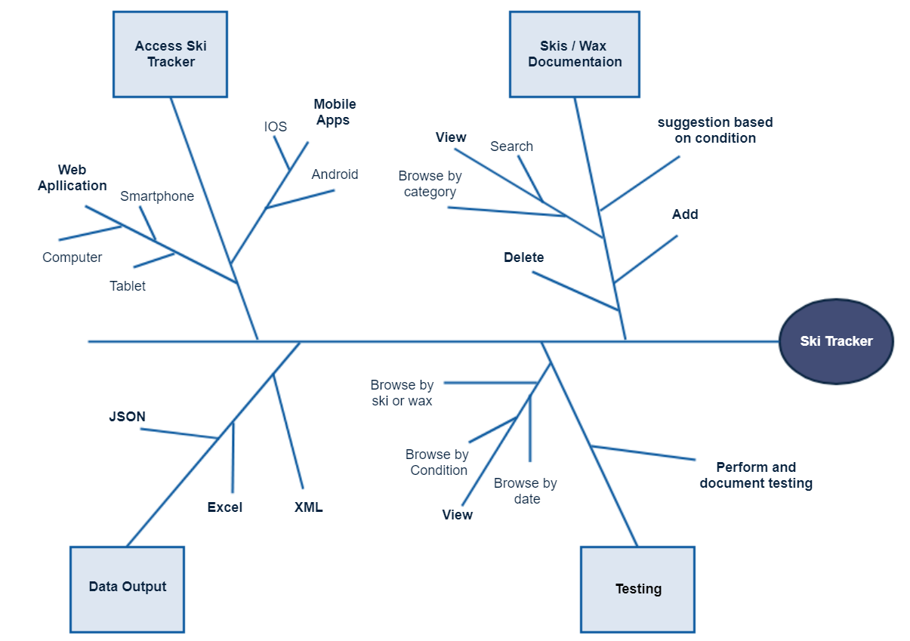

FIGURE 1: Partial feature tree for Ski Tracker

## Scope of Initial and Subsequent Releases

|  |  |  |  |
| --- | --- | --- | --- |
| Feature | Release 1 | Release 2 | Release 3 |
| FE-1, Ski info documentation | Fully implemented |  |  |
| FE-2, Wax info documentation | Not implemented | Fully implemented |  |
| FE-3, Ski testing | System for inputting test results and retrieval based on the date of test or a specific ski | Retrieval based on condition | Fully implemented |
| FE-4, Wax testing | Not implemented | System for inputting test results and retrieval based on the date of the test or a specific wax | Retrieval based on condition |
| FE-5, System access | IOS and Android phone apps | Web app and tablet specific IOS and Android apps | Windows phone and tablet app |
| FE-6, Ski suggestion | Not implemented | Based on input conditions | Based on retrieved weather for current location and input specifics |
| FE-7, Wax suggestion | Not implemented | Not implemented | Based on input conditions |
| FE-8, Sharing of data | Not implemented | allowing coaches / support staff the ability to view all their athlete’s data | Sharing data with a specific user |
| FE-9, Output of data | Not implemented | Not implemented | Fully implemented |

# Business Context

## Stakeholder Profiles

|  |  |  |  |  |
| --- | --- | --- | --- | --- |
| **Stakeholder** | **Major**  **Value** | **Attitudes** | **Major Interests** | **Constraints** |
| Athletes | Increased performance | Receptive, but expects ease of use | Easier recording for testing and easy review of previous tests | User-friendly |
| Wax Technicians | Decreased time testing and increased quality of waxing | Slightly resistant due to possibility of previously implemented systems | Ability to review previous wax information and the success of the combinations for the condition it was used | Must be able to review multiple athlete’s data |
| Coaches | Increased ability to analyze ski chose with athletes | Receptive | Ability to easily access athletes testing data | Must be able to review multiple athlete’s data |
| Wax Companies/ Ski Companies | Data on implementation of their waxes or skis | Receptive | More data on product performance to be used for research and development | Data transferable to other systems (e.g. Excel) |

## Project Priorities

|  |  |  |  |
| --- | --- | --- | --- |
| **Dimension** | **Driver (state objective)** | **Constraint (state limits)** | **Degree of Freedom (state allowable range)** |
| Schedule |  |  | Release of version 1.0 within the next 2 years |
| Features | The project must include all the features outlined for release 1.0 |  |  |
| Quality |  | All security tests must pass; 90 % of user acceptance tests must pass for release 1.0 |  |
| Staff |  | Staff must be willing to contribute for free |  |
| Cost |  | Budget only includes costs for hosting |  |

## Deployment Considerations

With the initial release documentation will need to be provided to aid users in the use of the application. The webserver purchased for hosting the application will need to be configured in a way that it can scale to a larger user base and amount of data. The application will need to be able to record data offline and online.