Phenomobile project

Raw Data
<here will be description on the raw data like hyper spectral and thermal image >

Files diagram

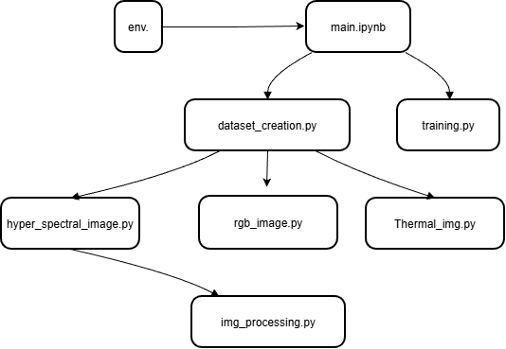

Files description
files store in Ubuntu folder

main.ipynb- in process
run the application from here . ( Later will be attached cli tool for manipulating the application.)

env.
Environment parameters like the server credentials and raw Data location. To some raw data will be attached annotation file that will include some additional information like the bounding box of the objects.

training.py
here we apply machine learning algorithm like classification or regression.

dataset_creation.py
The raw Data for the dataset creation store in the local server.
We take the image from the server and create two dataset one for hyper-spectral images and the other for thermal images. It is passable to create only one dataset.
By default only only hyper spectral dataset is done. If we want to add thermal dataset we must to set parameter "TH"=True in the ctor of this class . There are another parameter the relevant for the creation of the dataset as explained in the code itself.
If parameters "TH" and "HS" are true the datasets merged by SIFT algorithm and store as merged dataset.

Merge dataset
In this file we merge the reference dataset with the hyper Parameter dataset.

hyper_spectral_image.py :
include the functions for computation of the relevant indices from hyper- spectral image
Isolate the target object
Most of the image include the object target. It can be leaves (like leaves of sesame or corn ) or lettuce. Before compute the vegetation indices from the target object we must to isolate the target object and the calibration panel (if it included in the image). There are two option of isolate the objects – with hsv parameter of with ndvi parameters. The last option if preferred.

Option 1
We choose to do it with the separation of the HSV model. It is important to note that different values for the HSV parameters are used to isolated ,depend on the kind for the object and the background of the image. So in each scenario we must to tune the parameter and the condition based on image HSV values.

- The map of parameters below show the conditions suitable for each object gain by experience from the HS images we collected.
Map of conditions:
- leaves (sesame ,corn) : (hue_img > 0.25) & (saturation_img > 0.5)
- lettuce (BENI-ATAROT) (hue_img < 0.3) & (saturation_img > 0.5)

Option 2
Use ndvi values to isolate the leaves. This technique is better because it is work regard less the background of the rgb image. Also here we must to tune the ndvi threshold to filter out the leaves. The limit in this approach that its work good for wealth leaves , but in case of dried leaves the ndvi can be close to 0.1 and it contradict with other elements in the image that have this values.

Computing vegetation indices
Compute NDVI and other vegetation indices for the target object.s

Thermal_img.py
Compute the temperature for thermal image.
The metadata for this camera and for the image can be retrieve by exiftool application.
Our mission is to find the temperature of the leaves.
Every FLIR image file contain two images on the same plant bed: Thermal image and RGB image. The Thermal image sizes are included in the RGB image. (Picture in Picture)
We use the RGB image for detecting the leaves pixels:
- First we use hsv channels to receive the pixels of the leaves (* see comment below)
- Second : we eliminate the reflectance calibration panel from the RGB image and store it as gray image
- In this step we filter form the thermal image the pixels that higher from the air temperature and then apply logical AND with the gray cropped image.
At the end we receive image look like this shape:
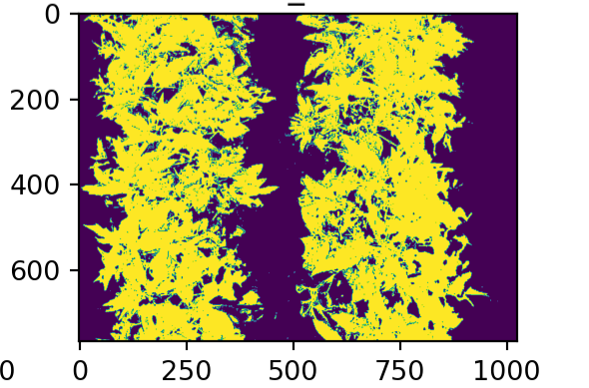
We compute the temperature of this pixels in the thermal images and save statistic parameter for this like the mean temperature.

Comment * : how we filter the leaves by hsv model
We apply the filter in filtered_rbg_img_by_hsv_channels function. The parameters compute for leaves of corn and sesame but may be different for other objects.
We use value and saturation channels to filter the object.
- Remove shadow (of the leaves ) : value channel > 0.3
- Remove calibration panel : value channel < 1
- Combine the last condition with saturation channel < 0.2

Image_processing.py
Include functions that necessary for isolating the objects in the image – for example in the case of the lettuce – that we have more than one object in the image and we want to compute the vegetation indices for each object oneself.

rgb_image.py
include functions to filter out objects (like plant or leaves) from rgb images and compute relevant index like hsv values of the plants.

