Lettuce project

Field organization
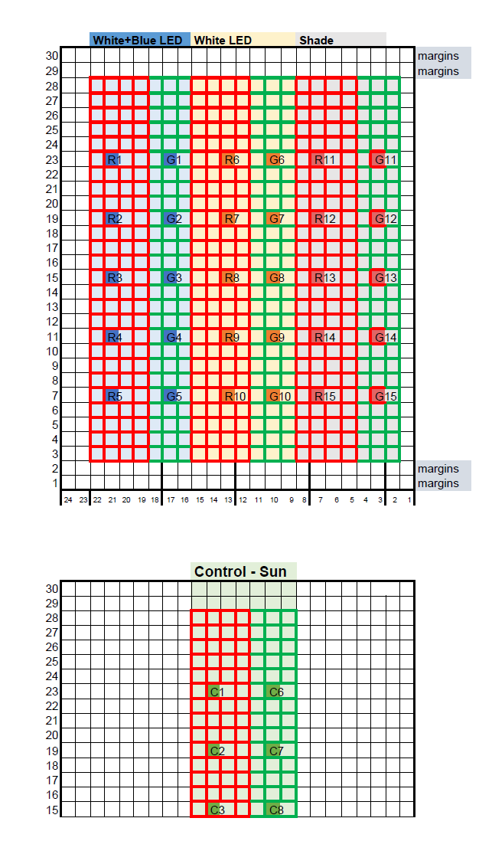

Raw data

RGB images
Rgb images of each kind of lettuce taken every couple of days.

Tree diagram of the hyper spectral folder
<PROJECT NAME>
- <YEAR>
  - <DATE>
    - RGB
      - <NUMBER X1>
      - <NUMBER X2>
      - […]
      - <NUMBER Xn>
    - <<csv file of the bounding boxes>>
In dataset_creation.py we apply create_RGB_ds and then a dataset with hsv values (like the mean of the hue value of a plant) computed and stored in dataset folder.

Hyperspectral images
Every batch of image attached json file with bounding boxes of the lettuces.
This is a csv file that created by annotation program (Make Sense ) on the png images of hyper spectral images.

Tree diagram of the hyper spectral folder
<PROJECT NAME>
- <YEAR>
  - <DATE>
    - HS
      - <NUMBER X1>
      - <NUMBER X2>
      - […]
      - <NUMBER Xn>
    - <<csv file of the bounding boxes>>

Comment about the orientation of image that use for the annotation
we found out that in the current configuration of the SPECIM hyper spectral camera png image is different in orientation from image that receive from reading the hdr file in the reflectance folder. The png image is rotaed 90 degrees to the right from the image extracted from the hdr file . so by default when we took the annotations from the annotation file we first rotate the image 90 degree to the right to adapt to the coordinated of bounding box. This behavior anchored in the rotate Boolean parameter that have default value of True in the ctor of image_processing class in image_processing.py – if alternative configuration will be set then the rotate parameter need to change.

Mapping between the images and kind of plants – first trial
Scientific explanation on the project can be found here.
Every time we take pictures of the lettuces we number them from 1 to 8. For example look at this image:
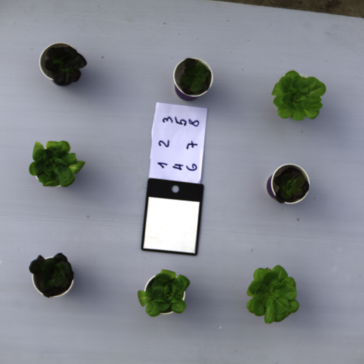
The mapping between them is as the follow:
Number 1:6 are correspond to plot : R1,G1,R6,G6,R11,G11
Number 7:8 are control group and correspond to C1,C6

R -stand for Red lettuces
G- stand for Green lettuces
C1 belong to the Reds, and C6 belong to the Greens
Light conditions
Be aware that actually there are only four class and for each class there are two samples:
- White and blue Led (R1,G1)
- White Led (R6,G6)
- Shade (R11,G11)
- Control (C1,C6)
Description on the plot arrangement can be found here.

Mapping between the images and kind of plants – second trial
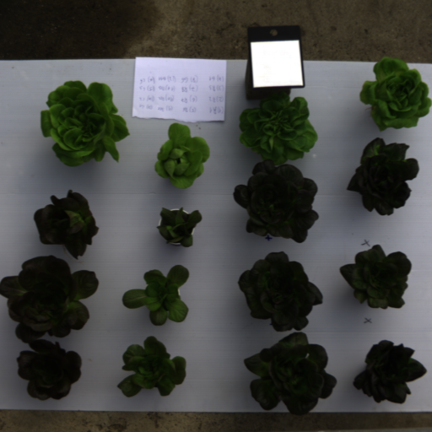
C6
C3
C2
C1
G11
R12
R11
R13
G6
R3
R8
R7
R2
R1
R6
G1
C1,C2,C3 belong to the red, C6 belong to the green.

Dataset creation
The raw dataset contain hyper-spectral images. We create from it dataset with vegetation indices for all the samples\objects in the raw images. Then we merge this dataset with reference dataset that contain the values of target variable (Anthocyanin) . you can found example to this dataset here.

Configuration json file
We use configuration file for the creation of the dataset.
The config file located in "config" folder and set in the .env file. Because of the different in thy way each raw dataset was crafted we created config file for each one of this dataset. So it is important to choose the right config file name in env file before run the script in the main file

Create rgb dataset of rgb images

First we collected rgb images (here is example of collection).then we assigned a bounding boxes for each one of lettuce in the image where the labels of each bb is the catalog id mark on paper in each image.
Then, We extract the hsv values From the plant pixels and store it in dataset. To create the rgb dataset we run the following script in main.py:
# The parameter for the creation are take from the env. file
ds_creation=dataset_creation.dataset_creation(FlirImageExtractor_path,
ENV_FILE=True,RGB=True)

A dataset of hsv values will be created in dataset folder. (example for this dataset is rgb_imgs_dataset_BneiAtarot_2025-12-28 16.csv) . The next step is to merge this dataset with reference dataset that contain the Anthocyanin amount for each plant. Example for this dataset is (Anthocyanin_BENI_ATAROT_2025-12-05.csv).
Here example of merge dataset:
#hyperParameterDatasetName='hyper_sp_imgs_dataset_BneiAtarot_2025-12-11 11.csv'
hyperParameterDatasetName='rgb_imgs_dataset_BneiAtarot_2025-12-28 16.csv'
reference_dataset_name='Anthocyanin_BENI_ATAROT_2025-12-05.csv'

cd=os.getcwd()

# Load environment variables from hidden .env file
dataset_folder=os.environ.get("dataset_folder")
home_directory_name=os.environ.get("home_directory_name")

#find the path to the home directory
splited_path=cd.split("/")
hd_idx=splited_path.index(home_directory_name)
separator = "/"
home_path=separator.join(splited_path[:hd_idx+1])

#set the directory path to the output_dataset (csv files)
datasets_paths=f"{home_path}/{dataset_folder}"
hyperParameterDatasetPath=f'{datasets_paths}/{hyperParameterDatasetName}'
referenceDatasetPath=f'{datasets_paths}/{reference_dataset_name}'

ds_creation=dataset_creation.dataset_creation(FlirImageExtractor_path,
ENV_FILE=True,CREATE=False)
ds_creation.merge_datasets(hyperParameterDatasetPath,
referenceDatasetPath,
'lettuce_BENI_ATAROT')

Create hyperspectral images dataset
After we collect the hyper-spectral images. We assigned a bounding box to each image (png image attached to every HS folder image) with a label. While we crafted the image we do not take picture for every sample in the reference dataset (as we do in the creation of the rgb) instead we take some random picks from each group (white_blue_led, white_led, shade,control) and than we assian to each of them labels from the same group. For example we take 3 plants from white_blue_led we assigned them the labels: R1,R2,R2.
So the first part in the creation of the hyper-parameters (hp) dataset was to create the dataset with the help of the bb annotations.

Than after the hp created we use strategy of up sampling the hp dataset to enable the merge to reference dataset.

Merge dataset

The structure of the merged dataset are shown here:

Table of rgb merged datasets:

Raw data images source | Raw Reference dataset | Processed images dataset name (hyper parameters) | Processed reference dataset name | Merged (completed) dataset
071225 | 051225 | rgb_imgs_dataset_BneiAtarot_2025-12-28 16 | Anthocyanin_BENI_ATAROT_2025-12-05.csv | complete_ds_of_Anthocyanin_BENI_ATAROT_2025-12-05_1767270034.8005881.csv
121225 | 091225 | rgb_imgs_dataset_BneiAtarot_2026-01-01 10 | Anthocyanin_BENI_ATAROT_2025-12-09.csv | complete_ds_of_Anthocyanin_BENI_ATAROT_2025-12-09_1767256767.5268679.csv
161225 | 171225 | rgb_imgs_dataset_BneiAtarot_2026-01-01 13.csv | Anthocyanin_BENI_ATAROT_2025-12-17.csv | complete_ds_of_Anthocyanin_BENI_ATAROT_2025-12-17_1767268236.1391623.csv
251225 | 251225 | rgb_imgs_dataset_BneiAtarot_2026-01-01 13.csv | Anthocyanin_BENI_ATAROT_2025-12-25.csv | complete_ds_of_Anthocyanin_BENI_ATAROT_2025-12-25_1767268299.6683538.csv

We combine all the completed dataset together to one dataset: complete_RGB_ds_of_Anthocyanin_BENI_ATAROT_2025_12.csv

Table of hyper spectral merged datasets:

Raw data images source | Raw Reference dataset | Processed images dataset name (hyper parameters) | Processed reference dataset name | Merged (completed) dataset
20251201 | 051225 | hyper_sp_imgs_dataset_created_at_20251201_from_BneiAtarot_2026-01-04 14.csv | Anthocyanin_BENI_ATAROT_2025-12-05.csv | complete_ds_of_Anthocyanin_BENI_ATAROT_2025-12-05_1767531339.0830667.csv
20251209 | 091225 | hyper_sp_imgs_dataset_created_at_20251209_from_BneiAtarot_2026-01-04 15.csv | Anthocyanin_BENI_ATAROT_2025-12-09.csv | complete_ds_of_Anthocyanin_BENI_ATAROT_2025-12-09_1767532262.7876825.csv
20251223 | 171225 | hyper_sp_imgs_dataset_created_at_20251223_from_BneiAtarot_2026-01-04 15.csv | Anthocyanin_BENI_ATAROT_2025-12-17.csv | complete_ds_of_Anthocyanin_BENI_ATAROT_2025-12-17_1767532587.5599837.csv
20251229 | 251225 | hyper_sp_imgs_dataset_created_at_20251229_from_BneiAtarot_2026-01-04 15.csv | Anthocyanin_BENI_ATAROT_2025-12-25.csv | complete_ds_of_Anthocyanin_BENI_ATAROT_2025-12-25_1767535006.4779913.csv

We concatenate this datasets and created: complete_HS_ds_of_Anthocyanin_BENI_ATAROT_2025_12.csv'

Functions
After the dataset created the popular function is train a model on this datasets. You can found examples for this in scripts sections and in script.ipynb attached to this file.
For example

Compute heatmap of r2 for ndi tables
ds_name='complete_ds_of_Anthocyanin_BENI_ATAROT_2025-12-05_1765460817.5458224.csv'

ml=training.training(dataset_name=ds_name)
print(ml.df.shape)

trainable_features=['ndvi_mean','lai_mean','evi_mean','Anthocyanin']
target='Anthocyanin'
ml.evaluate_regression_models(trainable_features,target)

r2_df=ml.compute_r2_for_ndi_tables(target)

Be aware to the time consuming it is take to compute this heatmap. It may take 10 minutes or more in cpu.

Scripts

Example of plot liner regression
ds_name='complete_ds_of_Anthocyanin_BENI_ATAROT_2025-12-05_1766935305.461822.csv'

ml=training.training(dataset_name=ds_name)
print(ml.df.shape)

trainable_features=['huePlantMean','Anthocyanin']
target='Anthocyanin'
ml.evaluate_regression_models(trainable_features,target)

ml.plot_linear_regression(trainable_features,target,indecator='catalog id')

The following block of code are example of merge datasets:
hyperParameterDatasetName='hyper_sp_imgs_dataset_BneiAtarot_2025-12-11 11.csv'
reference_dataset_name='Anthocyanin_BENI_ATAROT_2025-12-05.csv'

cd=os.getcwd()

# Load environment variables from hidden .env file
dataset_folder=os.environ.get("dataset_folder")
home_directory_name=os.environ.get("home_directory_name")

#find the path to the home directory
splited_path=cd.split("/")
hd_idx=splited_path.index(home_directory_name)
separator = "/"
home_path=separator.join(splited_path[:hd_idx+1])

#set the directory path to the output_dataset (csv files)
datasets_paths=f"{home_path}/{dataset_folder}"
hyperParameterDatasetPath=f'{datasets_paths}/{hyperParameterDatasetName}'
referenceDatasetPath=f'{datasets_paths}/{reference_dataset_name}'

ds_creation=dataset_creation.dataset_creation(FlirImageExtractor_path,
ENV_FILE=True,CREATE=False)
ds_creation.merge_datasets(hyperParameterDatasetPath,
referenceDatasetPath,
'lettuce_BENI_ATAROT')

Presentations

