# In-Text Citations

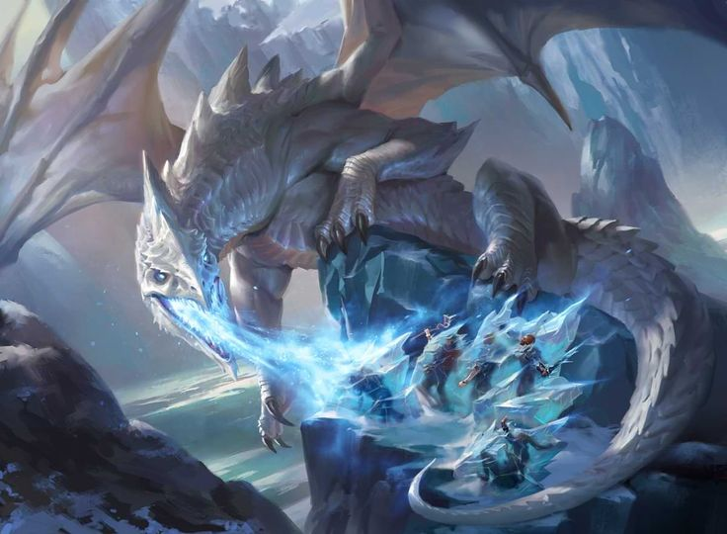

Figure 1: Bernier, M. 2022. Dragon Tactics: Follow These Tips for Truly Legendary Dragon Encounters.

(Bernier, 2022)

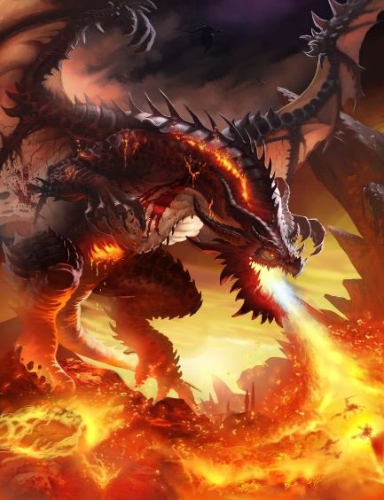

Figure 2: Haitao, L. 2016. Dragon5.

(Haitao, 2016)

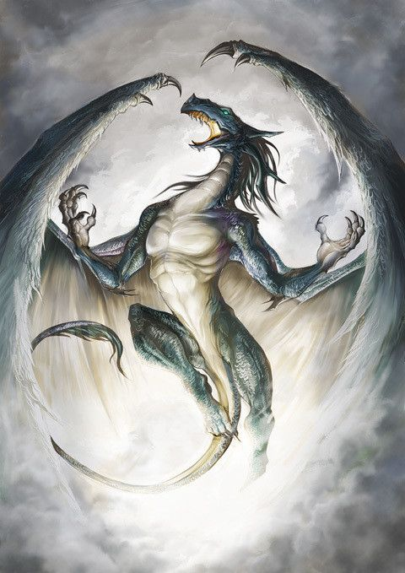

Figure 3: Wind Dragon. [s.a.].

([s.n.],[s.a.])

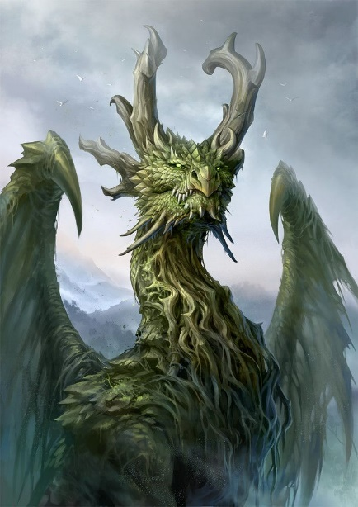

Figure 4: Tang, S. 2017. Forest Dragon.

(Tang, 2017)

For in-text citations of code, see comments in the TurnPlayerForm class.

# Reference List

Crunchyroll. [s.a.]. *Wind Dragon*. [Online]. Available at: <https://img1.ak.crunchyroll.com/i/spire3/03302008/6/3/c/4/63c4ae8b94ca30_full.jpg> [Accessed 27 March 2024].

D&DBeyond. 2022. *Dragon Tactics: Follow These Tips for Truly Legendary Dragon Encounters*. [Online]. Available at: <https://www.dndbeyond.com/posts/1337-dragon-tactics-follow-these-tips-for-truly?epik=dj0yJnU9RXNzMktaUEdDSWxSQ2pwUEczUU90YVRoUFdOUGpDM3omcD0wJm49a1NfcGxiYmIwU3RYa0RCd19sb0QwUSZ0PUFBQUFBR1lGWjZ3> [Accessed 27 March 2024].

Art Station. 2016. *dragon5*. [Online]. Available at: <https://www.artstation.com/artwork/yKVBK> [Accessed 27 March 2024].

Microsoft. [s.a.]. Form.FormClosing Event (Version 8.0) [Source code]. <https://learn.microsoft.com/en-us/dotnet/api/system.windows.forms.form.formclosing?view=windowsdesktop-8.0#system-windows-forms-form-formclosing> (Accessed 27 March 2024).

Mircrosoft. [s.a.]. FormClosingEventHandler Delegate (Version 8.0) [Source code]. <https://learn.microsoft.com/en-us/dotnet/api/system.windows.forms.formclosingeventhandler?view=windowsdesktop-8.0#definition> (Accessed 27 March 2024).

Art Station. 2017. *Forest Dragon*. [Online]. Available at: <https://www.artstation.com/artwork/bPWzk> [Accessed 27 March 2024].

*What are Delegates? (C# Basics, Lambda, Action, Func)*. 2020. YouTube video, added by Code Monkey. [Online]. Available at: <https://www.youtube.com/watch?v=3ZfwqWl-YI0> [Accessed 10 May 2024].