BEXIS 2.10.0

Data Dissemination Module

User Guide

Authors

Nafiseh Navabpour, Roman Gerlach, David Blaa

Contact

Website: <http://bexis2.uni-jena.de>

Email: bexis-support@uni-jena.de

Phone: +49-(0)3641-948968

Acknowledgement

The development of the BEXIS 2 software would not be possible without the German Research Foundation (DFG) funding the BEXIS++ project. BEXIS++ is a collaboration of the Friedrich-Schiller-University Jena (Dept. of Computer Science, Dept. for Geography), the Max-Planck-Institute for Biogeochemistry Jena, the Technical University Munich (Dept. Ecology and Ecosystem Management), the Gesellschaft für wissenschaftliche Datenverarbeitung mbH Göttingen (GWDG), and the Georg-August-University Göttingen.

**Content**

1 Overview 3

2 Publish a Dataset Version 3

2.1 Configurate 3

2.2 Publish 4

2.3 Zip 4

# Overview

The Data Dissemination Module, available via **Setup** (Cog button) and **Export Metadata**, provides a tool to export metadata to a standard compliant XML file. For every metadata structure in the system there is one tab in the tab strip.

The data grid in one tab shows all datasets belonging to the selected metadata structure.

Select a checkbox to mark the datasets you would like to export.

Please click the Export button and wait until the metadata XML file has been created successfully and a download link is available in-line.

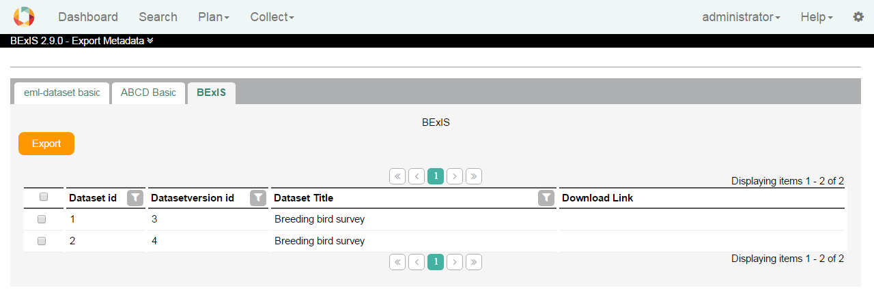

# Publish a Dataset Version

## Configurate

In the workspace a submisionConfig.xml is placed under “…\Workspace\Modules\DIM”.  
The data centers can be registered in this file. Here you can define requirements such as, for example, to export the primary data to csv.

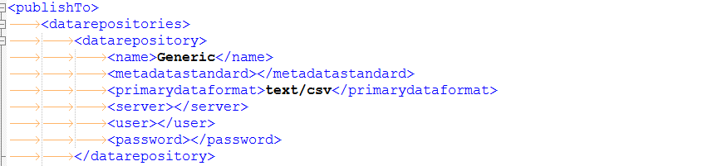

## Publish

The user can publish a dataset version if you go to the dataset and find the publish tab.  
The dropdown is showing all available data center. Select on and the system try to convert the data and the metadata as defined in the submissionConfig.xml. If something fails a message will displayed.  
There are two types of fails.

1. The system is not able to convert the data. The administrator should check the config and the convert option.
2. Metadata is not valid. This is a warning. You can go on but the metadata.xml in the zip ist not valid against the exported xsd schema

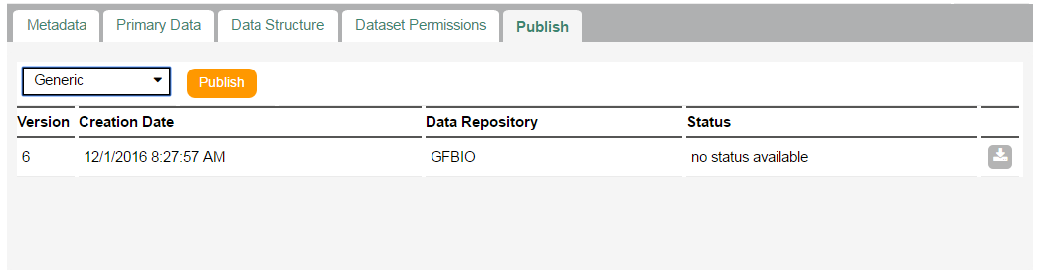

## Zip

The following files can be found in the zip file.

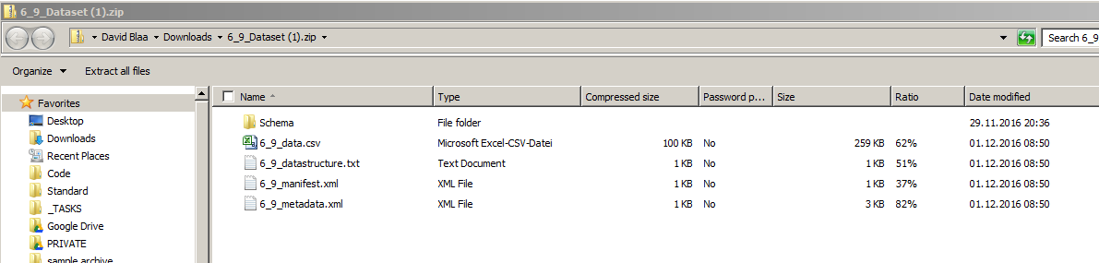

1. Schema - XSD Schema for the metadata
2. Data.*** - Primary Data
3. Data structure - Structure of the primary data
4. Manifest File - General information’s about the Dataset
5. Metadata - Metadata information’s about the dataset